Topic and Objectives
Our chosen business for this web application is an online PC game store. This store will allow customers to create accounts, view product details and purchase games for digital download. The target audience for this site is people who are passionate about PC gaming and will most likely have invested in high speed broadband and building their own machines. This site will offer a fast and convenient way to buy games.

Hierarchical Structure
The structure of this site is very simple. All forms but one are on the root of the server. The exception to this is the game details page which is behind the game list page. We are using two folders for images in this project. ‘GameImg’ is used for holding images which are uploaded from the admin page when adding a new game. The ‘Img’ folder contains images for the slideshow on the main page.

Visual Design
The theme for this website was chosen based on similar game and game store websites. The clean and dark aesthetic makes colours from the game images stand out and draw the eye. This means that users are more likely to stay on the website longer which will hopefully result in more purchases.

This site is primarily based on a single column layout using bootstrap. There are pages however, with both single, multiple column rows. On the game list page for example, the games are laid out in 4 columns across which are formatted using asp:ListView and ItemTemplate. Bootstrap has saved us a lot of time in the design phase and has allowed us to move more quickly on to the code behind it.

This site maintains its layout on every screen size we have tested on from 720p-1080p. This is due to the built-in scaling of bootstrap.
CSS classes were all taken from bootstrap and provided the jQuery necessary to animate buttons and outline focused textboxes with a slight glow. There were no special fonts used as the default sans-serif font suited the minimalist aesthetic quite well.

Database Design and Use
The database for this project contained five tables, seen below.
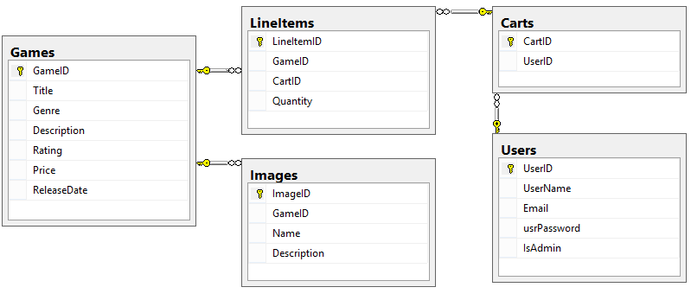
On the admin page there are four options. Add, update, delete and serialize a game. When the admin wants to add a game they must fill in the required information and provide an image to be displayed with the game. When the ‘Add Game’ button is clicked the games table is populated with the information provided and a new name is generated for the image. This new name is stored in the Images table. The image itself is stored in the ‘GameImages’ folder.
In the game list and game details page when a game is called the image name is taken from the database and appended to the ‘src’ field in the list view item template.
Update is nearly identical to this bar the image upload and delete uses a game id to find a record and remove it from the database.
Serialize to XML uses a stored procedure to pull a single record from the database using a game id which is input by the user. It then binds this record to a data table. The ‘WriteToXML’ function is then called and the XML file is saved to the desktop of the admin.

Technologies & Techniques Used
Naturally, the primary technologies used for this project were ASP and C#. ASP providing the controls and validation and C# allowing us to add functionality behind these controls and communicate with the database.

We made us of both ADO and Entity Framework during development. Entity Framework was used for all create, retrieve, update and delete tasks and ADO for binding information datasets and our password encryption when a user registers. The reason we used ADO for these two functions was that we felt we could accomplish the tasks more quickly and not because we believed it was a better option.

We have added two session states in our site. One for administrators and another for normal users. The navigation button for admin controls is hidden for users using some basic if else logic. If a normal user attempts to gain access to the admin page they will be automatically redirected to the default page. Similarly if an admin logs in they will be redirected to the admin controls page.

If neither of these session states are active then the site will redirect to the login/registration page and all other pages will be inaccessible.

Maintenance
Given the simplicity of the admin page we believe this site will be quite easy to maintain up to a point. Once the game list page reaches a certain amount of products it will become unfeasible to have them all on one page. At this point we would then separate them in to separate pages based on genre, rating and price. A search feature would also make navigating the site significantly easier as the product base grows.

In terms of the database we do not see any reason to extend it currently. However, given more time tables could be added for the news items. This would allow for a similar layout to the game list page meaning users could choose an article they wish to read and then be redirected to a page for that article.

Strengths and Weaknesses
From an ease of access perspective, the main strength of this site is the clear navigation. There is very little if no ambiguity and because of this anyone with basic website knowledge could easily purchase a product.

As mentioned previously redirects have been put in place to ensure non-logged in users cannot access any page except login/register.

The front end admin controls for interacting with the database are easy to understand which means that even non-programmers can manage site content.

Validation of the login, register and admin forms are also quite robust. Users cannot re-register an email address, login without correct credentials or leave null values in forms. Regular expression and required field asp validators were used to accomplish this.

