ECON 6760 - Assignment 1

Joe Martin

1/17/2022

Explore the data. For reference, this is the meaning for variables:

colony_n: Number of colonies colony_max: Maximum colonies colony_lost: Colonies lost colony_lost_pct: Percent of total colonies lost colony_added: Colonies added colony_reno: Colonies renovated colony_reno_pct: Percent of colonies renovated

# How many colonies were lost over time in Georgia  
ts_colony_ny <- colony %>%  
 filter(state == "New York") %>%  
 select(ym,colony_n)  
  
ts_colony_ga <- colony %>%  
 filter(state == "Georgia") %>%  
 select(ym,colony_n)  
  
ts_colony_ny <- ts(ts_colony_ny)  
ts_colony_ga <- ts(ts_colony_ga)  
  
plot(ts_colony_ga)

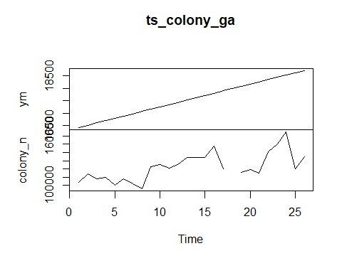

plot(ts_colony_ny)

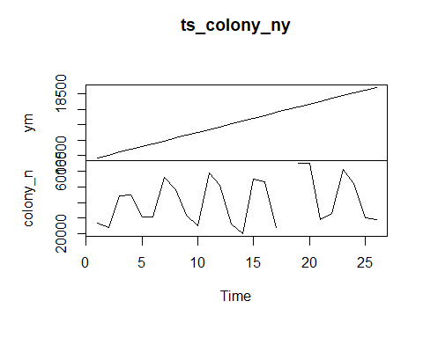 Although this is not economic data, this dataset is recorded quarterly. This is interesting because it is possible to see seasonal population trends. For example, filtering for colony numbers in Georgia, it is less clear how colony numbers are affected by weather, likely due to milder autumns and winters. However, when filtering for a state like New York where there are more dramatic changes in seasonal temperatures, it is clear that populations increase and decrease depending on the season.

#All of US  
  
ts_colony_usa <- colony %>%   
 filter(state == "United States") %>%  
 select(ym,colony_n)  
  
ts_colony_usa1 <- ts(ts_colony_usa)  
  
plot(log10(ts_colony_usa1))

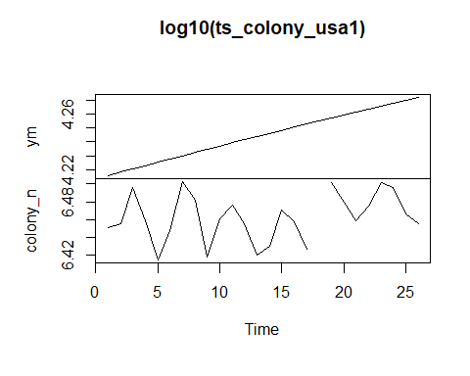

#using ggplot  
ts_colony_usa %>%  
 ggplot(aes(x = ym, y = log10(colony_n)))+  
 geom_line()

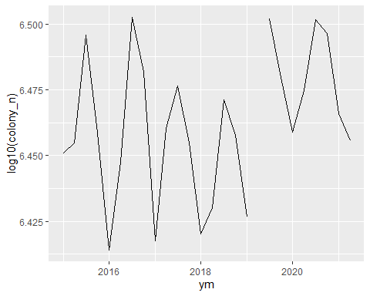

colony %>%  
 filter(state == "Georgia") %>%  
 ggplot(aes(x=ym, y = colony_lost))+  
 geom_smooth()

## `geom_smooth()` using method = 'loess' and formula 'y ~ x'

## Warning: Removed 1 rows containing non-finite values (stat_smooth).

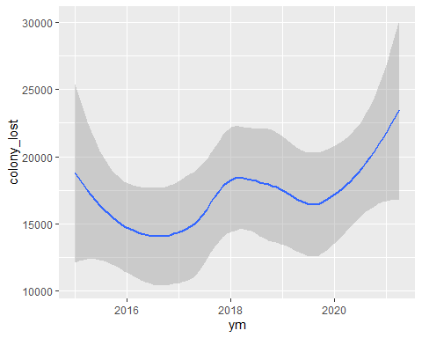

# Try using a natural log scale   
colony %>%  
 filter(state == "Georgia") %>%  
 ggplot(aes(x = ym, y = log10(colony_lost)))+  
 geom_smooth()

## `geom_smooth()` using method = 'loess' and formula 'y ~ x'

## Warning: Removed 1 rows containing non-finite values (stat_smooth).

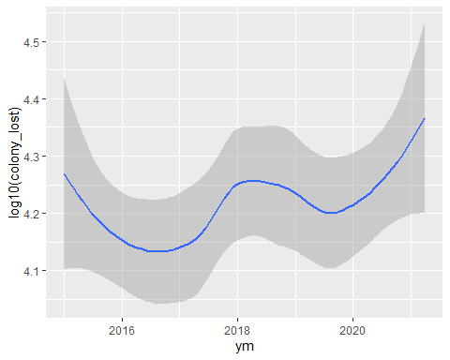

# Show plot as it appears on FRED website (https://fred.stlouisfed.org/series/CPIAUCSL)  
cpia %>%  
 ggplot(aes(x = year, y = CPIAUCSL))+  
 geom_smooth(se = FALSE)+  
 scale_x_continuous(breaks = seq(1950,2021, by = 5))

## `geom_smooth()` using method = 'loess' and formula 'y ~ x'

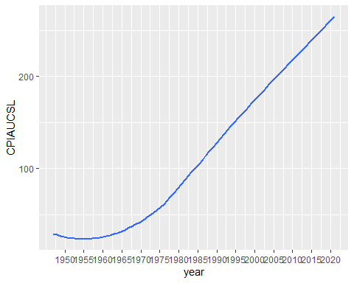

# natural log scale  
cpia %>%  
 ggplot(aes(x = year, y = ln_CPIA))+  
 geom_smooth(se = FALSE)+  
 scale_x_continuous(breaks = seq(1950,2021, by = 5))

## `geom_smooth()` using method = 'loess' and formula 'y ~ x'

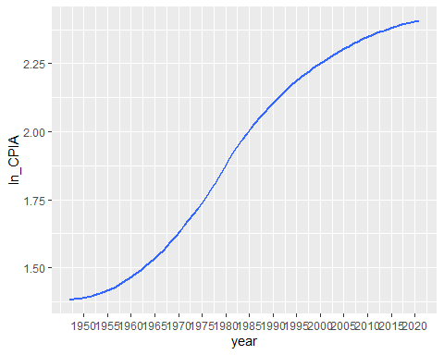

ts_cpia <- cpia %>%  
 select(DATE,CPIAUCSL)  
  
ts_cpia <- ts(ts_cpia)  
  
plot(diff(log10(ts_cpia)))

## Warning in diff(log10(ts_cpia)): NaNs produced

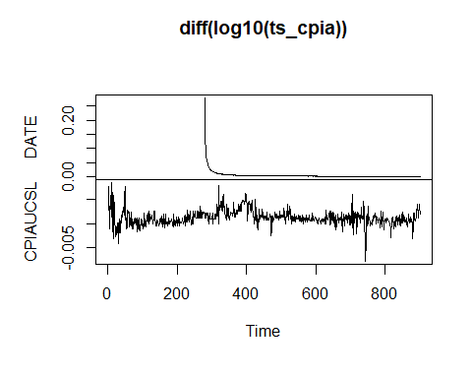

plot(ts_cpia)

