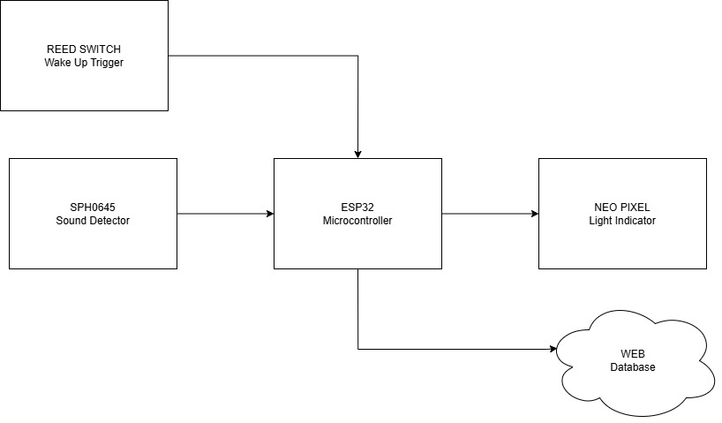

**Input**

* **Reed Switch:** Acts as a wake-up trigger for the ESP32 microcontroller.
* **SPH0645 Sound Detector:** Captures bee sound frequencies and converts them into digital signals.

**Process**

* **ESP32 Microcontroller:**
  + Processes the sound data from the SPH0645.
  + Activates the NeoPixel light indicator if necessary.
  + Transmits the recorded sound data to a web database.

**Output**

* **NeoPixel Light Indicator:** Provides visual feedback on system status.
* **Web Database:** Stores bee sound data for analysis.
* **Graphical Display:** The collected data is visualized as a graph for analysis.