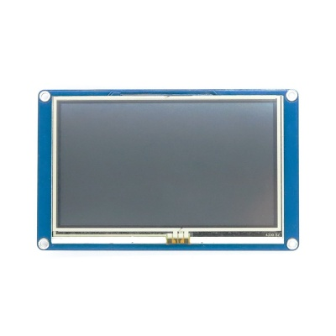

**NEXTION NX4827T043**

The NEXTION NX4827T043 is a powerful, user-friendly display designed for easy integration into embedded systems. It is used to display dynamic content like the trash bin levels (Plastic, Metal, Other) and the type of trash currently detected, offering a clear and intuitive user interface.

### Specifications:

• **Display Size**: 4.3 inches  
• **Resolution**: 480 x 272 pixels  
• **Interface**: Serial (TTL) Communication  
• **Touch Type**: Resistive Touchscreen  
• **Operating Voltage**: 5V  
• **Operating Temperature**: -20°C to +60°C  
• **Backlight**: White LED backlight  
• **Touch Panel**: Resistive 4-wire touch

### Advantages:

• **Integrated Design**: Supports graphical user interface (GUI) design directly on the display, eliminating the need for additional graphics processors.

• **Flexible Communication**: Works seamlessly with microcontrollers like Arduino, Raspberry Pi, etc., using serial communication.

• **Easy-to-use Software**: Nextion Editor software makes it simple to create customized user interfaces without complex coding.

• **Compact Design**: The 4.3-inch size fits easily into various applications, ideal for portable or fixed setups like waste management systems.

• **Low Power Consumption**: The display is energy-efficient, ideal for continuous monitoring systems.

### Application:

The NEXTION NX4827T043 is used in conjunction with the JSN B02 V2.0 ultrasonic sensors to provide a visual display of the trash bin's status. The display shows:

1. **Indicating whether the bin (Plastic, Metal, Other) is empty, partially filled, or full.**
2. **Displaying the type of trash detected, which is determined by another sensor or system in place.**

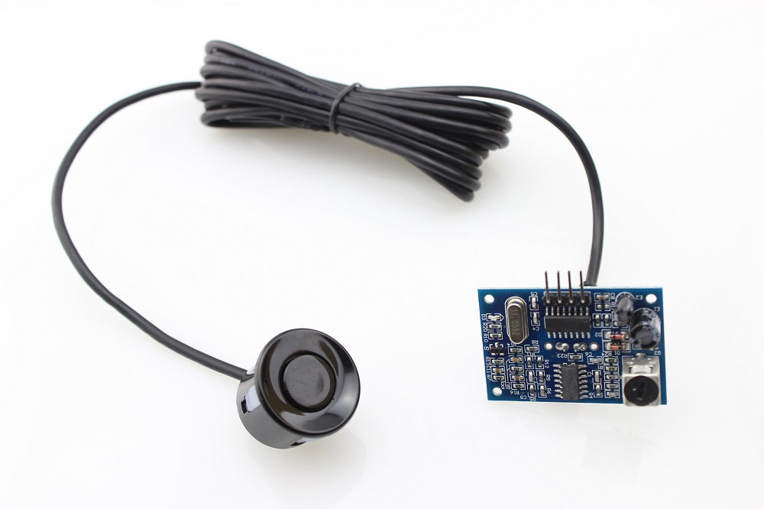

**JSN B02 V2.0 Ultrasonic Sensor**

The **JSN B02 V2.0** is a waterproof ultrasonic distance sensor designed to measure distances in a variety of environments. It emits ultrasonic waves and measures the time taken for the waves to bounce back after hitting an object. Based on the time taken, the sensor calculates the distance between itself and the object.

**Specifications:**

* **Operating Voltage:** 3.0V - 5.5V
* **Operating Current:** < 8 mA
* **Detection Range:** 3 cm to 350 cm
* **Accuracy:** ±1 cm
* **Waterproof Design:** Suitable for both indoor and outdoor applications
* **Interface:** TTL (Transistor-Transistor Logic) level output
* **Output Signal:** PWM (Pulse Width Modulation) or Serial Communication
* **Working Temperature:** -10°C to +70°C

**Advantages:**

* **Waterproof:** Can be used in harsh environments (e.g., waste bins, outdoors).
* **High Accuracy:** Reliable distance measurements with minimal error.
* **Versatile Interface:** Can work with microcontrollers like Arduino, Raspberry Pi, etc.
* **Wide Detection Range:** Detects objects from as close as 3 cm to as far as 350 cm.

JSN B02 V2.0 sensors are placed at the top of each trash bin (Plastic, Metal, Other). They continuously measure the distance between the top of the bin and the trash inside. As the trash level rises, the measured distance decreases. The sensor data is used for the following purposes:

1. **Determine if the bin is empty, partially filled, or full.**
2. **Trigger alerts for bin collection when a certain threshold is reached.**

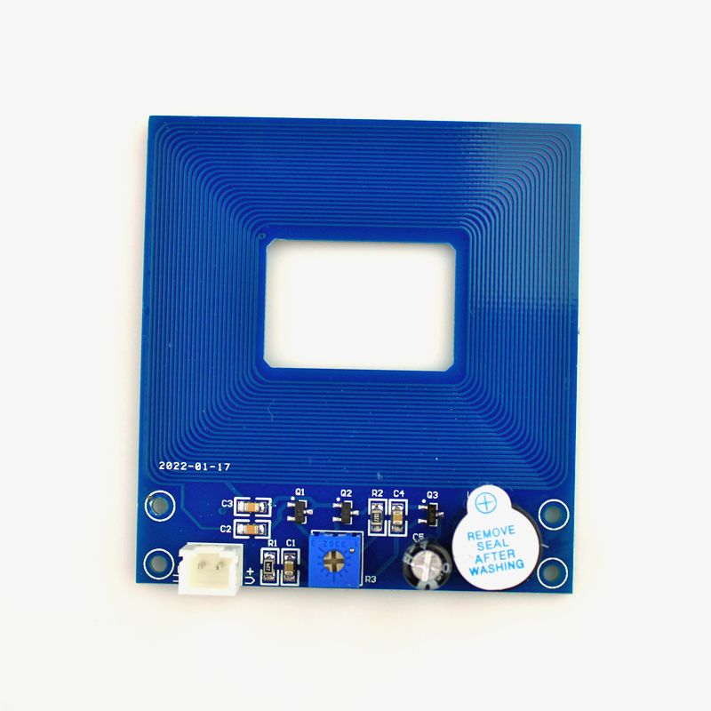

**Metal Detection Module - Contactless Metal Induction**

The **Metal Detection Module - Contactless Metal Induction** is a sensor designed to detect the presence of metal objects without physical contact. It uses electromagnetic induction to sense metallic materials and outputs a signal when a metal object is detected within its detection range.

**Specifications:**

* **Operating Voltage:** 5V DC
* **Detection Distance:** Up to 2 cm (depending on the size and type of metal)
* **Detection Type:** Contactless
* **Output Type:** Digital Output (High/Low)
* **Response Time:** < 2 ms
* **Operating Temperature: -20°C to +60°C**
* **Sensor Type: Inductive Proximity Sensor**
* **Board Size: 60.2 mm x 6**

**Advantages:**

* **Contactless Detection:** No physical contact is required to detect metal objects, ensuring longer sensor lifespan.
* **Fast Response Time:** Quick detection of metal objects, suitable for real-time applications.
* **High Sensitivity:** Can detect a variety of metals, including iron, aluminum, copper, and other conductive materials.
* **Durable and Reliable:** Designed to work in various environmental conditions.

Metal Detection Module is used to identify if the waste material being segregated is made of metal. When a metal object passes within the detection range of the sensor, it sends a digital signal to the microcontroller, which then classifies the object as metal. The module is integrated into the sorting system to:

1. **Detect metal objects in the trash stream.**
2. **Trigger the appropriate mechanism to direct metal waste to the designated bin.**
3. **Improve the accuracy of waste segregation by ensuring metal items are separated efficiently.**

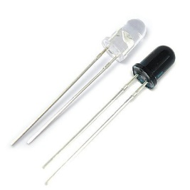

**IR LED (Infrared Light Emitting Diode)**

The IR LED works by emitting infrared light and measuring the reflection or transmission of that light to determine the transparency of an object. It helps classify waste items as either **Plastic** or **Other Materials** based on their ability to pass or block infrared light.

### Specifications:

• **Operating Voltage**: 1.2V to 3.7V  
• **Operating Current**: Typically 20mA  
• **Wavelength**: 850 nm to 950 nm (infrared spectrum)  
• **Detection Type**: Reflection-based (Non-contact)  
• **Detection Range**: Up to 5 cm (depending on object size and reflectivity)  
• **Response Time**: < 1 ms  
• **Operating Temperature**: -20°C to +60°C  
• **Power Output**: 50 to 100 mW  
• **Lens Type**: Domed or flat lens depending on application

### Advantages:

• **Non-contact Detection**: No physical interaction with the object, reducing wear and increasing the sensor's lifespan. •

**Fast Response Time**: Instant feedback on object transparency, making it ideal for real-time sorting. • **Efficient Sorting**: Helps classify plastic objects (transparent) and non-transparent items (like paper, cloth, etc

### ****Detection Logic****:

1. **Plastic Detection**:
   * When a **transparent plastic** object passes through, the infrared light passes through and is detected by the receiver. The **receiver** detects a **high value** because the infrared light is transmitted through the object, making it appear as transparent.
   * This is interpreted by the system as **Plastic**.
2. **Other Material Detection**:
   * When a **non-transparent object** (such as paper, fabric, or metal) blocks the infrared light, the receiver detects a **low value**. The object absorbs or reflects most of the infrared light, reducing the amount of reflected light reaching the receiver.
   * This is interpreted by the system as **Other** material (non-transparent items).

### ****Application****:

The IR LED sensor is integral to the waste sorting system, as follows:

1. **Plastic Classification**: If the object allows infrared light to pass through (transparent), it is classified as **Plastic**.
2. **Other Material Classification**: If the object blocks the infrared light (non-transparent), it is classified as **Other** material.
3. **Efficient Sorting**: Based on the received values (high or low), the microcontroller triggers the sorting mechanism to direct the waste to the appropriate bin.

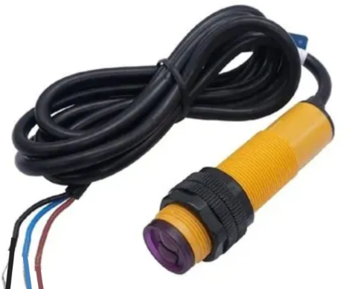

**Photoelectric Infrared Proximity Sensor**

The Photoelectric Infrared Proximity Sensor detects the presence of objects in a sorting area. It operates by emitting infrared light and detecting the light reflected from objects. The sensor provides a reliable, non-contact solution for identifying items in a sorting system and is crucial for effective waste management.

### Specifications:

• **Operating Voltage**: 5V to 30V DC  
• **Detection Range**: Up to 10 meters (depending on model and object reflectivity)  
• **Response Time**: < 1 ms  
• **Output Type**: Digital Output (Normally Open/Normally Closed)  
• **Detection Type**: Reflection-based (Active sensing)  
• **Sensing Angle**: 30° to 90° (depending on sensor model)  
• **Operating Temperature**: -25°C to +55°C  
• **Sensor Type**: Photoelectric (Infrared)  
• **Mounting Type**: Through-hole or Surface Mount

### Advantages:

• **Non-contact Detection**: Detects the presence of objects without physical contact, reducing wear and tear on components.

• **High Sensitivity**: Can detect both reflective and non-reflective objects, making it versatile for various applications.

• **Wide Detection Range**: Depending on the model, it can detect objects at a distance of up to 10 meters, making it suitable for larger or more spaced-out environments.

• **Fast Response Time**: Quick detection for real-time applications, essential in automated systems like waste sorting.

• **Versatile Use**: Can be used in multiple industries, including automation, waste management, and object presence detection.

### ****Application****:

The Photoelectric Infrared Proximity Sensor is used in waste sorting systems for presence detection and automated sorting. Here's how it works:

1. **Presence Detection**: The sensor identifies whether an object is in the sorting area, signaling the system to check the object.
2. **Signal Processing**: The sensor sends a signal to the microcontroller to determine the type of material, triggering the necessary action to segregate the waste.
3. **Continuous Monitoring**: The sensor keeps monitoring the sorting area in real-time, ensuring that every object is detected and classified without delay.

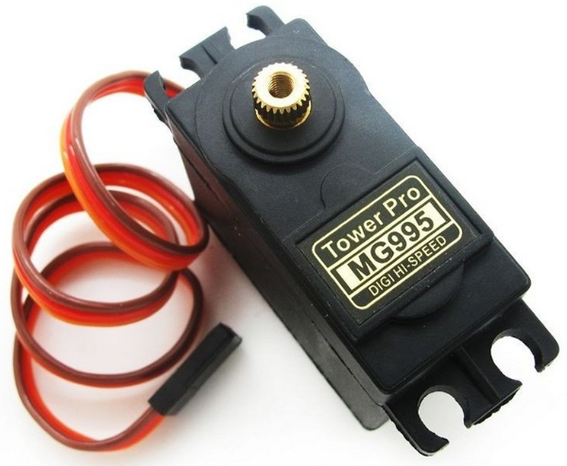

**MG995 Servo Motor**

The MG995 is a high-torque servo motor used to control mechanical components with precision. It operates using Pulse Width Modulation (PWM) signals to achieve accurate angular positioning. In the waste sorting system, the MG995 is used to control both the **ejection door** and the **slider mechanism** to ensure that waste items are sorted into the correct bins (Plastic, Metal, or Other).

### Specifications:

• **Operating Voltage**: 4.8V to 7.2V  
• **Torque**: 10 kg·cm at 6V  
• **Operating Speed**: 0.17 sec/60° at 6V  
• **Control Signal**: PWM (Pulse Width Modulation)  
• **Rotation Angle**: 0° to 180°  
• **Gear Material**: Metal gears for durability  
• **Operating Temperature**: -10°C to +60°C  
• **Size**: 40.7 mm x 19.7 mm x 42.9 mm

### Advantages:

• **High Torque**: Capable of moving heavier mechanical components like doors and sliders.  
• **Precise Control**: Accurate angular positioning ensures that objects are directed to the correct bins.  
• **Durable Build**: Metal gears increase the lifespan of the servo, making it suitable for continuous use.  
• **Versatile Use**: Can be used for multiple purposes in the sorting system, reducing the need for additional motors.  
• **Fast Response**: Quick response time allows for real-time sorting operations.

### ****Application****:

The MG995 Servo Motor plays a critical role in the waste sorting system by automating the physical sorting process. It ensures that:

1. **Door Control for Ejecting Objects**:
   * The MG995 controls the **ejection door** to release the detected item into the sorting area.
   * The motor rotates to open the door, allowing the object to fall into the designated bin, and then returns the door to its closed position.
2. **Slide Control to Direct Waste to the Correct Bin**:
   * The MG995 also operates the **slider mechanism**, which rotate to position the object over the correct bin (Plastic, Metal, or Other).
   * The motor adjusts the slider's position based on the object classification from the sensors, ensuring accurate segregation of waste.

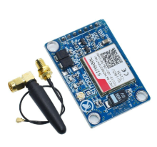

**SIM800A GSM Module for SMS Alerts**

The SIM800A is a GSM/GPRS module that enables microcontrollers to send and receive SMS messages, make calls, and connect to the internet via GPRS. In this project, the SIM800A is used to send an SMS alert when a trash bin reaches its full capacity, based on the readings from the **JSN B02 V2.0 Ultrasonic Sensors**.

### ****Specifications****:

* **Operating Voltage**: 5V
* **Power Consumption**:
  + **Standby**: 1 mA
  + **GSM Transmission**: 350 mA (Average), 2A (Peak)
* **Frequency Bands**: GSM 850/900/1800/1900 MHz
* **Communication Interface**: UART (TTL)
* **SIM Card Slot**: Supports 2G SIM Cards
* **Antenna**: External antenna for better signal reception

### ****Advantages****:

* **SMS Functionality**: Sends text messages to designated phone numbers.
* **Wide Network Compatibility**: Works on all GSM networks worldwide.
* **Low Power Consumption**: Efficient for battery-powered systems.
* **Reliable Communication**: Ensures delivery of SMS alerts even in areas with weak signal.

### ****Application:****

1. When a bin is detected as **full**, the microcontroller triggers the **SIM800A** to send an SMS alert to a predefined phone number.