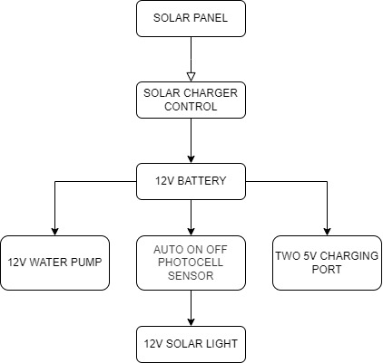

• **Solar Panel**: Converts sunlight into electrical energy (DC power).

• **Solar Charge Controller**: Regulates the voltage and current coming from the solar panel to prevent overcharging the battery.

• **Solar Battery**: Stores energy from the solar panel for later use.

• **12V DC Motor Pump**: Powered directly by the battery or via the charge controller's 12V output.

• **Solar Light**: Connected to the load output of the Solar Charge Controller controlled by Photocell Sensor

• **Two 5V Outputs**: Could be USB ports or DC-DC converters to step down the voltage from 12V to 5V for low-power devices.

**INPUT**

**SOLAR PANEL**

(Collects Energy)

**OUTPUT**

**12V MOTOR PUMP**

**12V SOLAR LIGHT**

**TWO 5V OUTPUT**

**PROCESS**

**SOLAR CHARGE CONTROLLER**

(Manages energy flow)

**INPUT:**

* **Solar Panel**: The solar panel receives sunlight and converts it into electrical energy, which powers the entire system.

**PROCESS:**

* **Solar Charge Controller**: The charge controller regulates the voltage and current coming from the solar panel, ensuring proper distribution of power to various outputs and charging the battery safely.

**OUTPUTS:**

* **12V Motor Pump**: Supplies power to operate the motor pump, which is used for your water refilling station.
* **12V Solar Light**: Provides power for lighting during the night.
* **5V Output**: Supplies power for charging mobile devices or other low-power electronics.