CS4500 (or CS5500) Operating Systems
Section 002
Project #2
Kernel Modules and Processes

Joseph Weibel
18 September 2026

Statement: “We have neither given nor received unauthorized assistance on this work.”

Virtual Machine Information

Directory and Name of Virtual Machine: jweibel/weibelj-virtual-machine
IP of Virtual Machine: 128.198.51.72
Password for VM Account: grader
Path to Source Code: grader

Part 1

1.1 How We Solved the Problems
When I initially ran this on my personal computer, I had a windows machine, so I was running this on Ubuntu through WSL. I ran into an issue with the kernel version is a Microsoft provided kernel which doesn’t enable me to load these kernel modules. I solved this issue by switching the school's VM that I have for the class.

1.2 What We learned

I learned about how to load kernel modules which I have never done before. I also learned how to troubleshoot loading kernel modules and figuring out incompatibilities between different distributions of linux.

1.3 How to Run Our Code
cd /opt/os-project2/hello
make
sudo insmod hello.ko
sudo lsmod | grep hello
sudo rmmod hello
sudo dmesg -T | tail
sudo rmmod hello

Part 2

2.1 When you load your module, which process is recognized as current?
When I load my modules insmod is recognized as current. This can be seen in the kernel message which show the print_self name is insmod. print_self: name=insmod pid=34583 state=TASK_RUNNING (0)

2.2 What is it called and what do you see from your module’s output?
In newer kernels pid 1 is systemd. In the output from print_self I get this: print_self: name=systemd pid=1 state=TASK_INTERRUPTI BLE (1)

2.3 Do you notice something not working again?
This is where I had the issue with TASK_NONINTERACTIVE because it is not defined in the kernel version I am using.

2.4 How We Solved the Problems
I had an error when I copied the task states from “https://linuxgazette.net/133/saha.html” because TASK_NONINTERACTIVE is not defined in the kernel version I was using so I had to remove that from the list.

2.5 What We learned
I learned that the task states get updated throughout time and how to reference new documentation to see what it was updated to.

2.6 How to Run Our Code
cd /opt/os-project2/print_self
make
sudo insmod print_self.ko
sudo lsmod | grep print_self
sudo rmmod print_self
sudo dmesg -T | tail -20
sudo rmmod print_self

Part 3

3.1 How We Solved the Problems
This was simple to implement once I got part 2 completed. All I did was copy the files and update the names. The only thing I had to look up was how to add a pid as an argument to a kernel module, or in general how to send any argument to the module. I also added some error handling to output if there is no argument given as well as invalid pid.

3.2 What We learned
How to add arguments to kernel modules as well as how to perform error handling for input inside a kernel module.

3.3 How to Run Our Code
cd /opt/os-project2/print_other
make
sudo insmod print_other.ko pid=$$
sudo lsmod | grep print_other
sudo rmmod print_other
sudo dmesg -T | tail -20
sudo rmmod print_other

Part 4

4.1 What’s the difference between a kernel module and a system call?
System calls are made for programs in user space to interact with resources in kernel space. One of the unbreakable rules in Linux is that user space and kernel space will never cross over to each other therefore system calls are used for this.

Kernel modules can be added to an already running kernel which will add functionality or do a specific task that doesn’t rely on rebuilding the kernel or rebooting the system.

4.2 Does the provided article still work? Use your own words to explain why you think this may be a good (or bad) thing.
When I ran this example code from 20 years ago it didn’t work. I received this error “fatal error: sys/syscall.h: No such file or directory”. When I ran make, the build failed during compilation when reading the headers because the import for sys/syscall.h is not a kernel header.

This is protecting the sys_call_table which is used to hold function pointers that will point to a specific system call to run. This is a security implementation that will prevent maliciously or ignorantly updating some of the core functions of the kernel.

Screenshots of Output

3.1 Code Output Screenshots with explanations

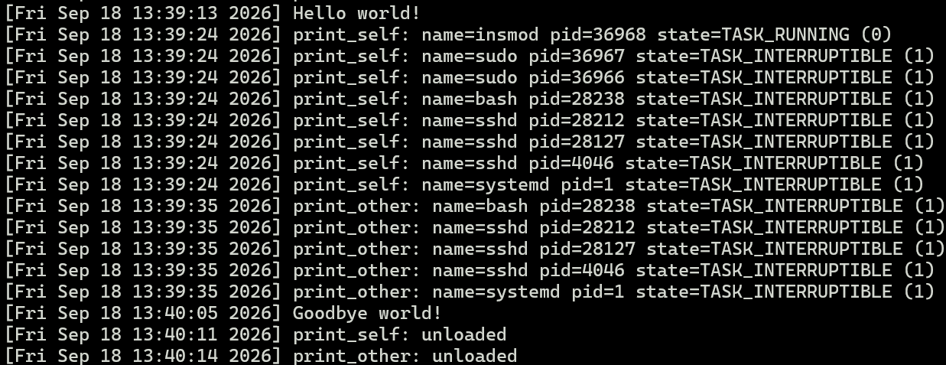
This shows me loading each module from parts one, two, and three. When I loaded hello and searched for it with dmesg it shows the print message I have defined in the code using printk(). When I loaded print_self it immediately recursively gets the PID of each parent task and prints the state of each task. For print_other I have it an argument of pid=$$ which is the PID of the current shell im using. This will recursively look at each parent process and print them out the same way. Then I moved into removing the kernel modules and you can see the goodbye message as well as print_self and print_other showing unloaded.

Resources

https://stackoverflow.com/questions/47586576/why-i-get-this-error-init-task-undeclared-first-use-in-this-function

https://linuxgazette.net/133/saha.html

https://git.kernel.org/pub/scm/linux/kernel/git/torvalds/linux.git/commit/

https://raw.githubusercontent.com/torvalds/linux/v6.8/kernel/pid.c

https://linux-kernel.vger.kernel.narkive.com/oJRnbfkU/find-task-by-pid-problem

https://sysprog21.github.io/lkmpg/

https://www.linuxjournal.com/article/4378

https://www.linuxjournal.com/files/linuxjournal.com/linuxjournal/articles/043/4378/4378l1.html

Depending on the project requirement, you may need to provide the password of a regular user or the root user.

