1. File structure:

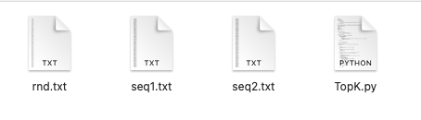

The program and the text files must be in the same directory.

1. Program

Program: TopK.py  
Command to run the program: python3 TopK.py [value of K]