## Database Design

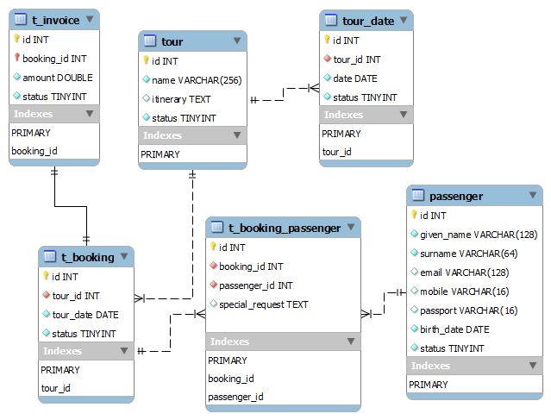

## Relationships:

* Each “Tour” has multiple “Tour Dates”
* Each “Tour Date” only belongs to a “Tour”
* Each “Tour” has many “Bookings”
* Each “Booking” only belongs to a “Tour”
* Each “Booking” has many “Passengers”
* Each “Passenger” has man “Booking”
* Each “Booking” has one “Invoice”
* Each “Invoice” only belongs to a “Booking”

## Values:

1. “Status” in “Invoice” can only be one of these three values: “Unpaid”, ”Paid”, and “Cancelled”;
2. “Status” in “Booking” can only be one of these three values: “Submitted”, “Confirmed”, and “Cancelled”;
3. “Status” in “Tour” can only be one of these two values: “Draft” and “Public”;
4. “Status” in “Tour Date” can only be these two values: “Enabled” and “Disabled”;
5. “Status” in “Passenger” can only be these three values: “Enabled” and “Disabled”;

## Functions need to be done:

* List all “Public” tours
* Edit a tour
* Create a tour
* Make a booking for a “Public” tour, and can only booking a “Enabled” tour date,
* Edit a booking and allow user to add/remove passenger in this booking

## Requirement

* Database: Mysql/Mariadb
* Backend Language: Laravel Framework (PHP).
* Frontend Language: jQuery+Bootstrap