Analysis of Heart Disease Mortality
Joe, July 2018

Executive Summary
This document presents an analysis of data concerning heart disease and their mortality rate across the United States at the county level. The analysis is based on 3198 observations of socioeconomics and health data, each containing specific characteristics of the county’s demographics, health and socioeconomic indicators.
After exploring the data by calculating summary and descriptive statistics and by creating visualizations of the data, several potential relationships between heart disease mortality and socioeconomics indicator has identified. After exploring the data, a predictive model to predict heart disease mortality rate per 100 thousand people was created.
After performing the analysis, the author presents the following conclusions:
While many factors can help indicate the county level of heart disease mortality rate, significant features* found in this analysis were:
- health__pct_physical_inacticity – Percent of adult population that is physically inactive. Higher percent of physically inactive are linked to have higher level of heart disease mortality.
- health__pct_diabetes – Percent of population with diabetes. Higher percent of diabetes are likely to have higher level of heart disease mortality

- health__pct_adult_obesity – Percent of adults who meet clinical definition of obese. Higher percent of clinical obesity are likely to have higher level of heart disease mortality.

- demo__pct_adults_bachelors_or_higher –Percent of adult population which has a bachelor's degree or higher as highest level of education achieved. Higher percent of adults holding a bachelor’s degree or above are likely to have less level of heart disease mortality
- demo__pct_adults_less_than_a_high_school_diploma –Percent of adult population that does not have a high school diploma. Higher percent of adults who don’t have high school diploma are likely to have higher level of heart disease mortality

* Significant Features in this reports means correlation between the feature column and mortality rate are higher than 0.5

Initial Data Exploration
The initial exploration of the data began with some summary and descriptive statistics.

Individual Feature Statistics
Summary statistics for minimum, maximum, mean, median, standard deviation, and distinct count were calculated for numeric columns, and the results taken from 3198 observations are shown here (figures are rounded to a maximum of 4 decimal places)

Column | Min | Max | Mean | Median | Std Dev | DCount
health__pct_physical_inacticity | 0.09 | 0.442 | 0.2772 | 0.28 | 0.0534 | 275
health__pct_ diabetes | 0.032 | 0.203 | 0.1093 | 0.109 | 0.0232 | 139
health__pct_adult_obesity | 0.131 | 0.471 | 0.3077 | 0.309 | 0.0432 | 264
demo__pct_adults_bachelors_or_higher | 0.0111 | 0.7990 | 0.1995 | 0.1765 | 0.0893 | 2744
demo__pct_adults_less_than_a_high_school_diploma | 0.0151 | 0.4735 | 0.1488 | 0.1332 | 0.0682 | 2783
heart_disease_mortality_per_100k | 109 | 512 | 279.3693 | 275 | 58.9533 | 301

Since heart_disease_mortality_per_100k is of interest in this analysis, it was noted that there are significantly large number of unique or same value, but the standard deviation and range indicates that there is considerable variance in the mortality rate of heart disease per 100 thousand people. A histogram of the heart_disease_mortality_per_100k column shows that the mortality values are loosely follow the normal distribution - in order words, most of heart disease mortality rate in US county are follow the average number of the nation:
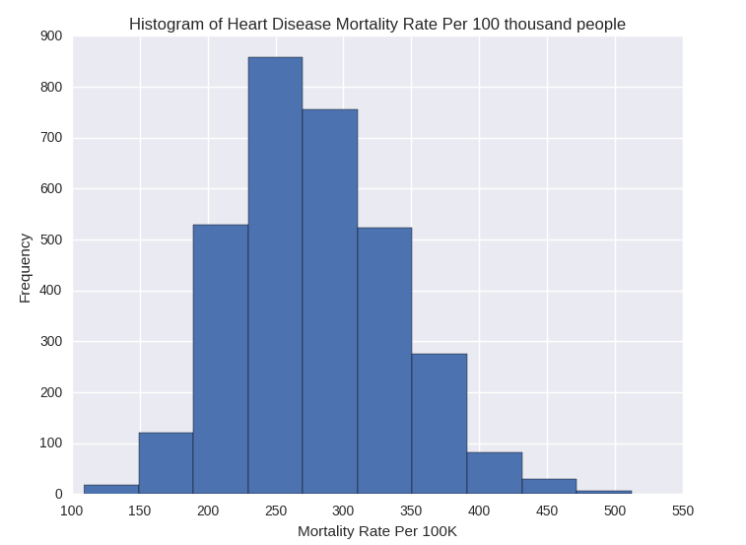
In addition to the numeric values, the heart disease mortality rate observations include categorical features, including:
- area__rucc–Rural-Urban Continuum Codes. This column forms a classification scheme that distinguishes metropolitan counties by the population size of their metro area, and nonmetropolitan counties by degree of urbanization and adjacency to a metro area. The official Office of Management and Budget (OMB) metro and nonmetro categories have been subdivided into three metro and six nonmetro categories. Each county in the U.S. is assigned one of the 9 codes.
- area__urban_influence –Urban Influence Codes. This column forms a classification scheme that distinguishes metropolitan counties by population size of their metro area, and nonmetropolitan counties by size of the largest city or town and proximity to metro and micropolitan areas.
- econ__economic_typology – County Economic Typology Codes. This column classifies all U.S. counties according to six mutually exclusive categories of economic dependence and six overlapping categories of policy-relevant themes. The economic dependence types include farming, mining, manufacturing, Federal/State government, recreation, and nonspecialized counties. The policy-relevant types include low education, low employment, persistent poverty, persistent child poverty, population loss, and retirement destination.
- yr – This columns classify A or B. The project description does not provide further information for this column

Bar charts were created to show frequency of these features, and indicate the following:
- Non-metro area are more common than metro area
- Small-metro with less than 1 million residents are more common than large metro area with more than 1 million residents.
- For Economic Typology, except for non-specialized, the most common are manufacturing dependent
One key observation is that the number of cylinders is usually four, and that other values have low frequencies, shown here:
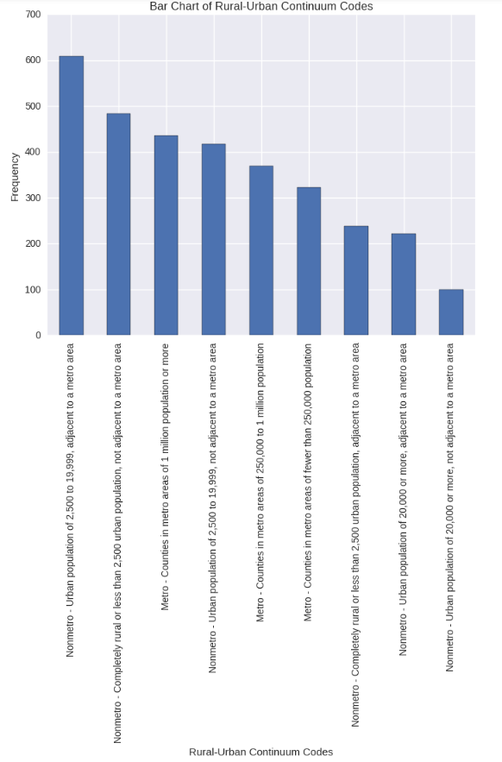
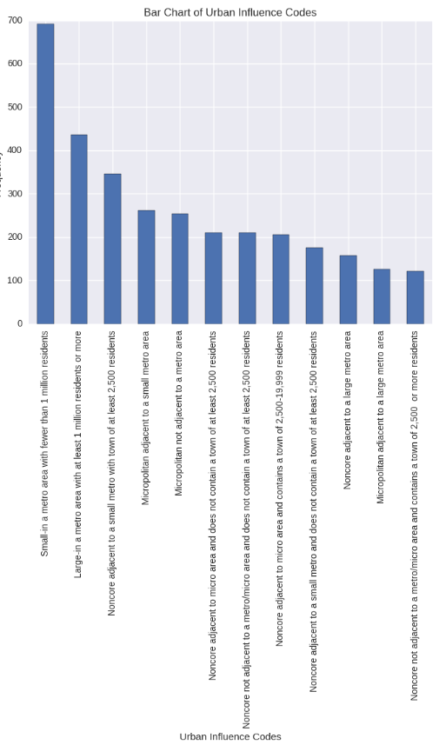
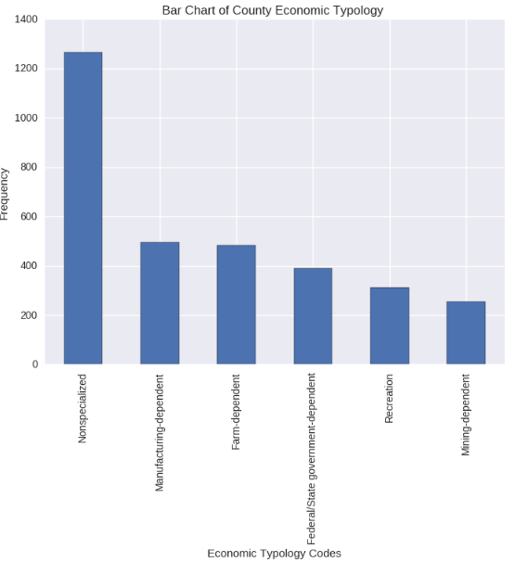

Correlation and Apparent Relationships
After exploring the individual features, an attempt was made to identify relationships between features in the data – in particular, between heart_disease_mortality_per_100k and the other features.

Numeric Relationships

The following present the correlation value between heart_disease_mortality_per_100k and various of data column. Insignificant correlation (Less than 0.1) are highlight as Red while Significant Correlation (higher than 0.5) are highlighted as Green

econ__pct_civilian_labor | -0.47664
econ__pct_unemployment | 0.37162
econ__pct_uninsured_adults | 0.333963
econ__pct_uninsured_children | -0.03446
demo__pct_female | 0.086974
demo__pct_below_18_years_of_age | 0.121863
demo__pct_aged_65_years_and_older | -0.05616
demo__pct_hispanic | -0.11235
demo__pct_non_hispanic_african_american | 0.375099
demo__pct_non_hispanic_white | -0.15742
demo__pct_american_indian_or_alaskan_native | 0.004622
demo__pct_asian | -0.26725
demo__pct_adults_less_than_a_high_school_diploma | 0.527382
demo__pct_adults_with_high_school_diploma | 0.428137
demo__pct_adults_with_some_college | -0.34076
demo__pct_adults_bachelors_or_higher | -0.54138
demo__birth_rate_per_1k | 0.142176
demo__death_rate_per_1k | 0.444757
health__pct_adult_obesity | 0.593324
health__pct_adult_smoking | 0.462174
health__pct_diabetes | 0.631285
health__pct_low_birthweight | 0.456464
health__pct_excessive_drinking | -0.29541
health__pct_physical_inacticity | 0.64981
health__air_pollution_particulate_matter | 0.1492
health__homicides_per_100k | 0.276234
health__motor_vehicle_crash_deaths_per_100k | 0.421081
health__pop_per_dentist | 0.284462
health__pop_per_primary_care_physician | 0.208817

From the correlation value, it is clear than health indicators of clinical obesity, diabetes and inactivity are highly linked with heart disease mortality. Besides, in socioeconomics perspective, education level is also strongly linked with heart disease mortality. Better education standard typically suggest a lower heart rate mortality rate. However, it is interested to know that the column econ__pct_civilian_labor, which indicate Percentage of Civilian labor force, have some negatively correlated with heart disease mortality rate, which suggest higher civilian labor force may suggest a lower heart disease morality rate

Categorical Relationships
Having explored the relationship between mortality rate and numeric features, an attempt was made to discern any apparent relationship between categorical feature values and heart rate mortality. The following box- plots show the categorical columns that seem to exhibit a relationship with the heart disease mortality rate:
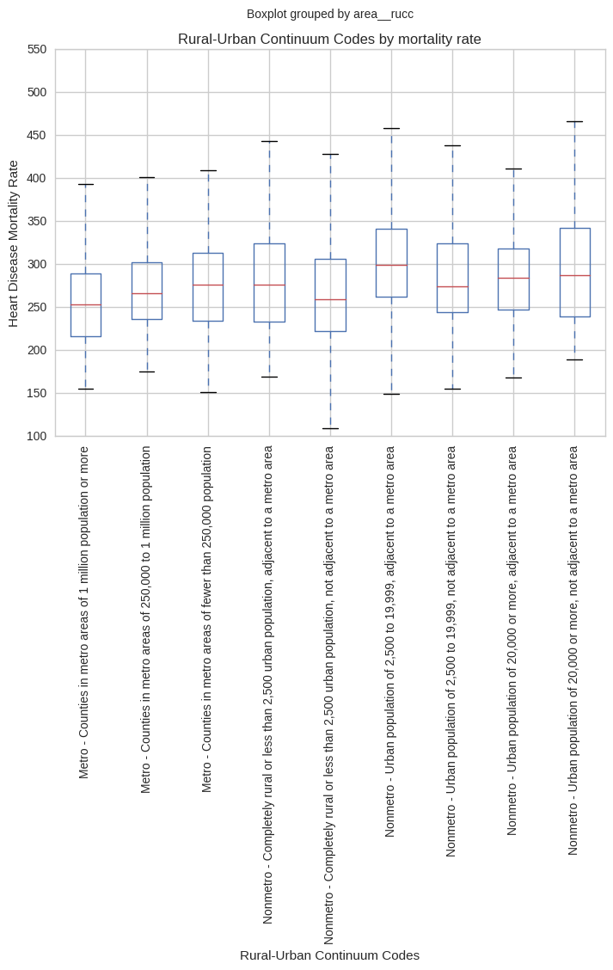

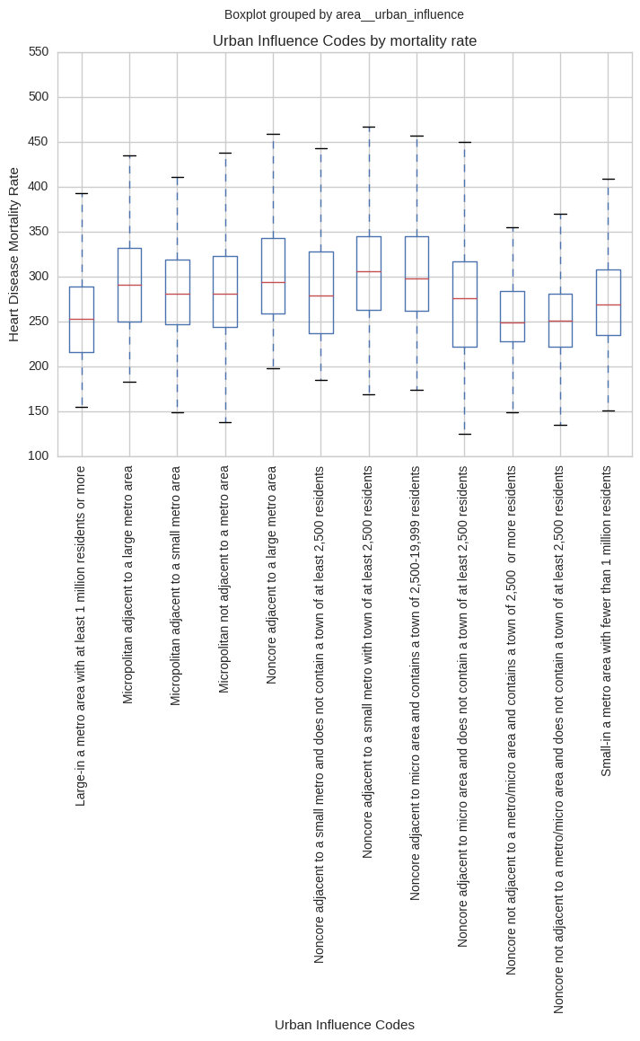
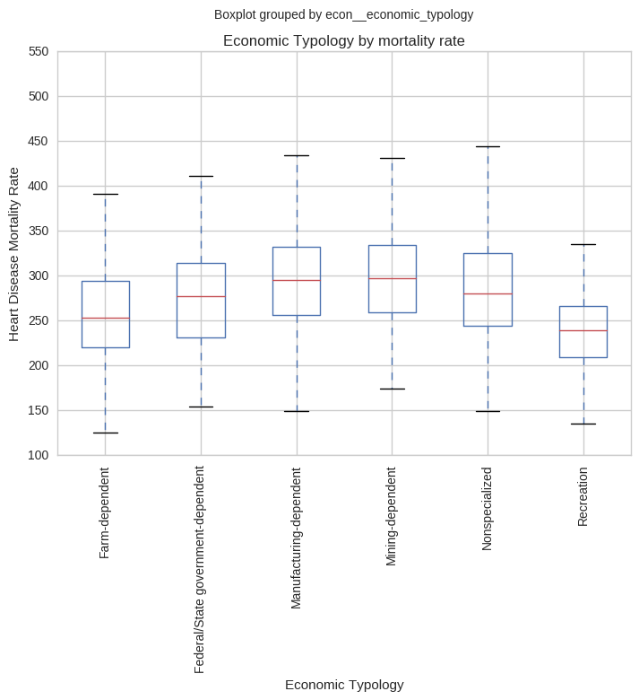

The box plots show that there are not significant differences in terms of the median and range of heart disease mortality rate for different categorical features. However, it is interesting to point out that:
- Metro area has typically lower than non-metro area, through the difference are not significant.
- Recreation industry is likely have the lowest heart disease mortality rate, while mining industry are highest.

Heart Disease Mortality Rate Prediction
I have created a regression model to predict the actual heart disease mortality rate per 100K person of a county. Based on the apparent relationships identified when analyzing the data, I have created a machine learning model to predict the heart_disease_mortality_per_100k value.

After evaluating several feature selection , I finally choose include all numeric feature that have correlation value between the selected column and the heart disease mortality rate column of 0.1 or higher in the model, and all category feature except yr.

I tried several machine learning algorithm, including but not limited to neural network regression, linear regression, boosted decision tree regression model, and decision forest regression. Finally, I choose boosted decision tree regression model to predict the heart_disease_mortality_per_100k, as it produce the lowest Root Mean Square Error (RMSE) score.

The model was trained with 70% of the data, and tested with the remaining 30%. The learning rate is 0.1. A scatter plot showing the predicted heart disease mortality rate and the actual heart disease mortality rate is shown below:
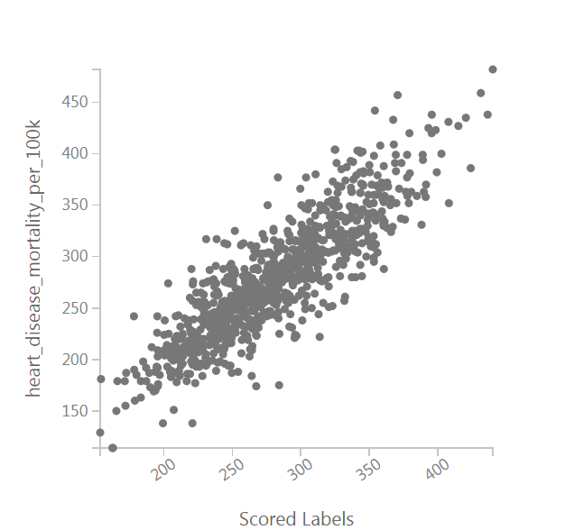

This plot shows a clear linear relationship between predicted and actual values in the test dataset. The Root Mean Square Error (RMSE) for the test results is 27.911288 in the calculated experiment.

However, when I submit my data to the platform for another set of actual data for further testing, the RMSE has increased to 35.6183, which is significantly higher than the calculated experiment.

Conclusion
This analysis has shown that the mortality rate of a heart disease can be confidently predicted from its characteristics. In fact, most of features in the dataset except percentage of uninsured child, percentage of female, percentage of 65 years and older, and percentage of native American can help us to predict the mortality rate. In particular, health indicator of percentage of physical inability, diabetes, and clinical obesity have a significant effect on heart disease mortality rate. Besides, education indicators of percentage of having bachelor degree or higher, and percentage of not having high school diploma, also play a significant roles.

