game dev: programmer: designer

**J**□**SEPHSIEREJK**□

## � PROFILE

### account services and game programmer

"First Class Trouble" - Invisible Walls

Developing the Multiplayer Game 'First Class Trouble' using unreal Engine, released on on PS Plus for PlayStation 4 and PlayStation 5, and Steam

Primarily work with c++ and JSon languages, and utilize Blueprints with UE

Create Front-End and Back-End Solutions for Matchmaking and Player Profile Features

Implemented Account Authentication, Cloud Saves, Party and Friend Features, Commerce, Moderation Tools, DLC Entitlements, and gathering Analytics

Developed all Customization Features, designing the UI interface with Photoshop and unreal's user Widgets, and using Cloud saving to store Data

Worked with 30 Modelers to create an easy Pipeline to add new Customization Assets

♦I--

I--

♦�

�

[joesierejko@rocketmail.com](mailto:joesierejko@rocketmail.com)

203-500-1261

joehogan23.github.io 87 Hampton Park.

Branford. CT 06405

into game

### gameplay & network programmer (temp),

Naval War College

Migrate Netcode from UNET 2017 to Mirror in Unity 2018

Fully integrate Chat Messaging Features, including User Mentions

Implement a Spreadsheet Reader to modify/update Systems Data through Excel Add additional Gameplay Feature Requests

### programming tutor, NEIT

Support students in Learning New Programming Languages

**1.1,J**

**Cl Cl c..:I**

**1.1,Ji:a:::**

**cc**

I­ I.I.,

**Cl**

**en**

## � SKILLS

*C#*

*CIC++*

Java

HTML

Javascript css

UE Blueprints JSon

Unity

Unreal Engine Visual Studio Photoshop AccelByte After Effects Perforce

JIRA

Adapt to how each student learns, using UML's, Pseudo-Code, and Stepping Through Code

Teach Students Skills to become more Self-Sufficient, checking for Runtime Errors, understanding how to read Compile Errors, and how to properly include and use Libraries to avoid Linker Errors

### intern programmer, Attollo LLC

Maintenance Programming for RQ-21 Simulator Software, using C, C++, C#, and XAML

Implemented a XAML-based 30 Model lmpoter to Add and Remove Models. Updates a Master XML file and Speeds Up Development Time by 1000%

* **Fixed User Interface Defects reported through Jira**

### mobile ar developer, Dewetron

Independently Developed AR Application, Published on Apple Stores and as a(n) APK Wrote a Generic, Reusable PDF Viewer to display Dewetron's Product Guide

Built Database of AR Target Images

Stream Videos from External Server to overlay Target Images

* **Button Events open email for Inquiries, and directs user to Product Links**

# GAME PROJECTS--------

'Aberrant' - B.S. Final Project, NEIT

## EDUCATION

Art Director, Programmer, Level Designer, UI/UX

**learn about this project: Joehogan23.github.io/aberrant.html**

**Team Size .I. .I. .I.**

**New England Institute of Technology BS Game Development & Simulation Programming East Greenwich, RI - GPA: 3.80**

New England Institute of Technology

**AS Game Development&. Simulation Programming East Greenwich, RI • GPA: 3.88**

**2018- 2020**

**2017-2018**

### 'Redrock Farmer' - Independent Project

Programmer, Graphic Designer, UI, Engine API

**learn about this project: Joehogan23.github.io/redrockrarmer.html**

**Team Size 1**

New England Institute of Technology BS Digital Recording Arts

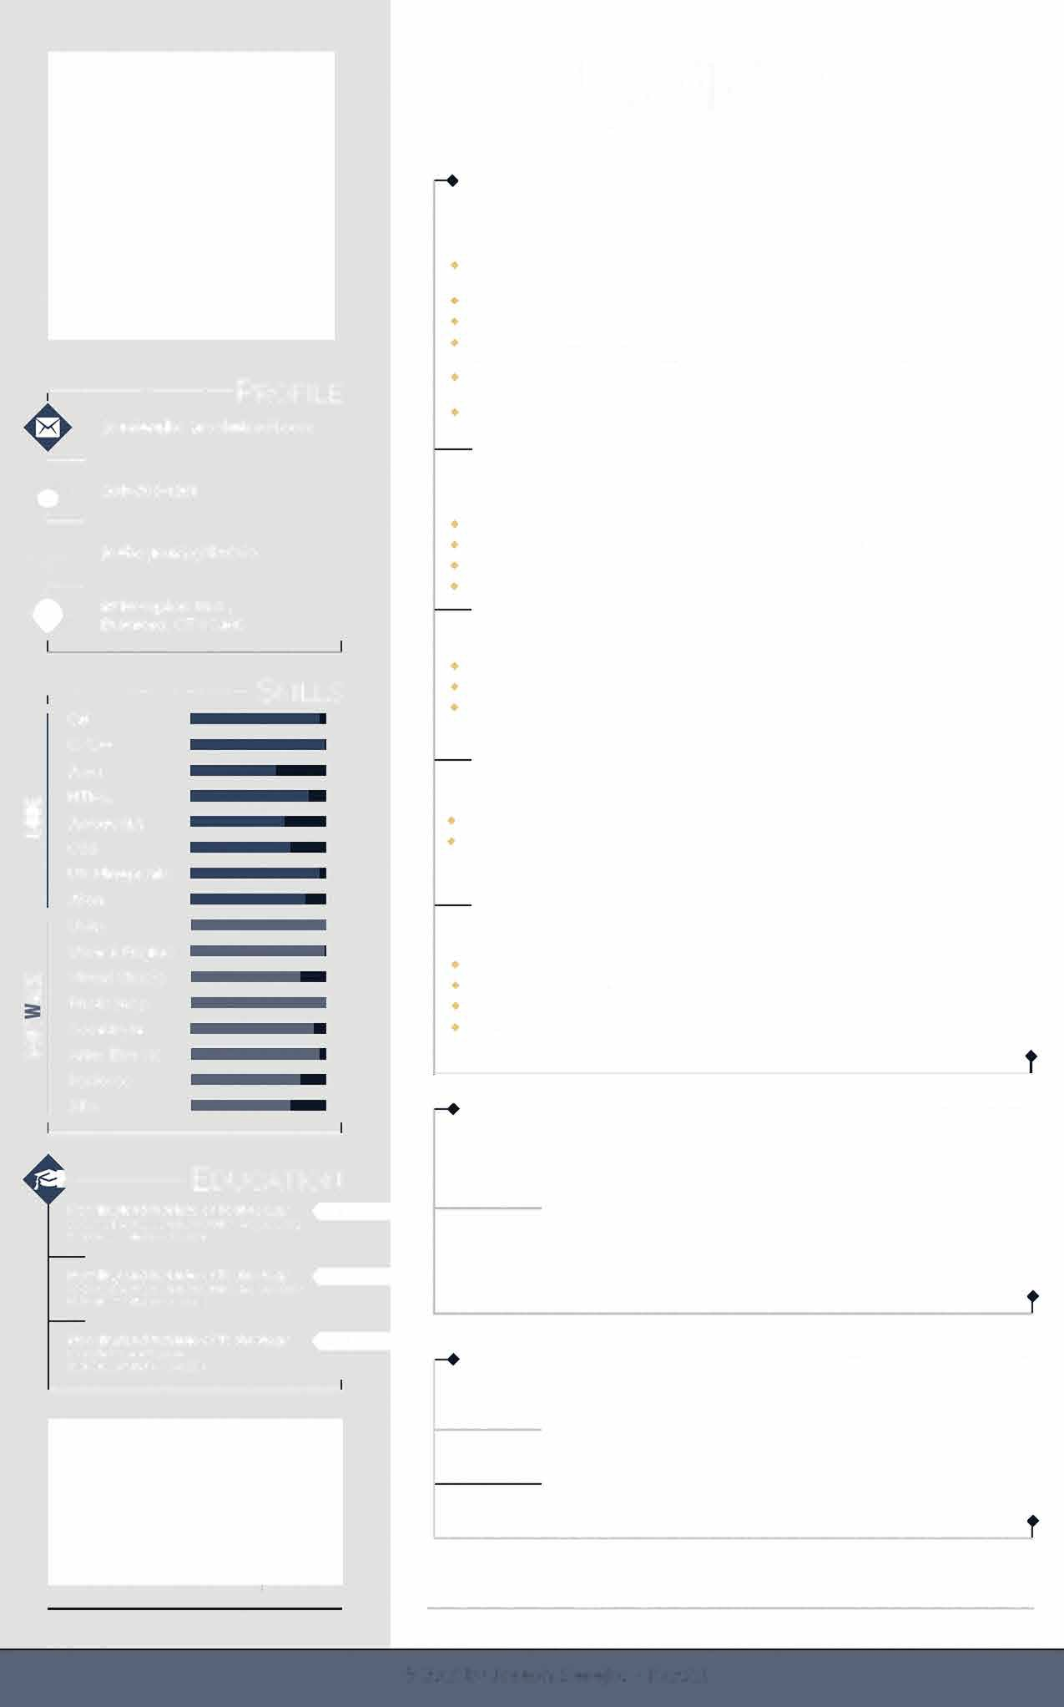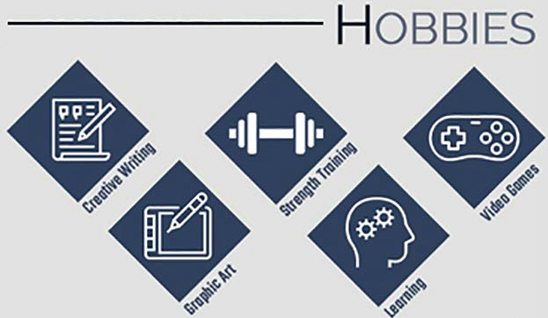

**East Greenwich, RI- GPA: 2.90**

**2009 • 2012**

# OTHER EXPERIENCE-------

member services, Planet Fitness, february 18 - april '19

technical support specialist, **ASSA** ABLOY, july '16 - march '17

graphic designer/animator/editor, Verizon FiOS1 **News,** june 13 - july '16

### Full-Color Resume: joehogan23.github.io/Resume.html

© 2021 by Joseph Sierejko -11/2021