JOSEPHSIEREJKO

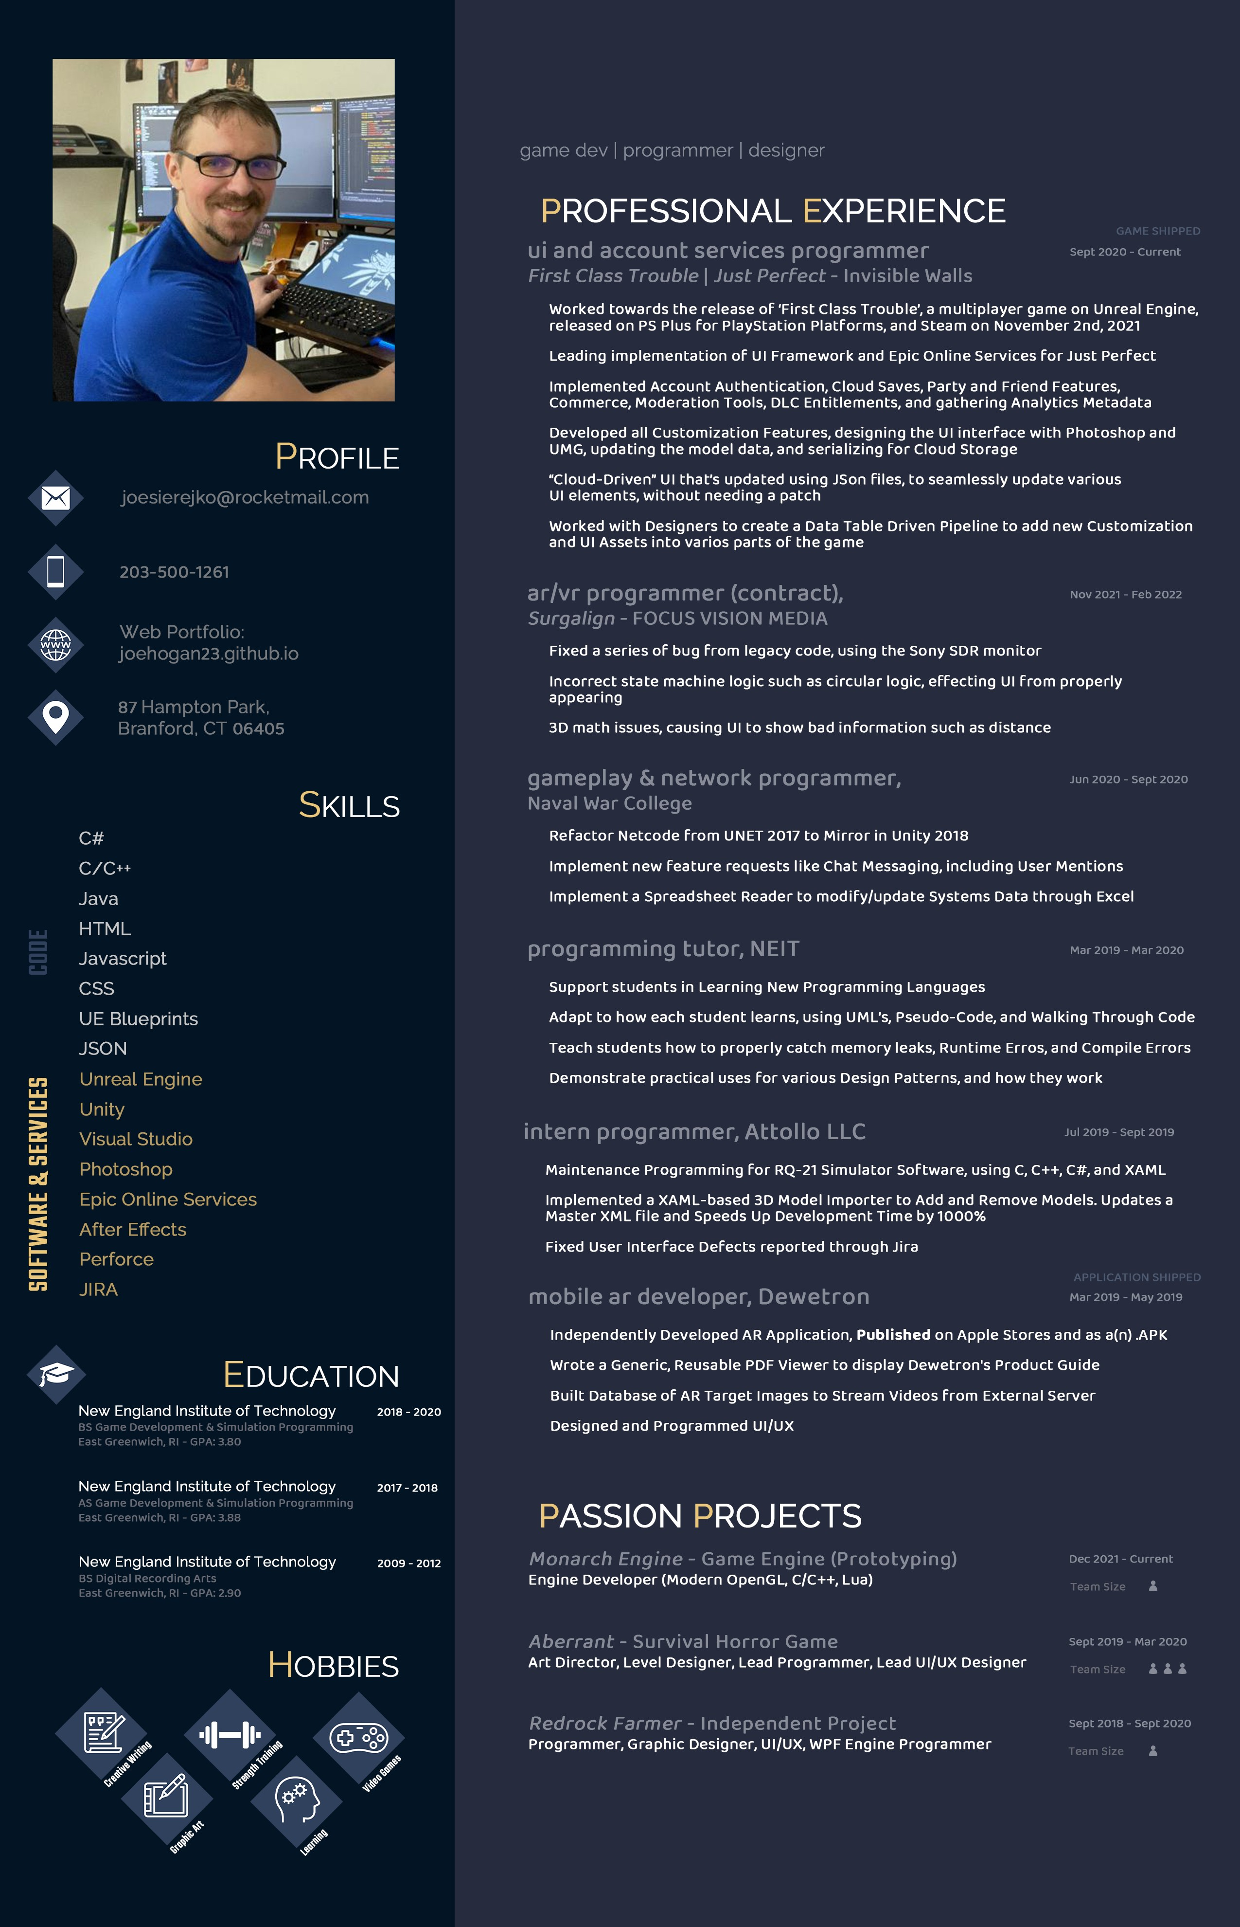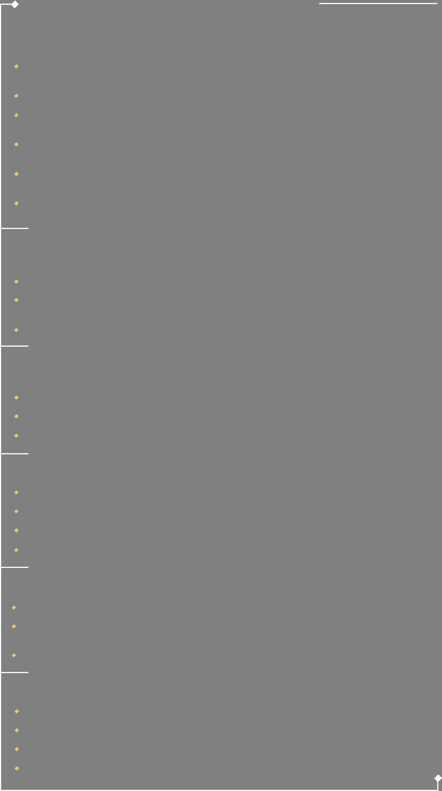

Printer-Safe Resume: **joehogan23.github.io/ResumePrint.html**

© 2022 by Joseph Sierejko - 02/2022