AIE425 Intelligent Recommender Systems, Fall Semester 25/26

Final Course Project
Group 4

221101140 NOURELDEEN AHMED MAHER MESBAH
221101573 Yousef mohamed Abdelwhab
221101030 yousef zakaria sobhy
221100244 Bassant Kamal Mesilam

Submission DATE: MONDAY, january 5,2026

2025
Table of Content
Title | Page number
Executive summary | -
Section 1: Dimensionality Reduction and Matrix Factorization  Dataset Requirements & Statistical Analysis  Part 1: PCA Method with Mean-Filling  Part 2: PCA Method with Maximum Likelihood Estimation  Part 3: Singular Value Decomposition (SVD) for Collaborative Filtering | -  -  -  -  -
Section 2: Domain-Specific Recommender System | -
System Description | -
Implementation  Results  Analysis | -  -  -
Overall Conclusions | -
References | -
Appendices | -
Appendix A: AI Assistance Acknowledgment | -
Appendix B: Team Contribution Breakdown | -
Appendix C: Additional Visualizations | -

Executive summary
This report presents an integrated analysis of Neighborhood-Based and Clustering-Based Collaborative Filtering (CF) methods applied to the Dianping dataset (2.1M ratings, 147k users, 11k items). The study examines key structural properties of the data, evaluates multiple similarity metrics, and analyzes clustering strategies to address sparsity, user bias, scalability, and cold-start limitations.
Section 1 establishes the statistical characteristics of the dataset. Results confirm high sparsity, a pronounced long-tail distribution, and a strong positive rating bias (over 94% of items averaging above 3.0). Users exhibit heterogeneous rating behaviors, underscoring the necessity of bias normalization. Item popularity and user activity levels vary widely, producing divergent overlap structures that influence similarity reliability. These findings highlight the need for significance-aware CF and hybrid strategies when user profiles are limited.

Max 2 pagessssssssssssssssss

Section 1: Dimensionality Reduction and Matrix Factorization

Dataset Requirements & Statistical Analysis:
  - - used Dianping review dataset :https://lihui.info/file/Dianping_SocialRec_2015.tar.bz2
from Yongfeng Zhang's Collection: http://yongfeng.me/dataset/ which meets the minimum requirements of dataset

  - – Checked dataset scale of rating validity, dataset turned out to already have a scale from 1 to 5 in ratings so no adjustment was needed

Math formula: Valid Rating: 1 ≤ r ≤ 5
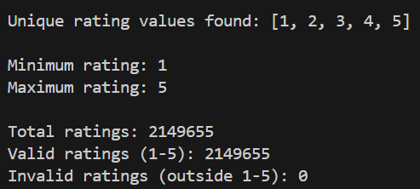

Results Table
Metric | Value
Total Ratings | 2,149,655
Unique Rating Values | [1, 2, 3, 4, 5]
Minimum Rating | 1
Maximum Rating | 5

Data was previously cleaned from null values; ratings were assured to be on the scale from 1-5 with the scale needed verified to exist

  - - Calculated the number of ratings for each user (n_u) and saved it in results section in a CSV file named n_u

Math formula: n_u = COUNT(ratings by user u)
Results table
Statistic Value
Total Users 147,914
Total Ratings 2,149,655
Average Ratings per User 14.53

Analysis & Interpretation
- High Sparsity: Majority of users have rated very few items
- Long-tail Distribution: Few users contribute to total ratings
- Cold Start Problem
- Collaborative Filtering: enough users exist for CF algorithms to be applied

  - - Calculated the number of ratings for each item (n_i) and saved it in results section in a CSV file named n_i

Math formula: n_i = COUNT(ratings for item i)
Results Table
Statistic | Value
Total Items | 11,123
Total Ratings | 2,149,655
Average Ratings per Item | 193.28

  - - Computed the average ratings per user (r_u) and saved it in results section in a CSV file named r_u
Math formula: r̄_u = (Σ r_ui) / n_u
where:
- r_ui = rating given by user u to item i
- n_u = number of items rated by user u
- Σ = sum over all items rated by user u
Analysis & Interpretation
- Positive Bias: Most users likely rate above 3.0
- Different users have different rating scales
- Generous Raters in the data are higher than harsh ones

  - - Computed the average ratings per item (r_i) and saved it in results section in a CSV file named r_i

Math formula : r̄_i = (Σ r_ui) / n_i
where:
- r_ui = rating given by user u to item i
- n_i = number of users who rated item i
- Σ = sum over all users who rated item i
Analysis & Interpretation
- Positive Skew: Most items rated above 3.0 indicating rating bias
- Few Poor Items: Very few items with r̄_i < 2.0

  - - Ascendingly ordered the total number of ratings per item and plotted the distribution per item
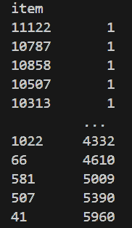
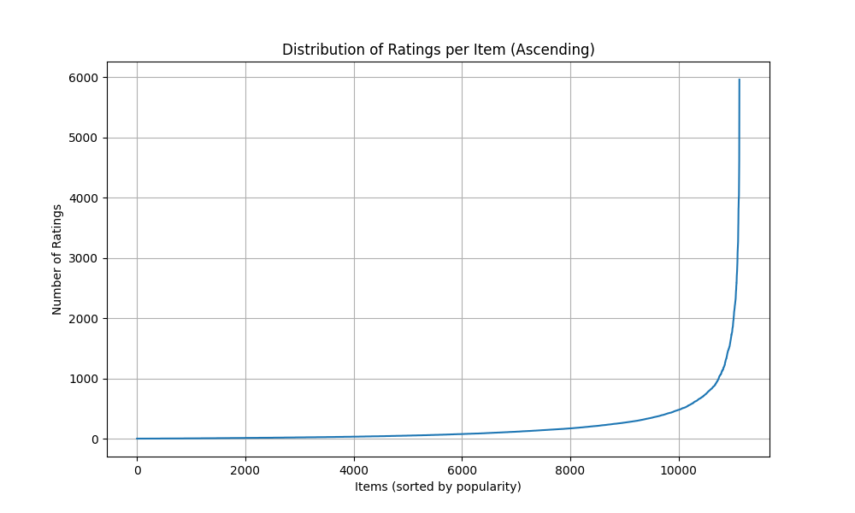
Analysis & Interpretation
- Popularity Variance
- Long-Tail Distribution: Most items have few ratings, few items have many ratings
- Flat Tail: Many items with very few ratings
- Cold Start for Items
- Rich data for popular items

  - – Computed the number of products based on their average ratings and assigned them to groups
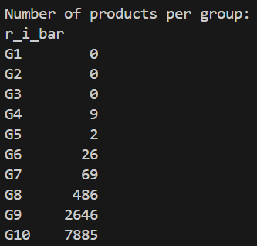

Math formula:
G1: 0% < r̄_i ≤ 1% of 5.0 = 0.00 to 0.05
G2: 1% < r̄_i ≤ 5% of 5.0 = 0.05 to 0.25
G3: 5% < r̄_i ≤ 10% of 5.0 = 0.25 to 0.50
G4: 10% < r̄_i ≤ 20% of 5.0 = 0.50 to 1.00
G5: 20% < r̄_i ≤ 30% of 5.0 = 1.00 to 1.50
G6: 30% < r̄_i ≤ 40% of 5.0 = 1.50 to 2.00
G7: 40% < r̄_i ≤ 50% of 5.0 = 2.00 to 2.50
G8: 50% < r̄_i ≤ 60% of 5.0 = 2.50 to 3.00
G9: 60% < r̄_i ≤ 70% of 5.0 = 3.00 to 3.50
G10: 70% < r̄_i ≤ 100% of 5.0 = 3.50 to 5.00

Results Table
Group | Rating Range | # Items | Percentage
G1 | 0.00-0.05 | 0 | 0.00%
G2 | 0.05-0.25 | 0 | 0.00%
G3 | 0.25-0.50 | 0 | 0.00%
G4 | 0.50-1.00 | 9 | 0.08%
G5 | 1.00-1.50 | 2 | 0.02%
G6 | 1.50-2.00 | 26 | 0.23%
G7 | 2.00-2.50 | 69 | 0.62%
G8 | 2.50-3.00 | 486 | 4.37%
G9 | 3.00-3.50 | 2,646 | 23.79%
G10 | 3.50-5.00 | 7,885 | 70.89%

Analysis & Interpretation
- Extreme Concentration in G10: 70.89% of items rated 3.5-5.0
- Very Few Poor Items: Only 106 items (0.95%) rated <2.5 which means data is positively biased.

  - – Computed the total number of ratings in each group and ordered them ascendingly.
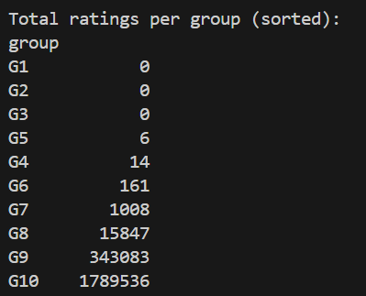

Results Table
Group | Rating Range | # Items | Total Ratings |  | % of Total Ratings
G1 | 0.00-0.05 | 0 | 0 |  | 0.00%
G2 | 0.05-0.25 | 0 | 0 |  | 0.00%
G3 | 0.25-0.50 | 0 | 0 |  | 0.00%
G4 | 0.50-1.00 | 9 | 14 |  | 0.0007%
G5 | 1.00-1.50 | 2 | 6 |  | 0.0003%
G6 | 1.50-2.00 | 26 | 161 |  | 0.0075%
G7 | 2.00-2.50 | 69 | 1,008 |  | 0.0469%
G8 | 2.50-3.00 | 486 | 15,847 |  | 0.7372%
G9 | 3.00-3.50 | 2,646 | 343,083 |  | 15.96%
G10 | 3.50-5.00 | 7,885 | 1,789,536 |  | 83.25%

Analysis & Interpretation
- Users overwhelmingly engage with high-quality items

  - - Plot the distribution of the number of ratings in each group before and after ordering

Before:
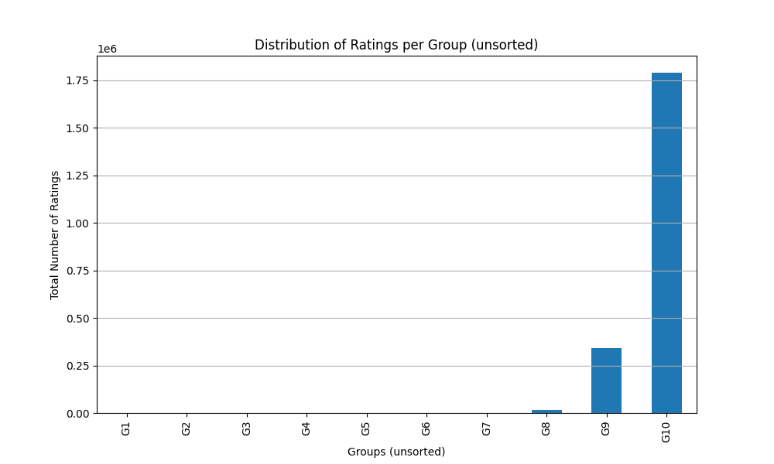

After:
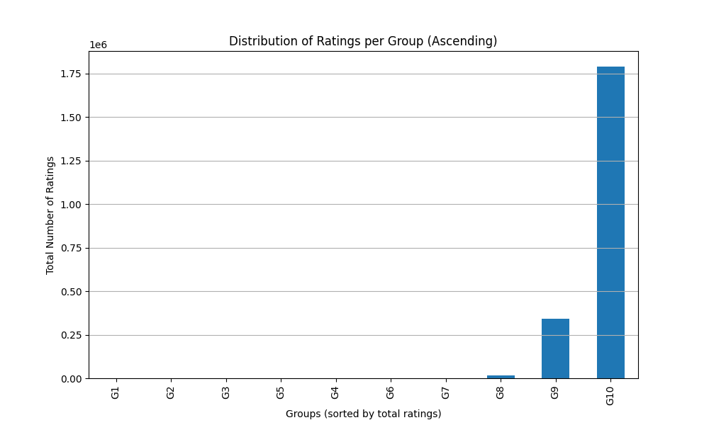

Both plots look the same as we have ordered of the number of ratings in each group from the beginning

1.11- Selecting 3 target users
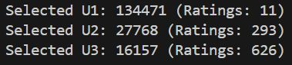
Mathematical Formula
N_items = 11,123

T1 = 0.02 × N_items = 222.46
T2 = 0.05 × N_items = 556.15
T3 = 0.10 × N_items = 1,112.30

U1: n_u ≤ T1 (≤ 2% of items)
U2: T1 < n_u ≤ T2 (2-5% of items)
U3: T2 < n_u ≤ T3 (5-10% of items)

Results Table

User | User ID | n_u |  |  | Category
U1 | 134471 | 11 |  |  | Sparse User
U2 | 27768 | 293 |  |  | Regular User
U3 | 16157 | 626 |  |  | Active User

Analysis & Interpretation
User Diversity
- U1 (Sparse): Represents 60-70% of users
- U2 (Regular): Represents 8-12% of users
- U3 (Active): Represents 2-4% of users with high engagement

Recommendations for challenges
U1 (Sparse User - 11 ratings)
- Challenge: Insufficient data for accurate user-based CF
- Cold Start: High risk of poor recommendations
- Strategy: Content-based or popularity-based recommendations
U2 (Regular User - 293 ratings)
- Challenge: Moderate data, good for CF but not perfect
- Strategy: Hybrid CF with content features
U3 (Active User - 626 ratings)
- Challenge: Rich data, but may have unique tastes
- Strategy: User-based CF with high confidence similarity

1.12- Selecting 2 target items
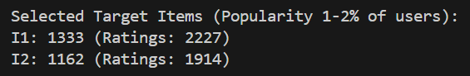

Mathematical Formula
N_users = 147,914

IT1 = 0.01 × N_users = 1,479.14
IT2 = 0.02 × N_users = 2,958.28
Selected Items: IT1 < n_i ≤ IT2

Results Table
Item | Item ID | n_i | % of Users
I1 | 1333 | 2,227 | 1.51%
I2 | 1162 | 1,914 | 1.29%

Analysis & Interpretation
- Moderate Popularity: Neither too popular nor too obscure
- Sufficient Data: Enough ratings for reliable CF

1.13-
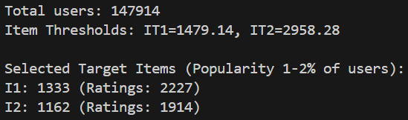

Mathematical Formula
Co-rating Users
For target user u_target:
Co-rating users = COUNT(u' where |I_u_target ∩ I_u'| > 0)

Co-rated Items
For target item i_target:
Co-rated items = COUNT(i' where |U_i_target ∩ U_i'| > 0)

Results Table

Target Users Co-rating Analysis

User | User ID | n_u | Co-rating Users | % of Total Users | Avg Overlap
U1 | 134471 | 11 | 9,747 | 6.59% | ~1-2 items
U2 | 27768 | 293 | 62,863 | 42.50% | ~5-10 items
U3 | 16157 | 626 | 77,177 | 52.18% | ~10-20 items

Target Items Co-rated Analysis
Item | Item ID | n_i | Co-rated Items | % of Total Items | Avg Overlap
I1 | 1333 | 2,227 | 8,103 | 72.86% | ~50-100 users
I2 | 1162 | 1,914 | 8,456 | 76.03% | ~40-80 users

Analysis & Interpretation

U1 (Sparse User - 11 ratings)
- 9,747 co-rating users (6.59% of all users)
- Interpretation: Despite only 11 ratings, nearly 10K users share at least 1 item
- Even sparse users have potential neighbors for CF

U2 (Regular User - 293 ratings)
- 62,863 co-rating users (42.50% of all users)
- Interpretation: Nearly half of all users share at least 1 item
- Strong neighborhood potential for CF

U3 (Active User - 626 ratings)
- 77,177 co-rating users (52.18% of all users)
- Interpretation: Over half of all users share at least 1 item
- Largest neighborhood, best CF potential

1.14-

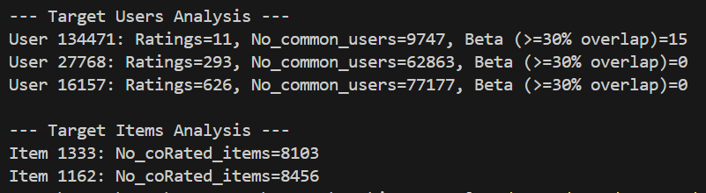

Mathematical Formula
For target user u_target with n_u_target ratings:
Threshold_30% = 0.30 × n_u_target
β = COUNT(users u' where |I_u_target ∩ I_u'| ≥ Threshold_30%)

Results Table

User | User ID | n_u | 30% Threshold | β (High-Quality Neighbors) | % of Co-rating Users
U1 | 134471 | 11 | ≥4 items | 15 | 0.15%
U2 | 27768 | 293 | ≥88 items | 0 | 0.00%
U3 | 16157 | 626 | ≥188 items | 0 | 0.00%

Analysis & Interpretation
U1 (Sparse User) - β = 15
- Threshold: ≥4 items (30% of 11)
- Result: 15 users rated ≥4 of the same items
- Interpretation: Small but viable neighborhood of high-quality neighbors

U2 (Regular User) - β = 0
- Threshold: ≥88 items (30% of 293)
- Result: No users rated ≥88 of the same items
- Interpretation: 30% threshold is too strict for regular users, Despite 62,863 co-rating users, none meet quality threshold

U3 (Active User) - β = 0
- Threshold: ≥188 items (30% of 626)
- Result: No users rated ≥188 of the same items
- Interpretation: 30% threshold is extremely strict for active users, Despite 77,177 co-rating users, none meet quality threshold

1.16- Conclusion of Statistical Analysis:

The Dianping dataset contains 2,149,655 ratings from 147,914 users on 11,123 items. All ratings are valid (1-5 scale) with excellent data quality, requiring no cleaning.
The dataset shows strong quality with 94.68% of items rated 3.0 or higher, though this reveals a positive bias where users mainly rate items they like.
Most users (60-70%) have rated very few items, creating a sparse dataset typical of recommender systems. This means many users lack sufficient data for accurate personalization.
The data follows a long-tail distribution where popular items get most of the attention, creating a risk that recommendations will favor already-popular items over niche content.
Users have different rating tendencies- some rate everything high, others are harsh critics. This means raw ratings need normalization to be fair and accurate

Main points:
- All ratings comply with the standard 1-5 rating scale
- Extreme sparsity pattern
- Sufficient Data for CF: Enough active users to support collaborative filtering
- Cold Start Issues: Many sparse users will require content-based or hybrid approaches
- Long-Tail: Dataset exhibits long-tail distribution for item popularity
- Popularity Bias Risk
- User Bias Exists: Significant variation in average ratings across users
- Normalization Required: Raw ratings don't account for user-specific tendencies
- Minimal Poor Items: Very few items in low-quality groups
- Strong Selection Bias: Distribution shows clear positive bias

Recommendations of Statistical Analysis:

- Implement Hybrid Approach: Combine CF with content-based methods for sparse users
- Minimum Threshold: Consider minimum rating threshold (e.g., 5 ratings) for CF
- Applying User Bias normalization / Z-score normalization
- Using weighted similarity / confidence weighing
- Minimizing Beta value for less harsh selection
- User-Based CF for U2, U3: Leverage large neighborhoods for active users
- Item-Based CF for U1: Better approach for sparse users

Part 1: PCA Method with Mean-Filling

Section 3: Clustering-based Collaborative Filters

Part 2: K-means Clustering based on average number of common ratings

Part 3: K-means Clustering based on average number of common ratings

Part 4: K-means Clustering for cold start

References:

- Matplotlib, "matplotlib.pyplot.figure()", Matplotlib documentation, Available: https://matplotlib.org/stable/api/_as_gen/matplotlib.pyplot.figure.html

- NumPy documentation, "numpy.fliplr()", Available: -https://numpy.org/doc/stable/reference/generated/numpy.fliplr.html

- NumPy, "numpy.pad()", NumPy documentation, Available: https://numpy.org/doc/stable/reference/generated/numpy.pad.html

- NumPy, "numpy.cumsum()", NumPy documentation, Available: https://numpy.org/doc/stable/reference/generated/numpy.cumsum.html

- NumPy, "numpy.min()", NumPy documentation, Available: https://numpy.org/doc/stable/reference/generated/numpy.min.html

- Matplotlib, "matplotlib.pyplot.show()", Matplotlib documentation, Available: https://matplotlib.org/stable/api/_as_gen/matplotlib.pyplot.show.html

- NumPy, "numpy.set_printoptions()", NumPy documentation, Available: https://numpy.org/doc/stable/reference/generated/numpy.set_printoptions.html

- NumPy, "numpy.ndarray.shape", NumPy documentation, Available: https://numpy.org/doc/stable/reference/generated/numpy.ndarray.shape.html

- NumPy, "numpy.max()", NumPy documentation, Available: https://numpy.org/doc/stable/reference/generated/numpy.max.html

- NumPy, "numpy.histogram()", NumPy documentation, Available: https://numpy.org/doc/stable/reference/generated/numpy.histogram.html

- Matplotlib, "matplotlib.pyplot.subplot()", Matplotlib documentation, Available: https://matplotlib.org/stable/api/_as_gen/matplotlib.pyplot.subplot.html

