AYANA
INTENT ENGINE™
An Intent-Orchestrated Hospitality Platform
Enterprise Architecture & Design Specification
(Internal Innovation Module)
Prepared by Ravi Kumar Krishnamoorthy
Version 1.0 — Design Specification, Not Yet Implemented in Production

1. Final Product Vision
AYANA is not a Property Management System. AYANA is an Intent-Orchestrated Hospitality Platform.
Traditional PMS platforms manage reservations. AYANA manages journeys. Traditional hotels allocate rooms. AYANA enables guests to achieve the reason they travelled.
SAID PLAINLY
The question changes from "How was your stay?" to "Did we successfully help you achieve the purpose of your journey?"

1.1 Why This Matters
Existing PMS platforms — Opera, Protel, Cloudbeds, Mews, StayNTouch, RMS, and their peers — are built around Guest, Reservation, Room, Check-in, Check-out, Billing, and Housekeeping. Every workflow, every dashboard, every automation in those systems ultimately traces back to the Reservation record.
AYANA introduces a new first-class object that does not exist in conventional hospitality software: Intent. Intent represents why the guest is travelling. Once Intent exists as a real, queryable, orchestratable entity — not a free-text note buried in a special-requests field — every downstream system can be redesigned to optimise for it.

1.2 Design Principles
- Think like an inventor, not like a PMS developer — do not copy the reservation-centric assumptions of existing platforms.
- Intent is independent and configurable, not a fixed enum bolted onto Reservation.
- A reservation may carry one or many Intents, each weighted, prioritised, and independently tracked to completion.
- Every Experience Blueprint, department task, and guest-facing screen originates from Intent — never the reverse.
- The guest-facing layer must be real and interactive, not a backend capability that only shows up in an internal dashboard.
- AI is designed for, not built prematurely — every engine here is deterministic and rule-based until a genuine data-driven case for machine learning exists.

2. Domain Model
The domain model replaces the conventional linear PMS chain (Guest → Reservation → Room) with a branching model in which Intent sits between the Reservation and everything the platform does in response to it.
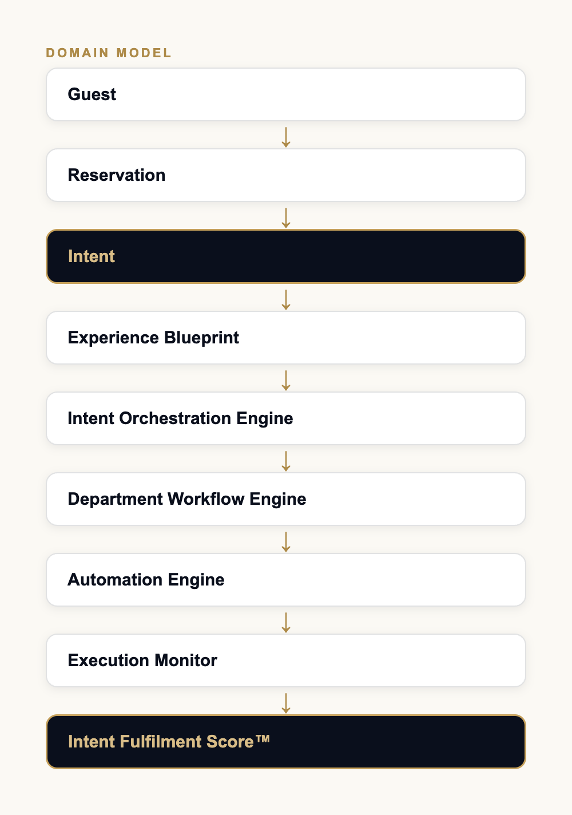
Figure 1 — AYANA domain model. Intent and Intent Fulfilment Score are highlighted as the two objects with no equivalent in conventional PMS platforms.

2.1 Object Definitions
Field | Description
Guest | The travelling individual or party. Owns AYANA Memory (persistent preferences) independent of any single stay.
Reservation | A booked stay at a property. Unchanged in shape from a conventional PMS reservation — dates, room category, rate, status.
Intent | Why the guest is travelling. An independent, versioned, configurable template instantiated onto a Reservation with a role (primary/secondary/supporting) and a weight.
Experience Blueprint | The set of tasks, preferences, and recommendations a given Intent instance generates. Auto-created the moment an Intent is attached to a Reservation.
Intent Orchestration Engine | Merges every Blueprint attached to a Reservation into one coherent plan — deduplicating, sequencing, detecting conflicts, and resolving them.
Department Workflow Engine | Routes each orchestrated task to the owning hotel department with the correct priority and SLA.
Automation Engine | Executes what can be executed without a human — marking an amenity check verified, sending a reminder, adjusting a recommendation.
Execution Monitor | Tracks every task to completion in real time and raises exceptions when an SLA is at risk.
Intent Fulfilment Score™ | The closing measurement — how completely each Intent, and the stay as a whole, was actually achieved.

3. Multi-Intent Architecture
A reservation supports one or many Intents — there is no architectural ceiling. Each attached Intent carries its own priority, weight, timeline, owner, workflow, success criteria, and completion status, and is tracked independently even while contributing to one blended stay-level view.

Example
- Primary Intent — Business Conference (60% weight)
- Secondary Intent — Family Vacation (30% weight)
- Supporting Intent — Wedding Anniversary (10% weight)

3.1 Intent Relationships
Conventional platforms treat every guest attribute as an independent record. AYANA models the relationships between Intents explicitly, so the platform reasons about combinations rather than a flat list:
Field | Description
Parallel | Two Intents proceed simultaneously with no dependency — e.g. Business + Family Vacation.
Sequential | One Intent’s activities are expected to conclude before the next begins — e.g. Conference → Vacation.
Dependent | One Intent’s task cannot start until another completes — e.g. Airport Pickup → Business Meeting.
Conditional | A task is generated only if a condition on another Intent’s state is met — e.g. if the meeting finishes before 3 PM, recommend the spa.
Exclusive | Two options cannot both be offered — e.g. Late Checkout OR Airport Lounge Access, not both.

3.2 Intent Object Fields
Field | Description
Priority | Relative importance among the Intents on this reservation.
Weight (%) | Contribution to the blended stay-level Intent Fulfilment Score.
Timeline | When this Intent’s activities are expected to occur within the stay.
Status | active, paused, completed, or removed.
Owner | The department or role accountable for this Intent’s Experience Blueprint.
Workflow | The generated, orchestrated set of department tasks.
Success Criteria | What "fulfilled" means for this specific Intent instance.
Completion Status | Per-task and rolled-up percentage complete.

4. Experience Blueprint
Every Intent automatically generates an Experience Blueprint — a concrete, checkable list of tasks, preferences, and recommendations, resolved from a versioned template rather than hand-authored per booking.

Worked example — Business Presentation
- Quiet room
- High-speed internet validation
- Printer availability
- Meeting room recommendation
- Coffee preference
- Airport pickup
- Express checkout
- Wake-up schedule
- Taxi reservation
- Early check-in recommendation

Worked example — Wedding Anniversary
- Romantic room allocation
- Restaurant recommendation
- Cake reminder
- Welcome message
- Lighting theme
- Music theme
- Photography package
- Late checkout recommendation

Worked example — Medical Recovery
- Ground floor preference
- Accessible room
- Dietary preferences
- Medication reminder option
- Quiet zone
- Companion accommodation
- Flexible housekeeping
- Transportation assistance
Each Blueprint item is typed as one of three kinds, which determines how it resolves to "done":
Field | Description
Auto-Ready | A deterministic property check the platform can verify itself at booking time (e.g. does this room category have verified high-speed internet).
Concierge Request | A guest- or staff-triggerable action that maps onto an existing service request type (e.g. airport pickup, wake-up call).
Department Task | A hotel-internal task with no guest-facing request equivalent, routed to a named department and owner (e.g. hold a specific meeting room).

5. Intent Orchestration Engine
This is the core innovation. When a reservation carries more than one Intent, the Orchestration Engine combines every attached Experience Blueprint into a single coherent plan rather than presenting the guest or the hotel with several disconnected checklists.
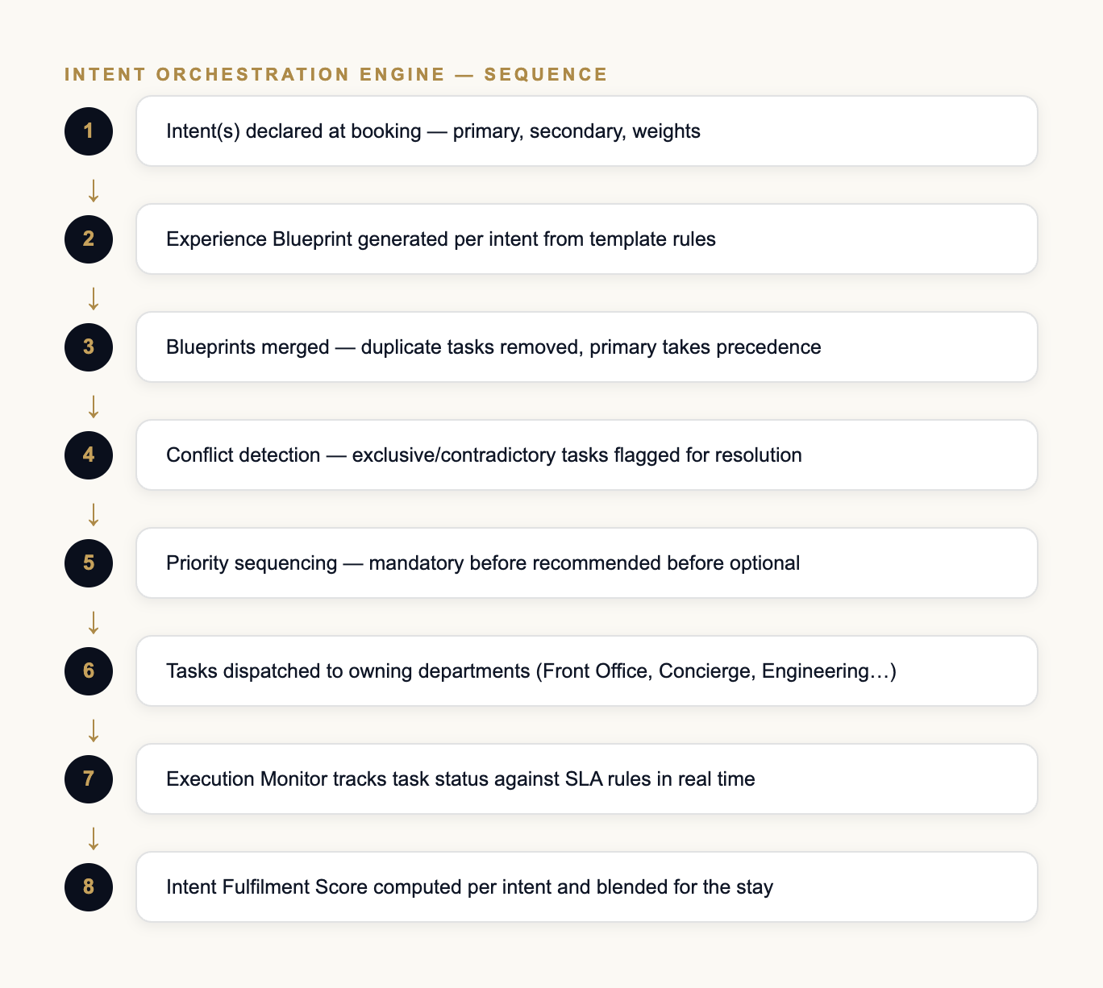
Figure 2 — Orchestration Engine processing sequence, from Intent declaration to a blended Fulfilment Score.

5.1 Responsibilities
- Merge every Blueprint attached to the reservation into one plan.
- Remove duplicate tasks that two Intents both generated.
- Detect conflicts — two Intents requesting contradictory room attributes, or exclusive options both being offered.
- Resolve conflicts using priority and weight, escalating to staff override where automatic resolution is not confident.
- Prioritise mandatory tasks over recommended tasks over optional tasks.
- Sequence activities against the stay timeline and against Intent relationships (parallel/sequential/dependent/conditional).
- Optimise for both guest experience and hotel operational load.
- Recommend improvements to the hotel’s own template library based on observed patterns.
- Allow a staff member to override any automatic decision, with the override logged.
- Expose a clean extension point for AI-driven optimisation once the platform has enough real data to justify it (see Section 12).

6. Department Automation & Workflow Engine
Orchestrated tasks are routed to the department that owns them. Each department receives only the tasks relevant to it — a Business Presentation Blueprint never appears in the Spa’s queue; a Wedding Anniversary Blueprint never appears in Engineering’s.

6.1 Departments
- Front Office
- Housekeeping
- Engineering
- Security
- Restaurants
- Kitchen
- Spa
- Transport
- Concierge
- Finance
- CRM
- Sales
- Maintenance

6.2 Workflow Engine Design
The Workflow Engine is the layer between an orchestrated task and a department’s task queue. It is responsible for assignment, escalation, and SLA tracking, independent of which Intent generated the task in the first place — so a hotel’s Front Office team works from one unified queue, not one queue per Intent type.
Field | Description
Assignment | Task is routed to a department and, where staffing data allows, a specific role or individual.
Acknowledgement | Department confirms receipt; unacknowledged tasks escalate per the SLA rule for that task’s priority.
Execution | Task is worked; status moves through the same pending → in-progress → done lifecycle already used for guest service requests.
Verification | Completion is either self-reported by staff or auto-verified where the task has a deterministic check (e.g. a system amenity flag).
Feedback to Orchestration Engine | Completion (or failure) flows back into the Execution Monitor and the Intent Fulfilment Score.

7. Rule Engine Design
Every Intent template carries a structured rule set, not a single flat checklist. This is what allows the same Intent template to behave differently for a VIP guest versus a first-time guest, or for a 3-star property versus a 5-star flagship, without forking the template.
Field | Description
Mandatory Tasks | Must be completed for the Intent to be considered fulfilled at all.
Recommended Tasks | Improve the Fulfilment Score but are not required.
Optional Tasks | Guest- or staff-initiated add-ons offered opportunistically.
Automation Rules | Which tasks resolve automatically versus require a human action.
Notification Rules | What triggers a guest or staff notification, and on which channel.
Escalation Rules | What happens when a task misses its SLA.
Exception Rules | How the Blueprint adapts when a prerequisite is unavailable (e.g. no accessible room in the requested category).
Service Recovery Rules | The offer generated automatically when a mandatory task fails.
SLA Rules | Time-bound expectations per task priority and department.
Time Rules | When a task becomes active relative to the stay timeline (e.g. wake-up call the morning of the meeting, not at booking).
Priority Rules | How competing tasks are ordered when department capacity is constrained.

8. Event Architecture & Purpose Evolution
AYANA is event-driven end to end. Every meaningful change in the guest’s journey — not just a booking or a checkout — is an event the Orchestration Engine can react to.
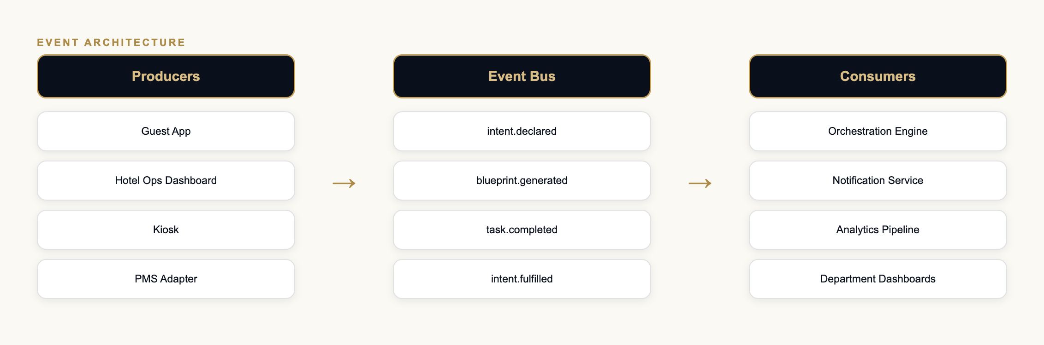
Figure 3 — Event flow from producing surface, through the event bus, to consuming services.

8.1 Representative Events
Field | Description
Guest arrives | Intent Engine recalculates the day’s workflow against actual arrival time.
Room changed | Experience Blueprint updates to reflect the new room’s attributes.
Flight delayed | Airport Pickup task is automatically rescheduled.
Meeting cancelled | Now-irrelevant tasks are removed from the active Blueprint, not just marked done.
Anniversary Intent added mid-stay | A restaurant reservation task is created immediately.
Intent changed | The entire Blueprint for that Intent is regenerated from the new template.

8.2 Purpose Evolution
Intent is dynamic, not fixed at booking. A guest or hotel staff member may add, remove, pause, resume, or modify an Intent, change its priority or weight, or mark it complete at any point in the stay. The Experience Blueprint regenerates automatically on any such change — without disturbing tasks that are already completed, so a guest never sees a finished task reappear as pending.

9. AI Readiness
No AI is implemented in the current design. Every engine described in this document is deterministic and rule-based. The architecture is deliberately shaped so that AI can be introduced later without a redesign — each engine exposes a clean scoring or ranking extension point that a learned model could occupy in place of the current rule table.

9.1 Future AI Capabilities (Not Built)
- Intent prediction from booking metadata and guest history
- Missing-service prediction
- Cross-selling
- Upselling
- Operational optimisation
- Guest behaviour learning
- Workflow optimisation
- Resource balancing
- Demand forecasting
- Journey optimisation
- A true recommendation engine
- A digital concierge with open-ended natural-language understanding

10. Entity Relationship Diagram & Database Schema
The diagram below is the target relational design for a production backend. It is independent of AYANA’s current client-only prototype, which has no database at all (see Section 18).
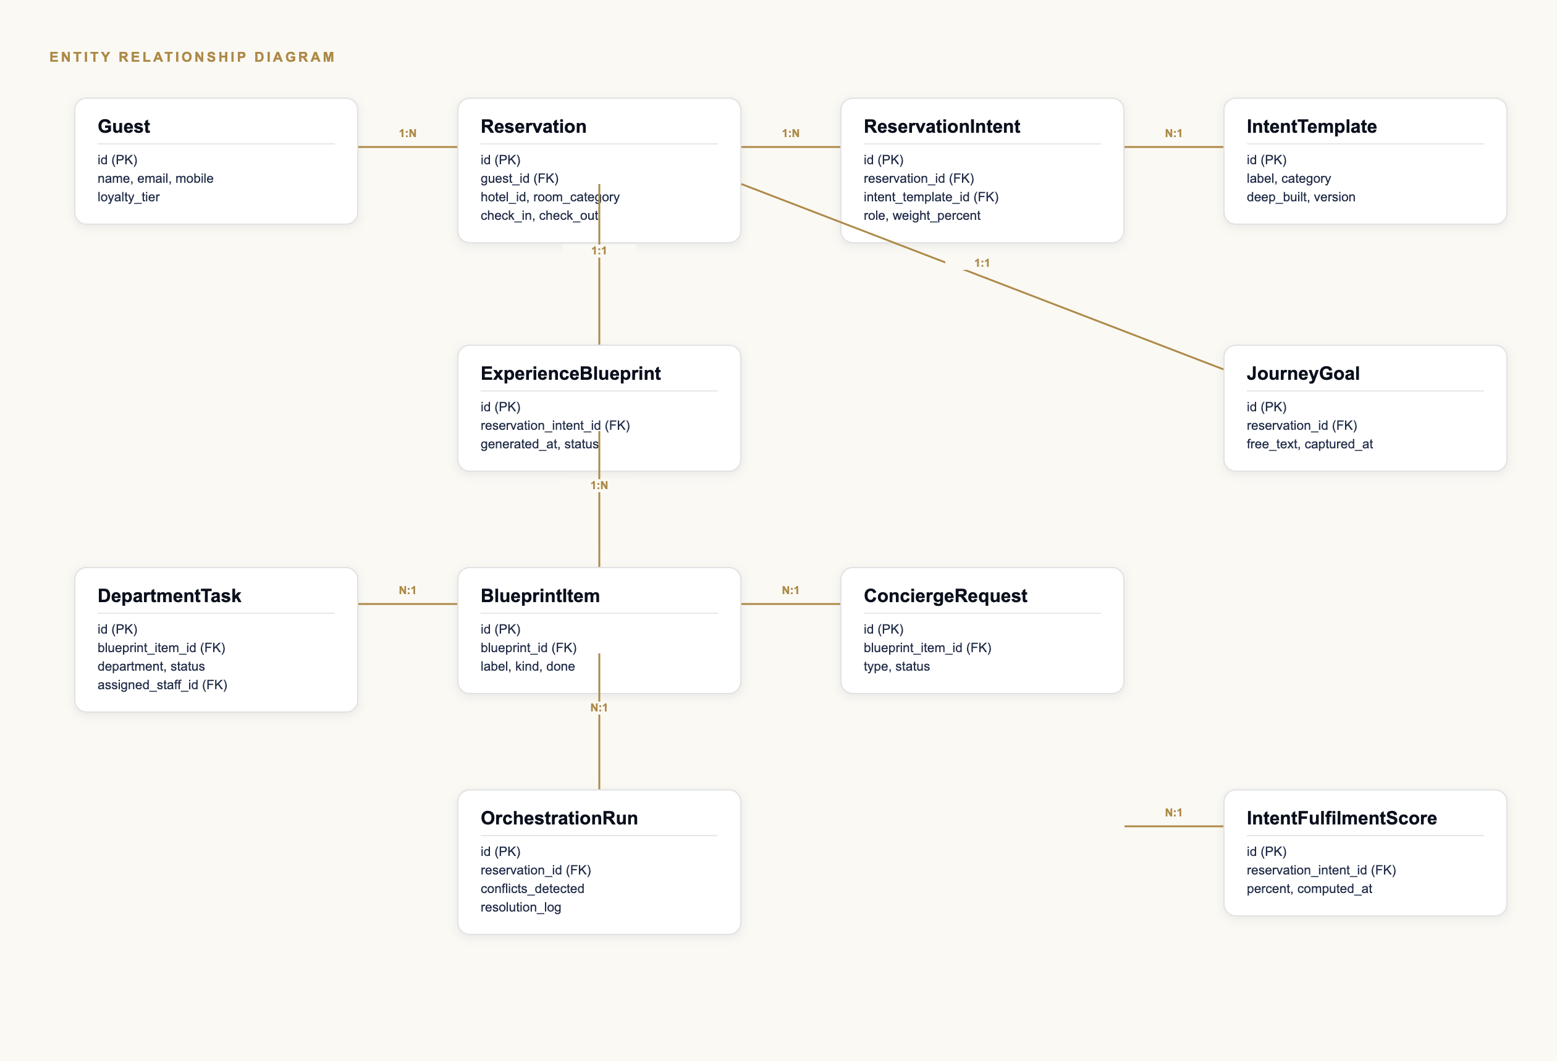
Figure 4 — Entity relationship diagram for the Intent Engine domain.

10.1 Core Tables
Field | Description
guest | One row per traveller. Owns AYANA Memory as a joined preferences table.
reservation | One row per booked stay. Unchanged from a conventional PMS reservation table.
intent_template | The versioned, configurable catalog of Intent types — hotel-, brand-, or industry-scoped.
reservation_intent | Join table attaching one or more intent_template rows to a reservation, with role and weight.
journey_goal | The guest’s free-text answer to "What would make this journey successful?", one row per reservation.
experience_blueprint | One row per reservation_intent — the generated plan for that Intent instance.
blueprint_item | One row per checklist line within a blueprint — label, kind, status.
department_task | One row per blueprint_item that resolved to a hotel-internal task, with department and assigned staff.
concierge_request | Existing guest-service-request table, reused where a blueprint_item maps to an existing request type.
orchestration_run | Audit record of one Orchestration Engine execution — conflicts detected, resolution taken.
intent_fulfilment_score | One row per reservation_intent, plus one blended row per reservation, computed on demand and cached.

11. Object Relationships
- A Guest has many Reservations (1:N).
- A Reservation has many ReservationIntents (1:N) — this is what makes multi-intent possible.
- A ReservationIntent references exactly one IntentTemplate (N:1) — the catalog entry it was instantiated from.
- A ReservationIntent has exactly one ExperienceBlueprint (1:1), generated at attachment time.
- An ExperienceBlueprint has many BlueprintItems (1:N).
- A BlueprintItem resolves to at most one DepartmentTask or one ConciergeRequest, never both (N:1 to each, mutually exclusive by kind).
- A Reservation has at most one JourneyGoal (1:1, optional).
- A Reservation has many OrchestrationRuns (1:N) — one per re-orchestration event.
- A ReservationIntent has many IntentFulfilmentScore snapshots over time (1:N), with the latest treated as current.

12. Microservice Architecture
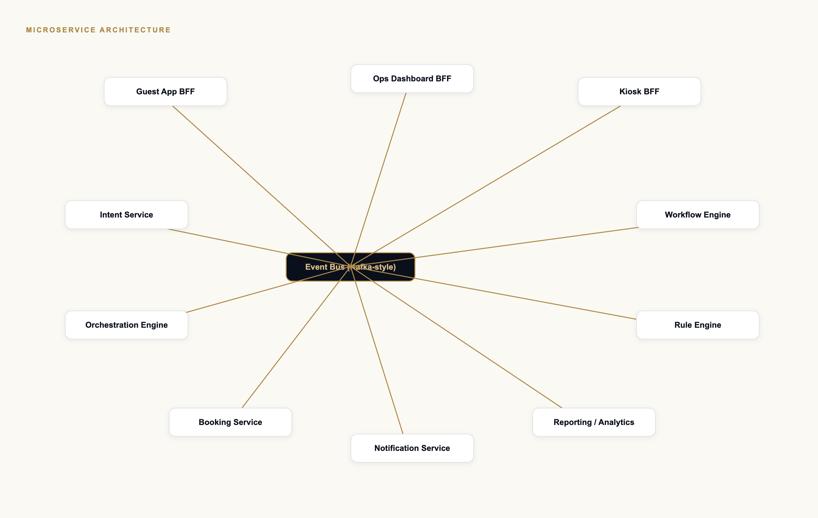
Figure 5 — Target microservice topology, communicating through a shared event bus.

12.1 Services
Field | Description
Intent Service | Owns the IntentTemplate catalog and ReservationIntent attachment/detachment.
Orchestration Engine | Consumes Intent and Reservation events; produces merged, conflict-resolved plans.
Workflow Engine | Owns DepartmentTask assignment, SLA tracking, and escalation.
Rule Engine | Evaluates the mandatory/recommended/optional and automation/notification/escalation rule sets per template.
Booking Service | Existing reservation lifecycle — unchanged in responsibility by this design.
Notification Service | Fan-out of guest- and staff-facing notifications across channels.
Reporting / Analytics | Intent Analytics, heat maps, and journey timeline aggregation.
Guest App BFF / Ops Dashboard BFF / Kiosk BFF | Backend-for-frontend layers matching AYANA’s existing three surfaces.

12.2 REST APIs
A representative (non-exhaustive) surface, versioned under /v1:
Field | Description
GET /v1/intent-templates | List the Intent catalog, filterable by category and by property/brand scope.
POST /v1/reservations/{id}/intents | Attach an Intent to a reservation with role and weight.
PATCH /v1/reservations/{id}/intents/{intentId} | Change priority, weight, or status (pause/resume/complete).
DELETE /v1/reservations/{id}/intents/{intentId} | Remove an Intent; triggers Blueprint regeneration for the remainder.
GET /v1/reservations/{id}/blueprint | The current merged, orchestrated Experience Blueprint for the stay.
POST /v1/reservations/{id}/journey-goal | Capture or update the free-text Journey Goal.
GET /v1/reservations/{id}/fulfilment-score | Per-intent and blended Intent Fulfilment Score.
GET /v1/departments/{department}/tasks | A department’s live task queue, generated across all active Intents.
PATCH /v1/department-tasks/{id} | Advance a task’s status; triggers Execution Monitor and guest-facing update.
POST /v1/intent-templates | Administrative: create a new template (industry/brand/property scoped).

13. Dashboards
Six dashboard surfaces, each reading from the same underlying Intent data at a different level of aggregation.
Field | Description
Guest Intent Dashboard | The guest-facing My Journey experience — see Section 15.
Property Intent Dashboard | Every active Intent across the property today, grouped by category and status.
Department Dashboard | A single department’s task queue across every Intent currently in-house.
Operations Dashboard | Cross-department load, SLA risk, and exceptions requiring a manager’s attention.
Intent Analytics | Completion rates, trends, and heat maps by Intent category, property, and season.
Guest Journey Timeline | A single reservation’s full timeline — Home → Airport → Pickup → Arrival → Check-in → [Intent stages] → Departure — each stage tagged Ready / In Progress / Completed / Delayed / Action Required.

14. Multi-Property, Multi-Brand, Multi-Language & Multi-Currency Support

14.1 Multi-Property
IntentTemplate rows carry an optional property_id scope. A template with no property_id is available to every property under the account; a scoped override lets one property customise a shared template (e.g. a different meeting-room recommendation flow) without forking it for everyone else.

14.2 Multi-Brand
A brand_id scope sits above property_id, letting a hotel group define a brand-standard Blueprint (e.g. every business-hotel brand gets the same core Business Presentation checklist) while individual properties still layer local specifics on top.

14.3 Multi-Language
Every guest-facing string in a template — labels, descriptions, notification copy, Today’s Mission items — is stored as a translation key, not literal text, resolved at render time against the guest’s selected language. Templates themselves stay language-neutral; only the rendered output localises.

14.4 Multi-Currency
Intent Engine objects never store currency amounts directly — cost implications (e.g. a paid upgrade recommended by an Intent) reference the existing Booking/Invoice currency context, so the Engine is currency-agnostic by construction rather than needing its own conversion layer.

15. Guest Experience Layer — The Visible Innovation
The Intent Engine must not remain a backend capability. Everything below is exposed through the Guest App, Web Portal, and Digital Concierge, so the guest directly experiences AYANA understanding why they travelled.

15.1 My Journey™
Replaces a plain Reservation / Room Number / Check-in / Check-out summary with a journey timeline: Home → Airport → Pickup → Hotel Arrival → Check-in → [each active Intent’s stage] → Departure. Every stage is tagged Ready, In Progress, Completed, Delayed, or Action Required.

15.2 My Intents™
The guest always sees their active Intents with a live progress percentage and a plain-language description of what remains — "Meeting begins tomorrow", "City Tour", "Restaurant Reserved · Cake Confirmed · Photography Ready."

15.3 Today’s Mission™
Each morning, a short list of what has already been arranged, framed to build confidence rather than simply list hotel information: wake-up completed, breakfast reserved, taxi confirmed, meeting room ready, presentation printing available, high-speed internet verified.

15.4 Intent Progress™
Intent Progress is not "how many hotel tasks are done" — it is "how prepared is the guest to achieve the reason for this journey", expressed as a single percentage per Intent plus the specific activities still remaining.

15.5 Smart Recommendations
Recommendations are always driven by the active Intent, never generic: a business Intent offers a meeting room; an Anniversary Intent offers flowers before dinner; a Family Vacation Intent surfaces a children’s activity starting in 30 minutes; a Medical Visit Intent surfaces hospital transport leaving in 25 minutes.

15.6 The One Question — Journey Goal™
Instead of "What is the purpose of your stay?", AYANA asks "What would make this journey successful?" and lets the guest answer freely — "I have the biggest presentation of my career tomorrow," "I am proposing to my partner," "I need complete peace and quiet," "I want quality time with my family." Stored verbatim as the Journey Goal; a future AI version may analyse it to improve orchestration, but today it is displayed back to the guest, not parsed.

15.7 Intent Fulfilment™
At checkout, AYANA asks not "How was your stay?" but "Did we help you achieve the purpose of your journey?" — with an independent Fulfilment Score per Intent, blended into one Overall Journey Fulfilment figure.
DESIGN PRINCIPLE
The guest should never feel they are interacting with software. They should feel the hotel understands them. The technology stays invisible; the guest feels continuously supported.

16. A New KPI: Intent Fulfilment Score™
Traditional hotels measure Guest Satisfaction, NPS, Occupancy, ADR, and RevPAR — all reservation- or revenue-centric. AYANA introduces a KPI measured against the guest’s own stated purpose.

Worked example
- Business Conference — 98%
- Family Vacation — 92%
- Wedding Anniversary — 100%
- Overall Stay Intent Fulfilment — 96%
Computed as the percentage of Blueprint items marked done, per Intent, blended by each Intent’s declared weight into one stay-level figure. This becomes a strategic operational KPI a hotel group can track property-over-property, alongside — not instead of — its existing revenue metrics.

17. Security Model, RBAC & Audit Trail

17.1 Security Model
- Journey Goal free text and Intent selections are guest PII, subject to the same consent and retention controls as AYANA Memory.
- IntentTemplate content is hotel/brand intellectual property, access-scoped accordingly.
- All service calls between the Intent Service, Orchestration Engine, and Workflow Engine are authenticated service-to-service, never guest-token-authenticated directly.

17.2 Role-Based Access Control
Field | Description
Guest | Read/write own Intents and Journey Goal; read own Blueprint and Fulfilment Score.
Front-line Staff | Read/write DepartmentTasks assigned to their department; read the guest context needed to complete them.
Duty Manager | Full property-level Intent Dashboard access; can override Orchestration Engine decisions.
Revenue / Ops Analyst | Read-only Intent Analytics; no access to individual guest Journey Goal text.
Template Administrator | Create/edit/archive IntentTemplates at their scoped level (property/brand/industry).
Platform Administrator | Full access, including cross-property template management and audit log access.

17.3 Audit Trail
Every OrchestrationRun, every staff override of an automatic decision, and every manual DepartmentTask status change is logged with actor, timestamp, and reason — mirroring the override-log pattern already used for check-in and payment overrides elsewhere in AYANA.

18. Scalability Design & Extensibility Strategy

18.1 Scalability
- IntentTemplate catalog is read-heavy and cacheable at the edge — templates change rarely relative to how often they are read.
- Blueprint generation is a pure function of (template, reservation context) and is safely parallelisable across reservations.
- The Orchestration Engine’s per-reservation merge is bounded by the small number of Intents on one reservation, not by property-wide volume — it scales horizontally by reservation, not by property.
- Execution Monitor is event-driven, not polling, so SLA tracking cost scales with actual task volume rather than with elapsed time.

18.2 Extensibility Strategy
- New Intent templates are configuration, not code — a hotel administrator can create, edit, duplicate, archive, or deactivate a template without a deployment.
- Industry, brand, and property template layers (Section 14) let AYANA extend into new hospitality segments (e.g. serviced apartments, resorts) by adding templates, not rewriting the Engine.
- The rule engine’s categories (mandatory/recommended/optional, automation, notification, escalation, exception, service recovery, SLA, time, priority) are the stable extension surface — a new Intent behaviour is expressed as new rules, not new code paths.
- Clone / import / export of templates lets a hotel group roll a proven template from one property to every other property in a single action.

19. Configuration & Template Management
Hotel administrators manage the Intent catalog directly:
- Create Intent
- Edit Intent
- Duplicate Intent
- Archive Intent
- Deactivate Intent
- Create Industry Templates
- Create Brand Templates
- Create Property Templates
- Clone Templates
- Import Templates
- Export Templates

20. Novelty & Differentiation Assessment
NOT LEGAL ADVICE
This section is a product-differentiation analysis, not a patentability opinion. Formal patentability — novelty, non-obviousness, and freedom-to-operate — requires a qualified patent attorney conducting a proper prior-art search. Treat this as the starting brief for that conversation, not a substitute for it.

20.1 What Appears Novel Relative to Conventional PMS Platforms
Field | Description
Intent as a first-class, multi-instance object | Conventional PMS platforms model guest purpose, if at all, as a static free-text field or a fixed enum on the reservation. AYANA models it as an independent entity with its own lifecycle, weight, and relationships to other Intents on the same reservation.
Multi-Intent weighted blending | No mainstream PMS blends multiple concurrent guest purposes into one weighted operational and measurement model.
Intent relationship typing (parallel/sequential/dependent/conditional/exclusive) | This is closer to workflow-engine or business-process-modelling territory than anything in existing hospitality software, applied specifically to guest purpose.
Auto-generated, template-driven Experience Blueprints | Existing platforms’ "special requests" are manually entered and manually actioned; AYANA’s Blueprint is generated and orchestrated automatically from a versioned template.
Department-agnostic task routing driven by guest purpose rather than department-initiated workflows | Conventional systems start from the department (housekeeping module, F&B module); AYANA starts from the guest’s Intent and routes outward.
Intent Fulfilment Score™ as a KPI | No conventional PMS measures "did we achieve the stated purpose of the trip" as a first-class, per-purpose, per-stay metric.
Guest-facing purpose transparency (My Journey™, Today’s Mission™) | Guests do not typically see an operational readiness view of their own stay framed around their own stated purpose in existing products.

20.2 Where AYANA Is Deliberately Not Novel
The underlying primitives — reservations, room categories, service requests, department task queues, notification delivery — are conventional and should remain so. The novelty claim is specifically the Intent layer and its orchestration, not a reinvention of hotel operations generally.

21. Relationship to the AYANA v1 Prototype
This document specifies the target production design. AYANA’s current running prototype — a client-side, deterministic demo with no real backend — implements a deliberately scoped slice of it, built to prove the guest-facing concept without the full production investment described above.

21.1 What the v1 Prototype Actually Builds
Field | Description
Intent selection | Primary + Secondary Intent per booking, with an informational weight — not the full priority/timeline/owner/success-criteria object model.
Intent catalog | The full 22-template catalog is selectable; only Business Presentation has a fully authored Experience Blueprint. Every other template resolves to a placeholder, proving catalog breadth without fabricating content.
Orchestration | Blueprint merge and deduplication between a primary and a secondary Intent, plus one concrete conditional-recommendation example. Full conflict detection/resolution and relationship typing (Section 3.1) is this document’s design, not yet built.
Department automation | Department Tasks are seeded at booking time and resolved by a hotel staff member in the Concierge Desk screen; there is no full Workflow Engine, SLA tracking, or escalation.
Guest experience layer | My Journey card, Today’s Mission checklist, Journey Goal capture, and Intent Fulfilment Score are built and live in the running app — this is the one area where the prototype and this specification are closely aligned.
Backend | None. All of Sections 10–12 (database, microservices, REST APIs) describe the target production architecture; the prototype persists everything in browser localStorage with no server.
The gap between this document and the prototype is intentional, not a shortfall to be hidden: the prototype exists to validate the guest-facing concept quickly and cheaply; this document exists to specify what a real deployment requires.

Appendix A — Full Intent Catalog
The platform allows unlimited future Intent templates; the twenty-two below are the launch catalog referenced throughout this document and implemented (as selectable options) in the v1 prototype.

Business
- Business Meeting
- Conference
- Sales Visit
- Business Presentation (deep-built in v1 prototype)
- Remote Working
- Job Interview
- Education

Celebration
- Anniversary
- Wedding
- Birthday
- Honeymoon
- Family Reunion

Health & Wellness
- Medical Visit
- Personal Wellness
- Spiritual Retreat

Leisure
- Family Vacation
- Staycation
- Adventure
- Leisure
- Sports Event

Life & Travel
- Transit Stay
- Emergency Travel

Appendix B — Representative Schema DDL
Illustrative, not exhaustive — a starting point for a real migration, omitting standard columns (tenant scoping, soft-delete, etc.) an implementation would add.
CREATE TABLE intent_template (
id UUID PRIMARY KEY,
label TEXT NOT NULL,
category TEXT NOT NULL,
deep_built BOOLEAN NOT NULL DEFAULT FALSE,
brand_id UUID NULL REFERENCES brand(id),
property_id UUID NULL REFERENCES property(id),
version INT NOT NULL DEFAULT 1
);
CREATE TABLE reservation_intent (
id UUID PRIMARY KEY,
reservation_id UUID NOT NULL REFERENCES reservation(id),
intent_template_id UUID NOT NULL REFERENCES intent_template(id),
role TEXT NOT NULL CHECK (role IN ('primary','secondary','supporting')),
weight_percent INT NOT NULL,
status TEXT NOT NULL DEFAULT 'active',
created_at TIMESTAMPTZ NOT NULL DEFAULT now()
);
CREATE TABLE experience_blueprint (
id UUID PRIMARY KEY,
reservation_intent_id UUID NOT NULL REFERENCES reservation_intent(id),
generated_at TIMESTAMPTZ NOT NULL DEFAULT now()
);
CREATE TABLE blueprint_item (
id UUID PRIMARY KEY,
blueprint_id UUID NOT NULL REFERENCES experience_blueprint(id),
label TEXT NOT NULL,
kind TEXT NOT NULL CHECK (kind IN ('auto_ready','concierge_request','department_task')),
done BOOLEAN NOT NULL DEFAULT FALSE
);
CREATE TABLE department_task (
id UUID PRIMARY KEY,
blueprint_item_id UUID NOT NULL REFERENCES blueprint_item(id),
department TEXT NOT NULL,
assigned_staff_id UUID NULL REFERENCES staff(id),
status TEXT NOT NULL DEFAULT 'pending'
);
CREATE TABLE journey_goal (
id UUID PRIMARY KEY,
reservation_id UUID NOT NULL REFERENCES reservation(id),
free_text TEXT NOT NULL,
captured_at TIMESTAMPTZ NOT NULL DEFAULT now()
);
CREATE TABLE intent_fulfilment_score (
id UUID PRIMARY KEY,
reservation_intent_id UUID NOT NULL REFERENCES reservation_intent(id),
percent INT NOT NULL,
computed_at TIMESTAMPTZ NOT NULL DEFAULT now()
);

