Materials and Methods
This study focuses on the simultaneous thermal and chemical decomposition of mixed post-consumer polyolefin waste into gaseous, liquid, and solid products under four market scenarios to produce ethylene, propylene, butene, naphtha, diesel, wax, BTX (benzene-toluene-xylene), aromatics, and specialty organic chemicals. The superstructure includes four upstream conversion technologies- CP, TOD, catalytic pyrolysis with HZSM-5 zeolite (CPY), and CO₂ plasma pyrolysis (PLASMA)-and two downstream wax upgrading technologies-HC and FCC. Four continuous split fractions control the allocation of feed among pathways and wax between upgrading routes. A feedforward neural network (PyrolysisNet) trained on 566 literature experiments predicts composition-adaptive product yields for three of the four reactor types at each simulation step. Table 1 summarizes the process parameters of the four upstream technologies considered in this study.
Table 1. Process parameters of the four upstream pyrolysis technologies considered in this study.
Technology | Reactor Type | Temp. (°C) | Atmosphere | Yield Prediction | Res. Time (s)
CP | Fluidized bed pyrolyzer | 500 | Inert N₂ (15 kg/hr) | PyrolysisNet (thermal) | 1.0
TOD | Circulating fluidized bed | 600 | 93:7 HDPE:O₂ + N₂ | Fixed yields ¹
CPY | Fluidized bed pyrolyzer | 500 | HZSM-5 + 7% O₂ | PyrolysisNet (catalytic) | 1.0
PLASMA | Non-equil. CO₂ plasma | 400 | CO₂ + O₂ | PyrolysisNet (plasma) | 20.0
Overview of the Superstructure Process Model
The conceptual refinery design for all scenarios was developed in BioSTEAM 2.51.3 ², an open-source Python-based steady-state process simulator for biorefinery design and techno-economic analysis, to process 250 tonnes of mixed waste polyolefins per day using common equipment found in pyrolysis refineries. We settled for a 250 tonnes/day (tpd) capacity in line with 300 tpd pyrolysis plants ^{1,3}. The mass and energy balance from the conceptual process model is used for TEA and LCA. The Soave-Redlich-Kwong (SRK) equation of state predicted the vapor-liquid equilibrium for the refinery. The feedstock composition reflects the average US municipal solid waste plastic stream after exclusion of PET, PVC, and heterogeneous multilayer films-resins that are either pre-sorted for mechanical recycling or produce corrosive by-products (e.g., HCl from PVC) under pyrolysis conditions ⁴. The remaining four-resin blend is normalized to 100 wt%: LDPE/LLDPE 44.2%, PP 23.4%, HDPE 22.0%, and PS 10.4% (Table S1), derived from waste characterization data including the 44 Mt of US plastic waste generated in 2019 ⁴ and North American resin production statistics ⁵ (see S1.1 for the derivation).
The superstructure refinery consists of six major processing sections: (i) feed pretreatment and splitting, (ii) pyrolysis (four parallel reactor technologies), (iii) product fractionation, (iv) hydrocracking, (v) fluid catalytic cracking, and (vi) turbogenerator electricity recovery. The mixed plastic feed enters Splitter 1, which divides it between a CP + TOD and an alternative branch (CPY + PLASMA). Within the conventional branch, Splitter 3 allocates feed between TOD and CP. Within the alternative branch, Splitter 2 divides feed between CPY and PLASMA. The merged CP + TOD vapors pass through a shared distillation train, producing ethylene, propylene, butene, naphtha, diesel, and wax. The wax fraction from distillation is divided by a fourth splitter between HC and FCC. CPY and PLASMA operate as self-contained subsystems with their own integrated separation trains. A turbogenerator (η = 0.35) combusts combined flue gas streams from CPY, PLASMA, and FCC to recover electricity. Like-products from all pathways are merged before collection: naphtha (from DISTILLATION + HC + FCC), diesel (from DISTILLATION + HC + FCC), wax (from HC + FCC), hydrogen (from HC + FCC), and BTX (from CPY benzene + toluene + xylene streams). The four split fractions-each bounded between 0.05 and 0.95-serve as the continuous optimization variables (Table 2). The complete superstructure process flow diagram is shown in Figure 1. Figure in S1-S4 show the detailed process flow diagrams for each individual pathway, and the equipment summary by pathway is provided in Table S5.
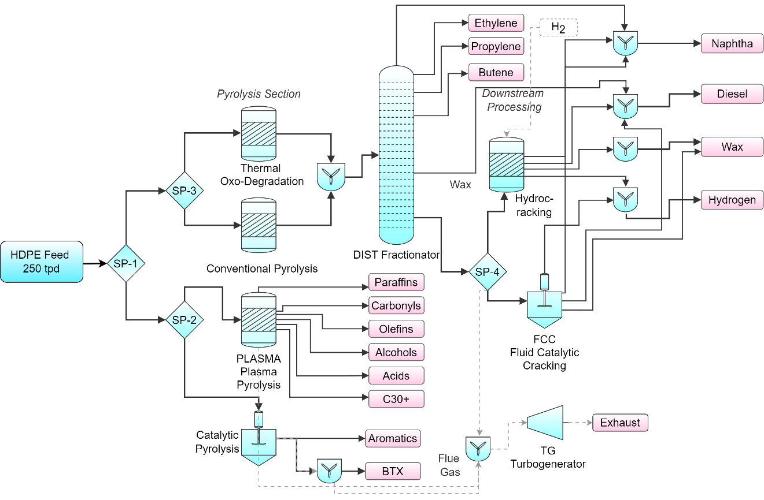
Figure 1. Superstructure PFD showing feed allocation among CP, TOD, CPY, and PLASMA; shared distillation and wax upgrading via HC and FCC; and turbogenerator electricity recovery from combined flue gas.
Table 2. Optimization decision variables and bounds.
Variable | Symbol | Description | Bounds | Initial
split_TOD | x₁ | Fraction of total feed to CP + TOD (rest to CPY + PLASMA) | 0.05–0.95 | 0.34
split_CP | x₂ | Fraction of CP + TOD stream to TOD (rest to CP) | 0.05–0.95 | 0.50
split_CPY | x₃ | Fraction of remaining feed to CPY (rest to PLASMA) | 0.05–0.95 | 0.50
split_HC | x₄ | Fraction of wax to HC (rest to FCC) | 0.05–0.95 | 0.50
Machine Learning Yield Prediction
A key feature of the superstructure is that the CP, CPY, and PLASMA reactors do not use fixed yield tables. Instead, we trained a feedforward neural network-PyrolysisNet-to predict pyrolysis product yields as a function of feedstock composition and operating conditions. At each simulation step, the reactor units query the trained model with the current HDPE, LDPE, and PP weight percentages in the feed, enabling the superstructure to respond dynamically to changes in feed allocation during optimization. For any non-polyolefin feedstock IDs present in the feed (e.g., PS), their mass is assigned to the HDPE input channel, as PS undergoes thermal cracking similar to polyolefins under the conditions modeled ⁶.

The model takes five inputs-HDPE (wt%), LDPE (wt%), PP (wt%), reaction temperature (°C), and vapor residence time (s)-and predicts eight product categories in wt%: liquid, gas, solid, gasoline-range hydrocarbons, diesel-range hydrocarbons, total aromatics, BTX, and wax (>C21). The architecture (Figure 2) consists of three hidden layers (5 → 64 → 128 → 64 → 8) with batch normalization, ReLU activation, and 10% dropout in each hidden layer, and a sigmoid output layer scaled to [0, 100] wt% (Table S6). The eight predicted wt% categories are then disaggregated into individual BioSTEAM compound mass fractions using fixed sub-distributions. For example, the gas fraction is distributed among H₂ (2%), CH₄ (20%), C₂H₄ (25%), C₃H₈ (25%), C₄H₈ (15%), CO (5%), and CO₂ (8%). Complete compound mappings for all eight output categories are provided in Tables S8-S9.

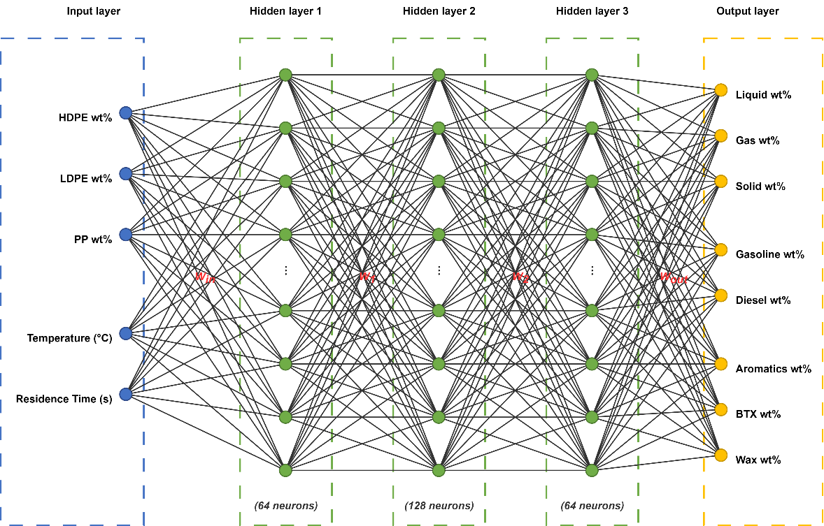
Figure 2. PyrolysisNet feedforward architecture: five inputs through three hidden layers (64-128-64) with batch normalization, ReLU, and 10% dropout, producing eight yield outputs via a sigmoid layer scaled to [0, 100] wt%.
PyrolysisNet was trained on 566 polyolefin pyrolysis experiments compiled from the literature. Rows with both temperature and vapor residence time missing were excluded, and solid yield outliers (>20 wt%, where the mean is 3%) were removed. We used the Adam optimizer (learning rate = 10⁻³, weight decay = 10⁻⁴, batch size = 32) with a ReduceLROnPlateau scheduler (patience = 50 epochs, factor = 0.5), early stopping (patience = 200 epochs), and trained for up to 2,000 epochs. Because many literature experiments report only a subset of the eight output categories, we employed a masked mean squared error (MSE) loss function that computes the loss only on valid (non-NaN) targets, combined with two soft constraint penalties:

 | $$\begin{matrix}L=\left[\sum{ }(i,j)m_{-}ij{\left({\overset{ˆ}{y}}_{-}ij-y_{-}ij\right)}^{2}\right]/\left[\sum{ }(i,j)m_{-}ij\right]+λ_{1}(1/N)\sum_{-}{ } k{\left({\overset{ˆ}{y}}_{-}liq+{\overset{ˆ}{y}}_{-}gas+{\overset{ˆ}{y}}_{-}sol-100\right)}^{2}+ \\ {\left.λ_{2}(1/N)\sum{ }\text{ kl }max\left(0,{\overset{ˆ}{y}}_{-}BTX-{\overset{ˆ}{y}}_{-}arom\right)\right]}^{2}\end{matrix}$$ | 1

where m_ij is the binary mask (1 = valid, 0 = missing), N is the batch size, λ₁ = λ₂ = 0.01 are penalty weights, and the two constraint terms enforce Liquid + Gas + Solid ≈ 100% and BTX ≤ Total aromatics, respectively. An 80/20 train-test split was used for evaluation; the model achieved test-set R² values ranging from 0.13 (gasoline-range hydrocarbons) to 0.74 (liquid), with a mean R² of 0.49 across all eight outputs. Test-set performance metrics and parity plots are reported in Table S7 and Figure S2. The base model, trained on conventional thermal (inert atmosphere) pyrolysis data, is extended to the three additional reactor chemistries via linear corrections:

 | $${\overset{ˆ}{y}}_{-}i,corrected(T)={\overset{ˆ}{y}}_{-}i,\text{ base }+α_{-}i+β_{-}i×T$$ | 2

where T is the reaction temperature in °C, and α_i and β_i are reactor-specific intercept and slope coefficients for each output category i. TOD corrections are anchored so that the correction equals zero at 400°C and are calibrated to experimental data from Olafasakin et al. [1] at 600°C for 100% HDPE at a 93:7 HDPE:O₂ ratio (Table S10). Catalytic corrections are derived from a two-point fit (temperature-bin midpoints at 600°C and 725°C) comparing catalytic (>10 wt% total aromatics, N ≈ 70) versus thermal (≤5 wt%, N ≈ 120) polyolefin experiments in the training database (Table S11). Plasma corrections use a mixed additive-multiplicative scheme calibrated to reproduce Case G (CO₂ plasma, residence time = 20 s) from Radhakrishnan et al. ⁷ at a virtual temperature of 450°C with 100% HDPE (Table S12). Post-correction normalization ensures that phase totals (Gas + Liquid + Solid) sum to 100%, sub-categories are scaled to fit within the liquid fraction, and BTX is capped at total aromatics. For plasma, phase totals are not normalized to 100% because CO₂ mass incorporation inflates total product yields to approximately 130% of feedstock mass ⁷. Parametric studies showing the model's sensitivity to temperature, residence time, feedstock composition, and reactor type are provided in Figures S3-S7.
Pyrolysis
The process model begins with feedstock pretreatment, where the mixed plastic waste is conveyed via a hopper system (reference cost: $534,114 at 500 tpd, scaled with exponent 0.6) and reduced in size in a hammer mill that requires 300 kW per tonne/hr of electricity ^{1,8}. The granulated plastics from the hammer mill are then screened, with 99% of the material passing through to the pyrolysis reactors and 1% recycled back for additional grinding. For conventional pyrolysis (CP), the screened feed enters a fluidized bed reactor operating at 500°C under inert N₂ atmosphere (15 kg/hr fluidizing gas). The Pyrolyzer unit queries PyrolysisNet with reactor_type = 'thermal' to predict composition-adaptive product yields. The pyrolysis vapors are sent to a cyclone (99% solids removal efficiency) that separates char, unconverted plastic, and any other solids from the vapor stream ^{6,9}. The clean vapor is cooled to 10°C before entering the shared distillation system. The solids collected from the cyclone and the non-condensable gases (NCGs) collected downstream are recirculated back to the combustion chamber to supplement natural gas in providing process heat.
For thermal oxo-degradation (TOD), the screened feed enters a circulating fluidized bed reactor at 600°C along with oxygen at a mass ratio of 93:7 (HDPE:O₂) and 15 kg/hr N₂ fluidizing gas, reducing external energy requirements by up to 84% compared to conventional pyrolysis ¹⁰. The TOD reactor uses fixed product yields calibrated to experimental data from Olafasakin et al. ¹, with an overall mass closure of 90.4% (Table S3). Cyclone solids are recirculated in the pyrolyzer; residual process heat is supplemented by unrecovered NCGs downstream.
For catalytic pyrolysis (CPY), the screened feed enters a fluidized bed reactor at 500°C with a zeolite (HZSM-5) catalyst and 7% oxygen equivalence ratio. The Pyrolyzer unit queries PyrolysisNet with reactor_type = 'catalytic', applying the catalytic correction (eq 2) to shift yields toward higher aromatics selectivity. Unlike CP and TOD, the CPY subsystem includes its own integrated separation train: flash separation at 10°C to split liquid from vapor, followed by four binary distillation columns (purchased cost: $320,258 each) operating with 99% top-product purity and 1% bottom-product losses. The four columns isolate benzene, toluene, other aromatics, and xylene as individual product streams. The remaining residue is collected as heavy fuel oil. Flue gas from the CPY separation is sent to the turbogenerator.
For plasma pyrolysis (PLASMA), the screened feed is converted via non-equilibrium CO₂ plasma at 400°C, using CO₂ (0.30 kg per kg feed) and supplementary O₂ (0.05 kg per kg feed) as reactive gases (reference reactor cost: $20,000,000 at 200,000 kg/day, scaled with exponent 0.7). The PlasmaReactor unit queries PyrolysisNet at a virtual temperature of 450°C and applies the plasma-specific correction (eq 2 and Table S12). Because CO₂-derived reactive species are incorporated into the products-yielding oxygenated compounds such as alcohols, acids, and carbonyls-the total product mass exceeds the feedstock mass by approximately 30% (CO₂ factor ≈ 1.30) ¹¹. The PLASMA subsystem includes integrated heavy/light separation, steam methane reforming (conversion = 90%), internal hydrocracking of the C30+ fraction (conversion = 95%), and a 90% gas recycle loop. Product streams include n-paraffins (naphtha surrogate), carbonyls (acetaldehyde surrogate), olefins (butane surrogate), alcohols (methanol surrogate), acids (acetic acid surrogate), and C30+ heavy fractions (lubricating oil surrogate). The complete operating conditions for all four pathways, including catalyst loading rates, fluidizing gas flows, and heat duties, are provided in Table S2.
Product Fractionation
For the CP + TOD branch, the merged pyrolysis vapors from both cyclones are cooled and condensed at 10°C to yield light gases and liquid pyrolysis oil. The condensate is sent to a flash separator operating at 0°C to separate the waxes from lighter fractions. The light gases, which consist of C1-C4 hydrocarbons, are further cooled to-110°C and compressed through two stages (first to 2 atm, then to 7 atm, η = 0.80 isentropic efficiency) using a series of refrigeration cycles, compressors, and condensers to separate C2-C4 gases from the methane-rich non-condensable gas (NCG). As stated earlier, the NCG is recycled to provide process heat in the pyrolysis section. The C2-C4 gases are heated to approximately 2°C and compressed to 25 atm.
The stream is then passed through a de-ethanizer column (LHK: C₂H₄/C₃H₈, distillate purity y_top = 0.99, bottoms purity x_bot = 0.01) to collect ethylene overhead. The bottoms of the de-ethanizer are sent to a depropanizer (LHK: C₃H₈/C₄H₈, y_top = 0.99, x_bot = 0.01), where propylene is separated from heavier hydrocarbons. The propylene stream is further compressed to 22 atm. The remaining C4+ hydrocarbons are passed sequentially through a debutanizer, a naphtha splitter, and a diesel splitter using boiling-point-based (T_b cutoff) component separation to collect: butene (light key cutoff at C₄H₈), naphtha (C7-C13, T_b cutoff at C₁₀H₂₂/C₁₄H₃₀), diesel (C14-C23, T_b cutoff at C₁₄H₃₀/C₂₄H₅₀), and wax (≥C24, collected as bottoms). Complete distillation specifications, including column pressures, reflux ratios, and key component assignments, are provided in Table S4. The diesel splitter and flash separator bottoms-collected as wax-are divided between hydrocracking and fluid catalytic cracking based on the fourth optimization variable (x₄ in Table 2).

Hydrocracking
Hydrocracking is a mature refining process that involves breaking down long-chain hydrocarbons into shorter-chain hydrocarbons by treating them with hydrogen in the presence of a catalyst at high temperature and high pressure ^{9,12}. The wax fraction allocated to HC is fed to a hydrocracking reactor (reference cost: $30,000,000 at 2,250 bbl/day, scaled with exponent 0.65, CE = 468.2) operating at 300°C and 89.7 atm. A zeolite catalyst is consumed at 200 kg/hr ($15.50/lb) ⁸. Hydrogen is provided as an external feed at a rate of 2% of plant capacity (5 tonnes/day at the 250 tpd basis). The hydrocracking products-naphtha and diesel-are separated using boiling-point splitters and merged with like-products from the distillation train. The power requirement for the hydrocracking unit is 6.9 kW per barrel/hr of feed throughput.

Fluid Catalytic Cracking
The wax fraction allocated to FCC is cracked over a zeolite catalyst in a riser-reactor-stripper-regenerator system ^{9,12}. The catalyst-to-feed mass ratio is 5:1, with a riser product residence time of 2.1 s. Twenty-four parallel cracking reactions convert C11-C40 hydrocarbons into lighter products (C5-C10 naphtha-range and C3-C8 gas-range). The FCC unit is modeled as a fully integrated system with auxiliary pump, feed preheater (vaporizing the feed), and air compressor. The regenerator operates at 2.79 atm and combusts coke deposits on the spent catalyst to regenerate it. The energy balance between the riser/reactor and regenerator is solved iteratively using a simultaneous system of linear equations, with temperatures converging within 0.1°C. The off-gas from the regenerator, which contains CO₂ and residual CH₄, is collected as FCCOffGas for direct emission accounting in the LCA. The FCC products are separated into naphtha and diesel using boiling-point splitters and merged with the corresponding streams from DISTILLATION and HC.

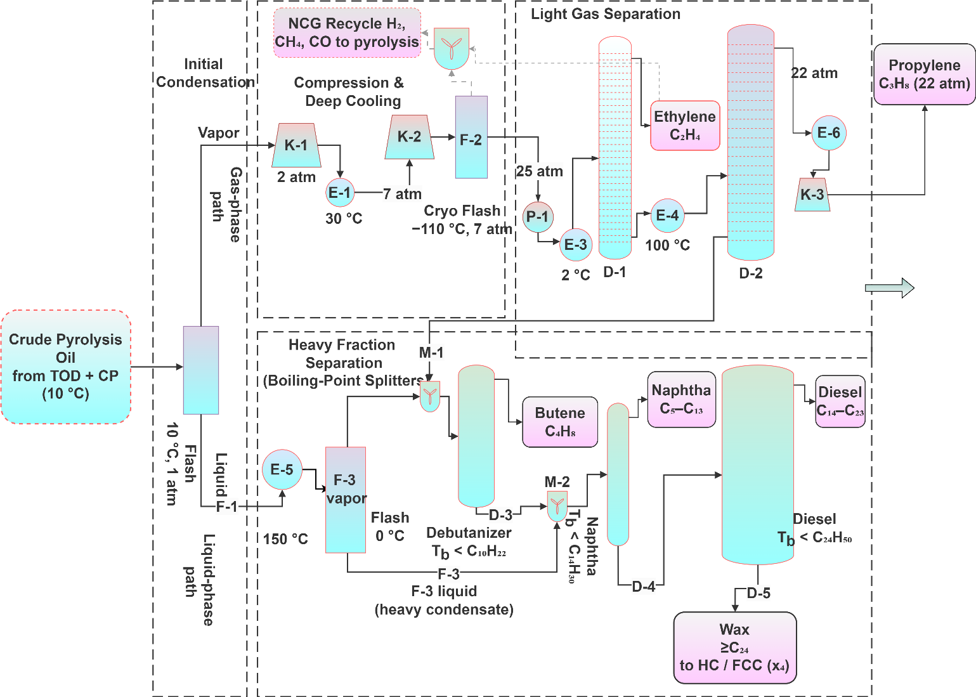
Figure 3. Process flow diagram for the shared distillation train (TOD + CP branch). Seven-stage separation from flash condensation through cryogenic light gas separation to heavy fraction boiling-point splitters. Products: ethylene, propylene, butene, naphtha, diesel, and wax. Column specifications are provided in Table S4
Turbogenerator
The combined flue gas streams from CPY, PLASMA, and FCC are sent to a turbogenerator that combusts all combustible species (H₂, CH₄, C₂H₄, CO, aromatics, etc.) using lower heating values (LHV) and generates electricity at a thermal-to-electric efficiency η = 0.35 (reference cost: $600/kW of generation capacity). The generated electricity offsets the plant's grid electricity consumption, reducing both operating cost and environmental impact.
Techno-Economic Analysis
Having defined the process model and its constituent unit operations, we next describe the economic evaluation framework. This study utilizes techno-economic analysis (TEA) to estimate the economic feasibility of the superstructure under all four market scenarios. The mass and energy balance from the BioSTEAM process model was used for capital and operating cost estimates. We employed the discounted cash flow rate of return (DCFROR) methodology commonly used in similar studies ^{1,8} to determine the minimum selling price (MSP) of feedstock defined as the breakeven feedstock price at which the net present value (NPV) equals zero at the specified internal rate of return.
Financial Assumptions
The plant is designed on the basis of the nth plant assumption, which implies that the technology is fully matured and similar technologies are already used in industry ^{1,13}. The financial assumptions made in this study follow closely with assumptions made in other TEA studies where the nth plant assumptions are used ^{1,13}. The study assumes that 40% of the capital expenses are financed by debt at 7% interest with a 10-year repayment period, while the remaining 60% is covered by equity. In estimation of the NPV, the study assumes a 10% internal rate of return (IRR) over a 20-year plant life (2020-2040), MACRS 7-year depreciation schedule, and a 21% federal corporate income tax rate. Working capital is 5% of fixed capital investment (FCI). The plant operates 333 days per year (7,992 hr/year, 91.2% availability). All costs in this analysis were indexed to 2020 dollars using the Chemical Engineering Plant Cost Index (CEPCI). Table 3 shows a complete list of the financial assumptions made in the study.
Table 3. Financial assumptions for the techno-economic analysis.
Parameter | Value
Internal rate of return (IRR) | 10%
Plant life | 20 years (2020–2040)
Depreciation | MACRS 7-year schedule
Income tax rate | 21%
Operating days | 333 days/year (91.2% availability)
Operating hours | 7,992 hr/year
Lang factor | 5.05
Construction schedule | 40%/60% (Year 1/Year 2)
Working capital | 5% of FCI
Debt fraction | 40%
Loan term | 10 years
Loan interest rate | 7%
Startup period | 0 months
Feedstock price | $0.02/kg waste plastic
Labor cost (250 tpd) | $252,625/year
Capital and Operating Cost
Fixed capital investment (FCI) refers to the initial investment required to set up the facility. Capital costs include engineering design, equipment, building, and other costs associated with licenses and permits. The total installed equipment cost for the superstructure is calculated using a Lang factor of 5.05:
Installed Cost $=$ Purchased Equipment Cost × Lang Factor (3)
The cost of equipment depends upon the type and capacity of the equipment. The mass and energy balance from the process model was used to determine the capacity of each unit. The study employs eq 4 using exponential scaling factors to adjust the equipment cost taken from the literature from the original capacity reported to the capacity required in this study:
 | $$C_{n}\text{ new }=C_{n}\text{ nef × }{\left(S_{0}\text{ new }/S_{0}\text{ ref }\right)}^{∧}n$$ | 3
where C new is the cost of the equipment at the new capacity, C ref is the original cost of the equipment reported in the literature, $S_{a}$ ref is the original capacity reported in the literature, $S_{an}$ new is the capacity of the equipment used in the study, and n is the exponential factor that varies from 0.6 to 1.0 depending upon the equipment. The study also employed the Chemical Engineering Plant Cost Index (CEPCI) to update the equipment cost from the time of design to the year 2020 using eq 5 :
 | $$C_{\text{a current }}=C_{\text{a base }}×(\text{ CEPCL_current }/\text{ CEPCL_base })$$ | 4
where CEPCI current and CEPCI base are the CEPCI at the current year and the year that the equipment was designed, respectively. Key equipment reference costs and their scaling parameters are provided in Table S5. The cost of heat exchangers, compressors, and distillation columns is calculated internally by BioSTEAM from their mass and energy duty requirements [2]. Operating costs are the ongoing expenses required to keep the facility running. The fixed operating cost (FOC) is calculated as:
 | $$FOC=FCI×\left(f_{a}tax+f_{a}ins+f_{a}\text{ maint }+f_{a}\text{ admin }\right)+\text{ Labor }×\left(1+f_{a}\text{ fringe }+f_{a}\text{ supplies }\right)$$ | 5
where $f_{α}tax=0.1\%,f_{α}$ ins $=0.5\%,f_{α}$ maint $=0.3\%$, and $f_{α}$ admin $=0.5\%$ are fractions of FCI, and $f_{α}$ fringe $=40\%$ and f supplies $=20\%$ are fractions of the base labor cost (Table S15). Labor costs are based on a 31-person staffing plan for a 2,000 tpd reference plant (Dutta et al. [15]; salaries adjusted per US Bureau of Labor Statistics data) and scaled linearly to the 250 tpd design capacity (scaling factor $=250/2,000=$ 0.125 ), yielding $\$252,625/$ year. The labor cost breakdown by position is provided in Table S14. Variable operating costs include utility costs (electricity, heating, cooling) computed directly from BioSTEAM's heat and power utility accounting, and feedstock cost at $\$0.02/kg$ waste plastic [3].
Life Cycle Assessment
Alongside the economic evaluation, we employed life cycle assessment (LCA) to evaluate the environmental impacts of converting waste polyolefins to value-added products via the superstructure. LCA is a widely accepted methodology for estimating the health and environmental impacts of a system or product ¹⁴,. This study adheres to the ISO 14040 and 14044 frameworks ¹⁴, which provide standardized guidelines for conducting LCA studies.
System Boundary and Functional Unit
The system boundary of the study is cradle-to-gate (Figure 4). This inclusive boundary involves all refining processes from feedstock intake through product collection, including all utilities (electricity, heating, cooling) and chemical inputs (natural gas, oxygen, catalysts). Notably, the cradle-to-gate perspective does not extend to encompass the environmental repercussions of products beyond the confines of the facility. Transportation of feedstock, end-of-life of products, and plant construction/decommissioning are excluded. The study employs a functional unit of 1 kg of mixed waste plastic processed in the facility.
Life Cycle Inventory
For the LCA inventory analysis, the study modeled five major hierarchy groups, feedstock intake, pretreatment and pyrolysis, product fractionation, hydrocracking/FCC, and turbogenerator electricity recovery. The mass and energy balance from the process model serves as inputs for all processing sections. We obtained life cycle emission factors from the ecoinvent 3.x database ¹⁵ (Allocation at the Point of Substitution, APOS) for all materials and energy inputs. The impact assessment was evaluated using the Tool for Reduction and Assessment of Chemicals and Other Environmental Impacts (TRACI) 2.1 methodology across ten midpoint impact categories: global warming (kg CO₂-eq), acidification (kg SO₂-eq), eutrophication (kg N-eq), smog (kg O₃-eq), ozone depletion (kg CFC-11-eq), respiratory effects (kg PM2.5-eq), ecotoxicity (CTUe), carcinogenics (CTUh), non-carcinogenics (CTUh), and fossil fuel depletion (MJ surplus). Global warming potential (GWP, kg CO₂-eq) serves as the primary metric for optimization. The emission factors used in this study are shown in Table 4 and Table S16.

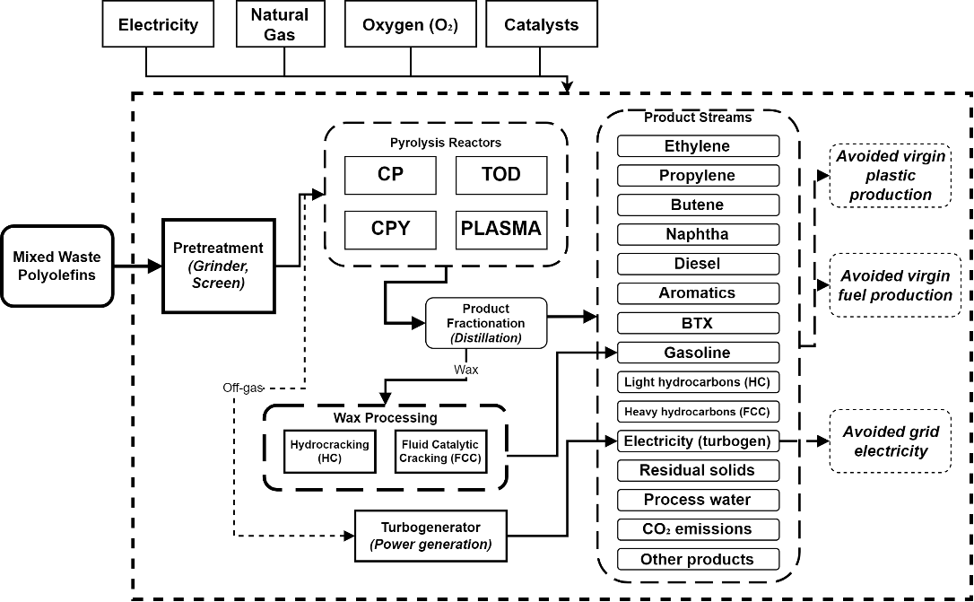
Figure 4. LCA system boundary (cradle-to-gate). System inputs include electricity, natural gas, oxygen, and catalysts. The functional unit is 1 kg of mixed waste plastic. Dotted arrows represent product displacement credits.
Table 4. Life cycle emission factors (GWP, kg CO₂-eq per unit) from ecoinvent 3.x (APOS) [18].
Resource | ecoinvent Process | GWP (kg CO₂-eq/unit) | Unit
Benzene | market for benzene, APOS, U | 1.994 | kg
Acetic acid | market for acetoacetic acid, APOS, U | 8.363 | kg
Acetaldehyde | market for acetaldehyde, APOS, U | 1.849 | kg
Heavy fuel oil | market for heavy fuel oil, APOS, U | 0.348 | kg
Lubricating oil | market for lubricating oil, APOS, U | 1.353 | kg
Oxygen | market for oxygen, liquid, APOS, U | 1.072 | kg
Methanol | market for methanol, APOS, U | 0.629 | kg
Butane | market for butane, APOS, U | 0.768 | kg
Naphtha | market for naphtha, APOS, U | 0.366 | kg
Diesel | market for diesel, APOS, U | 0.475 | kg
Ethylene | market for ethylene, average, APOS, U | 1.396 | kg
Propylene | market for propylene, APOS, U | 1.435 | kg
Wax | market for wax, lost-wax casting, APOS, U | 0.745 | kg
Hydrogen | market for hydrogen, liquid, APOS, U | 2.277 | kg
Electricity | market for electricity, med. voltage, APOS, U | 0.456 | MJ
Natural gas | market for natural gas, liquefied, APOS, U | 0.574 | m³
GWP Calculation
Product credits follow the displacement approach: each product stream displaces an equivalent amount of conventional fossil-derived production, and the corresponding environmental burden is subtracted from the process GWP $[1,3]$. The emissions associated with the primary product were estimated by allocating credits for all co-products in each scenario. The total GWP is computed hourly as:
 | $$GWP_{\text{_total }}=Σ_{-}s\left(F_{-}s×EF_{-}s×m_{\text{_as }}s\right)+GWP_{\text{_elec }}+GWP_{\text{_heat }}+GWP\text{ _FCC }$$ | 6
where $F_s$ is the mass flow rate of stream $s(kg/hr),EF_s$ is the emission factor of the mapped resource ( $kg{CO}_{2}$-eq/ kg ), and $m_{\text{s }}s$ is the multiplier (positive for environmental burdens, negative for product credits). The stream-to-resource mapping with multipliers is provided in Table S17 (see also S4.5). Electricity GWP is calculated as:
 | $$\text{ GWP }\text{elec} =P\text{ consumption }×3.6×\text{ EF electricity }$$ | 7
where $P_{\text{consumption }}$ consumption in kW and 3.6 converts kWh to MJ. Heat GWP is estimated from net cooling duty as:
 | $$GWP\text{ heat }=\left(Q_{\text{net cooling }}/1000/3600\right)×EF\text{ natural gas }$$ | 8
where Q net cooling is the sum of negative (cooling) heat duties in $kJ/hr$. FCC off-gas direct emissions are calculated as:
 | $$GWP_FCC=\overset{˙}{f}{CO}_{2}+32×\overset{˙}{f}{CH}_{4}$$ | 9
where the factor of 32 represents the 100-year GWP of methane relative to ${CO}_{2}$. The GWP is normalized to the functional unit as:
 | $$GWP_{\text{_per }}kg=GWP_{\text{_total }}\left(kg{CO}_{2}-eq/hr\right)/f\text{ feed }(kg/hr)$$ | 10
Carbon Abatement Cost
To provide an additional economic-environmental metric, we calculated the carbon abatement cost (CAC), which quantifies the economic cost of avoiding one kg of ${CO}_{2}$-equivalent emissions:
 | $$CAC=\text{ Net cost per kgfeed }/(-GWP\text{ per kgfeed })$$ | 11
where Net cost per kg feed $=($ Annual operating cost - Annual sales $)/$ Annual feed mass. A negative CAC indicates that the process both reduces emissions and generates net revenue (a win-win outcome) [1]. A positive CAC indicates the cost per kg CO2-eq avoided. The complete LCA methodology is detailed in Section S4.
Superstructure Optimization Formulation
The superstructure optimization is formulated based on material balance constraints to optimize the waste plastic processing pathway in terms of both economic and environmental sustainability. The optimization formulation involves one type of variable:
Continuous variable: x - This variable represents the split fractions that control the flow of waste plastic among the processing technologies. Unlike MILP-based superstructure formulations that use binary variables to select or exclude technologies ¹⁶, our formulation retains all technologies simultaneously and optimizes their relative throughput via continuous split fractions bounded away from zero $(x∈[0.05$, $0.95]$ ). This approach ensures that all pathways remain active at every evaluation, which is important because each pathway produces a distinct product slate and the optimal blend depends on market conditions. The four split fractions (Table 2) are defined as continuous decision variables in a Pyomo ConcreteModel ¹⁷. The optimization problem can be formulated as follows:

 | $$\begin{matrix}maxxscore(x) \\ \text{ s.t. }h(x)=0 (\text{ material balance, eqs }7-12) \\ x_{a}i^{∧}lo≤x_{a}j≤x_{a}i^{∧}up,j=1,2,3,4\end{matrix}$$ | 12
where $score(x)$ is the multi-objective function (eq 16), $h(x)$ represents the equality constraints from the material balance across all splitters, mixers, and unit operations (solved implicitly by BioSTEAM at each function evaluation), and $x_{\text{ad }}i^{∧}lo=0.05$ and $x_{\text{a }}d^{∧}up=0.95$ are the lower and upper bounds of the split fractions.
Material Balance
For each stage in the superstructure, the material balance needs to be satisfied. The incoming mixed waste plastic feed is split among the four upstream technologies through three chained splitters. The overall mass balance at the feed inlet is given by:
 | $$\text{ feed }=\overset{˙}{f}CP+TOD+\overset{˙}{f}CPY+PLASMA$$ | 13
The first splitter allocates the feed as:
 | $$\overset{˙}{f}CP+TOD=x_{1}×f_{2}\text{ feed }; f_{1}CPY+PLASMA=\left(1-x_{1}\right)×f_{2}\text{ feed }$$ | 14
Within the conventional pyrolysis branch, the second split allocates feed between TOD and CP:
 | $$\overset{˙}{f}TOD=x_{2}×\overset{˙}{f}CP+TOD; \overset{˙}{f}CP=\left(1-x_{2}\right)×\overset{˙}{f}CP+TOD$$ | 15
Within the alternative branch, the third split allocates feed between CPY and PLASMA:
 | $$\overset{˙}{f}CPY=x_{3}×\overset{˙}{f}CPY+PLASMA; \overset{˙}{f}PLASMA=\left(1-x_{3}\right)×\overset{˙}{f}CPY+PLASMA$$ | 16
The wax fraction from the distillation train is split between HC and FCC:
 | $$\overset{˙}{f}HC=x_{4}×\overset{˙}{f}wax; \overset{˙}{f}FCC=\left(1-x_{4}\right)×\overset{˙}{f}wax$$ | 17
The product flows from each processing technology are determined by the yield predictions (from PyrolysisNet or fixed yields) and the unit operation mass and energy balances:
 | $$F_{n}pk=fp^{∧}in×YIELD_{n}pk$$ | 18
where F p. k is the mass flow of product k obtained from processing technology $p,\overset{˙}{f}p^{∧}$ in is the feed mass flow entering technology p , and YIELD pk is the yield of product k from technology p (predicted by PyrolysisNet for CP, CPY, and PLASMA, or taken from fixed experimental data for TOD). Like-products from multiple pathways are merged before collection:
 | $$F_{n}k^{∧}\text{ total }=\sum_{n}{ }pF_{n}p_{k}$$ | 19
The annual revenue from selling all products is calculated as:
 | $$SALE=\sum_{n}{ }k\left(Fk^{∧}total×P_{n}k×t_{n}op\right)$$ | 20
where $P_{an}k$ is the selling price of product k (Table 4) and $t_{op}=7,992hr/$ year is the annual operating hours.

Reference
(1) Olafasakin, O.; Ma, J.; Bradshaw, S. L.; Aguirre-Villegas, H. A.; Benson, C.; Huber, G. W.; Zavala, V. M.; Mba-Wright, M. Techno-Economic and Life Cycle Assessment of Standalone Single-Stream Material Recovery Facilities in the United States. Waste Management 2023, 166, 368–376. https://doi.org/10.1016/j.wasman.2023.05.011.
(2) Cortes-Peña, Y.; Kumar, D.; Singh, V.; Guest, J. S. BioSTEAM: A Fast and Flexible Platform for the Design, Simulation, and Techno-Economic Analysis of Biorefineries under Uncertainty. ACS Sustain. Chem. Eng. 2020, 8 (8), 3302–3310. https://doi.org/10.1021/acssuschemeng.9b07040.
(3) Gracida-Alvarez, U. R.; Winjobi, O.; Sacramento-Rivero, J. C.; Shonnard, D. R. System Analyses of High-Value Chemicals and Fuels from a Waste High-Density Polyethylene Refinery. Part 1: Conceptual Design and Techno-Economic Assessment. ACS Sustain. Chem. Eng. 2019, 7 (22), 18254–18266. https://doi.org/10.1021/acssuschemeng.9b04763.
(4) Milbrandt, A.; Coney, K.; Badgett, A.; Beckham, G. T. Quantification and Evaluation of Plastic Waste in the United States. Resour. Conserv. Recycl. 2022, 183, 106363. https://doi.org/10.1016/j.resconrec.2022.106363.
(5) Geyer, R.; Jambeck, J. R.; Law, K. L. Production, Use, and Fate of All Plastics Ever Made. Sci. Adv. 2017, 3 (7). https://doi.org/10.1126/sciadv.1700782.
(6) Lopez, G.; Artetxe, M.; Amutio, M.; Bilbao, J.; Olazar, M. Thermochemical Routes for the Valorization of Waste Polyolefinic Plastics to Produce Fuels and Chemicals. A Review. Renewable and Sustainable Energy Reviews 2017, 73, 346–368. https://doi.org/10.1016/j.rser.2017.01.142.
(7) Radhakrishnan, H.; Gnangbe, S.; Duereh, A.; Iffat Uday, S. U.; Lusi, A.; Hu, H.; Hu, H.; Wright, M. M.; Bai, X. Non-Equilibrium Plasma Co-Upcycling of Waste Plastics and CO2 for Carbon-Negative Oleochemicals. Green Chemistry 2024, 26 (16), 9156–9175. https://doi.org/10.1039/d4gc02340d.
(8) Gracida-Alvarez, U. R.; Winjobi, O.; Sacramento-Rivero, J. C.; Shonnard, D. R. System Analyses of High-Value Chemicals and Fuels from a Waste High-Density Polyethylene Refinery. Part 1: Conceptual Design and Techno-Economic Assessment. ACS Sustain. Chem. Eng. 2019, 7 (22), 18254–18266. https://doi.org/10.1021/acssuschemeng.9b04763.
(9) Lopez, G.; Artetxe, M.; Amutio, M.; Alvarez, J.; Bilbao, J.; Olazar, M. Recent Advances in the Gasification of Waste Plastics. A Critical Overview. Renewable and Sustainable Energy Reviews 2018, 82, 576–596. https://doi.org/10.1016/j.rser.2017.09.032.
(10) Brown, J. L.; Radhakrishnan, H.; Coffman, I.; Tumu, K.; Curtzwiler, G.; Vorst, K.; Smith, R. G.; Brown, R. C.; Bai, X.; Daugaard, T. J. Thermal Oxo-Degradation and Catalytic Upgrading of Plastic Waste to Light Olefins for a Circular Economy. Energy & Fuels 2025, 39 (37), 18013. https://doi.org/10.1021/acs.energyfuels.5c02862.
(11) Radhakrishnan, H.; Gnangbe, S.; Duereh, A.; Iffat Uday, S. U.; Lusi, A.; Hu, H.; Hu, H.; Wright, M. M.; Bai, X. Non-Equilibrium Plasma Co-Upcycling of Waste Plastics and CO2 for Carbon-Negative Oleochemicals. Green Chemistry 2024, 26 (16), 9156–9175. https://doi.org/10.1039/d4gc02340d.
(12) Bezergianni, S.; Kalogianni, A. Hydrocracking of Used Cooking Oil for Biofuels Production. Bioresour. Technol. 2009, 100 (17), 3927–3932. https://doi.org/10.1016/j.biortech.2009.03.039.
(13) Humbird, D.; Davis, R.; Tao, L.; Kinchin, C.; Hsu, D.; Aden, A.; Schoen, P.; Lukas, J.; Olthof, B.; Worley, M.; Sexton, D.; Dudgeon, D. Process Design and Economics for Biochemical Conversion of Lignocellulosic Biomass to Ethanol: Dilute-Acid Pretreatment and Enzymatic Hydrolysis of Corn Stover. 2002.
(14) ISO 14040:2006 - Environmental management — Life cycle assessment — Principles and framework. https://www.iso.org/standard/37456.html (accessed 2025-12-18).
(15) Wernet, G.; Bauer, C.; Steubing, B.; Reinhard, J.; Moreno-Ruiz, E.; Weidema, B. The Ecoinvent Database Version 3 (Part I): Overview and Methodology. International Journal of Life Cycle Assessment 2016, 21 (9), 1218–1230. https://doi.org/10.1007/S11367-016-1087-8/METRICS.
(16) Song, H.; Yang, G.; Xue, P.; Li, Y.; Zou, J.; Wang, S.; Yang, H.; Chen, H. Recent Development of Biomass Gasification for H2 Rich Gas Production. Applications in Energy and Combustion Science 2022, 10, 100059. https://doi.org/10.1016/J.JAECS.2022.100059.
(17) Bynum, M. L.; Hackebeil, G. A.; Hart, W. E.; Laird, C. D.; Nicholson, B. L.; Siirola, J. D.; Watson, J.-P.; Woodruff, D. L. Pyomo — Optimization Modeling in Python. 2021, 67. https://doi.org/10.1007/978-3-030-68928-5.

