Southampton Solent University
School of Media and Arts Technology
Faculty of Computing

Output and Reflection on Personal Skills and Activities

Course title: Graduate and Professional Development

Tutor’s name : Joe Appleton

Table of Contents
Table of Contents 1
List of Figures 2
Introduction 3
Literature Survey 4
Methodology 5
Results 6
Myers Briggs Type Test 6
Feedback Data 7
Team Feedback 8
WhatsApp Data 9
Discussion 10
Conclusions 11
Reference list 12
Appendices A
Appendix A: A
Appendix B B
Appendix C C
Appendix D D
Appendix E E
Appendix F F

List of Figures
FIGURE 1: MYERS BRIGGS TEST COLLECTIVE RESULTS 6
FIGURE 2: MYERS BRIGGS TEST AVERAGE RESULTS 6
FIGURE 3: FEEDBACK TABLE 7
FIGURE 4: GROUP PERFORMANCE OUT OF 5 7
FIGURE 5: TEAM REFLECTION RESULTS OUT OF 5 8
FIGURE 6: TEAM REFLECTION IMPROVEMENT AREAS 8
FIGURE 7: TEAM REFLECTION OVERALL REVIEW 9
FIGURE 8: TEAM FEEDBACK FORM A
FIGURE 9: IMMEDIATE PEER FEEDBACK FORM B
FIGURE 10: TRELLO GROUP HUB C
FIGURE 11: GROUP PROJECT PLAN D

Introduction
In 1965 an exhaustive literature review was conducted on 50 preceding studies in order to derive a model for the developmental sequence in small groups by Bruce W. Tuckman, and later revised by Tuckman and Jensen (1977). The review resulted in the most renown and commonly used framework consisting of 5 stages, forming, storming, norming, performing and adjourning.
The urge to understand how people form connections and develop a sense of structure through their groups will never expire, especially with the developing world providing more business opportunities. Each business is devolved from a network of teams forming the business architecture. Understanding the framework would enable companies the ability to build the pathway in which they form groups, minimising the time required to form these groups as well as increasing the efficiency and global success rate of the process. As a result, business functionality increases driving profits up.
This essay will critically analyse a small-scale study on the formation of a group, conducted within a university environment, tasked with delivering a presentation of a selected topic; Social Media and Data Privacy. This paper will argue that, although the formation of our team identified similar stages to Tuckman and Jensen (1977), the hypothesis which was most relative was that of Braaten (1975), nonetheless it will highlight both the limitations and constraints among the findings, and comparative models.

Literature Survey
Tuckman’s (1965) framework on ‘Developmental Sequence in Small Groups’ proposes a generic route in which group development occurs. The framework descends from the extensive literature review of 50 individual studies, associated with group formation over time, in which the proposed route is felicitous to both the social and task realm.
The implied pathway of group development consists of four stages forming, storming, norming and performing. However, Tuckman and Jensen (1977) reviewed research on small-group development undergone in the last 10 years in order to identity studies which empirically trial Tuckman’s (1965) framework, which, in turn, resulted in the fifth stage, adjourning. Of the 22 studies analysed only 1 was found to directly question the framework, Runkel et al (1971). While Runkel et al (1971) directly set out to test the model, and restrict observer bias via group rotations, Tuckman and Jensen (1977) highlighted how reliability of the results could be called into question, due to researcher methodology of collecting only behaviours identified by Tuckman’s (1965) framework and not others.
Although Runkel et al (1971) was the only study to empirically test Tuckman’s (1965) framework, the study was not the cause of the additional stage, adjourning. Instead the identification of a ‘termination’ stage by Braaten’s (1975) review, along with the studies of Gibbard and Hartman (1973) which expand on the life cycle model as first proposed by Mills (1964).
Subsequently, the termination stage came to light due to the nature of social realms developing interpersonal feelings which affect members upon the “death of the group”. As more studies adopted the concept of a life cycle approach it was deemed reasonable to adapt the framework to host that of recent literature, under the respect of Tuckman’s (1965) framework being derived from previous literature.
Retrospectively building on the development of small groups, it was deemed relevant to take into consideration the Myers-Briggs Type Indicator (MBTI), Myers (1962) upon group formation. Myers (1962) introduced a structured approach to assess introspective psychological preferences, formulating a member’s personality traits. The development of Myers (1962) mirrors that of Tuckman (1966) regarding the formulation deriving from previous conceptual theories and or literature, specifically that of Jung (1923).
Consequently, the issue of accuracy and true representation come into question; the nature of theorems derived from conceptual based research enables studies to be victim of interpretation and poor methodology which can have underlying implications in the resulting outcome.

Methodology
The objective of the study was to critically analyse the development of a small group within a university environment, via a presentation on an issue relevant to today. My group was comprised of seven students, six male and one female, six of whom study Business Information Technology and I, who is reading Information and Technology Management.
Upon assignment, the group individually undertook the Myers Briggs type indicator test (Myers 1962). This test enabled a quantitative data profile to be generated on the personality of each member. Appropriately, a Trello Board was created in order to maintain schedule and share our documents (appendix C), along with a WhatsApp group, which was mutually decided on being the primary method of contact. As a result, Trello became a hub of mixed data whilst WhatsApp enabled the harvesting of qualitative data as well as the arrangement of meetings to complete tasks.
Once accustomed to the project management tools, WhatsApp was used to delegate a time and place in which the team would meet and assign roles. A simple table was designed by our team leader in which each task was listed, and members would highlight tasks they would feel comfortable executing. The table was then shared on Trello and acted as the foundation to distribute workload and research (appendix D).
To enable the input of our immediate peers, Joe had created a global survey, via OneDrive Forms, which peers could anonymously submit (appendix B). This survey utilised the mixed methods approach via quantitative ratings out of 5 as well as a qualitative comments field to encourage further reflection. Once all the peer presentations had been conducted, the results were published in an excel format which was publicly accessible. I utilised this data by highlighting all feedback for our group and calculating the average for quantitative ratings to produce a graph in which the average performance in each field is clearly stated.
After completion of our presentation, the team leader and I designed a OneDrive Form to peer review one another within the team using a mixed methods approach (appendix A). Quantitative data was collected on the group and qualitative data was collected for each member to provide a base to reflect on. To distribute the survey, an anonymous submission URL was shared on both Trello and WhatsApp to minimise confusion and ensure each member provided feedback. The team leader then shared the results charts on Trello to be used in further individual and peer reflection.

Results

Myers Briggs Type Test

Collective representation of each members MBTI Results as a bar chart, values represent personality traits as a percentage.

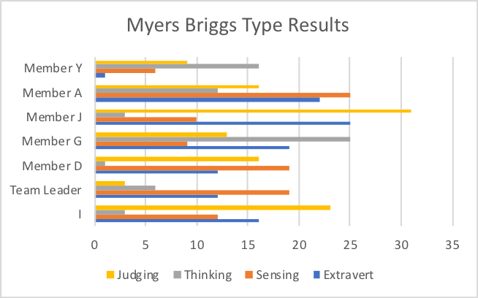

Figure 1: Myers Briggs Test Collective Results

Average MBTI results of each member represented as a pie chart to identify overall group personality traits.

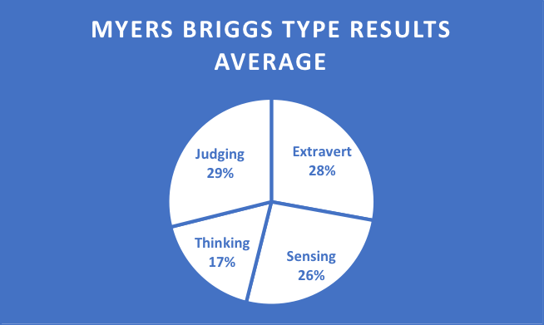

Figure 2: Myers Briggs Test Average Results

Feedback Data

Feedback table for our group, derived from the peer feedback form in table format, including further average calculations (appendix B).

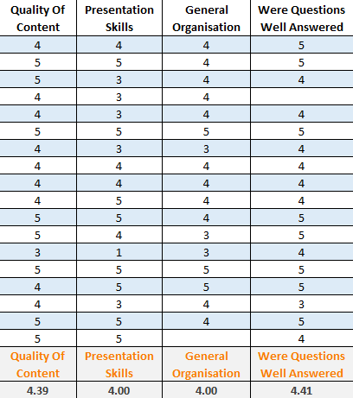

Figure 3: Feedback Table

Average group performance ratings out of 5, derived from the immediate peer feedback form (appendix B).
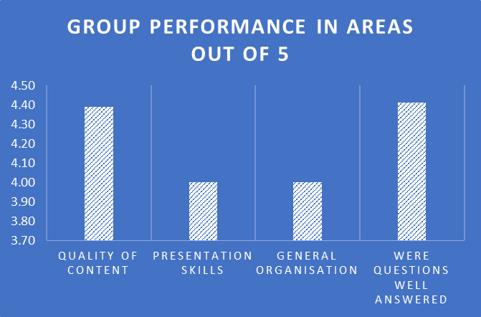

Figure 4: Group Performance out of 5

Team Feedback

Average group performance ratings out of 5, derived from the team feedback form (appendix A).

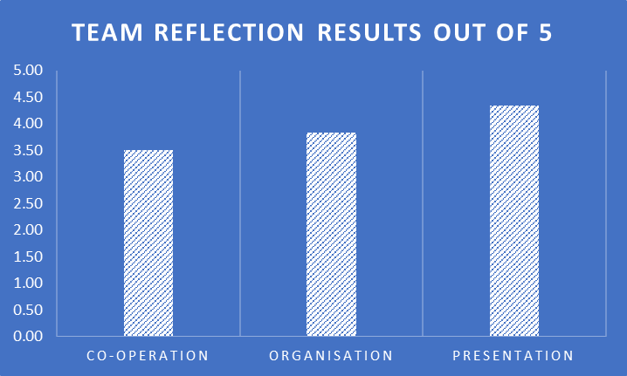

Figure 5: Team Reflection Results out of 5

Qualitative feedback for areas of improvement, derived from the team feedback form (appendix A).

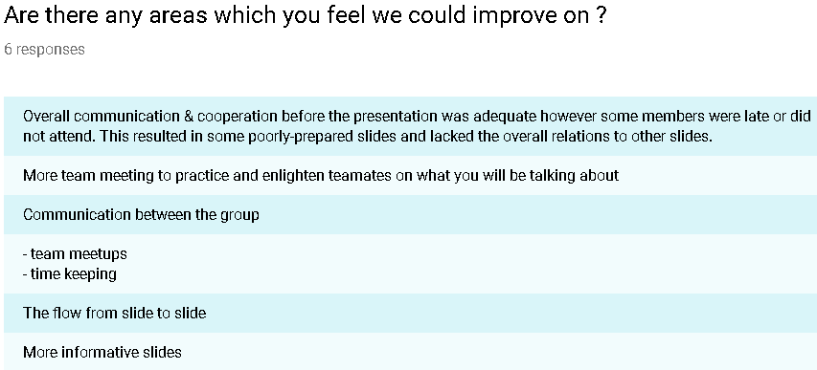

Figure 6: Team Reflection Improvement Areas

Qualitative non-specific feedback derived from the team feedback form (appendix A).

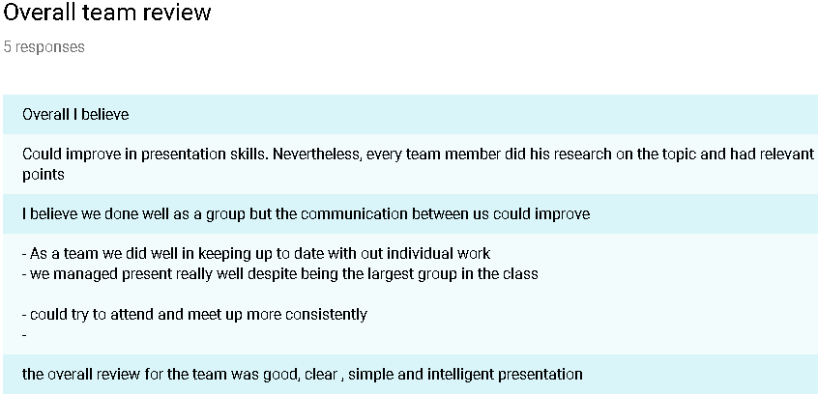

Figure 7: Team Reflection Overall Review

WhatsApp Data
Initial concerns from week one was the lack of communication from all members. This was until 5 days in member D suggested “We should probably meet up sometime…” the team leader then asked, “can we with meet up on Monday 1:30-2:30pm?”

From week two onwards the team leader had handled the organisation of meetings and ensured the attendance of fellow members, “Don’t forget to meet up in the library for our meeting today”.

Nearing week 4, the team leader reserved an area for the group to enact a practice presentation, “The pod room has been booked for tomorrow at 1:15 till 2:40” to which Member A highlighted “I have work, what about after 4?”.

The resulting meeting was re-scheduled 3 hours later however, miscommunication occurred over which meeting was to be attended. As a result, the team leader was the only member at the original meeting asking, “where is everyone?”.

Three weeks post presentation the team leader and I express our frustration over missing forms and work from multiple members, “There’s still only 4 responses on the survey…”.

Discussion
While the overall objective was achieved, and the presentation was delivered without disruption, I have come to think team functionality was some what hindered in attendance. I believed the development of the team could be described using Tuckman’s (1965) framework due to the ironic group ice-breaker task to critically analyse both Tuckman (1965) and Tuckman and Jensen’s (1977) journals, utilising a precompiled grid featuring six questions composed of who, what, where, when, why and how.
This identified as the ‘forming’ stage of the group however, the group averted the ‘storming’ stage due to prompt agreement on our female member being the team leader. Our team leader then handled the organisation of tasks for those at meetings, arranged via WhatsApp and Trello, conceivably identifying as the ‘norming’ stage. Although multiple stages of Tuckman’s (1965) were identified, I do not regard the group ever reaching the ‘performing’ stage.
Upon the completion of the presentation, members began to become ignorant to group discussions, tasks or even attending meetings and seminars, resembling that of the ‘storming’ stage and that of, the later suggested, ‘adjourning’ stage by Tuckman and Jensen (1977). Due to the group following an irregular route to that of Tuckman and Jensen (1977), it is more likely the most coordinating hypothesis is that of Gibbard and Hartman (1973), in which members lose their sense of direction or motivation, due to the death of “strong interpersonal feelings” or reliance to the leader, developed through the task. However, I believe that others may easily mistake the formation pathway for that of Tuckman’s (1965) as a result of the identical environment and variables to Runkel et al (1971), this can be further be mistaken due to the vulnerability of observer bias. Moreover, it could also be argued that the groups methodology could fall into that of the Punctuated Equilibrium Model, Gersick (1991), assumed due to the irregular path of development.
Given the possible models it is best to suggest that the group mirrored the model proposed by Braaten (1975) due the nature of it being a task realm environment, in which Tuckman’s (1965) stages are incorporated with the addition of termination.
Additionally, the validity and accuracy of the MBTI results can be placed under scrutiny due to members actions not resembling that of their results. Members who identified strongly as both extravert and thinking types rarely exhibited social confidence or a sense of forward thinking upon presenting. Although, the reliability could be deemed as a misinterpretation from those who undertook the survey rather than MBTI itself.

Conclusions
To summarise, this report has critically analysed a team presentation in a university environment against the developmental sequence in small groups, Tuckman (1965).
Throughout the study multiple stages of development could be identified to align with that of Tuckman and Jensen (1977) however, the structure of stages varied and resulted in no framework being truly representative to that of our group. As a result, the concluded framework was deemed to resemble that of Braaten (1975).
Unfortunately, due to the nature of this study there are multiple limitations which arise, not only is the literature reviewed by Tuckman (1965) not truly representative of group formation stages but, throughout the review, Tuckman highlights the susceptibility of observer bias in the social realm scenarios. This was found to remain true when attempting to align the groups development to an existing framework, the subjectivity of which can be open to misinterpretation, as well as observer bias.
To conclude this essay, I do not believe the results empirically test the hypothesis of Tuckman’s (1965) development framework to the scrutiny in which it is suggested. However, it echoes the call for a more refined methodology towards the control of variables along with utilising mixed data in identifying stages to reduce observer bias.

Reference list
BRAATEN, L. J. 1975. Developmental phases of encounter groups and related intensive groups. Interpersonal Development, 5(2), 112-129.

GERSICK, C., 1991. REVOLUTIONARY CHANGE THEORIES: A MULTILEVEL EXPLORATION OF THE PUNCTUATED EQUILIBRIUM PARADIGM. Academy of Management Review, 16(1), 10-36

GIBBARD, G. and J. HARTMAN, 1973. The Oedipal Paradigm in Group Development. Small Group Behavior, 4(3), 305-354

JUNG, C., 1923. ON THE RELATION OF ANALYTICAL PSYCHOLOGY TO POETIC ART1. British Journal of Medical Psychology, 3(3), 213-231

MYERS, I., 1962. The Myers-Briggs Type Indicator: Manual (1962).

RUNKEL, P. et al., 1971. Stages of Group Development: An Empirical Test of Tuckman's Hypothesis. The Journal of Applied Behavioral Science, 7(2), 180-193

TUCKMAN, B., 1965. Developmental sequence in small groups. Psychological Bulletin, 63(6), 384-399

TUCKMAN, B. and M. JENSEN, 1977. Stages of Small-Group Development Revisited. Group & Organization Studies, 2(4), 419-427

Appendices
Appendix A: Team Feedback Form

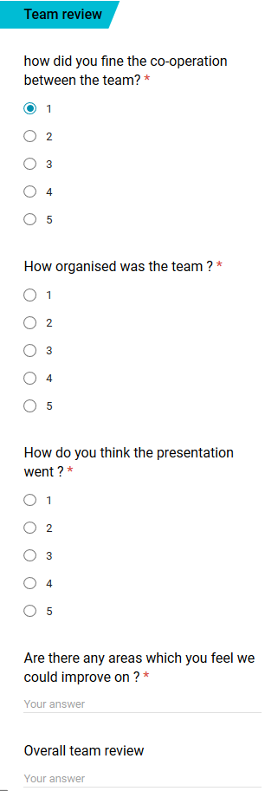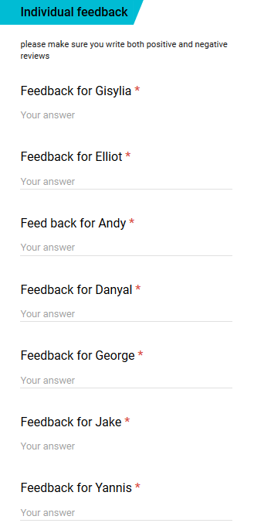

Figure 8: Team Feedback Form

Appendix B: Immediate Peer Feedback Form

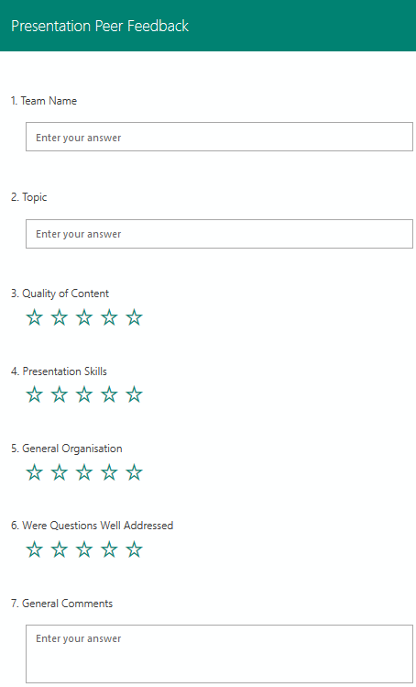

Figure 9: Immediate Peer Feedback Form

Appendix C: Trello Group Hub

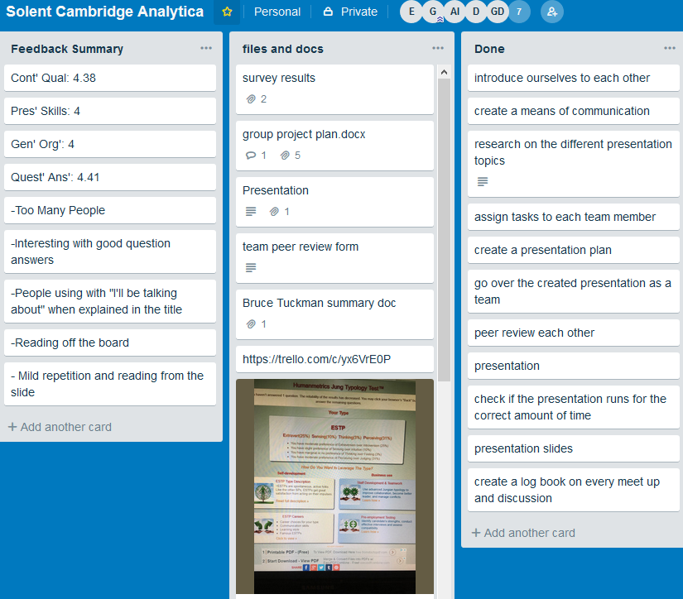

Figure 10: Trello Group Hub

Appendix D: Group Project Plan

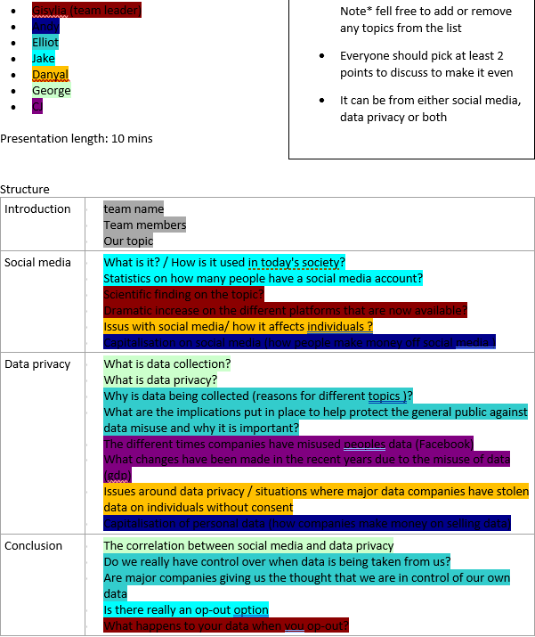

Figure 11: Group Project Plan
Appendix E: Curriculum Vitae

Professional profile
A motivated and inspired character currently reading Information Technology Management at Southampton Solent University. Over 6 years of experience on small-scale development and in-house testing, developing, implementation, support, security and more. Seeking new challenges and interests towards the field of security research and systems.
Skills summary
- Fluent in VB.NET, C#, PHP, HTML
- Experience with C++, Python, JavaScript, Lua, MySQL, Memory, Linux/UNIX, Nginx, Windows, NodeJS, Sqlmap
- Strong understanding of security and GDPR compliance
- Customer relations and support
- Comfortable in terminal environments, Visual Studio, Notepad++, GitHub, IDA
- UI & UX
- Malware & Memory analysis
Employment history
2011 – Present Unknown2.Me,
Lead Developer (Owner)

- Develop a UNIX virtual environment to host and serve web content securely
- Conduct regular security audits to ensure GDPR compliance and certificate strength
- Handling of customer questions and support tickets
- Design and implementation of desktop applications using VB.NET, C++
- Development and deployment of a bespoke CMS plugin using PHP and SQL
- Responsible for the testing and implementation of updates
- Maintaining of web and desktop content
- Identification of limitations and alternative solutions
- Continuously provide an updated documentation of changes and system events

Education and qualifications
- BSc (Hons) Information Technology Management, TBA – Southampton Solent University – 2019
- A Levels, Computing (B), Chemistry (D), Mathematics (E) – Lawrence Sheriff Sixth Form – 2016
- 15 GCSEs (A*- C) – Bilton High School – 2013
References available on request

Appendix F: Social Profiles

https://codepen.io/ElliotMarks

https://twitter.com/_ElliotM

https://github.com/ElliotMarks

