New Wheels Project

Introduction to SQL

Problem Statement
Business Context
A lot of people in the world share a common desire: to own a vehicle. A car or an automobile is seen as an object that gives the freedom of mobility. Many now prefer pre-owned vehicles because they come at an affordable cost, but at the same time, they are also concerned about whether the after-sales service provided by the resale vendors is as good as the care you may get from the actual manufacturers.
New-Wheels, a vehicle resale company, has launched an app with an end-to-end service from listing the vehicle on the platform to shipping it to the customer's location. This app also captures the overall after-sales feedback given by the customer.
Objective
New-Wheels sales have been dipping steadily in the past year, and due to the critical customer feedback and ratings online, there has been a drop in new customers every quarter, which is concerning to the business. The CEO of the company now wants a quarterly report with all the key metrics sent to him so he can assess the health of the business and make the necessary decisions.
As a data analyst, you see that there is an array of questions that are being asked at the leadership level that need to be answered using data. Import the dump file that contains various tables that are present in the database. Use the data to answer the questions posed and create a quarterly business report for the CEO.

Business Questions

Question 1: Find the total number of customers who have placed orders. What is the distribution of the customers across states?
Solution Query:
SELECT
COUNT(DISTINCT(customer_id)) AS total_customers
FROM order_t;

SELECT
state,
COUNT(customer_id) AS total_customers
FROM customer_t
GROUP BY state
ORDER BY total_customers DESC;
Output:
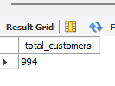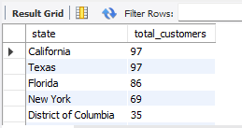

Observations and Insights:
- Theres a total of 994 customers, 35% of the total live in California, Texas, Florida, and New Yor
- The data appears to be in a uniform distribution, with a 49% drop off in customers form the 4th state with the most customers to the 5th state, but the remaining states have similar customer counts.
- The data is likely showing that population is a driving factor to the number of customers on the new wheels app, since the top 4 states with the most customers happen to be the 4 most populated states.

Question 2: Which are the top 5 vehicle makers preferred by the customers?
Solution Query:
SELECT
vehicle_maker,
COUNT(customer_t.customer_id) AS customer_count
FROM product_t
JOIN order_t
ON product_t.product_id = order_t.product_id
JOIN customer_t
ON order_t.customer_id = customer_t.customer_id
GROUP BY vehicle_maker
ORDER BY customer_count DESC
LIMIT 5;
Output:
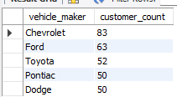
Observations and Insights:
- The top 5 vehicle makers are Chevrolet, Ford, Toyota, Dodge, and Pontiac; with Chevrolet being a clear favorite
- Chevrolet is the clear favorite amongst customers, but the distribution is uniform
- Dodge and Pontiac have the same amount of purchases

Question 3: Which is the most preferred vehicle maker in each state?
Solution Query:
SELECT *
FROM
(
SELECT
state,
vehicle_maker,
COUNT(customer_id) AS total_customers,
RANK() OVER (PARTITION BY state ORDER BY COUNT(customer_id) DESC) AS vehicle_ranking
FROM product_t
JOIN order_t USING (product_id)
JOIN customer_t USING (customer_id)
GROUP BY state, vehicle_maker
)
AS perferred_vehicle
WHERE vehicle_ranking = 1
ORDER BY total_customers DESC;
Output:
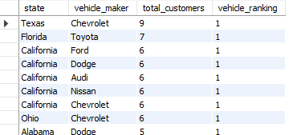
Observations and Insights:
- California has a 5 way tie for most popular vehicle maker; Nissan, Ford, Dodge, Chevrolet, Audi
- Chevrolet is ranked first in Ohio, California, and Texas, supporting the claim from the previous question that Chevrolet is the most popular brand
- Due to the heavy concentration of customers in California, New Wheels should look to expand marketing pushes within California

Question 4: Find the overall average rating given by the customers. What is the average rating in each quarter?

Consider the following mapping for ratings: “Very Bad”: 1, “Bad”: 2, “Okay”: 3, “Good”: 4, “Very Good”: 5
Solution Query:
WITH customer_rating AS (
SELECT
customer_feedback,
quarter_number,
CASE WHEN customer_feedback = 'very bad' THEN '1'
WHEN customer_feedback = 'bad' THEN '2'
WHEN customer_feedback = 'okay' THEN '3'
WHEN customer_feedback = 'good' THEN '4'
WHEN customer_feedback = 'very good' THEN '5'
END AS total_rating
FROM order_t
)
SELECT
ROUND(AVG(total_rating), 2) AS average_total_rating
FROM customer_rating;
WITH customer_rating AS (
SELECT
customer_feedback,
quarter_number,
CASE WHEN customer_feedback = 'very bad' THEN '1'
WHEN customer_feedback = 'bad' THEN '2'
WHEN customer_feedback = 'okay' THEN '3'
WHEN customer_feedback = 'good' THEN '4'
WHEN customer_feedback = 'very good' THEN '5'
END AS total_rating
FROM order_t
)
SELECT
quarter_number,
ROUND(AVG(total_rating), 2) AS rating_per_quarter
FROM customer_rating
GROUP BY quarter_number
ORDER BY quarter_number;
Output:
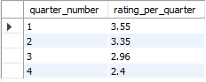
Observations and Insights:
- The average total rating is estimated 3.14, meaning that the average customer feedback is okay
- Progressively, the customer feedback gets worse, starting from 3.55 in quarter 1, to 2.4 in quarter 4, with a steady decline from quarter to quarter
- This decline indicates customer dissatisfaction overtime

Question 5: Find the percentage distribution of feedback from the customers. Are customers getting more dissatisfied over time?
Solution Query:
WITH feedback_customer AS (
SELECT
quarter_number,
SUM(CASE WHEN customer_feedback = 'Very Good' THEN 1 ELSE 0 END) AS VERY_GOOD,
SUM(CASE WHEN customer_feedback = 'Good' THEN 1 ELSE 0 END) AS GOOD,
SUM(CASE WHEN customer_feedback = 'Okay' THEN 1 ELSE 0 END) AS OKAY,
SUM(CASE WHEN customer_feedback = 'Bad' THEN 1 ELSE 0 END) AS BAD,
SUM(CASE WHEN customer_feedback = 'Very Bad' THEN 1 ELSE 0 END) AS VERY_BAD,
COUNT(customer_feedback) AS FEEDBACK
FROM order_t
GROUP BY quarter_number
ORDER BY quarter_number
)
SELECT
quarter_number,
ROUND((VERY_GOOD/FEEDBACK), 2) AS VERY_GOOD,
ROUND((GOOD/FEEDBACK), 2) AS GOOD,
ROUND((OKAY/FEEDBACK), 2) AS OKAY,
ROUND((BAD/FEEDBACK), 2) AS BAD,
ROUND((VERY_BAD/FEEDBACK), 2) AS VERY_BAD
FROM feedback_customer
GROUP BY quarter_number
ORDER BY quarter_number;
Output:
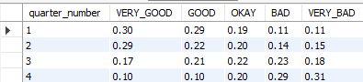
Observations and Insights:
- ‘Very good’ is the highest feedback for the first 2 quarters, ‘okay’ is the highest for Q3 and ‘very bad’ is the highest for Q4
- “bad’ and ‘very bad’ were tied for the lowest rated feedback for quarter 1-2, and ‘very good’ became the lowest rated the last two quarters
- Shows a complete flip in customer satisfaction as the year goes on

Question 6: What is the trend of the number of orders by quarter?
Solution Query:
SELECT
quarter_number,
COUNT(order_id) AS TOTAL_ORDERS
FROM order_t
GROUP BY quarter_number
ORDER BY quarter_number;
Output:
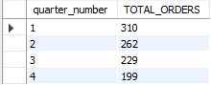
Observations and Insights:
- The first quarter yielded the highest total orders than any other quarter
- Following the first quarter, the total number of orders declined at a steady rate
- The decrease in sales is likely due to gradual decrease in customer satisfaction, as founded in the previous questions.

Question 7: Calculate the net revenue generated by the company. What is the quarter-over-quarter % change in net revenue?
Solution Query:
WITH quart_rev AS (
SELECT
quarter_number,
ROUND(SUM(quantity * (vehicle_price - ((discount / 100) * vehicle_price))), 0) AS revenue
FROM
order_t
GROUP BY
quarter_number
)
SELECT
quarter_number,
revenue,
LAG(revenue) OVER (ORDER BY quarter_number) AS previous_revenue,
ROUND(
(revenue - LAG(revenue) OVER (ORDER BY quarter_number)) /
LAG(revenue) OVER (ORDER BY quarter_number),
2) AS quart_perc_change
FROM
quart_rev;
Output:
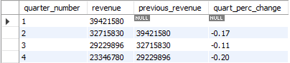
Observations and Insights:
- First quarter has the highest net revenue of any other quarter, with a steady decline after that
- Similarly, there is a quarter over quarter percent change in each quarter, showing that net revenue is decreasing each quarter
- The largest drop off in revenue appears to be Q2 to Q3, which is around the same time that customers expressed dissatisfaction in their feedback
- Likewise. the continued drop off in revenue directly correlates with the previous findings in a decrease in orders from the beginning of the year to the end.

Question 8: What is the trend of net revenue and orders by quarters?
Solution Query:
SELECT
quarter_number,
COUNT(order_id) AS total_orders,
SUM(vehicle_price * quantity) AS total_revenue
FROM order_t
GROUP BY quarter_number
ORDER BY quarter_number ASC;
Output:
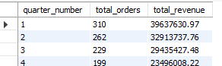
Observations and Insights:
- Similarly to what we saw with net revenue, total orders peaks with Q1 and decreased from Q2 to Q4
- The biggest drop off in orders appears to be from Q1 to Q2, a

Question 9: What is the average discount offered for different types of credit cards?
Solution Query:
SELECT
credit_card_type,
ROUND(AVG(discount), 2) AS average_discount
FROM order_t t1
INNER JOIN customer_t t2
ON t1.customer_id = t2.customer_id
GROUP BY credit_card_type
ORDER BY average_discount DESC;
Output:
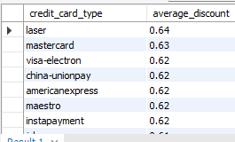

Observations and Insights:
- The highest average discount is laser with 0.64%
- Visa-electron, china-unionpay, americanexpress, maestro, and instapayment share the same value of 0.62.
- The discounts appear very uniformly distributed

Question 10: What is the average time taken to ship the placed orders for each quarter?
Solution Query:
SELECT
quarter_number,
ROUND(AVG(DATEDIFF(ship_date, order_date)), 2) AS average_shipping_time
FROM order_t
GROUP BY quarter_number
ORDER BY AVERAGE_SHIPPING_TIME;
Output:
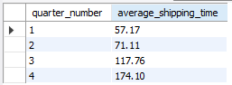
Observations and Insights:
- Q1 is the most efficient quarter in terms of shipping day
- From Q1 to Q4, shipping time increases drastically
- This is interesting because the past statistics revealed spike in orders during Q1 and decline Q2 to Q4.
- It would be likely to assume that the decrease in customer satisfaction is due to the rise in shipping time

Business Metrics Overview
Total Revenue | Total Orders | Total Customers | Average Rating
< '125482804.43'> | <1000> | <994> | <3.07>
Last Quarter Revenue | Last quarter Orders | Average Days to Ship | % Good Feedback
<23496008.22> | < 199> | <105.04> | <20%>
Note: These values must be derived using SQL queries. Some of them may have already been obtained while answering previous questions.

Business Recommendations
- Improve overall employee performance, start by getting the shipping time down. This would result in greater customer satisfaction and positive word of mouth, leading to more new customers.
- Offer promotions to new and existing customers to get the order numbers back up and create positive word of mouth for the business
- Reach out to customers from Q1 for more feedback or testimonials to help restore faith in New Wheels among the fading customer base.

