**Chapter 1: Web Research Questions**

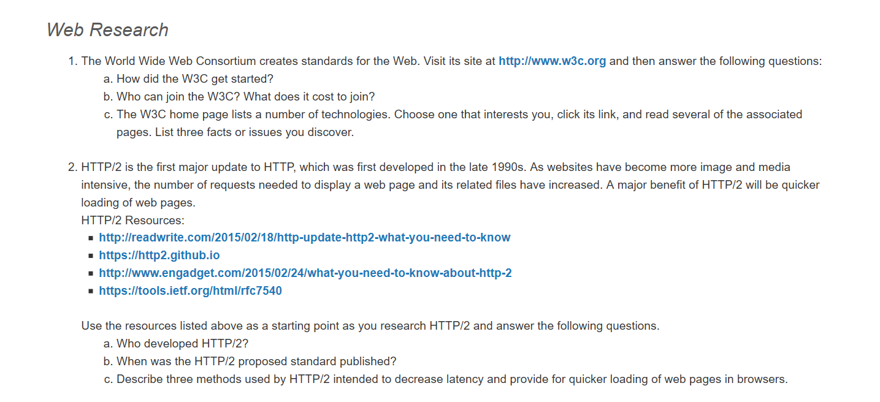

1.

1. In 1989, Tim Berners-Lee devises the first version of the web through the use of the very first form of HTML. In the following few years, the interest on this new technology grew immensely until in 1994, there was the first World Wide Web conference held and later that year, the World Wide Web Consortium was established.
2. Any organization or group can join the W3C. The cost of membership depends on the size of the organization wanting to join and their country of origin.

2.

1. The developers of SPDY (pronounced “speedy”), Mike Belshe, and Roberto Peon were all part of the development of HTTP/2.
2. HTTP/2 was published on February 17, 2015.
3. There are a few reason why HTTP/2 is faster that the regular HTTP or HTTPS. One of the reasons is that HTT2 is faster is because it sends the requests in binary rather than in text. For a machine, this makes it much easier to understand. HTTP/2 also keeps only 1 connection open, along which traffic travels in both directions. This is much better than the previous method which was to open a new connection for each transfer. HTTP/2 is also “multiplexed” meaning that it can send multiple files at once rather than just one at a time.