rdForeign direct investment, corporate social responsibility, and malaria control in Mozambique - trends, risks, and opportunities

## Introduction

Mozambique is a Southern-East African country with a surface area of nearly 800,000 m2 (more than 3 times that of the United Kingdom) and a population of nearly 30 million inhabitants. Though low-income, Mozambique experienced an upward trend in gross domestic product (GDP) per capita from approximately 200 USD in the late 90s to 623 in 2014, followed by a steep decrease in 2015 down to 382 in 2016 (WB 2016).

Mozambique's economic growth up to 2014 was facilitated by the government's open policy towards foreign direct investment (FDI), a plentiful supply of natural resources (Rogers 2014), and relatively inexpensive labor. Foreign investment in Mozambique is largely geared towards the export market, and heavily concentrated. 63% of exports come from aluminum, electricity, minerals, and gas, with each sector displaying high degrees of concentration (greater than 50% of the export share of the previous four industries are attributable to one company) (Sutton 2014). The total number of foreign enterprises operating in Mozambique is not ascertainable, but in both quantity and diversity of sources, FDI has increased dramatically in recent years (Sutton 2014). Mozambique was the Sub-Saharan African country with the greatest increase in FDI (defined by the World Bank as cross-border investment to establish a lasting interest) inflows from 2006 to 2014, registering a boom between 2010 and 2014 of about 5000 million USD (UNCTAD 2012).

The impact of FDI on economic growth and other economic indicators has been largely assessed (Alfaro et al. 2006) (Almfraji and Almsafir 2014) (Brundtland 1999). As FDI has been found to improve working conditions in low-income countries and, consequently, population ability to pay (Bloom and Canning 2008), they are likely to improve access to healthcare and, therefore, improve health (Feenstra and Hanson 1997). However, there is some evidence that FDI may have adverse effects on health, through increasing the consumption of “bads” such as tobacco and alcohol and the level of harmful pollution (Pazienza 2015) (Shahbaz et al. 2015). It has been recently assessed that FDIs are weakly associated with a marginal benefit in adults’ life expectancy in low and middle income countries (no impact has been found on children’s health), yet investments into the secondary sector (for being polluting) have been found potentially harmful (Burns et al. 2017).

In Mozambique, improvements in health have accompanied economic expansion, but the country still lags behind in many basic health outcomes (Williams et al. 2015). For example, clusters exist in Southern Mozambique with HIV prevalence as high as 50% (González et al. 2015).

Malaria is a protozoan parasitic disease, transmitted to humans by mosquitoes. The *Plasmodium falciparum* species, transmitted by the female *Anopheles* mosquito, accounts for a large majority of deaths (N. J. White et al. 2014). Estimates for the year 2015 quantify the burden of malaria in Mozambique in 8,300,000 cases and 15,000 associated deaths (WHO 2016). Despite the still high malaria burden, Mozambique is part of the "Elimination Eight (E8)" malaria initative, with the country-specific goal of malarai elimination by 2030. Elimination efforts have been particularly active in Southern Mozambique, in border areas contiguous with Swaziland and South Africa, where the goal is elimination by 2020 (Moonasar et al. 2016).

Several economic activities are strictly linked to malaria. On the one hand, particularly agricultural-based and extraction activities are responsible for considerable increases in the malaria burden, through land and environment modifications that favor the efficiency of mosquitos in spreading the malaria parasites (Sheela et al. 2017). On the other hand, the same activities, are barely carried out without consistent investment towards malaria management, both prevention and prompt treatment: firms need to protect their workers against infections to maintain their productivity high. In this regards, there is little evidence on economic burden malaria places on the private sector in endemic countries: however, available reports point to profitability of founding malaria control (Nonvignon et al. 2016). Malaria control carried out by some multinational companies have been highly successful and strategies implemented were adopted as a model for the whole country (Asante et al. 2011).

Private investments in malaria control can be done as part of the “normal actions” of private sector or can go slightly beyond what is strictly needed for having workers’ health to carry out activities and be seen as part of the corporate social responsibility (CSR). CSR is defined as those cases in which a company goes "beyond the legal requirements of the country in which they operate" in their work towards that country's long-term interests, in such a systematic manner that it becomes "business as usual" (Ortega et al. 2016).

Motivations for engaging in CSR has been analyzed in the economic literature. Enterprises would have no incentives to engage in CSR according to Friedman (Friedman 1970) as firms are organized to maximize their profits only. The opposite view is that CSR is actually a strategy for maximizing profits. According to this vision, CSR helps enterprises to make their products known and, therefore, foment consumers’ demand (Porter and Kramer 2002). CSR also helps building a positive reputation of enterprises among institutions and communities where they operate: this is particularly useful for foreign firms that have no previous contacts with the host country/communities (Zhu, Sun, and Leung 2013).

A study has recently looked at the propensity and at the magnitude of CSR to the host communities in the US by comparing foreign and local enterprises (Blonigen and O’Fallon 2011). They found that foreign-owned enterprises are less likely to give, but that when they do give, it is substantially more in magnitude than domestic firms, everything else equal. Their null hypothesis was that foreign firms give as much as local ones based on the assumptions that firms decide on CSR decisions from a strict profit maximization perspective and that, therefore, foreign or local ownership does not affect such a choice. One alternative hypothesis was that foreign firms are less likely to give or give less than local because their products are mainly not for the local markets and because foreign managers have higher propensity to give not locally but either internationally or to their country of origin. A second alternative hypothesis is that foreign firms give more than the local ones. This may be supported by the fact that foreign companies have different culture from local, more in favor of giving or because foreign firms use CSR to overcome political and cultural barriers in the host country that would not be able to mitigate differently.

The relationship between FDI and foreign aid may also be an interesting determinant of CSR: if aid from a particular country increases FDI from the same country to the same host communities, incentives to engage in CSR from foreign private companies may disappear (Selaya and Sunesen 2012). In other words, why should foreign companies donate to the host country when the government of the country of origin is already giving?

Private foreign investors showed a great optimism during the International Monetary Fund meeting held in Maputo, the Mozambican city capital, in 2014 (Pfeiffer et al. 2017). Beginning in late 2015, the flood of FDI into Mozambique (and many other subsaharan African nations) slowed to a trickle. The impact of this slowdown on CSR is not yet known, but it can reasonably be assumed that it will mean a reduction in CSR activities (albeit with lag). Almost in parallel to this, Mozambique has had serious financial problems which have resulted in default (Economist 2017). Given the rapidly changing economic and epidemiologic context in Mozambique, a comprehensive and current understanding of both (a) the landscape of FDI and CSR in Mozambique and (b) public health issues (namely, malaria control) which are directly affected those investments is sorely needed. Such an understanding may foster greater private interest in for-profit investment in public health measures. Likewise, it can facilitate better public sector understanding of potential industry partners and stakeholders (a prerequisite to greater public-private collaborations), and guide the public sector away from an inflexible dependence on FDI for the provision of public health necessities.

We carried out a systematic review of economic and public health research pertaining to FDI, CSR, malaria and Mozambique. This paper gives an overview of trends in FDI and CSR in Mozambique as well as a synthesis of academic literature on the topic, with a focus on its impact on malaria control. It is by no means comprehensive, but offers a consolidated starting point for understanding both the place of FDI and CSR in the literature, as well as where the interests and incentives of the public and private sectors converge and differ in regards to malaria control.

# Methods

We sought to identify and describe sources of information regarding FDI and CSR in Mozambique, particularly in regards to malaria control and elimination. We carried out this identification process via 2 distinct approaches to understanding FDI, CSR and malaria in Mozambique:

1. Identification and analysis of quantitative datasets.
2. Systematic review of both grey literature (news, company websites, etc.) and academic literature.

## Quantitative datasets

We examined trends from multiple datasets related to FDI, CSR and malaria in Mozambique. These included the "Doing Business" data pertaining to the measurement of regulatory efficiency (WB 2016), the GADM (Gadm 2009), the Deutsche Bundesbank Data Repository for foreign exchange rate history (Bundesbank 2015), the Knoema World Data Atlas for macroeconomic trends (Knoema 2015), the World Bank data portal for information containing to net foreign inflows and FDI, USAID Demographic and Health Survey data on sociodemographics and health-related practices (WB 2017), the Instituto Nacional de Estatistica for granular data pertaining to Mozambique's population and economic activities (INE 2017), the Institute for Health Metrics and Evaluation data pertaining to disease trends over time (IHME 2015), the International Monetary Fund's open datasets pertaining to FDI (IMF 2003), and the United Nations Conference on Trade and Development's data on FDI (UNCTAD 2012).

## Systematic review

### Grey literature

Our grey literature review followed known practices (Godin et al. 2015, Adams et al. (2016)), relying on internet searches and linked references. Sources include, but are not limited to UN reports on economic trends, WHO reports and brochures pertaining to health trends, company websites and brochures, newspaper articles, and think-tank white papers.

### Academic literature

In order to gauge research attention and focus on FDI and CSR insofar as they affect Mozambique and malaria, four systematic searches were carried out using the EBSCOhost and NCBI/pubmed databases. Our search queries are detailed below:

1. "(malaria) and (corporate social responsibility)" (no results found in EBSCO)
2. "(malaria) and (foreign direct investment)"
3. "(mozambique) and (corporate social responsibility)" (no resuts found in EBSCO)
4. "(mozambique) and (foreign direct investment)"

# Results

## Quantitiative datasets pertaining to FDI and CSR in Mozambique

According to the IMF, 69 countries had foreign direct investment in Mozambique as of the end of 2015. The below chart shows the top 10 countries ranked by amount invested in Mozambique.

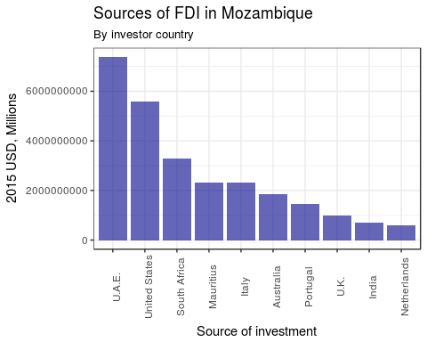

What stands out is the presence of many "non-Western" countries in the top 10. Though reliable data only go as far back as 2009, the landscape of investment 20 years prior would have been both (a) far smaller and (b) primarily composed of western countries, especially given that Mozambique emerged so late from civil war (1994). Though as of 2015, China did not figure in the top 10 FDI countries in Mozambique, its upward trend is notable, with approximately 1.5 million USD invested in 2010 to nearly 100 million by 2015 (a 60-fold increase).

### Massive increase in FDI

Following independence (1974), Mozambique saw two decades of low and unsteady foreign investment, largely due to the civil war (which did not end until 1992). Thereafter, foreign investment began a steady increase but leveled off by the late 1990s. However, the discovery of novel sources of oil and gas set off a new spur of investments beginning in 2007, and continuing through last year. From 2010 to 2013, foreign direct investment grew from 1.26 to 6.70 billion USD, a more than five-fold increase (WB 2015).

In addition to the discovery of new resources, recent growth has also been fueled by political and economic reforms which have made it easier for foreigners to do business in Mozambique. Of particular note, inflation remained relatively low (at least through 2014) (Bundesbank 2015).

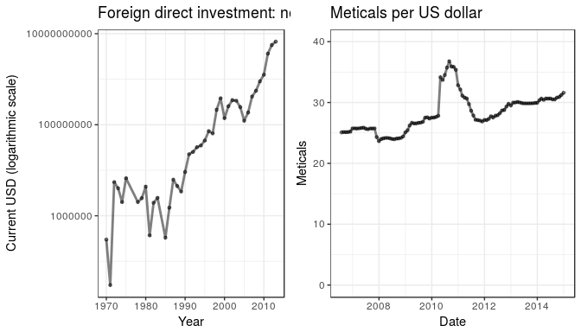

The massive increases in FDI have also been facilitated by dramatic decreases in the costs to import and export, as well as the costs of starting a business and registering property (WB 2016).

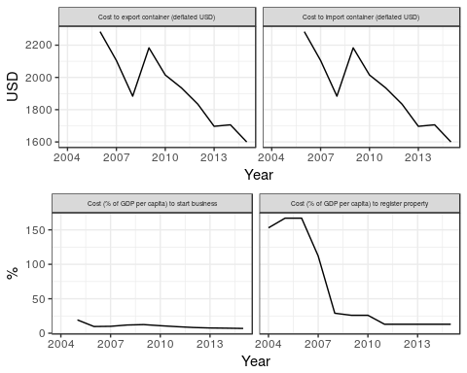

### Breakdown by industry

Most of recent growth has come in the "extractive" industries, a term encompassing a range of industry, but in the Mozambican context largely applying to hydrocarbons and mining (INE 2015).

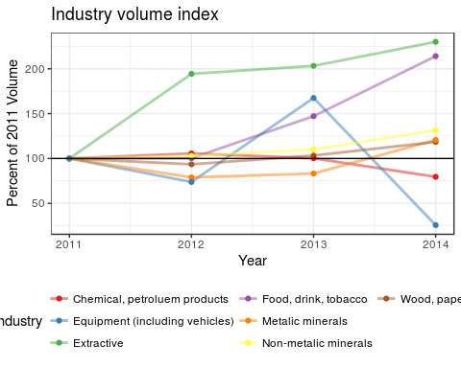

The late 2015 economic slow-down in the developing world, particularly the low price of oil, could have serious repercussions for FDI in Mozambique. That said, the mining of metals and the service industries both make up a larger share of Mozambique's economic output than the extraction of hydrocarbons, which should somewhat buffer the Mozambican economy from the negative effects of low oil prices.

### Breakdown by region

Despite the concentration of private investment in regional projects, growth has been similarly large in all provinces From 2000 to 2009, GDP approximately doubled, with the greatest growth occurring in Inhambane (119% growth from 2000 to 2009), and the least robust grwoth in Nampula (95%) (Knoema 2015).

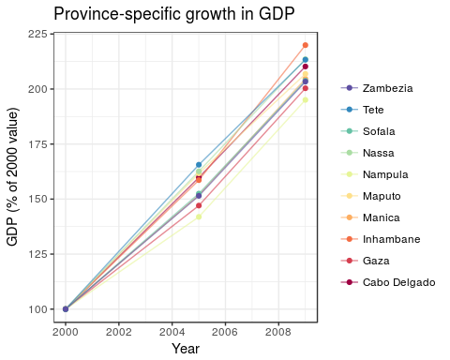

The homogeneity in growth comes somewhat as a surprise, as it defies the general developing world pattern in that growth in areas that already had high GDP (Maputo and the coastal provinces) was as robust as growth in areas with previously low GDP.

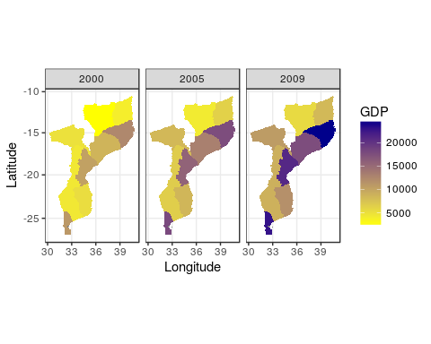

FDI is associated with CSR. Whether under the guise of CSR or not, it is noteworthy that the private sector currently does play a role in malaria control activities. According to 2011 DHS data, greater than 7 in every 1,000 households had a private company carry out indoor residual spraying (DHS 2011). And, in some clusters, the percent of houses covered by private IRS was greater than 25%.

Interestingly, though the UN data indicated that corporations don't actively engage in malaria control as part of CSR, the geographic distribution of households which had their homes sprayed by a private entity are clustered in areas where foreign firms operate, particularly in the south (around Maputo) in the East, where extractive industry activity is highest.

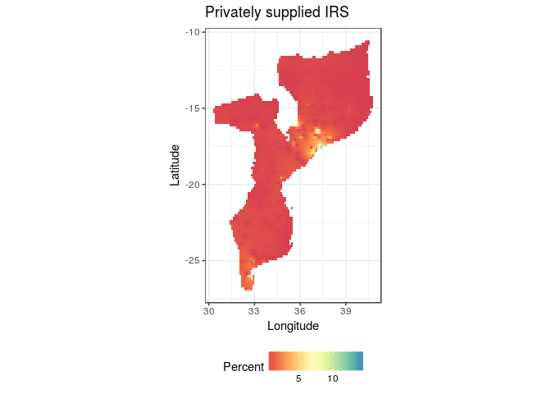

## Systematic review

### Grey literature

#### Grey literature search strategy

We devised 2 simple search queries, and use www.google.com and www.bing.com to retrieve results. The queries were:

1. Mozambique foreign direct investment malaria
2. Mozambique corporate social responsibility malaria

#### Grey literature search results

Google returned 266,000 results for the former query, and 240,000 for the latter (506,000 in total); Bing returned 4,620 and 20,900, respectively. We screened the top 50 results from both services (a total of 100 items) for both queries For the former, of the 100 items identified, 33 were identical in both search engines (yielding a total of 67 unique items); in the latter, 39 were identical (yielding a total of 61 unique items).

#### Grey literature synthesis

Our grey literature review returned relatively little information which was not readily available in those sources uncovered in the data review and systematic review. Very few foreign companies operating in Mozambique have any publicly available information regarding corporate social responsibility activities.

Corporate social responsibility in Mozambique is new in nomenclature, but activities which could be classified as CSR have existed for decades. The number of firms actively engaging in CSR cannot be ascertained (given the large and ever-changing number of small businesses), but virtually all of the largest firms, both foreign and domestic, have a CSR component.

Firms with CSR activities are often large and foreign. Among the largest "key players" in Mozambican CSR are Coca-Cola, British Petroleum and Colgate-Palmolive. State conglomerates, such as Águas de Moçambique and Electricidade de Moçambique, also participate in CSR activities (Compact 2007). Large communications firms, such as Vodacom and MCEL, and banks (BIM and BCI) have a CSR component, but generally focus on culture, environment and sport, avoiding activities which could either complement or conflict with the health sector (Kaufmann and Simons-Kaufmann 2015).

Among major foreign companies, those operating in extraction - particularly mining - appear to be the most involved with malaria. BHP Billiton has been active in vector control support to the governments of Mozambique, Swaziland, and South Africa, particularly in the early 2000s (BHP 2014). Kropfmuhl AG and Vale, also mining companies, have carried out CSR related to both community development and malaria control in Northern Mozambique (Kaufmann and Simons-Kaufmann 2015).

Most CSR-funded activities are focused on education, community development, women's rights and entrepreneurship. According to a UN poll, none of the country's largest firms invest directly in malaria-related CSR activities (Compact 2007). That said, a majority of the firms interviewed by the UN indicated that one of the principal reasons for investment in CSR is to complement government efforts. To the extent that malaria accounts for more of the loss in disability-adjusted life years in Mozambique than comparable countries (IHME 2015), malaria control's lack of representation among core CSR activities is a notable absence. One important exception is the Nando's-lead Goodbye Malaria Trust, an umbrella organization which inclues a development impact bond, the Goodbye Malaria initiative, and partnerships with several other foreign firms operating in Mozambique.

### Academic literature

Our search is outlined in the below PRISMA-based diagram.

The below table shows the results retrieved for the systematic review. Full article information is in the bibliography

The below chart shows our systematically retried publications by date. What is most striking is how little academic attention has been given to CSR, with none given to the intersection of CSR and malaria.

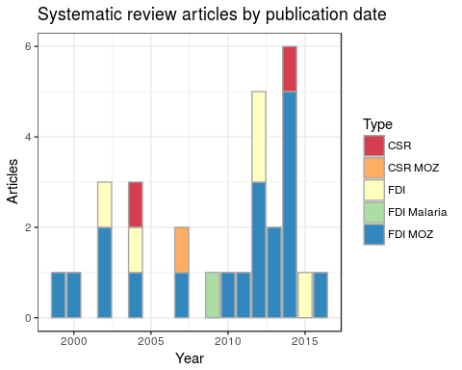

### Qualitative synthesis of systematic review of academic literature

The literature is largely clear on two points: (1) that economic growth in Mozambique has been fueled in large part by foreign direct investment, and (2) that economic growth has been accompanied by a rapid decrease in malaria morbidity and mortality. There is no clear consensus regarding the extent to which the former is a result of the latter, and researchers disagree on how much of a role FDI has played in improving the social and economic conditions of Mozambicans.

Mozambique has a unique social and economic system, which is particularly attractive to foreign investment. The Mozambican economy is "oriented to incentivize large-scale FDI projects" (Robbins and Perkins 2012). Land distribution, for example, despite being igualitarian *de juro* has been *de facto* aimed at satisfying the interests of large foreign firms (German, Schoneveld, and Mwangi 2013). In extractive industries, and particular the sugar industry, the state has gone so far as to encourage unprofitable entreprise by propping up an internal market so as to keep foreign inflows of cash from drying out, a process described as a "mediating bureaucracy" (Buur, Tembe, and Baloi 2012). Another part of the attraction of FDI to Mozambique is the extent to which the state and society, both formally and informally, subsidize the cost of labor by allowing for below subsistence wages.

In one view, the last two decades of economic growth are largely irrelevant to the well-being of Mozambicans due to the "porous and extractive" nature of FDI (Castel-Branco 2014). In other words, since both investment and profit are largely external to the Mozambican economy and society, "positive spillovers" into local firms are few and far between (Winkler 2013).

CSR is one way of offsetting the trend, and its potential for mutually beneficial effects is high, particularly when its resources target malaria control. Per one analysis, malaria elimination in an endemic country like Mozambique would lead to a 16% increase in FDI (Azemar and Desbordes 2009). The possibility of re-directing resource rents to socially beneficial ends is acknolwedged by multiple authors (Robbins and Perkins 2012, Castel-Branco (2014)).

However, the re-direction or resource rents to CSR is complicated. If coerced (through higher taxes or fewer incentives to investment), the recent decrease in FDI may be exacerbated. If voluntary, particularly in the case of expenditures in medicine and health, the public's health would be largely dependent on private whim, a recipe for unsustainability at best and potential epidemiologic catastrophe at worst.

In summary, Mozambique's high ratio of FDI to GDP and general allowance of "porous" foreign investment represents an opportunity for scaling up the private sector's engagement with public health, as a means to offset the lack of social benefits that traditional FDI has entailed. A coercive (tax-based) approach to scaling up this engagement may lead to a withdrawl of FDI from the country. The alternative, an increase in CSR, is a possible route for creating synergies, particular in the case of malaria elimination.

# Discussion

The intensity of CSR activity seems to closely track FDI, but generally avoids malaria control. The few malaria-related CSR projects in recent years has come in large, "mega-projects" whose well-publicized malaria abatement activities are profit-driven (Mouzin and al. 2011) or whose primary aim is not profit-related (Han 2015). Though the former is often portrayed as a "win-win" for business and public health, the latter also offers tangible benefits for private industry, and should be understood as operating under the same conditions and with the same motivations. To the extent that most CSR activity has avoided the health sector (including malaria) in favor of cultural, environmental, education and more general "development" activities, it is reasonable to assume that this may be due to the perceived costs of malaria control, lack of perceived PR benefits, the government and NGO's predominant role in the area, as well as the "opt-in" nature and privacy/legal issues generally related to engaging in health-related campaigns.

## Scaling up malaria control through CSR: opportunity and risk

### Opportunity

The historical absence of malaria-related CSR represents an opportunity for complementarity. In addition to improvements in public health, both the private and public sectors stand to benefit economically from a scaling up of malaria control driven by the private sector. By increasing malaria control activities, as a share of total CSR expenditures, public funds could be redirected towards other areas of health. Likewise, if private CSR activities pivoted towards malaria control rather more general philanthropical gestures, CSR would have a more direct impact on wellbeing (with less temporal lag), thereby fulfilling the public relations goals of the firms that invest in CSR. Finally, for many industries, the firm itself is a potential direct beneficiary, given that improvements in employee health and a reduction in employee absenteeism can be directly correlated to productivity.

### Risk

Scaling up CSR while also encouraging its redirection towards malaria control is not without risks. The most notable downfall of this approach is the potential for the inadvertent dependence on the private sector for what is essentially a public good. Were CSR targeting malaria control to reach significant levels (and the government were to enact a correspoding redirection of funds towards the financing of other health areas), then a situation would be created in which the public sector had essentially divested from a public good. This would be unwise and dangerous.

A secondary risk is that increased private sector involvement in malaria control could cause a decrease in public sector *competence* in the prevention and treatment of malaria. This could have negative consequences in the case of either a financial or economic crisis (in which CSR activity would be curtailed) or an increase in malarial activity. By the same token, CSR involvement in malaria control could potentially portend, at least initially, less effective interventions. Private firms' incentives, though aligned with the public's in terms of malaria, are not identical, and pressures from shareholders and for positive public perception might motivate malaria control strategies which do not necessarily carry with them the most recent scientific knowledge.

A third risk is a lack of coordination. Both in terms of logistical activities as well as biological realities (drug and insecticide resistance, etc.), coordination of malaria control activities is absolutely essentially if Mozambique is going to make the transition to eradication. The issue of coordination could be solved through an activities and outcomes reporting/surveillance structure (necessarily managed by the state), but compliance could be problematic.

A final risk is that of volatility. By centralizing malaria control under the auspices of the government, public health authorities can effectively distribute malaria control expenditures to where and when they are most needed. If this control were only in the hands of private firms, expenditure would likely transform into a function of firm-specific profitability and shareholder incentives, as well as market cycles. This could lead to a situation in which malaria control activities are most prevalent in areas where the economy is strongest, rather than areas where the need is greatest.

# Conclusion

High FDI in Mozambique and growing interest in CSR both call for increased reflection on the private sector's role in the delivery of public goods. A refocusing of CSR expenditures into areas where the need is greatest (specifically, malaria control) could lead to better health and greater profits. This "win-win" for the public and private sectors represents a rare opportunity, which deserves more discourse, research and experimentation.

That said, the growing interest in CSR suggests both that (a) the need for services exist and (b) that corporations (especially foreign firms) have enough excess capital to finance these services. Both of these factors suggest the need for a better-fitting taxation rate, and a more efficient delivery of public services. That said, in the short-term, increasing the efficiency and effectiveness of CSR activity through a re-pivoting towards malaria control should remain a goal.

# References

Adams, Jean, Frances C. Hillier-Brown, Helen J. Moore, Amelia A. Lake, Vera Araujo-Soares, Martin White, and Carolyn Summerbell. 2016. “Searching and Synthesising ‘Grey Literature’ and ‘Grey Information’ in Public Health: Critical Reflections on Three Case Studies.” *Systematic Reviews* 5 (1). Springer Nature. doi:[10.1186/s13643-016-0337-y](https://doi.org/10.1186/s13643-016-0337-y).

Alfaro, Laura, Areendam Chanda, Sebnem Kalemli-Ozcan, and Selin Sayek. 2006. “How Does Foreign Direct Investment Promote Economic Growth? Exploring the Effects of Financial Markets on Linkages,” September. National Bureau of Economic Research. doi:[10.3386/w12522](https://doi.org/10.3386/w12522).

Almfraji, Mohammad Amin, and Mahmoud Khalid Almsafir. 2014. “Foreign Direct Investment and Economic Growth Literature Review from 1994 to 2012.” *Procedia - Social and Behavioral Sciences* 129 (May). Elsevier BV: 206–13. doi:[10.1016/j.sbspro.2014.03.668](https://doi.org/10.1016/j.sbspro.2014.03.668).

Asante, Kwaku P, Charles Zandoh, Dominic B Dery, Charles Brown, George Adjei, Yaw Antwi-Dadzie, Martin Adjuik, et al. 2011. “Malaria Epidemiology in the Ahafo Area of Ghana.” *Malaria Journal* 10 (1). Springer Nature: 211. doi:[10.1186/1475-2875-10-211](https://doi.org/10.1186/1475-2875-10-211).

Azemar, C., and R. Desbordes. 2009. “Public Governance, Health and Foreign Direct Investment in Sub-Saharan Africa.” *Journal of African Economies* 18 (4). Oxford University Press (OUP): 667–709. doi:[10.1093/jae/ejn028](https://doi.org/10.1093/jae/ejn028).

BHP. 2014. “BHP Billiton Case Study: Malaria.” <https://www.bhp.com/-/media/bhp/documents/investors/reports/2004/norvatispresentation.pdf>.

Blonigen, Bruce, and Cheyney O’Fallon. 2011. “Foreign Firms and Local Communities.” Working Paper 17282. Working Paper Series. National Bureau of Economic Research. doi:[10.3386/w17282](https://doi.org/10.3386/w17282).

Bloom, David, and David Canning. 2008. “Population Health and Economic Growth,” 1–25.

Brundtland, Gro Harlem. 1999. “WHO on Health and Economic Productivity” 25 (2): 396–402.

Bundesbank. 2015. “Exchange Rates for the Us Dollar in Mozambique / Usd 1 = Mzn.” <https://www.quandl.com/data/BUNDESBANK/BBEX3_M_MZN_USD_CA_AC_A01>.

Burns, Darren K., Andrew P. Jones, Yevgeniy Goryakin, and Marc Suhrcke. 2017. “Is Foreign Direct Investment Good for Health in Low and Middle Income Countries? An Instrumental Variable Approach.” *Social Science & Medicine* 181 (May). Elsevier BV: 74–82. doi:[10.1016/j.socscimed.2017.03.054](https://doi.org/10.1016/j.socscimed.2017.03.054).

Buur, Lars, Carlota Mondlane Tembe, and Obede Baloi. 2012. “The White Gold: The Role of Government and State in Rehabilitating the Sugar Industry in Mozambique.” *Journal of Development Studies* 48 (3). Informa UK Limited: 349–62. doi:[10.1080/00220388.2011.635200](https://doi.org/10.1080/00220388.2011.635200).

Castel-Branco, Carlos Nuno. 2014. “Growth, Capital Accumulation and Economic Porosity in Mozambique: Social Losses, Private Gains.” *Review of African Political Economy* 41 (sup1). Informa UK Limited: S26–S48. doi:[10.1080/03056244.2014.976363](https://doi.org/10.1080/03056244.2014.976363).

Compact, U N Global. 2007. “Corporate Social Responsibility: Country Report Mozambique.” <http://www.undp.org/content/dam/mozambique/docs/Poverty/UNDP>.

DHS. 2011. “USAID.” <http://dhsprogram.com/what-we-do/survey/survey-display-362.cfm>.

Economist. 2017. “Mozambique’s Default: Mozambique Fails to Pay Its Debts.” *The Economist*, January. Economist. <https://www.economist.com/news/middle-east-and-africa/21715030-mozambique-fails-pay-its-debts-mozambiques-default>.

Feenstra, Robert, and Gordon Hanson. 1997. “Foreign Direct Investment and Relative Wages: Evidence from Mexico’s Maquiladoras.” *Journal of International Economics* 42 (3-4): 371–93. <https://EconPapers.repec.org/RePEc:eee:inecon:v:42:y:1997:i:3-4:p:371-393>.

Friedman, Milton. 1970. “The Social Responsibility of Business Is to Increase Its Profits.” *Corporate Ethics and Corporate Governance*. Springer Berlin Heidelberg, 173–78. doi:[10.1007/978-3-540-70818-6_14](https://doi.org/10.1007/978-3-540-70818-6_14).

Gadm. 2009. “GADM Database of Global Administrative Areas Version 1.0.”

German, Laura, George Schoneveld, and Esther Mwangi. 2013. “Contemporary Processes of Large-Scale Land Acquisition in Sub-Saharan Africa: Legal Deficiency or Elite Capture of the Rule of Law?” *World Development* 48 (August). Elsevier BV: 1–18. doi:[10.1016/j.worlddev.2013.03.006](https://doi.org/10.1016/j.worlddev.2013.03.006).

Godin, Katelyn, Jackie Stapleton, Sharon I. Kirkpatrick, Rhona M. Hanning, and Scott T. Leatherdale. 2015. “Applying Systematic Review Search Methods to the Grey Literature: A Case Study Examining Guidelines for School-Based Breakfast Programs in Canada.” *Systematic Reviews* 4 (1). Springer Nature. doi:[10.1186/s13643-015-0125-0](https://doi.org/10.1186/s13643-015-0125-0).

González, Raquel, Orvalho J. Augusto, Khátia Munguambe, Charlotte Pierrat, Elpidia N. Pedro, Charfudin Sacoor, Elisa De Lazzari, et al. 2015. “HIV Incidence and Spatial Clustering in a Rural Area of Southern Mozambique.” Edited by Jean KEditor Carr. *PLOS ONE* 10 (7). Public Library of Science (PLoS): e0132053. doi:[10.1371/journal.pone.0132053](https://doi.org/10.1371/journal.pone.0132053).

Han, Lily. 2015. “Malaria in Mozambique: trialling payment by results.” <http://www.theguardian.com/global-development-professionals-network/2014/mar/31/malaria-control-payment-by-results>.

IHME. 2015. “GBD Prifle: Mozambique.” [www.medbox.org/gbd-profile-mozambique/download.pdf](http://www.medbox.org/gbd-profile-mozambique/download.pdf).

IMF. 2003. “International Monetary Fund’s Foreign Direct Investment Trends and Statistics.” <https://www.imf.org/external/np/sta/fdi/eng/2003/102803.htm>.

INE. 2015. “Economic Statistics.” <http://www.ine.gov.mz/>.

———. 2017. “Instituto Nacional de Estatistica.” <http://www.ine.gov.mz/>.

Kaufmann, Friedrich, and Claudia Simons-Kaufmann. 2015. “Corporate Social Responsibility in Mozambique.” *CSR, Sustainability, Ethics & Governance*, December. Springer International Publishing, 31–50. doi:[10.1007/978-3-319-26668-8_2](https://doi.org/10.1007/978-3-319-26668-8_2).

Knoema. 2015. “GDP of Mozambique by Region, Province and Country.” <http://knoema.com/atlas/Mozambique/ranks/GDP-at-Constant-Prices>.

Moonasar, Devanand, Rajendra Maharaj, Simon Kunene, Baltazar Candrinho, Francisco Saute, Nyasatu Ntshalintshali, and Natashia Morris. 2016. “Towards Malaria Elimination in the Mosaswa (Mozambique, South Africa and Swaziland) Region.” *Malaria Journal* 15 (1). Springer Nature. doi:[10.1186/s12936-016-1470-8](https://doi.org/10.1186/s12936-016-1470-8).

Mouzin, Eric, and Et al. 2011. “Business Investing in Malaria Control: Economic Returns and a Healthy Workforce for Africa.” *Progress & Impact Series*, no. 6.

Nonvignon, Justice, Genevieve Cecilia Aryeetey, Keziah L. Malm, Samuel Agyei Agyemang, Vivian N. A. Aubyn, Nana Yaw Peprah, Constance N. Bart-Plange, and Moses Aikins. 2016. “Economic Burden of Malaria on Businesses in Ghana: A Case for Private Sector Investment in Malaria Control.” *Malaria Journal* 15 (1). Springer Nature. doi:[10.1186/s12936-016-1506-0](https://doi.org/10.1186/s12936-016-1506-0).

Ortega, María Isabel, Samantha Sabo, Patricia Aranda Gallegos, Jill Eileen Guernsey De Zapien, Antonio Zapien, Gloria Elena Portillo Abril, and Cecilia Rosales. 2016. “Agribusiness, Corporate Social Responsibility, and Health of Agricultural Migrant Workers.” *Frontiers in Public Health* 4 (March). Frontiers Media SA. doi:[10.3389/fpubh.2016.00054](https://doi.org/10.3389/fpubh.2016.00054).

Pazienza, Pasquale. 2015. “The Relationship Between Co2 and Foreign Direct Investment in the Agriculture and Fishing Sector of Oecd Countries: Evidence and Policy Considerations.” *Intellectual Economics* 9 (1). Elsevier BV: 55–66. doi:[10.1016/j.intele.2015.08.001](https://doi.org/10.1016/j.intele.2015.08.001).

Pfeiffer, James, Sarah Gimbel, Baltazar Chilundo, Stephen Gloyd, Rachel Chapman, and Kenneth Sherr. 2017. “Austerity and the ‘Sector-Wide Approach’ to Health: The Mozambique Experience.” *Social Science & Medicine* 187 (August). Elsevier BV: 208–16. doi:[10.1016/j.socscimed.2017.05.008](https://doi.org/10.1016/j.socscimed.2017.05.008).

Porter, KE, and MR Kramer. 2002. “The Competitive Advantage of Corporate Philanthropy.” *Harvard Business Review*, no. 80. Harvard University Press. doi:[10.1186/s12936-016-1506-0](https://doi.org/10.1186/s12936-016-1506-0).

Robbins, Glen, and David Perkins. 2012. “MINING FDI AND INFRASTRUCTURE DEVELOPMENT ON AFRICAS EAST COAST: EXAMINING THE RECENT EXPERIENCE OF TANZANIA AND MOZAMBIQUE.” *Journal of International Development* 24 (2). Wiley-Blackwell: 220–36. doi:[10.1002/jid.2817](https://doi.org/10.1002/jid.2817).

Rogers, Lina. 2014. “Natural resources boom sustaining growth in Mozambique.” <http://www.abo.net/oilportal/topic/view.do?contentId=2195109>.

Selaya, Pablo, and Eva Rytter Sunesen. 2012. “Does Foreign Aid Increase Foreign Direct Investment?” *World Development* 40 (11). Elsevier BV: 2155–76. doi:[10.1016/j.worlddev.2012.06.001](https://doi.org/10.1016/j.worlddev.2012.06.001).

Shahbaz, Muhammad, Samia Nasreen, Faisal Abbas, and Omri Anis. 2015. “Does Foreign Direct Investment Impede Environmental Quality in High-, Middle-, and Low-Income Countries?” *Energy Economics* 51 (September). Elsevier BV: 275–87. doi:[10.1016/j.eneco.2015.06.014](https://doi.org/10.1016/j.eneco.2015.06.014).

Sheela, A.M., A. Ghermandi, P. Vineetha, R.V. Sheeja, J. Justus, and K. Ajayakrishna. 2017. “Assessment of Relation of Land Use Characteristics with Vector-Borne Diseases in Tropical Areas.” *Land Use Policy* 63 (April). Elsevier BV: 369–80. doi:[10.1016/j.landusepol.2017.01.047](https://doi.org/10.1016/j.landusepol.2017.01.047).

Sutton, John. 2014. *MAPA Empresarial de Moçambique*. International Growth Centre. <http://personal.lse.ac.uk/sutton/mozambique_portuguese_edn_updated_version_web.pdf>.

UNCTAD. 2012. *Investment Policy Review: Mozambique*. United Nations.

WB. 2015. “Foreign Direct Investment, Net Inflows (Bop, Current Us$).” <http://data.worldbank.org/indicator/BX.KLT.DINV.CD.WD>.

———. 2016. *Doing Business 2016: Measuring Regulatory Quality and Efficiency*. World Bank. [http://www.doingbusiness.org/~/media/GIAWB/Doing%20Business/Documents/Annual-Reports/English/DB16-Chapters/DB16-Mini-Book.pdf](http://www.doingbusiness.org/~/media/GIAWB/Doing Business/Documents/Annual-Reports/English/DB16-Chapters/DB16-Mini-Book.pdf).

———. 2017. “World Bank Open Data.” <https://data.worldbank.org/>.

White, Nicholas J, Sasithon Pukrittayakamee, Tran Tinh Hien, M Abul Faiz, Olugbenga A Mokuolu, and Arjen M Dondorp. 2014. “Malaria.” *The Lancet* 383 (9918). Elsevier BV: 723–35. doi:[10.1016/s0140-6736(13)60024-0](https://doi.org/10.1016/s0140-6736(13)60024-0).

WHO. 2016. “World Malaria Report.” <http://apps.who.int/iris/bitstream/10665/252038/1/9789241511711-eng.pdf?ua=1>.

Williams, Brian G., Eleanor Gouws, Pierre Somse, Mpho Mmelesi, Chibwe Lwamba, Trouble Chikoko, Erika Fazito, et al. 2015. “Epidemiological Trends for Hiv in Southern Africa: Implications for Reaching the Elimination Targets.” *Current HIV/AIDS Reports* 12 (2). Springer Nature: 196–206. doi:[10.1007/s11904-015-0264-x](https://doi.org/10.1007/s11904-015-0264-x).

Winkler, Deborah. 2013. “Potential and Actual FDI Spillovers in Global Value Chains.”

Zhu, Yan, Li-Yun Sun, and Alicia S. M. Leung. 2013. “Corporate Social Responsibility, Firm Reputation, and Firm Performance: The Role of Ethical Leadership.” *Asia Pacific Journal of Management* 31 (4). Springer Nature: 925–47. doi:[10.1007/s10490-013-9369-1](https://doi.org/10.1007/s10490-013-9369-1).