Foreign direct investment, corporate social responsibility, and malaria control in Mozambique - trends, risks, and opportunities

April 5, 2017

## Abstract

Foreign direct investment (FDI) in Mozambique has increased rapidly in the last two decades. The growing interest in corporate social responsibility (CSR) - combined with a recent push for malaria elimination - suggest the need for a critical examination of the role of FDI in malaria control and elimination. Through a systematic review of the literature, we find that there has been a notable increase in research pertaining to FDI, CSR and malaria in recent years. Consensus among researchers is that this increase has not been accompanied by a substantial private sector investment in malaria control (with a few notable exceptions). This suggests a potential opportunity for scaling up privately driven malaria control as a means to both improve public health and increase return on investment. However, given the lack of coordination between public and private sectors, even when interests coincide, an over-reliance on foreign and private initiative for funding eradication is not without risks.

## Introduction

Mozabique's recent economic growth has been facilitated by the government's open policy towards foreign investment, a plentiful supply of natural resources (particularly minerals and hydrocarbons) (Rogers 2014) and relatively inexpensive labor. Improvements in health have accompanied economic expansion, but Mozambique still lags behind in basic health outcomes - particularly those related to malaria - even by regional standards. Most economic activities have to deal with malaria: particularly agricultural-based and extraction activities cannot be carried out without consistent investment towards malaria management, both prevention and prompt treatment. This can be done as part of the “normal activities” of private sector or can go slightly beyond what is strictly needed for the activities and be seen as part of the corporate social responsibilityDespite strong evidence showing that improved health yields substantial economic benefits (Brundtland 1999, Bloom and Canning (2008)), there is little evidence regarding the extent to which "corporate social responsibility" (CSR) activities of foreign firms have targeted or impacted malaria. Understanding the relationship between FDI, CSR and malaria is essential to identifying which incentives and barriers to private sector involvement in malaria elimination exist, as well as identifying potential opportunities and synergies for scaling up private sector involvment in malaria elimination.

That said, The few malaria-related CSR projects in recent years has come in large, "mega-projects" whose well-publicized malaria abatement activities are profit-driven (Mouzin and al. 2011) or whose primary aim is not profit-related (Han 2015). Though the former is often portrayed as a "win-win" for business and public health, the latter also offers tangible benefits for private industry, and should be understood as operating under the same conditions and with the same motivations.

Private foreign investors showed a great optimism during the FMI meeting held in Maputo in 2014 (reference needed). Beginning in late 2015, the flood of FDI into Mozambique (and many other subsaharan African nations) slowed to a trickle. The impact of this slowdown on CSR is not yet known, but it can reasonably be assumed that it will mean a reduction in CSR activities (albeit with lag). Almost in parallel to this, Mozambique has had serious financial problems which have resulted in default (reference needed <http://www.economist.com/news/middleeast-and-africa/21715030-mozambique-fails-pay-its-debtsmozambiques-default>). Given the rapidly changing economic and epidemiologic context in Mozambique, a comprehensive and current understanding of both (a) the landscape of FDI and CSR in Mozambique and (b) public health issues (namely, malaria control) which are directly affected those investments is sorely needed. Such an understanding may foster greater private interest in for-profit investment in public health measures. Likewise, it can facilitate better public sector understanding of potential industry partners and stakeholders (a prerequisite to greater public-private collaborations), and guide the public sector away from an inflexible dependence on FDI for the provision of public health necessities.

We carried out a systematic review of economic and public health research pertaining to FDI, CSR, malaria and Mozambique. This paper gives an overview of trends in FDI and CSR in Mozambique as well as a synthesis of academic literature on the topic, with a focus on its impact on malaria control. It is by no means comprehensive, but offers a consolidated starting point for understanding both the place of FDI and CSR in the literature, as well as where the interests and incentives of the public and private sectors converge and differ in regards to malaria control.

# Methods

We sought to identify and describe sources of information regarding FDI and CSR in Mozambique, particularly in regards to malaria control and elimination. We carried out this identification process via 2 distinct approaches to understanding FDI, CSR and malaria in Mozambique:

1. Identification and analysis of quantitative datasets.
2. Systematic review of both grey literature (news, company websites, etc.) and academic literature.

## Quantitative datasets

We examined and analyzed trends from multiple datasets related to FDI, CSR and malaria in Mozambique. These included the "Doing Business" data pertaining to the measurement of regulatory efficiency, the GADM, the Deutsche Bundesbank Data Repository for foreign exchange rate history, the Knoema World Data Atlas for macroeconomic trends, the World Bank data portal for information containing to net foreign inflows and FDI, USAID Demographic and Health Survey data on sociodemographics and health-related practices, the Instituto Nacional de Estatistica for granular data pertaining to Mozambique's population and economic activities, and Institute for Health Metrics and Evaluation data pertaining to disease trends over time.

## Systematic review

### Grey literature

Our grey literature review followed known practices (Godin et al. 2015, Adams et al. (2016)), relying on internet searches and linked references. Sources include, but are not limited to UN reports on economic trends, WHO reports and brochures pertaining to health trends, company websites and brochures, newspaper articles, and think-tank white papers.

### Academic literature

In order to gauge research attention and focus on FDI and CSR insofar as they affect Mozambique and malaria, four systematic searches were carried out using the EBSCOhost and NCBI/pubmed databases. Our search queries are detailed below:

1. "(malaria) and (corporate social responsibility)" (no results found in EBSCO)
2. "(malaria) and (foreign direct investment)"
3. "(mozambique) and (corporate social responsibility)" (no resuts found in EBSCO)
4. "(mozambique) and (foreign direct investment)"

# Results

## Quantitiative datasets pertaining to FDI and CSR in Mozambique

### Massive increase in FDI

Following independence (1974), Mozambique saw two decades of low and unsteady foreign investment, largely due to the civil war (which did not end until 1992). Thereafter, foreign investment began a steady increase but leveled off by the late 1990s. However, the discovery of novel sources of oil and gas set off a new spur of investments beginning in 2007, and continuing through last year. From 2010 to 2013, foreign direct investment grew from 1.26 to 6.70 billion USD, a more than five-fold increase (WB 2015).

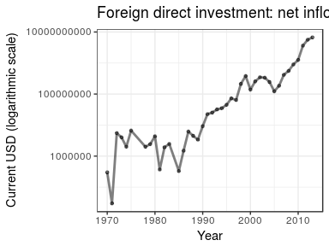

In addition to the discovery of new resources, recent growth has also been fueled by political and economic reforms which have made it easier for foreigners to do business in Mozambique. Of particular note, inflation remained relatively low (at least through 2014) (Bundesbank 2015).

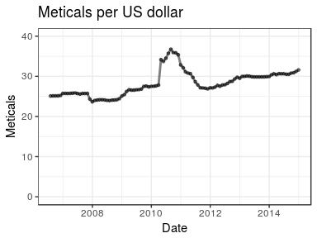

The massive increases in FDI have also been facilitated by dramatic decreases in the costs to import and export, as well as the costs of starting a business and registering property (Bank 2016).

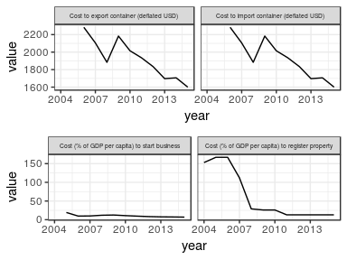

### Breakdown by industry

Most of recent growth has come in the "extractive" industries, a term encompassing a range of industry, but in the Mozambican context largely applying to hydrocarbons and mining (INE 2015).

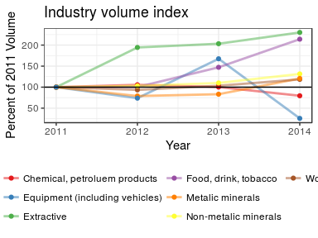

The late 2015 economic slow-down in the developing world, particularly the low price of oil, could have serious repercussions for FDI in Mozambique. That said, the mining of metals and the service industries both make up a larger share of Mozambique's economic output than the extraction of hydrocarbons, which should somewhat buffer the Mozambican economy from the negative effects of low oil prices.

### Breakdown by region

Despite the concentration of private investment in regional projects, growth has been similarly large in all provinces From 2000 to 2009, GDP approximately doubled, with the greatest growth occurring in Inhambane (119% growth from 2000 to 2009), and the least robust grwoth in Nampula (95%) (Knoema 2015).

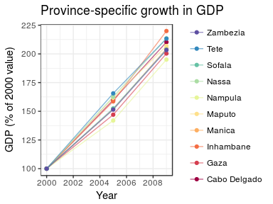

The homogeneity in growth comes somewhat as a surprise, as it defies the general developing world pattern in that growth in areas that already had high GDP (Maputo and the coastal provinces) was as robust as growth in areas with previously low GDP.

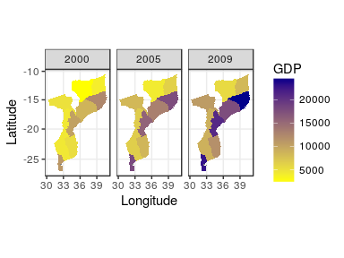

### CSR in Mozambique

Corporate social responsibility in Mozambique is new in nomenclature, but activities which could be classified as CSR have existed for decades. The number of firms actively engaging in CSR cannot be ascertained (given the large and ever-changing number of small businesses), but virtually all of the largest firms, both foreign and domestic, have a CSR component.

Firms with CSR activities are often large and foreign. Among the largest "key players" in Mozambican CSR are Coca-Cola, British Petroleum and Colgate-Palmolive. State conglomerates, such as Águas de Moçambique and Electricidade de Moçambique, also participate in CSR activities (Compact 2007).

### Malaria-related CSR and other corporate activity

Most CSR-funded activities are focused on education, community development, women's rights and entrepreneurship. According to a UN poll, none of the country's largest firms invest directly in malaria-related CSR activities (Compact 2007). This may be due to the perceived costs of malaria control, lack of perceived PR benefits, the government and NGO's predominant role in the area, as well as the "opt-in" nature and privacy/legal issues generally related to engaging in health-related campaigns.

That said, a majority of the firms interviewed by the UN indicated that one of the principal reasons for investment in CSR is to complement government efforts. To the extent that malaria accounts for more of the loss in disability-adjusted life years in Mozambique than comparable countries (IHME 2015), malaria control's lack of representation among core CSR activities is a notable absence.

Whether under the guise of CSR or not, it is noteworthy that the private sector currently does play a role in malaria control activities. According to 2011 DHS data, greater than 7 in every 1,000 households had a private company carry out indoor residual spraying (DHS 2011). And, in some clusters, the percent of houses covered by private IRS was greater than 25%.

Interestingly, though the UN data indicated that corporations don't actively engage in malaria control as part of CSR, the geographic distribution of households which had their homes sprayed by a private entity are clustered in areas where foreign firms operate, particularly in the south (around Maputo) in the East, where extractive industry activity is highest.

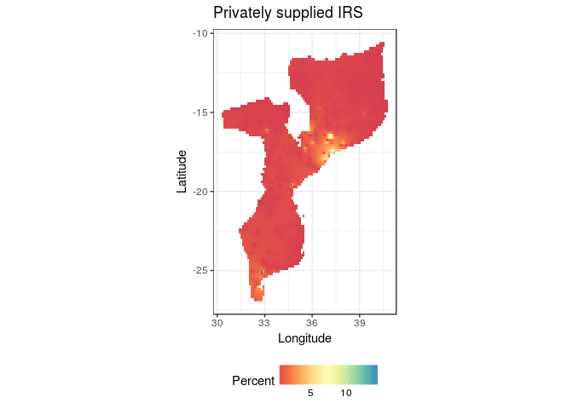

## Systematic review

### Grey literature

#### Grey literature search strategy

We devised 2 simple search queries, and use www.google.com and www.bing.com to retrieve results. The queries were:

1. Mozambique foreign direct investment malaria
2. Mozambique corporate social responsibility malaria

#### Grey literature search results

Google returned 266,000 results for the former query, and 240,000 for the latter (506,000 in total); Bing returned 4,620 and 20,900, respectively. We screened the top 50 results from both services (a total of 100 items) for both queries For the former, of the 100 items identified, 33 were identical in both search engines (yielding a total of 67 unique items); in the latter, 39 were identical (yielding a total of 61 unique items).

#### Grey literature synthesis

Our grey literature review returned relatively little information which was not readily available in those sources uncovered in the data review and systematic review. Very few foreign companies operating in Mozambique have any publicly available information regarding corporate social responsibility activities.

One notable exception is the Nando's-lead Goodbye Malaria Trust, an umbrella organization which inclues a development impact bond, the Goodbye Malaria initiative, and partnerships with several other foreign firms operating in Mozambique (more details here).

### Academic literature

Our search is outlined in the below PRISMA-based diagram.

The below table shows the results retrieved for the systematic review. Full article information is in the bibliography

The below chart shows our systematically retried publications by date. What is most striking is how little academic attention has been given to CSR, with none given to the intersection of CSR and malaria.

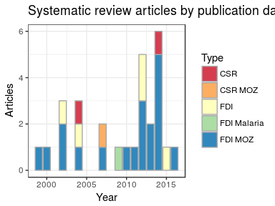

### Qualitative synthesis of systematic review of academic literature

The literature is largely clear on two points: (1) that economic growth in Mozambique has been fueled in large part by foreign direct investment, and (2) that economic growth has been accompanied by a rapid decrease in malaria morbidity and mortality. There is no clear consensus regarding the extent to which the former is a result of the latter, and researchers disagree on how much of a role FDI has played in improving the social and economic conditions of Mozambicans.

Mozambique has a unique social and economic system, which is particularly attractive to foreign investment. The Mozambican economy is "oriented to incentivize large-scale FDI projects" (Robbins and Perkins 2012). Land distribution, for example, despite being igualitarian *de juro* has been *de facto* aimed at satisfying the interests of large foreign firms (German, Schoneveld, and Mwangi 2013). In extractive industries, and particular the sugar industry, the state has gone so far as to encourage unprofitable entreprise by propping up an internal market so as to keep foreign inflows of cash from drying out, a process described as a "mediating bureaucracy" (Buur, Tembe, and Baloi 2012). Another part of the attraction of FDI to Mozambique is the extent to which the state and society, both formally and informally, subsidize the cost of labor by allowing for below subsistence wages.

In one view, the last two decades of economic growth are largely irrelevant to the well-being of Mozambicans due to the "porous and extractive" nature of FDI (Castel-Branco 2014). In other words, since both investment and profit are largely external to the Mozambican economy and society, "positive spillovers" into local firms are few and far between (Winkler 2013).

CSR is one way of offsetting the trend, and its potential for mutually beneficial effects is high, particularly when its resources target malaria control. Per one analysis, malaria elimination in an endemic country like Mozambique would lead to a 16% increase in FDI (Azemar and Desbordes 2009). The possibility of re-directing resource rents to socially beneficial ends is acknolwedged by multiple authors (Robbins and Perkins 2012, Castel-Branco (2014)).

However, the re-direction or resource rents to CSR is complicated. If coerced (through higher taxes or fewer incentives to investment), the recent decrease in FDI may be exacerbated. If voluntary, particularly in the case of expenditures in medicine and health, the public's health would be largely dependent on private whim, a recipe for unsustainability at best and potential epidemiologic catastrophe at worst.

In summary, Mozambique's high ratio of FDI to GDP and general allowance of "porous" foreign investment represents an opportunity for scaling up the private sector's engagement with public health, as a means to offset the lack of social benefits that traditional FDI has entailed. A coercive (tax-based) approach to scaling up this engagement may lead to a withdrawl of FDI from the country. The alternative, an increase in CSR, is a possible route for creating synergies, particular in the case of malaria elimination.

# Discussion

## Scaling up malaria control through CSR: opportunity and risk

### Opportunity

The historical absence of malaria-related CSR represents an opportunity for complementarity. In addition to improvements in public health, both the private and public sectors stand to benefit economically from a scaling up of malaria control driven by the private sector. By increasing malaria control activities, as a share of total CSR expenditures, public funds could be redirected towards other areas of health. Likewise, if private CSR activities pivoted towards malaria control rather more general philanthropical gestures, CSR would have a more direct impact on wellbeing (with less temporal lag), thereby fulfilling the public relations goals of the firms that invest in CSR. Finally, for many industries, the firm itself is a potential direct beneficiary, given that improvements in employee health and a reduction in employee absenteeism can be directly correlated to productivity.

### Risk

Scaling up CSR while also encouraging its redirection towards malaria control is not without risks. The most notable downfall of this approach is the potential for the inadvertent dependence on the private sector for what is essentially a public good. Were CSR targeting malaria control to reach significant levels (and the government were to enact a correspoding redirection of funds towards the financing of other health areas), then a situation would be created in which the public sector had essentially divested from a public good. This would be unwise and dangerous.

A secondary risk is that increased private sector involvement in malaria control could cause a decrease in public sector *competence* in the prevention and treatment of malaria. This could have negative consequences in the case of either a financial or economic crisis (in which CSR activity would be curtailed) or an increase in malarial activity. By the same token, CSR involvement in malaria control could potentially portend, at least initially, less effective interventions. Private firms' incentives, though aligned with the public's in terms of malaria, are not identical, and pressures from shareholders and for positive public perception might motivate malaria control strategies which do not necessarily carry with them the most recent scientific knowledge.

A third risk is a lack of coordination. Both in terms of logistical activities as well as biological realities (drug and insecticide resistance, etc.), coordination of malaria control activities is absolutely essentially if Mozambique is going to make the transition to eradication. The issue of coordination could be solved through an activities and outcomes reporting/surveillance structure (necessarily managed by the state), but compliance could be problematic.

A final risk is that of volatility. By centralizing malaria control under the auspices of the government, public health authorities can effectively distribute malaria control expenditures to where and when they are most needed. If this control were only in the hands of private firms, expenditure would likely transform into a function of firm-specific profitability and shareholder incentives, as well as market cycles. This could lead to a situation in which malaria control activities are most prevalent in areas where the economy is strongest, rather than areas where the need is greatest.

# Conclusion

High FDI in Mozambique and growing interest in CSR both call for increased reflection on the private sector's role in the delivery of public goods. A refocusing of CSR expenditures into areas where the need is greatest (specifically, malaria control) could lead to better health and greater profits. This "win-win" for the public and private sectors represents a rare opportunity, which deserves more discourse, research and experimentation.

That said, the growing interest in CSR suggests both that (a) the need for services exist and (b) that corporations (especially foreign firms) have enough excess capital to finance these services. Both of these factors suggest the need for a better-fitting taxation rate, and a more efficient delivery of public services. That said, in the short-term, increasing the efficiency and effectiveness of CSR activity through a re-pivoting towards malaria control should remain a goal.

## References

Adams, Jean, Frances C. Hillier-Brown, Helen J. Moore, Amelia A. Lake, Vera Araujo-Soares, Martin White, and Carolyn Summerbell. 2016. “Searching and Synthesising ‘Grey Literature’ and ‘Grey Information’ in Public Health: Critical Reflections on Three Case Studies.” *Systematic Reviews* 5 (1). Springer Nature. doi:[10.1186/s13643-016-0337-y](https://doi.org/10.1186/s13643-016-0337-y).

Azemar, C., and R. Desbordes. 2009. “Public Governance, Health and Foreign Direct Investment in Sub-Saharan Africa.” *Journal of African Economies* 18 (4). Oxford University Press (OUP): 667–709. doi:[10.1093/jae/ejn028](https://doi.org/10.1093/jae/ejn028).

Bank, World. 2016. *Doing Business 2016: Measuring Regulatory Quality and Efficiency*. World Bank. <http://www.doingbusiness.org/~/media/GIAWB/Doing%20Business/Documents/Annual-Reports/English/DB16-Chapters/DB16-Mini-Book.pdf>.

Bloom, David, and David Canning. 2008. “Population Health and Economic Growth,” 1–25.

Brundtland, Gro Harlem. 1999. “WHO on Health and Economic Productivity” 25 (2): 396–402.

Bundesbank. 2015. “Exchange Rates for the Us Dollar in Mozambique / Usd 1 = Mzn.” <https://www.quandl.com/data/BUNDESBANK/BBEX3_M_MZN_USD_CA_AC_A01>.

Buur, Lars, Carlota Mondlane Tembe, and Obede Baloi. 2012. “The White Gold: The Role of Government and State in Rehabilitating the Sugar Industry in Mozambique.” *Journal of Development Studies* 48 (3). Informa UK Limited: 349–62. doi:[10.1080/00220388.2011.635200](https://doi.org/10.1080/00220388.2011.635200).

Castel-Branco, Carlos Nuno. 2014. “Growth, Capital Accumulation and Economic Porosity in Mozambique: Social Losses, Private Gains.” *Review of African Political Economy* 41 (sup1). Informa UK Limited: S26–S48. doi:[10.1080/03056244.2014.976363](https://doi.org/10.1080/03056244.2014.976363).

Compact, U N Global. 2007. “Corporate Social Responsibility: Country Report Mozambique.” <http://www.undp.org/content/dam/mozambique/docs/Poverty/UNDP>.

DHS. 2011. “USAID.” <http://dhsprogram.com/what-we-do/survey/survey-display-362.cfm>.

German, Laura, George Schoneveld, and Esther Mwangi. 2013. “Contemporary Processes of Large-Scale Land Acquisition in Sub-Saharan Africa: Legal Deficiency or Elite Capture of the Rule of Law?” *World Development* 48 (August). Elsevier BV: 1–18. doi:[10.1016/j.worlddev.2013.03.006](https://doi.org/10.1016/j.worlddev.2013.03.006).

Godin, Katelyn, Jackie Stapleton, Sharon I. Kirkpatrick, Rhona M. Hanning, and Scott T. Leatherdale. 2015. “Applying Systematic Review Search Methods to the Grey Literature: A Case Study Examining Guidelines for School-Based Breakfast Programs in Canada.” *Systematic Reviews* 4 (1). Springer Nature. doi:[10.1186/s13643-015-0125-0](https://doi.org/10.1186/s13643-015-0125-0).

Han, Lily. 2015. “Malaria in Mozambique: trialling payment by results.” <http://www.theguardian.com/global-development-professionals-network/2014/mar/31/malaria-control-payment-by-results>.

IHME. 2015. “GBD Prifle: Mozambique.” <www.medbox.org/gbd-profile-mozambique/download.pdf>.

INE. 2015. “Economic Statistics.” <http://www.ine.gov.mz/>.

Knoema. 2015. “GDP of Mozambique by Region, Province and Country.” <http://knoema.com/atlas/Mozambique/ranks/GDP-at-Constant-Prices>.

Mouzin, Eric, and Et al. 2011. “Business Investing in Malaria Control: Economic Returns and a Healthy Workforce for Africa.” *Progress & Impact Series*, no. 6.

Robbins, Glen, and David Perkins. 2012. “MINING FDI AND INFRASTRUCTURE DEVELOPMENT ON AFRICAS EAST COAST: EXAMINING THE RECENT EXPERIENCE OF TANZANIA AND MOZAMBIQUE.” *Journal of International Development* 24 (2). Wiley-Blackwell: 220–36. doi:[10.1002/jid.2817](https://doi.org/10.1002/jid.2817).

Rogers, Lina. 2014. “Natural resources boom sustaining growth in Mozambique.” <http://www.abo.net/oilportal/topic/view.do?contentId=2195109>.

WB. 2015. “Foreign Direct Investment, Net Inflows (Bop, Current Us$).” <http://data.worldbank.org/indicator/BX.KLT.DINV.CD.WD>.

Winkler, Deborah. 2013. “Potential and Actual FDI Spillovers in Global Value Chains.”