##### **Title:** IP-10 kinetics in the first week of therapy are strongly associated with (subsequent) bacteriological confirmation of tuberculosis in HIV- infected patients starting tuberculosis treatment.

##### **Authors:**

Alberto L García-Basteiro1,2,3, Edson Mambuque1, Alice den Hertog4,5, Belén Saavedra1, Inocencia Cuamba1, Laura Oliveras1,2, Silvia Blanco1,2, Helder Bulo1, Joe Brew1,2, Luis Cuevas, Frank Cobelens3, Augusto Nhabomba1, Richard Anthony4,5,6.

**Affiliations:**

1 Centro de Investigação em Saude de Manhiça (CISM). Rua 12, Cambeve CP 1929 Maputo, Mozambique

2 ISGlobal, Barcelona Ctr. Int. Health Res. (CRESIB), Hospital Clínic - Universitat de Barcelona, Rossello, 132, 08036, Barcelona, Spain.

3Amsterdam Institute for Global Health and Development (AIGHD) Amsterdam, The Netherlands

4 KIT Biomedical Research, Royal Tropical Institute (KIT), Meibergdreef 39, 1105 AZ Amsterdam, the Netherlands.

5Institute for Life Sciences and Chemistry, HU University of Applied Sciences Utrecht, Utrecht, The Netherlands

6Current affiliation: Tuberculosis reference laboratory, Center for Infectious Disease Research, Diagnostics and Perinatal Screening (IDS), National Institute for Public Health and the Environment (RIVM), P.O. Box 1, 3720 BA, Bilthoven, The Netherlands,

**Word Count:**

**Keywords**

Tuberculosis, biomarkers, IP-10, treatment monitoring, Mozambique, resistance

**Abstract**

**Introduction (739)**

Tuberculosis (TB) remains a primary global health concern but the tools to diagnose and manage patients on long and complex treatment regimens are suboptimal. The World Health Organization (WHO) estimates that there were around 10.4 million new cases of TB in 2015.1 Only two thirds of these estimated cases are actually reported to the health authorities and consequently start treatment. Furthermore, only 57% and 15% of notified incident pulmonary and extra pulmonary TB cases respectively are ever bacteriologically confirmed (through sputum smear, culture or molecular methods).1 Among this large group of clinically diagnosed patients, there is likely a proportion of cases who do not have TB despite initiating TB treatment2,3, or have drug resistant TB but receive first line therapy4; in both scenarios, first line TB therapy is inappropriate. Providing TB treatment to a patient without TB risks side effects and delays the diagnosis of the true cause of symptoms (if the patient is ever diagnosed). First line treatment given to a patient with DR-TB could select resistant mutants to any remaining active drugs as well as delaying proper TB treatment. Thus, improved diagnostics to ascertain TB diagnosis and monitor TB treatment are high-priority target product profiles in TB diagnostics.5

The traditional methods used to monitor TB treatment are culture conversion or sputum smear conversion, resolution of radiological signs or clinical improvement.6 They all have considerable limitations. Sputum smear lacks sensitivity to diagnose TB and does not provide information on the viability of *M. tuberculosis.* Culture (solid or liquid), although sensitive, provides results only after several weeks. Under programmatic conditions sputum and culture conversion are only performed at month 2 of treatment if an initial bacteriological confirmation of TB was obtained at diagnosis. Clinical improvement also indicates the initial TB diagnosis was correct, although the variety of symptoms, the coexistence of other comorbidities and the existence of asymptomatic TB patients makes TB symptom monitoring relatively unreliable. Radiological improvement is slow, requires expert interpretation, and in many cases might only become obvious after several months. Thus, new tools and methods are needed. In recent years, several assays and strategies have been evaluated for their utility in TB treatment monitoring, among them : sputum based strategies (EBA methods, new NAATs or whole blood bactericidal activity), lung function testing, radiological based biomarkers (including XR scores, ultrasound or PET/CT), transcriptomic profiling and host immune biomarkers (including interferon gamma release assays, IGRAs).6 However, all these methods have limitations and are not programmatically applied.

Of special interest is the use of easily measurable host immune biomarkers correlated with disease severity since they could potentially be used at point of care level7, and would likely be cheap and easy to perform while reducing operator dependence on current methods.8 Several acute proteins, cytokines, subsets of T-lymphocytes or matrix metalloproteinases activated from tissue destruction have been investigated as potential markers for treatment monitoring.6,9 However, there is no established biomarker that can be used for this purpose yet. One of the most promising molecules whose kinetics have been associated with good treatment response is IP-10 (CXCL-10). IP-10 is a pro-inflammatory chemokine involved in several pathological processes. Increased levels have been observed at diagnosis of cancer patients as well as patients with active infections or autoimmune diseases.10 IP-10 participates in recruitment of activated T cells, macrophages, NK cells.11 Increased serum IP-10 has been associated with active and latent TB.12–14 Although most studies exploring the role of IP10 in treatment monitoring have been conducted with limited sample size (a few dozens in most cases), some have shown a correlation between sputum conversion and IP10-decreased levels, both in plasma and dried plasma samples.15,16 Significant decreases in IP-10 have also been shown to have high sensitivity to predict good response at month 2 of treatment17 and even correlation with treatment outcomes18. A pilot study in Nigeria and Nepal showed that sputum smear positivity at diagnosis could be predicted through a decrease in plasma levels of IP-10 after only seven days of treatment19. In the present study we examined if this early response was also observable in an HIV infected population, which due to impaired immunity, might show a different IP-10 in response to TB disease/treatment. The lack of accessible and effective tools to follow long and complex TB treatment regimens means that we need follow up studies to further assess the role of IP-10 as a potential tool to monitor treatment response or to identify patients receiving inappropriate therapy. It is also critical that any host biomarkers widely applied remain informative in HIV infected populations, a group with a much higher risk of developing TB disease.

We investigated whether changes in the kinetics of IP-10 in the first week of therapy are associated with bacteriological confirmation at diagnosis among adult HIV infected patients starting TB treatment. As a secondary objective we explored the relationship between kinetics of serum levels of IP-10 and treatment outcomes.

**Methods**

*Study setting*

The study was conducted in the district of Manhiça, Southern Mozambique, by the Centro de Investigação em Saude de Manhiça (CISM from its acronym in Portuguese). At the time of the study the district had 178,000 inhabitants living in 39,000 households. Further demographic characterization of the district can be found elsewhere.20 The prevalence of HIV among adults aged 18-47 is 39.9%.21 Despite a very low case notification rate in the country, TB notification rates in the district of Manhiça have been rising at least since the late 1990s.1,22,23 Mortality during TB treatment has been reported to be very high, especially among HIV infected individuals.24 A recent study showed that the MDR prevalence in the district is 4% and 15% among new and retreatment cases respectively.25

TB treatment is offered free of charge at all district health units. For first line treatment, fixed dose combinations in both the intensive and continuation phase are used.. Treatment is given on a weekly basis. The front line diagnostic test among HIV infected TB presumptive cases is Xpert® MTB/RIF, which is performed at CISM’s BSL-3 mycobacteriology laboratory.

*Study design and procedures*

We enrolled consecutively presumptive TB cases referred for TB diagnosis at the HIV clinic at Manhiça Health Care Centre (MHC), from August 2015 to March 2016. A

presumptive TB case was defined as someone presenting with cough and/or weight loss and/or fever and/or night sweats of any duration. Before any study procedure, patients signed informed consent. Inclusion criteria included: being diagnosed with Tuberculosis, aged 18 years or more at the start of the study and having documented proof of HIV infection. The only exclusion criterium was having been under TB treatment in the last 6 months prior study initiation.

Those study participants who ended up with a TB diagnosis (regardless of bacteriological confirmation) were referred to the NTP office at MHC to start TB treatment. Blood samples were collected before TB treatment initiation (D0) and on days 7 (D7) and 60 (D7). A window of 3 days (D7-D10) was permitted in the second visit and 10 days in the final visit (D55-D65) to facilitate patients’ visits at the MHC.

Patients were instructed to provide two samples of sputum the day after being recruited into the study (as per national guidelines). In those cases where a patient did not provide a sputum sample, a spot sputum sample was collected before blood retrieval and ATT initiation.

*Lab procedures*

Around 5 ml of blood were collected at Day 0 to allow for CD4 counts testing and 2-5 in the subsequent visits. Blood was collected at the MHC in vacutainer tubes without anti-coagulants and transported to the immunology lab at CISM (which is adjacent to the MHC), where sera was retrieved after centrifugation at 1,500 rpm for 15 minutes. Sera was stored at -20ºC.

Serum samples from all patients were tested using a commercial IP-10 ELISA (Becton Dickinson and Company, New Jersey, USA, - Human IP-10 ELISA Set. Cat. No. 550926) following the manufacturer’s instructions. Samples were measured at 1:100 (and 1:1000 fold dilution). A standard curve was produced using freshly prepared serial dilutions of a reference standard provided in the ELISA kit from 500 pg/ml to 7.8 pg/ml.

All sputum samples were tested for Xpert® MTB/RIF, liquid culture (BACTECTM MGITTM 960) and sputum smear (Ziehl Neelsen stain) as per manufacturer and internal standard operating procedures at CISM’s mycobacteriology laboratory.

*Definitions and hypothesis.*

A TB case was defined as any person starting anti TB treatment at the NTP office in MHC. They could be lab confirmed (through sputum smear, Xpert® MTB/RIF of liquid culture) or clinically diagnosed as per WHO guidelines.26 For treatment outcomes patients were classified as cured, treatment completed, treatment failed, died, lost to follow up or not evaluated; treatment success was defined as the sum of “cured” and “treatment completed”.

Prior to the study analysis and blinded to lab information, we developed an algorithm of expected treatment response based on IP-10 kinetics and previous findings by Den Hertog (figure 1).19 Briefly, a measurably raised level of IP-10 (IP10 >781 pg/ml) at D0 and a decrease of 300pg/ml in serum IP-10s levels at D7 was hypothesized to be associated with a good response to ATT, meaning the patient likely had drug susceptible TB at diagnosis and was responding to therapy. High levels of IP-10 at diagnosis without a decrease at D7 was interpreted as indicating a poor TB treatment response, due to for example drug resistant TB, a disease other than TB at D0, or lack of exposure to anti-TB drugs (e.g. non compliance, poor absorption). Low levels of IP-10 at diagnosis (less than 781 pg/ml), regardless of their values at D7 were interpreted as no evidence of TB based on IP-10. We thus predicted that there would be a higher proportion of bacteriologically confirmed cases among those who showed a “good response” in our IP-10 kinetics response algorithm (**Figure 1**).

*Data collection and analysis*

Completed questionnaires were double entered into an electronic database using the REDCap software (version 5.7.3 Copyright © RedCap Creative Group, Amarillo, TX, USA). Data were exported from completed questionnaires and prepared for analysis. Several demographic, clinical and socio-economic characteristics were collected at the time of recruitment and ATT initiation. Adherence and sample information data was collected at D7 and D60. Patients’ TB treatment adherence information was collected through self-reporting. Treatment outcomes were collected passively at month 6 through the NTP registry book. All deaths were also confirmed through the demographic surveillance system in place by CISM (which covers nearly 100% of the population of the district). Data were analysed using STATA version 13 and R version 3.3.1. Pearson’s Cchi-squared and Fishers’s exact tests were used to analyse the association between lab confirmation at diagnosis and kinetics of IP-10 at Day 7 and 60.

*Ethical considerations*

The study was approved by the CISM’s Internal Scientific Committee, CISM’s Institutional Bioethics Committee for Health (CIBS—Comité Institucional de Bioética para a Saúde) and the National Bioethics Committee for Health (CNBS, Comité Nacional de Bioética para a Saúde) of Mozambique (Reference 118/CNBS/14). All individuals provided written informed consent before participation in the study.

**Results**

*Baseline characteristics*

A total of 127 patients were recruited into the study with a mean age of 37.1 years. Seventy-four (58.3%) were male and 80 patients (63.0%) had bacteriologically confirmed TB. Of those, 4 showed mutation to rpoB gene with Xpert® MTB/RIF, although only 2 were confirmed as MDR through liquid culture, and 7 (9.2%) were mono-resistant to isoniazid. 35 patients (34.3% of those whose CD4 count was measured) had less than 100 CD4 counts at recruitment. 28 patients (23%) died during the course of anti-tuberculosis therapy **(table 1).** Blood samples were available for 118 and 101 patients at D7 and D60 respectively.

All patients without mutation in the rpoB gene started first line intensive anti tuberculosis therapy at D0 (isoniazid, rifampicin, ethambutol and pyrazinamide) and the 4 cases with detected rpoB mutation started the standard second line treatment with kanamycin, ethionamide, levofloxacin, pyrazinamide, ethambutol and cycloserine.

*IP 10 kinetics*

At the start of treatment (D0), 68.5% of the patients had raised levels of IP-10 in serum (higher than 781 pg/ml); 48.9% among the clinically diagnosed and 80.0% among bacteriologically confirmed TB cases (p value <0.0001 using Pearson’s Chi-Squared test with Yates’ continuity correction).

**Figure 2** depicts the evolution of IP-10 kinetics in the three time points (Day 0, day 7 and day 60 after starting treatment. In a majority of cases the decline occurred during the first 7 days of anti tuberculosis therapy. Cases with bacteriological confirmation and high IP10 levels at diagnosis experienced a higher decline in IP10 levels than those clinically diagnosed (mean decline difference 2231 pg/dl, 95% CI 897-3566, p = 0.0013 using Student’s t-Test).

*Prediction of TB laboratory confirmation based on IP-10 kinetics during the first week of treatment.*

According to our prediction algorithm based on IP-10 kinetics, 61 patients showed a decline (greater than 300 pg/ml) in IP-10 levels between D0 and D7. The proportion of laboratory confirmed patients was higher among those who showed this level of decline in IP10 levels compared to those who did not (poor response) (78.7% vs 50.9% p value: 0.002 using Pearson’s Chi-squared test with Yates’ continuity correction). Among those who had no evidence of drug resistance, laboratory confirmation was almost 1.7 times more frequent among those with a decline in IP-10 levels in the first week of treatment than those who did not show a decline (74.5% vs 44.0% p value 0.002). Assuming that all TB clinically diagnosed (bacteriologically negative) cases had no active TB at diagnosis, our prediction algorithm based strictly on IP-10 kinetics would have been correct in 64.2% of the cases, being 65.6% if we restrict to those with fully susceptible to first line drugs. **Table 3**

*Prediction of IP-10 kinetics performance based on bacteriological confirmation at D0.*

Our prediction was that laboratory confirmed cases would more frequently show a decline in IP-10 levels >300 pg/ml, compared to those patients clinically diagnosed (bacteriologically negative). Indeed, the proportion of “good response” based on IP-10 kinetics among bacteriologically confirmed cases was more than twice that of clinically diagnosed cases (62.3% vs 31.7%, p value =0.003 using a 2-sample test for equality of proportions with continuity correction). Similar results were obtained if we include only fully susceptible patients (63.3% vs 31.0% for lab confirmed and clinically diagnosed cases respectively, p value 0.001) **(table 3)**

*IP-10 kinetics and treatment outcomes*

**Discussion**

This study builds on previous research assessing the role of IP-10 in TB treatment monitoring and confirms that it is potentially one of the most promising serum biomarkers to assess first week treatment response, also in a HIV positive population. We show that IP10 levels are generally elevated before TB treatment and increased levels are associated with TB bacteriological confirmation among HIV infected patients. In our HIV infected cohort, IP-10 levels decreased during the initial phases of treatment in most patients with high IP-10 levels at diagnosis, as other studies have also shown in HIV uninfected populations15,17,19. This study confirms that a measurable reduction in IP10 of 300 pg/ml in the first seven days of therapy was strongly associated with bacteriological confirmation of TB disease. We interpret this to mean that a proportion of clinically diagnosed patients might not actually have TB and are inappropriately exposed to anti TB drugs.

High IP10 levels, defined as IP10>781 pg/dl, used as a single screening tool, would have ruled out 20% of bacteriologically confirmed TB cases, which is below what has been considered acceptable by a WHO panel5 for a disease with bad prognosis and high risk of transmission. This small but significant proportion of bacteriologically confirmed cases which did not have measurably raised IP-10 levels (as has been observed in other studie,15,19 ) and warrants further investigation. Even with this limitation a failure to respond to TB therapy based on the lack of an IP10 response after only seven days could be used to target the identify patient group most likely to benefit from further diagnostic and clinical.

The minimum agreement.

Our “a priori” hypothesis was that MDR patients would not show a decrease in IP-10 levels during the first week of treatment, but the number of MDR strains or Rif resistant strains in our sample was too limited to test this assumption. In addition, the number of drugs to which *M tuberculosis* is resistant or how different levels of resistance affect the kinetics of IP-10 is unknown. This was the reason why we conducted a subgroup analysis among those fully susceptible to first line drugs. However these results merely emphasize the need to assess IP-10 in settings with high prevalence of drug resistance TB, such as Eastern Europe.

In addition to the small number of patients with drug resistance, our study had several other limitations. First, we do not know exactly how many of clinically diagnosed TB patients were in fact infected with tuberculosis. Presumably a proportion of the 43 culture negative PCR negative pulmonary cases were uninfected and unnecessarily received treatment for TB. This is supported by the fact that clinically diagnosed cases were 3 times less likely to show a response to therapy based on IP10 kinetics, 25 (60%) of 42 clinically diagnosed cases had no IP10 response versus only 16 (21%) of 77 bacteriologically confirmed cases. The failure of 16 of the 77 bacteriologically diagnosed cases to show an IP10 response at day 7 means that the lack of a response cannot be used to rule out TB but does not rule out the lack of an IP-10 response being used to target patients likely to benefit from further diagnostic and clinical follow up. Secondly, the ELISA kit and the serum dilutions measured resulted in a IP-10 detection limit of IP-10 limit of 780 pg/ml, thus some patients might have been classified as non “responders” due to initially low IP-10 levels, despite having higher IP-10 levels than the average serum values in adult populations.27,28 Thirdly, in this study we were not able to closely follow up with patients beyond their month 2 visit. More detailed follow up could have shed light on differential diagnosis concomitant processes explaining original TB like symptoms’ contribution to a better characterization of clinically diagnosed patients showing no response with regards to IP-10 kinetics. Lastly, our definition of good response was a decline of 300 pg/ml in IP-10 levels, based on a previous study by den Hertog et al.19 However, this threshold was established based on a limited number of patients and larger studies are needed to explore the use of alternative thresholds or alternative strategies (e.g. percent decrease). Sensitivity analysis of different thresholds could also be explored by combining datasets of individual similar studies.

In conclusion, this study confirms an association between a decrease in IP-10 levels during the first week of treatment in HIV positive patients and a bacteriological confirmation at diagnosis. Future work should explore the use of IP-10 kinetics in combination with other promising biomarkers to further increase the sensitivity and identify the group of the approximately 30% of patients who do not present with initially raised levels of circulating IP-10, agroup warrnting more detailed investigation. Additionally, similar studies should be undertaken in settings with high levels of drug resistance, as biomarker kinetics may be able to identify patients with drug resistance on inappropriate therapy much more rapidly than is possible with microscopy or culture. In summary, the correlation of this responsive easily measured biomarker14,19,29 with culture conversion or the identification of specific patient populations needs to be studied further.

**Funding**

This study was funded by FIND through a grant to Richard Anthony (Royal Tropical Institute, The Netherlands. This work was also partially supported by the Erasmus Mundus Joint Doctorate Program of the European Union through a training grant to ALGB. ISGlobal (ALGB) is a member of the CERCA Programme, Generalitat de Catalunya, Spain.

**Acknowledgements**

The authors would like to thank all the study participants for their cooperation, as well as Alberto Junior (CISM), Amelia Dava, Sebastiao Mabunda (CISM), and Ruben Langa (NTP) for their assistance in the conduct of the study. Special thanks to CISM director, Dr Eusebio Macete, and Fausta Temba (District Health Director) for their constant support.

**References**

1 World Health Organization. Global Tuberculosis Report 2016. Geneva, Switzerland, 2016.

2 Buijtels PC, Iseman MD, Parkinson S, *et al.* Misdiagnosis of tuberculosis and the clinical relevance of non—tuberculous mycobacteria in Zambia. *Asian Pac J Trop Med* 2010; **3**: 386–91.

3 Siddiqi K, Lambert M-L, Walley J. Clinical diagnosis of smear-negative pulmonary tuberculosis in low-income countries: the current evidence. *Lancet Infect Dis* 2003; **3**: 288–96.

4 Falzon D, Jaramillo E, Wares F, Zignol M, Floyd K, Raviglione MC. Universal access to care for multidrug-resistant tuberculosis: an analysis of surveillance data. *Lancet Infect Dis* 2013; **13**: 690–7.

5 World Health Organization. High-priority target product profiles for new tuberculosis diagnostics : report of a consensus meeting. Geneva, Switzerland: WHO/HTM7TB/2014.18, 2014.

6 Rockwood N, du Bruyn E, Morris T, Wilkinson RJ. Assessment of treatment response in tuberculosis. *Expert Rev Respir Med* 2016; **10**: 643–54.

7 Chegou NN, Sutherland JS, Malherbe S, *et al.* Diagnostic performance of a seven-marker serum protein biosignature for the diagnosis of active TB disease in African primary healthcare clinic attendees with signs and symptoms suggestive of TB. *Thorax* 2016; **71**: 785–94.

8 den Hertog AL, Mayboroda O a, Klatser PR, Anthony RM. Simple rapid near-patient diagnostics for tuberculosis remain elusive--is a ‘treat-to-test’ strategy more realistic? *PLoS Pathog* 2011; **7**: e1002207.

9 Clifford V, Zufferey C, Street A, Denholm J, Tebruegge M, Curtis N. Cytokines for monitoring anti-tuberculous therapy: A systematic review. *Tuberculosis* 2015; **95**: 217–28.

10 Liu M, Guo S, Hibbert JM, *et al.* CXCL10/IP-10 in infectious diseases pathogenesis and potential therapeutic implications. *Cytokine Growth Factor Rev* 2011; **22**: 121–30.

11 Dufour JH, Dziejman M, Liu MT, Leung JH, Lane TE, Luster AD. IFN-gamma-inducible protein 10 (IP-10; CXCL10)-deficient mice reveal a role for IP-10 in effector T cell generation and trafficking. *J Immunol* 2002; **168**: 3195–204.

12 Angiolillo AL, Sgadari C, Taub DD, *et al.* Human interferon-inducible protein 10 is a potent inhibitor of angiogenesis in vivo. *J Exp Med* 1995; **182**: 155–62.

13 Chegou NN, Heyckendorf J, Walzl G, Lange C, Ruhwald M. Beyond the IFN-  horizon: biomarkers for immunodiagnosis of infection with Mycobacterium tuberculosis. *Eur Respir J* 2014; **43**: 1472–86.

14 Wergeland I, Pullar N, Assmus J, *et al.* IP-10 differentiates between active and latent tuberculosis irrespective of HIV status and declines during therapy. *J Infect* 2015; **70**: 381–91.

15 Tonby K, Ruhwald M, Kvale D, Dyrhol-Riise AM. IP-10 measured by Dry Plasma Spots as biomarker for therapy responses in Mycobacterium Tuberculosis infection. *Sci Rep* 2015; **5**: 9223.

16 Zhu Y, Jia H, Chen J, *et al.* Decreased Osteopontin Expression as a Reliable Prognostic Indicator of Improvement in Pulmonary Tuberculosis: Impact of the Level of Interferon-??-Inducible Protein 10. *Cell Physiol Biochem* 2015; **37**: 1983–96.

17 Chung WY, Yoon D, Lee KS, *et al.* The Usefulness of Serum CXCR3 Ligands for Evaluating the Early Treatment Response in Tuberculosis: A Longitudinal Cohort Study. *Medicine (Baltimore)* 2016; **95**: e3575.

18 Chavez K, Ravindran R, Dehnad A, Khan IH. Gender biased immune-biomarkers in active tuberculosis and correlation of their profiles to efficacy of therapy. *Tuberculosis* 2016; **99**: 17–24.

19 Den Hertog AL, Montero-Martín M, Saunders RL, *et al.* Cytokine kinetics in the first week of tuberculosis therapy as a tool to confirm a clinical diagnosis and guide therapy. *PLoS One* 2015; **10**: 1–15.

20 Sacoor C, Nhacolo a., Nhalungo D, *et al.* Profile: Manhica Health Research Centre (Manhica HDSS). *Int J Epidemiol* 2013; **42**: 1309–18.

21 González R, Munguambe K, Aponte J, *et al.* High HIV prevalence in a southern semi-rural area of Mozambique: a community-based survey. *HIV Med* 2012; **13**: 581–8.

22 García-Basteiro A, Ribeiro R, Brew J, *et al.* Tuberculosis on the rise in southern Mozambique (1997-2012). *Eur Respir J* 2016; **In press**.

23 Lopez-Varela E, Augusto OJ, Guerra L, *et al.* Low paediatric tuberculosis case detection rate in Southern Mozambique. *Eur Respir J* 2016; **47**: 1003–5.

24 García-Basteiro AL, Respeito D, Augusto OJ, *et al.* Poor tuberculosis treatment outcomes in Southern Mozambique (2011–2012). *BMC Infect Dis* 2016; **16**: 214.

25 Valencia S, Respeito D, Blanco S, *et al.* Tuberculosis drug resistance in Southern Mozambique: results of a population-level survey in Manhiça. *Int J Tuberc Lung Dis* 2017; : In press.

26 World Health Organization. Definitions and reporting framework for tuberculosis – 2013 revision. WHO/HTM/TB/2013.2, 2013.

27 Kleiner G, Marcuzzi A, Zanin V, Monasta L, Zauli G. Cytokine levels in the serum of healthy subjects. *Mediators Inflamm* 2013; **2013**: 434010.

28 Kim HO, Kim H-S, Youn J-C, Shin E-C, Park S. Serum cytokine profiles in healthy young and elderly population assessed using multiplexed bead-based immunoassays. *J Transl Med* 2011; **9**: 113.

29 Corstjens PLAM, Tjon Kon Fat EM, de Dood CJ, *et al.* Multi-center evaluation of a user-friendly lateral flow assay to determine IP-10 and CCL4 levels in blood of TB and non-TB cases in Africa. *Clin Biochem* 2016; **49**: 22–31.

**Table 1.** Baseline characteristics of patients participating in the study.

|  |  |
| --- | --- |
| **Characteristics** | **n (%)** |
| **TB case** |  |
| Clinically diagnosed | 47 (37.0) |
| Laboratory confirmed | 80 (63.0) |
| smear | 54(67.5) |
| MGIT culture (MTB) | 74(92.5) |
| Xpert | 79(99.0) |
| **Resistance pattern (n=76)** |  |
| Rif Resistant | 4 (5.2) |
| MDR | 2 (2.6) |
| H monoR | 7 (9.2) |
| **Sex** |  |
| Male | 74 (58.3) |
| Female | 53 (41.7) |
| **CD4 counts (n=102)** |  |
| <100 | 35 (34.3) |
| 100-299 | 39 (38.2) |
| >300 | 28 (27.5) |
| **On Antiretroviral Treatment** |  |
| Yes | 75(61.5) |
| No | 47(38.5) |
| **Age in years; mean (SD)** | 37.1 (10.1) |
| **Treatment outcomes** |  |
| Died | 28(23.1) |
| Completed treatment | 23(19.0) |
| Cured | 49(40.5) |
| Failed | 3(2.5) |
| Lost to follow up | 13(10.7) |
| Not evaluated | 5(4.1) |

**Table 2. Prediction of bacteriological status at diagnosis by IP-10 response between D0 and D7**

|  |  |  |  |  |  |  |  |  |  |
| --- | --- | --- | --- | --- | --- | --- | --- | --- | --- |
|  |  | All cases | | | | Excluding any case with DR | | | |
|  |  | Total cases | n | (%) | p-value | Total cases | n | (%) | p-value |
| Response to treatment | TB bacteriologically confirmed | 61 | 48 | **0.79** | 0.002 | 51 | 38 | 0.75 | 0.002 |
| TB clinically diagnosed | 13 | 0.21 | 13 | 0.25 |
| Poor response to treatment | TB bacteriologically confirmed | 57 | 29 | 0.51 | 50 | 22 | 0.44 |
| TB clinically diagnosed | 28 | **0.49** | 28 | 0.56 |
|  |  | 118 |  |  |  | 101 |  |  |  |

**Table 3.** Prediction of treatment response based on IP-10 kinetics by laboratory confirmation status at D0.

|  |  |  |  |  |  |  |  |
| --- | --- | --- | --- | --- | --- | --- | --- |
|  |  | **All cases** | | | **Cases fully susceptible to first line anti TB drugs** | | |
|  |  | n | % | p value | n | % | p value |
| **Bacteriologically confirmed TB (n=77)** | Response to treatment (decline >300pg/ml) | 48 | 62.34 | <0.0001 | 38 | 63.33 | 0.0010 |
| Poor response to treatment (decline <300pg/ml) | 16 | 20.78 | 13 | 21.67 |
| Poor response to treatment (low IP10 at D0) | 13 | 16.25 | 9 | 15.00 |
| **Clinically diagnosed TB (n=41)** | Response to treatment (decline >300pg/ml) | 13 | 31.71 | 13 | 31.71 |
| Poor response to treatment (decline <300pg/ml) | 24 | 58.54 | 24 | 58.54 |
| Poor response to treatment (low IP10 at D0) | 4 | 9.76 | 4 | 9.76 |

|  |  |  |  |  |
| --- | --- | --- | --- | --- |
| X |  | **TB treatment response based on IP-10 kinetics D0-D7** | **n** | **%** |
| **All cases** | Bacteriologically confirmed TB (n=77) | Response to treatment (decline >300pg/ml) | 48 | 62.3 |
| Poor response to treatment (decline <300pg/ml) | 16 | 20.8 |
| Poor response to treatment (low IP10 at D0) | 13 | 16.3 |
| Clinically diagnosed TB (n=41) | Response to treatment (decline >300pg/ml) | 13 | 31.7 |
| Poor response to treatment (decline <300pg/ml) | 24 | 58.5 |
| Poor response to treatment (low IP10 at D0) | 4 | 9.8 |
| **Cases fully susceptible to first line anti TB drugs** | Bacteriologically confirmed TB (n=60) | Response to treatment (decline >300pg/ml) | 38 | 63.3 |
| Poor response to treatment (decline <300pg/ml) | 13 | 21.7 |
| Poor response to treatment (low IP10 at D0) | 9 | 15.0 |
| Clinically diagnosed TB (n=42) | Response to treatment (decline >300pg/ml) | 13 | 31.7 |
| Poor response to treatment (decline <300pg/ml) | 24 | 58.5 |
| Poor response to treatment (low IP10 at D0) | 4 | 9.8 |

**Figure 1.** Predictive algorithm of treatment response based on IP-10 Kinetics between D0 and D7

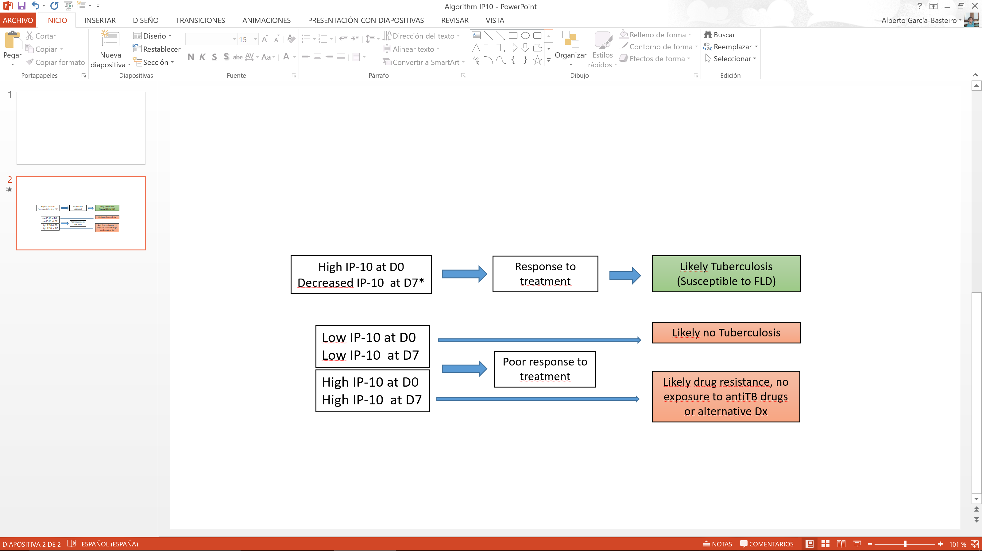

Acronyms: FLD: First line anti Tuberculosis Drugs; Dx: diagnosis;

Low IP10 defined as IP-10 < 781 pg/ml

High IP10 defined as IP-10 >781 pg/ml

*Decreased IP-10, when IP10 levels at D7 were 300 pg/ml lower than at D0

**Figure 2.** Kinetics of IP-10 at three time points (D0, D7 and D60). N=126.

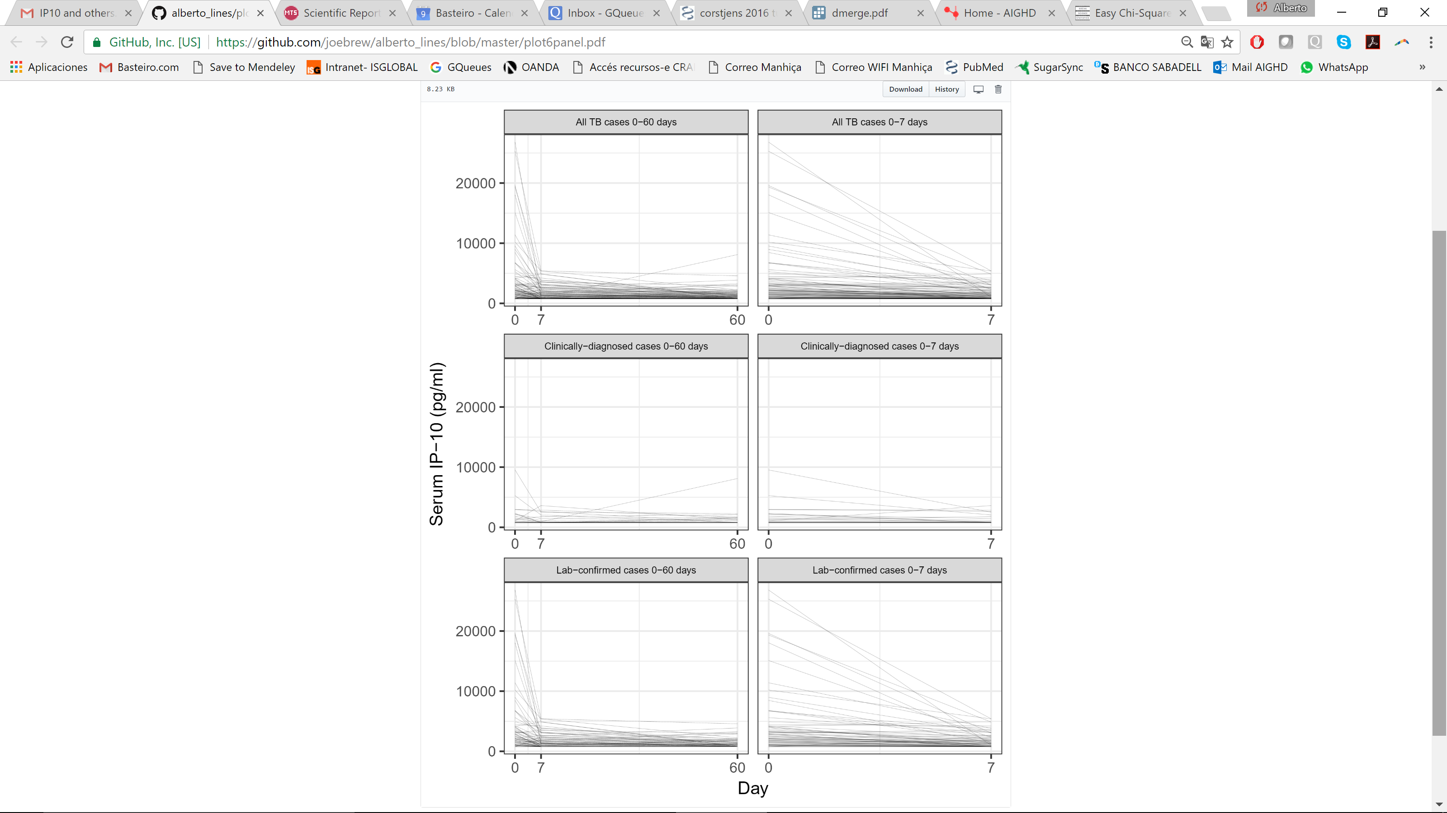

Figure 3

