Silent pessimists - researchers' perceptions of malaria eradication and implications for health spending

# Introduction

## Background

The scientific and public health communities have had eradication on their long-term agenda since the WHO established the Global Malaria Eradication Program in the 1950s (Nájera, González-Silva, and Alonso 2011). Following the failure of the WHO's first attempt, the focus shifted away from global eradication and towards local elimination and control strategies.

In recent years, much of the discourse regarding malaria has shifted back to global eradication (Roberts and Enserink 2007), with funders, researchers, and public health practitioners rallying to the cause (Tanner et al. 2015). The Bill and Melinda Gates Foundation has begun actively promoting eradication as feasible "within a generation" (Gates 2014), and the leadership of the World Health Organization (WHO) has supported this goal. Even in areas of high endemicity, advances in immunology, parasitology, modeling and vaccinology, along with rapid economic development, have made eradication appear a more feasible goal, even if not possible in the short term (Snow 2015, Eckhoff et al. (2014)). From both administrative (Yamey 2004) and scientific (Alonso et al. 2011) points of view, eradication has never before received so much attention, nor appeared so within grasp.

Most of the current research on expert opinion regarding the feasibility of malaria eradication focuses on the rather than the and the (Tanner et al. 2015). The participants in the Malaria Eradication Research Agenda (MalERA) process, in particular, have positioned themselves as thought leaders in the field of guiding research goals and identifying gaps in order for elmination to occur (Alonso et al. 2011). Though the MalERA authors firmly state that eradication is feasible given the "current tools and state of knowledge", mentions to the time frame are vague ("within the lifetime of young scientists just embarking on their careers") and no mention is made of the perception of the probability of achieving eradication.

## The problem

The WHO Global Malaria Programme (GMP) has acknowledged that it "needs to take an official position on how and under what timeline malaria eradication could be achieved" (“Malaria Policy Advisory Committee to the WHO: Conclusions and Recommendations of Seventh Biannual Meeting” 2015). Such a position could inform policy, and plays a crucial role in the economic analysis of the expected value of malaria control inteventions.

However, no such position has been taken. This omission is likely intentional, and certainly understadable, given that MalERA's and the WHO GMP's goals are to guide research and technology in the direction of eradication, and not necessarily address the larger and much more subjective questions of and .

But just how close are we to eradication? The objective serves to inspire, rally funder support, motivate researchers, and focus the efforts of public health practitioners. Proponents of disease eradication point to the success of historical and current campaigns (smallpox and polio, respectively), and highlight the benefits in health and wealth to future generations. However, the opportunity cost of investments in eradication-specific interventions can be high. And the “expected value” of an investment in a binary scenario (eradication or not) is a function of the probability of the scenario’s occurrence, and the temporal lag of that occurrence. Therefore, knowing the likelihood and time frame of eradication of malaria is essential for making sound investments in health.

## The need for the wisdom of crowds

Patients often ask for a “second opinion”, a request which implicitly recognizes two important truths: (1) that an expert can sometimes be wrong and (2) that the combined opinions of multiple people can better approximate the truth than the opinion of only one. As Sir Francis Galton demonstrated in his famous ox-weight experiment (Wallis 2014), averaging the opinions of many can be more accurate than taking the opinion of any single expert, since the biases of diverse viewpoints can be complementary and symbiotic.

Additionally, one could argue that assessing likelihood and time frame of eradication is too important, subjective and complex a task to be left to only powerful individuals or small panels and committees. It requires the “wisdom of crowds.” Measuring consensus and discord among disease-specific researchers from a variety of disciplines can serve as a barometer of (informed) opinion, both guiding resources and identifying areas of concern (Keenan et al. 2013).

## Rationale

A great deal of previous research already covers the the cost per case prevented (E. Sicuri et al. 2011, Silumbe et al. (2015), Bôtto-Menezes et al. (2016), Ilunga-Ilunga et al. (2014), Dalaba et al. (2015)). Likewise, a literature exists which could serve as a model for quantifying the location-specific opportunity costs associated with funneling funds towards malaria eradication (Stuckey et al. 2014, White et al. (2011), Korenromp (2012)). The correct discount rate for estimating the value of future lives saved is more of a philosphical question than an economic one. This leaves only the probability and time-frame to eradication, questions which have been addressed anecdotally, but never answered quantitatively.

The economic case for striving to achieve malaria eradication is compelling (Barofsky, Anekwe, and Chase 2015). Though the case-specific marginal cost of eradication can be expected to be high (relative to a simple control approach), successful eradication would mean massive recurring savings in the long-term (Barrett 2013). However, to the extent that the case-specific marginal cost of prevention in an eradication campaign is high, estimating the likelihood of success is fundamental to the correct distribution of resources, particularly in low-income environments.

In other words, the rational assignment of resources for malaria eradication campaigns hinges on the expected value of those campaigns. We can describe this relationship formulaically below:

1. is the return on investment at time (T) (the "end of malaria"). We take the present value of the benefits multiplied by the probability of succcess minus the value of costs times the probability of success, and multiplyboth terms by the discount rate traised to T to arrive at the return on investment.

## Objective

The objective of this study is simple: to help guide the optimal distribution of health resources by gauging (expert) opinion about, estimating the likelihood of, and quantifying the time frame to malaria eradication through a systematic survey of malaria research professionals from a wide array of academic disciplines.

# Methods

## Ethics

This research followed the principles of the Declaration of Helsinki. The study's protocol was approved by the Scientific Committee of the Barcelona Institute for Global Health.

## Participants

Our study population included all first authors (with available email addresses) returned in a PubMed search for the term "malaria" from January 1, 2010 through December 20, 2016. Personalized emails addressing the author by name and mentioning the relevant paper were sent to each of the 7680 authors during the period from December 20, 2016 through January 2, 2017. Researchers were invited to participate by clicking a link to the survey form. Participants were informed directly on the survey form of the study's purpose, that responses were not guarnteed to be anonymous, and where to find further details on the study.

## Survey

The survey was simple, consisting of only name, email, and four content-related fields along with a "general comments" section. The survey was administered and data were collected through Google Drive. The original survey is viewable at <https://goo.gl/forms/IroAEooDuJ6KM5Ho2>.

Content-related survey fields consisted of:

1. Area of expertise.
2. Perceived probability (%) of malaria eradication in 10, 20, 30, 40, and 50 years.
3. Free choice perceived number of years until malaria eradication.
4. Ranking of the WHO's "health system building blocks" in regards to attention needed in order to achieve eradication.

## Analysis

Survey results were first analyzed descriptively. Following Francis Galton's example, we naively take the average of all responses as the likely point estimate for event probabilities, and the totality of the responses to each numeric question as the likely confidence interval of those likelihoods and time frames.

Ordinary least squares regression was employed to estimate the effect of area of expertise on the eradication pessimism-optimism (through the proxy of perceived years to eradication).

Content analysis of free text comments was carried out using frequency analyses. Comments were categorized and coded according to (more details needed here).

All analysis was carried out in R language (R Core Team 2015). All analysis code, as well as the code used for the identification and contacting of participants, is publicly available at <https://github.com/joebrew/malaria_survey>.

The searching and retrieval of information from the PubMed database was carried out using the RISmed package (Kovalchik 2015). Qualitative analysis relied on the RQDA package (citation needed here).

# Results

A total of 873 researchers participated in the survey.

## Expertise profile

Areas of expertise were non-exclusive and self-described, with participants having the option to choose from up to 3 of 10 checkboxes, or to write in one or more "other" areas of expertise. 336 participants (38.5%) declared only one area of expertise, with 823 (94.3%) declaring three or fewer.

Participants had a total of 228 unique (self-described) areas of expertise, of which 34 areas of expertise had 5 or more participants.

|  |  |
| --- | --- |
| Area | Researchers |
| Epidemiology | 349 |
| It | 340 |
| Parasitology | 316 |
| Biology | 275 |
| Clinical medicine | 207 |
| Immunology | 100 |
| Statistics | 83 |
| Entomology | 58 |
| Entomology | 58 |
| Economics | 34 |
| Public health | 29 |
| Public health | 29 |
| Chemistry | 27 |
| Chemistry | 27 |
| Virology | 23 |
| Anthropology | 20 |
| Political science | 13 |
| Medical entomology | 12 |
| Pharmacology | 9 |
| Vector control | 9 |
| Ecology | 8 |
| Malaria | 8 |
| Infectious disease | 7 |
| Medicinal chemistry | 7 |
| History | 6 |
| History | 6 |
| Biochemistry | 5 |
| Bioinformatics | 5 |
| Drug discovery | 5 |
| Drug discovery | 5 |
| Gis | 5 |
| Microbiology | 5 |
| Pharmacy | 5 |
| Vector biology | 5 |

## Likelihood of eradication

Participants were asked to quantify (as a percentage) the likelihood of eradication in the next 10, 20, 30, 40, and 50 years. Most participants saw eradication as extremely unlikely in the next 10-30 years, but increasingly likely thereafter. The following figure shows the distribution of year-specific likelihood perceptions (panels A-E), as well as an illustration of how both likelihood and uncertainty grow over time (panel F).

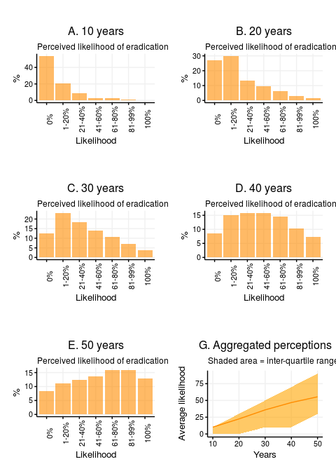

## Time frame to eradication

Participants were asked to provide the number of years they believe it will take until eradication can be achieved. 57 (6.5%) were either blank or uninteligible, whereas 816 participants responded. Among respondants, 611 (74.9 %) estimated that it would be 50 or more years until eradication. The below histogram shows the distribution of responses, appended at 50.

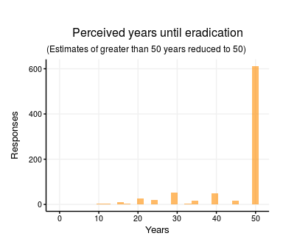

## Difference in perceptions by expertise

Participants were heterogenous in their perceptions, with all of the 5 pre-determined cut-offs containing the whole range of likelihoods (0-100%), and the free-form time frame responses suggesting that eradication would be achieved in as little as 0 to as many as "never". Heterogeneity can be partly explained by area of expertise, as evidenced by significant differences in the perceived years to eradication by area of expertise.

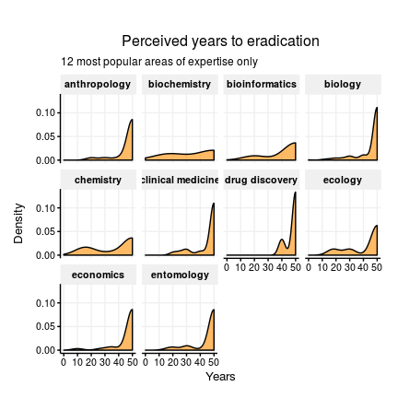

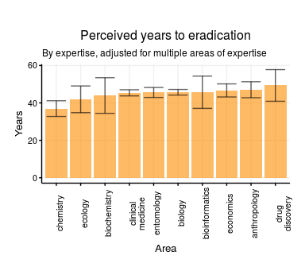

Heterogeneity by area of expertise is also apparent in perceived likelihood of eradication over the pre-defined five time-points, as seen below.

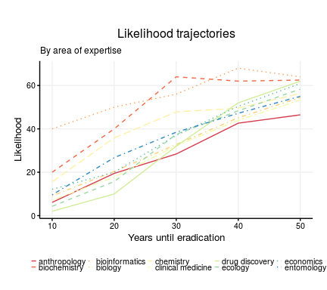

## Health system building blocks

Finally, researchers were asked to rank the WHO's 6 health system building blocks as needing the most to least attention (6-1 scale) in order for eradication to be achieved. Disagreement was high, as evidenced by the variance in responses in the below point and violin chart. However, the general tendency was that governance was recognized as the most important area requiring attention, with health information thought to be the area least requiring attention.

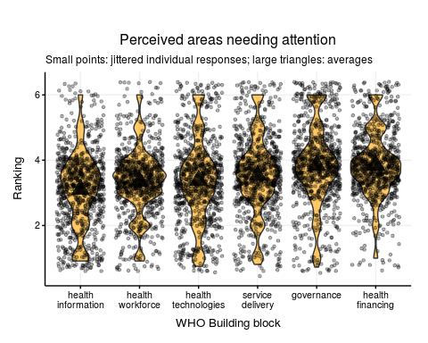

# Discussion

## Collective pessimism

Our study reveals a striking gap between the public discourse on malaria eradication, and those views held (largely privately) by malaria researchers. Approximately three-quarters of respondents believe that malaria will not be eradicated in the next 50 years; in other words, assuming our pool of respondents is of typical post-PhD age, most believe they will not live to see eradication.

If we take the pooled opinions of researchers, as revealed through this survey, as the best approximation of truth available, then the disconnect between public discourse on malaria eradication and private opinion is troubling. It suggests that the goals set by the Bill and Melinda Gates Foundation (eradication "within a generation") and the WHO GMP (eradication "within the lifetime of young scientists just embarking on their careers") are unrealistic at best, and misleading at worst. This has important implications for spending in public health, since the attention and resources of funders, researchers and government agencies are directed to those areas where a result is expected.

On the other hand, there are many reasons to be skeptical that the combined "wisdom of crowds" of malaria researchers is a reliable indicator of truth. First, academic researchers are specialists - their narrow, field-specific view of eradication's feasibility is arguably less reliable than the more "global" views of the WHO, or Bill Gates. Second, a number of biases may come in to play in this study.

Among these biases, 4 are worth mentioning specifically. (1) "Conjunction fallacy" suggests that the general goal of eradication may seem less likely than the sum of the goals of country-specific elimination. (2) A (reverse) variant of the "hot hand fallacy", in which researchers may mistakenly base their assessment of current chances of eradication on previous failures. (3) Parkinson's law of triviality suggests that researchers may disproportionately see the challenges of their own research (antimalarial drug resistance, etc.) as larger or more relevant to the global eradication campaign than they really are. (4) Finally, and ironically, "optimism bias" may play a perverse role in researchers' responses; though eradication is certainly a goal desired by all, one could argue that malaria research specialists subconciously realize that they actually stand to lose out profesionally in the case of eradication.

Whether the collective "wisdom" of researchers is worth adhering to or not is arguable. That said, to the extent that researchers' private opinions differ so greatly from those of global health leaders is itself a noteworthy result. If leaders' high levels of optimism are well-placed, this suggests that researchers are unduly pessimistic, and efforts should be made to convince them that eradication is more feasible than they realize. If, on the other hand, collective wisdom is a better forecasting agent than the proclamations and objectives of global health leaders, then it is important to recognize the sad truth that we are likely further from eradication than we would like to be. In this case, though the discourse on eradication can be motivating and inspiring, resources should be directed in a manner that reflects an intended outcome's likelihood of occurrence.

## Building blocks to eradication

It is noteworthy that there was so much discord among researchers in regards to which WHO building blocks required the most attention in order for eradication to be achieved. All six possible categories received votes for both the lowest and highest levels of importance, as well as every level in between. And the difference between "health information" (the building block deemed as least important) and "governance" (the most important) was less than 0.5 on a 1-6 scale.

This discord suggests that the path to implementing strategies for eradication is not clear, at least from the perspective of this study's participants. This could mean that further work is needed in order to prioritize which areas require the most investment and attention in order for eradication to occur. On the other hand, one could interpret this result as reflecting the fact that previous work on priorities (ie, MalERA) has not been fully accessed or understood by the larger malaria research community.

## Areas of expertise

It is noteworthy that among the most "optimistic" experts were from the field of bioinformatics. This could be explained by the fact that, relative to other more "traditional" areas of science, informatics regularly sees paradigm shifts, and changes in technology and breakthroughs occur at a more rapid rate. That said, the high degree of optimism among chemists would seem to contradict this hypothesis. At any rate... (more details will go here).

## Limitations

In addition to the biases mentioned above, this study has many limitations. First, though results are not disclosed at the individual level, this survey was not entirely anonymous, suggesting that social desirability bias may have influenced responses, and that selection bias likely meant our pool of participants were substantially different from those who choose not to participate.

Second, we made no distinguishment between quality of research, years of experience, academic achievements, geographical area, etc. Our inclusion criteria were simple and rudimentary, allowing us to access many diverse viewpoints, but (perhaps inappropriately) weighting all viewpoints as equal.

Third, this study included the corresponding authors of indexed journals. Though certainly a group with important knowledge related to malaria, this misses malaria control program employees, health agency workers, and other stakeholders. Their experiences and viewpoints are most likely vastly different from those of academecians.

## Implications

Our survey attempted to quantify the likelihood of and time frame to malaria eradication by gauging the collective opinion of malaria researchers. Our results suggest that eradication is unlikely in the short and medium terms, and that there exists a great deal of disagreement among researchers in regards to which areas require the most attention in order for eradication to occur. The implication of these results are three-fold: (1) that those working or investing in eradication-specific campaigns should factor in the low likelihood and long time frame when calculating those campaigns' expected value; (2) that champions of near-term eradication need to make a more compelling case to malaria researchers of eradication's feasibility, in order to better focus and inspire the latter; and (3) that discord among malaria researchers as to which areas need the most attention in order for eradication to occur suggests a need for open discussion and concensus-making, so that resources and focus are directed appropriately.

# References

Alonso, Pedro L., Graham Brown, Myriam Arevalo-Herrera, Fred Binka, Chetan Chitnis, Frank Collins, Ogobara K. Doumbo, et al. 2011. “A Research Agenda to Underpin Malaria Eradication.” *PLoS Med* 8 (1). Public Library of Science (PLoS): e1000406. doi:[10.1371/journal.pmed.1000406](https://doi.org/10.1371/journal.pmed.1000406).

Barofsky, Jeremy, Tobenna D. Anekwe, and Claire Chase. 2015. “Malaria Eradication and Economic Outcomes in Sub-Saharan Africa: Evidence from Uganda.” *Journal of Health Economics* 44 (December). Elsevier BV: 118–36. doi:[10.1016/j.jhealeco.2015.08.002](https://doi.org/10.1016/j.jhealeco.2015.08.002).

Barrett, S. 2013. “Economic Considerations for the Eradication Endgame.” *Philosophical Transactions of the Royal Society B: Biological Sciences* 368 (1623). The Royal Society: 20120149–9. doi:[10.1098/rstb.2012.0149](https://doi.org/10.1098/rstb.2012.0149).

Bôtto-Menezes, Camila, Azucena Bardají, Giselane dos Santos Campos, Silke Fernandes, Kara Hanson, Flor Ernestina Martínez-Espinosa, Clara Menéndez, and Elisa Sicuri. 2016. “Costs Associated with Malaria in Pregnancy in the Brazilian Amazon, a Low Endemic Area Where Plasmodium Vivax Predominates.” Edited by Nicholas P. Day. *PLoS Negl Trop Dis* 10 (3). Public Library of Science (PLoS): e0004494. doi:[10.1371/journal.pntd.0004494](https://doi.org/10.1371/journal.pntd.0004494).

Dalaba, Maxwell, Patricia Akweongo, Raymond Aborigo, Happiness Saronga, John Williams, Gifty Aninanya, Rainer Sauerborn, and Svetla Loukanova. 2015. “Cost to Households in Treating Maternal Complications in Northern Ghana: A Cross Sectional Study.” *BMC Health Services Research* 15 (1). Springer Science: 34. doi:[10.1186/s12913-014-0659-1](https://doi.org/10.1186/s12913-014-0659-1).

Eckhoff, Philip A, Caitlin A Bever, Jaline Gerardin, and Edward A Wenger. 2014. “Fun with Maths: Exploring Implications of Mathematical Models for Malaria Eradication.” *Malar J* 13 (1). Springer Science: 486. doi:[10.1186/1475-2875-13-486](https://doi.org/10.1186/1475-2875-13-486).

Gates, Bill. 2014. “We Can Eradicate Malaria—Within a Generation.” *Breaking a Fever*. Gates Notes. <https://www.gatesnotes.com/Health/Eradicating-Malaria-in-a-Generation>.

Ilunga-Ilunga, Félicien, Alain Levêque, Léon Okenge Ngongo, Félicien Tshimungu Kandolo, and Michèle Dramaix. 2014. “Costs of Treatment of Children Affected by Severe Malaria in Reference Hospitals of Kinshasa, Democratic Republic of Congo.” *J Infect Dev Ctries* 8 (12). Journal of Infection in Developing Countries. doi:[10.3855/jidc.4622](https://doi.org/10.3855/jidc.4622).

Keenan, Jeremy D., Peter J. Hotez, Abdou Amza, Nicole E. Stoller, Bruce D. Gaynor, Travis C. Porco, and Thomas M. Lietman. 2013. “Elimination and Eradication of Neglected Tropical Diseases with Mass Drug Administrations: A Survey of Experts.” Edited by María-Gloria Basáñez. *PLoS Negl Trop Dis* 7 (12). Public Library of Science (PLoS): e2562. doi:[10.1371/journal.pntd.0002562](https://doi.org/10.1371/journal.pntd.0002562).

Korenromp, Eline L. 2012. “Lives Saved from Malaria Prevention in Africa–evidence to Sustain Cost-Effective Gains.” *Malar J* 11 (1). Springer Science: 94. doi:[10.1186/1475-2875-11-94](https://doi.org/10.1186/1475-2875-11-94).

Kovalchik, Stephanie. 2015. *RISmed: Download Content from Ncbi Databases*. <https://CRAN.R-project.org/package=RISmed>.

“Malaria Policy Advisory Committee to the WHO: Conclusions and Recommendations of Seventh Biannual Meeting.” 2015. *Malar J* 14 (1). Springer Science. doi:[10.1186/s12936-015-0787-z](https://doi.org/10.1186/s12936-015-0787-z).

Nájera, José A., Matiana González-Silva, and Pedro L. Alonso. 2011. “Some Lessons for the Future from the Global Malaria Eradication Programme (19551969).” *PLoS Med* 8 (1). Public Library of Science (PLoS): e1000412. doi:[10.1371/journal.pmed.1000412](https://doi.org/10.1371/journal.pmed.1000412).

R Core Team. 2015. *R: A Language and Environment for Statistical Computing*. Vienna, Austria: R Foundation for Statistical Computing. <https://www.R-project.org/>.

Roberts, L., and M. Enserink. 2007. “MALARIA: Did They Really Say . Eradication?” *Science* 318 (5856). American Association for the Advancement of Science (AAAS): 1544–5. doi:[10.1126/science.318.5856.1544](https://doi.org/10.1126/science.318.5856.1544).

Sicuri, E., C. Davy, M. Marinelli, O. Oa, M. Ome, P. Siba, L. Conteh, and I. Mueller. 2011. “The Economic Cost to Households of Childhood Malaria in Papua New Guinea: A Focus on Intra-Country Variation.” *Health Policy and Planning* 27 (4). Oxford University Press (OUP): 339–47. doi:[10.1093/heapol/czr046](https://doi.org/10.1093/heapol/czr046).

Silumbe, Kafula, Joshua O Yukich, Busiku Hamainza, Adam Bennett, Duncan Earle, Mulakwa Kamuliwo, Richard W Steketee, Thomas P Eisele, and John M Miller. 2015. “Costs and Cost-Effectiveness of a Large-Scale Mass Testing and Treatment Intervention for Malaria in Southern Province, Zambia.” *Malar J* 14 (1). Springer Science. doi:[10.1186/s12936-015-0722-3](https://doi.org/10.1186/s12936-015-0722-3).

Snow, Robert W. 2015. “Global Malaria Eradication and the Importance of Plasmodium Falciparum Epidemiology in Africa.” *BMC Medicine* 13 (1). Springer Science: 23. doi:[10.1186/s12916-014-0254-7](https://doi.org/10.1186/s12916-014-0254-7).

Stuckey, Erin M., Jennifer Stevenson, Katya Galactionova, Amrish Y. Baidjoe, Teun Bousema, Wycliffe Odongo, Simon Kariuki, et al. 2014. “Modeling the Cost Effectiveness of Malaria Control Interventions in the Highlands of Western Kenya.” Edited by Georges Snounou. *PLoS ONE* 9 (10). Public Library of Science (PLoS): e107700. doi:[10.1371/journal.pone.0107700](https://doi.org/10.1371/journal.pone.0107700).

Tanner, Marcel, Brian Greenwood, Christopher J. M. Whitty, Evelyn K. Ansah, Ric N. Price, Arjen M. Dondorp, Lorenz von Seidlein, et al. 2015. “Malaria Eradication and Elimination: Views on How to Translate a Vision into Reality.” *BMC Medicine* 13 (1). Springer Science. doi:[10.1186/s12916-015-0384-6](https://doi.org/10.1186/s12916-015-0384-6).

Wallis, Kenneth F. 2014. “Revisiting Francis Galton’s Forecasting Competition.” *Statistical Science* 29 (3). Institute of Mathematical Statistics: 420–24. doi:[10.1214/14-sts468](https://doi.org/10.1214/14-sts468).

White, Michael T, Lesong Conteh, Richard Cibulskis, and Azra C Ghani. 2011. “Costs and Cost-Effectiveness of Malaria Control Interventions - a Systematic Review.” *Malar J* 10 (1). Springer Science: 337. doi:[10.1186/1475-2875-10-337](https://doi.org/10.1186/1475-2875-10-337).

Yamey, G. 2004. “Roll Back Malaria: A Failing Global Health Campaign.” *BMJ* 328 (7448). BMJ: 1086–7. doi:[10.1136/bmj.328.7448.1086](https://doi.org/10.1136/bmj.328.7448.1086).