Costs associated with malaria in pregnancy in the Brazilian Amazon

Camila Botto-Menezes¹, Azucena Bardají², Flor Ernestina Martínez-Espinosa², , Silke Lutzelschwab³, Kara Hanson³, Clara Menéndez², Elisa Sicuri²

- Fundação de Medicina Tropical Doutor Heitor Vieira Dourado, Manaus, Brazil
- Barcelona Centre for International Health Research (CRESIB, Hospital Clínic-Universitat de Barcelona), Barcelona, Spain
- London School of Hygiene and Tropical Medicine, London, UK

Background
Information on costs associated with malaria in low transmission areas where P.vivax predominates is scarce. This is more evident for malaria treatment in pregnant women in these areas for which economic data is so far inexistent. This study aims to estimate the costs of treatment of malaria during pregnancy in the Brazilian Amazon.

Methods and data analysis
Between January 2011 and March 2012 household costs for the treatment and prevention of malaria during pregnancy were collected through an exit survey at a tertiary referral hospital, Fundaçâo de Medicina Tropical Doutor Heitor Vieira Dourado (FMT-HVD) and at a health post in the Manaus metropolitan area, Amazonas state. Pregnant women and women in the post-partum diagnosed with malaria were interviewed after an outpatient visit or at discharge after admission. Health staff was interviewed on the resources used at the health facilities for the treatment of malaria. Treatment unit costs were obtained from the administration department of the FMT-HVD. Bootstrap simulations were used to allow for uncertainty in household cost distributions and mixed method approach was used to estimate provider unit costs.

Findings
Seventy-four questionnaires were included in the analysis, corresponding to either one or multiple contacts 64 pregnant or post-partum women experienced with the facility. Ninety-six% of contacts were due to P.vivax and 4% to P.falciparum. Median (interquartile range) household prevention costs were US$ 15.66(13.03) and US$ 3.94(4.74) among outpatients and inpatients, respectively. Household direct+indirect costs were US$ 18.53(26.97) and US$ 129.70(110.89) for an outpatient and an inpatient episode, respectively. Household costs increased to US$ 45.70(52.69) and US$ 216.29(188.71) when previous symptomatic treatments sought were included. Median costs for the treatment of P.vivax considering relapses ranged from US$ 25.21(44.50) to US$ 259.50(277.72) depending on whether women were inpatients or outpatients and on whether previous treatment was sought. Provider costs associated with P.falciparum for an outpatient visit and an inpatient episode were US$ 151.27 and 451.64, respectively. For the P.vivax cost were US$ 153.80 and 461.24. Total provider costs were US$ 22,548.25 for the year 2010, of which 85% was the cost of P.vivax treatment.

Conclusion
Malaria in pregnancy is responsible of a significant economic burden. Especially when relapses are considered, costs associated with P.vivax during pregnancy are higher than costs associated with P. falciparum. Effective strategies for control and elimination of malaria in the area would imply high saving for both patients and the health system. The information generated may help health policy decisions for the current control and future elimination of malaria in the area.

Introduction

Malaria during pregnancy (MiP) is associated with maternal and foetal morbidity and mortality [1]. The reported clinical consequences of malaria infection during pregnancy are severe malaria, maternal anemia, threatened or actual miscarriage or preterm labor, low birth weight and malaria morbidity in infancy [2-5].

Besides these consequences, pregnant women in Plasmodium vivax (P.vivax) endemic areas are vulnerable to experience more than one malaria episode during pregnancy. Because primaquine, the unique hypnozoitocidal drug licensed, is contraindicated in pregnancy, pregnant women with clinical P.vivax malaria cannot receive radical cure, which can result in multiple relapses of infection during the gestational period [6, 7]. Any episode of malaria exposes pregnant women to malaria paroxysm, which threats the outcome of pregnancy [2].

According to the Pan American Health Organization, in 2008, Brazil was responsible for 75% of MiP episodes in the American continent. Of these MiP episodes reported in the American continent in 2008, Manaus city area reported 571 cases, representing 10% of the American continent cases [8]. In Brazil, the incidence of malaria is almost exclusively (99.8% of the total number of cases) restricted to the Amazon Region, and the P vivax represent 83.7% of malaria species [9].

The Brazilian National Program for Malaria Control is based on case management by early diagnosis and treatment. All malaria cases are confirmed by microscopy. In Brazil, malaria is a notifiable disease and every confirmed case has to be reported through the national surveillance system (SIVEP) [8]. Since 2006 the Ministry of Health recommends active detection of malaria infection with microscopy (thick blood smear) at each antenatal care (ANC) visit to all pregnant women living in the Amazon region [10]. Currently, intervention measures of the Brazilian government aim to control the disease. The elimination of disease in the Brazilian Amazon Region is a challenge to tackle in the next future [11].

In addition to causing a significant clinical burden, MiP leads to an important, although mostly neglected, economic burden [12, 13]. The little information available on the economics of MiP is restricted to P.falciparum endemic areas.. As for clinical consequences, the economics of P.vivax malaria in the country has been neglected [14]. Data on the socio-economic aspects of malaria in Brazil were mainly published in the 90’s. At that time attention was focused on P.falciparum malaria, which was responsible for 44% of the outpatient cases and for high lethality rates. Most studies focused either on the estimate of the value of time losses due to malaria among specific group of workers, mainly miners, or on the estimate of the cost and the cost-effectiveness of malaria control programs [15-20]. Recently, some attention has been devoted to the economic evaluation of diagnostic tools for the identification of the most cost-effective strategy for malaria control in Brazil [21, 22].

The Brazilian National Health System is based on the principle of universal access to care. Malaria treatment is provided only through the National Health System and it is free to patients, implying great challenges on public finance of healthcare [23]. Even if no medical costs are incurred by patients other costs are likely to have a relevant impact on household budgets, such as indirect and transportation costs [12].

No published data exists on the socio-economic aspects of MiP in Brazil. This study aims to describe the costs of the treatment of MiP in Manaus, an endemic area in the Amazonas State, both from the health system and the household point of view. This information is of relevance in the evaluation of the cost-effectiveness of malaria preventative strategies, and to inform health policy decision-making for malaria control during pregnancy in this endemic region. Studies that focus on the socio-economic aspects of malaria are key to understand and tackle the main challenges for future malaria elimination in the region. In a context of competing health problems and of limited resources, public health decisions need to be evidence-informed by a comprehensive knowledge of the economic burden associated with the disease.

Methods

Study area and population

The study was carried out at the Fundação de Medicina Tropical Doutor Heitor Vieira Dourado (FMT-HVD) and at the João Avelino Pereira Health Post, in the city of Manaus, capital of the Amazonas State. Manaus is situated at the confluence of the Negro and Solimões rivers, North of Brazil. It is the most populous city of Amazonas, with around 2 million inhabitants. The per capita income for the city was about US$ 10,661 in the year 2006 [24]. Manaus is one of the three municipalities that accounted for about one fifth of the total number of malaria cases notified in Brazil in 2008. The Annual Parasitic Index (API) in Manaus was of 39.2/1,000 inhabitants in 2005 and 14.6/1,000 inhabitants in 2008, being classified as a medium risk malaria transmission area (10 to 49.9 cases/1.000 inhabitants)[25]. In 2011, Manaus reported 215 MiP episodes, most of them by P. vivax (96.3%). Of MiP episodes reported in Manaus in 2011, 159 MiP episodes were reported in FMT-HVD, of which 151 episodes of P. vivax and 8 episodes of P. falciparum[8]. The FMT-HVD is a tertiary referral centre for health care and research on tropical diseases in the Brazilian Northern region. It reports around 30% of the malaria cases occurring in the municipality, and it provides care to patients seeking treatment from very far away areas in the Amazonas state [11]. It runs a Passive Case Detection (PCD) system and an admission ward among other curative services, such as basic and specialized care, and a day hospital addressed to patients retained for 8 up to 12 hours. The admission unit had 143 beds in 2010, working 24 hours every day of the week to guarantee the management of emergencies of tropical infectious disease cases. João Avelino Pereira clinic is a primary health care centre with no admission unit located in an endemic malaria area in the outskirt of Manaus.

Study design

This study was conducted in the context of the PregVax multicentre collaborative project, a health-facility based cohort observational study aimed to determine the burden and impact of P.vivax infection in pregnancy conducted in five P.vivax endemic countries: Brazil (BR), Guatemala (GT), Colombia (CO), India and Papua New Guinea (PNG).

Patient costs
From January 2011 to March 2012, pregnant and postpartum women attending to either the PCD system of the FMT-HDV or to the Joao Avelino Health Post, and diagnosed with clinical malaria due to any Plasmodium species microscopy confirmed, were invited to participate in the study when leaving the facility after an outpatient visit or at discharge after admission. After written informed consent was given, they were administered with a questionnaire. Data on patients’ costs for the treatment and prevention of malaria during pregnancy were collected. These included direct (medical and non-medical) and indirect costs incurred to reach and while at the health facility and for any treatments sought earlier. In addition, personal information, such as age, marital status, place of residence, main working activity and time lost because of the illness were collected.

For the purpose of the analysis, the duration of any single malaria episode was estimated as 28 days, in order to distinguish between visits on the same episode and a new one. A relapse was considered when a study woman was diagnosed with clinical malaria due to P.vivax confirmed by microscopy more than 28 days apart.

Women’s place of residence (neighbourhood) was identified on electronic maps and distance to the health facility was measured linearly. Average transportation costs per unit of distance were estimated.

Provider costs
Information on provider costs for the treatment of a malaria case in a pregnant woman was collected at the Administration Department of the FMT-HVD by checking administrative files reporting all economic and financial costs incurred by the hospital during the year 2010 and by interviewing Administration Department personnel. Information on both capital (long term capital investments and vehicles) and recurrent costs (personnel, medical and non-medical supplies, external outpatient consultations, etc) was collected. Additional information was obtained from websites of public health institutions [26, 27]. Drug costs were taken from the list of drugs that compulsorily need to be discounted from producers when sold to the public administration, according to the Brazilian policy of maximum price for private sells to the governmental health sector. Such a discount is minimum 24.92% applied to the production price net of taxes [28].

Calculation of drug costs was based on the current recommendations for malaria treatment during pregnancy in Brazil. Standard treatment for P. vivax in pregnant women consists of oral Chloroquine (CQ) (1500 mg, over three days) and a weekly prophylactic regimen of CQ (300 mg, over 12 weeks). The treatment is completed with Primaquine six months after delivery [29]. The current recommendation for the treatment P. falciparum malaria in pregnant women is Quinine plus Clindamycin in the first trimester and Artemether-Lumefantrine in the second and third trimesters. Severe P.vivax malaria cases are treated as for P.falciparum clinical malaria. Malaria diagnosis costs (parasitaemia determination by microscopy) per case were taken from a study recently published [22].

Data analysis
From the household perspective, both costs per malaria episode and costs incurred by the same woman in the case of multiple contacts with the health facility were estimated. Both costs incurred at the FMT-HVD or at Joao Avelino only, and including any treatment sought earlier for the same episode were considered. Direct costs were broken down into medical, transportation and other costs (food, phone calls, etc). Indirect costs were calculated by multiplying reported time lost by the minimum wage in force in Brazil. Due to distribution skewness, median and interquartile range (IQR) were used to report results on costs instead of mean and standard errors. However, mean values were also shown to provide and exhaustive description of cost distributions. Probabilistic sensitivity analysis was undertaken through bootstrap simulation with 1000 replications [30, 31].

From the health provider perspective, unit costs of an outpatient visit and of a one bed/day admission due to a P.falciparum or a P.vivax malaria case were estimated using a mixed approach of bottom-up and top-down costing [32]. Top-down costing was the approach used on cost data provided by the FMT-HVD. Line cost items, once information not related with malaria management was eliminated, were grouped and assigned to indirect, intermediate and direct cost centres based on the proportion of staff whose main activity could be imputed to each of the identified cost centres. Line cost items included recurrent costs such as water, energy, cleaning, communication, transportation, other contracted services such as legal expenses, security, maintenance, and capital costs. Capital costs included vehicles, evaluated at their replacement value, and capital investments; mainly the construction of new buildings or the restoration of old ones within the FMT-HVD facilities, undertaken between 2005 and 2010. Useful life was considered as 30 years for buildings and 10 years for vehicles. Identified indirect cost centres were administration, research and cleaning/laundry/kitchen/transportation (CLKT). Intermediate cost centres were pharmacy and laboratory/diagnosis and direct cost centres were an outpatient visit, a bed/day as inpatient, a day hospital and a basic attention episode. Costs imputed to pharmacy cost centre included non disease-specific drugs (such as paracetamol), and medical supplies commonly used in all causes of outpatient or inpatient care (e.g. cotton, alcohol, gauzes, etc). Step-down accounting was the approach used to allocate indirect costs to intermediate and subsequently intermediate to direct cost centres [33]. The unit of calculation for direct cost centres was an outpatient visit. It was assumed that a day of admission corresponds to 4, a day hospital to 2, and a basic attention to half outpatient visits, respectively. Number of staff and estimated utilization were the allocation criteria used to redistribute administration, CLKT and research costs to intermediate cost centres. Number of days of admission or number of outpatient/basic attention visits were the criteria used to allocate intermediate cost centres to direct cost centres. Unit cost for an inpatient case was based on an average of 3 days of admission. Specific antimalarial treatment for P.vivax or P.falciparum for the outpatient or inpatient cases was added to the outpatient and inpatient cost estimates.

Total costs for the treatment of a P.vivax malaria case in a pregnant woman at the FMT-HVD for the year 2010 were estimated by multiplying P.vivax specific unit costs for an outpatient visit or for an admission times the number of outpatient visits or admissions caused by P.vivax for the same year. Total costs for the treatment of a P.falciparum malaria case were estimated using the same approach as for P.vivax. To estimate total costs associated with detection of malaria cases the unit cost of a malaria case diagnosed by microscopy was multiplied by the number of blood slides undertaken in pregnant women at the FMT-HVD in the year 2010 that resulted negative. All costs were expressed in US$ 2011. The average exchange rate Brazilian Real/US$ of 0.57 (January 2011 – March 2012) was applied.

Results

Characteristics of study subjects
A total of 64 women diagnosed with clinical malaria were enrolled in the study between January 2011 and March 2012. Most of them (96%) were enrolled during pregnancy and the remaining 4% was enrolled during postpartum (Table 1). Malaria cases were quite homogenously distributed throughout data collection period. Information from eighty outpatient or admission visits was collected through standardized questionnaires. Two observations were not included in the analysis as delivery took place more than 6 weeks before the interview and 4 observations were excluded as delivery occurred before the interview and the delivery date was unknown. Almost half of the women (47%) were between 20 and 29 years of age, and a high percentage (20%) was between 10 and 19 years old, with the youngest aged 11 years. Despite their young age, many women had between 1 to 3 children, excluding their current pregnancy. Most women (67%) were from the Manaus urban area, and their main activity was housework (72%). Nineteen out of 64 sick women came from the east of the Manaus area (Jorge Teixeira, Distrito Industrial II, Puraquequara, Zumbi, Mauazinho) and 11 out 64 came from Tarumã neighbourhood, the two areas where the incidence of malaria is known to be highest [34] (Figure 1). Because the FMT-HVD is the referral centre for the Amazonas State for malaria treatment, some of the women enrolled were from outside the Manaus area. Specifically, three of them were from adjacent municipalities (Presidente Figueiredo and Rio Preto da Eva) and another three each from very distant municipalities (Sao Gabriel da Cachoeira, Barcelos and Tapaua) (Figure 2). The median distance from the health facility was 8.75 km, with the mean at 71.26 km and the maximum at 850 km.

Characteristics of malaria episodes
Ten out of the 64 study women presented twice to the health facility during data collection period; eight cases were new malaria episodes and two cases were the same episode according to definitions considered in the study. The median number of episodes per woman was 1.16. Of the 74 episodes of malaria, 96% (N=71) were due to P.vivax and the remaining 4% (N=3) to P.falciparum. Ninety two percent of the cases were reported at the FMT-HVD and 8% at the João Avelino Health Post (Table 2). The majority of malaria cases were treated as outpatients (89%). Among the eight malaria cases that required admission, six were due to P.vivax.

The use of bed nets was very low (5%) and 12% reported having taken chloroquine as prevention of malaria relapse. Insecticides and skin repellents were commonly used in 26% and 19% of cases, respectively. No malaria preventive tool was reported in nearly 40% of the malaria cases. Bus was the transportation more frequently used (51%) to reach the health facility, followed by car/motorbike (27%), and taxi (7%). Two women travelled by boat along the Negro river. Pattern of treatment followed by the study women for the same malaria episode is represented in Figure 3. Six women enrolled at the FMT-HVD sought previous treatment at a pharmacy, while 2 women enrolled at the João Avelino Health Post reported having visited another health post previously.
Patients’ costs
Mean prevention costs were US$ 13.30 for outpatient and 3.85 for inpatient (Table 3). Very few women reported to have used malaria preventative measures and median costs were equal to zero with skewed distributions. Total median cost per episode, including direct and indirect costs, were US$ 18.53 (26.97) for an outpatient visit and US$ 129.70 (110.89) for an inpatient visit. Total median costs including previous treatments sought were US$ 45.70 (52.69) and 216.29 (188.72) for an outpatient and an inpatient visit, respectively. Out-of-pocket transportation median costs were US$ 10.66 (18.35) for an outpatient visit and 20.42 (50.47) for an inpatient visit. Unit cost of transportation, per km, was US$ 1.81 on average with a median of 0.66 (1.31).

Median costs associated with P.vivax relapses were US$ 259 (277.72) in the case that the first contact with the health facility was an admission visit and the second contact was an outpatient visit (Table 4). Median costs were US$ 25.21 (44.50) if both contacts were outpatient visits. Considering previous treatments sought, these costs increased up to US$ 335.85 (130.90) and 71.18 (25.94), respectively.

Probabilistic Sensitivity analysis
Mean patients’ costs on prevention increased up to US$ 15.66 for an outpatient visit and 3.94 for an inpatient visit (Table 3). Median total costs incurred at the health facility were US$ 18.22 (26.98) and 149.80 (106.13) for an outpatient and inpatient visits, respectively. Median total costs including previous treatments sought were US$ 45.93 (51.99) for an outpatient visit and US$ 240.78 (110.92) for an inpatient visit.

Provider costs
Drug excluded, the cost of one bed/day of admission was US$ 149.52 while the cost of an outpatient visit was US$ 146.05. The costs of one outpatient visit and of an admission at the FMT-HVD were US$ 153.80 and 461.80 for P.vivax, and 151.27 and 451.64 for P.falciparum, respectively. Higher costs associated with P.vivax were due to higher drug costs for chloroquine chemoprophylaxis to be taken after each episode. In 2010, a total of 117 clinical malaria cases in pregnant women were reported at the FMT_HVD, 102 as outpatients and 15 as inpatients. Twenty-three outpatient cases were due to P.falciparum and 79 to P.vivax. Of the 15 malaria cases that were admitted, all were due to P.vivax. Total provider costs were US$ 22,548.25, of which 19,068.97 (85%) were due to P.vivax treatment. The number of malaria diagnosis by microscopy undertaken at the FMT-HVD in pregnant women in the year 2010 that resulted negative was of 258. Being the unit cost of a malaria diagnosis by microscopy of US$ 12.77, total costs for the total number of malaria cases diagnosed in pregnant women were US$ 3,294.66.

Total costs
Total mean costs, including patients and provider costs, for the treatment of a clinical malaria case during pregnancy at the tertiary hospital were US$ 181.65 and 628.04 for P.vivax malaria treated as outpatient and as inpatient, respectively. These costs increased up to US$ 346.41 and to US$ 874.54 if P.vivax relapses occured with an admission followed by an outpatient visit or with two outpatient visits, respectively. Mean costs for an outpatient visit caused by P.falciparum were US$ 179.12 while an admission costed on average US$ 618.44.

Discussion

This is the first study that estimates costs associated with the treatment of malaria due to P.vivax during pregnancy and considering costs associated with P. vivax relapses.

Although medical costs, as well as other costs associated with visits or admissions, such as food, were almost completely covered by the health system, pregnant women borne a consistent economic burden, especially as inpatients, in terms of indirect costs. These can reach the 1.20% of the local annual per capita income and the 3.4% if relapses from P.vivax infection are considered.

Being a low malaria transmission area, one could argue that malaria during pregnancy is not a major public health concern in Brazil. Our estimates pointed to the fact that from an economic and financial point of view provider costs for the treatment of malaria during pregnancy in Brazil represent only a small proportion of the total health budget. Provider costs associated with the treatment of the 117 confirmed cases of MiP constituted only the 0.05% of the total activities undertaken in 2010 in the tertiary hospital. However, costs associated with MiP are higher when costs of diagnostic tests performed also to the pregnant women who resulted negative are considered. These costs (US$ 3,296.66) were just slightly lower than total costs for the treatment of all pregnant women with P.falciparum infection (US$ 3,479.28). Interestingly, diagnostic, together with surveillance costs are independent from malaria transmission levels. These costs will be incurred until malaria eradication would be achieved. In addition, costs associated with MiP would be extremely higher if all the consequences of malaria during malaria in pregnancy on the mother, on the outcome of pregnancy and on the newborn were considered.

A few previous studies engaged with the economics of malaria in Brazil. Average individual costs associated with malarial infections in several Brazilian gold mining areas were found to represent approximately the 12% of the median annual salary [19]. In a mining town of the Brazilian Amazon, a new program based on community-based dipstick test diagnosis and treatment in which all community members were offered free diagnosis and mefloquine treatment lead to conspicuous savings of 77% compared to passive case detection with quinine plus tetracycline used as first line treatment [18, 20]. The total costs of another malaria control programme that included both vector control and case management for about 7 years, was US$ 616 million. The overall cost-effectiveness of the malaria control activities was US$ 69 per Disability-Adjusted Life Years averted. Case treatment was more cost-effective than vector control, particularly where P.falciparum was prevalent and insecticide spraying was not effective [15]. In another study, the aggregate productivity loss because of malaria for the years 1990-1994 in the city of Manaus, Amazonas state, was estimated to be about US$ 15.000 [16]. More recently, thick smear diagnostic has been found to be more cost-effective than rapid tests even in remote areas of the Amazonian basin if accuracy of microscopes is maintained high [21]. The non-exclusive use of microscopy for malaria is the most cost-effectiveness diagnostic strategy if patients’ access is high in the Extra-Amazon region [22]. None of these studies is comparable with the present one, both because of the different objectives and of the different target population.

The aim of this study was not to demonstrate significant differences between the treatment costs associated with P.vivax and those associated with P.falciparum. However, results obtained suggest that the highest costs are incurred by women with P.vivax if relapses are taken into account. In addition, being P.vivax the largely most prevalent malaria parasite in the area, total costs for the treatment of malaria in pregnancy for both the health system and the families in the Brazilian Amazonas are mostly associated with this parasite rather than to P.falciparum.

Low use and expenses on preventative tools and, in particular, on (non insecticide-impregnated) bed nets were found among women who experienced MiP. Insecticide-treated nets (ITNs) have just recently been introduced as a malaria control tool in the area and nets are currently distributed for free to the population that live in endemic areas. Therefore, at the time of the study, pregnant women in the sample were likely not to have used ITNs. Median prevention costs among women who were admitted were lower than those borne by women who were outpatients, suggesting that lower expenditure in prevention is associated with higher gravity of the disease.

The Fundação de Vigilância em Saúde do Amazonas is the agency of the Amazonas government directly in charge of all malaria prevention activities, from education to ITNs distributions. Costs associated with these activities have not been included in the study as was not part of our objectives. However, if these were included the cost associated with MiP would be far higher than our estimates.

In this study, top-down was the prevalent, although not exclusive, approach used to estimate provider unit costs. Although this approach is considered by some authors as a second best compared to micro-costing both for the assumptions it implies and as it allows to estimates only average and not disease specific unit costs, it can be seen as reasonably precise in this context for the high level of details of financial and activity data used provided by the FMT-HVD [35]. To validate our results on provider costs, they were compared against unit costs published in WHO-Choice for tertiary hospitals in Brazil [36]. Our results are not dissimilar to WHO-Choice ones, the latter being equal to 110.08 International US$ 2005 for bed/day excluding both drug and diagnostic, which corresponds to US$ 150.60 for the year 2010. WHO-Choice estimates are much lower than ours in the outpatient case, being of International US$ 2005 44.59, corresponding to US$ 61. We believe that our estimates for the outpatient case are higher because of the high diagnostic/laboratory costs that reflect the accurate standard of care followed at the FMT-HVD.

From a financial point of view, the FMT-HVD receives most of the contribution for malaria treatment from the Amazonas State rather than from the National Health System. The National Health System refunds only about US$ 130 for a malaria admission, that is about one third of the estimated cost. In the case of outpatient malaria the refund from the National Health System is only US$ 5, that is the 3% of the total estimated cost.

Health system costs were mainly collected at a tertiary referral hospital and the costs for the treatment of MiP were calculated based on the number of cases recorded at the FMT-HVD. On one hand, the estimated unit costs are likely to be higher than the State average both because the FMT-HVD offers more complete malaria care than any other health facility in the area and because the more severe cases are likely to present at the referral hospital for treatment. On the other hand, our findings did not mean to be representative of the situation of the whole Amazonas State. We aimed at demonstrating that even in low transmission areas where P.vivax dominates costs associated with MiP can be extremely high compared with the local socio-economic conditions.

By estimating treatment costs of MiP in this study we dealt with one aspect only of the economics of MiP. The economics of MiP and of malaria in general has a wider content in low-transmission areas in which elimination is technically feasible. The case of Brazil is peculiar as malaria elimination is not just a Brazilian issue but rather a matter of the whole Amazon Basin. Although most part of the Amazon area is Brazilian, the Basin is shared among several other countries: Colombia, Bolivia, Ecuador, and Perú. In this context, elimination can be considered as a public good, where each of the Amazon Basin countries have a strong incentive to free ride from contributing to achieving it. This means that each country would take advantage of the others’ efforts to invest in elimination without financially contribute to it. Therefore elimination involves a huge coordination problem among countries [37]. Brazil may have the interest to mostly or, perhaps, entirely finance elimination efforts in the whole Amazon Basin as it is the country with the higher malaria burden. With reference to elimination, the present study, by estimating MiP treatment costs, offers invaluable information on the economic benefits elimination could lead to. This study offers estimates of how much money could be saved for the treatment of MiP in the area and could be used in cost-benefit analysis of malaria elimination and eradication [38].

Table 1. Baseline characteristics of the study subjects (N=64)

 | N | %
Age
10-19 | 13 | 20
20-29 | 30 | 47
30-39 | 20 | 31
≥ 40 | 1 | 2
Marital status
Common-law wife | 35 | 55
Married | 12 | 19
Single | 17 | 27
Living area
Urban | 43 | 67
Rural | 21 | 33
Number of children (excluding the current one)
0 | 25 | 40
1 to 3 | 28 | 44
4 to 7 | 11 | 16
Main activity
Housewife | 46 | 72
Peasant | 2 | 3
Other formal occupation | 15 | 23
Student | 1 | 2
 | Median | IQR
Number of episodes per woman | 1.16 | 0.2
Duration of clinical symptoms (days) | 5 | 4
Number of nights admitted (if inpatient) | 3 | 1
Time taken to reach health facility ª (hours) | 1 | 0.83
Estimated distance between home and health facility^{b} (Km) | 8.75 | 18.9

ª Minimum time was 5 minutes and maximum 72 hours
^{b} Average distance was 71.26 km, minimum was 1.4 and maximum was 850.

Table 2. Characteristics of malaria episodes (N=74)
 | N | %
Type of malaria episodes (Plasmodium species)
P.vivax | 71 | 96
P.falciparum | 3 | 4
Women status at the time of interview
Pregnant | 70 | 95
Postpartum | 4 | 5
Place of interview
FMT-HVDª | 68 | 92
Health post^{b} | 6 | 8
Type of PCD^{c} in relation to Plasmodium species
Inpatient P.vivax | 6 | 8
Inpatient P.falciparum | 2 | 3
Outpatient P.vivax | 65 | 87
Outpatient P.falciparum | 1 | 1
Malaria prevention tools used
Bed net | 4 | 5
Drugs (CQ^{d}) | 9 | 12
Skin repellent | 14 | 19
Insecticide | 19 | 26
No prevention | 28 | 38
Transportation to the health facility
Bus | 38 | 51
Own car/motorbike | 20 | 27
Taxi | 5 | 7
Boat | 2 | 0.03
Other^{e} | 9 | 15

ª Fundação de Medicina Tropical Doutor Heitor Vieira Dourado – Amazonas
^{b} Health Post João Avelino
^{c} Passive case detection
^{d} Chemoprophylaxis
^{e} It includes walking and lift from someone

Table 3. Costs per malaria episode incurred by the pregnant women (US$ 2011)
 | Outpatients N=66 |  |  |  |  |  |  |  | Inpatients N=8
 | Pvivax=65; Pfalciparum=1 |  |  |  |  |  |  |  | Pvivax=6; Pfalciparum=2
 | Mean |  | Median |  |  |  | IQRª |  | Mean | Median |  |  |  | IQRª
Deterministic analysis
Prevention costs | 13.30 |  | 0 |  |  |  |  | 11.54 | 3.85 |  | 0 |  |  |  | 4.14
Costs of previous symptomatic treatment sought | 2.98 |  | 0 |  |  |  |  | 2.66 | 15.34 |  | 0.81 |  |  |  | 7.25
Transportation costs the health facility | 17.45 |  | 10.66 |  |  |  |  | 18.35 | 40.59 |  | 20.42 |  |  |  | 50.47
Other costs at the health facility^{b} | 1.78 |  | 0 |  |  |  |  | 2.96 | 1.26 |  | 0 |  |  |  | 1.48
Medical costs for treatment at the health facility^{c} | 2.93 |  | 0 |  |  |  |  | 1.78 | 0 |  | 0 |  |  |  | 0
Indirect costs at this health facility^{d} | 3.06 |  | 2.94 |  |  |  |  | 1.47 | 110.11 |  | 105.71 |  |  |  | 35.22
Indirect costs whole episode (including previous symptomatic treatments)^{e} | 48.66 |  | 19.88 |  |  |  |  | 53.10 | 170.36 |  | 126.26 |  |  |  | 93.95
Total costs per episode at the health facility^{f} | 27.85 |  | 18.53 |  |  |  |  | 26.97 | 166.80 |  | 129.70 |  |  |  | 110.89
Total costs whole episode (including previous symptomatic treatments)^{g} | 76.23 |  | 45.70 |  |  |  |  | 52.69 | 242.38 |  | 216.29 |  |  |  | 188.71
Probabilistic sensitivity analysis (bootstrap based on 1000 replications)
Prevention costs | 15.66 |  | 0 |  |  |  |  | 13.03 | 3.94 |  | 0 |  |  |  | 4.74
Total costs per episode at the health facility | 27.20 |  | 18.22 |  |  |  |  | 26.98 | 165.49 |  | 149.80 |  |  |  | 106.13
Total costs whole episode (including previous symptomatic treatments) | 75.90 |  | 45.93 |  |  |  |  | 51.99 | 242.36 |  | 240.78 |  |  |  | 110.92
ª Interquartile range
^{b} These include cost for food, drink and phone calls
c These include laboratory fees and drugs not provided at the health facility
d These include the value of time lost at the health facility and money spent to contract a substitute in the main economic activity
e These include the value of time lost during the whole pattern of treatment sought and money spent to contract a substitute in the main economic activity
f These include all costs, direct and indirect, associated with treatment incurred at the health facility
g These include all costs, direct and indirect, associated with treatment incurred at the health facility plus direct and indirect costs eventually previously incurred for the same episode

Table 4. Costs incurred by the women for the treatment of P.vivax malaria in case of relapse or same episode with multiple contacts across different scenariosª (US$ 2011)

 | N (cases) Mean |  |  | Median | IQR^{b}
Relapse
Inpatient + Outpatient at the health facility 2 |  | 259.50 |  | 259.50 | 277.72
Inpatient + Outpatient (including previous symptomatic treatments) 2 |  |  | 335.85 | 335.85 | 130.90
Outpatient + Outpatient at the health facility 6 |  |  | 38.53 | 25.21 | 44.50
Outpatient + Outpatient (including previous symptomatic treatments) 6 |  |  | 73.91 | 71.18 | 25.94
Same episode
Outpatient + Outpatient at the health facility 2 |  |  | 83.69 | 83.69 | 114.04
Outpatient + Outpatient (including previous symptomatic treatments) 2 |  |  | 202.32 | 202.32 | 290.46
ª Relapse was considered when the same women was interviewed for the second time after more than 28 days from the first interview. Women could be either be
inpatients at the first interview and outpatients at the second or outpatients at both the first and second interview.
^{b} Interquartile range
Figure 1. Manaus municipality and neighbourhoods of residence of women participating in the study

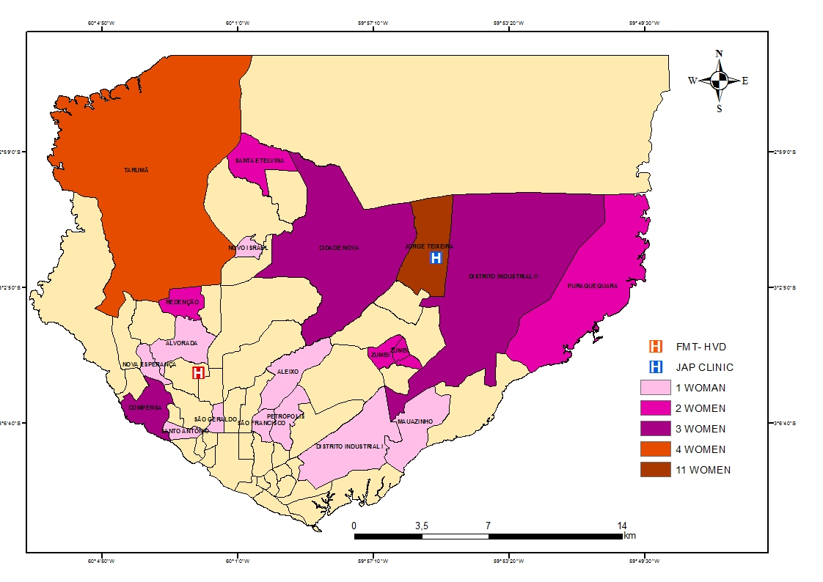

Figure 2. Amazonas state and region of residence of women participating in the study

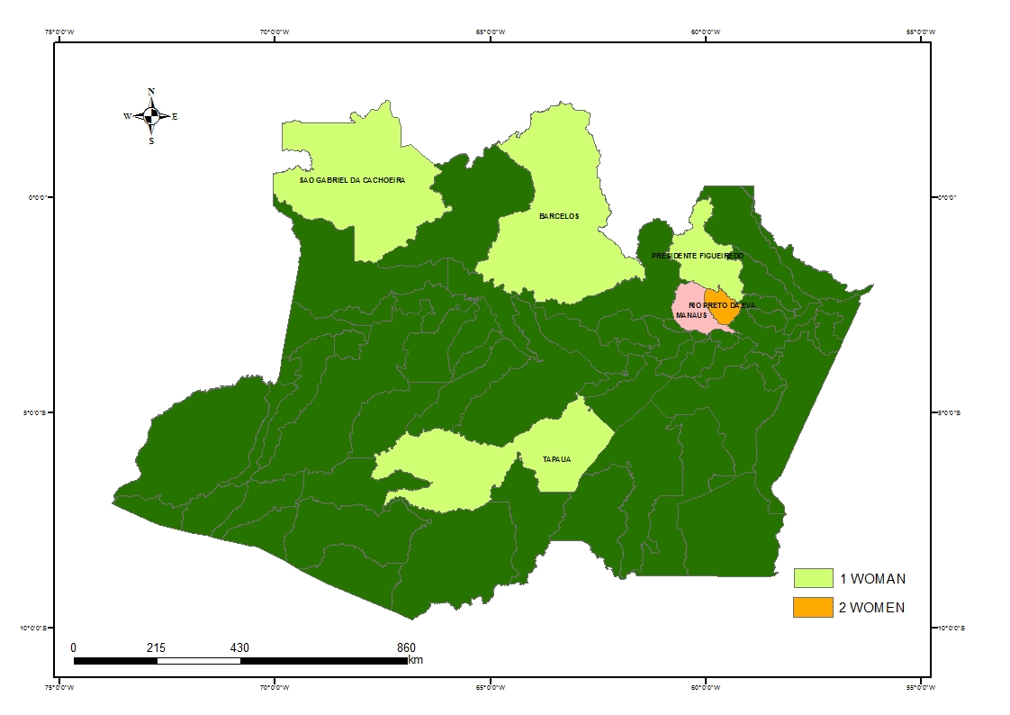

Figure 3. Pattern of treatment sought per malaria episode

Inpatients
N=8
Outpatients
N=60
FMT
-
AM
Inpatients
N=8
Outpatients
N=60
FMT
-
AM
Outpatients
N=6
Health post
Outpatients
N=6
Health post
Episodes surveyed in this study
N=5
Pharmacy
N=5
Pharmacy
N=1
Pharmacy
N=1
Pharmacy
N=2
Health Post
N=2
Health Post
Previous treatment sought for
the same episode

References

