**Title**: “Tuberculosis on the rise: incidence risk from 1997 to 2012 in a southern province of Mozambique”

**Authors:**

Rafaela Miranda de Moraes Ribeiro, Ivan Manhiça, Salomé, Joe Brew, Alberto García-Basteiro

**Authors affiliation**:

Instituto de Higiene e Medicina Tropical, Lisboa, Portugal

Centro de Investigação em Saúde de Manhiça (CISM)

ISGlobal, Barcelona, Hospital Clinic-Universitat de Barcelona

Ministry of Health, National Tuberculosis Program, Maputo, Mozambique

**Corresponding author**:

Alberto L García-Basteiro

Email: alberto.garcia-basteiro@manhica.net

**Keywords:**

Incidence risk, tuberculosis, Mozambique, Manhiça

**Word count:** 2,246

**Abstract**

**INTRODUCTION:**

Tuberculosis (TB) is a disease of major public health importance in Mozambique, one of the few high burden countries where incidence rates have not improved in recent years. Though TB unto itself can be a devastating disease, around 58% of all Mozambicans stricken with TB are co-infected with Human Immunodeficiency Virus (HIV). The estimated TB incidence in 2014 was 552 cases per 100.000 population. Together with Afghanistan, Bangladesh, the Democratic Republic of the Congo, Nigeria and Zimbabwe, Mozambique has the lowest case detection rates of the world, around 39% according to the World Health Organization (1).

The National Tuberculosis Control Program (NTP) in Mozambique was launched in 1977, as part of the Mutual Assisted Programme of the International Union Against Tuberculosis and Lung disease (IUATLD) and started to be applied on nationwide basis in 1985 (2)(3). The TB patient registration system began in 1984 and short course therapy followed in the late eighties (3)(4), even when the country was facing the adverse context of a civil war, with shortage of qualified medical staff, supplies and fragile deployment systems within the country. With the concurrent emergence of the HIV in the 1980´s and its impact on industrialised countries, TB regained importance as a public health problem, and the DOTS strategy (direct observed therapy, short-course therapy) was launched in the early nineties, and promoted by WHO as best practices for TB control (5). In 1996, almost all districts of Mozambique were covered by the national guidelines, with complete coverage in 2000 (4).

Targeted efforts to improve the TB surveillance systems and strengthening operational research will help to identify priority areas for TB control in the country. Up to date, very few studies on burden of disease assessment have been published in the country. Thus, the aim of this study is to evaluate how the incidence rates of TB and other key indicators for TB control evolved from 1997 to 2012 in a high TB HIB burden area of Southern Mozambique(6) (7).

**METHODS:**

Study design and setting

This is a longitudinal retrospective descriptive study using tuberculosis patients’ data from the registry books of the National Tuberculosis Control Program (NTP) for the district of Manhiça in the period of 1997 to 2012. All patients starting TB treatment were registered.

The study was conducted at Manhiça Health Research Center (CISM from its acronym in Portuguese), located in the district of Manhiça, in Souther Mozambique. CISM has a health and demographic surveillance system (HDSS) in the so-called study area, which by 2012, followed 92 000 individuals (covering around 53% of the district population) living in 20.000 geo-positioned households. The system monitors important demographic events, such us births, deaths, migration movements or pregnancies, allowing for precise population estimates. An update of the health profile of the study area, has been recently published elsewhere.8

The prevalence of HIV infection in adults of the district aged 18-47 was 39.9% in 2010 and the incidence of smear positive TB among PLHIV was 847 per 100.000 in 2011. A recent community incidence study in children under 3 conducted in 2012-2013 revealed a minimum incidence of 456 per 100.000 for this age group.

The TB control program in the District of Manhiça

In the district of Manhiça, registry books of the National Tuberculosis Program have existed since 1986 and patients were registered in the two main health centres: Manhiça´s District Hospital and Xinavane Rural Hospital (located 52 kilometres apart from one another). There are also currently 12 peripheral health care centres, which refer samples and patients to these two hospitals. After diagnosis, patients were registered in the main centres and after the first intake of medication, they were referred to their closest peripheral health centre where treatment is supervised under a modified DOT (once weekly). In the district of Manhiça, due to the geographical dispersion of the population, TB patients can be assigned a “godfather” (usually a relative) who will ensure the intake of the patients´ medication, which is given on a weekly basis during both the initiation and continuation phases. The smear controls were done in the two main hospitals.

Case definitions

TB case definitions changed during the study period. In this analysis we used the WHO definitions, revised in 2013 and updated in 2014 (8). TB cases were classified as new, previously treated or unknown TB treatment history. Previously treated patient category includes: relapse (true relapse or reinfection), treatment after failure, treatment after lost to follow up and other previously treated patients. During the study period, the registry books of NTP program in Mozambique also used other terms: “recurrent TB”, “chronic TB”, which were recoded as “previously treated TB patients”, as well as for “MDR-TB” patients.

Following WHO definitions for incident cases, we considered all new cases and relapse cases as incident cases. For the purpose of this study we also considered the former classification of “recurrent case” as an incident case (9).

Smear positivity was defined according to the IUTLD smear grading scheme, considering scanty in at least one slide as a positive result, and smear negative patient as patients having two sputum smear negative in two different occasions according to the local guidelines since 2004 (10). Xpert MTB/RIF was not done routinely.

Throughout the years some variables included in the TB registry books changed: in 2006 HIV status began to be registered in the tuberculosis registry books; TB case definitions changed, and multi drug resistant tuberculosis (MDR-TB) began to be registered in 2011.

Regarding treatment outcomes patients were classified as cured, treatment completed, treatment failed, died, lost to follow up and not evaluated; treatment success was defined as the sum of “cured” and “treatment completed”.

Data analysis

Data from registry books were double entered using electronic software (Openclinica. [www.openclinica.org](http://www.openclinica.org/)) and information was checked, cleaned and analysed using R ([www.R-project.org](http://www.r-project.org/)) . Descriptive statistics were used to describe TB profile in the district during the study period.

Our estimations for population at risk for each year between 1997 and 2007 were based on the annual demographic estimates of the National Institute of Statistics (INE, from its acronym in Portuguese) from Mozambique. In 1997 and 2007 two national census occurred and the population projection estimates for the period 1998-2006 were updated with 2007 census data. From 2008 onwards, we applied CISM’s Demographic Surveillance System (DSS) growth rates to the previous population estimates.

We grouped the entire study period into 4 year time bands, in order to minimize the effect of circumstantial situations (low human resources, heavy rains, etc.) which could affect some of the TB indicators. We have also stratified the population by age groups, according to the WHO classification and the data we had from the census. TB-HIV analysis was only possible since 2007 onwards, when HIV testing was fully implemented at the NTP offices.

Ethical considerations

The Manhiça Health Research Centre approved this research proposal for ethic and scientific integrity. Formal permission to use official information contained in the books was granted by the Manhiça District Health Officer.

**RESULTS:**

Overall and demographic characteristics:

Over the 16 year period of the study, 8.985 cases of tuberculosis were registered by the National Program of Tuberculosis Control in the district of Manhiça, 70.1% (6,296) of them in Manhiça District Hospital and 29.9% (2,686) in the Rural Hospital of Xinavane. The mean age of registered TB patients was 33.9 years old (standard deviation of 17,4), the median was 33 (interquartile range: 24-45) and the mode was 30 years old. The absolute number of cases was higher among men (55.9%) than women (44.1%), and the age group with the greatest number of cases was 30-34 years-old (14.2% of all cases).

During the study period, the population of the district increased from 130,351 in 1997 to an estimated 175,942 inhabitants in 2012 (a 35% increase), while the absolute number of tuberculosis cases registered in 2008-2012 was nearly 3 times higher compared to 1997-2001 (4,183 and 1,487 cases respectively).

Incidence risk

During our study period there were 8,985 incident cases (94,1%). The tuberculosis incidence rate increased over the years of the study, for all age groups, from a total of 174 cases per 100,000 in 1997 to 573 incident cases per 100,000 at risk in 2012 (see figure).

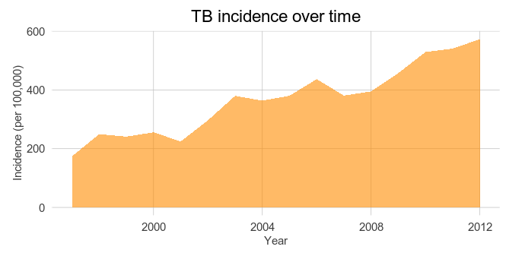

Those aged 40-44 had the highest incidence rate of all age groups (819 per 100,000 annually) (see figure).

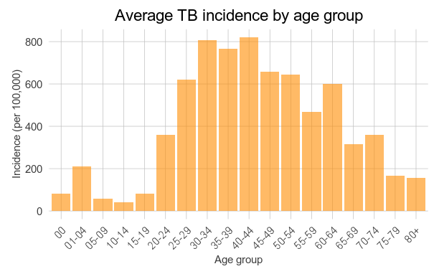

The incidence of TB, always higher among males than females during the study period, has seen a particular divergence over the last few years (see figure).

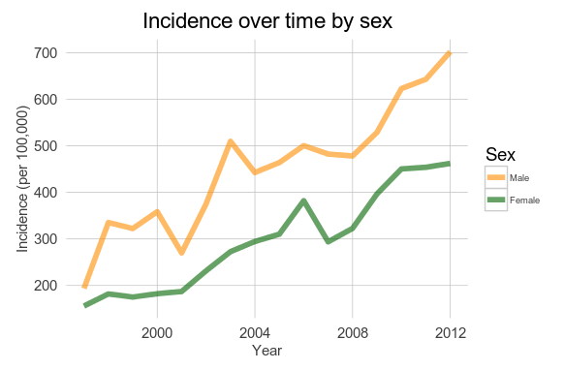

Generally speaking, incidence was highest among those who were middle-aged (see figure).

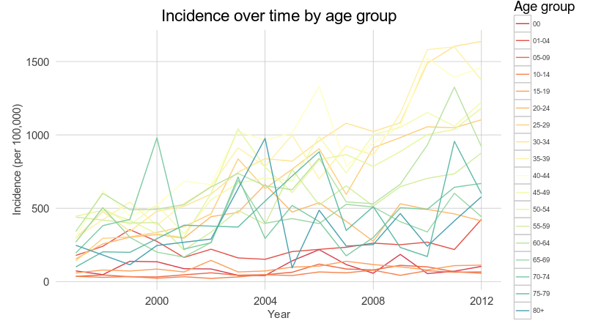

Over the course of the entire time period, incidence risk was highest among all sub-groups for males aged 40 to 44 (annualized incidence of 1,362 per 100,000). The incidence in men for this age group was nearly three times higher than the corresponding the incidence in women. This male female gap can be observed across all adult age groups:

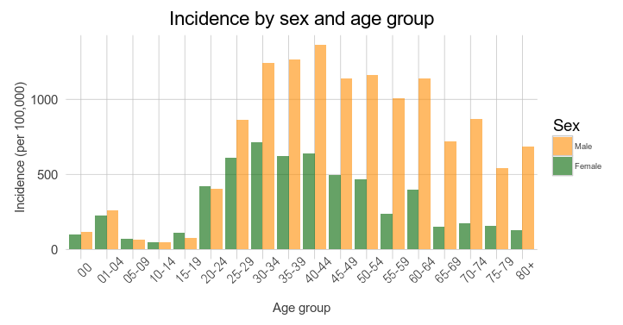

Among children, the group with the lowest incidence, males and females had similar trends.

HIV status and TB

HIV status via TB registry books was unreliable until 2008. However from 2008 onwards the HIV status was recorded in more than 98% of registered incident TB patients’ HIV status is recorded. The growth in TB during that period, as well as TB-HIV co-infection cases as a proportion of all TB cases has increased sharply in recent years (see figure)

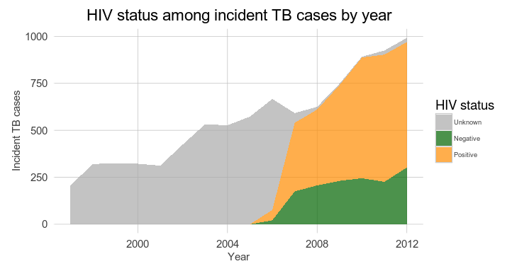

The total number of incident TB cases with known HIV status during the study period was 4,986 (52.1%), all in recent years. Among these, 3,512 had HIV of all 70,4% of tested patients. 52,7% (1,851 cases) were male and 47.3% (1,661 cases) were female. Patients aged from 15 to 49 years old represented 29.6% (2,789 cases) of all TB/HIV-infected patients (see figure).

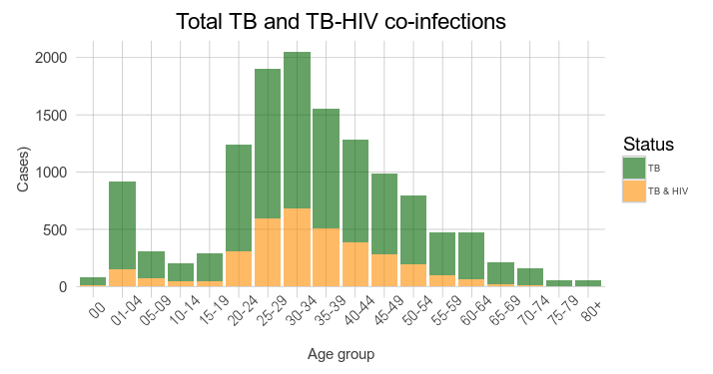

TB type and smear testing

The total number of registered pulmonary cases was 8,013 (83.8% of total number of cases), of which 6,661 cases (83.0% of pulmonary cases) had a smear result, and 4,999 cases (62.3% of pulmonary cases) had a smear positive result.

The number of TB patients starting treatment who were tested for a smear test increased from 1997 until 2003, when 82.9% of them underwent AFB smear at diagnosis. Afterwards proportions decreased until 2009 and thereafter flatlined (see figure).

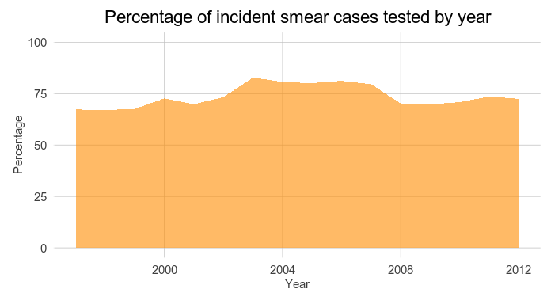

Though the percentage of incident cases remained relatively stable over the study period, the number of smears increased over time, in close correlation with the total number of incident cases (see figure).

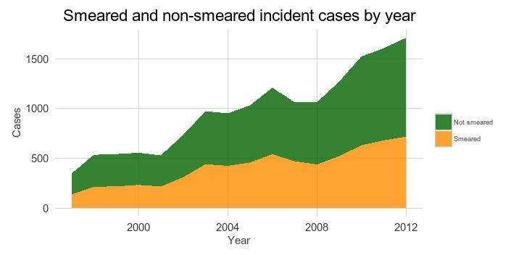

The proportion of smear negative results (among the pulmonary cases having a smear test) increased during the study period, with 43.2% of pulmonary TB being smear negative in 2009-2012, a significant increase over the 16.8% negative rate during the first four years of the study period (Pearson’s Chi-squared test with Yates’ continuity correction: p < 0.001).

Regarding HIV infection, 80.2% (1,091 cases) smear negative pulmonary TB were HIV-infected, while in smear positive pulmonary TB this proportion was 67.1% (1,397 cases) (Pearson’s Chi-squared test with Yates’ continuity correction: p < 0.001).

Extrapulmonary TB (EPTB) accounted for 16.4% (1,477 cases) of the total number of cases. From all the EPTB having any HIV status (843 cases), 641 cases (76.0%) were HIV-infected. The rate of TB/HIV co-infection among incident cases of TB grew during the study period (see figure).

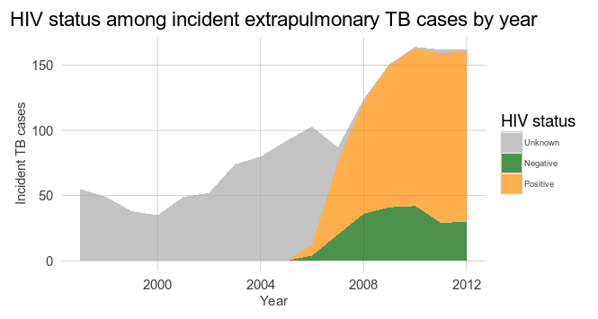

Previously treated vs new patients

During the study period 8,495 cases (89.0%) were classified as new, 878 (9,2%) were previously treated patients, while treatment history was not known on 172 (1.8%).

The proportion of previously treated patients did not greatly vary by year with a mean value of 9% (see figure).

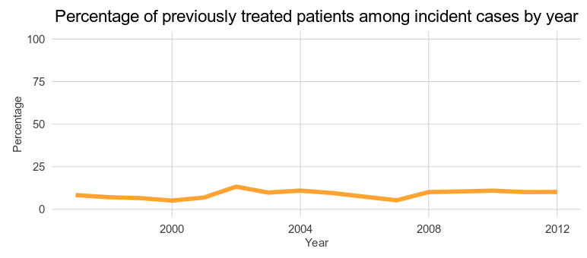

Among the previously treated patients having an HIV status, 76.3% (368 cases) were HIV-infected.

Treatment outcomes

Over the study period the overall proportion of treatment success for registered patients was 68.2% (6,534 cases), the proportion of cured patients decreased while treatment completed increased (see figure). A total of 1,478 patients starting TB treatment died (15.4%) during the study period.

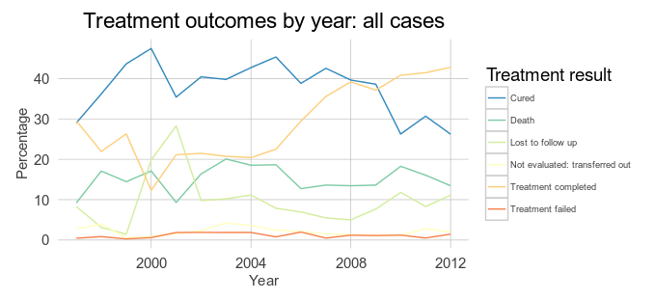

Previously treated versus new patients differed in some areas. Though the likelihood of being cured were similar between the two groups (Pearson’s Chi-squared test with Yates’ continuity correction: p < 0.89), previously treated patients had significantly higher rates of being lost to follow up or otherwise not completing treatment (p < 0.001) (see figure).

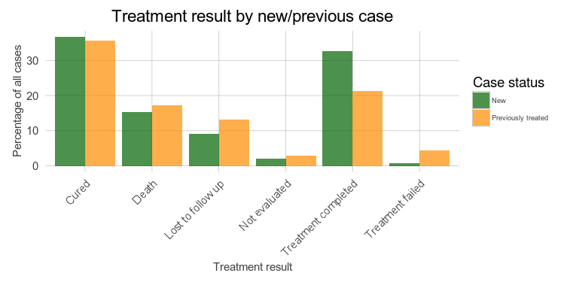

Overall women had a higher proportion of treatment success 70.8% of cases (2,966) compared to 66.2% (3,568) in men (p < 0.001). Similarly, women saw fewer deaths: 14.8% (595 cases) compared to 17.0% (883), respectively (p = 0.003). Lost to follow up as treatment outcome was also more frequent in men: 10.9% (568 cases) than in women 82% (329 cases) (p < 0.001).

The likelihood of being of being lost to follow up differed significantly by age, as well, with young people generally at greatest risk (p < 0.001) (see figure).

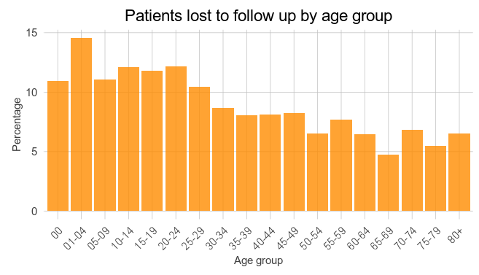

Among patients with known HIV status and known treatment outcome, the likelihood of death was significantly higher among those with HIV than those without (OR of 1.1, 95% confidence interval: 1.07-1.13). Generally speaking (and with the notable exception of infants), the likelihood of death was higher among older patients.

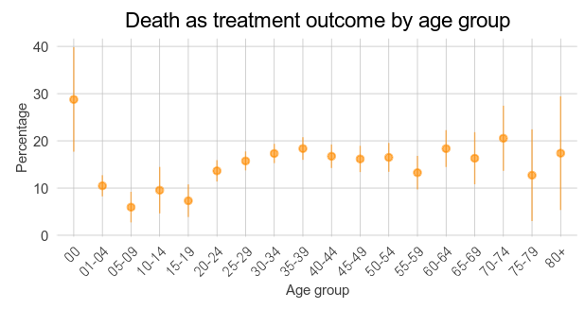

Treatment failed in similar proportions in HIV-positive patients and HIV negative patients: 1.0% (37 cases) against 1.0% (14 cases), respectively (p = 0.87); and also for men and women: 1.3% (64 cases) and 1.2% (51 cases), respectively (p = 0.96).

**DISCUSSION:**

This study shows that the incidence of tuberculosis in the District of Manhiça is increasing, having nearly tripled over the 16 year period of observation. TB patients were generally young adults and increasingly co-infected with HIV. Over time, we observed a trend of increasing bacteriologically unconfirmed disease. Incidence was higher than men than women across all age groups except for the very young (where incidence was very low generally).

The trend towards increased TB incidence and increased TB-HIV co-infection represents an important threat to public health. Further research is needed regarding the potential social, migratory, and biomedical implications and dimensions of this increase. Nonetheless, this study, though simple in its methods and approach, can inform public health practice and guide future scientific investigation into the areas of TB, TB-HIV co-infection, and general infectious disease surveillance in Southern Africa.

**REFERENCES:**

1. Who. Global tuberculosis report 2014 (WHO/HTM/TB/2014.08). 2014;

2. Salomao MA. The National Tuberculosis Control Programme in Mozambique, 1985-1990. Bull Int Union Tuberc Lung Dis [Internet]. 1991 Dec [cited 2015 Jun 2];66(4):175–8. Available from: http://www.ncbi.nlm.nih.gov/pubmed/1687510

3. Murray CJ, DeJonghe E, Chum H, Nyangulu D, Salomao a, Styblo K. Cost-effectiveness of Chemotherapy for Pulmonary Tuberculosis in Three Sub-Saharan African Countries. Lancet. 1991;338:1305–8.

4. Cliff J, Walt G, Nhatave I. What ’ s in a Name ? Policy transfer in Mozambique : DOTS for tuberculosis and sy ... 2004;

5. Ogden J, Walt G, Lush L. The politics of “branding” in policy transfer: The case of DOTS for tuberculosis control. Soc Sci Med. 2003;57(1):179–88.

6. Garcia-Basteiro a. L, Lopez-Varela E, Respeito D, Gonzalez R, Naniche D, Manhica I, et al. High tuberculosis burden among people living with HIV in southern Mozambique. Eur Respir J [Internet]. 2014;45(2):547–9. Available from: http://erj.ersjournals.com/cgi/doi/10.1183/09031936.00145714

7. González R, Munguambe K, Aponte JJ, Bavo C, Nhalungo D, Macete E, et al. High HIV prevalence in a southern semi-rural area of Mozambique: A community-based survey. HIV Med. 2012;13(10):581–8.

8. Organization WH. Definitions and reporting framework for tuberculosis–2013 revision [Internet]. 2013. Available from: http://apps.who.int/iris/handle/10665/79199

9. Report GT. Methods used to estimate the global burden of disease caused by TB. 2012;2009(2):1–22.

10. Auld AF, Mbofana F, Shiraishi RW, Alfredo C, Sanchez M, Ellerbrock T V., et al. Incidence and Determinants of Tuberculosis among Adults Initiating Antiretroviral Therapy - Mozambique, 2004-2008. PLoS One. 2013;8(1):2004–8.

11. García-Basteiro AL, López-Varela E, Respeito D, González R, Naniche D, Manhiça I, et al. High tuberculosis burden among people living with HIV in southern Mozambique. Eur Respir J [Internet]. 2015 Feb [cited 2015 Apr 22];45(2):547–9. Available from: http://www.ncbi.nlm.nih.gov/pubmed/25395030

12. Perez-Hoyos S, Naniche D, Macete E, Aponte J, Sacarlal J, Sigauque B, et al. Stabilization of HIV incidence in women of reproductive age in southern Mozambique. HIV Med [Internet]. 2011;500–5. Available from: http://www.ncbi.nlm.nih.gov/pubmed/21794055

13. Pfeiffer J, Montoya P, Baptista AJ, Karagianis M, Pugas MDM, Micek M, et al. Integration of HIV/AIDS services into African primary health care: Lessons learned for health system strengthening in Mozambique - A case study. J Int AIDS Soc. 2010;13(1):1–9.