Identifying opportunities: measuring the economic impact of malaria elimination in Mozambique

Proposal for project 2: Foreign investments to finance malaria elimination: evidence from the south of Mozambique

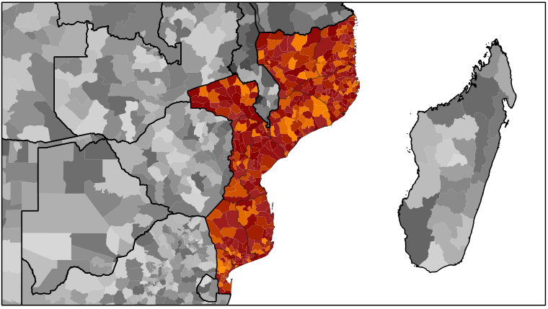

Joe Brew, MPH, MA

Erasmus Mundus, TransGlobalHealth PhD Proposal

# Project summary

The elimination of malaria in Mozambique will require foreign capital. The purpose of this project is to inform guide the flow of that capital to interventions, projects, business opportunities and areas which stand to gain the most from eradication, both in terms of economic and health improvements. By (1) quantifying the burden of malaria across spatial and sociodemographic lines, (2) modeling the impact of certain kinds of investments on the economy and health and (3) building a public "toolkit" to make sure that high-quality data are readily available to potential investors, this project seeks to facilitate the partnerships and collaborations necessary for the eradication of malaria.

# Description of the project

## Background and significance (relevance and innovativeness)

The elimination of malaria from Mozambique is not an obstacle to be surmounted, but rather an opportunity to be seized. The eradication of this disease will save countless lives, unleash the human potential of Mozambicans, and help to facilitate the country's fuller participation in the international economy.}

Elimination of malaria will require collaboration between large foreign funding sources, policy makers, and local public health practitioners. The nature of this partnership, however, does not need to be based on aid; in fact, sustainable solutions will require that incentives and incentives be clearly measured, so as to attract foreign investment. With good data, and a comprehensive presentation of those data, a symbiotic solution to Mozambique's malaria endemic can be achieved.

## Objectives

The objectives of this project are three-fold:

1. **Diagnosis:** Identify the current economic burden of malaria in mozambique across economic sectors, regions, time and sociodemographic groups.
2. **Prognosis:** Evaluate, model and compare projected intervention outcomes (quantifying uncertainty) both in terms of economic and health gains.
3. **Treatment:** Translate knowledge into action by building data "toolkits" and investment guides, fostering public-private partnerships, outlining best practices for eradication, and incorporating a strong evaluation component (for the post-project period) so that the global health, scientific and business communities can learn from the experience.

## Main research questions

What is the current economic burden of malaria in Mozambique? Which sectors of the economy stand to gain most from eradication? Which investment opportunities are likely to result in the greatest health and economic gains?

## Theoretical framework

Since the benefits of malaria eradication will traverse the health, education and industry sectors of the Mozambican economy, so to does the project seek to address eradication's economic impact across these lines. By using standardized measurement tools and comparative observational analysis methods[1], eradication-related investment opportunities can be quantified in a way that will guide foreign investment for the mutual benefit of the investor, the people of Mozambique and the scientific and global health communities at large.

A great deal of work has been carried out quantifying the costs of specific malaria control practices in Tanzania,[2] [3] [4] but very little has been done to quantify the human and economic costs of the endemic.[5] Most work dealing on the economic side of malaria either focuses largely on the health sector and treatment costs[6] and focus on other African countries.[7] Nonetheless, solid methods have been developed to assess malaria’s economic costs across settings;[8] this project will employ those methods.

This project aims to draw largely on a dual cost-utility and cost-minimisation analysis. The cost-utility approach will be employed to quantify benefits to the health sector and Tanzanian economy in general, whereas the cost-minimisation approach will be employed primarily for the purposes of communication with the business and investment communities at-large.[9]

## Research approach

**Phase 1:** For the "prognosis" phase of the project, I will conduct (a) a literature review of malaria-related economic evaluations, (b) a meta-analysis of the economic returns on malaria interventions in East Africa, and (c) a series of qualitative focus groups involving principal actors and stakeholders from both representative Mozambican political, economic and social groups, as well as potential international investment groups. The latter will take place only following approval from the appropriate ethical committees, institutional review boards, and governmental agencies.

**Phase 2:** For the "diagnosis" phase of the project, I will design, distribute, collect and analyze a large survey detailing labor market and social activity, as well as clinical history, among a representative cross-section of Mozambicans. This will allow for a clear assessment of how malaria impacts economic activity and attitudes. In the analysis, I will simulate (using established methods from the field of health economics[10]) differential reductions in malaria's burden by time and space, so as to guide potential investors to where the "opportunities for improvement" are greatest.

**Phase 3:** The "treatment" phase of this project will consist of both of the publication of academic articles related to phases 1 and 2, as well as a more informal "toolkit" of best practices and guidelines, so as to guide international investment.[11]

The analysis phase of the project will consist of (1) feature generation, aggregation and public data joins, (2) model construction and (3) model testing.

**Research Deliverables: Dissemination of Results and Publication Policy:** This study has both scientific (objectives 1 and 2) and policy (objective 3) components. For the former two, the economic burden of malaria will be presented by space, time, sociodemographic characteristics and differential sector impact, and submitted to high impact journals for publication, with credit attributed to the relevant universities, governmental agencies and Erasmus Mundus organization. This deliverable will guide further research as well as inform potential investors as to which sectors of the economy are most open to positive disruption, and where return is likely highest. For the latter, the main objective is the development and dissemination of an investment framework for any potential foreign investor. This "framework" consists of both a "toolkit" (open-source statistical code) as well as an interactive (web-based) platform to help guide investors in the identification of potentially profitable and mutually beneficial opportunities.

Words: 954

# References

ME Drummon, MJ Sculpher, GW Torrance, et al. Methods for the economic evaluation of health care programmes, 3rd ed, Oxford University Press, 2005.

E Etiabe, O Onwujekwe, et al. What co-morbidities do people with malaria have and what are their patterns of health seeking in Nigeria? Niger J Clinic Pract. 2015 Jan-Feb;18(1):22-6.

LM Lorenz, HJ Overgaard, et al. Investigating mosquito net durability for malaria control in Tanzania - attrition, bioefficacy, chemistry, degradation and insecticide resistance (ABCDR): study protocol. BMC Public Health. 2014 Dec 13;14(1):1266.

M Maheu-Giroux, MC Castro. Cost-effectiveness of larviciding for urban malaria control in Tanzania. Malar J. 2014 Dec 4;13(1):477.

L Mangham-Jeffries, V Wiseman, et al. Economic evaluation of a cluster randomized trial of interventions to improve health workers’ practice in diagnosing and treating uncomplicated malaria in cameroon. Value Health. 2014 Dec; 17(8):783-91.

J Matowo, J Kitau, et al. Trends in the selection of insecticide resistance in Anopheles gambiae s.I. mosquitoes in northwest Tanzania during a community randomized trial of longlasting insecticidal nets and indoor residual spraying. Med Vet Enotmol. 2014 Dec 24.

JF Mosha, HJ Sturrock, et al. The independent effect of living in malaria hotspots on future malaria infection: an observational study from Misungwi, Tanzania. Malar J. 2014 Nov 21;13:445.

AJ Oostovegls, GA De Wit, et al. Use of DALYs in economic analyses on interventions for infectious diseases: a systematic review. Epidemiol Infect. 2014 Dec 12:1-12.

E Walter, S Zehetmayr. Guidelines on Health Economic Evaluation: Consensus paper. April 2006, Institut fur Pharmaokonomische Forschung. <http://www.ispor.org/peguidelines/source/Guidelines_Austria.pdf>

1. ME Drummon, MJ Sculpher, GW Torrance, et al. Methods for the economic evaluation of health care programmes, 3rd ed, Oxford University Press, 2005.
2. M Maheu-Giroux, MC Castro. Cost-effectiveness of larviciding for urban malaria control in Tanzania. Malar J. 2014 Dec 4;13(1):477.
3. LM Lorenz, HJ Overgaard, et al. Investigating mosquito net durability for malaria control in Tanzania - attrition, bioefficacy, chemistry, degradation and insecticide resistance (ABCDR): study protocol. BMC Public Health. 2014 Dec 13;14(1):1266.
4. J Matowo, J Kitau, et al. Trends in the selection of insecticide resistance in Anopheles gambiae s.I. mosquitoes in northwest Tanzania during a community randomized trial of longlasting insecticidal nets and indoor residual spraying. Med Vet Enotmol. 2014 Dec 24.
5. JF Mosha, HJ Sturrock, et al. The independent effect of living in malaria hotspots on future malaria infection: an observational study from Misungwi, Tanzania. Malar J. 2014 Nov 21;13:445.
6. E Etiabe, O Onwujekwe, et al. What co-morbidities do people with malaria have and what are their patterns of health seeking in Nigeria? Niger J Clinic Pract. 2015 Jan-Feb;18(1):22-6.
7. L Mangham-Jeffries, V Wiseman, et al. Economic evaluation of a cluster randomized trial of interventions to improve health workers’ practice in diagnosing and treating uncomplicated malaria in cameroon. Value Health. 2014 Dec; 17(8):783-91.
8. AJ Oostovegls, GA De Wit, et al. Use of DALYs in economic analyses on interventions for infectious diseases: a systematic review. Epidemiol Infect. 2014 Dec 12:1-12.
9. E Walter, S Zehetmayr. Guidelines on Health Economic Evaluation: Consensus paper. April 2006, Institut fur Pharmaokonomische Forschung. <http://www.ispor.org/peguidelines/source/Guidelines_Austria.pdf>
10. The methods will depend, to some extent, on the kind and quality of data available. That said, my intention is to use stoachistic modeling to quantify both the likelihood and uncertainty of moving from different economic productivity "states" as a function of a region's or an individual's likelihood of malaria infection. Hidden Markov models, such as Baum-Welch's method, as well as Markov chain Monte Carlo methods, will be utilized.
11. See https://joebrew.shinyapps.io/sliv/ for an example of a similar project, created solely by the applicant.