JOE BREW (UFID: 0402-8902)
Homework 4: Geocoding Attributable table
PHC 6194: Spatial Epidemiology

Question 1
Project Background: We have an address table which has the address information of all dry-cleaning facilities in Orlando city. This dataset is named as “Orlando.dbf”. The variables in the data include:
“COUNTY”: the county of the facility;
“FAC_NAME”: the name of the facility;
“FAC_ID”: the unique ID of the dry-cleaning facility in Orlando;
“FAC_ADDR”: the street address of the dry-cleaning facility;
“FAC_CITY”: the city of the dry-cleaning facility;
“FAC_ZIP”: the zipcode of the dry-cleaning facility;

Part 1A
Geocode the address table with an address locator, create a new shapefile of “Orland_DCF.shp” and make a screen shot to show the map from geocoding .

The specific steps for this project:

- Download TIGER files for Orlando/Orange County from the U.S. Census Bureau
http://www.census.gov/cgi-bin/geo/shapefiles2010/main;

- Define a correct coordinate system if the downloaded shapefile in step 1 has no coordinate systems;

- Create a new address locator;

Note: please select the right address style; Use the shapefile which you download in step 1 as a reference map; output the longitude and latitude information;

- Geocoding the table;

- Make a screen shot to copy the map from ArcGIS and paste it in a word document for grading.
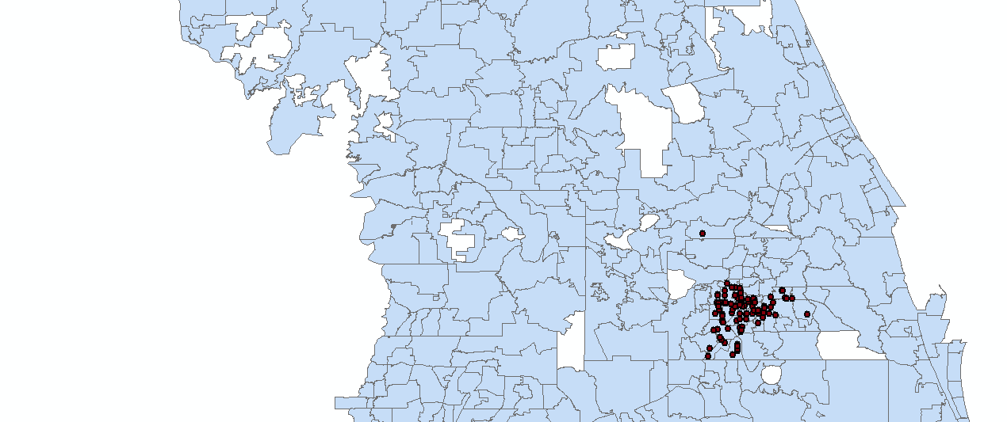

Part 1b

Geocoding with composite address locator, create a new shapefile of “Orland_DCF_zip.shp” and make a screen shot to show the map from geocoding .

The specific steps for this project:
- Download 2000 5-digit Postal code Shapefile in Florida:
http://www.census.gov/geo/www/cob/z52000.html#shp
- Creating a composite address locator using TIGER files from 1a and 5-digit Postal code Shapefile as references datasets;
- Repeats the same steps in 1a and Geocoding “Orlando.dbf”
- Make a screen shot to copy the map from ArcGIS and paste it in a word document for grading..

Question 2: Add X, Y table and create a new shapefile
The dataset of “FL_wel.xls” provides the X,Y coordinate system of the private wells in FL. The X,Y coordinate system is as the format of degrees, minutes, and seconds in a field with a delimiter of “-”.

- Please convert the values to decimal degrees and store them in a numeric field.

Note: a. You can use any software including SAS or Excel to complete the work
b. When converting to decimal degrees, convert longitude values that are in the western hemisphere or latitude values that are in the southern hemisphere to negative decimal degree values. (Attention: All wells locate in FL)

- Create the layer (i.e. shapefile) of “FL_PRIVATE_WELL” with a geographic coordinate system of “WGS 84” with the cleaned X,Y table using one of the following methods which we discussed in the class;
Using the Tools menu and click Add XY Data (i.e Method 1 in the handout);
Using Method 2 in the handout (i.e “display X,Y data”);
Or
Using ArcCatalog to create a feature class from X, Y table.

- Make a screen shot to copy the map from ArcGIS and paste it in a word document for grading..

