JOE BREW (UFID 0402-8902)

Homework 6: Spatial Analysis
PHC 6194: Spatial Epidemiology

Questions:
The Alachua county, has experienced a substantial increase in population. Demographic data suggests this increase has occurred because of families moving to the region. It has been decided that a new hospital must be built and as GIS specialist, you have been assigned the task of finding the potential site.

Solutions:
To come up with some preliminary alternatives for the hospital site you have identified two simple criteria:

- The new hospital should not be located close to existing hospitals
- The new hospital should be built on suitable land use (appropriate land use and slope)

Datasets:
Dataset | Description
Elevation | Raster dataset representing the elevation of the area
Landuse | Raster dataset representing the land-use types over the area
Hospitals | Feature class representing the existing hospitals in the region

Please follow the tutorial and find the best locations for this hospital. Please export the final map as image and insert the image in this document for grading. Please export the
image of the model which you create for the work and submit the image too.

# Load package
library(sp)
library(raster)
library(spatstat)
library(rgdal)

# Setwd
setwd("/home/joebrew/Documents/uf/phc6194/hw6")

# Read in objects and transform to same projection system

# Elevation (raster)
elevation <- readGDAL("elevation1.tif") # read in
relevation <- raster(elevation) # rasterlayer version
#ielevation <- as.im(elevation) #image version

# Hospitals (spatial dataframe)
hospitals <- readOGR(".", "Hospital")
hospitals <- spTransform(hospitals,
CRS(proj4string(elevation)))
# Land use (raster)
land_use <- readGDAL("Land_use.tif")
rland_use <- raster(land_use) # raster version

land_use <- spTransform(land_use,
CRS(proj4string(elevation)))
rland_use <- spTransform(rland_use,
CRS(proj4string(elevation)))

# Alachua boundary
boundary <- readOGR(".", "Alachua_Boundary")
boundary <- spTransform(boundary,
CRS(proj4string(elevation)))
#####
# Quick plot of elevation and hospitals to confirm that coordinate
# transformation worked
#####
#image(elevation, col= grey(1:99/100), axes=TRUE)
#plot(hospitals, col = "red", add = TRUE)
#image(land_use, col= adjustcolor(grey(1:99/100), alpha.f=0.2), axes=TRUE)

# Pick best place for new hospital.
# It should be far from other hospitals and should be on appropriate land / slope

# First, let's generate a random set of possible points
x <- sample(seq(min(coordinates(elevation)[,1]),
max(coordinates(elevation)[,1]),
length = 10000),
10000)
y <- sample(seq(min(coordinates(elevation)[,2]),
max(coordinates(elevation)[,2]),
length = 10000),
10000)
posibs <- data.frame(cbind(x,y))
coordinates(posibs) <- ~x+y

# Now, let's get the land use for each of those points
posibs_land_use <- extract(rland_use, coordinates(posibs))

# Now let's get the elevation for each of those points
posibs_elevation <- extract(relevation, coordinates(posibs))

# Put land_use and elevation together
posibs_data <- data.frame("land_use" = posibs_land_use,
"elevation" = posibs_elevation)

# Bind it all into a spatial dataframe
posibs <- SpatialPointsDataFrame(coords = coordinates(posibs),
data = posibs_data)

# Get right CRS / proj4string
proj4string(posibs) <- CRS(proj4string(elevation))

# So, now we have all these random points with their associated
# land_use and elevation
# This is called posibs, and it's a SpatialPointsDataFrame

# Now, let's keep only those points which are in Alachua County
x <- over(posibs, polygons(boundary))
posibs <- posibs[which(!is.na(x)),]

# Plot posibs to confirm that it works well
plot(posibs, col = adjustcolor("black", alpha.f = 0.1))
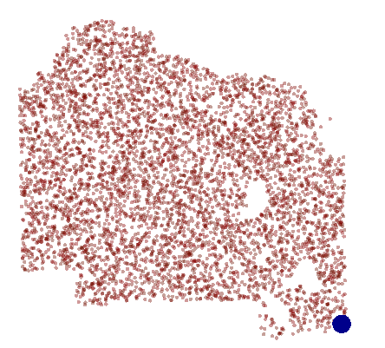
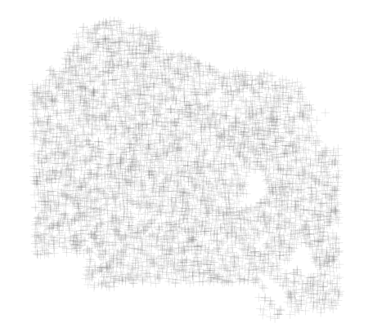

# Land use is a numeric coded object - and we have not been given instructions
# As far as how to code it!
# Base on the (somewhat confusing) email, I'm assuming that 1-10 is good land
# for hospitals and all others are bad?
# I'll recode accordingly
posibs$land_use <- ifelse(posibs$land_use >= 1 & posibs$land_use <= 10, "bad", "good")

# Now, let's keep only those possible locations with good land use
posibs <- posibs[which(posibs$land_use == "good"),]

# Let's plot to see what we're left with
plot(posibs, col = adjustcolor("black", alpha.f = 0.1))

# So, now we're left with about 50,000+ possible locations
# Let's get rid of those with bad slopes

# To get elevation change at each point, we'll
# need to make assumptions. I'm assuming that the hospital
# will be 100 meters in all directions from a central point
library(rgeos)
buffers <- gBuffer(posibs, width = 100)
proj4string(buffers) <- CRS(proj4string(elevation))

# Get elevation differential for each area in buffers
zmax <- extract(relevation,
coordinates(posibs),
buffer = 100,
fun = max,
na.rm = TRUE) #max
zmin <- extract(relevation,
coordinates(posibs),
buffer = 100,
fun = min,
na.rm = TRUE) #min
# Now add total diferential for area back to posibs
posibs$slope <- zmax - zmin

# Get distance from nearest hospital
posibs$distance_from_nearest_hosp <- NA
for (i in 1:nrow(posibs)){
hosp <- spDistsN1(coordinates(hospitals), pt = coordinates(posibs)[i,])
posibs$distance_from_nearest_hosp[i] <- min(hosp, na.rm = TRUE)
}

spDistsN1(coordinates(posibs), pt = coordinates(hospitals)[1,])

##################
# NOW FOR THE FINAL CALCULATIONS

# Let's scale both slope and distance from nearest hospital
posibs$slope_rec <- scale(posibs$slope)
posibs$distance_rec <- scale(posibs$distance_from_nearest_hosp)

# We wan't LOW slope but HIGH distance, so let's invert slope
# so that both variables we want high
posibs$slope_rec <- posibs$slope_rec * -1

# I'm going to weight distance 3 times as much as slope,
# since slope can be fixed through modern engineering
posibs$distance_rec <- posibs$distance_rec *2

# Assign a score (at this point, it's just a combo of slope_rec and distance_rec,
# since I've already weighted)
posibs$score <- posibs$distance_rec + posibs$slope_rec

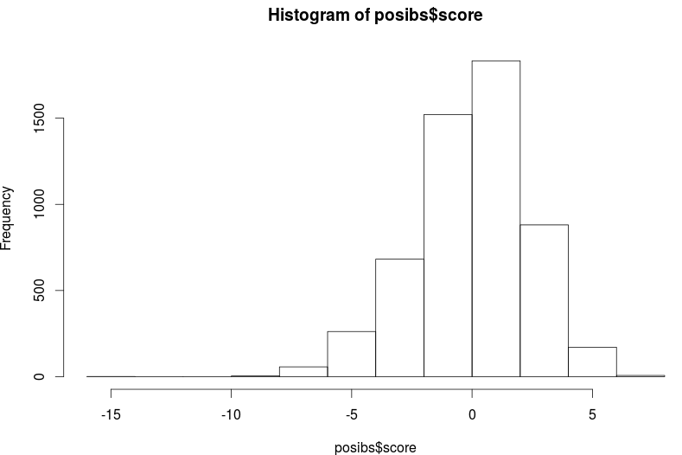
# Look at that score
hist(posibs$score)

# Make a color vector and plot
library(RColorBrewer)
myrange <- ceiling(max(posibs$score)) - ceiling(min(posibs$score))
mycols <- colorRampPalette(c("darkred", "darkgreen"))(myrange + 1)
mycols <- adjustcolor(mycols, alpha.f = 0.4)

plot(posibs,
pch = 16,
cex = 0.6,
col = mycols[ceiling(min(posibs$score)) + ceiling(posibs$score) + 1] )

# Best place to build new hospital
points(posibs[which(posibs$score == max(posibs$score)),],
col = "darkblue", pch = 16,
cex = 3)

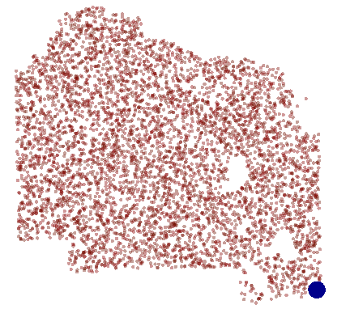

# Haha - well, it's flat and far away from other hospitals...
# And I guess that's what I asked for. :/

Here's my proposal for the hospital:
