Joe Brew

PHC 6053 – Assignment 8

Part 1: SAS outputs

Part 2: SAS and R code

*Note: I used R as a supplement to SAS for this assignment. I did the entirety of the assignment in both, and code is side by side. Because I have find certain dataset manipulations to be hard in SAS (subsetting, dealing with categorical data, etc.), I relied largely on R for number 5. I’m worse at SAS than I am at R, and make a note of when I know my SAS output is incorrect (but my R output is correct)

1. NA

2. **AGE**

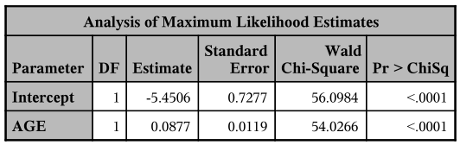 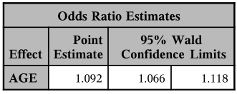

**BMI**

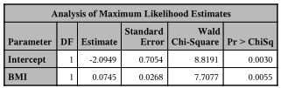 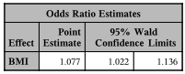

**BMIGROUP**

CORRECT. *(I did this in R because I’m not confident in using categorical variables in logistic regression in SAS, but I am in R)

|  |  |  |  |  |  |  |
| --- | --- | --- | --- | --- | --- | --- |
| Category | Estimate | Std. Error | Z | P | OR | 95% CI |
| Intercept | -0.4875 | 0.1439 | -3.389 | 0.0007 | 0.614 | 0.462-0.812 |
| Overweight | 0.5323 | 0.1966 | 2.708 | 0.006768 | 1.703 | 1.160-2.509 |
| Obese | 0.6698 | 0.2860 | 2.342 | 0.0192 | 1.954 | 1.117-3.440 |

*THE BELOW IS INCORRECT! But hey, give me credit, since I KNOW it’s incorrect, and I know how to get the correct answers, which are:

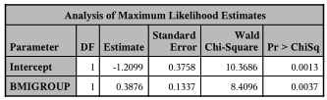 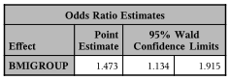

**SEX**

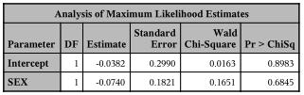 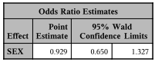

**BPMEDS**

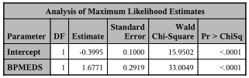 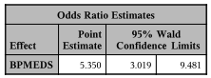

**PREVSTRK**

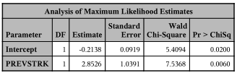 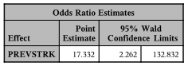

3.

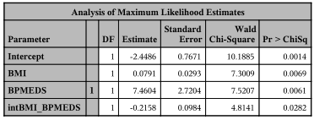 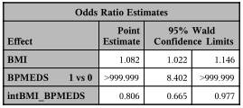

4.

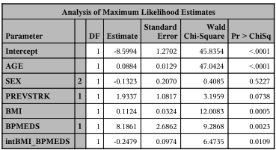 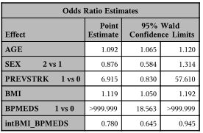

5.

|  |  |  |
| --- | --- | --- |
| **Variable** | **Unadjusted OR (95% CI)** | **Adjusted OR (95% CI)** |
| AGE | 1.092 (1.066-1.118) | 1.092 (1.066-1.121) |
| SEX | 0.929 (0.650-1.327) | 0.876 (0.583-1.314) |
| *PREVSTRK* | 17.332 (2.262-132.832) | 6.923 (0.583-1.314) |
| BMI (BPMEDS=No) | 1.082 (1.022-1.470) | 1.116 (1.048-1.190) |
| BMI (BPMEDS=Yes) | 0.872 (0.719-1.044) | 0.866 (0.713-1.037) |

(The following table uses values obtained from the models from question 2 only)

|  |  |
| --- | --- |
| **Variable** | **Unadjusted OR (95% CI)** |
|  |  |
| BMI (single variable model) | 1.077 (1.023-1.136) |
| BPMEDS (single variable model) | 5.350 (3.084-9.746) |
|  |  |
| Obese vs. Normal | 1.954 (1.117-3.344) |
| Overweight vs. Normal | 1.703 (1.160-2.509) |