**/*JOE BREW**

**PHC 6053**

**Exam 1*/**

*READ IN THE DATA FROM ASSIGNMENT 1;

LIBNAME exam1 'E:\workingdirectory\phc6053\exam1';

**DATA** exam1.mydata;

SET exam1.fghm81;

RUN;

*ASSIGN THE DATA TO &DAT;

%let dat=exam1.mydata;

RUN;

*OPTIONAL: OUTPUT DIRECTLY AS A PDF FILE/;

ods pdf file = "E:\workingdirectory\phc6053\exam1\exam1.pdf" notoc;

/* CREATE A BMIGROUP VARIABLE*/

**data** &dat;

set &dat;

BMIGROUP=**.**;

if BMI<**18.5** then BMIGROUP=**1**;

if BMI >= **18.5** & BMI < **25** then BMIGROUP = **2**;

if BMI >= **25** & BMI < **30** then BMIGROUP = **3**;

if BMI >= **30** then BMIGROUP = **4**;

RUN;

# /* 1. Remove all the individuals in the underweight BMI group AND all the individuals with a BMI which is 40 or larger*/

/* VARIABLE NAMES:

BMIGROUP (4 level categorical variable labeled as directed [1=under, 2=norm, 3=over, 4=obese)

BMIOVER (2 level categorical variable, labeled as 1=overweight, 2=not)

BMIOBESE (2 level categorical variable, labeled as 1=obese, 2=not)

BMIDUM (4 level categorical variable labeled in English as underweight (removed), normal, over, obese)

*/

**data** dat2;

set &dat;

if BMIGROUP = **1** then delete;

if BMI > **40** then delete;

run;

/* Create LN(SYSBP)*/

**data** dat2;

set dat2;

LNSBP=**.**;

LNSBP=log(SYSBP);

run;

/* Create DUMMY variables for each shift */

**data** dat2;

set dat2;

if BMIGROUP = **2** then BMIOVER = **0**;

if BMIGROUP = **2** then BMIOBESE = **0**;

if BMIGROUP = **3** then BMIOVER = **1**;

if BMIGROUP = **3** then BMIOBESE = **0**;

if BMIGROUP = **4** then BMIOVER = **0**;

if BMIGROUP = **4** then BMIOBESE = **1**;

run;

/* Create BMIDUM (for use with GLM)*/

**proc** **format**;

value bmigroupcode **2**='normal' **3**=' over' **4**=' obese';

**run**;

**data** dat2;

set dat2;

BMIDUM = BMIGROUP;

**data** dat2;

set dat2;

format BMIDUM bmigroupcode.;

run;

/*TAKE A LOOK AT THE FIRST 7 OBSERVATIONS*/

**proc** **print** data=dat2 (obs=**7**);

**run**;

# /* 2. Create a scatterplot with LOESS curve for Y=LN(SYSBP) by BMI */

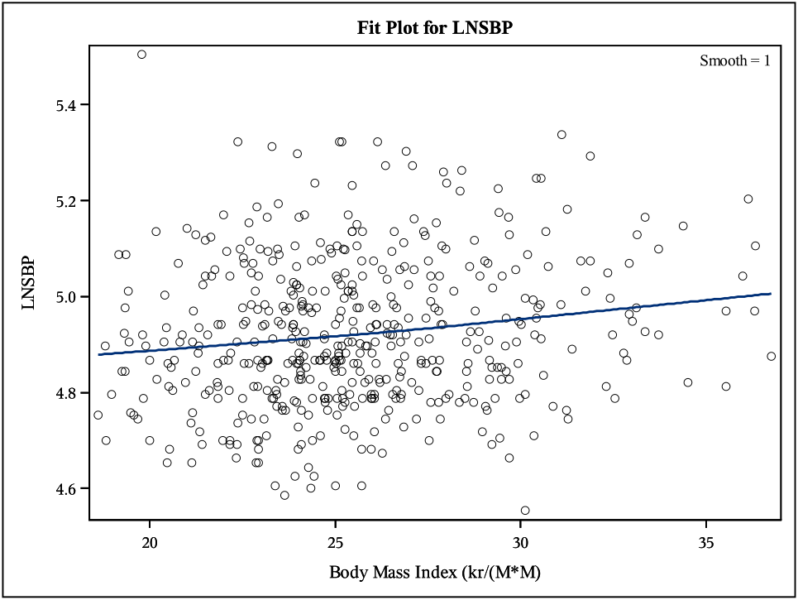

/* (Note: you found the simple linear regression equation for this relationship in an assignment) */

**proc** **loess** data=dat2;

model LNSBP=BMI;

**run**;

# /*3. Create side-by-side boxplots of Y= LNSBP by BMI groups (you should only have 3 groups now).*/

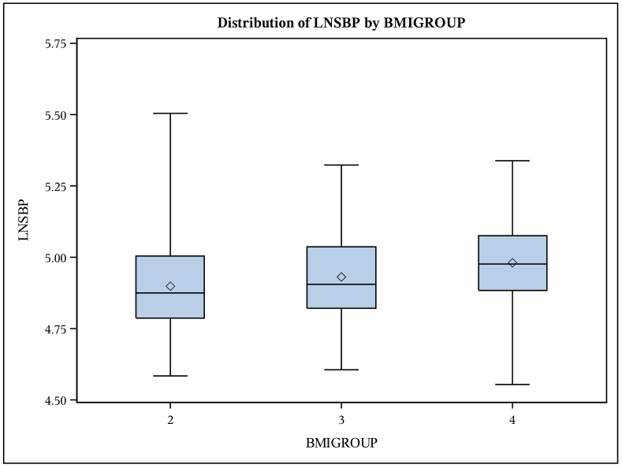

/* first sort the data*/

**proc** **sort** data=dat2;

by BMIGROUP;

**run**;

**proc** **boxplot** data=dat2;

plot LNSBP*BMIGROUP;

**run**;

# /* 4. Conduct a linear regression analysis for Y = LNSBP using the indicator variables you created for BMI groups as predictors.

Provide only the table of parameter estimates

(note: if you want to convince yourself, run an ANOVA on this data and compare the results to those of the reg model)*/

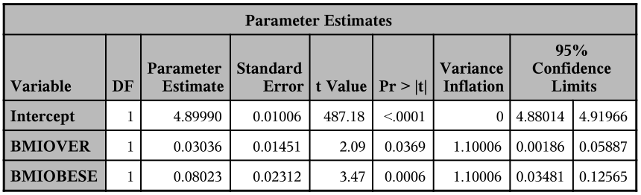

**proc** **reg** data=dat2;

model LNSBP= BMIOVER BMIOBESE/clb vif ;;

**run**;

**quit**;

# /*5. Conduct a linear regression analysis for Y=LNSBP using BMI groups.

In comparison to the previous model, you must use your software to create the indicator variables

for you while still using normal individuals as the reference group.

The goal is to obtain the same analysis as the previous question without coding

the indicator variables directly. Provide only the table of parameter estimates */

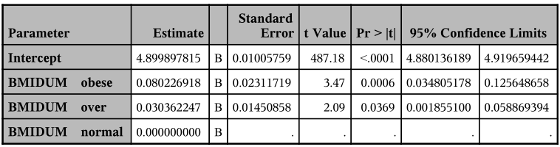

**proc** **glm** data=dat2;

class BMIDUM;

model LNSBP=BMIDUM / solution clparm; ;

**run**;

**quit**;

# /*6. Using the results from the model in question 4 (or 5, since they should be identical)......*/

/* a. Write the estimated regression model */

$$Y_{i}= β_{0}+ β_{1}{ X}_{1}{+ β}_{2}{ X}_{2} {+ …+β}_{i}{ X}_{pi}+ ε_{i}$$

$${LNSBP}_{i}= β_{0}+ β_{1}{ X}_{1}{+ β}_{2}{ X}_{2} {+ …+β}_{i}{ X}_{pi}+ ε_{i}$$

$${\hat{Y}=}_{} β_{0}+ β_{obese}{ X}_{obese}{+ β}_{overweight}{ X}_{overweight}$$

$${E(LNSBP|BMIGROUP)}_{}= β_{0}+ β_{obese}\left(obese\right){+ β}_{overweight}(overweight)$$

$${E(LNSBP|BMIGROUP)}_{}= 4.8999+0.08023\left(obese\right)+0.03036(overweight)$$

/* b. Interpret all three parameter estimates in the model clearly in the words of the problem */

The **intercept** (4.8999) is the mean log of systolic blood pressure (LNSBP) when both dummy variables (obese / over) are equal to 0. In other words, this is the mean LNSBP for a person of normal weight.

The **estimate for obese** (0.08023) is the mean increase in LNSBP when ${ X}_{obese}$ increases by one unit. Given that this is a binary dummy variable, this simply means that this is the mean difference between the LNSBP of obese relative to normal.

The **estimate for over** (0.0304) is the mean increase in LNSBP when ${ X}_{over}$ increases by one unit. Given that this is a binary dummy variable, this simply means that this is the mean difference between the LNSBP of overweight relative to normal.

/* c. Show EXPLICITLY how you can use the model to estimate the mean LNSBP for each of the three levels of BMI.

Show all work.

(Note: you should verify for yourself that these are simply the sample means for the three groups in analysis

(which does not adjust for any other covariates))*/

One can estimate mean LNSBP by simply plugging a person’s characteristics into the model. For example, a person of normal weight gets a 0 in the obese and a 0 in the over categories. Accordingly, their estimated mean LNSBP will be

$$E(LNSBP|{BMIGROUP}_{normal})= 4.8999+0.08023\left(0\right)+0.03036(0)$$

$$E(LNSBP|{BMIGROUP}_{normal})= 4.8999$$

Likewise, one could estimate the mean LNSBP of an obese person by simply plugging in a 1 for the appropriate placeholder.

$$E(LNSBP|{BMIGROUP}_{obese})= 4.8999+0.08023\left(1\right)+0.03036(0)$$

$$E\left(LNSBP | {BMIGROUP}_{obese}\right)= 4.8999+0.08023$$

$$E\left(LNSBP | {BMIGROUP}_{obese}\right)= 4.98013$$

# /* 7. Create a scatterplot of Y=LNSBP and X=BMI grouped by BPMEDS with LOWESS curves for each value of BPMEDS.

(Note: don't answer here but... what is "happening" behind this plot? Think about it!"*/

 

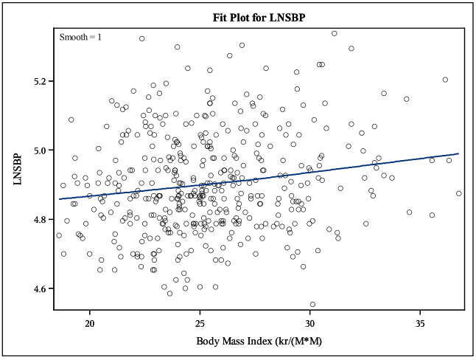 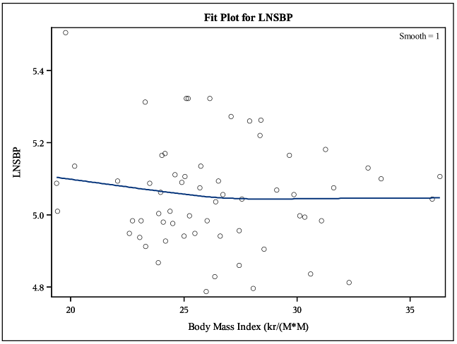

/* First, create a BPMEDSREC variable which uses English instead of numbers*/

**proc** **format**;

value bpmedscode **0**='no' **1**=' yes' ;

**run**;

**data** dat2;

set dat2;

BPMEDSREC = BPMEDS;

**data** dat2;

set dat2;

format BPMEDSREC bpmedscode.;

run;

/* Now sort the data*/

**proc** **sort** data=dat2;

by BPMEDSREC;

**run**;

**proc** **loess** data=dat2;

by BPMEDSREC;

model LNSBP=BMI;

**run**;

# /* 8. Conduct a linear regression analysis for Y=LNSBP using BMI (quantitative), BPEMDS (reference=no), and their interaction term.

Allow software to handle reference category and interaction term. Provide only table of

parameter estimates.*/

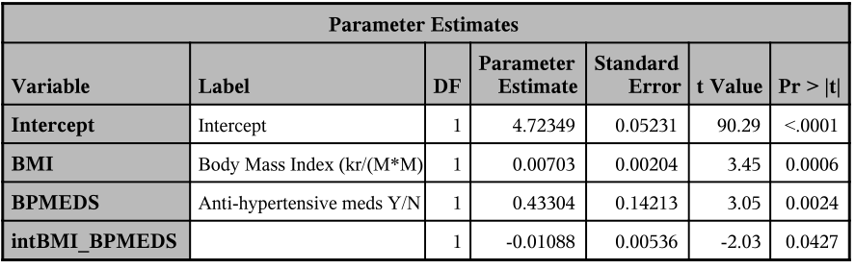

/* First, create interaction term*/

**data** dat2;

set dat2;

intBMI_BPMEDS = BMI * BPMEDS;

run;

**proc** **reg** data=dat2;

model LNSBP= BMI BPMEDS intBMI_BPMEDS;

**run**;

**quit**;

# /* 9. Using the results from the model in question 8... */

/* a. Write the complete estimated regression model */

$$Y_{i}= β_{0}+ β_{1}{ X}_{1}{+ β}_{2}{ X}_{2} {+ …+β}_{i}{ X}_{pi}+ ε_{i}$$

$${LNSBP}_{i}= β_{0}+ β_{1}{ X}_{1}{+ β}_{2}{ X}_{2} {+ …+β}_{i}{ X}_{pi}+ ε_{i}$$

$${E\left(LNSBP | BMI, BPMEDS\right)}_{}= β_{0}+ β_{BMI}{ X}_{BMI}{+ β}_{BPMEDS}{ X}_{BPMEDS}{+ β}_{intBMIBPMEDS}{ X}_{{intBMIBPMEDS}_{}}$$

$${\hat{Y } }_{}= β_{0}+ β_{BMI}(BMI){+ β}_{BPMEDS}{ \left(BPMEDS\right)}_{}{+ β}_{intBMIBPMEDS}(intBMIBPMEDS)$$

$$E\left(LNSBP | BMI, BPMEDS\right)= 4.72349+0.00703\left(BMI\right)+0.43304\left(BPMEDS\right)-0.01088(intBMIBPMEDS)$$

/* b. Show EXPLICITLY how to use the complete estimated model to find the estimated equations for each BPMED group and provide the simplified equations relating LNSBP and BMI for each BPMED group */

BPMEDS = 0

$$E\left(LNSBP | BMI, {BPMEDS}_{0}\right)= 4.72349+0.00703\left(BMI\right)+0.43304\left(0\right)-0.01088(0)$$

$$E\left(LNSBP | BMI, {BPMEDS}_{0}\right)= 4.72349+0.00703\left(BMI\right)$$

BPMEDS = 1

$$E\left(LNSBP | BMI, {BPMEDS}_{1}\right)= 4.72349+0.00703\left(BMI\right)+0.43304\left(1\right)-0.01088(BMI)$$

$$E\left(LNSBP | BMI, {BPMEDS}_{1}\right)= 5.15653- 0.00385(BMI)$$

/* c. Provide an interpretation, in the words of the problem, of the effect of BMI on the mean LNSBP for each BPMED group. */

Among those **not** on BPMEDS, for each 1 unit increase in BMI, the population mean LNSBP is estimated to **increase** by 0.00703 units.

Among those on BPMEDS, for each 1 unit increase in BMI, the population mean LNSBP is estimated to **decrease** by 0.00385 units.

/* d. Use the current model to estimate the mean LNSBP within each BPMED group for BMI values of 20, 30 and 40.

Show your work and provide a summary table of your calculated estimates. */

BPMEDS = 0

BMI=20

$E\left(LNSBP | {BMI}_{20}, {BPMEDS}_{0}\right)= 4.72349+0.00703\left(20\right)+0.43304\left(0\right)-0.01088(0)$

$E\left(LNSBP | {BMI}_{20}, {BPMEDS}_{0}\right)= 4.86409$

BMI=30

$E\left(LNSBP | {BMI}_{30 }, {BPMEDS}_{0}\right)= 4.72349+0.00703\left(30\right)+0.43304\left(0\right)-0.01088(0)$

$E\left(LNSBP | {BMI}_{30 }, {BPMEDS}_{0}\right)= 4.93439$

BMI=40

$E\left(LNSBP | {BMI}_{40 }, {BPMEDS}_{0}\right)= 4.72349+0.00703\left(30\right)+0.43304\left(0\right)-0.01088(0)$

$E\left(LNSBP | {BMI}_{40 }, {BPMEDS}_{0}\right)= 5.00469$

BPMEDS = 1

BMI=20

$E\left(LNSBP | {BMI}_{20}, {BPMEDS}_{1}\right)= 4.72349+0.00703\left(20\right)+0.43304\left(1\right)-0.01088(20)$

* $E\left(LNSBP | {BMI}_{20}, {BPMEDS}_{1}\right)=$ 5.07953

BMI=30

$E\left(LNSBP | {BMI}_{30}, {BPMEDS}_{1}\right)= 4.72349+0.00703\left(30\right)+0.43304\left(1\right)-0.01088(30)$

* $E\left(LNSBP | {BMI}_{30}, {BPMEDS}_{1}\right)=$ 5.04103

BMI=40

$E\left(LNSBP | {BMI}_{40}, {BPMEDS}_{1}\right)= 4.72349+0.00703\left(40\right)+0.43304\left(1\right)-0.01088(40)$

* $E\left(LNSBP | {BMI}_{40}, {BPMEDS}_{1}\right)=$ 5.00253

|  |  |  |  |
| --- | --- | --- | --- |
|  | **BMI** | | |
| **BPMEDS** | **20** | **30** | **40** |
| **0** | 4.86409 | 4.93439 | 5.00469 |
| **1** | 5.07953 | 5.04103 | 5.00253 |

# /*10. Conduct a linear regression analysis for Y = LNSBP using bmi groups (categorical, reference=normal), BPMEDS (reference = no) and their interaction term.

It is up to you to determine how to handle the reference categories and interaction term, but I highly suggest allowing the software to handle these components instead of creating variables yourself. Provide only the table of parameter estimates. */

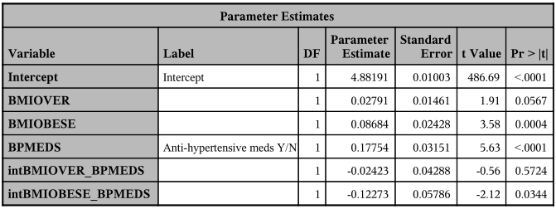

/* First, create multilevel interaction terms*/

**data** dat2;

set dat2;

intBMIOVER_BPMEDS = BMIOVER * BPMEDS;

run;

**data** dat2;

set dat2;

intBMIOBESE_BPMEDS = BMIOBESE * BPMEDS;

run;

**proc** **reg** data=dat2;

model LNSBP= BMIOVER BMIOBESE BPMEDS intBMIOVER_BPMEDS intBMIOBESE_BPMEDS;

**run**;

**quit**;

# /* 11. Using the results from the model in question 10... */

/* a. Write the complete ESTIMATED regression model. */

$$Y_{i}= β_{0}+ β_{1}{ X}_{1}{+ β}_{2}{ X}_{2} {+ …+β}_{i}{ X}_{pi}+ ε_{i}$$

$${LNSBP}_{i}= β_{0}+ β_{1}{ X}_{1}{+ β}_{2}{ X}_{2} {+ …+β}_{i}{ X}_{pi}+ ε_{i}$$

$${E\left(LNSBP | BMIOVER, BMIOBESE, BPMEDS\right)}_{}=$$

$$β_{0}+ β_{BMIOVER}{ X}_{BMIOVER}{+β_{BMIOBESE}{ X}_{BMIOBESE} β}_{BPMEDS}{ X}_{BPMEDS}{+ β}_{intBMIOVERBPMEDS}{ X}_{{intBMIOVERBPMEDS}_{}}{+ β}_{intBMIOBESEBPMEDS}{ X}_{{intBMIOVERBPMEDS}_{}}$$

$${\hat{\hat{Y} } = β}_{0 }+ β_{BMIOVER}{ \left(BMIOVER\right)}_{}{+β_{BMIOBESE}{ \left(BMIOBESE\right)}_{}+ β}_{BPMEDS}{ \left(BPMEDS\right)}_{}{+ β}_{intBMIOVERBPMEDS}(intBMIOVERBPMEDS) {+ β}_{intBMIOBESEBPMEDS}(intBMIOBESEBPMEDS)$$

$$E\left(LNSBP | BMIOVER, BMIOBESE, BPMEDS\right)= 4.88191+0.02791\left(BMIOVER\right)+0.08684\left(BMIOBESE\right)+0.17754\left(BPMEDS\right)-0.02423\left(intBMIOVERBPMEDS\right)-0.12273(intBMIOBESEBPMEDS)$$

/* b. Use the current model to estimate the mean LNSBP within each BPMED group for each BMI category.

I manually wrote this model into R to do the calculations:

model10 <- function(bmiover, bmiobese, bpmeds){

4.88191 +

(0.02791*bmiover) +

(0.08684*bmiobese) +

(0.17754*bpmeds) -

(0.02423*(bmiover*bpmeds)) -

(0.12273*(bmiobese*bpmeds))}

BPMEDS = 1 BMI = NORMAL

$$E\left(LNSBP | {BMIOVER}_{0}, {BMIOBESE}_{0}, {BPMEDS}_{1}\right)= 4.88191+0.02791\left(BMIOVER\right)+0.08684\left(BMIOBESE\right)+0.17754\left(BPMEDS\right)-0.02423\left(intBMIOVERBPMEDS\right)-0.12273(intBMIOBESEBPMEDS)$$

$$E\left(LNSBP | {BMIOVER}_{0}, {BMIOBESE}_{0}, {BPMEDS}_{1}\right)= 4.8819 +0.17754\left(1\right)$$

$$E\left(LNSBP | {BMIOVER}_{0}, {BMIOBESE}_{0}, {BPMEDS}_{1}\right)=5.05945$$

BPMEDS = 1 BMI = OVER

$$E\left(LNSBP | {BMIOVER}_{1}, {BMIOBESE}_{0}, {BPMEDS}_{1}\right)= 4.88191+0.02791\left(BMIOVER\right)+0.08684\left(BMIOBESE\right)+0.17754\left(BPMEDS\right)-0.02423\left(intBMIOVERBPMEDS\right)-0.12273(intBMIOBESEBPMEDS)$$

$$E\left(LNSBP | {BMIOVER}_{1}, {BMIOBESE}_{0}, {BPMEDS}_{1}\right)=5.06313$$

BPMEDS = 1 BMI = OBESE

$$E\left(LNSBP | {BMIOVER}_{0}, {BMIOBESE}_{1}, {BPMEDS}_{1}\right)= 4.88191+0.02791\left(BMIOVER\right)+0.08684\left(BMIOBESE\right)+0.17754\left(BPMEDS\right)-0.02423\left(intBMIOVERBPMEDS\right)-0.12273(intBMIOBESEBPMEDS)$$

$$E\left(LNSBP | {BMIOVER}_{0}, {BMIOBESE}_{1}, {BPMEDS}_{1}\right)=5.02356$$

BPMEDS = 0 BMI = NORMAL

$$E\left(LNSBP | {BMIOVER}_{0}, {BMIOBESE}_{0}, {BPMEDS}_{0}\right)= 4.88191+0.02791\left(BMIOVER\right)+0.08684\left(BMIOBESE\right)+0.17754\left(BPMEDS\right)-0.02423\left(intBMIOVERBPMEDS\right)-0.12273(intBMIOBESEBPMEDS)$$

$E\left(LNSBP | {BMIOVER}_{0}, {BMIOBESE}_{0}, {BPMEDS}_{0}\right)=$ 4.88191

BPMEDS = 0 BMI = OVER

$$E\left(LNSBP | {BMIOVER}_{1}, {BMIOBESE}_{0}, {BPMEDS}_{0}\right)= 4.88191+0.02791\left(BMIOVER\right)+0.08684\left(BMIOBESE\right)+0.17754\left(BPMEDS\right)-0.02423\left(intBMIOVERBPMEDS\right)-0.12273(intBMIOBESEBPMEDS)$$

$E\left(LNSBP | {BMIOVER}_{1}, {BMIOBESE}_{0}, {BPMEDS}_{0}\right)=$ 4.90982

BPMEDS = 0 BMI = OBESE

$$E\left(LNSBP | {BMIOVER}_{0}, {BMIOBESE}_{1}, {BPMEDS}_{0}\right)= 4.88191+0.02791\left(BMIOVER\right)+0.08684\left(BMIOBESE\right)+0.17754\left(BPMEDS\right)-0.02423\left(intBMIOVERBPMEDS\right)-0.12273(intBMIOBESEBPMEDS)$$

$E\left(LNSBP | {BMIOVER}_{0}, {BMIOBESE}_{1}, {BPMEDS}_{0}\right)=$ 4.96875

|  |  |  |  |
| --- | --- | --- | --- |
|  | **BMI** | | |
| **BPMEDS** | **NORMAL** | **OVERWEIGHT** | **OBESE** |
| **0** | 4.88191 | 4.90982 | 4.96875 |
| **1** | 5.05945 | 5.06313 | 5.02356 |

Show your work and provide a summary table of your calculated estimates. (Note: you can verify for yourself that these are the sample means for the groups defined by each combination of BMI group and BPMEDS)

# /*12. Conduct a linear regression analysis for Y=LNSBP using PREVSTRK (ref=no) as only predictor */

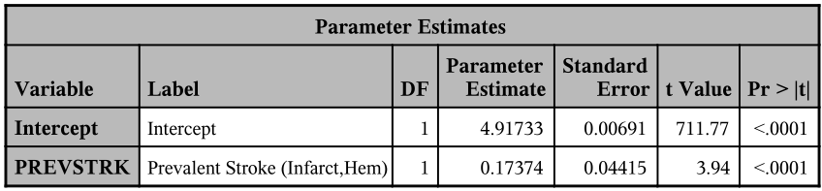

/* a. provide on the table of parameters from the output. */

**proc** **reg** data=dat2;

model LNSBP = PREVSTRK;

**run**;

**quit**;

/* b. Interpret precisely, in the words of the problem, the parameter estimate for PREVSTRK and its confidence interval */

The **parameter** **estimate for PREVSTRK** (0.17374) is the mean increase in LNSBP when ${ X}_{PREVSTRK}$ increases by one unit. This simply means that this is the mean difference between the LNSBP of those with prevalent stroke relative to normal. Individuals for whom PREVSTRK=1 (ie, those with prevalent stroke) have a population mean LNSBP 0.17374 units greater than those for whom PREVSTRK=0 (ie, those without prevalent stroke).

(The **intercept** (4.91733) is the mean log of systolic blood pressure (LNSBP) when the PREVSTRK variable is 0. In other words, this is the mean LNSBP of those who do not have prevalent stroke.)

# /*13. Conduct a linear regression analysis for Y=LNSBP using PREVSTRK (ref=no), BMI (quantitative) and BPMEDS (ref=no), and the interaction term between BMI (quantitative) and BPMEDS (reference=no).

Provide only the table of parameter estimates.*/

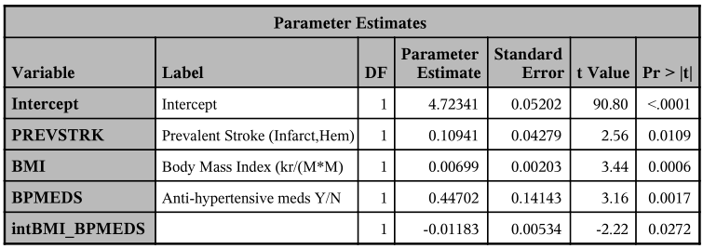

**proc** **reg** data=dat2;

model LNSBP = PREVSTRK BMI BPMEDS intBMI_BPMEDS;

**run**;

**quit**;

/*14. Calculate the percent change in the parameter estimate for PREVSTRK between the two models in questions 12 and 13.

(note: You might also check the parameter estimates from the model in question 8 to see how "stable" the estiamtes are for BMI, BPMEDS and their interaction;

Question 12 parameter estimate for PREVSTRK: 0.17374

Question 13 parameter estimate for PREVSTRK: 0.10941

Percent change = (0.17374 - 0.10941) / 0.17374

**37% decrease** (ie, when adjusted for other variables, the effect of prevstrk on LNSBP is reduced by 37%)

# /*15. Conduct a linear regression analysis for Y=LNSBP using AGE, PREVSTRK (ref=no), BMI (quant), BPMEDS (ref=no), and the interaction term between BMI (quant) and BPMEDS (ref=no)*/

/* a. Provide only the table of parameter estimates. */

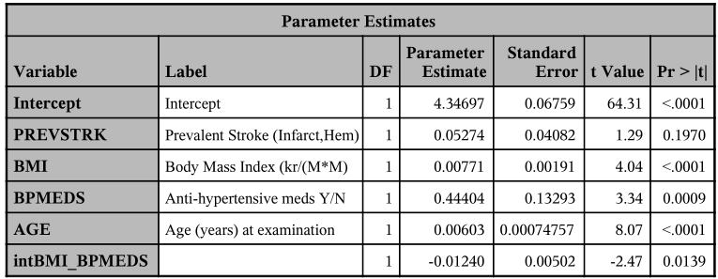

/* b. Provide interpretations, in the words of the problem, of the parameter estimates for AGE and PREVSTRK */

AGE: Adjusting for other variables, for each one unit increase in age, the population mean for LNSBP is estimated to increase by 0.00603 units.

PREVSTRK: After adjustment for other variables, individuals for whom PREVSTRK=1 (ie, those with prevalent stroke) have a population mean LNSBP 0.05274 units greater than those for whom PREVSTRK=0 (ie, those without prevalent stroke)

/* c. Write the full estimated regression model. */

$$E\left(LNSBP | {PREVSTRK, BMIOVER}_{}, {BPMEDS}_{}, AGE, intBMIBPMEDS \right)=$$

$$4.34697+ 0.05274\left(PREVSTRK\right)+0.00771\left(BMI\right)+0.44404\left(BPMEDS\right)+0.00603\left(AGE\right)-0.01240(intBMIBPMEDS)$$

/* d. Explain precisely what the intercept represents in this analysis. Is this value meaningful in this situation? */

The intercept is the hypothetical population mean of LNSBP for individuals for whom all of the parameter estimates are 0. In laymen’s terms, this means the estimated population mean LNSBP for people without prevalent stroke, with a BMI of 0, who are not on BPMEDS, who are 0 years old.

This is **not** meaningful. The physical laws of the universe (as far as I know) do not allow for a BMI of 0.

/* e. Write the estimated regression model for the individuals with BPMEDS=no and interpret the partial slope of the BMI term, in the words of the problem. */

$$E\left(LNSBP | {PREVSTRK, BMIOVER}_{}, {BPMEDS}_{0}, AGE, intBMIBPMEDS \right)=$$

$$4.34697+ 0.05274\left(PREVSTRK\right)+0.00771\left(BMI\right)+0.44404\left(BPMEDS\right)+0.00603\left(AGE\right)-0.01240(0)$$

$$E\left(LNSBP | {PREVSTRK, BMIOVER}_{}, {BPMEDS}_{0}, AGE, intBMIBPMEDS \right)=$$

$$4.34697+ 0.05274\left(PREVSTRK\right)+0.00771\left(BMI\right)+0.00603\left(AGE\right)$$

Among those not on BPMEDS, and holding constant prevalent stroke and age, for each 1 unit increase in BMI, the population mean LNSBP is estimated to increase by 0.00771 units.

/* f. Write the estimated regression model for individuals with BPMEDS=Yes and interpret the partial slope of the BMI term in the words of the problem. */

$$E\left(LNSBP | {PREVSTRK, BMIOVER}_{}, {BPMEDS}_{1}, AGE, intBMIBPMEDS \right)=$$

$$4.34697+ 0.05274\left(PREVSTRK\right)+0.00771\left(BMI\right)+0.44404\left(BPMEDS\right)+0.00603\left(AGE\right)-0.01240(intBMIBPMEDS)$$

$$4.34697+ 0.05274\left(PREVSTRK\right)+0.00771\left(BMI\right)+0.44404\left(1\right)+0.00603\left(AGE\right)-0.01240(1*BMI)$$

$$4.79101+ 0.05274\left(PREVSTRK\right)+0.00603\left(AGE\right)-0.00469(BMI)$$

Among those on BPMEDS, and holding constant prevalent stroke and age, for each 1 unit increase in BMI, the population mean LNSBP is estimated to decrease by 0.00469 units.

**proc** **reg** data=dat2;

model LNSBP = PREVSTRK BMI BPMEDS AGE intBMI_BPMEDS;

**run**;

**quit**;

ods pdf close;