**Introducing ESRI’s ArcGIS Desktop v10.2:**

**In Class Tutorials**

These tutorials provide step-by-step illustrated instructions for learning to use ArcGIS v10.2 They are optimized for use with the Microsoft Windows version of ArcGIS. Users of operating systems other than MS Windows are expected to know how 1) to find and open a software application once installed and 2) to find files and folders on their laptops\computers.

**Setup**

You must complete two tasks before beginning these tutorials.

1. You must download and install ArcGIS v10.2 on the laptop that you will have with you in class. Please see the class syllabus for more information.
2. You must download the sample GIS data that will be used for this tutorial.
   1. The data can be found in the Resources/Lecture 1 folder on the course website. The file is entitled “Lecture_1_Dataset.zip”.
   2. Download the file from the course website to the laptop that you will have with you in class. This file is a compressed archive, which contains a folder ironically entitled “Lecture_1_Dataset. Uncompress (unzip) the archive’s contents to a location on the hard drive of your laptop.
   3. This new Lecture_1_Dataset folder will be your working directory for these tutorials. *For the purposes of this tutorial, I chose to store the contents of the Lecture_1_Dataset.zip in the following folder: C:\Users\sandieha\Teachings\SpatialGuest14\Lecture_1_Dataset\.*
3. You are now ready to proceed to Tutorial A.

The ArcGIS Desktop software suite consists of three primary software applications: ArcCatalog, ArcMap, and ArcToolbox.

**Contents of the Lecture_1_Dataset folder**

Spatial data layers (ESRI’s shapefile format)

*Point features*

1. fdem_ems_sep08_Project_Alachua_15_mile – “This dataset contains Emergency Medical Service Locations in Florida. The EMS stations dataset consists of any location where emergency medical services (EMS) personnel are stationed or based out of, or where equipment that such personnel use in carrying out their jobs is stored for ready use. This dataset was created by TechniGraphics, Inc. for the Florida Division of Emergency Management.” (copied from the original data source’s metadata). I modified the original data source, in such a manner that all locations that fall outside of a 15-mile boundary around Alachua County are excluded.
2. gc_health_jul09_Project_Alachua_15_mile – “This dataset contains 2009 Health Care Facility Information for the State of Florida. It is a combination of health care facilities (Abortion Clinic, Dialysis Clinic, Medical Doctor, Nursing Home, Osteopath, State Laboratory/Clinic, and Surgicenter/Walk-In Clinic) from the Florida Department of Health.” (copied from the original data source’s metadata). I modified the original data source, in such a manner that all locations that fall outside of a 15-mile boundary around Alachua County are excluded.
3. gc_hospitals_may11_Project_15_mile – “ This dataset contains 2011 Hospital Facility Information for the State of Florida.” (copied from the original data source’s metadata). I modified the original data source, in such a manner that all locations that fall outside of a 15-mile boundary around Alachua County are excluded.

*Polyline features*

1. Alachua_County_Roads_tgr12001lkA – spatial data layer that was assembled by ESRI from the 2000 US census TIGER data and which depicts the roads and streets for Alachua County, FL.

*Polygon features*

1. Alachua_County_Boundary_tgr12001cty00 – spatial data layer that was assembled by ESRI from the 2000 US census TIGER data and which depicts the boundary of Alachua County, FL.
2. Alachua_County_Census_Blocks_tgr12001blk00 – spatial data layer that was assembled by ESRI from the 2000 US census TIGER data and which depicts the census blocks for Alachua County, FL.
3. Alachua_County_water_bodies_tgr12001wat – spatial data layer that was assembled by ESRI from the 2000 US census TIGER data and which depicts the water bodies within Alachua County, FL.

Non-spatial dataset

1. uscensus2000.dbf – a non-spatial data table assembled by ESRI, summarizing data from the 2000 US census on the distributions of demographic, race, gender, and household related variables by census block within Alachua County, FL.

Data sources

Data assembled by ESRI is available from the company’s website:

<http://arcdata.esri.com/data/tiger2000/tiger_statelayer.cfm?sfips=12>

Other data is available through the website of the Florida Geographic Data Library’s Metadata Explorer: <http://www.fgdl.org/metadataexplorer/explorer.jsp>

**First time user of ArcGIS:**

1. Verify if the software is correctly authorized and available
   1. Click “All programs”🡪 “ArcGIS” 🡪 “ArcGIS Administrator”; The administrator window is shown as below;

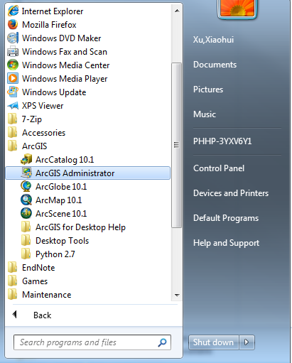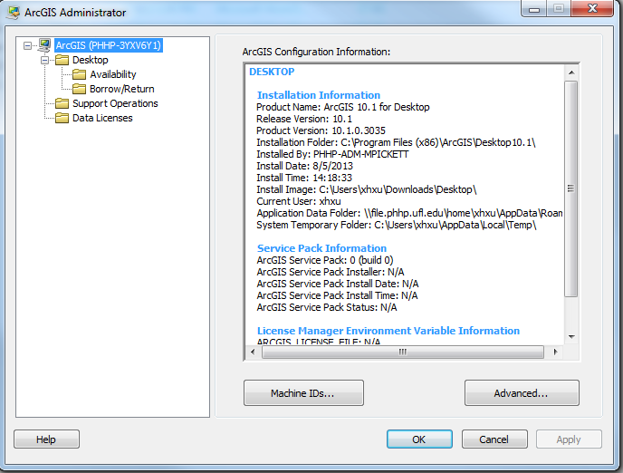

* 1. Click “Availability” to check if the software is correctly authorized; if it is “yes”, the software is ok.

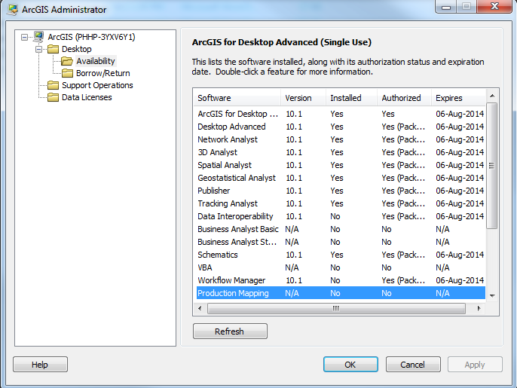

**Tutorial A. Introducing ArcCatalog**

1. Open ArcCatalog
   1. Select ArcCatalog from the Start Menu, or Mac equivalent.

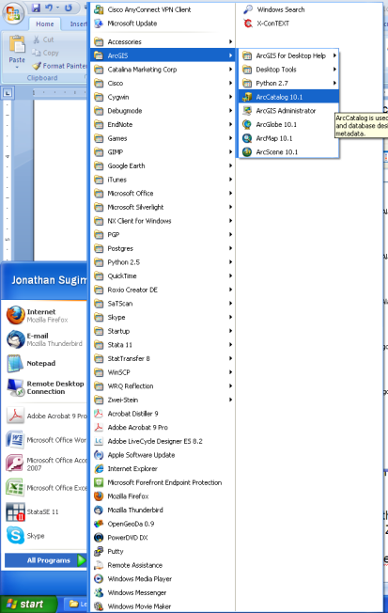

* 1. Once open, perform the following tasks to configure the ArcCatalog window.
     1. Verify that the Catalog Tree window is visible.

Select Catalog Tree from the Windows menu.

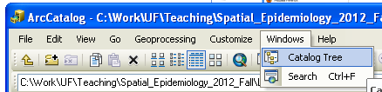

* + 1. Verify that the appropriate toolbars are visible.
       1. Select Customize\Toolbars, and verify that only the Geography, Location, Metadata, Main Menu and Standard toolbars are checked.
       2. Check or uncheck the toolbars listed until the Toolbars submenu looks like the following figure.

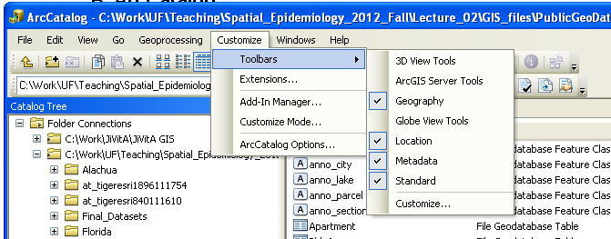

1. Folder Connection or disconnection
   1. Folder Connection

*Information:* Folder Connections are saved by ArcGIS as a shortcut to any folder on your hard drive or server connections. Typically, Folder Connections are used as shortcuts to folders where ArcGIS project files or GIS data are stored, for example, a working directory.

* + 1. Our working directory for these tutorials will be the “Lecture_1_Dataset” folder that you downloaded from the course website and uncompressed.
    2. There are three methods for establishing a Folder Connection.
       1. Select Connect from the File menu.
       2. Select the  Standard toolbar.
       3. Right-click on Folder Connections in the Catalog Tree window, and selection Connect to Folder.

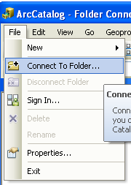 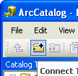 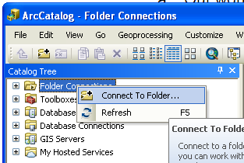

* + 1. Navigate to the “Lecture_1_Dataset” folder.

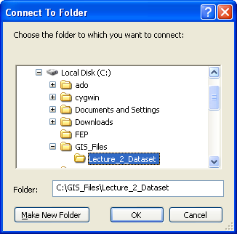

* + 1. Click Ok.
    2. The Lecture_1_Dataset should appear under Folder Connections in the Catalog Tree window.
    3. Clicking on the “+” or ”-“ symbol to the left of the Lecture_1_Dataset will display and hide the contents of this folder, respectively.

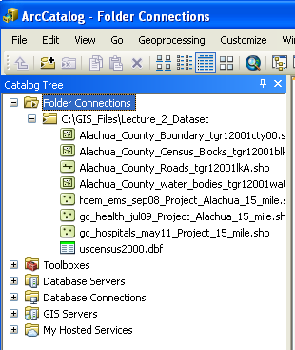

* 1. Folder disconnection
     1. Select the folder and then click “” in the toolbar;

1. Connect or disconnect to the service;
   1. Example of EPA water ArcGIS server
      1. Double click on GIS Servers

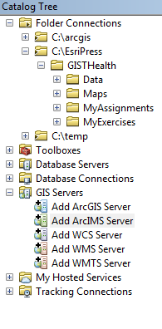

* + 1. Select “Use GIS service” and click “next”

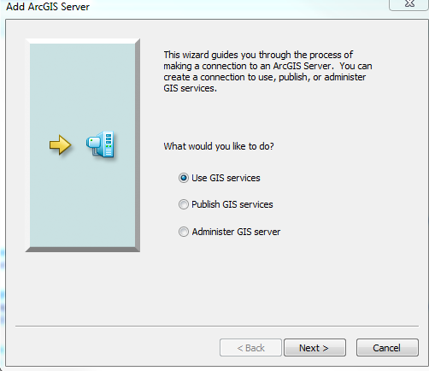

* + 1. Type in http://watersgeo.epa.gov/arcgis/services

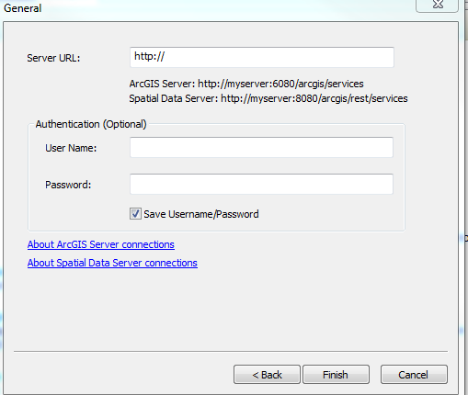

* + 1. You will then see a list of data from the server. You can click on each of those services one at a time.

(Data information: <http://www.epa.gov/waters/geoservices/docs/archives/waters_mapping_services.html> )

* 1. Disconnect
     1. Right click the fold to disconnect or delete the data.

1. Create and name a geodatabase

*Information:* ArcGIS can work with a wide-variety of formats for storing digital GIS data. Previous versions of the ArcGIS relied heavily on the portable Shapefile format, which is the format of the data currently stored in the Lecture_1_Dataset folder. Later versions of ArcGIS reorganized datasets into a geodatabase, which is a relational database storing multiple spatial and non-spatial datasets. There are two types of geodatabase formats, personal and file. The personal geodatabase is an older version stored as a single Microsoft Access database, and the file geodatabase is a more flexible version stored as a folder structure. We will be using the file geodatabase format for these tutorials.

* 1. Select the Lecture_1_Dataset folder under Folder Connections in the Catalog Tree.
  2. There are two different methods for creating a new File Geodatabase
     1. Right-click on the Lecture_1_Dataset folder in the Catalog Tree, and then select New\File Geodatabase from the shortcut menu that appears.
     2. Select New\File Geodatabase from the File menu.

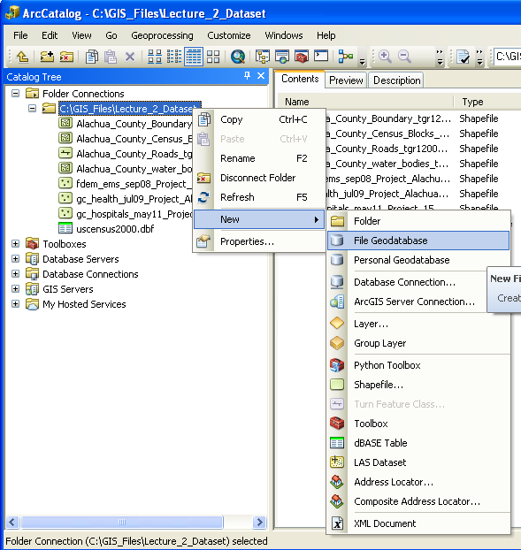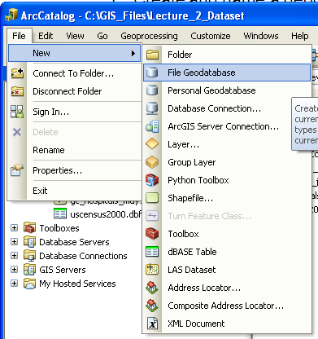

* 1. The new file geodatabase will appear under the Lecture_1_Dataset folder in the Catalog Tree window.
  2. Name the geodatabase
     1. Select the new geodatabase in the Contents window.
     2. Select Rename from the File menu.
     3. Type for the new name “Lecture_1” for the new geodatabase in the Contents window.

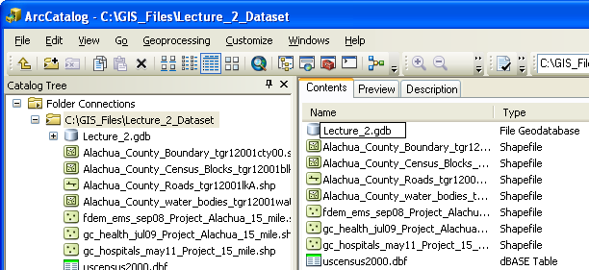

1. Import shapefiles into the Lecture_1 geodatabase

*Information:* For this task we will be using the Feature Class to Feature Class, Feature Class to Geodatabase (multiple), and Table to Table tools, which are included in the ArcToolbox software application. ArcToolbox will be discussed later in this set of tutorials.

* 1. Right-click on the Alachua_County_Boundary_tgr12001cty00.shp shapefile listed under the Lecture_1_Dataset folder in the Catalog Tree window.
  2. Select Export\To Geodatabase (single) from the shortcut menu.

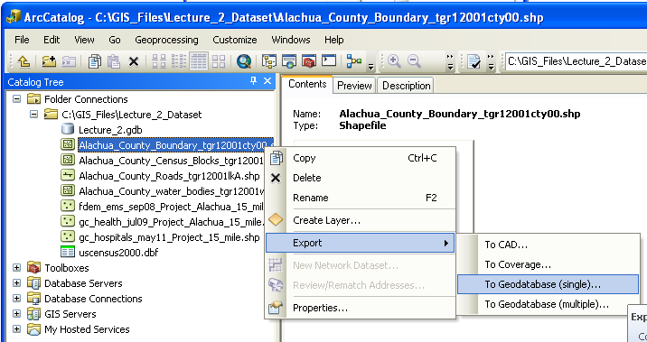

* 1. The Feature Class to Feature Class tool window will appear, with the Input Features already assigned.

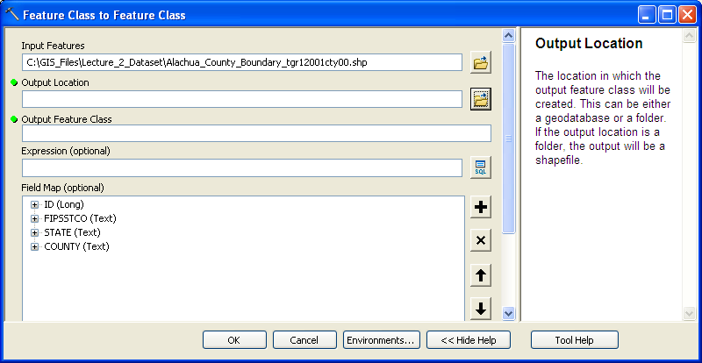

* 1. Click on the folder symbol located to the right of the Output Location input space.
  2. Navigate to Folder Connections\Lecture_1_Dataset\.

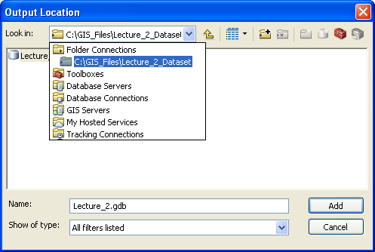

* 1. Select the Lecture_1.gdb, and click the Add button.

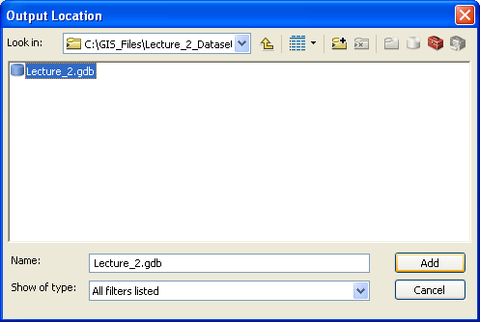

* 1. Under Output Feature Class, type in the following name for the feature class “Alachua_County_Boundary_tgr12001cty00”

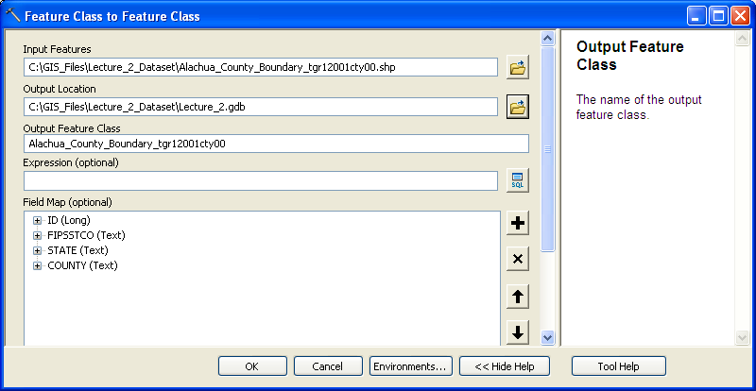

* 1. Click the Ok button located at the bottom of the Feature Class to Feature Class window.
  2. The newly imported layer should appear under the Lecture_1 geodatabase in the Catalog Tree window.

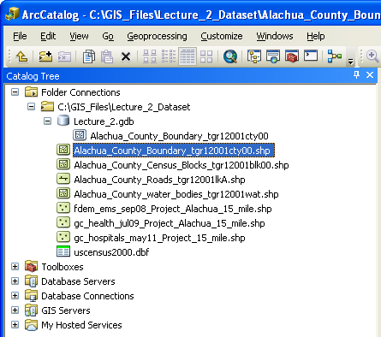

* 1. Importing multiple shapefiles at one time
     1. Select the Lecture_1_Dataset folder in the Catalog Tree window.
     2. In the Content window, select all of the shapefiles in the Lecture_1_Dataset folder, excluding the Alachua_County_Boundary_tgr12001cty00.shp. Multiple files may be selected by holding down the mouse button and dragging a box around the files to be selected, as shown below. Do not include the uscensus2000.dbf file, because this is not a shapefile.

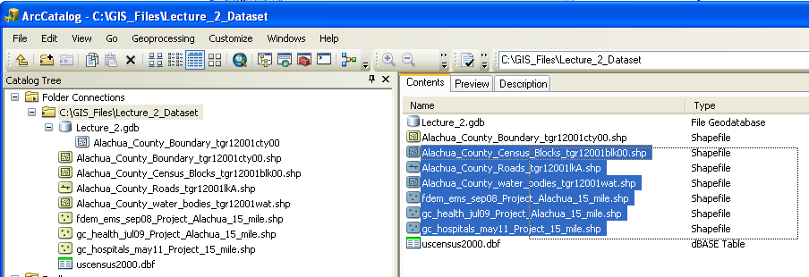

* + 1. Right-click on the selected files, and choose Export\To Geodatabse (multiple).

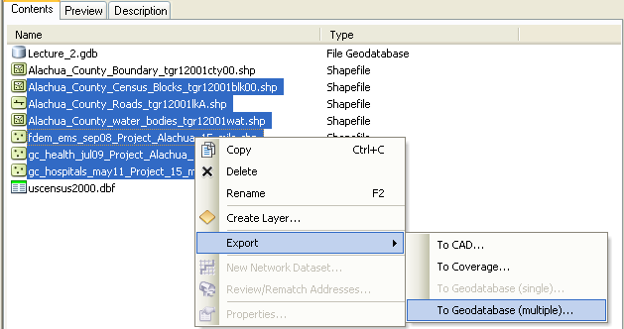

* + 1. The Feature Class to Geodatabase (multiple) tool window will appear, and each of the selected shapefiles should be listed.

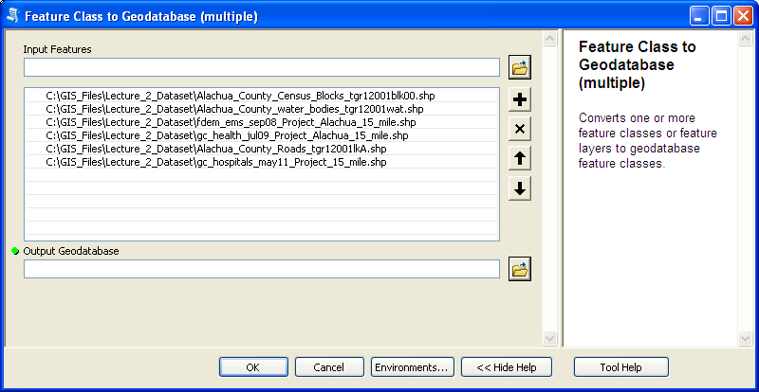

* + 1. Click on the folder symbol located to the right of the Output Location input space.
    2. Navigate to Folder Connections\Lecture_1_Dataset\.



* + 1. Select the Lecture_1.gdb, and click the Add button.



* + 1. Click the Ok button located at the bottom of the Feature Class to Geodatabase (multiple) window.
    2. It will take some time for the tool to process.
    3. The newly imported features should appear in the list under the Lecture_1 geodatabase in the Catalog Tree.

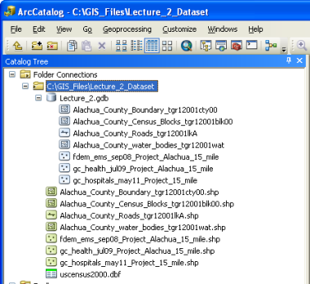

**In class exercise A.1**

Work with a partner to complete the following task:

- Importing a non-spatial data table into the file geodatabase.

- Apply the same process as you did for importing the Alachua_County_Boundary_tgr12001cty00 shapefile into the Lecture_1 geodatabase.

- The only differences will be that you will be importing the uscensus2000.dbf table (located in the Lecture_1_Dataset folder of the Catalog Tree) and you will be using the Table to Table tool. Name the Output Table: “uscensus2000”.

This is what the Table to Table tool window should look like before you click OK.

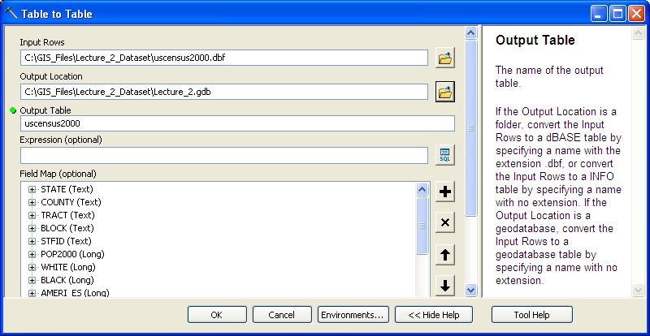

1. The Preview tab

The Preview tab provides the user a quick visualization of the contents of spatial (a map or the attribute table) and non-spatial (table) datasets.

1. Examine and edit metadata

*Information:* Metadata provides a standardized description of a data layer, including, among other things, a summary of its contents, credits for assembling the dataset, and details concerning the spatial projection and geographic coordinate system (where appropriate).

* 1. View existing metadata for a feature class
     1. In the Catalog Tree window, select the fdem_ems_sep08_Project_Alachua_15_m layer in the Lecture_1 geodatabase.
     2. Select the Description tab in the right-hand window of ArcCatalog.
     3. The metadata will be listed in the right-hand window of ArcCatalog.

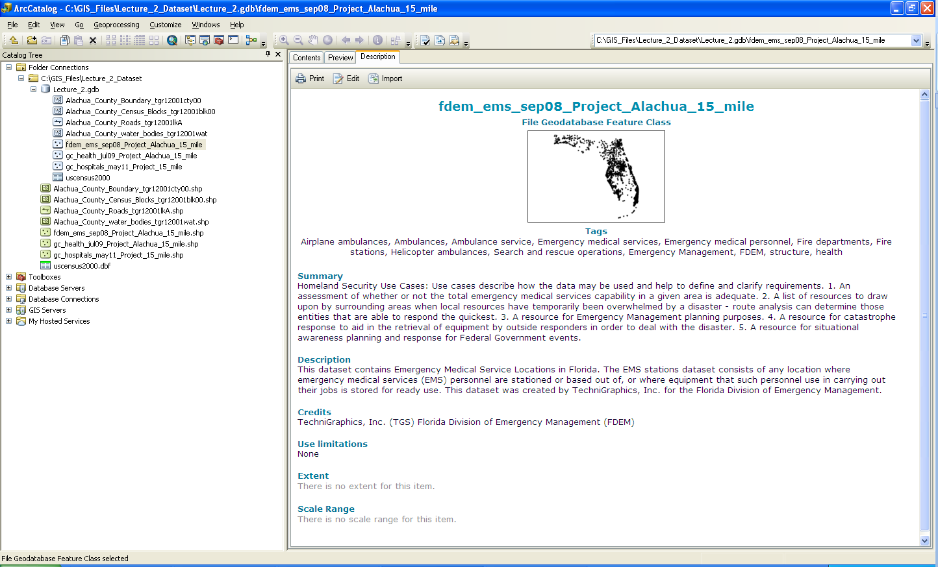

* 1. Edit metadata for a feature class
     1. Open the metadata for the gc_hospitals_may11_Project_Alachua_15_mile layer in the Lecture_1 geodatabase.
     2. Select the Edit button, located at the top of the Description tab.

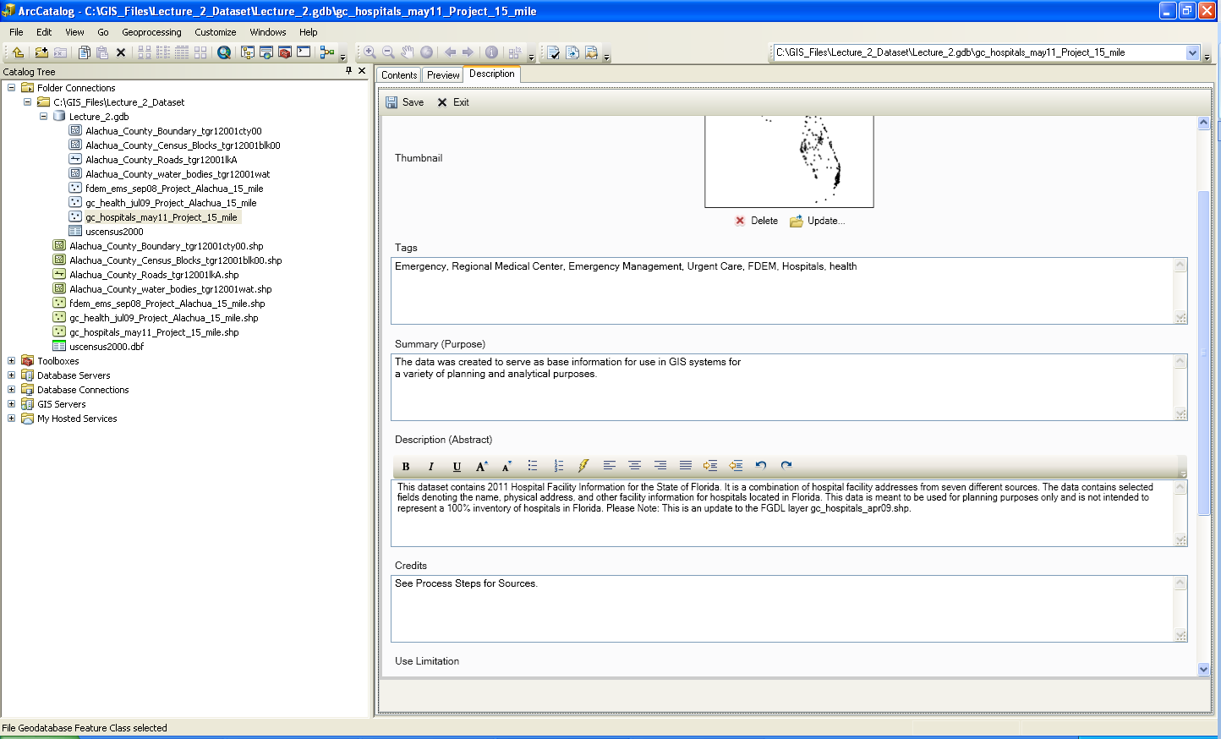

* + 1. Add the following sentence to the end of the Summary (Purpose) section: “For example, analyses conducted in PHC 6194: Spatial Epidemiology.”
    2. Select the Save button, located at the top of the Description tab.
    3. The metadata should look like the following:

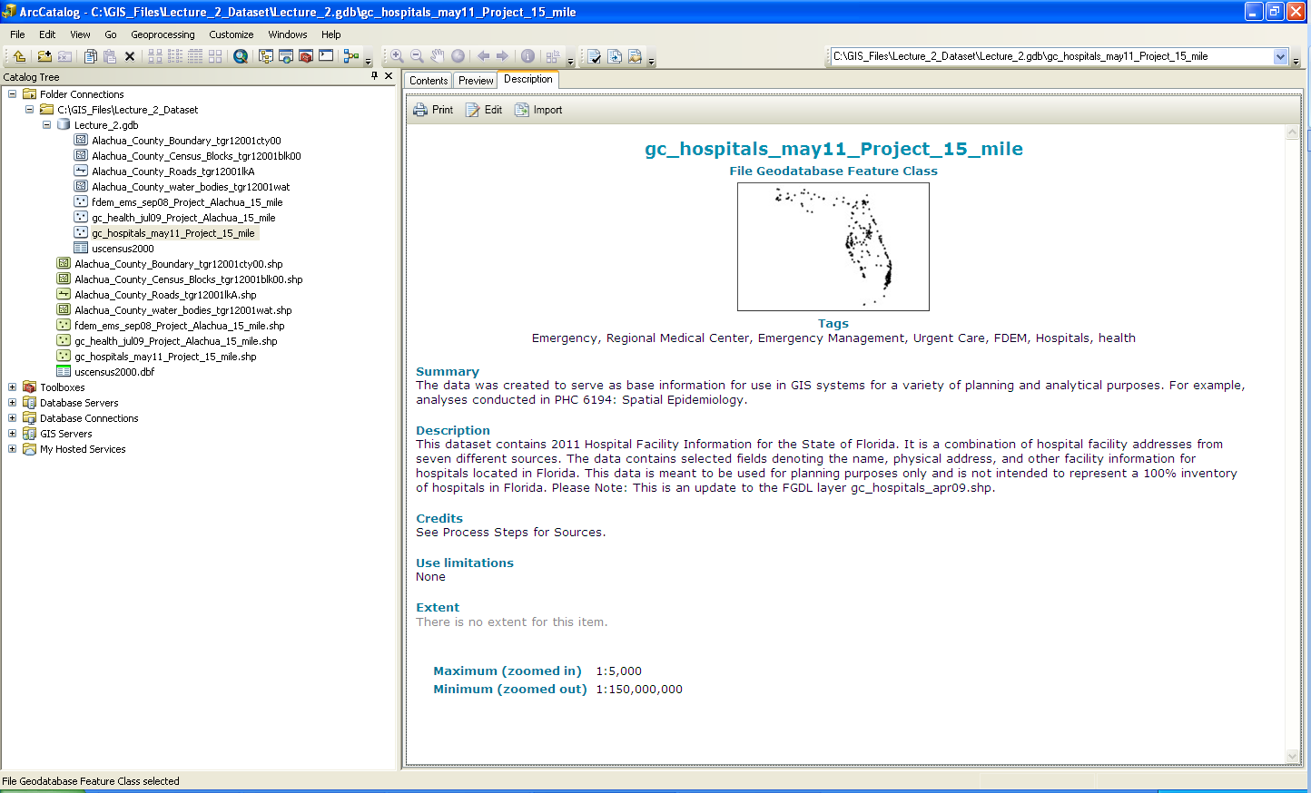

1. Export a geodatabase layer to a shapefile.
   1. Select the fdem_ems_sep08_Project_Alachua_15_m layer in the Lecture_1 geodatabase.
   2. Right-click and choose Export\To Shapefile (single).

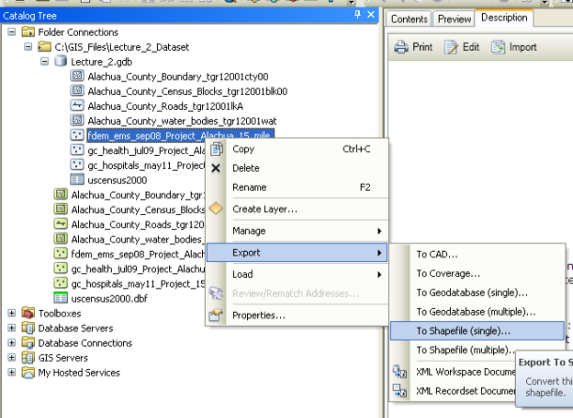

* 1. The Feature Class to Feature Class tool window will appear.
  2. Select the Folder Connections\Lecture_1_Dataset as the Output Location.
  3. Type the name “Test_Export” into the Output Feature Class section of the Feature Class to Feature Class tool window.
  4. Click Ok.

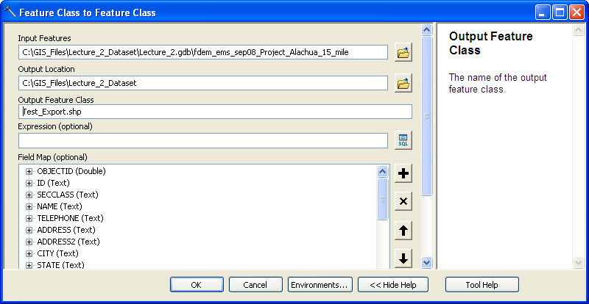

* 1. The Test_Export shapefile should appear in the Catalog Tree window under the Lecture_1_Dataset folder.

1. Copy, Rename and Delete Files
   1. All operation Similar to Window explore

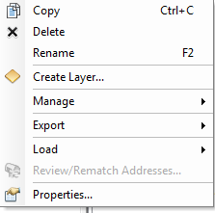

1. Close ArcCatalog.

**Tutorial B: Introducing ArcMap**

Among the applications included in the ArcGIS software suite, ArcMap is certainly the one that you will use the most.

1. Open ArcMap: Two different methods
   1. Independently: Select ArcMap from the Start Menu, or Mac equivalent.

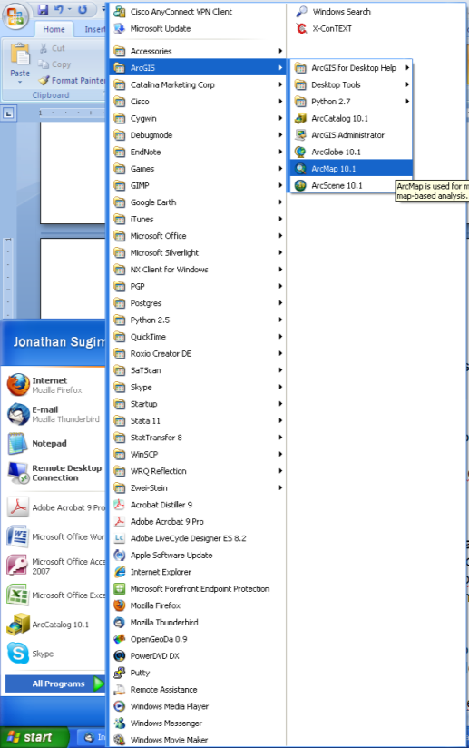

* 1. From ArcCatalog: Open ArcCatalog and Click on the  button, located on the Standard Toolbar.

1. ArcMap layout

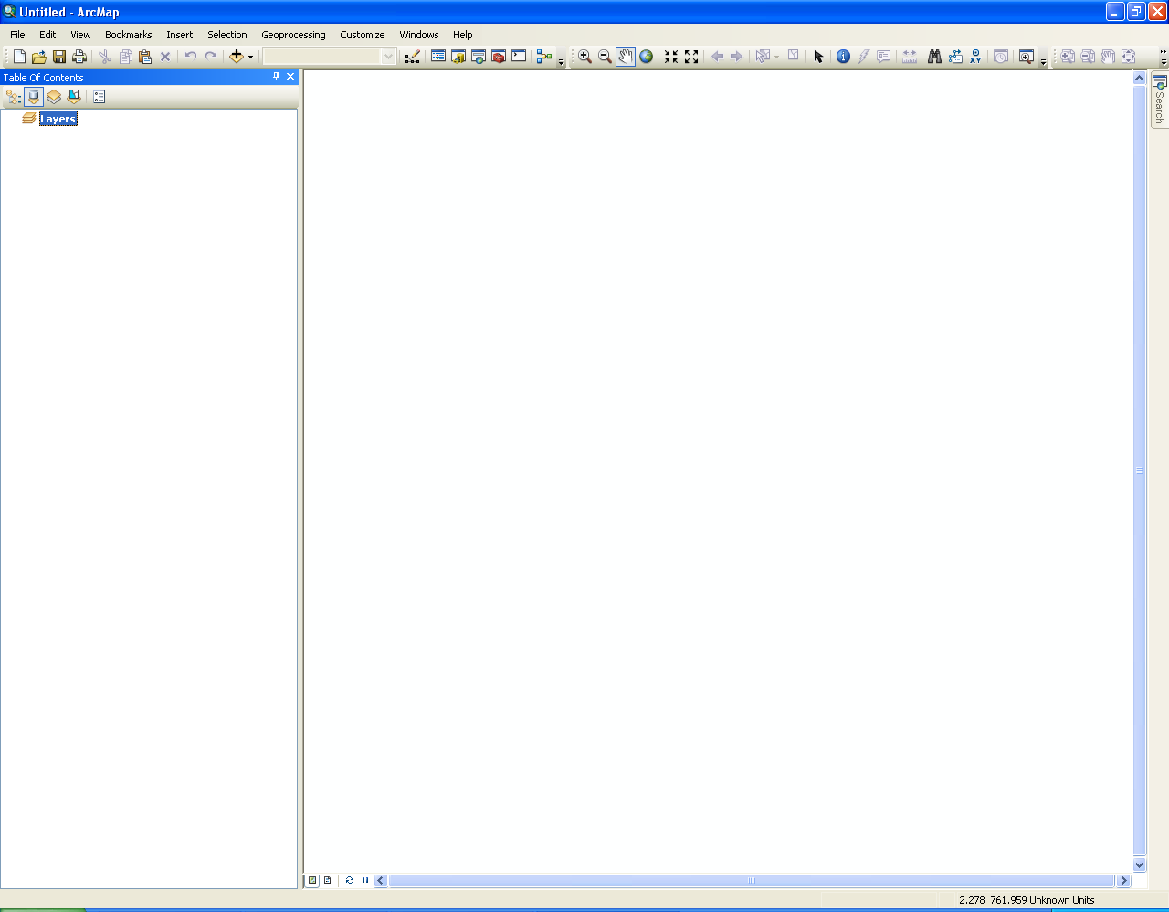

Table of Contents panel

Toolbars

Map panel

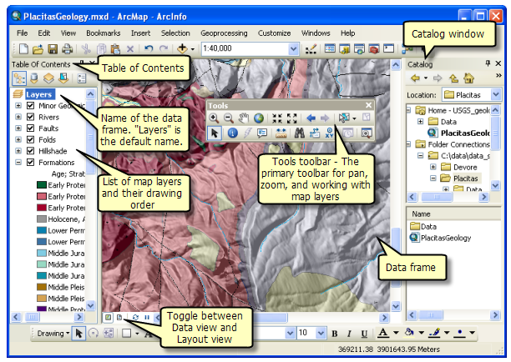

1. Make sure that the Standard, Tools, and Layout toolbars are visible

*Information:* There are a number of toolbars available for use in ArcMap, but three of these are essential for this tutorial and for much of the work that you will likely do for this course and for future GIS projects.

* 1. Select the Toolbar submenu from the Customize menu.
  2. Notice that there are a large number of toolbars, which illustrates the diversity of functions available through ArcMap and its extensions.
  3. Ensure that the Layout, Standard, and Tools bars are checked.

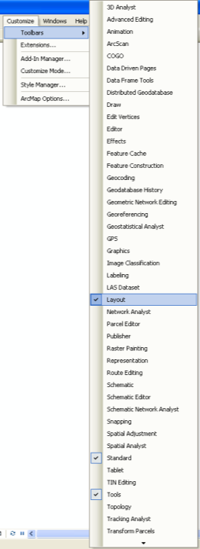

1. Add and remove a layer in ArcMap
   1. To add any spatial or non-spatial data layer to your ArcMap project, you must click the  symbol from the Standard toolbar.
      1. Click the  symbol on the Standard toolbar.
      2. In the Add Data window, navigate to the Lecture_1 geodatabase located in the Lecture_1_Dataset folder under Folder Connections.
      3. Select the Alachua_County_Census_Blocks_tgr12001blk00 layer.

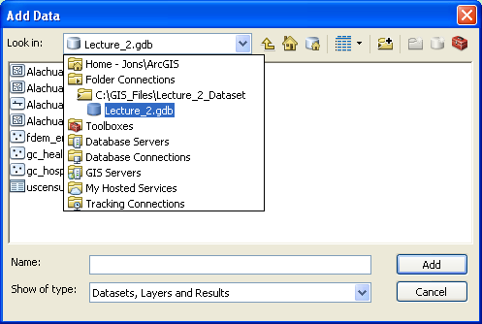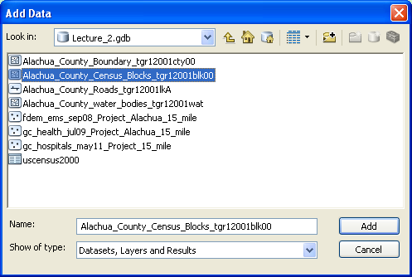

* + 1. Your ArcMap window should now look like the following (the map’s color may differ between users).

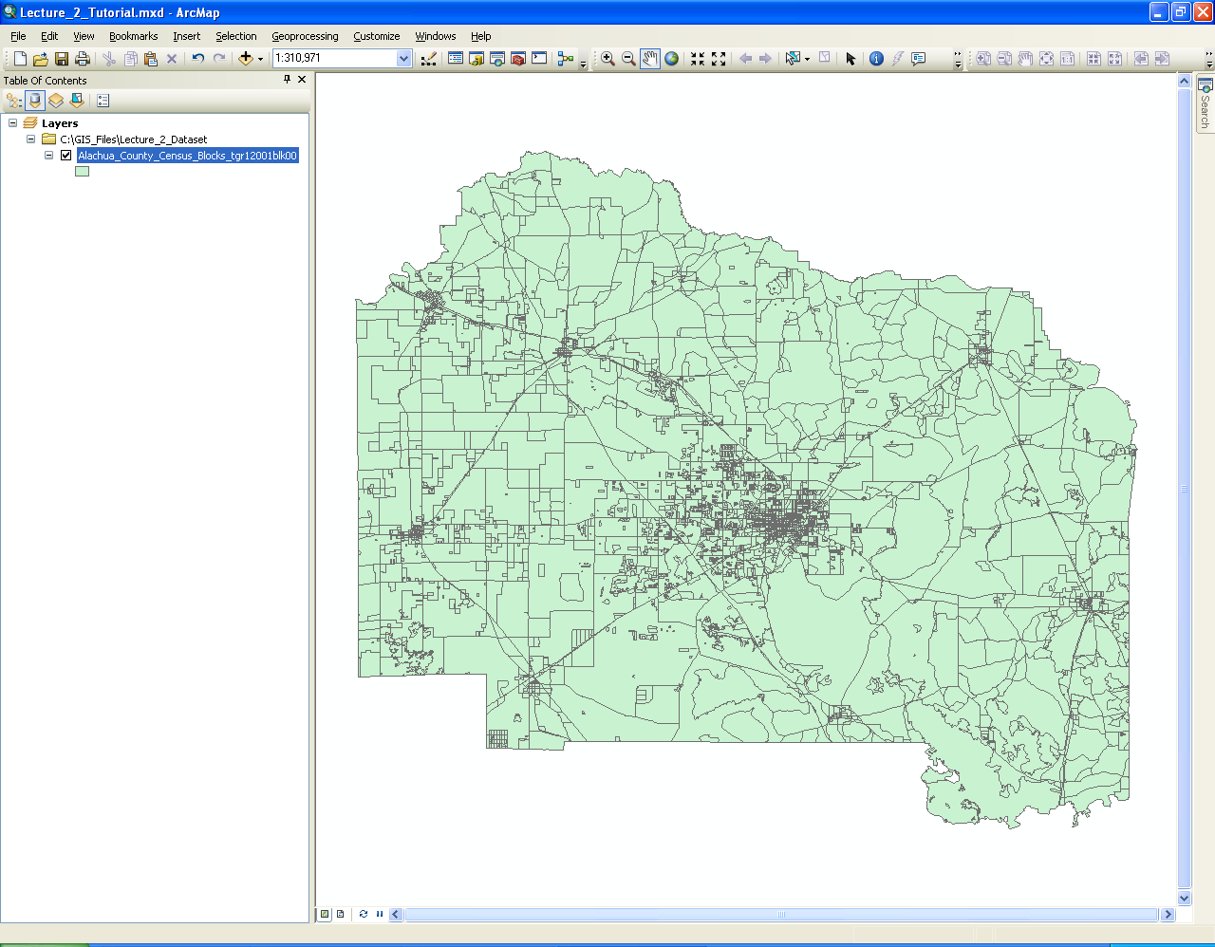

* 1. Removing layers from a map
     1. Select the Alachua_County_Census_Blocks_tgr12001blk00 layer
     2. Right-click the selection and click Remove.

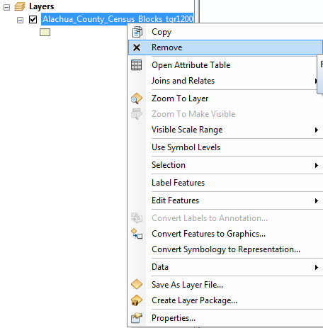

1. Map brows tools

These tools affect the scale and location of the spatial data displayed in the Map Window.

* 1. Fixed zoom: in and out
  2. The  and  tools located on the Tools toolbar allow the user to zoom in and out, respectively, in fixed increments.
  3. Practice zooming in and out using these two tools.
  4. Full Extent zoom tool

1. The  tool located on the Tools toolbar allows the user to zoom to the full-extent of all of the data layers included in the ArcMap project.
2. Click on this tool to return to the original map scale.
   1. User-defined zoom in and out tools (the magnifying glasses)
3. The  and  tools located on the Tools toolbar allow the user to zoom in and out, respectively, to a customized scale.
4. Zoom in using the  tool as illustrated below.
   * + 1. Select the  tool.
       2. Form a box as illustrate below (left) around the UF and Gainesville section of Alachua County.
5. Zoom out using the  tool as illustrated below.
6. Select the  tool.
7. Form a box as illustrate below (left). The new view in the Map panel is illustrated below on the right.

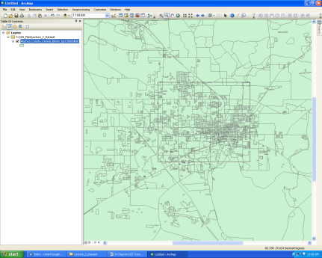 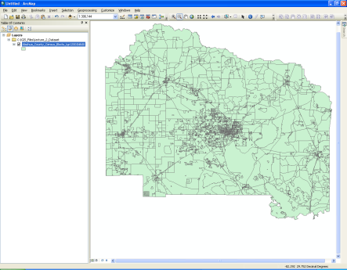

1. Right click the selected layer and zoom to the layer;

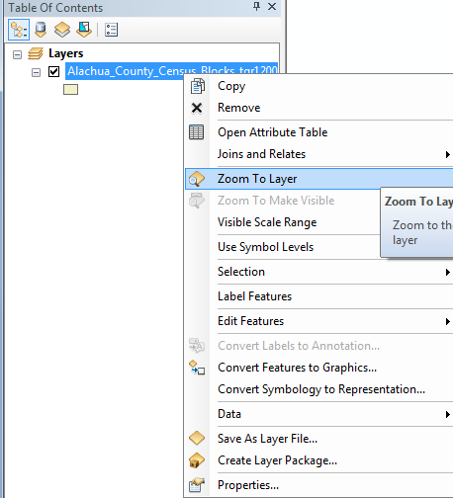

* 1. Go Back to Previous and Go to Next Zoom tools
     1. The  and  tools located on the Tools toolbar allow the user to return to the Previous scale or Go to the Next scale.
     2. Practice moving backward and forward through your current scale change history.
     3. Click on the Full Extent zoom tool.
  2. Use Pan tool
     1. The Pan tool,  , is located on the Tools toolbar. This tool allows the user to move to different portions of the map while remaining at a fixed geographic scale.
     2. Click on the  tool.
     3. Place the mouse cursor (displayed as a hand symbol) over the map panel.
     4. Click and hold down the left mouse button.
     5. Drag the cursor around. You will see the map moving in the direction that you are dragging the mouse cursor.

1. Making layers Visible\Invisible in the Map panel
   1. Deselect all features using the  tool on the Tools toolbar.
   2. In the Table of Contents uncheck the box located immediately to the left of the fdem_ems_sep08_Project_Alachua_15_mile layer.

 

* 1. The points from the fdem_ems_sep08_Project_Alachua_15_mile layer will no longer be visible in the Map panel. This further demonstrates that only the features that were selected from the fdem_ems_sep08_Project_Alachua_15_mile layer were exported to the fdem_subset spatial data layer.

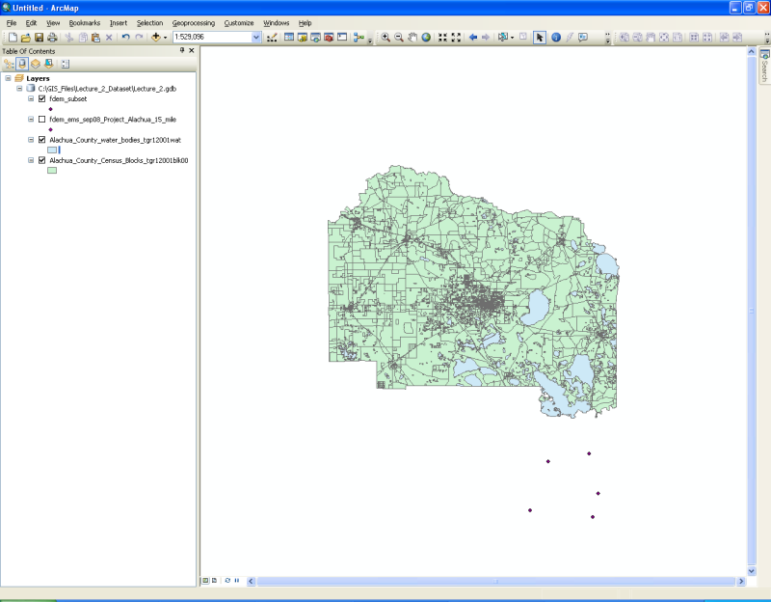

* 1. This is the primary method for managing the visibility of a spatial data layer in ArcMap.

1. The Identify tool

The Identify tool, , allows the user to explore the non-spatial (Attribute) data associated with a spatial feature.

1. Make only the following layer Visible:

- gc_hospitals_may11_Project_15_mile

- Alachua_County_Boundary_tgr12001cty00

1. Select the Identify tool from the Tools toolbar.
2. Use the mouse cursor to select the only point located below (South) of Alachua County.

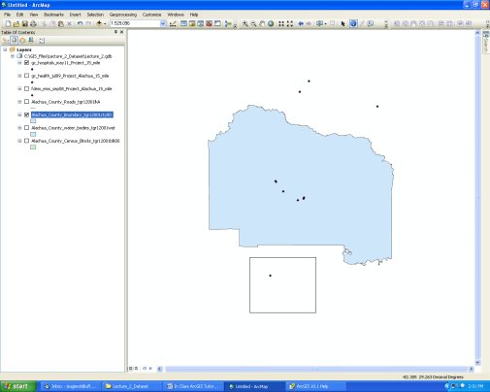

1. Explore the values that appear in the Identify window, such as the name of the hospital (Tri-County Hospital – Williston).
2. Use the mouse cursor to select all of the hospitals that fall within Alachua County.

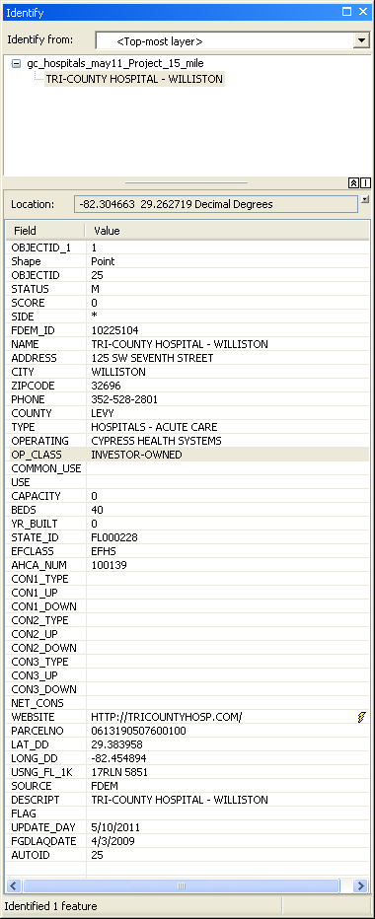 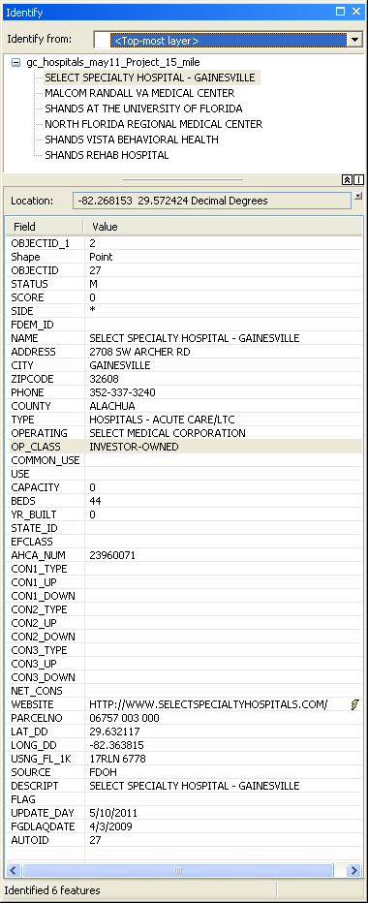

Multiple Feature

Single Feature

1. Explore the values that appear in the Identify window.
2. Selection tools

*Information:* This set of tools allows the user to select sets of features within a spatial data layey.

1. Select Features tool set
   * 1. The Select by Rectangle tool,  , is located on the Tools toolbar. This tool allows the user to select a single or multiple features visible in the Map panel using a rectangle shaped box. This is likely to be the most commonly used member of the Select Features toolset.
     2. Select the  tool.
     3. Selecting a single or contiguous group of features
        1. Use the mouse cursor to form a box around the group of points located outside of the county boundary in the upper right-hand portion of the Map panel, as illustrated below on the left. 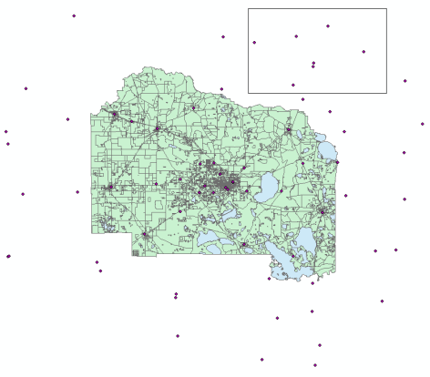 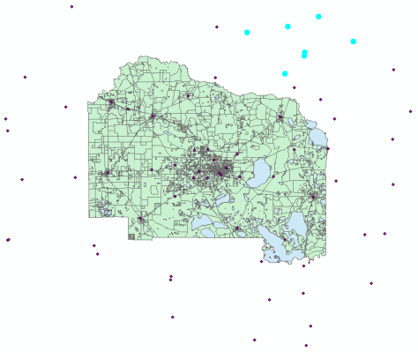
        2. The map window should look like the figure above on the right, with the selected features highlighted in bright aqua blue.
     4. Selection of multiple non-contiguous groups of features

To select non-contiguous groups of features, hold down the Shift key while forming a rectangle around your second (third, fourth, etc.) group features, as illustrated below.

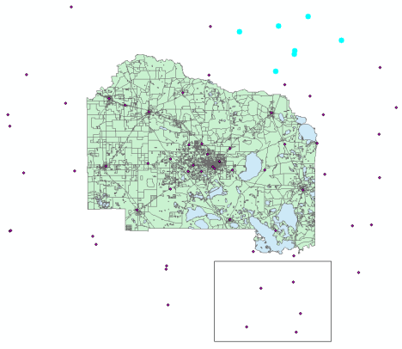

* + 1. Other members of the toolset.
       1. The other members of the Select Features toolset include the tools illustrate below. The name of each tool explains its mode of the selecting features.

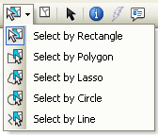

* + - 1. To select one of these other members of the Select Features toolset, click on the small triangle located to the right of the Select by Rectangle tool, and the list of members will appear.
      2. Practice selecting features using one of these tools.
    1. Other options in the Selection menu

We will discuss the Select by Attribute and Select by Location functions located in the Selection menu later in this set of tutorials.

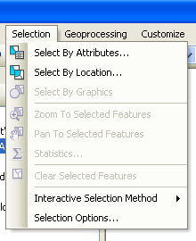

1. Deselecting features
   * 1. Deselect a single or a set of features
        1. Hold down the Shift key
        2. Form a Rectangle (assuming you are using the Select by Rectangle tool) around the single or group of features that you would like to de-select, as shown below on the left.
        3. The end result is shown below on the right.

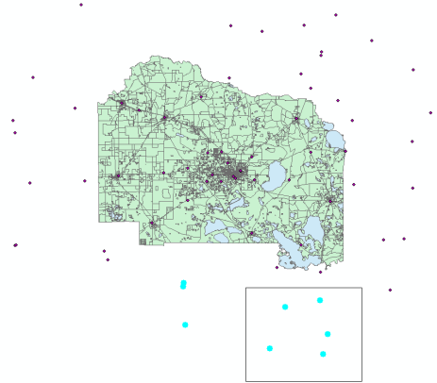 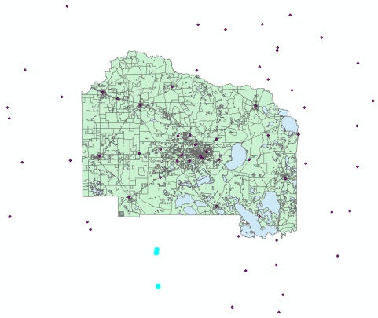

* + - 1. Another method for deselecting single or a group features is to select Interactive Methods\Remove From Current Selection from the Selection menu, and then perform the steps illustrate above for selecting single or a contiguous group of features.

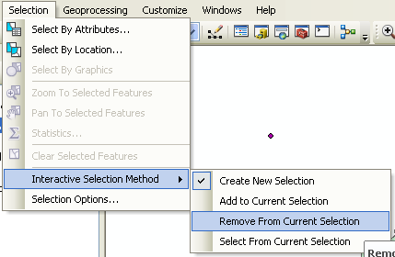

* + 1. De-select all selected features at one time.

Select either the Clear Selected Features from the Selection Menu or the  tool from the Tools menu.

1. Making a layer selectable\Unselectable

*Information:* If you have multiple overlapping spatial data layers visible on the map (such as we do here) but you only want to select features from a subset of the layers, ArcMap allows you to set which layers are Selectable\Not Selectable.

1. Select the List By Selection button () in the Table of Contents panel.

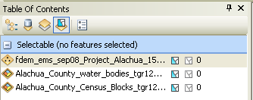

1. Clicking on the  symbol located to the right of the name of a Selectable layer will set the layer to not selectable.

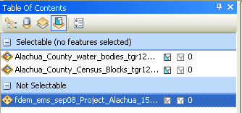

1. Clicking on the  symbol located to the right of the name of a Not Selectable layer will return its status to Selectable.
2. Return all layers to Selectable Status.
3. Click on the List By Source button, , located at the top of the Table of Contents Panel.
4. Export selected features as a new spatial data layer

One possible reason for selecting a subset of the features within a spatial data layer is to generate a new spatial data layer containing only the selected features.

1. Zoom to Full Extent.
2. Select the five point features in the lower right portion of the Map View, as shown below.

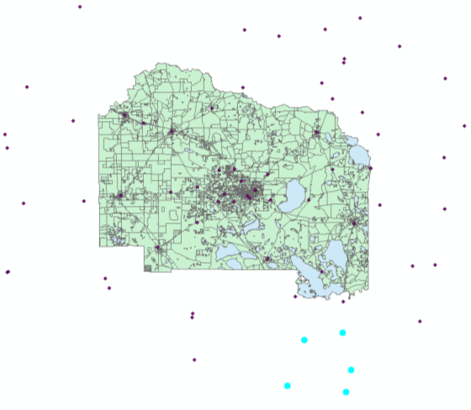

1. In the Table of Contents panel, right-click on the fdem_ems_sep08_Project_Alachua_15_mile layer and select the Data\Export Data option from the shortcut menu.

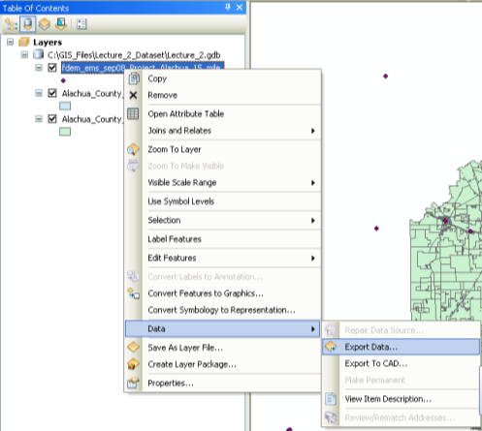 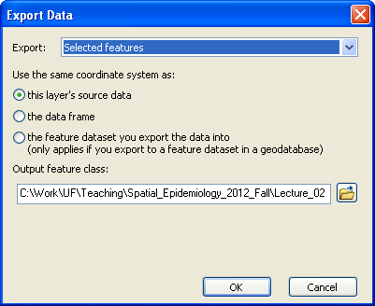

1. The Export Data window will appear (see above right).
2. Ensure that the Export option is set to “Selected features” and that the [Use the same coordinate system as:] option is set to “this layer’s source data”.
3. Click on the folder symbol located to the right of the [Output feature class:] field.
4. Navigate to the Lecture_1 geodatabase located in the Lecture_1_Dataset folder under Folder Connections.

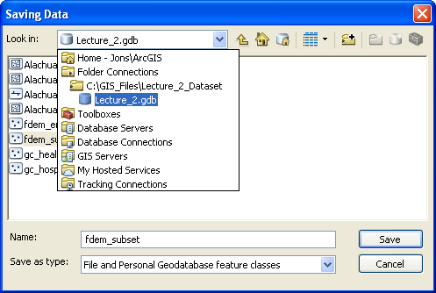

1. Type the name “fdem_subset” into the file Name field.
2. Click Save.
3. Click Ok in the Export Data window.
4. Select Yes when the following dialogue box appears.

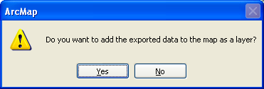

1. Save your ArcMap project file.

*Information:* As we have seen, spatial data layers are saved in a variety of file formats, with the shapefile or geodatabase formats used predominantly by ArcGIS. ArcMap allows you to construct projects that link multiple spatial and non-spatial data-layers, for the purposes of constructing maps and conducting analyses. These projects can (and should) be saved in a separate ArcMap file format, with the file extension “.mxd”.

* 1. Add two layers: “Alachua_County_Census_Blocks_tgr12001blk00” and “Alachua_County_Roads_tgr12001lkA” from Lecture_1 geodatabases
  2. Select Save As from the file menu.
  3. In the Save As window, navigate to the Lecture_1_Dataset folder on your laptop. Notice that for this window ArcMap does not show the Folder Connections. The Folder Connections functionality is reserved for accessing spatial and non-spatial datasets.
  4. Type in the File Name “Lecture_1_Tutorial”.
  5. Click Save

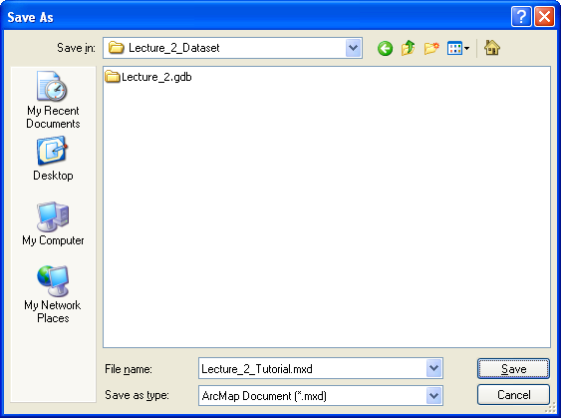

Once you have saved an ArcMap project file for the first time, you can select Save from the File menu or the  symbol from the Standard toolbar to save changes directly to the file.

Note: Please make sure to tell the differences between mxd files and map data

* + - 1. Delete files of “Alachua_County_Census_Blocks_tgr12001blk00” and “Alachua_County_Roads_tgr12001lkA” from Lecture_1 geodatabases;
      2. Open Lecture_1_Tutorial.MXD file and see what will happen;
      3. The new view in the Map panel is illustrated below on the right.

**In class exercise B.1**

Work with a partner to complete the following tasks:

- Add the “Alachua_County_water_bodies_tgr12001wat” geodatabase layer to the ArcMap project.

- Used the Zoom and Pan tools to reach an ArcMap window that looks similar to the following. Again, your color scheme may differ from this illustration; we will address that issue later.

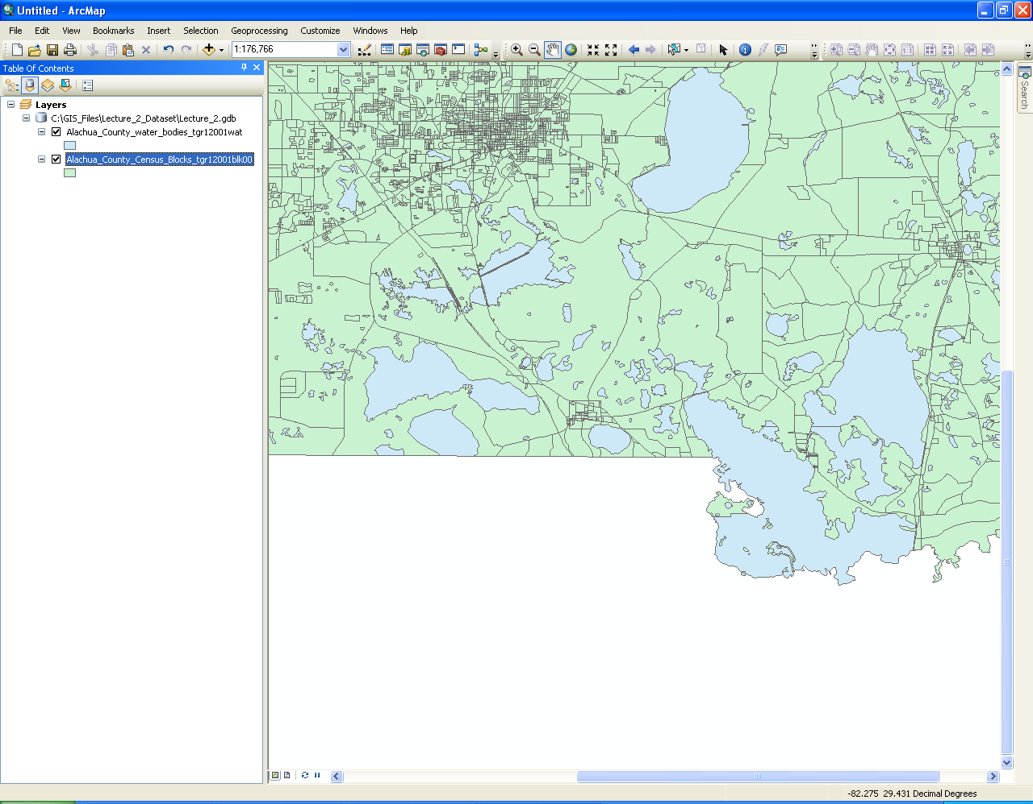

**In class exercise B.2**

Work with a partner to complete the following tasks:

- Add the following geodatabase layers to ArcMap:

- Alachua_County_Boundary_tgr12001cty00

- Alachua_County_Roads_tgr12001lkA

- gc_health_jul09_Project_Alachua_15_mile

- gc_hospitals_may11_Project_15_mile

- Make only the following layers Visible:

- gc_hospitals_may11_Project_15_mile

- Alachua_County_Boundary_tgr12001cty00

- Make only the gc_hospitals_may11_Project_15_mile layer Selectable.

- Select all of the hospitals (members of the gc_hospitals_may11_Project_15_mile layer) that fall within Alachua County.

- Export the selected hospitals into the Lecture_1 geodatabase, using the layer name “Alachua_hospitals”.

- Make only the following layers Visible:

- Alachua_hospitals

- Alachua_County_Boundary_tgr12001cty00

- The end result should look like the following

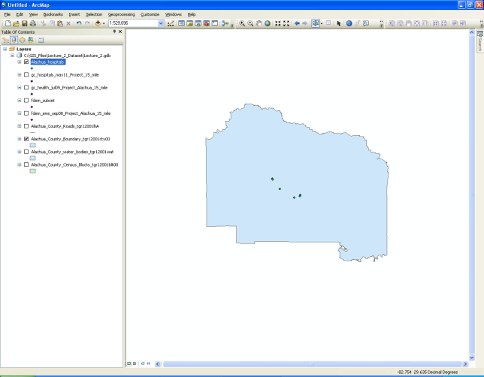

Clean-up phase:

- Make all layers Visible and Selectable.

1. Map view
2. Change to the Layout view

*Information:* ArcMap provides a separate Layout view in the Map panel for visualizing how your map product will look.

* + - 1. There are two methods to for toggling between the Data and Layout views in the Map panel.
         1. Select Data or Layout View from the View menu.
         2. Select the Data () or Layout () View symbols located in the lower left corner of the Map panel.

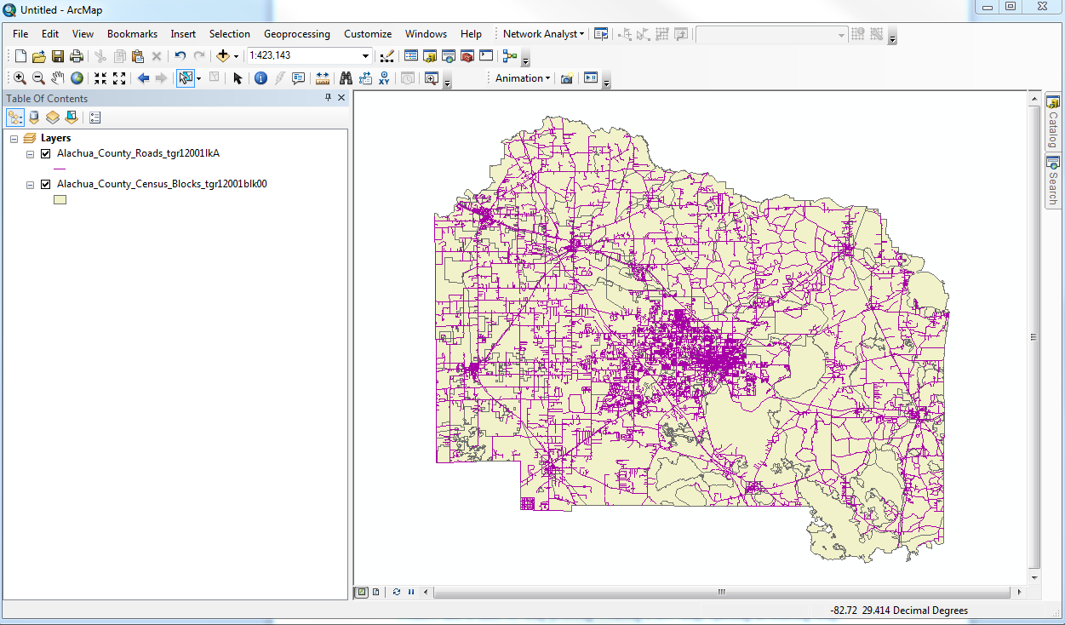

Data and Layout View buttons

* + - * 1. We need to reshape the data frame to fit the page.

Select the  tool from the Tools toolbar.

Use the mouse cursor to select the edge of the data frame. The selection will be indicated by the data frame’s edge turning blue and squares appearing at the corners and the middle of the frame’s sides.

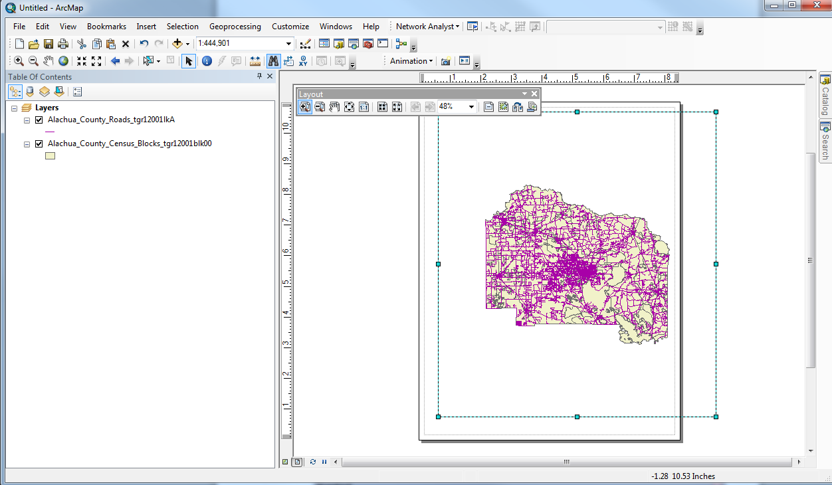

1. Layout Zoom and Pan tools

*Information:* There are separate zooming and pan tools for navigating in the Layout View. Imagine that you have a digital photograph of your map product (i.e., the page as it looks in the Layout View). The Layout Zoom and Pan tools allow you to zoom in and out and pan across the photograph, without affecting how much of the spatial data is displayed in the overall map (i.e., the geographic extent).

The Zoom and Pan tools that we already discussed (all located on the Tools toolbar) can be used in the Layout View, but they will change the scale of the map data displayed in the data frame of the Layout View. This distinction between the functionalities of these two sets of zoom and pan tools is important, and if forgotten, it can lead to a fair amount of frustration on the part of the user.

These tools are located on the Layout toolbar, shown below.



Each tool is described below, starting from the left.

 - This tool allows the user to conduct a customized zoom-in on the Layout page. The mouse cursor is used to create a box around the area of the Layout page where the user would like to zoom in to.

- This tool allows the user to conduct a customized zoom-out on the Layout page. The mouse cursor is used to create a box around the area of the Layout page that the user would like to zoom out from.

- This tool allows the user to pan across the Layout View.

- This tool allows the user to zoom to the full extent of the page in the Layout View.

- This tool allows the user to zoom to 100% in the Layout View, i.e., what the page will look like when printed.

-This tool allows the user to zoom-in at fixed increments in the Layout View.

-This tool allows the user to zoom-out at fixed increments in the Layout View.

-This tool allows the user to return to toggle backward through the Layout zoom and pan history.

-This tool allows the user to toggle forward through the Layout zoom and pan history.

1. Add multiple data frame
   1. Click to create a blank new file in ArcMap;
   2. Click “Layers” of data frame and rename the data frame “Layers” as “map 1”;
   3. Add two files of “Alachua_County_Census_Blocks_tgr12001blk00” and “Alachua_County_Roads_tgr12001lkA”
   4. Click insert and select “data frame” to add another data frame;

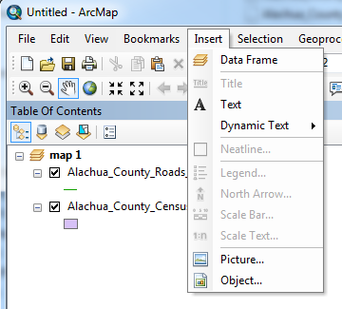

* 1. Click “new data frame” and rename the data frame as “Map 2”;
  2. Add two files “Alachua_County_Boundary_tgr12001cty00” and “fdem_ems_sep08_Project_Alachua_15_mile”
  3. Note: only Active data frame can be seen in Map Panel under data view
  4. To switch the active data frame, right click the data frame and click “activate”;

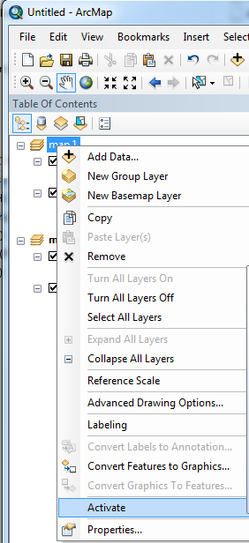

* 1. Switch map view to layout view, adjust the maps and align two maps one page.

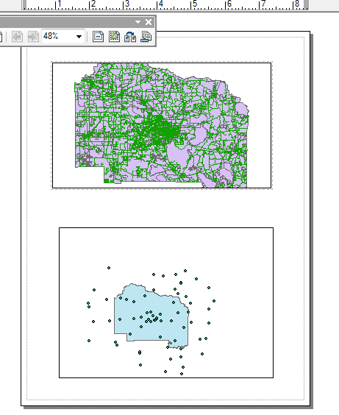

**Tutorial C: Introducing ArcToolbox**

ArcToolbox is a suite of tools designed to conduct specific tasks without having to use the ArcCatalog or ArcMap interface. There is some overlap between the functions available through ArcMap and those provided by ArcToolbox. ArcToolbox offers a wide variety of functions, some of which we will learn and use later in the course. We will just learn how to access the suite of tools and briefly describe the categories of tools available.

Open ArcToolbox within ArcMap

Access to the ArcToolbox is available either through ArcCatalog or ArcMap. You select the  button on the Standard toolbar in either of these applications and ArcToolbox will open as a panel.

