**Name: JOE BREW (UF ID 0402-8902)**

**PHC 6937: Spatial Epidemiology**

**Homework 1: Exploring ArcMap**

In this homework, the map shapefiles of county and walking trail in FL are provided. (Please download the homework dataset in the fold of homework (week 2) from the courseweb and save it in the local driver of your computer and unzip the file.)

These two shapefiles include “FCTY2.shp” (FL county map) and “existing_trail_Apr09.shp” (i.e. FL walking trail map)

Question 1:

1. Following the instruction sheet “exploring ArcMap”, start the ArcMap software;
2. Rename the data frame “Layers” to “FL county”;
3. Add the shapefile “FCTY2.shp” in the data Frame;
4. Please label each county by name;
5. Switch to map layout view and export the map as JPEG format;
6. Insert the picture in a word file as the answer to this question.

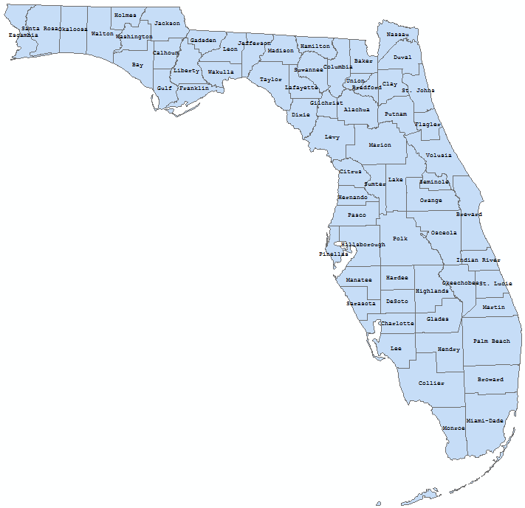

Questions 2:

1. Following the instruction sheet of “exploring ArcMap”, start the ArcMap software.
2. Rename the data frame “Layers” into “FL_county”;
3. Add the shapefile “FCTY2.shp” in the data Frame;
4. Insert another data frame and rename it as “FL_County_trail”;
5. Add the shapefiles “FCTY2.shp” (FL county map) and “existing_trail_Apr09.shp” (i.e. FL walking trail map) under the data frame “FL_County_trail”;

Note: ignore the Geographic information system pop-up window by clicking on “close”

1. If you cannot see the walking trail layer, please move the “existing_trail_Apr09.shp” before the “FCTY2.shp”;
2. Switch to map layout view, resize and move two maps into a good fit;
3. Export the map into JPEG format and insert it in your homework word file as the answer to this question.

