Homework #2 – JOE BREW (UFID: 0402-8902)

Please refer to lecture 2 tutorials and its geodatabase to answer the following questions.

1. What are the coordinate systems in each of the datasets and the feature classes which are not in a dataset?

**Alachua Dataset:**

GCS_North_American_1983 (Projected: NAD_1983_StatePlane_Florida_North_FIPS_0903_Feet)

**Florida Dataset:**

GCS_North_American_1983 (Projected: PCS_Albers)

**USA Dataset:**

GCS_WGS_1984

**World Dataset:**

GCS_WGS_1984

**Alachua_Blockgroup feature class:**

None given, so I defined projection as GCS_North_American_1983 (imported from USA dataset)

**Hospital_wrongprj feature class:**

GCS_WGS_1984 (Projected: WGS_1984_UTM_Zone_17N)

1. What was wrong of the coordinate system information in the data layer “hospital_wrongprj”?

It was incorrectly given in the transverse Mercator projection (WGS_1984_UTM_Zone_17N), when in reality, the coordinates are latitude and longitude. Accordingly, it should be given the WGS 1984 geographic coordinate system.

1. You have a choice between “Geographic Coordinate System” and “Projected Coordinate System” for “Hosptial_wrongprj” layer, which one should be chosen and why?

In this case, one should choose a geographic coordinate system. That is because these data are in a 3d representation using latitude and longitude.

1. What is the X, Y Coordinate of the hospital in UTM 17N coordinate system?

There are multiple hospitals in this coordinate system. In latitude and longitude, they are as follows:

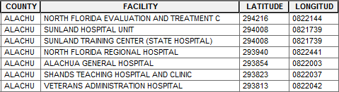

Once we convert the projection to the UTM 17N coordinate system, we can see that the coordinates are quite different:

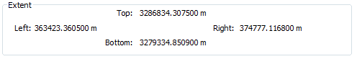

1. Make a screen shot to show the correct locations of hospitals in Alachua County.

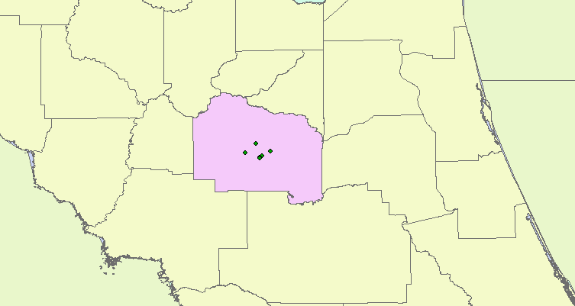 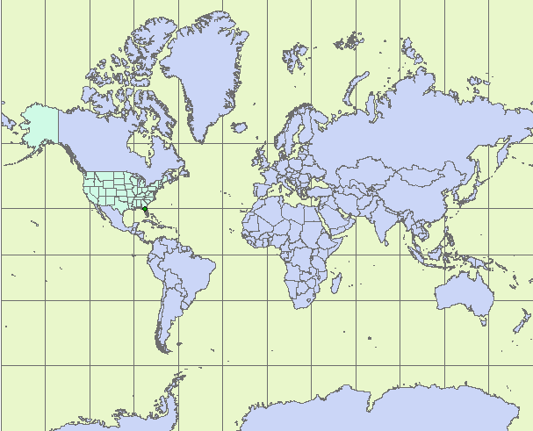

1. Make a screen shot for the Robinson Projection

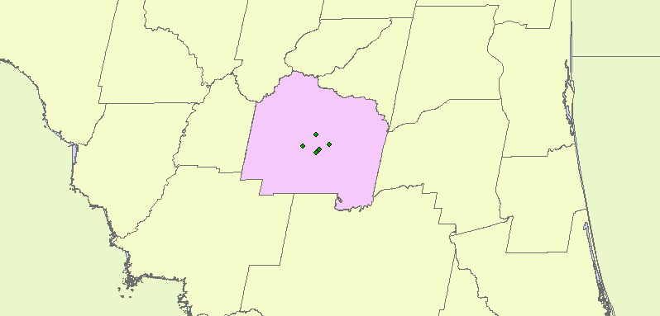 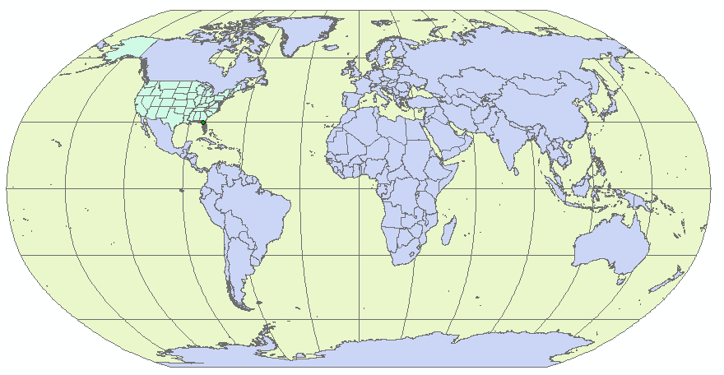

1. Make a screen shot for another different projection of your choice;

Winkle 1world

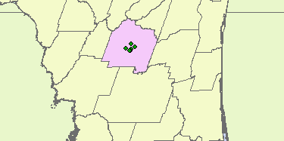 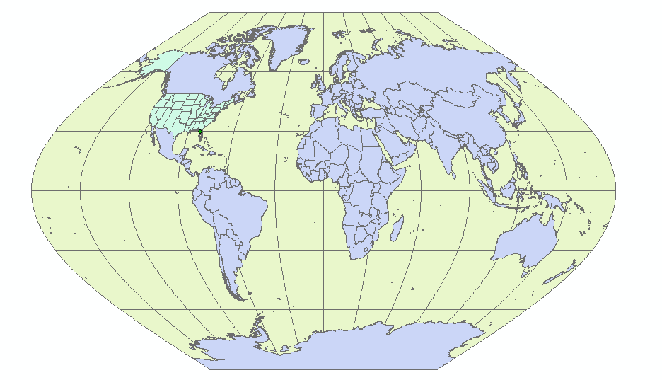

1. Make a screen shot of yourlastname projection.

