**Disease mapping:**

**In Class Tutorials**

This tutorial provides step-by-step illustrated instructions for disease mapping. In this tutorial, the students are expected to know how 1) to create a thematic disease map, i.e. choropleth map; 2) to map multiple variables; 3) to set up animation mapping. All data are available in the Geodatabase of “Data_disease mapping.mdb”.

Data sources for this Tutorial are:

1. [*ERSI*](http://www.google.com/url?sa=t&rct=j&q=&esrc=s&source=web&cd=1&ved=0CB8QFjAA&url=http%3A%2F%2Farrow.acpafl.org%2FServiceCenter%2Fgis_main.aspx&ei=11tnUMuxDJCm8ATk-4HADQ&usg=AFQjCNHLA1XA2ZqiGP8J6QMsioFIWfze3Q&sig2=wK7yohWYzsAABdcTBSojVg) Tutorial
2. U.S Census Burea

<http://www2.census.gov/cgi-bin/shapefiles2009/county-files?county=12001>

**Tutorial A. Create a thematic disease map**

Thematic Maps display the spatial pattern of a single phenomenon, or the spatial relationships between several phenomena. The key elements of thematic map include title, legend, north arrow, scale and source statement. A good map should inform, reveal, clarify or convince. The purpose of this tutorial is to create a thematic map to show the spatial distribution of lung cancer of mortality rate by race and gender.

Data to be used

*Polygon features*

USA_CTY: Represents all Counties in the USA.

*Table:*

USA_CTY_LUNGCA: Dataset contains the Mortality rates of all counties in the USA between 1970-1994. The variables include

RWM70_90 (Mortality rate in White males),

CWM70_90 (Count of deaths in White males),

RWF70_90 (Mortality rate in White females),

CWF70_90 (Count of deaths in White females),

RBM70_90 (Mortality rate in Black males),

CBM70_90 (Count of deaths in Black males),

RBF70_90 (Mortality rate in Black females),

CBF70_90 (Count of deaths in Black females)

1. Join the table with map ;
   1. Open ArcMap ;

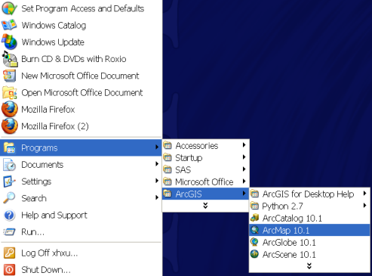

* 1. Add the feature class of “USA_CTY” and the table of “USA_CTY_LUNGCA” into ArcMap;
  2. Right click “USA_CTY” and Select “join”

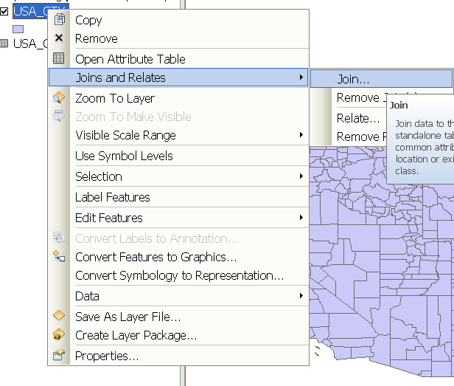

* 1. Join **the table of** “USA_CTY_LUNGCA” in the feature class of “USA_CTY”

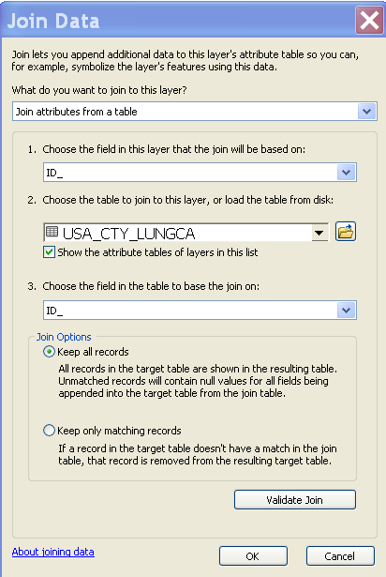

* 1. Export **the joined** feature class as “LungCounty7094”

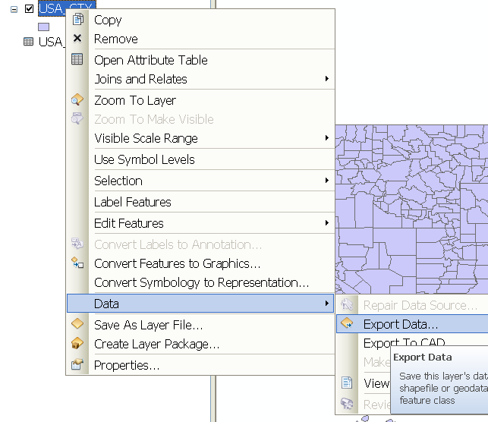

1. Create a thematic disease map to display the lung cancer mortality rate of white male.
   1. Add the shapefile of “LungCounty7094” into ArcMAP;
   2. Right click the file, go to and click “properties”

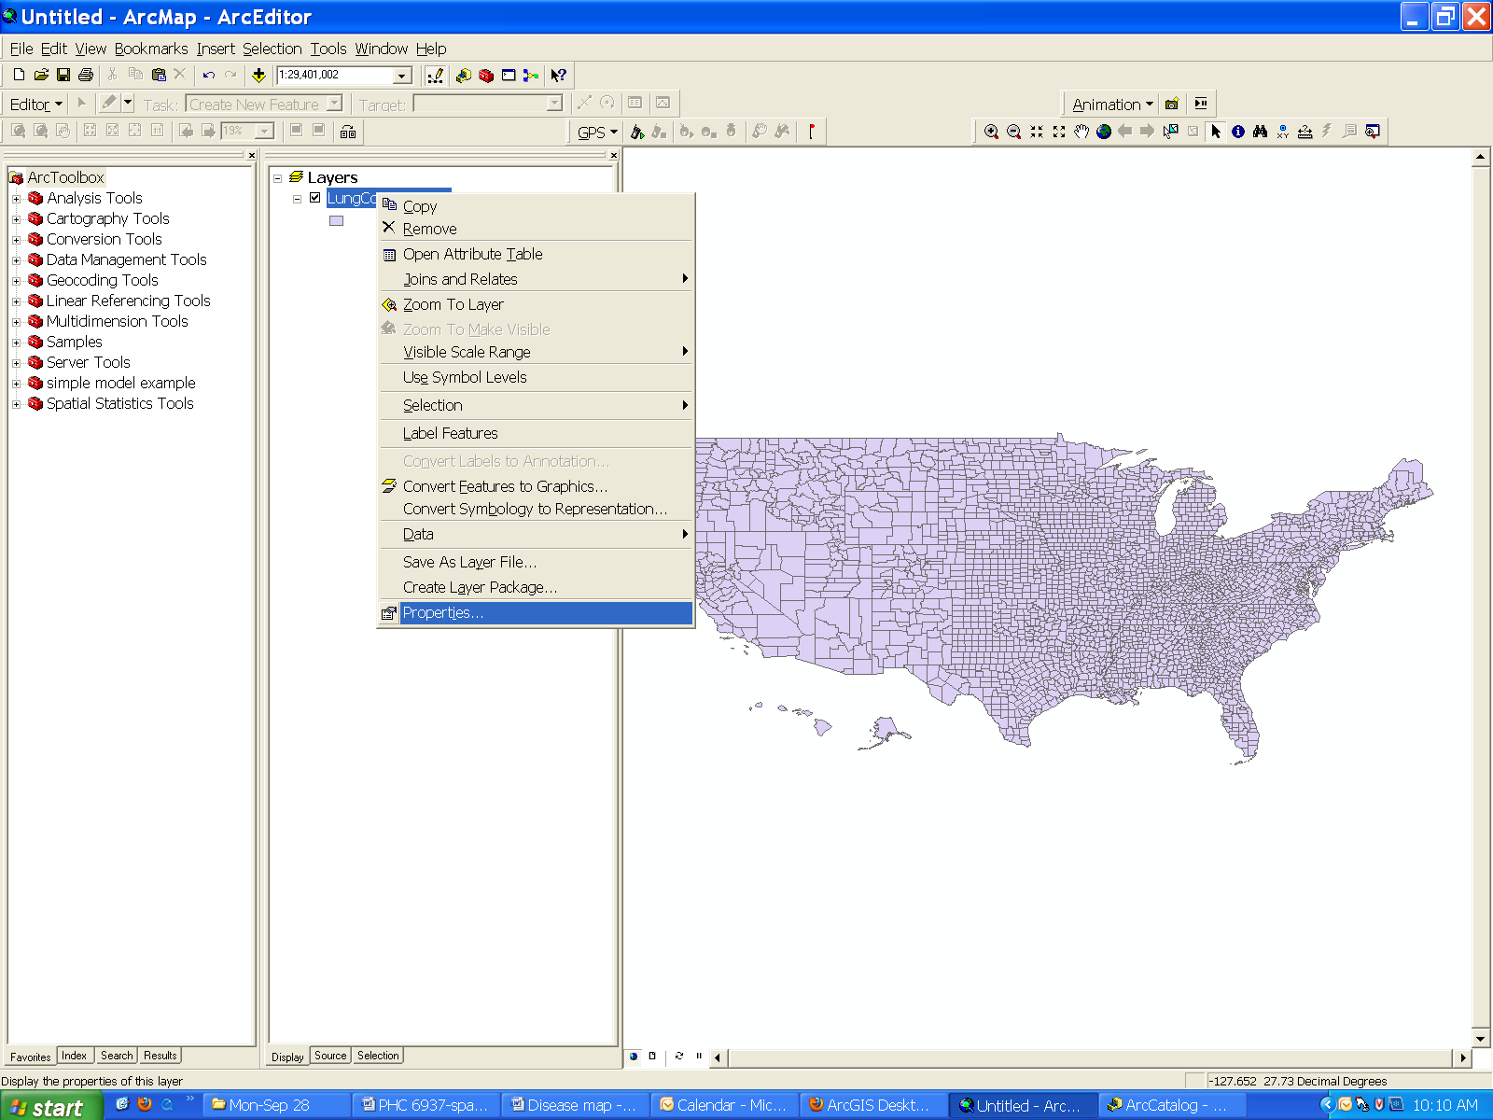

* 1. Click “Symbology” in the layer properties windows and select the attribute field to symbolize the feature;

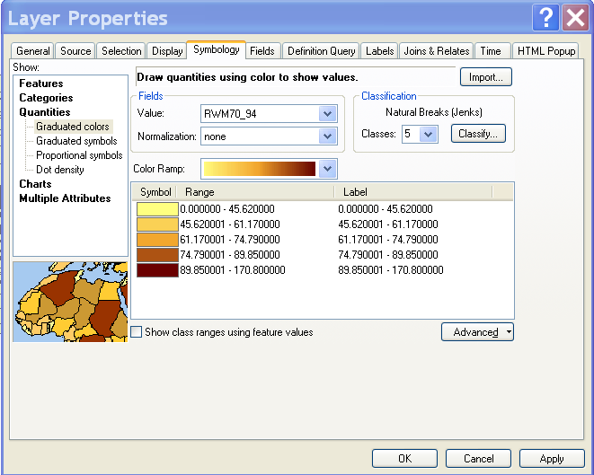

* 1. Define the classification;
     1. Click the “Classify” button



* + 1. Change the number of category to “4”;

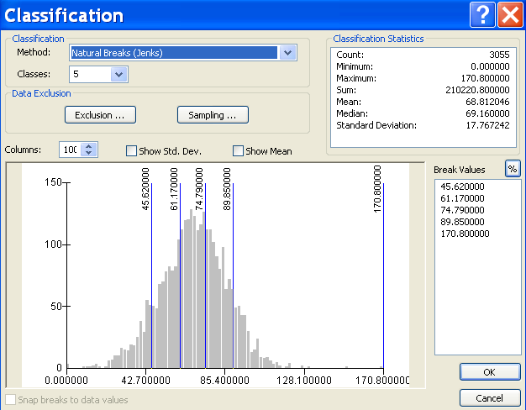

* + 1. Try different methods to define the categories;



* 1. Change color ramp
     1. Click “Color ramp” to change other color;



* + 1. Import additional style for display;

1. Download Color Brewer Color Ramp Style Set from <http://arcscripts.esri.com/details.asp?dbid=14403>
2. Unzip it.
3. Open the Layer properties and click on ‘Symbology’ tab in ‘ArcMap 10.1’.
4. Click “Symbols” and select “properties for all Symbols”

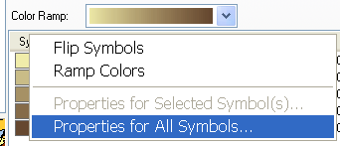

1. Click “Style References..”

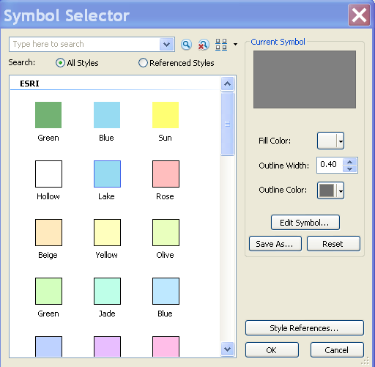

1. Click “Add Style to List..” and add ‘ColorBrewer.style’ that is obtained from setp a.

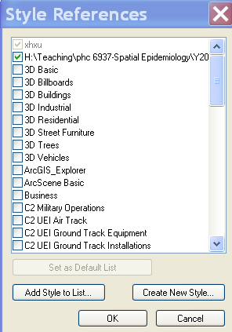

1. Select ‘ColorBrewer.style’ and make it default.
2. Close the layer properties once and open it again, you will see newly generated color ramp.

**Appendix : Manually Pick the color**

1. You have to pick each color ramp value manually from <http://colorbrewer2.org/> .
2. Open the Layer properties and click on ‘Symbology’ tab in ‘ArcMap 10.1’.
3. Double click on one of the color symbol beneath ‘Symbol’ that gives you a ‘Symbol Selector’ window.

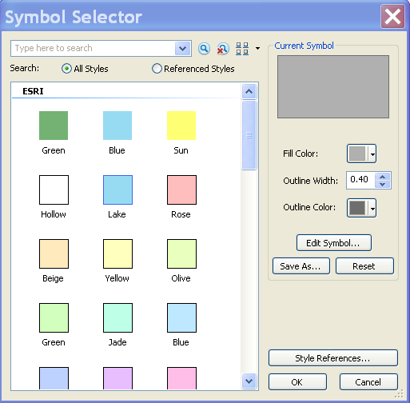  
4. Click on ‘Edit Symbol’.  
5. Click on Color box inside ‘Simple Fill’ area.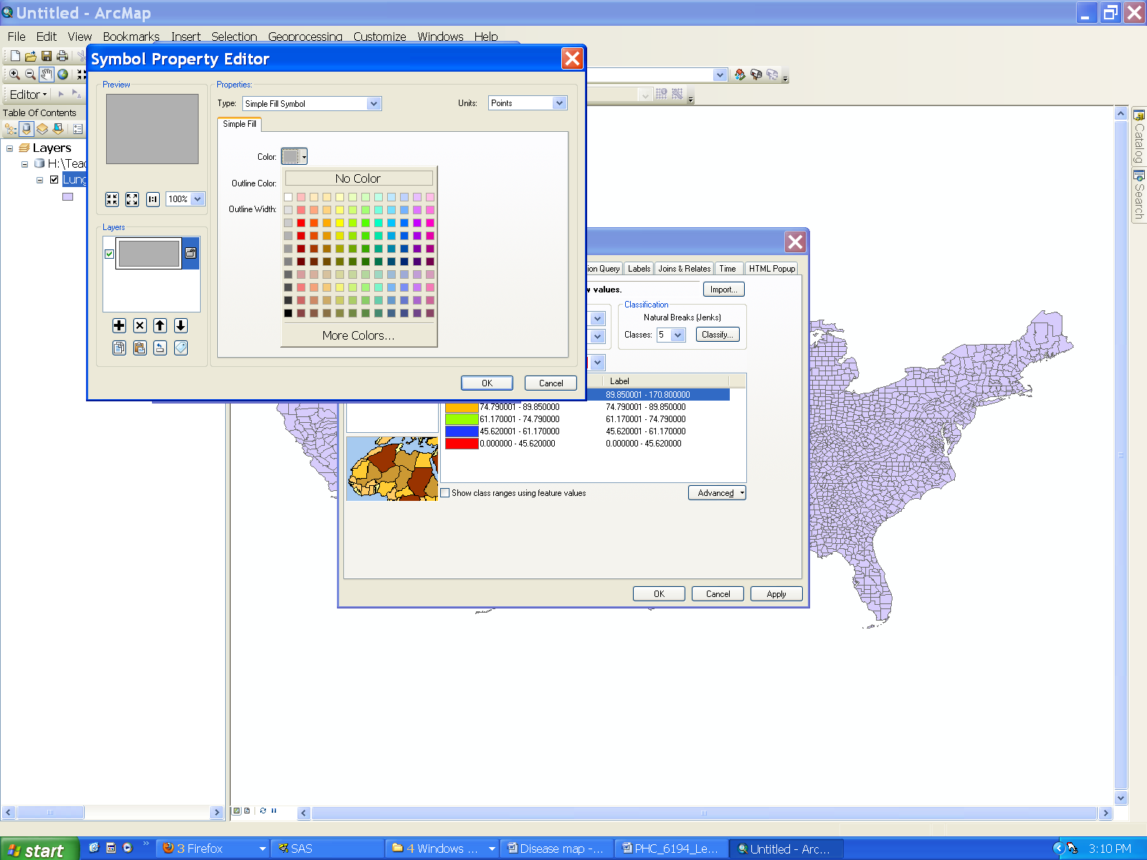  
6. Click on “More Colors” which gives you Color Selector.

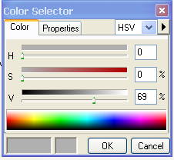  
7. Choose RGB from Drop down box located in the top right.  
8. Then, update values that come from Colorbrewer.

* 1. Edit the Label;
     1. Click Label and select Format labels;

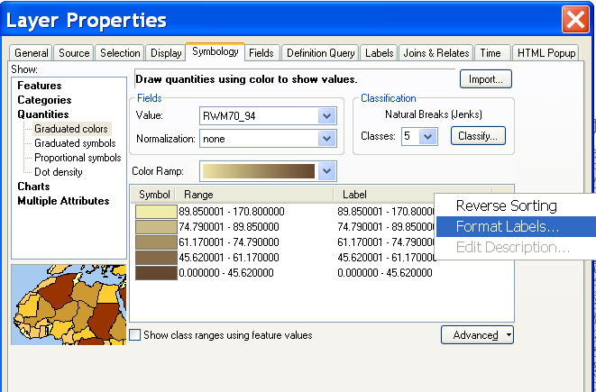

* + 1. Change Rounding to “2”

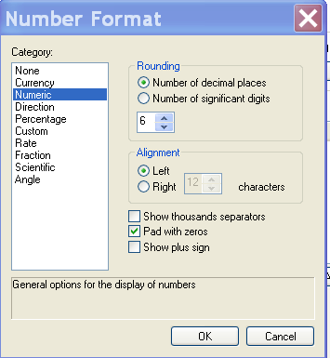

* + 1. Click ok
    2. Return to the window of layer properties and Click OK.
  1. Insert the title, legend, north arrow, scale and source statement
     1. Insert the title;
        1. **Importantly, before you insert any items above, please switch map view from “data view” to “layout view”**

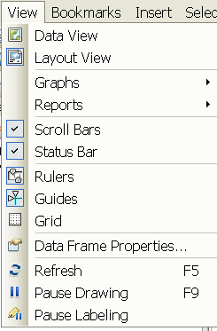

**Or**

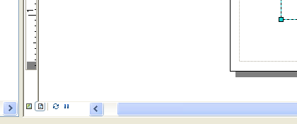

* + - 1. Please get familiar with the tools of layout view



Tell the difference with the tools of data view



* + - 1. Click “insert” and select “title”;

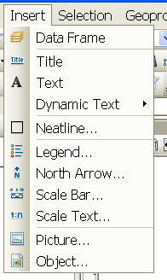

* + - 1. Type the title and double click the title

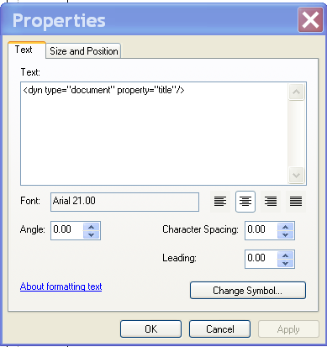

* + - 1. Click “change symbol” to edit the title;

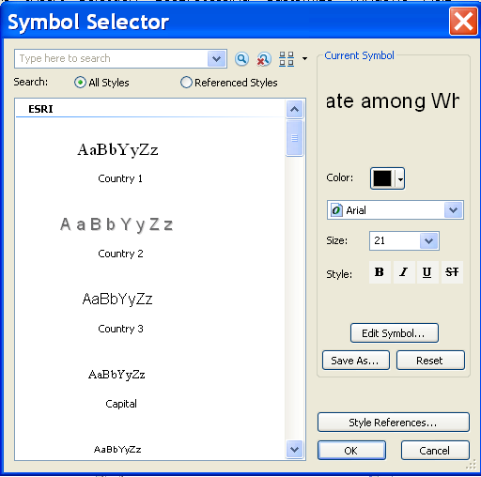

* + 1. Insert the Legend;
       1. Click “insert” and select “legend”;

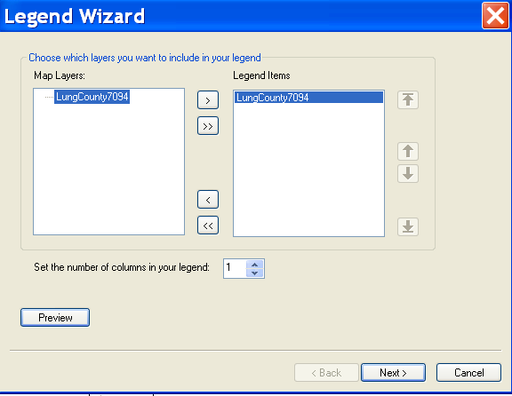

* + - 1. Click “next” to the end.
      2. Double click the legend to edit it
         1. Change the title of the legend;

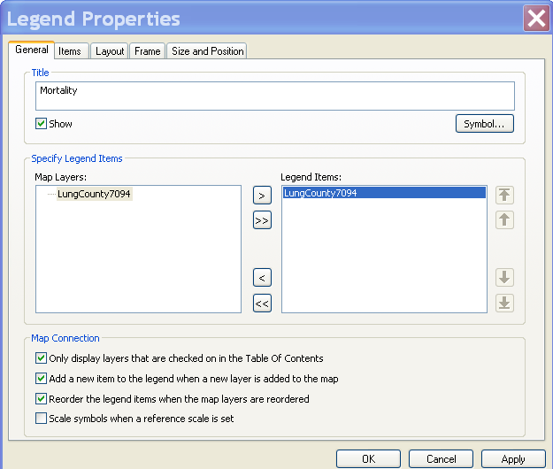

* + - * 1. Not display the layer name and head name;

 

* + - * 1. Double click the legend and click the tab of “Item”
        2. Click “Style”;

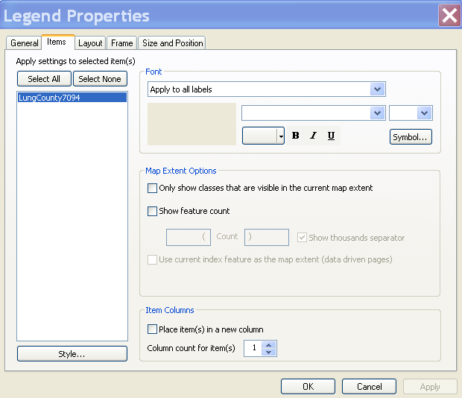

* + - * 1. Click “properties”

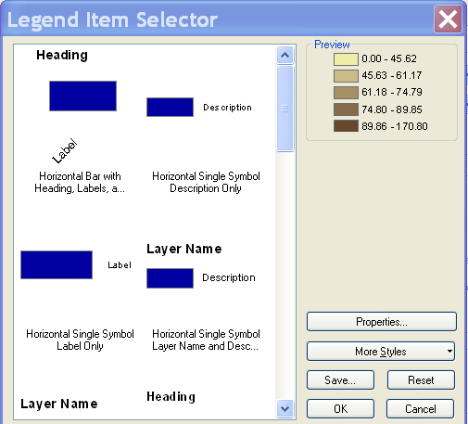

* + - * 1. Uncheck “Show Layer Name” and “show Heading”

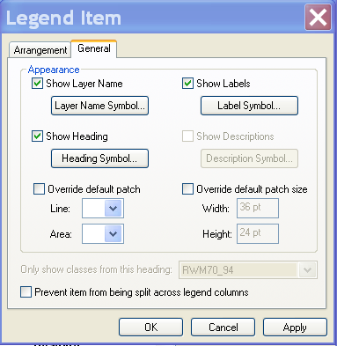

* + - * 1. Click “apply” and “ok”
    1. **Your turn:** Insert the North Arrow, Scale Bar, and Scale Text;
    2. Please edit them ;
    3. Export the map as a picture format;

1. Insert several maps in a page;
   1. Insert a new data frame;

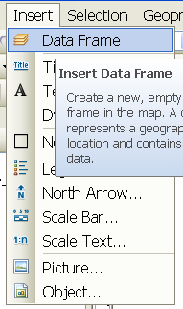

* 1. Copy “LungCounty7094” to the new data frame;
  2. Repeat the steps in section #2 and generate the choropleth map for mortality rate among white female;
  3. Switch to “layout view”;
  4. Practice align two maps in a page

**Tutorial B. Map two more variables**

In this tutorial, we will create a map of year house built and number of elevated blood cases in Allegheny County, PA. See the following map.

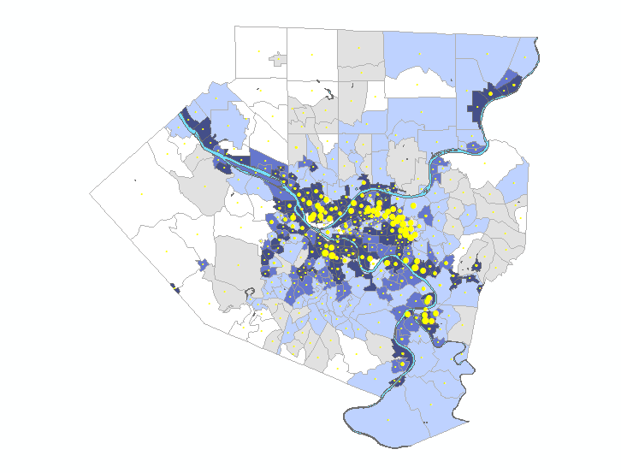

**Median Year House Built**

1940 or earlier

1941 - 1950

1951 - 1960

1961 - 1970

1971 or later

**No. Elevated Blood**

**Cases By Tract**

!

0 - 10

!

11 - 20

!

21 - 40

!

41 - 80

!

81 - 150

Data to be used

*Polygon features*

Allen_lead: represent all census tracts in Allegheny County, PA. The attribute table include the number of elevated blood lead cases and the average of year of the buildings.

1. Add the feature class of “Allen_lead” into Arcmap;
2. Right click the file, go to and click “properties”
3. Click “Symbology” in the layer properties windows;
4. Select the “multiple attribute” under the “show” window;

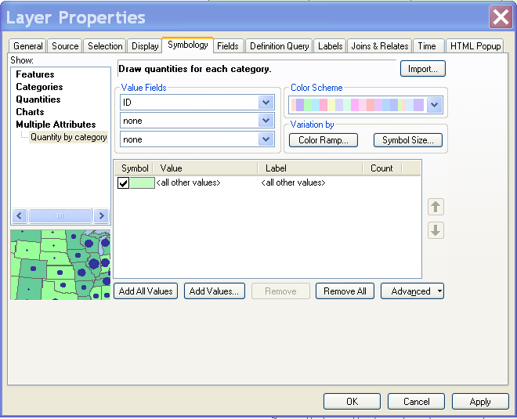

1. Select “year house built” in the first row of “field value”;
2. Uncheck the “<all other values>” under symbol and click “add all values” at the bottom;

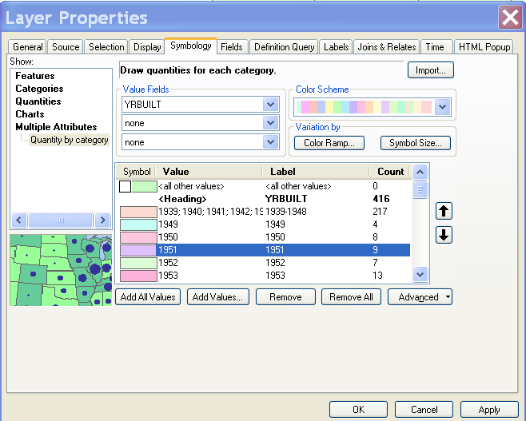

1. Press down Shift key to select the first ten records

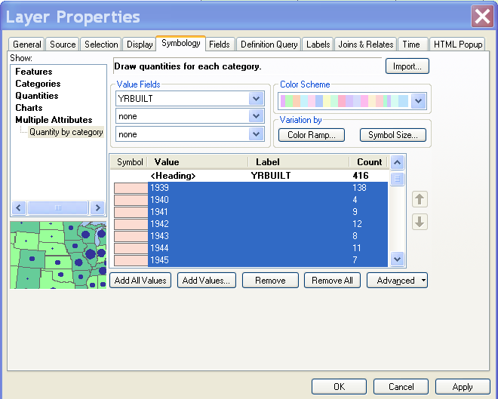

1. Right click the highlighted area and select “Group values”;

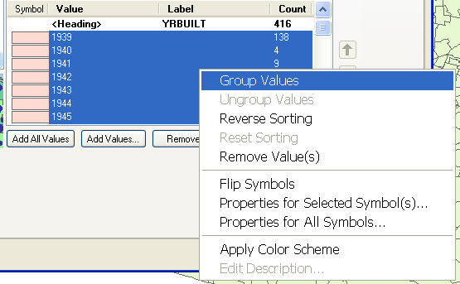

1. Click the value under label and modify the label as “1939-1948 ;

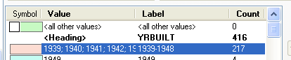

1. Repeat steps 7-9 and create four more groups.
2. Press Shift key to select all created groups and Click “Color Scheme” to change the colors

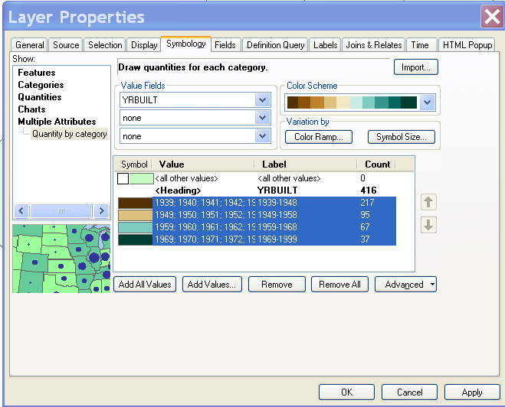

1. Click “Symbol Size”

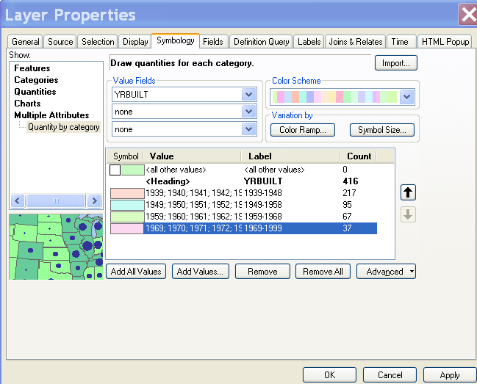

1. Select “number elevated blood lead cases” in the window of “Draw quantities using color to…”;

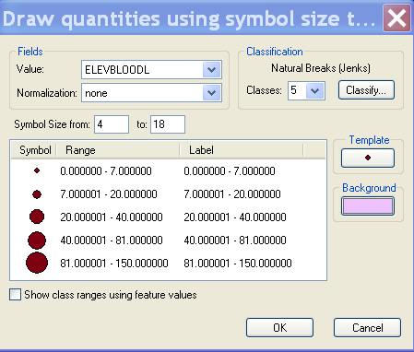

1. Click “OK” and “Apply”

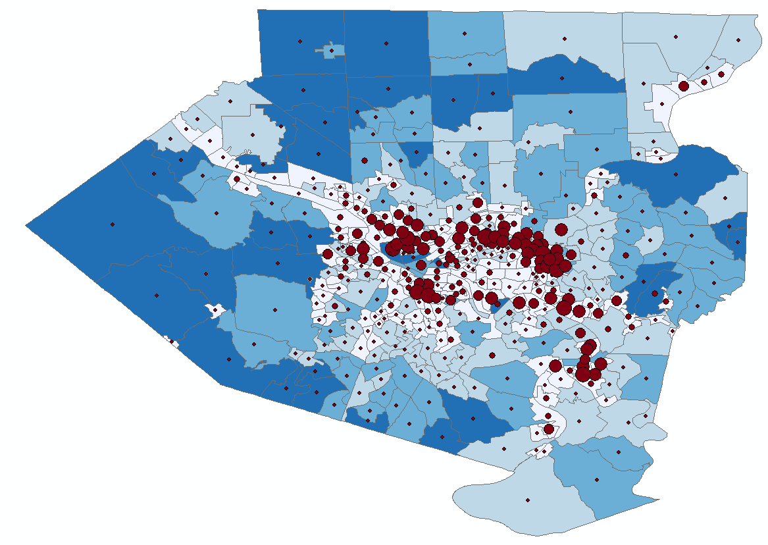

1. Switch the “layout view” to check the map

**Tutorial C. Create an animation map**

In this tutorial, we will create an animation map to show the change of population distribution across the study area from 1800 to 2010.

*Polygon features*

USA_CTY_POP: This dataset is used in the Animation in ArcMap tutorial. It includes the county population information every ten years from 1800 to 2010 in a subset of U.S. Counties.

1. Create a choropleth map with the variable “POP”;
   1. Open ArcMap and Add USA_CTY_POP;
   2. Right click “USA_CTY_POP” and select “properties”

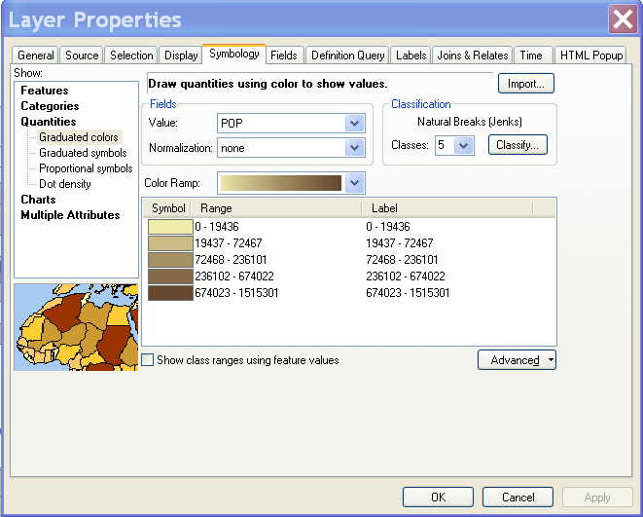

* 1. Set up the information as shown in the figure above.
  2. Click “ok”

1. Creating a temporal animation
   1. Double-click the temporal dataset in the table of contents to open the Layer Properties dialog box.
   2. Click the Time tab.
   3. Check Enable time on this layer. (The Time properties and Advanced settings controls are now made available. Also, some of the controls are populated for your convenience. You can choose to change these depending on your needs.)

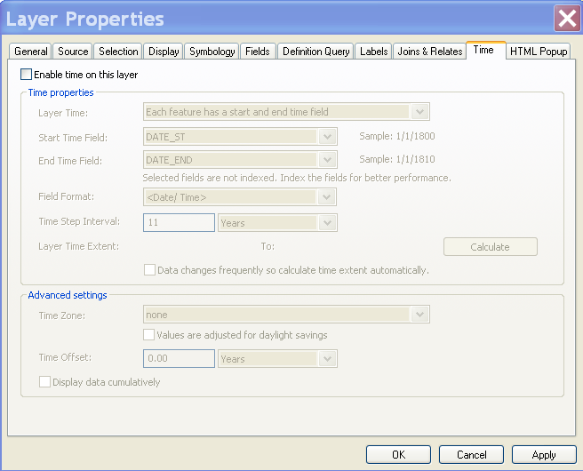

* 1. Based on whether the time stamps for the data are stored in a single field or in two fields in the attribute table, you can choose one of the following options for defining the value for Layer Time.

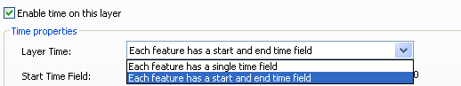

As our dataset have a start and end time field, we select the second choice.

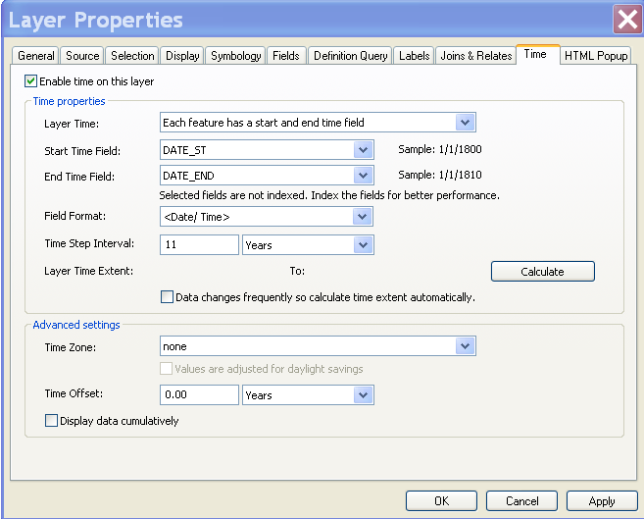

* 1. Set Start time field and End time field to these time values as above.
  2. Click Calculate to calculate the time extent of your data.

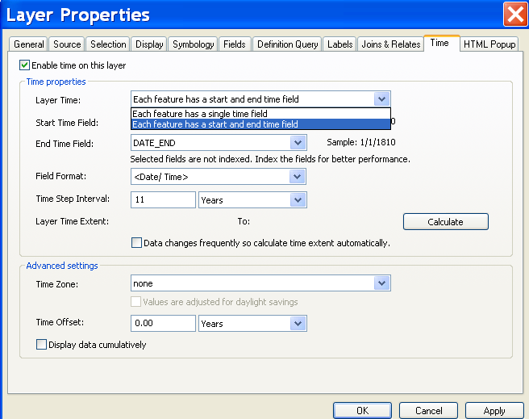

* 1. Based on how you want to visualize your data, ensure that Time step interval is set appropriately.
  2. Click ok to save the setting and close the window.

1. Playing the animation with the Time Slider window
   1. Invoke the Time Slider window by clicking the Time Slider button Time Slideron the Tools toolbar.



* 1. Features of the Time Slider window

|  |
| --- |
| Time Slider features |

* 1. Click the Play button Playto play a time animation that steps through your data sequentially.
  2. Click the Options button Optionsto set the time slider properties. Go to “Playback” tab. You can set up the playing speed.

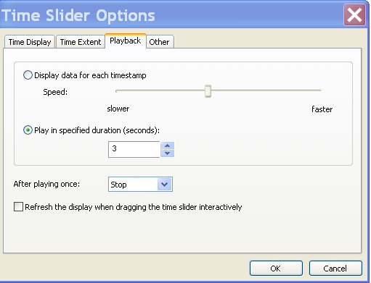

* 1. Click the Export To Video button Export to Videoto export your time visualization to a video or as sequential images.

