Department of Epidemiology

University of Florida

Gainesville, Florida

Friday, October 24th, 2014

Journal of Epidemiology and Community Health

BMJ Journals, BMA House,Tavistock Square

London, WC1H 9JR, UK

Re: Chaparro MP, Whaley SE, Crespi CM, Koleilat M, Nobari TZ, Seto E, Wang MC. Influences of the neighbourhood food environment on adiposity of low-income preschool-aged children in Los Angeles County: a longitudinal study.

*J Epidemiol Community Health*. 2014 Jul 10. doi: 10.1136/jech-2014-204034.

Dear Editor,

Chaparro et al’s study of the relationship between early childhood adiposity and nearby food environment represented an important examination of an understudied population. Though their conclusions are certainly thought-provoking, the methods by which they arrived at these conclusions, though common, left me with questions.

First, the authors characterize the advantages of weight-for-height z-score (WHZ) as “more appropriate” than body mass index (BMI) for studying longitudinal adiposity. Though they are right to point out that WHZ has the advantage of being “independent of height at all ages,” they overlook the fact that over-time variability in WHZ is not independent of level of adiposity[1] (see figure 1).[2] To avoid heteroscedasticity, BMI percentile-for-age should be considered the standard for longitudinal pediatric obesity studies such as this. Statistically, using WHZ incorrectly “overweights” the overweight.

Second, defining “neighbourhood” by census tract and buffer zone, though extremely common in US studies, should be avoided (see figure 2)[3]. Los Angeles County (LAC) census tracts are disuniform and large in size (median internal maximum Euclidean distance of 1.47 miles in the case of LAC) and ignore entirely both inter-tract population distribution as well as true travel time, a much better metric than distance for what constitutes a likely food acquisition environment (especially in a setting as pedestrian-averse as LAC). The authors could refine their analysis by (1) using census blocks instead of tracts (thereby reducing median internal maximum Euclidean distance by 85% as well as variance), (2) employing population-weighted centroids rather than boundary buffers,[4] and (3) and calculating travel time (rather than distance) for the construction of buffer zones, using any of the many widely-available tools made for doing so. [5],[6]

Finally, the authors stress the implications of the non-linear nature of the correlation between healthy food outlet density and pediatric adiposity found in their study, when the oddness of this relationship may simply be due to the non-specificity of the manner by which neighbourhood was constructed, as well as the disequal variability in change in adiposity likely incurred as a result of using WHZ. Substantiating the claim that a previously unknown “threshold effect” at which an increasing density of health food outlets *decreases* healthy food consumption would require more accurate measurement.

I applaud the authors for this important study of an area that requires further research, and wait impatiently for future studies to employ more refined methods, so as to better elucidate the epidemiology of pediatric obesity.

Joe Brew

Words: 394

Figure 1 : Heteroscedasticity and non-linear relationships between height, weight and age (in a Florida school-aged population). Disequal variance at increasing adiposity makes WHZ inappropriate for multivariate longitudinal models.

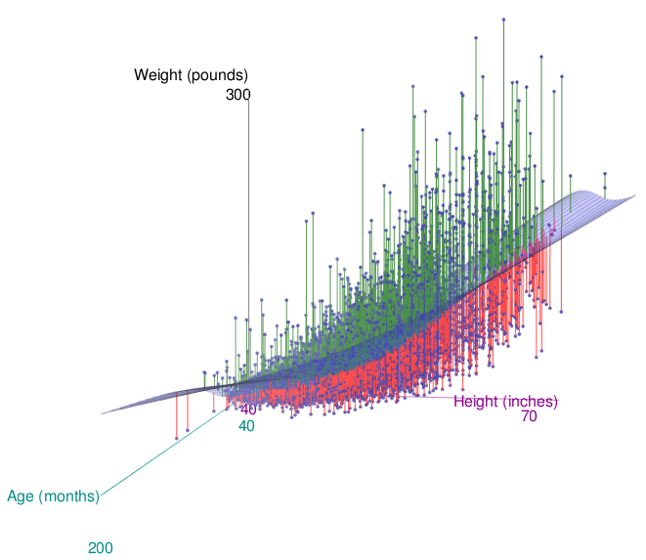

Figure 2 : Los Angeles County census tracts’ (left) and blocks’ (right) maximum internal Euclidean distance (miles)

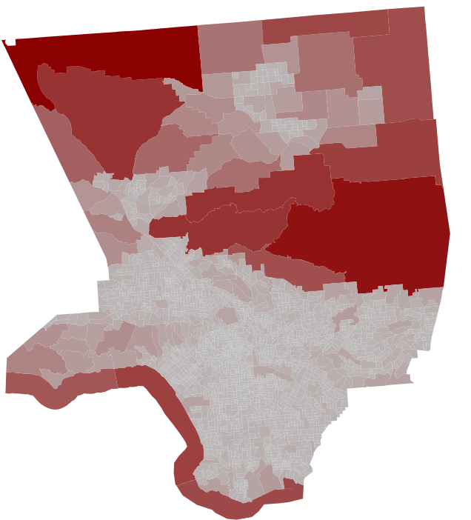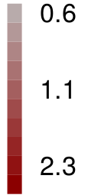 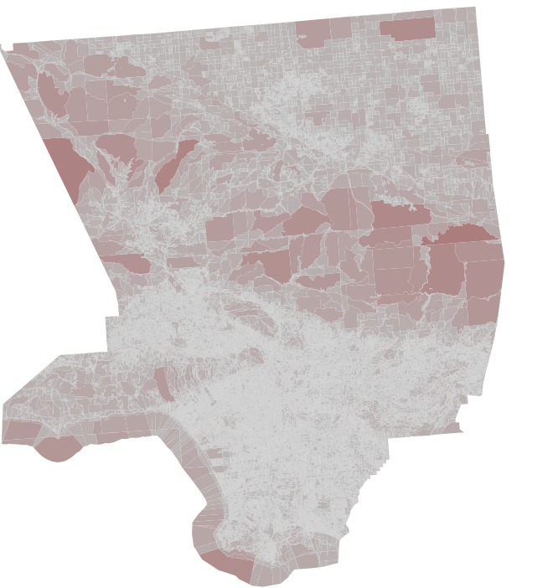

1. Cole T, Faith M, Pietrobelli A, Heo M. What is the best measure of adiposity change in growing children: BMI, BMI %, BMI z-score or BMI centile? *European Journal of Clinical Nutrition* 2005; 59:419. <http://www.nature.com/ejcn/journal/v59/n3/full/1602090a.html>
2. Figure generated by Joe Brew using R software and the RGL and car libraries. Data is “jittered” Alachua County Public Schools health screening data, as used in the Alachua County Health Department’s Community Health Improvement Plan evaluation of youth obesity (2014).

   Daniel Adler, Duncan Murdoch and others (2014). rgl: 3D visualization device system (OpenGL). R package version 0.94.1143. [http://CRAN.R-project.org/package=rgl](http://cran.r-project.org/package=rgl).

   John Fox and Sanford Weisberg (2011). An {R} Companion to Applied Regression, Second Edition. Thousand Oaks CA: Sage. URL: <http://socserv.socsci.mcmaster.ca/jfox/Books/Companion>.

   R Core Team. *R: A Language and Environment for Statistical Computing*. R Foundation for Statistical Computing. Vienna, Australia. 2014. [http://www.R-project.org](http://www.r-project.org).
3. Figure generated by Joe Brew using R software. R Core Team. *R: A Language and Environment for Statistical Computing*. R Foundation for Statistical Computing. Vienna, Australia. 2014. [http://www.R-project.org](http://www.r-project.org) Base shapefiles provided by Census, 2010. U.S. Census Bureau. <https://www.census.gov/geo/maps-data/data/tiger-line.html>
4. Burgoine T, Alvanides S, Lake A. Creating ‘obesogenic realities’; do our methodological choices make a difference when measuring the food environment? *Int J Health Geogr* 2013;12:33. <http://www.ncbi.nlm.nih.gov/pmc/articles/PMC3723649/>
5. Ozimek A, Miles D. Stata utilities for geocoding and generating travel time and travel distance information. *Stata Journal* 2011;11:106-119. <http://www.stata-journal.com/sjpdf.html?articlenum=dm0053>
6. Kahle D, Wickham H. ggmap: Spatial Visualization with ggplot2. *The R Journal* 2013;5:1. <http://journal.r-project.org/archive/2013-1/kahle-wickham.pdf>