Joe Brew

PHC 6053

Assignment 4

For the simple linear regression using Y = LNSBP and X = BMI create:

histogram of the residuals

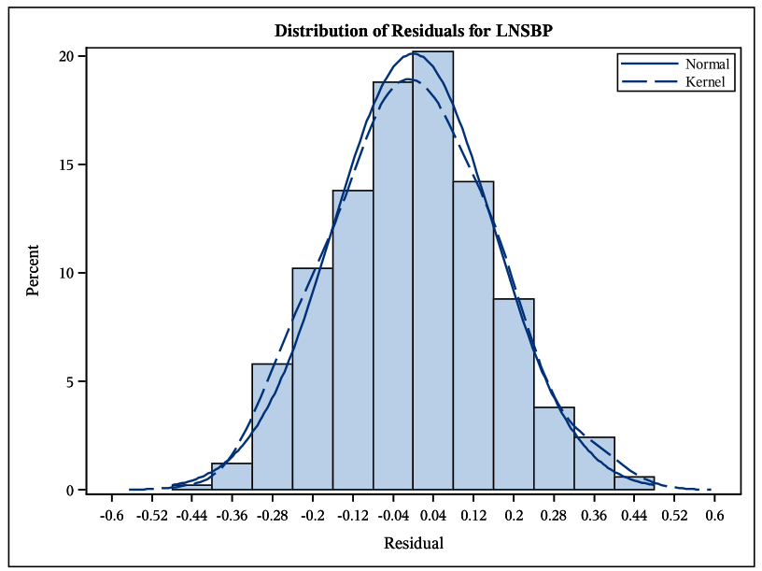

qq-plot of the residuals

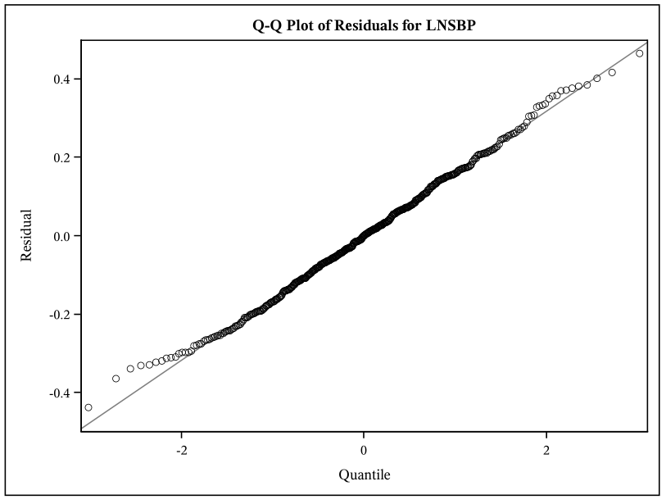

scatterplot of the residuals vs. BMI

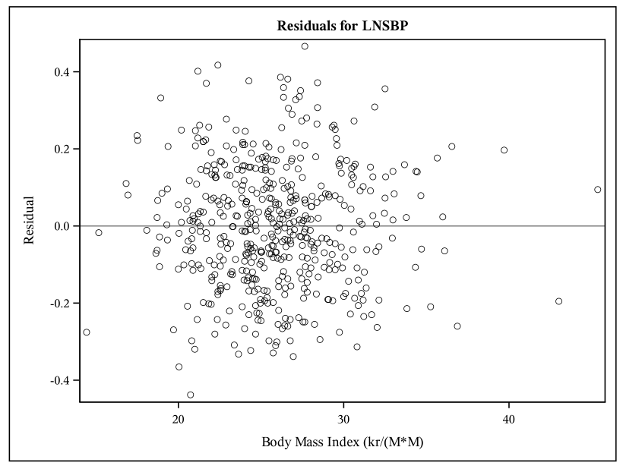

scatterplot of residuals vs. predicted values.

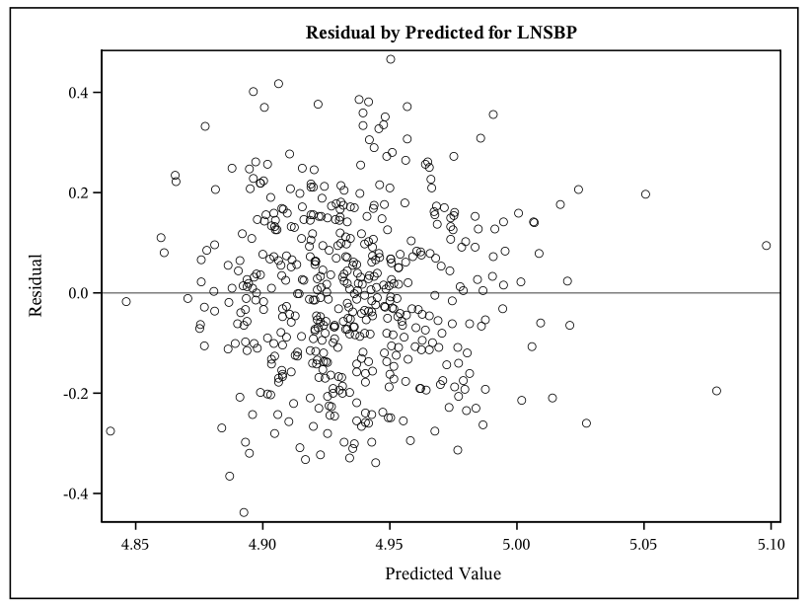

For the linear regression using Y = LNSBP and X = FEMALE create

histogram of the residuals

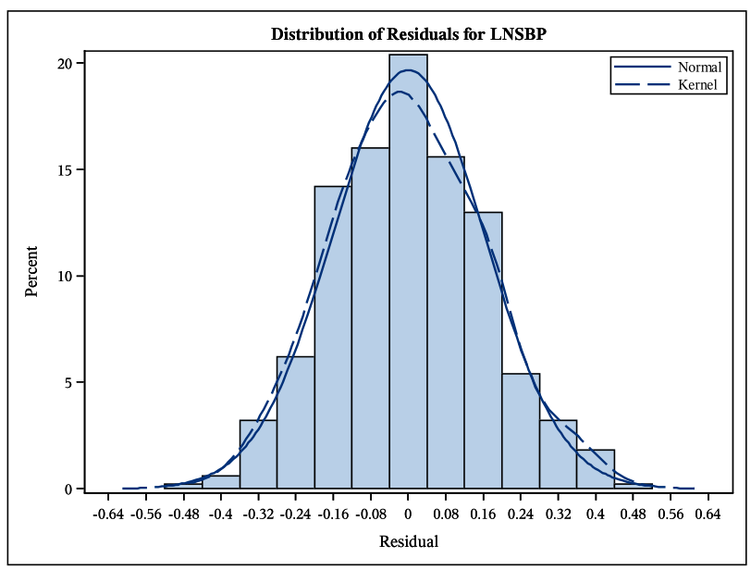

qq-plot of the residuals

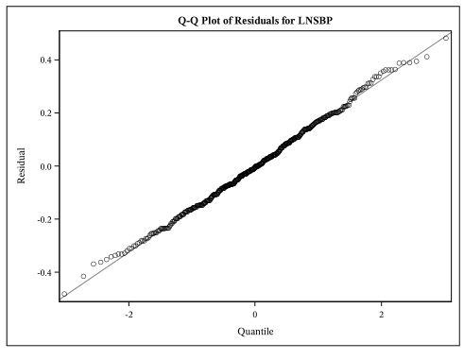

scatterplot of the residuals vs. FEMALE

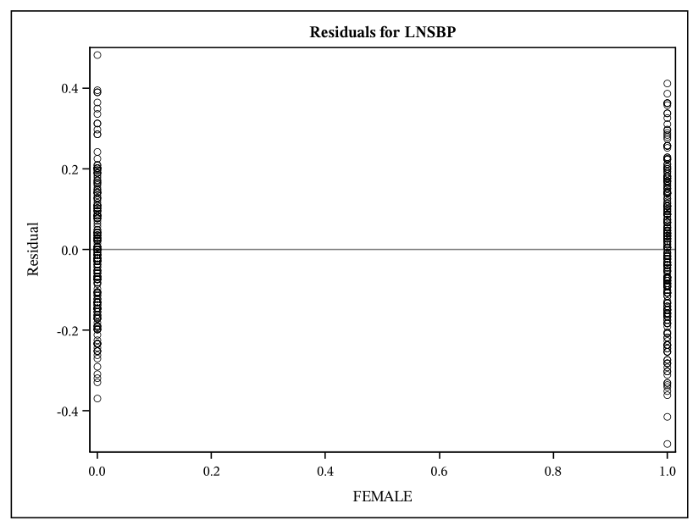

scatterplot of residuals vs. predicted values.

