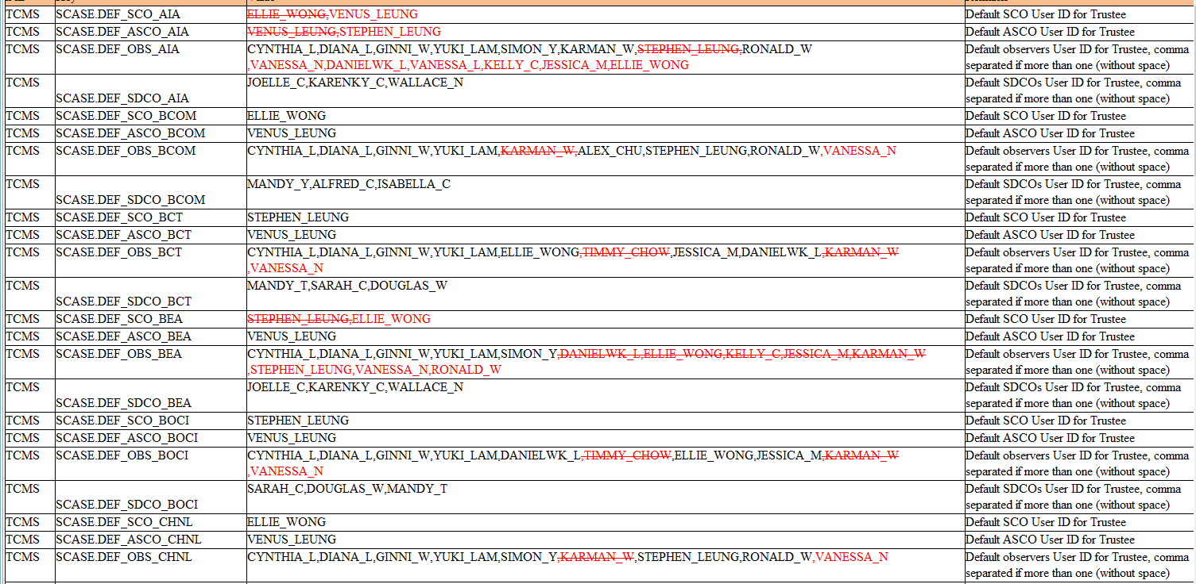

TCMS SCASE.DEF_SCO_AIA TCMS SCASE.DEF_ASCO_AIA TCMS SCASE.DEF_OBS_AIA

TCMS

SCASE.DEF_SDCO_AIA

TCMS

SCASE.DEF_SCO_BCOM

TCMS

SCASE.DEF_ASCO_BCOM

TCMS

SCASE.DEF_OBS_BCOM

TCMS

SCASE.DEF_SDCO_BCOM

TCMS SCASE.DEF_SCO_BCT

TCMS SCASE.DEF_ASCO_BCT TCMS SCASE.DEF_OBS_BCT

TCMS

SCASE.DEF_SDCO_BCT TCMS SCASE.DEF_SCO_BEA TCMS SCASE.DEF_ASCO_BEA TCMS

TCMS

SCASE.DEF_OBS_BEA

SCASE.DEF_SDCO_BEA

TCMS SCASE.DEF_SCO_BOCI

TCMS

SCASE.DEF_ASCO_BOCI

TCMS SCASE.DEF_OBS_BOCI

TCMS

SCASE.DEF_SDCO_BOCI

TCMS TCMS

SCASE.DEF_SCO_CHNL SCASE.DEF_ASCO_CHNL

TCMS SCASE.DEF_OBS_CHNL

ELLIE WONG VENUS_LEUNG

VENUS_LEUNG STEPHEN_LEUNG

CYNTHIA_L.DIANA_L.GINNI_W.YUKI_LAM.SIMON_Y KARMAN_W.STEPHEN LEUNG RONALD_W

VANESSA_N.DANIELWK_L,VANESSA_L,KELLY_C.JESSICA_MELLIE_WONG

JOELLE_C.KARENKY_C,WALLACE_N

ELLIE WONG

VENUS_LEUNG

CYNTHIA_L,DIANA_L.GINNI_W.YUKI_LAM.KARMAN_WALEX_CHU,STEPHEN_LEUNG.RONALD_W.VANESSA_N

MANDY Y ALFRED_C.ISABELLA_C

STEPHEN_LEUNG

VENUS_LEUNG

CYNTHIA_L,DIANA_L.GINNI_W.YUKI_LAM,ELLIE_WONG TIMMY_CHOW JESSICA_M.DANIELWK_L-KARMAN_W

VANESSA_N

MANDY_T,SARAH_C,DOUGLAS_W

STEPHEN LEUNG ELLIE_WONG

VENUS_LEUNG

CYNTHIA_L.DIANA_L.GINNI_W.YUKI_LAM.SIMON_Y DANIELWK_L.ELLIE WONG KELLY_C.JESSICA_MKARMAN_W STEPHEN_LEUNG,VANESSA_N.RONALD_W

JOELLE_C.KARENKY_C,WALLACE_N

STEPHEN_LEUNG

VENUS_LEUNG

CYNTHIA_L,DIANA_L.GINNI_W.YUKI_LAM,DANIELWK_L-TIMMY_CHOWELLIE_WONG.JESSICA_M-KARMAN_W

VANESSA_N

SARAH_C.DOUGLAS_W.MANDY_T

ELLIE WONG

VENUS_LEUNG

CYNTHIA_L.DIANA_L.GINNI_W.YUKI_LAM.SIMON_Y-KARMAN_W.STEPHEN_LEUNG.RONALD_W.VANESSA_N

Default SCO User ID for Trustee

Default ASCO User ID for Trustee Default observers User ID for Trustee, comma separated if more than one (without space) Default SDCOS User ID for Trustee, comma separated if more than one (without space)

Default SCO User ID for Trustee

Default ASCO User ID for Trustee

Default observers User ID for Trustee, comma

separated if more than one (without space) Default SDCOS User ID for Trustee, comma separated if more than one (without space) Default SCO User ID for Trustee

Default ASCO User ID for Trustee

Default observers User ID for Trustee, comma separated if more than one (without space) Default SDCOS User ID for Trustee, comma separated if more than one (without space) Default SCO User ID for Trustee

Default ASCO User ID for Trustee

Default observers User ID for Trustee, comma separated if more than one (without space) Default SDCOS User ID for Trustee, comma separated if more than one (without space)

Default SCO User ID for Trustee

Default ASCO User ID for Trustee

Default observers User ID for Trustee, comma

separated if more than one (without space) Default SDCOS User ID for Trustee, comma separated if more than one (without space) Default SCO User ID for Trustee

Default ASCO User ID for Trustee

Default observers User ID for Trustee, comma separated if more than one (without space)