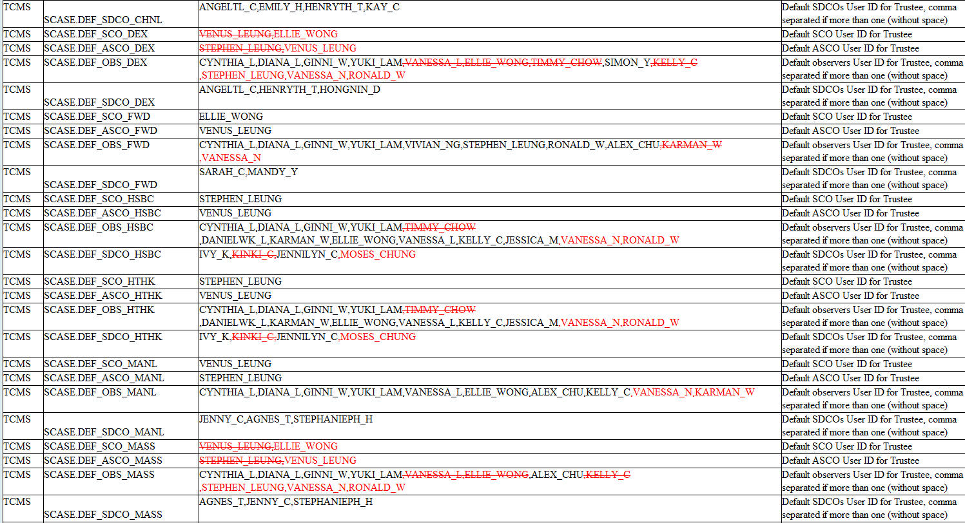

TCMS

TCMS

TCMS

SCASE.DEF_SDCO_CHNL SCASE.DEF_SCO_DEX

SCASE.DEF_ASCO_DEX

TCMS SCASE.DEF_OBS_DEX

TCMS

TCMS

SCASE.DEF_SDCO_DEX SCASE.DEF_SCO_FWD

TCMS

SCASE.DEF_ASCO_FWD

TCMS SCASE.DEF_OBS_FWD

TCMS

SCASE.DEF_SDCO_FWD TCMS SCASE.DEF_SCO_HSBC TCMS SCASE.DEF_ASCO_HSBC TCMS SCASE.DEF_OBS_HSBC

TCMS SCASE.DEF_SDCO_HSBC

TCMS SCASE.DEF_SCO_HTHK TCMS SCASE.DEF_ASCO_HTHK TCMS SCASE.DEF_OBS_HTHK

TCMS SCASE.DEF_SDCO_HTHK

TCMS SCASE.DEF_SCO_MANL TCMS SCASE.DEF_ASCO_MANL TCMS SCASE.DEF_OBS_MANL

TCMS

SCASE.DEF_SDCO_MANL TCMS SCASE.DEF_SCO_MASS TCMS SCASE.DEF_ASCO_MASS TCMS SCASE.DEF_OBS_MASS

TCMS

SCASE.DEF_SDCO_MASS

ANGELTL_C,EMILY_H.HENRYTH_T.KAY_C

VENUS LEUNG ELLIE_WONG

STEPHEN_LEUNG VENUS_LEUNG

CYNTHIA_L,DIANA_L.GINNI_W.YUKI_LAM-VANESSA_L_ELLIE_WONG TIMMY CHOW SIMON_Y KELLY_C

STEPHEN_LEUNG VANESSA_N,RONALD_W

ANGELTL_C.HENRYTH_T.HONGNIN_D

ELLIE_WONG

VENUS_LEUNG

CYNTHIA_L.DIANA_L.GINNI_W.YUKI_LAM,VIVIAN_NG.STEPHEN_LEUNG.RONALD_W.ALEX_CHU-KARMAN_W

VANESSA_N

SARAH_C,MANDY_Y

STEPHEN_LEUNG

VENUS_LEUNG

CYNTHIA_L,DIANA_L.GINNI_W.YUKI_LAM-TIMMY_CHOW

DANIELWK_L.KARMAN_W.ELLIE_WONG, VANESSA_L,KELLY_C.JESSICA_M.VANESSA_N.RONALD_W IVY_K,KINKI_C.JENNILYN_C,MOSES_CHUNG

STEPHEN LEUNG

VENUS_LEUNG

CYNTHIA_L.DIANA_L,GINNI_W,YUKI_LAM-TIMMY_CHOW

DANIELWK_L,KARMAN_W.ELLIE_WONG, VANESSA_L.KELLY_C.JESSICA_M,VANESSA_N,RONALD_W IVY_K,KINKI_C.JENNILYN_C,MOSES_CHUNG

VENUS_LEUNG

STEPHEN_LEUNG

CYNTHIA_L,DIANA_L.GINNI_W.YUKI_LAM,VANESSA_L.ELLIE_WONG,ALEX_CHU KELLY_C,VANESSA_N,KARMAN_W

JENNY_C.AGNES_T,STEPHANIEPH_H

VENUS LEUNG ELLIE_WONG

STEPHEN LEUNG VENUS_LEUNG

CYNTHIA_L.DIANA_L.GINNI_W ̧YUKI_LAM-VANESSA_L_ELLIE_WONG,ALEX_CHU KELLY_C

STEPHEN_LEUNG, VANESSA_N.RONALD_W

AGNES_T,JENNY_C.STEPHANIEPH_H

Default SDCOS User ID for Trustee, comma

separated if more than one (without space) Default SCO User ID for Trustee Default ASCO User ID for Trustee Default observers User ID for Trustee, comma separated if more than one (without space) Default SDCOs User ID for Trustee, comma separated if more than one (without space)

Default SCO User ID for Trustee

Default ASCO User ID for Trustee

Default observers User ID for Trustee, comma

separated if more than one (without space) Default SDCOS User ID for Trustee, comma separated if more than one (without space) Default SCO User ID for Trustee Default ASCO User ID for Trustee

Default observers User ID for Trustee, comma separated if more than one (without space) Default SDCOs User ID for Trustee, comma separated if more than one (without space)

Default SCO User ID for Trustee

Default ASCO User ID for Trustee

Default observers User ID for Trustee, comma

separated if more than one (without space) Default SDCOs User ID for Trustee, comma separated if more than one (without space) Default SCO User ID for Trustee Default ASCO User ID for Trustee Default observers User ID for Trustee, comma separated if more than one (without space) Default SDCOs User ID for Trustee, comma separated if more than one (without space)

Default SCO User ID for Trustee

Default ASCO User ID for Trustee

Default observers User ID for Trustee, comma separated if more than one (without space) Default SDCOS User ID for Trustee, comma separated if more than one (without space)