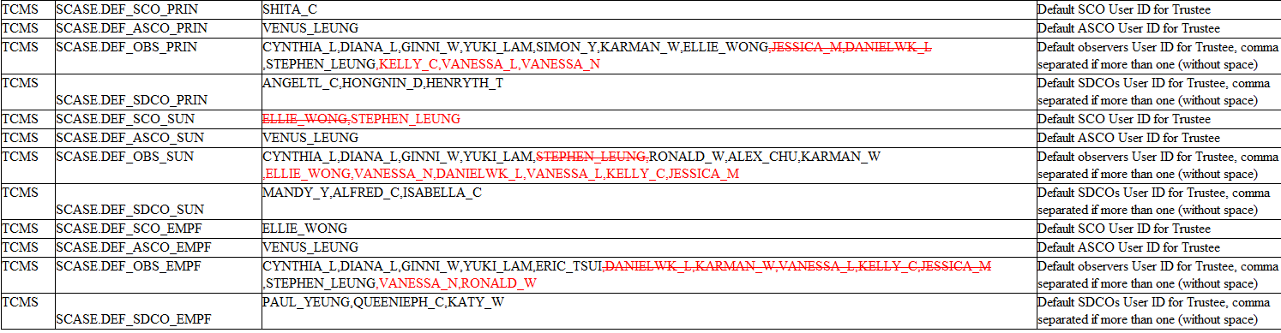

TCMS TCMS

SCASE.DEF_SCO_PRIN SCASE.DEF_ASCO_PRIN TCMS SCASE.DEF_OBS_PRIN

TCMS

SCASE.DEF_SDCO_PRIN

TCMS

SCASE.DEF_SCO_SUN

TCMS

SCASE.DEF_ASCO_SUN

TCMS SCASE.DEF_OBS_SUN

TCMS

SCASE.DEF_SDCO_SUN TCMS SCASE.DEF_SCO_EMPF

TCMS TCMS

TCMS

SCASE.DEF_ASCO_EMPF

SCASE.DEF_OBS_EMPF

SCASE.DEF_SDCO_EMPF

SHITA_C

VENUS LEUNG

CYNTHIA_L,DIANA_L.GINNI_W.YUKI_LAM,SIMON_Y.KARMAN_W.ELLIE_WONG JESSICA_M.DANIELWK_L

STEPHEN_LEUNG KELLY_C,VANESSA_L,VANESSA_N

ANGELTL_C.HONGNIN_D.HENRYTH_T

ELLIE WONG STEPHEN_LEUNG

VENUS LEUNG

CYNTHIA_L.DIANA_L,GINNI_W.YUKI_LAM,STEPHEN_LEUNG RONALD_W.ALEX_CHU,KARMAN_W

ELLIE_WONG,VANESSA_N,DANIELWK_L.VANESSA_L.KELLY_C.JESSICA_M

MANDY_Y,ALFRED_C.ISABELLA_C

ELLIE_WONG

VENUS_LEUNG

CYNTHIA_L.DIANA_L.GINNI_W ̧YUKI_LAM,ERIC_TSUI,DANIELWK_L.KARMAN_W_VANESSA_L.KELLY_C_JESSICA_M

STEPHEN_LEUNG VANESSA_N.RONALD_W

PAUL_YEUNG QUEENIEPH_C.KATY_W

Default SCO User ID for Trustee

Default ASCO User ID for Trustee

Default observers User ID for Trustee, comma separated if more than one (without space) Default SDCOS User ID for Trustee, comma separated if more than one (without space)

*Default SCO User ID for Trustee*

Default ASCO User ID for Trustee

Default observers User ID for Trustee, comma

separated if more than one (without space) Default SDCOS User ID for Trustee, comma separated if more than one (without space)

*Default SCO User ID for Trustee*

Default ASCO User ID for Trustee

Default observers User ID for Trustee, comma

separated if more than one (without space) Default SDCOS User ID for Trustee, comma separated if more than one (without space)