draft: work in progress
[Classes experience for students]
functional specification

Executive Summary

Background
Alliance Francaise de Shanghai provides general courses for French following 10 level curriculum based on the Common European Framework of Reference for Languages (CEFRL). Assessment is mandatory in General French curricula. It has 4 parts, which are: reading, listening, writing and speaking.
- Basic user: Breakthrough (A1.1 and A1.2), Elementary (A2.1 and A 2.2).
- Independent user: Intermediate (B1.1, B1.2, B1.3) and Upper intermediate (B2.1, B2.2, B2.3)
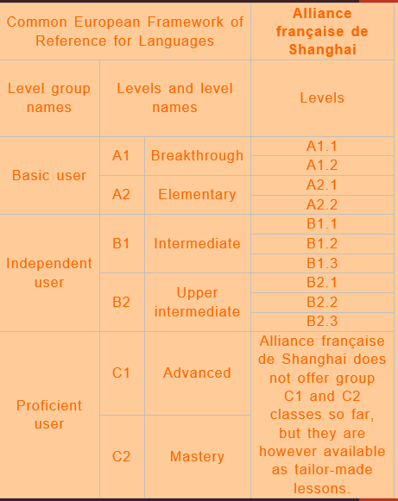
There are 5 sessions per year. Each session lasts either 2 months or 4 months.
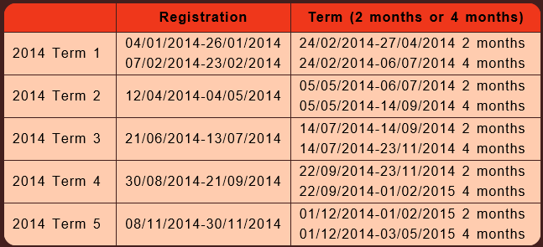

This spec focuses on Class experiences. Students and teachers registration to classes flow from high level are described as below:
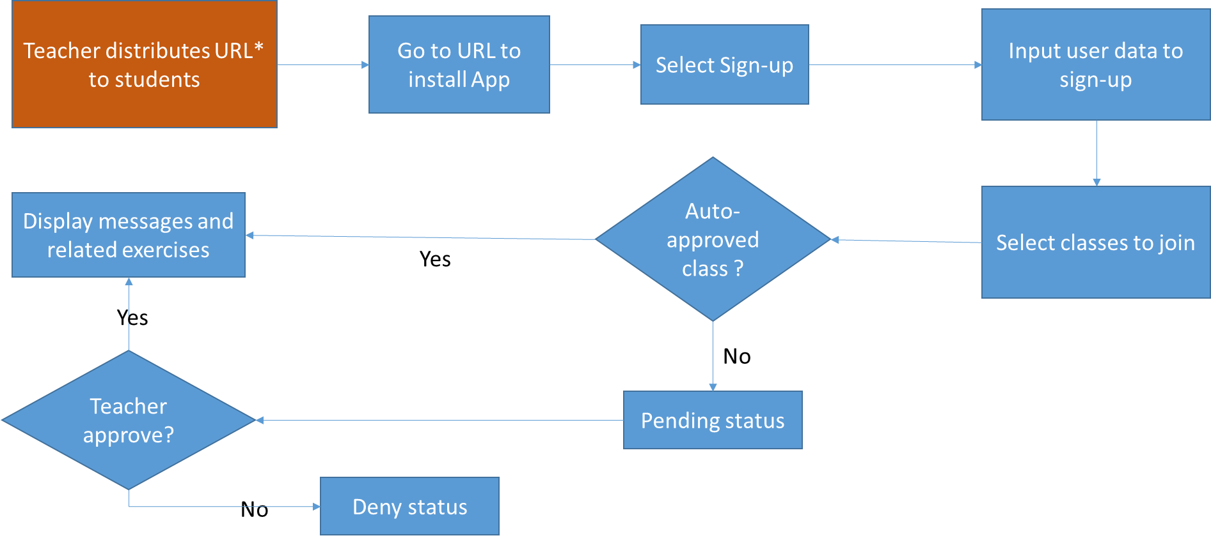

Scenario Goals & Non-Goals

Goals for teachers related to class experience
Following are goals for Classes related scenarios for teachers. Classes have below status from point of view of teachers:
- Auto approved – whoever can join the class, consider as public class
- Manual approval – teacher or admin will approve a request to join the class

Classes Goals for Teachers | Priority
Teacher (or admin) can add a new class | 1
Teacher can edit a class | 2
Teacher can remove a class? | 3
Teacher can change a class approval between auto approval and manual approval? | 3
Teacher can assign students to a class | 1
Teacher can assign exercises to a class | 2
Teacher can remove students from a class | 3
Teacher can de-assign exercises from a class | 3

Goals for students related to classes experience.
Classes will have below status from point of view of students:
- Not joined
- Joined
- Pending – wait for teachers to approve
- Not approved – refused from teacher
- Cancelled – request withdrawn from students

Classes Goals for Students | Priority
Student can request to join a class | 1
Student can see a list of classes he requested and corresponding status | 1
Student can leave a class (status turned to “not joined” or we introduce another status?) | 3
Student can withdraw his request to join a class (cancel the joining request) | 3

Detailed Feature Requirements

Following is class joining flow for students:
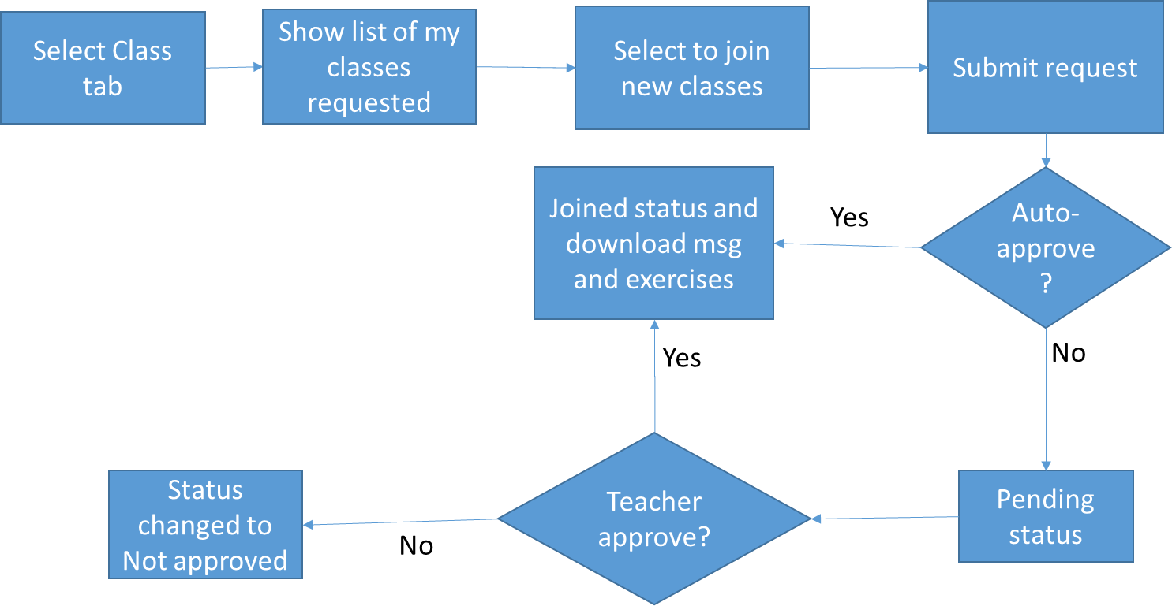

My class viewer for students

When user Me menu item from bottom, they get into personal setting page. From this page, users will see “my class” menu.
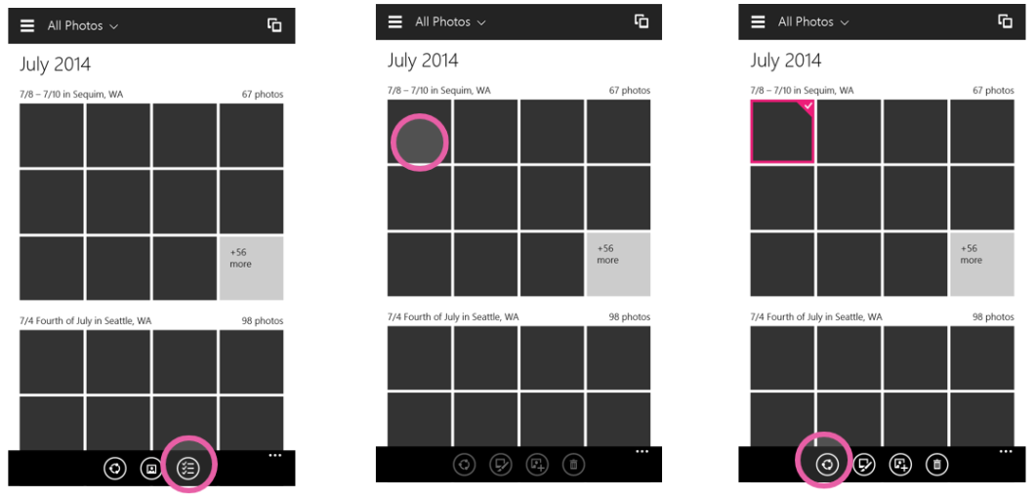
On any list view
<need design>
Flow tbd

Press and hold
Press and hold content
When user presses over a photo/video and holds, a context menu drops down with share as a menu item. User can quickly share the content using the share menu item.
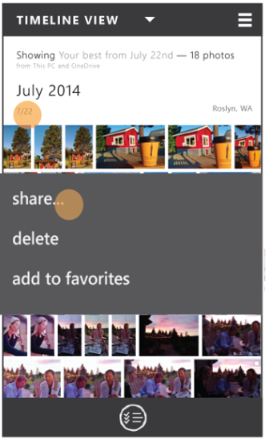
Press and hold headers
When user presses over a heading (like a date or month) and holds, a context menu drops down with share as a menu item. All the content under the heading is selected and can be shared by using the share menu item.
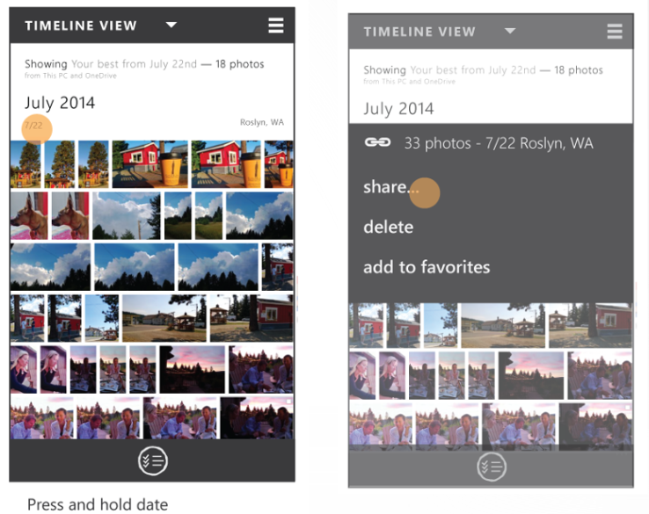

UI feature | Description | PC Shortcut | PM string | Proposed string | Final string
Context menu item | Share action is available as a context menu item  For M1,  Phone and pc- share is top most item on list | Not needed | Share…

Share as link
User’s explicit choice to share using a link
For users that start seeing the benefit of sharing content as link (in scenarios where it is promoted) and for users who are regular OneDrive users or understand the benefits of cloud hosted content, we need to provide an explicit entry point for sharing as link.

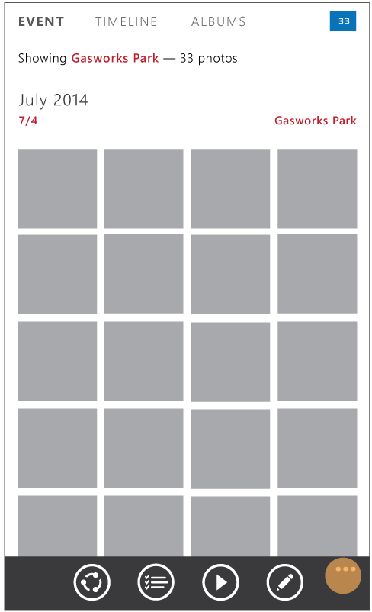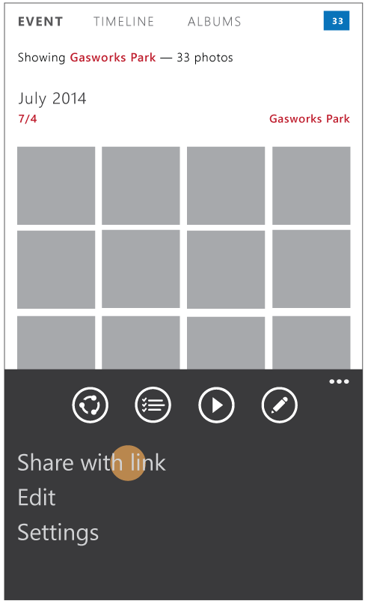

Will be covered in spec review #2
Share as link offered to user by app based on meeting criteria
When certain criteria is met (like one or more files selected is of rich format) then the user is offered the option of link explaining the benefits in their particular scenario.

<insert screen>
UI feature | Description | PC Shortcut | PM string | Proposed string | Final string
Menu item | Menu item in list view page.  Gives user the option of sharing content as link |  | Create a link
Menu item | Menu item in viewer  Gives user the option of sharing content as link |  | Create a link

UX Flows

Share standard content (one photos/video) from viewer
Enables user to share content in view.
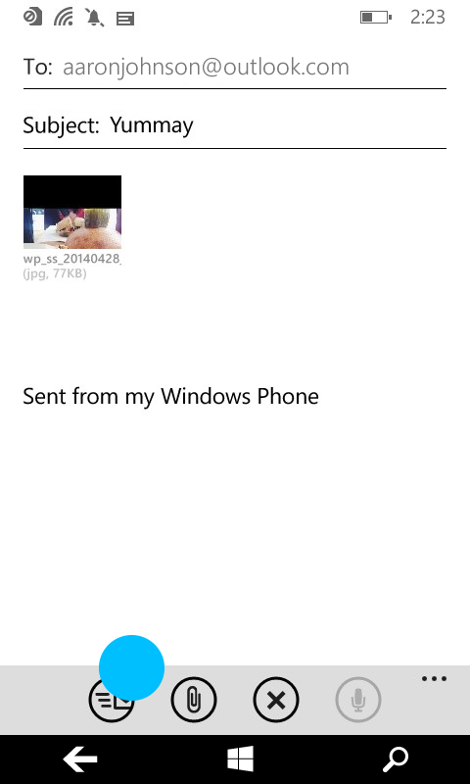
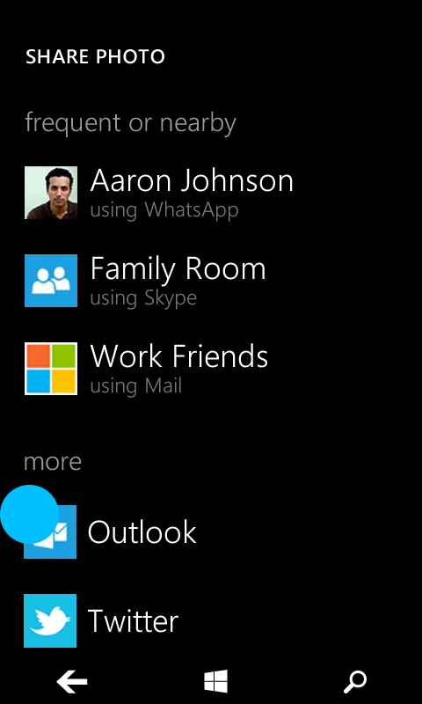
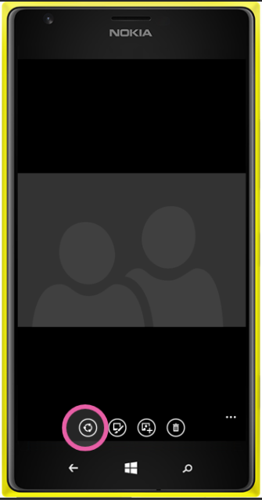
We will also support the (global) share charm entry point (and it’s replacement in threshold) to kick start the share flow.
Compressing video
Compression functionality is handled by the target app and is subject to their logic and data limits. Compression UI (progress) is handled between the share contract and target app. No work needs to be done from the Photos team.
Download content/Preparing content Progress UX
Progress shown to user as content is:
- Getting downloaded from OneDrive
- Creating data package
Standardize phone blue reqs and use for phone and pc in threshold.
<design needed>

Share Rich Media Types from viewer
Sharing Bursts/Stacks
<design needed>
Sharing Nokia Rich Media Types (like cinemagraph, living images etc.)
<design needed>

Share multiple/Event photos and/or videos from any list view
We will enable customers to share content from list views in the following ways:
- Press and hold content
- Press and hold headers
- (selection mode) Select multiple content->(optional)edit selection->->Share
- (selection mode) Select headers->(optional)edit selection->Share
- (share mode) Share->Edit selection -> confirm selection
We will enable users to individually select multiple content (as is supported in blue on phone and pc) and in addition, enable users to select events (and thereby all the content under that event). For example: ‘share all highlights from Tara’s birthday party’ or ‘Share the best of my photos from July’. This does not include sharing albums.

#1: Press and hold content
<need clearer design>
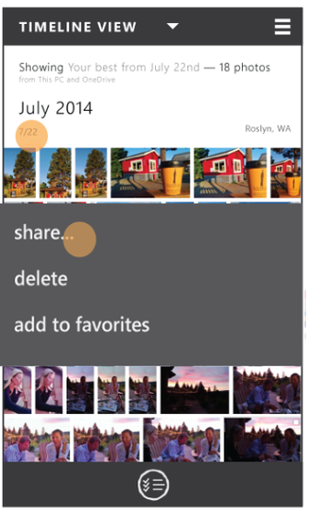

#2: Press and hold header
Users can press and hold any heading available on the list views. This automatically opens a context menu with the option to share all the contents contained under the header.

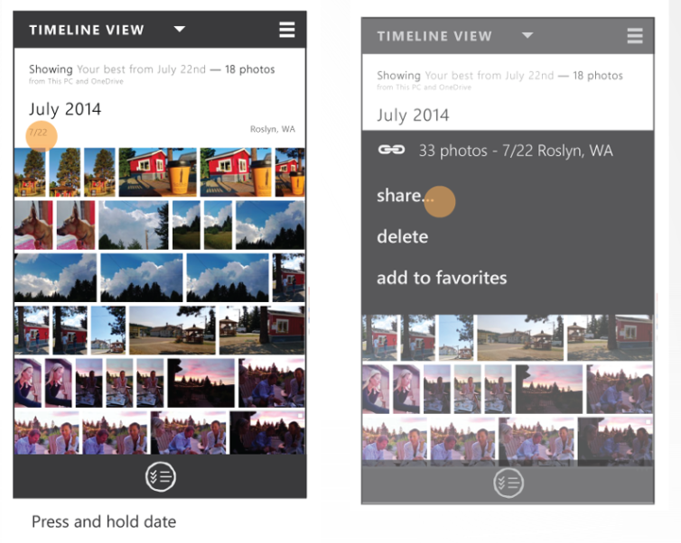

#3: (selection mode) Select multiple content->(optional)edit selection->->Share
From any list view available on the Raconteur app, we will enable customer to enter a selection mode where they can select multiple photos and videos through the selection picker. PC should have parity w/ functionality available from selection picker available in phone blue.
‘Selection picker’ button should be available to users from any list view.
One user starts selecting content, ‘share’ button should be clearly visible to users. Once share button is pressed, there will not be any verification of content selected.
The selection commanding should include the ability to select a combination of photos and videos to share. This has been a limitation in the past.
Phone:
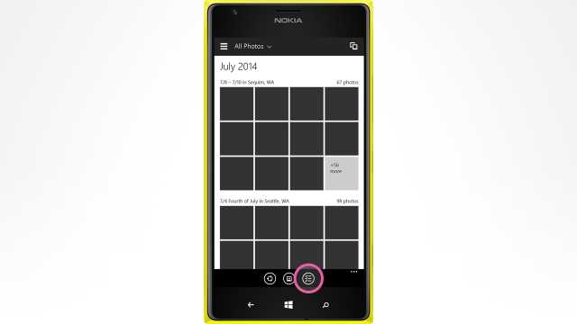
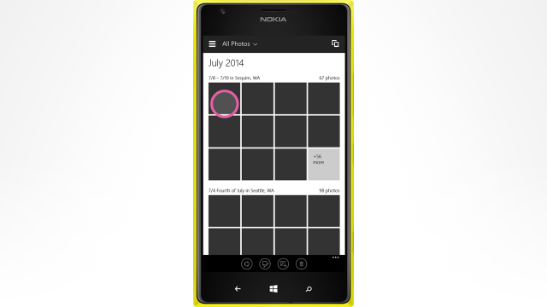
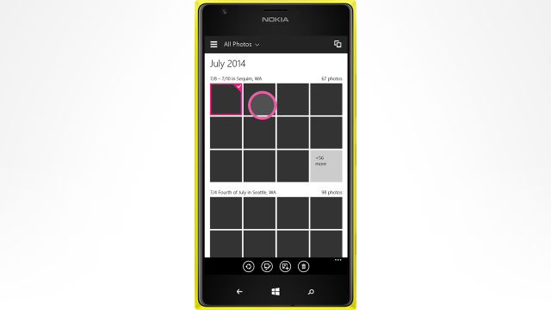
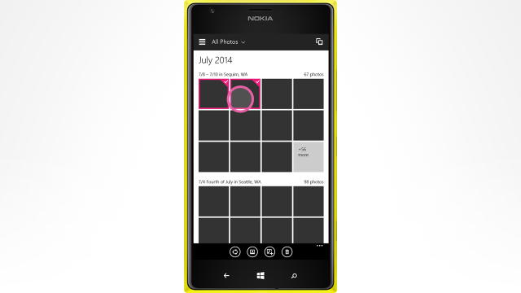
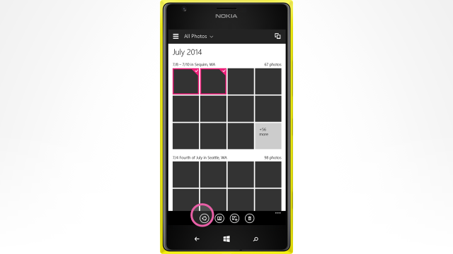

#4: (selection mode) Select headers->(optional)edit selection->Share
From any list view available on the Raconteur app:
- Selection button should be available to users from any list view.
- We will enable customer to enter a selection mode where they can select multiple photos and videos and any header through the selection picker. User can select multiple headings. For example from timeline view, user can select ‘July 2014’ heading or ‘7/22’ heading.
- All headers have an affordance for selecting. Users can visually understand that they can select headers.
- Once user starts selecting content, ‘share’ button should be clearly visible to users.
- Once share button is pressed, there will not be any verification of content selected.
<Insert screenshot>
The below is a rough idea.
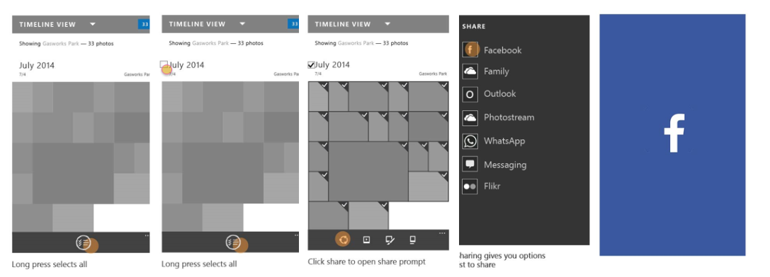
#5: (share mode) Share->Edit selection -> confirm selection
From any list view available on the photos app, share entry point should be clearly visible and available on canvas for user selection. Since both the selection mode entry point and the share entry point are going to be visible on the screen, we need to provide some differentiator between the two, so as to provide value add to customer.
PC/tablet:
User is viewing content in list. Share entry point is clearly visible and user clicks it.
<insert screenshot>
All content under headers fully visible on screen is pre-selected and it becomes clear to users what is already pre-selected and that they can edit the selection. User can then view the selection and makes edits as needed.
<Insert screenshot>
User can edit the selection including unselecting headers that were auto-selected. User confirms the selection and is then entered into the share flow.
<Insert screenshot>]

UI feature | Description | PC Shortcut | PM string | Proposed string | Final string
Button | Button available on any list view that when clicked initiates the share flow.  For M1.1.1,  Phone&PC- share button on app bar is right of select button and left of delete button | needed | Share
Button | Enables selection mode from any list view where user can select multiple items (photos and videos)  *Note: Not in scope for this spec. Detailed in Rich Views spec. | needed | Select

Need screens for this.
What is going to be pre-selected by default?
App bar changes, next step (clear selection, continue to next step, cancel?)

Share Flow Overview
In M1, we will enable users to share any content in two ways:
- Share as file- the physical files to be uploaded onto target app. We assume most users want to upload files to target apps and we do not want to disrupt this flow.
- Share as OneDrive link – Share a link to a location on OneDrive where all the content is available. We want to promote sharing as link to users where there is a payoff from doing so (Example: sharing special file types as OneDrive link that can be rendered with richness on any device).

User expectations/guidelines for share flow
- Promote share as link where it makes sense and adds value to user.
- Seamless experience – users don’t need to worry whether the content lives in the cloud or locally or 3rd party service. We need to handle mixed source content gracefully.
- Don’t made it harder to share as file – While we want to provide users the added benefits that come with sharing as link, we don’t want to make it harder to share as file to the apps and people they are used to. Only alter flow when there is clear value prop to user.
- Fast and responsive - Avoid having users experience large wait times while system is processing actions. This might include setting size restrictions during upload or download processes
- Users have control over what they share and how they do so

Share flow – All up

Share as File

Sharing standard format local content as files
Size
Share actual size of content. Target app can perform size alteration and compression as needed.
Packaging Mechanism for Local files
On par with what we have for phone and pc today, that is, creating a data package of locally backed storage file(/s).

Sharing standard format OneDrive content as files
Download
In the case where content lives in the cloud and needs to be shared via the photos app on any device as files, the content needs to be downloaded from cloud to local device in order to share those contents as files to target apps. We will download the full size content from OneDrive.
Size
Share actual size of image.
Packaging Mechanism for OneDrive files
Share target to receive full size content from photos app as storage files.
UX- downloading content
Since OneDrive content displayed on apps needs to be downloaded to share contents as file, we need to show the progress of the download to users.
<Design needed- for viewer and list view>
UI feature | Description | PC Shortcut | PM string | Proposed string | Final string
Indeterminate progress bar | Shows progress of downloading content from cloud when sharing files from viewer. Overlay over viewer page where you can still see content in viewer in the background. |  | Loading content
Indeterminate progress bar | Shows progress of downloading content from cloud when sharing files from any list view. Overlay over list view page where you can still see listed and selected content in background. |  | Loading content

Sharing rich format local content as files
When users capture rich media types (RMTs) on their windows devices, we want to enable sharing those content. One way to preserve the “richness” of those formats is to share the content as a OneDrive link (where OneDrive will support rendering this rich types with full control and interaction experience comparable to what is available via photos app viewer). Sharing links may work for some users, but we also need to provide support for those who want to send files instead.
Sending rich file formats in their original form limits viewing these types on other platforms. For example- Microsoft’s .pano file type cannot be rendered on iOS and android platforms. Since senders shouldn’t need to worry about the recipient’s device platform, we need to compress these rich types in standard formats (jpegs/mp4s) that can be handled on any platform.
All supported rich formats listed here: Sharing and Storing Rich Media Spec.
John McElmurray is the PM for rich media and has more rich media types details in the above listed spec.
Format conversion
The rich media team will provide an API query to return the standard format files of appropriate size (for sharing) for one or more selected RMTs
The table below lists the final file type that is shared to the share target, when sharing as file.
Rich Type being shared | What is finally shared | File type | Notes
Analyzed Rich Types
Stack/Soft Duplicates | Hero photo | jpeg
Bursts, photo loops
Microsoft Types
Explicit Bursts | Hero photo | jpeg
Cubemap pano | Flatted pano | jpeg
Nokia Types
Bursts/smart sequences | Final product of chosen smart sequence type | jpeg
2d pano from nokia app
Refocus | Final focus choice | jpeg
Reframe | Final frame choice | jpeg
Living moments | Image  (Potentially video?) | jpeg | The image is highest priority (since it was taken in Photo mode) but I can see scenarios for wanting to share the video frames as well
Cinemapgraph | Looping video | GIF or MP4 | GIF, MP4, or JPG are all valid representations (in order of most accurate representation)
parallax | snapshot of the current viewing angle | jpeg | There are several valid representations – GIF or video showing the parallaxing effect, a JPG of the shot taken, or a snapshot of the current viewing angle
selfie | Finally touched up image | jpeg
Nokia rich capture/dynamic mode | HDR or Flash/noflash image | jpeg

Size
Share actual size of standard format file.

Sharing rich format OneDrive content as files
Download
In the case where RMT lives in the cloud and needs to be shared via the photos app on any device as files, the standard format file needs to be downloaded from cloud to local device in order to share those contents as files to target apps.
Format conversion
The rich media+OneDrive team will provide an API query to return the standard format files of appropriate size (for sharing) for one or more selected RMTs in the Cloud
Dependency on which team?
Size
Share actual size of standard format file.
Packaging Mechanism for OneDrive files
Share target to receive full size content from photos app as storage files.
UX- downloading content
Same as in section 9.4.2

Data Package for ‘share as file’
Support in Blue
- PC: Data package work was performed by OneDrive team in Blue.
  - For details: See section 9.1 on Photo and Video Viewer – Functional spec for 8.1 and SkyDrive app sharing spec for 8.1
- Phone: In Blue nothing other than the photo binary was sent
Support in Threshold
List of all possible data package properties: http://msdn.microsoft.com/en-us/library/windows/apps/windows.applicationmodel.datatransfer.datapackagepropertyset.aspx
System provided properties listed here: http://portals/wpblue/blue/specstore/Blue%20Specs/Share%20Contract%20Phone%20Roadshow.pptx
Data package properties to be sent through the share contract:
Data package property | Description | Required? | Support
ApplicationListingUri | Gets or sets the Uniform Resource Identifier (URI) of the app's location in the Windows Store |  | Provided by system
ApplicationName | Gets or sets the name of the app that created the DataPackage object | Yes | Provided by system
ContentSourceApplicationLink | Gets or sets the application link to the content from the source app. It is a companion property that you use to attribute shared content. |  | Provided by raconteur app
Description (Body) | Gets or sets text that describes the contents of the DataPackage  String, e.g. “File from the Mail app” |  | Provided by raconteur app.  Text in tables below.
FileTypes | Specifies a vector object that contains the types of files stored in the DataPackage object. | Yes | Raconteur app provides file extensions of file(/s) being shared
Square30x30Logo | Gets or sets the source app's logo |  | Provided by raconteur app
Thumbnail | Gets or sets a thumbnail image for the DataPackage. | Yes | Raconteur app provides:  - A thumbnail of the item in the Viewer  - Thumbnails of items in list view
Title (Subject) | Gets or sets the text that displays as a title for the contents of the DataPackage object.  String, e.g. “1 photo” | Yes | Provided by raconteur app.  Text in tables below.
Specific Requirements:
Data package property | PM text |  | UA approved text | Comments | Final
Sharing 1 photo from viewer
Content | n/a | n/a |  | Single photo as storage file | n/a
Title | Photo from <location> taken on <date/date range> |  |  | Metadata about location/date in photo
Description | Shared from <host app name> app  Link to download app from store for device |  |  | String to indicate the file and host app that is sharing it  Link to download app from store for device
Sharing 1 photo from viewer
Content | n/a | n/a |  | Single video as storage file | n/a
Title | Video from <location> taken on <date/date range> |  |  | Add location/date metadata
Description | Shared from <host app name> app  Link to download app from store for device |  |  | String to indicate the file and host app that is sharing it
1 Rich Media Type from viewer
Content | n/a | n/a |  | Single photo/video as a storage file.  *conversion from RMT to standard type detailed in sections 9.4.2 and 9.4.3 | n/a
Title | <Rich media type name> from <location> taken on <date/date range> |  |  | Add location/date metadata
Description | Shared from <host app name> app  Link to download app from store for device |  |  | String to indicate the file and host app that is sharing it
Multiple photos and videos from list view
Content | n/a | n/a |  | Each item as storage file | n/a
Title | Photos from <location> taken on <date/date range>  OR  Videos from <location> taken on <date/date range>  OR  Photos and videos from <location> taken on <date/date range> |  |  | Add location/date metadata
Description | Shared from <host app name> app  Link to download app from store for device |  |  | String to indicate the file and host app that is sharing it

Error Handling
UX

<Design needed- for viewer and list view>
UI feature | Description | PC Shortcut | PM string | Proposed string | Final string
Toast | Display toast on viewer screen. |  | <based on which error occurs. Strings detailed below.>
Toast | Display toast on list view screen with selected content persisted. |  | <based on which error occurs. Strings detailed below.>
Error List
Continue what was supported in blue on pc: section 9.1.2 on spec
The Share platform allows source apps to provide a custom string to the Share flyout. The error cases and the corresponding custom strings are detailed below.

In these error cases, the Viewer/list view should opt-out of Share and provide the appropriate message as part of the data package.
New list:
Scenario | PM text | UA approved text | Comments | Final
File not present | This photo or video has been moved or deleted. |  | Error message shown when a file has been moved or deleted and the user tries to share it
Share invoked from share charm entry point | This action has been disabled. Please use the share button in the app instead. |  | Since the share charm is going away in Threshold, we are not going to do any work to plumb it. Therefore we will throw an error asking users to use the in-app share entry point
Cannot share due to no internet connection |  |  | If there is no internet, we cannot complete the share action.  Phone blue: Allows users to complete share flow, but share task is queued and will be sent when user connects to internet.
Cannot download OneDrive content to share due to lack of internet connection | Cannot get <content type> from Cloud. Please check your internet connection and try again. |  | Cannot download OneDrive content to share due to lack of internet connection  - Connection lost  - Airplane mode
Unable to download content from OneDrive due to invalid/incorrect/out-of-date credentials | Incorreect credentials. Please |  | Thumbnail exists in app but the password has expired or the account has been deleted/suspended making the contents in the cloud no longer accessible.
OneDrive is down |  |  | Cannot connect to OneDrive since OneDrive is down.
 |  |  | User is on battery saver mode
Error in generating standard format from rich format |  |  | File conversion from rich format to standard format failed.

Old list:
Scenario | PM text | UA approved text | Comments | Final
File not present | This photo or video has been moved or deleted. Select something else and try again. | This photo or video has been moved or deleted. | Error message shown when a file has been moved or deleted and the user tries to share it | Yes  Updated 12.6.12
User is in live camera feed mode |  | Take a photo or video, and then share it. | Error message shown when the user is looking at the live camera feed in the Camera app and invokes Share | Yes
User is looking at an unstitched panorama or is in the process of stitching the panorama |  | Your panorama isn’t quite ready yet. Stitch this panorama, and then share it. | Error message shown when the user tries to share an unstitched panorama | Yes
General error case |  | Restart the app, and then try to share. | Error message shown in general cases where we’re not sure what happened | Yes
User is in Edit mode  Note: this is for M1 only. This error message will be removed in MP when Tweak enables Share while editing. |  | Your file has unsaved changes. Save your changes, and then share it. | Error message shown when user is in Edit mode and invokes Share. This string will be removed in MP. | Yes
Error in generating standard format from rich format

Share as OneDrive Link
Given that all content will be backed in the cloud, we should enable users to take advantage of this and share content as links where it makes sense to users and has a clear value prop to them.

Criteria for offering OneDrive links
We will only offer OneDrive link as an option to users where there is a clear value prop for them. Users will have the ability to take our offer, or to decline it (share as file attachments) based on their needs. We will not always offer them that choice since that adds additional steps to all existing workflows, and doesn’t offer clear value in most cases.
In M1, if the following criteria are met, user will be offered a choice of link or attach:
# | Criteria | Requirement
1 | User has an MSA Account | Has to always be met. We will only offer links to user who already have an MSA account that the photos app is aware of.
2 | If any of the selected content is of RMT (cinemagraph etc.). List of all possible RMTs listed here Sharing and Storing Rich Media Spec. | In addition to criteria #1.

UX- Offering links for RMT
Think about explaining permissioning to users when links are offered
When criteria is met, the user is offered the option of sharing the selected content as OneDrive links or as files, explaining the benefit of sharing as OneDrive link in that scenario. The user is then forced to make an explicit choice to move to the next step in the share flow.
[Viewer] Imagine the below is a cinemagraph:
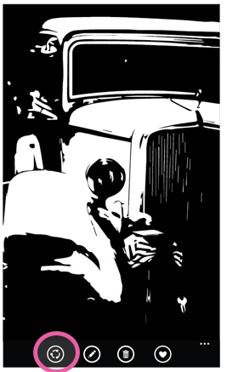 when user clicks share button -> 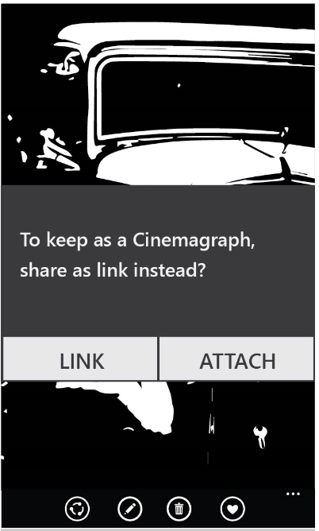
UI feature | Description | PC Shortcut | PM string | Proposed string | Final string
Modal Dialog | Explain to the user the benefit of sharing as link. User has to make an explicit choice. |  | To keep as a <rich type>, share as link instead?
Button on Modal Dialog | Share as OneDrive link.  This is the default button. Where possible highlight this option with different coloring as seen here: http://msdn.microsoft.com/en-us/library/windows/apps/xaml/hh738363.aspx |  | Link
Button on modal dialog | Share as file attachment |  | Attach

[List View]
User may have selected one or more rich types, in addition to one or more standard types from list view to share. Selecting one or more rich types meets the criteria to offer links.
<Design needed>
UI feature | Description | PC Shortcut | PM string | Proposed string | Final string
Modal Dialog | Explain to the user the benefit of sharing as link. User has to make an explicit choice. |  | To keep as a <rich type>, share everything as a link instead?
Button on Modal Dialog | Share as OneDrive link |  | Link
Button on modal dialog | Share as file attachment |  | Attach

Explicit Share as link entry point
Once users start getting used to being offered links (when selected content meets criteria) or users familiar with cloud sharing, we need to enable users who choose to share content as links instead of as files.
<need design for list view and viewer>
UI feature | Description | PC Shortcut | PM string | Proposed string | Final string
Menu item | Gives user the option of sharing content as link |  | Share link to content

Share link to content already in OneDrive
User selects content that lives in the cloud already, and chooses to share that content as an OneDrive link.
Getting a link
When the user selects one or more files from list view or viewer and chooses to share link to content, the system gets back a single link from OneDrive that contains a pointer to all the selected content, and hands that link to the share contract. This can be achieved through OneDrive by creating bundles and getting links to bundles that will the surfaced to recipients as virtual folders.
Use OneDrive SetPermissions API to generate links using the following properties:
- Type=link
- Link type=View Only
Maximum number of items
OneDrive APIs currently do not support bundling of more than 100 items in a single link. To respect this limit, we must handle the error gracefully.
UX- getting link progress
It might take some time to get a OneDrive link to all content selected, and therefore we need to show some progress UX.
<design needed for list view and viewer>
UI feature | Description | PC Shortcut | PM string | Proposed string | Final string
Indeterminate progress bar | Shows progress of getting a link from OneDrive. Overlay over viewer page where you can still see content in viewer in the background. | n/a | Getting link
Indeterminate progress bar | Shows progress of getting a link from OneDrive. Overlay over list view page where you can still see selected content in list view in the background. |  | Getting link

Viewing the shared link
The recipient(/s) on clicking the link would be taken to a list view that displays all the shared content.
Senders can later on view content they have shared through OneDrive web share page or through Raconteur app’s shared content page. In order to have parity with current experience, bundles are created for each share event.
In this scenario folders should be named by default:
Scenario | PM text |  | UA approved text | Comments | Final
Sharing 1 photo/video/RMT from viewer | Shared <file type> on <date>
Sharing 1 or multiple photo/video/RMT from list view  Only one type shared | Shared <file type>s on <date>
Sharing 1 or multiple photo/video/RMT from list view  Multiple types shared | Shared items on <date>

Link configurations and permissioning
- View only, can’t edit
- Doesn’t need to have OneDrive account to view (no sign in or sign up needed)
- Link can be further shared to any number of people, who can access it without restrictions
- Content only hosted on sender’s OneDrive. Not hosted on recipient’s OneDrive.
- Max number of distinct viewers?
- If sender deletes OneDrive content, recipients can no longer view the content
- If sender deletes their OneDrive account, recipients can no longer view the content

Share link to Local and/or OneDrive standard format content
User selects content, some of which live in cloud already and some of which live on local device (yet to get to cloud), and want to share their entire selection as OneDrive link.
On demand Uploading of local content to OneDrive
When users selects content that lives locally on device but is to be shared as an OneDrive link to the target apps, we need to upload the local content onto OneDrive.
If only local content was selected, then upload all local content to OneDrive and get a single OneDrive link that points to the entire set.
If mixed source content was selected (some local, some cloud), the upload the local content onto OneDrive and get a link to entire set link that represents both the content that already existed in OneDrive and the newly uploaded content
Upload location is the same as the location as where the content would be later backed up.
Upload size
Upload as much as needed to render a “good enough” view. 1600px?
If users selects multiple photos or videos that live on local device to upload to OneDrive, uploading the full resolution version of these files could take a really long time and forces the users to wait while this process occurs in order to move on to the next step of the share flow. In order to mitigate this, we should upload a max of 1600 pixels (display is good enough on most devices) during the on-demand upload process.
This on-demand upload needs to be compliant with the sync solution. It should not create two copies of the content in the cloud.
If we upload low res during on-demand upload and hi-res during sync process (mostly likely when user is connected to wifi) then we should ensure that the content referenced in the link is automatically and appropriately updated to point to the hi-res version without creating any duplication of content.
Open for investigation: on-demand upload compliant with sync solution

UX- Uploading content
Since OneDrive upload could take a significant amount of time, we need to show users upload progress.
<Insert screenshot>
Viewer:
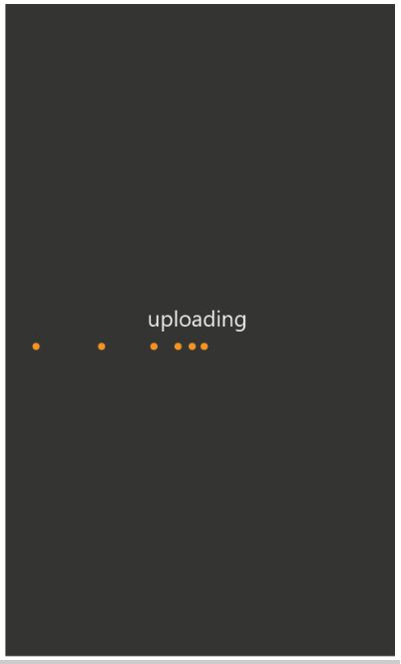
List View:
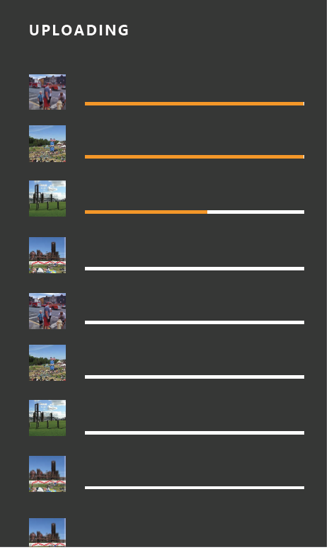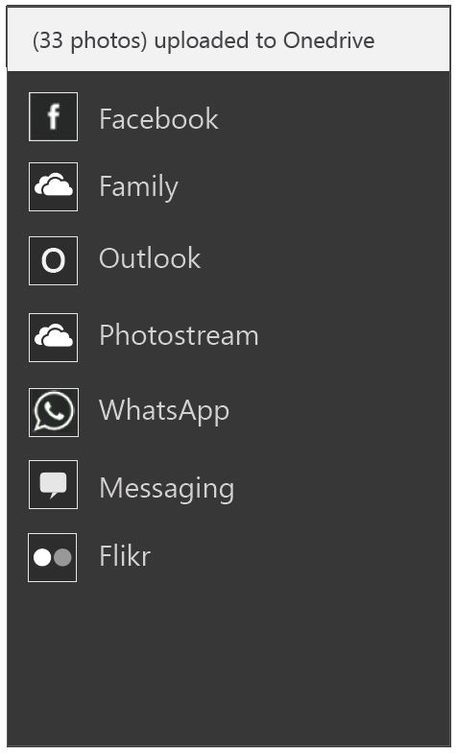
UI feature | Description | PC Shortcut | PM string | Proposed string | Final string
Page | Shows progress of uploads. Shows visual representation of each item being uploaded, progress of the uploads and enables user interaction (like cancel) |  | Upload progress page
Indeterminate progress bar | Shows progress of getting a uploading content to OneDrive. Overlay over viewer page where you can still see content in viewer in the background. |  | Uploading…
toast | Shows when the uploaded content is complete. For example ’33 photos uploaded to OneDrive’

Getting a link
The OneDrive link needs to reflect the entire set of selected content, irrespective of its source.
UX- getting link progress
It might take some time to get a OneDrive link to all content selected, and therefore we need to show some progress UX.
<design needed for list view and viewer>
UI feature | Description | PC Shortcut | PM string | Proposed string | Final string
Indeterminate progress bar | Shows progress of getting a link from OneDrive. Overlay over viewer page where you can still see content in viewer in the background. | n/a | Getting link
Indeterminate progress bar | Shows progress of getting a link from OneDrive. Overlay over upload progress page where you can still see selected content in list view in the background. | n/a | Getting link

Viewing shared link
A consumer clicking this link, would be able to seamlessly view all the selected content.

Share link to local and/Or OneDrive RMT content
Same as above

Deep App links
full section is TBD.
Generated link is a deep link to:
- Raconteur app
- If raconteur app does not exist, OneDrive app
- Else, OneDrive web
On pc, OneDrive web experience is probably better than or equal to app experience
Let OneDrive decide between showing OneDrive app or OneDrive web

On the receiving side, if the user has the racounteur app, the link should open in Racounteur.
If user has not downloaded racounter,
- Prompt user to download the app
- If racounter app does not exist on the platform, then open content in OneDrive app.
If user has not downloaded OneDrive app,
- Prompt user to download the app
- If racounter app does not exist on the platform, then open content in OneDrive web.

The link has the following link configurations:
- Providing links is a stripped down version of “shared albums” or “shared folders”
- Assume view only permissions for recipients with link.
- Neither sender nor recipient can edit (add/delete) content to the virtual folder once the link is created
  - More advanced sharing with ability to manage albums will come in the future
- Link will not be surfaced and available to sender once the share flow is complete
  - Sender will not be able to find all the links they have shared (unless they have manually saved the link after each share)
- Recipient with link can always access the contents. Shared link persists for the life of the send (or as long as the sender has an active OneDrive account)
- If user renames or deletes pictures that are referenced via a link (to a OneDrive virtual folder), we will follow OneDrive policies on this. That is,
  - Renamed pictures will still be accessible
  - Deleted pictures will no longer be accessible.
Open issue: need to verify the OneDrive policies on renaming/deleting content referenced in virtual folders

Data Package for ‘share as link’
Data package properties to be sent through the share contract:
Data package property | Description | Required? | Support
ApplicationListingUri | Gets or sets the Uniform Resource Identifier (URI) of the app's location in the Windows Store |  | Provided by system
ApplicationName | Gets or sets the name of the app that created the DataPackage object | Yes | Provided by system
ContentSourceApplicationLink | Gets or sets the application link to the content from the source app. It is a companion property that you use to attribute shared content. |  | Provided by raconteur app
Description (Body) | Gets or sets text that describes the contents of the DataPackage  String, e.g. “File from the Mail app” |  | Provided by raconteur app.  Text in tables below.
FileTypes | Specifies a vector object that contains the types of files stored in the DataPackage object. | Yes | Raconteur app provides file extensions of file(/s) being shared
Square30x30Logo | Gets or sets the source app's logo |  | Provided by raconteur app
Thumbnail | Gets or sets a thumbnail image for the DataPackage. | Yes | Raconteur app provides:  - A thumbnail of the item in the Viewer  - Thumbnails of items in list view
Title (Subject) | Gets or sets the text that displays as a title for the contents of the DataPackage object.  String, e.g. “1 photo” | Yes | Provided by raconteur app.  Text in tables below.

Specific Requirements:
Data package property | PM text |  | UA approved text | Comments | Final
Sharing 1 photo/video/RMT from viewer
Content | n/a | n/a |  | Single URI to file | n/a
Title | Photo from <location> taken on <date/date range> |  |  | Metadata about location/date in photo
Description | Shared from <host app name> app  Link to download app from store for device |  |  | String to indicate the file and host app that is sharing it  Link to download app from store for device
Sharing 1 photo from viewer
Content | n/a | n/a |  | Single URI to file | n/a
Title | Video from <location> taken on <date/date range> |  |  | Add location/date metadata
Description | Shared from <host app name> app  Link to download app from store for device |  |  | String to indicate the file and host app that is sharing it
1 Rich Media Type from viewer
Content | n/a | n/a |  | Single URI to file | n/a
Title | <Rich media type name> from <location> taken on <date/date range> |  |  | Add location/date metadata
Description | Shared from <host app name> app  Link to download app from store for device |  |  | String to indicate the file and host app that is sharing it
Multiple photos/videos/RMTs from list view
Content | n/a | n/a |  | Single URI to bundle | n/a
Title | Photos from <location> taken on <date/date range>  OR  Videos from <location> taken on <date/date range>  OR  Photos and videos from <location> taken on <date/date range> |  |  | Add location/date metadata
Description | Shared from <host app name> app  Link to download app from store for device |  |  | String to indicate the file and host app that is sharing it

Error Handling
UX
Same as section 9.4.6
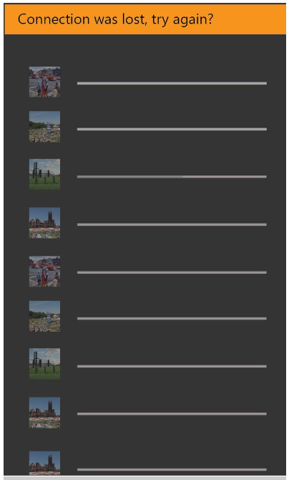
<Design needed- for viewer and list view>
UI feature | Description | PC Shortcut | PM string | Proposed string | Final string
Toast | Display toast on viewer screen. |  | <based on which error occurs. Strings detailed below>
Toast | Display toast on list view screen with selected content persisted. |  | <based on which error occurs. Strings detailed below.>
Toast | Display toast on upload progress page. |  | <based on which error occurs. Strings detailed below.>

List of errors
Scenario | PM text | UA approved text | Comments | Final
Can’t connect to cloud | Can’t connect to cloud at this time. Please try sharing again at a later time. |  | Cannot establish connect with cloud at all.
Connection lost while uploading content to OneDrive | Connection was lost. Check your internet connection and try again. |  | Connection lost while uploading content to OneDrive
Upload failed | Uploading to cloud failed. Check your internet connection and try again. |  | Upload failed for some reason.
User selected more than 100 files to share as link |  |  | OneDrive APIs currently do not support bundling of more than 100 items in a single link.

Share rich file formats

Rich Media Types (current and as prototypes)
Complete list:
- Microsoft
  - Cubemap panoramas (Photosynth on windows 8.1)
  - Bursts (windows phone 8.1)
  - Photo loops (windows 8.1)
- Nokia
  - .NAR burts/smart sequences
  - 2D panorama
  - Refocus
  - Reframe (digital negative)
  - Living moments/images
  - Cinemagraph
  - Parallax
  - selfie
Supported in M1:
- Explicit Bursts/smart sequences
- Soft duplicates (implicit bursts)
- Panoramas (Nokia)
- Panorama (Microsoft)
During M1, we want to enable sharing of rich formats unique to platforms we own, to be able to be seamlessly shared and consumed on non-windows devices.
Post M1, we will target support for more rich formats listed above.

Share as File (Standard format)
Share flow
When we detect that the user is sharing a special file type(s), we offer them the option of sharing as link to preserve richness of the file type and support rich rendering of the file. If the user chooses to forgoe share as link, then we share the content as files of standard formats (jpegs, mp4s).
Packaging content
Priority | Rich file format | Shared format
1 | Explicit burst | Share cover photo, jpeg
1 | Implicit burst (soft duplicates) | Share cover photo, jpeg
2 | panorama | jpeg
3 | cinemagraph | Video, mp4

Shaun: Sharing a pano should result in a nice experience for all recipients, regardless of their target OS, with a possibly upgraded experience for Windows users.
I don’t know how to have an upgraded experience here – we will need to think about that.

could share pano as pano, jpeg and let the target apps choose which format. Assume most wont support pano anyway.

Sharing rich file format in all their glory

Share Flow
This happens when user chooses to ‘share as link’ or “quick share”. By promoting “share as link” in general, we also dually achieve the purpose of promoting users to share their rich formats as links to recipients.
Packaging Content
- Upload image+backing data to OneDrive (if local content)
- Generating link to uploaded content
- Share OneDrive link to recipient(/s) per customer request
- Recipient can view linked content in full richness

Share Targets
Scope under review for M1

Phone and PC on par with share target support.

i.e. Any target app that has implemented the share extensions and is registered with the share contract to receive photos and/or videos, and is downloaded on the user’s device should be surfaced as share target options during classic share flow.
Pm work: need to get top tier share targets to register to receive links from OneDrive on both PC and phone.
Support sharing to top 2-4 target apps (for photo and video content) in the following categories:
- Social: Facebook, Instagram, Twitter
- Messaging: Whatsapp, Snapchat, Text/SMS
- Email: Outlook, Hotmail, Gmail
- For video: Youtube
Do we want to support Bluetooth for M1?
Need to add market based top tier share targets.
Share Target Issues
*Assume app is already installed on user’s device.
Share Target/Scenario support in Blue | Share 1 photo (as file) |  | Share 1 video (as file) |  | Share multiple photos and videos (includes bulk selection) (as file) |  | Share as Link
 | PC | Phone | PC | Phone | PC | Phone | PC | Phone
Facebook
Instagram
Twitter
Whatsapp
Snapchat
Text/SMS
Outlook
Hotmail
Gmail
Youtube

Error conditions
We will make the flow easier in case of failures. If failure (such as: video too large to compress) occurs in the target app, user would be brought back (or be easily able to navigate back) to content that was selected in the view that is was selected in. Content that was selected in the view that is was selected in persists till successful share flow is complete.

Share Previews/Consumption
Scope under review for M1
Still gathering requirements from top tier share targets to determine data package to create to enable targets to create rich views.
Rich preview when shared as OneDrive link
Recipient on any target app, gets a rich preview of content shared with them. This preview was automatically generated and requires no effort on the sender’s side. Generally the contents should contain:
- Good preview of content shared (all or a subset is shown directly as thumbnails)
- Link to view all (or view in full resolution)
- OneDrive or photos app branding
User’s that receive a OneDrive link should be able to:
- Access content (view only) without logging in or signing up for OneDrive
- Access content while logged in
- Access content from multiple accounts
- share that link with more friends and family, who will also be able to access the content per above requirements
OneDrive will enable rich viewing experiences for special file formats.
Content supporting rich previews
In order to enable rich previews when content is sent from the racounter app, we need to send the following pieces of information:
Priority | Data | Reason | Example
3 | - app icon  - app name | The platform ask would be to pass the app icon and the app name so that the string on Facebook that's called out in the attached images would read "Movie Moments for Windows Phone" | 

M2 Detailed Feature Requirements
<Placeholder for M2 feature requirements>
Things to address:
Download size restrictions
Share actual size of standard format file.
If users selects multiple photos or videos that live on OneDrive, downloading the full resolution version of these files could take a really long time and forces the users to wait while this process occurs in order to move on to the next step of the share flow. In order to mitigate this, we should download a max of 1600 pixels (display is good enough on most devices).

Video trimming
If user selects large # files, then have logic to reduce size
Albums
- 2 entry points: search and select photos and create album, create album and add photos
Shared albums
As detailed previously, the share entry points from the various views available on the photos app, kick start the share flow. Since we are offering users the
Option | Description | Pro | Con
 | Both entry points are provided on the app bar  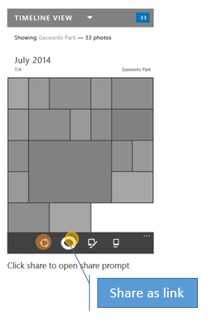 | - ‘share as link’ is highly discoverable | - Users can get confused between the regular share icon and ‘share as link’ icon if they are similar  - Already too many icons on app bar
 | Shows the ‘share as link’ as a menu item  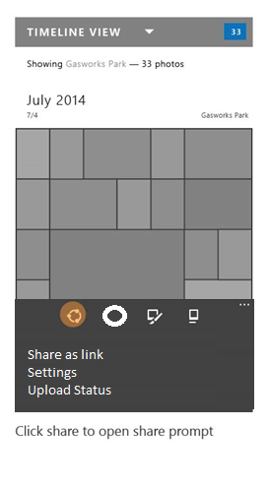 | - Doesn’t distract from regular share flows | - Harder to discover (If flighting suggests that several users use it, then we can consider it a first class citizen)  - What’s the point of enabling it, and then hiding as menu item?
 | Provides some customization on top of the Share picker UI enabling users to toggle between sharing as file or sharing as a link. Always default to ‘attachment’ and enable users to switch to ‘link’.  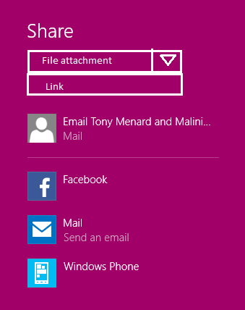 | - Natural part of current share flow  - Doesn’t disrupt regular share as file flows | - Limit discovery of ‘share as link’ option  - What is the phone solution?  - will we need to send content to share contract that enables both options, to make this happen?  - Unclear on how we will enable uploading local content using this entry point  - Dependency on threshold  - extra step
 | Provides some customization on top of the Share picker UI enabling users to toggle between sharing as file or sharing as a link.  Choose the selected option based on content selected. Like if they have selected 50 photos + videos, then suggest sharing as link, where the user has option of toggling to regular file share. | - Promoting share as link wherever we think best  - Prevents potential failures in target apps  - Natural extension of current share flow | - Confusing to users as to why we sometimes recommend file share and sometimes recommend share as link  - Reason for providing recommendation is not explicitly stated to user  - Users may make mistakes if they don’t notice the option we pre-selected for them  - Dependency on threshold
 | Provides some customization on top of the Share picker UI enabling users to toggle between sharing as file or sharing as a link.  Always default to ‘link and enable users to switch to ‘attachment. | - Highly promotes share as link option  - Natural extension of current share flow | - No clear (or communicated) value prop when sharing small amount of content  - Limits target app options potentially  - How does this look like on phone?  - Dependency on threshold
 | Always ask users to make a choice after they choose share entry point  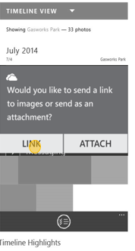  (add copy link to clipboard functionality) | - Promotes share as link  - Opportunity to communicate to user why they should share as link | - Always adding one extra step to share flow.  - Not intuitive to users who don’t know enough or want to make an explicit choice  - Becomes repetitive, perceived as annoying  - Alarming (at least the first few times) to have a dialog like this
 | Only provide form to user if they meet some criteria  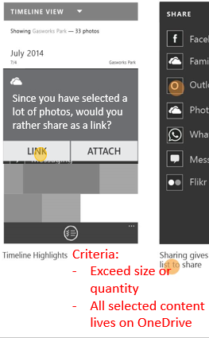  (add copy link to clipboard functionality) | - Promotes sharing as link especially for the scenarios we think that has the most value for  - Clearly explains value prop based on current selection for sharing as link (Example: Looks like you have selected a large amount of photos. Would you rather share as a link?) | - Hard to determine criteria since data limits vary extensively by app  - Seems magical when the option is provided, don’t know how to find the entry point when user selection doesn’t meet our set criteria
 | Regular share entry point that gives used a custom page enabling them to make choices on whether they want to share as file or as link. Page may look something like this:  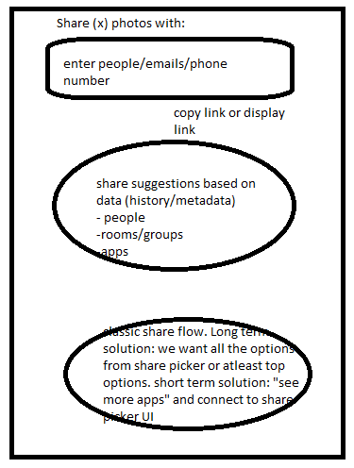 | - Promotes share as link without confusing users  - Provides user ability to share as file to the apps they use  - Flexible for future items like auto-suggestions (people, rooms/groups) and shared albums  - No dependency on Threshold  - Could take a dependency on integrating share targets into this UI | - Doesn’t enable users to share links to apps they are used to. Only file share is enabled for share targets.  - Page could get quite heavy  - For M1, share charm exists and experiences would differ  - In M1, have to go through share charm.
 | Let the target app choose. Photos app to provide both physical files and URL to content and the target app will choose which one they prefer to use. | - Target apps customize for sharing option that best meets their needs  - No extra UI, no user decision to be made | - User may get confused as to why certain apps display links while other have physical files  - User not in control of the choice, dependent on target app to make the right choice (apps have to be updated to add in this logic)  - Many target apps would choose to get physical content (as opposed to file) so chances of sharing as link become slim

These options are still under evaluation and a final decision has not been made. Due to it’s flexibility, chose option #8 for further exploration in section 9.2.2

Custom Share flow
Note: not in scope for M1
The solution detailed below combines the benefits of promoting sharing via OneDrive links as well as giving users the option of the classic share (as file to apps they want).
<insert screenshot>
Top box:
- “quick share” or “Share as OneDrive link”
- Enables user to enter recipients
- User can quickly complete the share flow if all content selected lives on OneDrive
  - Open issue: do we want them to wait around if we need to upload local content to OneDrive
  - Feedback loop and user interaction if upload fails
- This would immediately send the content to recipient(/s)
  - Open issue: is sender the customer or the racounteur service?
  - Ideally: customer’e email
  - How do we balance user completing share flow quickly and all the processing/uploading that needs to happen esp around large sets
- Supports sharing via email as P1
  - Supports texting as P2

[Post M1] Middle circle:
- Top share recommendations based on user’s history, image metadata etc.
- Includes suggestions for people, rooms and groups, target apps
- More details in future specs
Bottom circle:
- “classic share” or “Share as file”
- This portion is to enable users to share via target apps they are used to
- This performs share as file (classic share)
If we cannot incorporate share picker target apps into the custom share page, then we enable users to get to share picker UI from this screen.

Quick Share OR Share as OneDrive Link
New custom way to share content.
Packaging content
The table below details how we will package all the selected content to provide the Share contract an OneDrive link.
Content selected for sharing as OneDrive link | OneDrive link to content exists? | Package content
All OneDrive | Yes | Generate one link to all selected content (that is, one link to all bundled content)
All local | No. Needs to be uploaded. | Need to upload content to OneDrive. Generate one link to all uploaded content
Mixed source – some local, some Onedrive | Some have links, some need to be uploaded | Need to upload local content to OneDrive. Generate one link to all selected (available and uploaded to OneDrive) content

When does the upload happen? Do users need to wait while upload occurs? Feedback loop and user interaction when upload failures occur.
Event to trigger OneDrive backup option to users
- The first time user selects ‘share as link’ we will provide a trigger event to ask the user to backup using OneDrive in case they don’t already.
- If the user continues to not backup using OneDrive, then we can provide the trigger event on some regular cadence to drive users toward OneDrive backup for their photo and video content.

Generated Link

- Do we know which content is on OneDrive?
- For mixed source:
Get bundle ID (for existing OneDrive content)
Upload API (for local content) – maybe at the same time as above(get resource ID)
Add to bundle API (give resource ID)
- No current support for knowing whether the content lives on Onedrive
- Need API support to getting links and upload in the background [CJ]

Classic Share OR Share as File
Regular share flow using share contract and Share picker
Packaging content
When customer choses to share content as physical files (as opposed to link), then we need to provide the right mechanisms for gathering that content based on where the selected content lives:
Content selected for sharing as file | OneDrive link available? | Packaging solution
All OneDrive  *May have thumbnail versions on the local device, but full res lives in OneDrive only. | Yes | Option 1:  Get URI backed storage file for all selected content. Group all storage files and send as one single data package to Share contract.  Option 2:  Download all content to local device  Open issue: device storage implications for low cost devices
All local | No. | Get locally backed storage file for all selected content. Group all storage files and send as one single data package to Share contract.
Mixed source – some local, some OneDrive | Some have links, some don’t. | Option 1:  Get URI backed storage file for all selected content. Get locally backed storage file for all selected content. Group all storage files and send as one single data package to Share contract.  Option 2:  Download all OneDrive content to local device. Get locally backed storage file for all selected content. Group all storage files and send as one single data package to Share contract.  Open issue: device storage implications for low cost devices

Open question: Is URI backed storage file faster and/or cheaper than downloading OneDrive content to local device and then treat it as a local file.
Note: URI backed storage files shipping for Phone in Threshold M1.
How does this affect the apps requirements to have data access? I.e. apps define their capabilities and typically if they do image picker they would not necessarily need network access, but with this they would, correct?

The table below is tbd as we figure out flow.
UI feature | Description | PC Shortcut | PM string | Proposed string | Final string
App icon | Share as link |  | Share as link
Menu item | Share as link |  | Share as link
Page | Page showing the progress of uploading local content to OneDrive. Explains to user that the content doesn’t live on OneDrive already and so we need to Upload before we can share this content as a link. All content selected is shown as thumbnails with progress bars as upload occurs. Allow user to cancel and exit this form at any time. |  | Upload page
toast | Shows when the uploaded content is complete. For example ’33 photos uploaded to OneDrive’ |  | Upload complete toast

Health requirements

Data Consumption

Storage Consumption

Battery

Telemetry & Test in Production
Guidelines

Telemetry

Test in Production

Risks & Open Issues
Guidelines

Risks

Open Issues

Tenet Fundamentals
Guidelines - Click the links under Applicability and Assessment to understand requirements and get help.
 | Tenet Quality Area | Compliance/Quality value explained | Applicability and Assessment
Compliance – all teams | Accessibility | Features and scenarios just work for users with impairments and that leverage assistive technologies | Get Started
Compliance – all teams | Geopolitical | Features and content pose minimal or no legal or business risk in any market | Get Started
Compliance – all teams | Privacy and Safety | Protecting customer data from misuse, and ensuring services and features are safe and secure | Get Started
Compliance – all teams | Protocols | Networking protocols are documented according to Microsoft and regulatory requirements | Get Started
Compliance – all teams | Security and Anti-Fraud | Making Windows experiences the most secure and privacy-protecting OS on the market | Get Started
Tenets - all teams | Compatibility | Apps, devices and sites just work | Get Started
Tenets - all teams | Performance | Responsiveness, storage space, data usage and power satisfy competitive needs | Get Started
Tenets - all teams | Reliability | Devices and scenarios are measurably reliable per competitive needs | Get Started
Tenets - all teams | World-Readiness | Features and scenarios work for and excite customers worldwide per competitive needs | Get Started
Tenets - some teams | Developer Experience | Developers have the APIs, samples, and documentation needed to build great apps | Get Started
Tenets - some teams | Manageability | Cloud OS is enabled via automation and remote management of all applications, features, roles, and services | Get Started
Tenets - some teams | User Experience | UI meets UX guidelines around design and usability | Get Started

DOCUMENT UPDATE HISTORY

Date | Author | Changes
3/18/2014 | MaliniJa | First Draft of one pager
4/25/2014 | MaliniJa | Initial Review of scenarios, goals and non-goals complete
5/16/2014 | MaliniJa | File Share (Standard Format, local content) detailed spec review complete  Sections 5, 9.1, 9.2, 9.4.1 reviewed.
 | MaliniJa | File Share (Standard Format, local content) spec Signoff.  Sections 5, 9.1, 9.2, 9.4.1 locked.
 | MaliniJa | OneDrive Share detailed spec review complete
 | MaliniJa | OneDrive Share spec signoff
 | MaliniJa | RMT detailed spec review complete
 | MaliniJa | RMT spec signoff
appendix

Definitions & Acronyms

References

Feature Q&A / Decisions

Appendix (Deleted content that may be of use later)
Share one video questions
Open issue: can we improve the flow other than expecting the user to restart flow
Does the default experience on PC vary from phone?
Are there any differences in sharing videos between phone and pc?
Yes – they use the same share contract, but the user experience is different depending on what apps are available on the platform. Apps only show up if the register for the video file extension and they are installed on the device. E.g., facebook must support “.mp4” and must be installed on the phone before it will show in the list (discoverability issue?).
Do the share targets (let’s say gmail for example) compress the videos to the same extent?
On PC: no
On phone: if you use the in-box SMS texting or mail app, it will attempt to do compression automatically. If it can’t compress it enough, it will fail.
What are the other differences that you know of, and which device does it better?
Phone is better since you don’t have to find the share charm. A button on canvas invokes the share picker.
Difference in share targets:
Is there a difference in what target apps are available based on pc or phone? Are there some target apps that are supported for sharing video on one but not the other?
Facebook on PC doesn’t support video but facebook on phone does. I’m sure there are other instances of support on PC but not on phone or vice versa for cross platform apps.
PC seems to have fewer apps for social video sharing in general.
Why is for example 6snap or youtube not showing up as share targets (on phone) when I select a video?
First of all, there is not an official YouTube app on PC or on the phone, but that’s a problem that probably won’t get solved. (google embargo on Microsoft)
It wasn’t possible for apps without special provisioning from Microsoft (ie, only nokia or whatsapp who worked with us directly) to share a video before Blue (Arun, is this true? I think in 8.0 video could only be shared to special apps and inbox apps like mail and messaging)

As for 6snap, I assume (like snapchat on other platforms) you are expected to capture within the app to insure there is less spam and that the content is “in the moment.” However, if the developer (Rudy Hyun) wanted to, he could register for the video share contract in WP 8.1

