1. Introduction

Organizations in many industries today are facing increasingly rapid environmental change and fast-changing competitive dynamics, forcing them to learn how to make decisions both quickly and effectively (Carlsson & El Sawy, 2008; Eisenhardt, 1989). The growth of digitization both exacerbates this environmental turbulence and suggests solutions, e.g., real-time data warehousing and data stream analytics to bring more information to decision-makers faster (Nadj & Schieder, 2016; Stodder, 2014; Watson & Wixom, 2007), and adding to this the use of artificial intelligence, automated event processing, and the Internet of Things (IoT) to create a real-time enterprise (Chaudhuri, Dayal, & Narasayya, 2011; O’Leary, 2008). The movement toward real-time technologies and organizations shortens the cycle time between sensing, decision making, and acting, endowing the organization with vital agility (Kohtamäki & Farmer, 2017; Park, El Sawy, & Fiss, 2017). However, achieving the state of the art in real-time capabilities is inefficient and expensive (Townsend et al, 2017) and not without difficulties both technological and organizational (HBR, 2015). Legacy systems must be upgraded or replaced with new technologies. Organizational capabilities must be matured; for example, managers and employees need to learn how to deal with data that arrives more rapidly and at a different grain (Clark & El Sawy, 2010). Human decision-makers have limited cognitive and attentional resources which, although they may be augmented by decision support systems (DSS), remain a powerful constraint on information processing (Lerch & Harter, 2001). Accordingly, we posit that organizations will budget their investments (of money and attention) in real-time capabilities, pushing the envelope in some domains but not in others.
An important question motivating research is therefore: when (i.e., for what types of problems and decisions) are real-time capabilities enabled by information systems most valuable? And conversely: when can they be omitted? The answers to these questions would be valuable in helping practitioners focus their investments in the suite of technologies aimed at speeding up the organization’s ability to sense its environment, make decisions, and implement new actions, which we’ll group under the term real-time business intelligence (RTBI).

2. Hypothesis Development
Business intelligence (BI) is defined broadly by Chen et al, 2012 as “the techniques, technologies, systems, practices, methodologies, and applications that analyze critical business data to help an enterprise better understand its business and market and make timely business decisions.” RTBI is distinguished from the broader construct by its focus on acquiring and processing data in near real-time in an effort to reduce latency in an organization’s adaptive loop of sensing and responding to its environment (Nadj & Schieder, 2016). Hackathorn (2004) coined the term action distance for the delay between the occurrence of a business event and an organization’s response to it. Action distance is the sum of three latencies: data latency, the time required to capture and store data about the event, analysis latency, the time required to analyze and disseminate information about the event, and decision latency, the time required for a person to understand the event and decide on a response. Eisenhardt (1989) defined real-time information as “information about a firm’s operations or environment for which there is little or no time lag between occurrence and reporting”; she saw successful firms in high-velocity environments focusing on this operational information, as opposed to forecasts and analysis. RTBI is therefore characterized by tools and techniques meant to reduce any or all of these latencies, and bring near-real-time operational information to decision makers. Examples include IoT devices and sensors generating live data streams about business operations (reducing data latency), data stream analytics replacing batch-based ETL (reducing analysis latency), and AI-based automation of certain decisions (reducing decision latency).
Our motivating question fits into a literature rooted in the information processing view of organizations, which highlights how information systems (IS) capabilities’ effects on business outcomes are moderated by characteristics of the business environment—a contingency framework (Daft & Lengel, 1986; Park et al, 2017). This literature also frequently overlaps with the theory of dynamic capabilities, which is based in the resource-based view of the firm and describes organizational capabilities that help the firm “to integrate, build, and reconfigure internal and external competencies to address rapidly changing environments” (Eisenhardt & Martin, 2000; Teece, Pisano, & Shuen, 1997; Zollo & Winter, 2002). Aspects of environmental dynamism considered in the dynamic capabilities literature include velocity, unpredictability, and a combination of the two called turbulence. Pavlou and El Sawy (2006, 2011) for example showed that dynamic capabilities, developed from a firm’s competence at leveraging information technology (IT) and composed of sensing, learning, integrating, and coordinating capabilities, have a greater positive influence on operational capabilities in new product development as environmental turbulence increases. The same concern with environmental contingency is also found in the organizational learning literature, which, with its tradition of simulation research, has modeled even more aspects of environmental dynamism such as direction, magnitude, and frequency of change (Stieglitz, Knudsen, & Becker 2016), turbulence, munificence (Posen & Levinthal, 2012), velocity, ambiguity, complexity, and unpredictability (Davis, Eisenhardt, & Bingham, 2009). Fink, Yogev, and Even (2017) argue for the inclusion of organizational learning as “an important theoretical lens for understanding how [business intelligence] creates business value” because of BI’s central concerns with decision making and environmental change. A recent example of this theory making its way into the IS literature is (Lee et al, 2015) who show that environmental dynamism moderates the relationship between IT ambidexterity and organizational agility.
The literatures pertaining to the information processing view, dynamic capabilities, and organizational learning all give us reason to believe that the RTBI’s real-time capability (i.e. the reduction of latency in action distance) has business value, and that this value is contingent upon the dynamics of the business environment. Sambamurthy, Bharadwaj, and Grover (2003) have argued that real-time business intelligence and analytics are (part of) an important dynamic capability allowing firms to adapt to rapidly-changing business environments. Brown & Eisenhardt (1997) found that businesses on “the edge of chaos” adapted by making frequent, small probes of the future, necessitating the ability to quickly sense and respond (Park & El Sawy, 2012). From a pragmatic standpoint it is often argued that speed of the sense-respond or OODA loop is essential to getting ahead of the competition (Houghton et al, 2004; Rivera, 2015). We infer that the faster the organization’s sense-respond loop, the shorter its action distance, the better able it is to achieve successful decision outcomes; and moreover, that this effect should only increase as environmental turbulence increases.

Hypothesis 1: As latency in a decision maker’s sense-respond loop decreases (i.e. as it approaches real-time action distance), decision making performance in turbulent environments increases.

Hypothesis 2: As turbulence increases, the positive impact of real-time business intelligence on decision making performance will increase.

The dynamic capabilities view implies that adaptation requires not only the rapid acquisition of new information (to modify existing operational routines) but also the ability to evolve away from outdated information that is no longer relevant. RTBI can be classified as a knowledge-based dynamic capability (Denford, 2013), and central to that view is that “new knowledge cannot be turned into competitive advantage unless an organization is willing to let go of its investments in old knowledge (Hermann, Gassmann, & Eisert, 2007). Research shows that there are a number of pathologies stemming from the path-dependent nature of learning, such as ‘success traps’, ‘failure traps’ (Levinthal & March, 1993), and learned risk-aversion (Denrell & March, 2001; March, 1996). The managed unlearning of outdated knowledge in order to make way for the new, which de Holan, Phillips, and Lawrence (2004) called “organizational forgetting”, has received relatively little attention, but the dynamic capabilities view strongly suggests that such a capability is essential to RTBI. This process has not been clearly identified in typologies of knowledge-based dynamic capabilities (Denford, 2013) so we refer to it as organizational forgetting capability, adapting the term from de Holan’s (et al., 2004) paper title, although we are also fond of LICalzi & Marchiori’s (2014) phrase “packing light while chasing a moving target”. Abandoning hard-won knowledge is, of course, not to be taken lightly, so there is a need for new research to understand how an organizational forgetting capability complements the value of real-time business intelligence in turbulent environments. The amount of knowledge pruning that needs to occur is likely dependent on the rate of environmental change.

Hypothesis 3: If a decision maker discards old knowledge, decision making performance in turbulent environments increases. A nonlinear relationship is hypothesized: some optimal rate of organizational forgetting will have a greater positive impact on performance than a too-high or too-low rate.

We expect there will be an interaction between real-time business intelligence and active organizational forgetting capability, particularly at very high levels of turbulence. Accordingly, we see in practice that many businesses are leveraging data streams instead of data warehouses in fast-paced environments: preferring to continually analyze the freshest data from a recent time window rather than leveraging what may be more accurate and integrated data in historical databases (Zliobaite et al., 2012). We expect that the decision maker in a very turbulent environment who processes data quickly and is not biased by outdated knowledge will perform as well as possible on “the edge of chaos”.

Hypothesis 4: The positive impacts of real-time business intelligence and organizational forgetting capability will interact, producing a performance impact greater than the sum of the two effects.

3. Research Design: Simulating the Multi-Armed Bandit
Computer simulation research in organization theory has an excellent tradition of allowing theoreticians to independently model different dynamics of the business environment, conditions that are difficult to measure and to manipulate in the outside world, but can be controlled precisely and independently in the virtual world of an agent-based or stochastic processes simulation (Carley, 2002; Davis, Eisenhardt, & Bingham, 2007). In the organizational learning literature in particular, simulation methods have been very fruitful in studying environmental contingency effects on sensing-responding decision making processes (e.g., Posen & Levinthal, 2012; Stieglitz et al, 2016). In this study, we extended a canonical simulation model—the multi-armed bandit—to test our hypotheses about real-time business intelligence and organizational forgetting capability.
The “multi-armed bandit” is a well-established model for the study of sequential decision making behavior under uncertainty (Denrell & March, 2001; Puranam et al, 2015; Robbins, 1952; Stieglitz et al, 2016). In the model, a decision maker (or organization) is presented with a number of options to choose from (one may visualize a casino slot machine or “one-armed bandit” but in this case with numerous arms), each with a different, unknown, probability distribution over rewards. By selecting options one at a time, the organization accumulates rewards or losses while forming beliefs from experience about the expected values of each option. In the bandit model, decision making cannot be separated from sampling. Each choice generates profit or loss but also helps the decision maker learn something about the option that was chosen (and only that option). The recurring tactical decision therefore is characterized by a meta-decision which we may call the strategic aspect of the model: should the decision-maker take the option currently believed to have the highest expected payoff, or should he choose a different option in order to gain more information about its (potentially greater, but yet unknown) rewards?
Some of the key findings are that even in a stable environment, the organization achieves the best performance with a strategy that mixes regular exploitation of the best-known option with some amount of exploration of other options (March, 1991); that in a changing environment, which can be represented by intermittently altering the probability distributions over rewards, the optimal balance of the two activities (i.e., the optimal strategy) changes (Posen & Levinthal, 2012); and that the path-dependent nature of learning in this model can generate risk-aversion endogenously (Denrell & March, 2001; March, 1996). We selected the multi-armed bandit model for this research because its long tradition in peer-reviewed research establishes its legitimacy, and allows us to compare our findings meaningfully with prior research. Bandit simulations can reproduce some of the same findings as evolutionary models of competitive selection and adaptation, another popular form of simulation in organization theory (Denrell & March, 2001). The bandit model’s central features are an iteration between action and learning, and the decision-maker’s memory of past experiences, so it is very compatible with our construal of RTBI as a reduction in action time, and is an ideal model for studying how a decision maker manages memory. Furthermore, bandit models have recently acquired some real-world relevance—they are being used in software such as Google Analytics for A/B testing, by Yahoo! for personalizing news articles and advertisements, and in other practical online experiments (Hanov, 2012; Li et al, 2010; Whyte, 2013).

3.1. Program Specifics
In order to ground our research in extant literature, we began by replicating a recent example of the multi-armed bandit by Posen and Levinthal (2012), before extending the program to test our own hypotheses. Theirs is a particularly well-documented implementation which includes a model of environmental turbulence that we can use in our hypothesis tests. It is becoming one of the better-cited bandit papers, and has attracted other replication and extensions (LiCalzi & Marchiori, 2014). Replicating the results of their main experiments (see Figures 1 and 2, below) validated that our implementation was faithful to theirs and free of software bugs. In addition, this helped assure that any findings we report are the results of intentional manipulations we subsequently made to the model’s assumptions, rather than quirks of our code. Finally, we believe that replicating other researchers’ results is a meaningful contribution to science.
Our program was coded in Python and all simulations were run in Python 3.5.2. The program has been designed in a modular way to make it easy for other researchers to further replicate and extend the model, and has been released as an open-source project. [Web address and details omitted to preserve author anonymity during review.]
At the heart of the multi-armed bandit model are a set of N alternatives from which an organization or decision maker must choose, each with its own probability distribution over rewards. In each time-step of the process the decision maker makes a choice, receives a reward based on a random draw from the probability distribution of the chosen option, and learns (or updates its beliefs) about the relative or absolute favorability of the alternatives. Replicating the Posen and Levinthal implementation as exactly as possible, we used the following parameters:

- N = 10
- Probability distributions over rewards are Bernoulli. Rewards are +1 or -1, with the probability of a favorable reward for each option P= [p₁,…,p_{N}] determined at the initialization of the program by independent draws from a Beta distribution with α=2 and β=2. This is a symmetrical bell-shaped distribution with a mean 0.5 and standard deviation 0.22, but (unlike the Normal distribution) is strictly bounded between 0 and 1, making it a good choice for generating random probabilities.
- Rewards are cumulative. In each turn the organization earns a reward of +1 or -1. The organization begins with a “stock” of zero and the simulation runs for 500 turns.
- Within each experimental treatment we replicate the simulation 1000 times, computing the mean and variance of the stock in turn 500 as the main outcome variable (“performance”).
- The decision maker’s beliefs Q = [q_{i},…,q_{N}] about the N options are estimates of p₁,…,p_{N} derived from the feedback the organization has received on its choices. Initial beliefs are set to 0.5 across the board and once the decision maker has some experience with an option, its belief is an average of 1 for each positive reward and 0 for each negative reward experienced with that option.
- Turbulence is simulated as probabilistic shocks to the payoff probabilities P. The parameter T specifies the probability that a shock will occur in any given turn. In the event of a shock, some of the payoff probabilities p₁,…,p_{N} are re-drawn from the initial Beta distribution. A simulated coin flip for each arm determines if its payoff probability will be re-drawn or remain unchanged.
The decision maker’s sequential choices among the N alternatives are determined by its strategy. A number of strategies can be, and have been, articulated for bandit models. A myopic or “greedy” strategy chooses, in every time period, the option believed to have the greatest probability of reward. A more common model from the exploitation-exploration literature is an “ε-greedy” rule in which the believed-best option is chosen most of the time, but with probability ε the organization chooses one of the other options at random. In such a model, the parameter ε characterizes the organization’s strategy. Posen and Levinthal adopt a more sophisticated implementation of strategy characterized by the “softmax” algorithm in which the probability of choosing any option i is m_{i}, a function of the organization’s belief about it’s payoff, q_{i}. Specifically, m_{i} is given by:

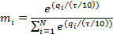

In this model, the parameter τ characterizes the organization’s strategy. At very small levels of τ, differences in beliefs are weighted heavily and the organization will almost always choose the believed-best option. Even when “exploring” it will be most likely inclined to try the believed-second-best option and is very unlikely to visit the believed-worst option. At higher levels of τ, the organization is increasingly indifferent to the differences in beliefs about payoffs and more likely to try the alternatives that it does not have positive experiences with. The benefit of the softmax algorithm is its sensitivity to the strength of the organization’s beliefs about the differences in favorability between options.

3.2. Measurement of Attainable Performance
Research using bandit simulations has shown that the optimal exploration strategy (ε or τ) differs in different environmental conditions. In order to find the best-attainable performance for a given experimental condition, we followed Posen and Levinthal’s (2012) procedure: first we simulated the model at five levels of τ: 0, 0.25, 0.5, 0.75, and 1.0, and from the results we determined the mean performance at each level of τ. Their first experiment held the environment stable (zero turbulence). Figure 1 demonstrates our replication of their first experiment’s results, revealing the nonlinear relationship of strategy to performance.
In addition to performance, Posen and Levinthal measured “exploratory choice” as the probability of choosing a different option in period t than that which was chosen in period t-1, and “knowledge” as one minus the sum of squared error of the decision maker’s estimated payoffs relative to the true payoffs of each alternative. Our simulation’s outcomes on these measures, too, match the reference study. See Figure 1.
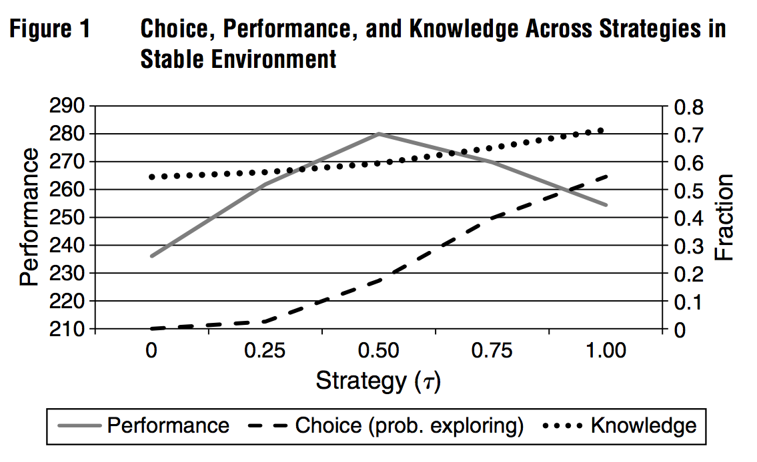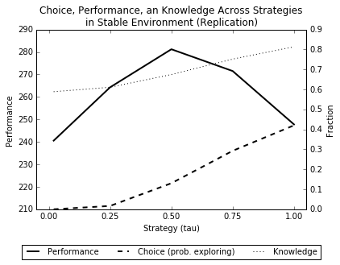
Figure 1. Posen and Levinthal (2012), Fig 1 (left) and our replication (right)

With this type of simulation output for each experimental condition, Posen and Levinthal fit a third-order polynomial to the data and solved for the τ defining the maximum of that curve. This method saved them the necessity of simulating dozens or hundreds of levels of τ, which would have been computationally prohibitive. This method was used to generate their second main experiment’s findings. Manipulating the turbulence variable T, they experimented with eight levels of turbulence and showed that the optimal strategy (τ) increased (i.e. favored more exploration) from low to moderate levels of turbulence and then declined at high levels of turbulence. In addition, they showed that the second derivative of the performance versus strategy curve increases (becomes less negative) with turbulence; this implies that at extreme levels of turbulence, finding the optimal strategy matters less than at moderate levels of turbulence. Figure 2 demonstrate that our simulation replicates these qualitative findings correctly, although our curves do appear noticeably smoother due perhaps to some volatility in the way the optimal τ is estimated from a fitted curve.

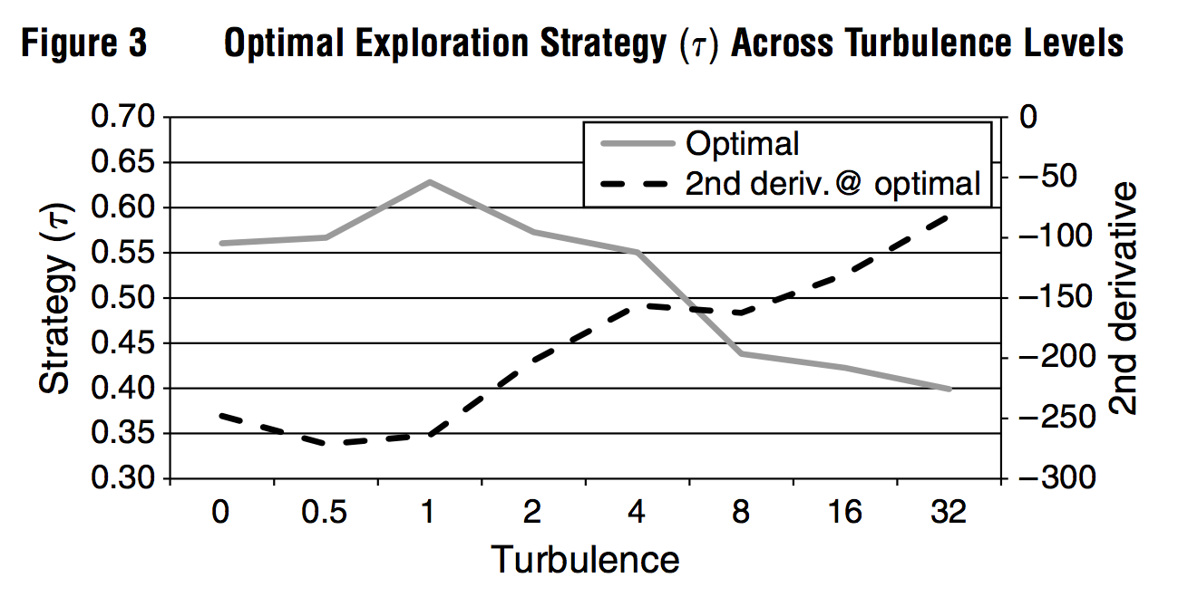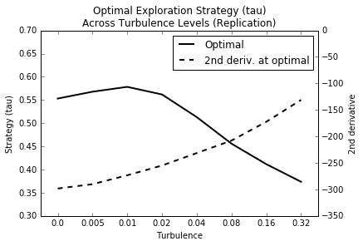
Figure 2. Posen and Levinthal (2012), Fig 3 (left) and our replication (right)

In our main study which follows, we continued to use these methods to estimate the optimal strategy, and the expected level of performance attainable with that strategy, as we varied the experimental conditions discussed below. We refer to the latter measure as “attainable performance” in our findings.

3.3. Real-time Business Intelligence
One feature of the typical multi-armed bandit simulation that stands out, from the perspective of an information systems scholar, is that the decision-maker is assumed to receive feedback and learn from the outcomes of his decisions instantaneously and without error, before making subsequent decisions. The first extension we introduced to the validated simulation model was a relaxation of this assumption. We introduced an integer latency parameter, L. The decision maker receives and learns from a decision outcome L turns later (after having made L choices in the meantime). We experimented with values of L from 0 (i.e., real-time) to 16 turns. Real-time business intelligence (RTBI) is understood to have the effect of reducing latency in the decision maker’s sensing-responding loop, hence greater RTBI is represented by lower L.
Hypothesis 1 predicts that in turbulent environments, attainable performance decreases as latency (L) increases. We experimented with turbulence (T) of 0, 0.005, 0.01, 0.02, 0.04, 0.08, 0.16, and 0.32. Figure 3 illustrates the observed effect of latency on performance at a moderate level of turbulence (T=0.04). At this level of turbulence, the performance cost of latency is dramatic and unambiguous. With a real-time feedback loop (L=0), the decision maker achieved markedly greater performance than with a delayed feedback loop (L=16), and the function is monotonic. Every decrease in latency corresponded to an increase in attainable performance.
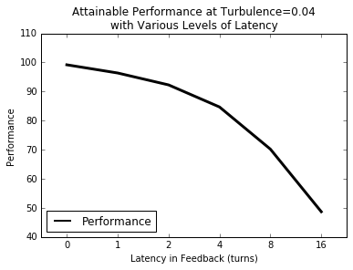
Figure 3. Attainable performance decreases as latency in feedback loop increases

Confirming Hypothesis 1, this pattern is seen quite clearly at every level of turbulence simulated, except the stable case (T=0). The impacts of latency on performance can be seen in Figure 4, with the results at each level of turbulence made relative by subtracting them from their performance at L=0.

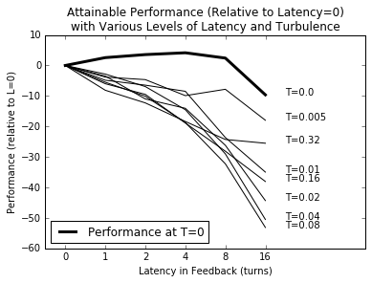
Figure 4. Impacts of latency on attainable performance at various levels of turbulence

Interestingly, the difference is greatest at moderate levels of turbulence: 0.04 and 0.08. This contradicts what we expected, as in Hypothesis 2 we predicted that the value of RTBI would scale monotonically with turbulence. To view these results another way, we subtract attainable performance at L=16 from attainable performance at L=0 to create a measure we may call “cost of latency” or conversely “value of real-time”. As Figure 5 illustrates, it is plainly nonlinear.

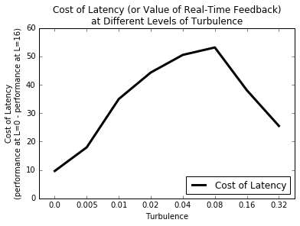
Figure 5. Nonlinear effect of turbulence on the value of real-time

To try to explain the nonlinearity, we observe the absolute performance at each level of turbulence—i.e., the raw data that went into Figure 4. What is shown in Figure 6 is that, at the higher levels of turbulence (T=0.16, T=0.32), performance tends to decline to an average of zero, the theoretical long-run average of completely random guesses.

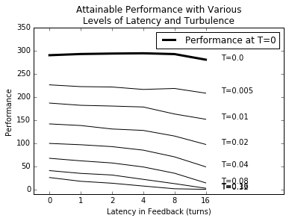
Figure 6. Attainable performance at various levels of latency and turbulence

We may conjecture that in extremely turbulent environments, knowledge becomes outdated so quickly that the decision maker simply cannot benefit from his learning no matter how quickly he processes the data. Therefore, we find that real-time business intelligence is most impactful at a moderate level of turbulence—where the environment is stable enough that knowledge can be exploited for profit, but changes quickly enough that there is a real advantage to rapid learning from real-time information.

3.4. Organizational Forgetting Capability
As previously mentioned, we believe that organizational forgetting is an often taken-for-granted component of organizational learning which may need to be made explicit in order to gain a complete understanding of the decision maker’s performance under uncertainty. We modeled organizational forgetting as a simple time window of memory: the decision maker renews his beliefs about the payoffs of his options each turn based on data received in the past M turns. If a particular arm i had not been chosen during that time window, the belief q_{i} would revert to the initial value 0.5.
Hypothesis 3 predicts that at some optimal level of organizational forgetting capability (that is, the regular discarding of outdated knowledge), ceteris paribus, attainable performance will be at its highest. To test this hypothesis, we conducted an additional experiment in which we re-ran the model with ten treatments of the memory parameter M: 50, 100, 150, 200, 250, 300, 350, 400, 450, and 500. Recall that M specifies a time window of memory as a number of turns, with lower values meaning that old knowledge is discarded sooner. Because by default (and in faithful replication of the prior study) we simulate 500 turns of time, M=500 is the control case in which no knowledge is discarded. As before, for each turbulence level we simulated the model at five levels of the strategy variable τ, fit a third-order polynomial, and computed “attainable performance” from the maxima of these curves. We expect that in changing environments, some balance between too short of a memory and too long of a memory will yield the highest attainable performance.
Figure 7 shows the results of these experiments.

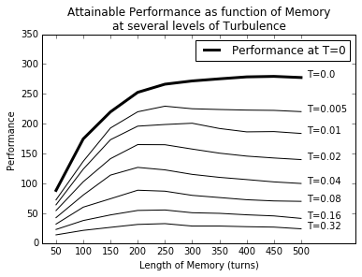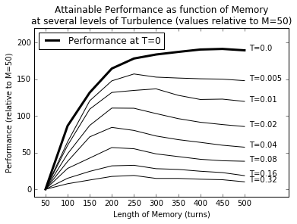
Figure 7. Attainable performance as a function of Memory;
absolute (left) and relative to M=50 (right)

The data reveals that in all turbulent environments (T>0), a short memory (less than 150 turns or so) corresponds to substantially lower attainable performance than a moderately-long memory of 150 to 300 turns. Less dramatic but certainly visible is a deleterious effect of a very long memory up to 500 turns. Hypothesis 3 predicted an inverted-U shaped function of memory on performance, and this is confirmed by the simulation output.
Viewed another way, a graph of the best M for each level of turbulence shows us that an M of 200-300 is optimal in all but the stable environment; thus, an organization enjoys better performance in a turbulent environment if it systematically “forgets” outdated experience. See Figure 8.

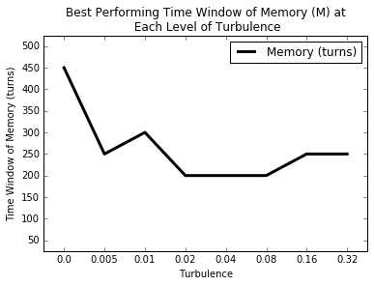
Figure 8. Best M for each turbulence level

In Hypothesis 4, we predicted a complementarity between a low-latency sensing-responding loop and an optimal level of active organizational forgetting. Visually, the curve shown in Figure 5 should move upward when M is at its optimum level, meaning that prudent organizational forgetting increases the value of real-time feedback loops. This is in fact seen in Figure 9: the cost of latency (value of real-time) is higher in any turbulent environment when M is set to a moderate quantity like 200, 250, or 300 than when no experience is ever forgotten. This evidence supports Hypothesis 4.
Furthermore, the function of turbulence on the cost of latency, seen in Figure 5, retains the same nonlinear shape at all levels of M except the lowest we sampled, M=50. As Figure 9, illustrates, at that very high rate of organizational forgetting, real-time business intelligence always has a positive value but this value declines roughly linearly as turbulence increases, probably due to the fact that it is hard to leverage any learning at all when turbulence is extreme.
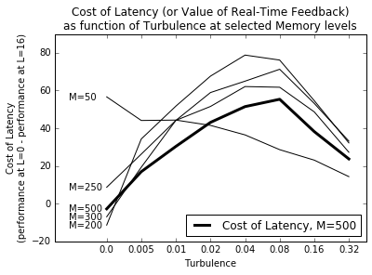
Figure 9. Interaction between organizational forgetting and real-time BI

3.4. Validation
Davis et al. (2007), in their roadmap for developing theory using simulation methods, provide clear guidelines for validating computational models of theorized phenomena. Because these simulations contribute “if/then” knowledge (e.g., if decision-makers learn and make decisions in this way, then the effect of real-time BI will be as the simulation results show), internal validity is of utmost importance. We must demonstrate that we are modeling what we claim to be modeling, and that neither software bugs nor arbitrary initialization parameters are determining the outcomes.
Davis et al. advise that researchers validate their simulations in at least two ways. First, simulation results must be compared with the propositions of “simple theory” that the study builds upon. If the simulation does not reproduce those starting points for theory development, then something may be wrong with our code or we may be modeling a different phenomenon than the one intended. In the present study, the long-established trade-off between exploration and exploitation (March 1991) is one such theoretical building block. Our successful replication of Posen and Levinthal’s (2012) first experiment shows that our model demonstrates this trade-off in accord with prior research. Although Davis et al do not require replication of another researcher’s work, or even of a canonical model, reviewers who worked with us on earlier forms of this research encouraged the practice. We argue that replicating a model that has already been validated by peer review study provides an even stronger form of verification, because there is an established literature that agrees on the phenomenon actually modeled. Moreover, as we extend the model and perform our own experiments, we can state with confidence that it is our manipulations alone, and not a difference in modeling, that determine any differences in outcomes.
The second guideline given by Davis and co-authors is that simulation researchers must perform robustness checks (also called sensitivity analysis) to demonstrate that the computational model is stable, that is, that its results aren’t overly dependent on arbitrary parameters or initialization values. To demonstrate the robustness of our results, we re-ran simulations with different numbers of arms (N), different numbers of turns, different samples of τ levels. We also tried a variation on the model with payoff probabilities P drawn from a uniform distribution rather than a Beta distribution, and a variation in which the decision maker used an ε-greedy strategy. Robustness checks were performed at four key junctures: at the replication of Posen & Levinthal’s first experiment (see Figure 1), the replication of their second experiment (see Figure 2), our first new experiment with real-time business intelligence (see Section 3.3), and our second new experiment with organizational forgetting capability (see Section 3.4). Our findings were found to be robust to many variations in simulation parameters, although limits to this robustness are noted below.
The code to re-run these robustness checks and reproduce the raw data is provided online in the open source code repository [URL withheld to preserve author anonymity in review process].

Robustness of replication of Posen & Levinthal’s (2012) first experiment. The following figures show results of several variations on the implementation described in section 3.1. They all demonstrate the key finding (see Figure 1): the dependence of performance on a balance of exploration and exploitation (the solid black line in each graph).

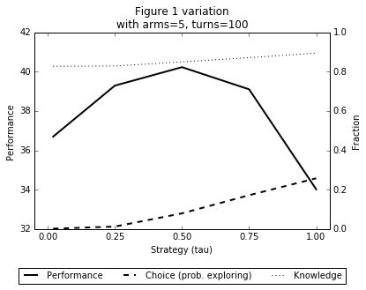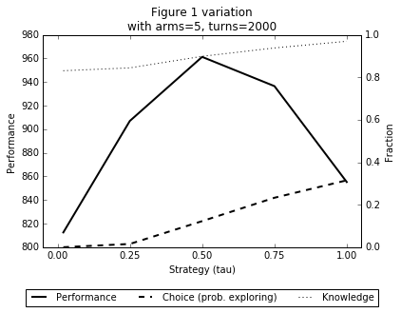
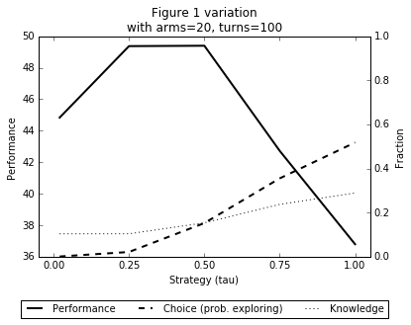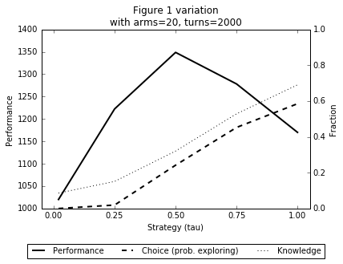
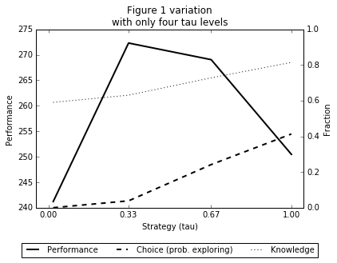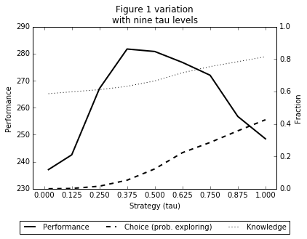
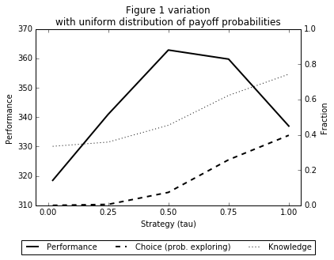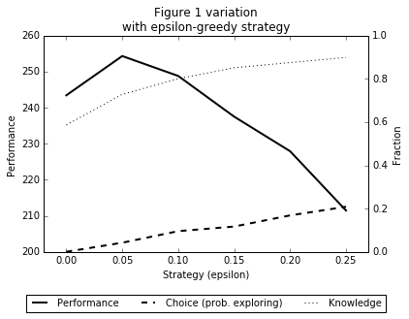

Robustness of replication of Posen & Levinthal’s (2012) second experiment. The following figures show results of several variations on the implementation described in section 3.1. More often than not, they demonstrate the key finding (see Figure 2) that the optimal strategy (τ) increases (favors exploration more) and then decreases (favors exploitation more) as turbulence increases. Notable exceptions are the case where a 5-armed bandit is simulated for 100 turns, the case where a 20-armed bandit is simulated for 2000 turns, and the case where the decision maker uses an ε-greedy strategy instead of a softmax strategy. Thus we have identified some limits to the robustness of Posen and Levinthal’s (2012) results, but at the same time demonstrated that they are robust to quite a few variations in simulation parameters.

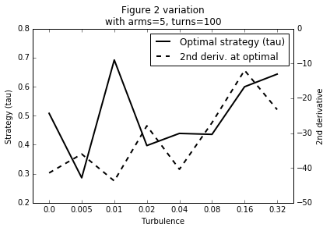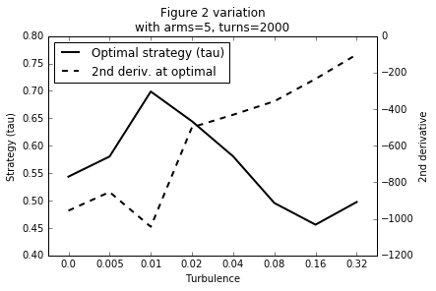
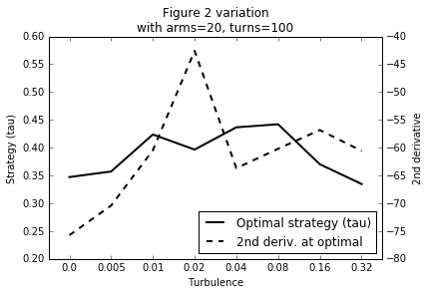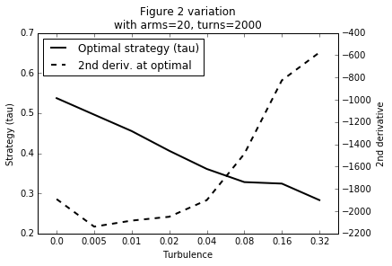
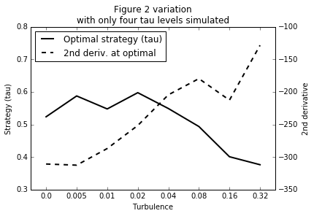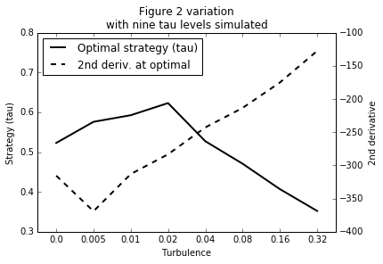
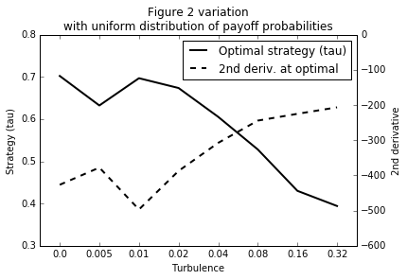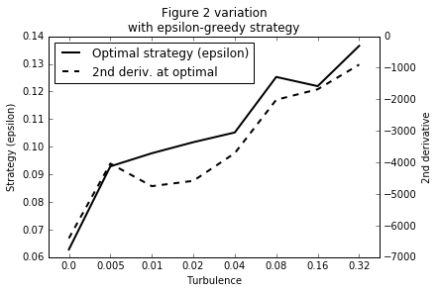

Robustness of our first experiment’s key result. Our first experiment varied the level of latency (L) in the decision maker’s sensing-responding loop, to test Hypotheses 1 and 2. Unexpectedly, we discovered a nonlinear relationship between turbulence and the cost of latency (as seen in Figure 5) instead of the linear relationship predicted by Hypothesis 2. The figures below illustrate the robustness of this result by reproducing Figure 5 with several different variations on simulation parameters. All variations support the same finding, although the variation using an ε-greedy strategy function yields some extreme values that don’t inspire confidence in its reliability.

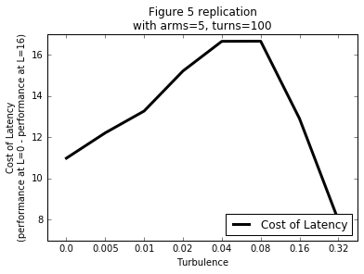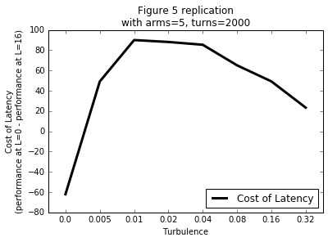
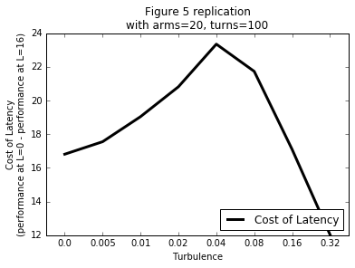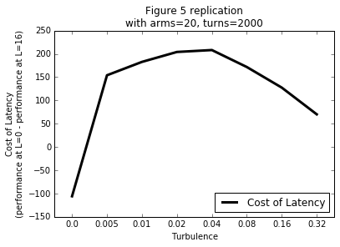
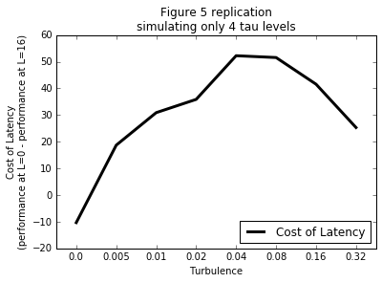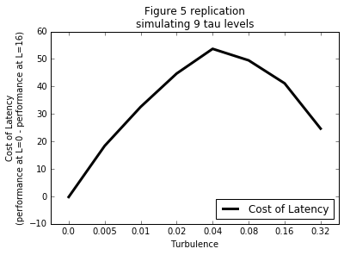
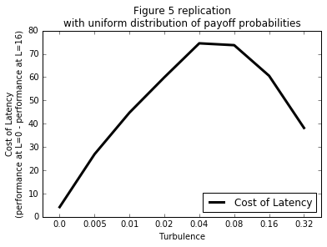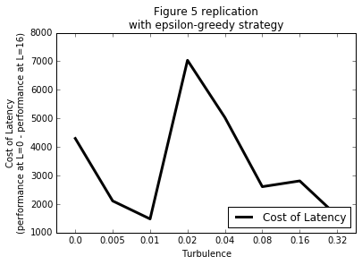
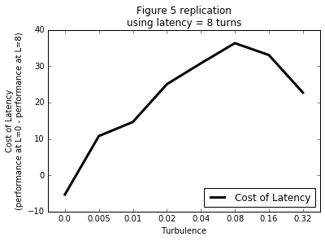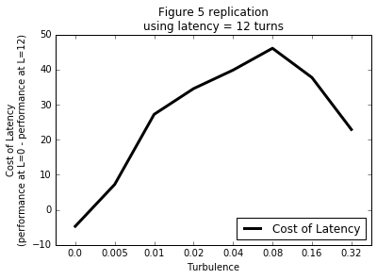
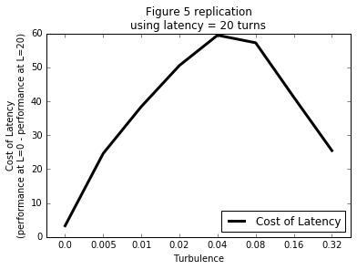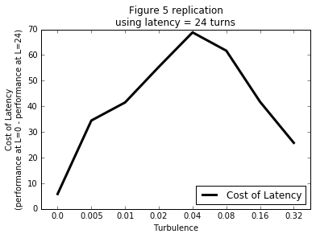

Robustness of our second experiment’s key result. In our second experiment, we also varied the time window of memory (M) in the decision maker’s evaluation of options. The main finding, confirming Hypothesis 3, was that the decision maker would perform best with a memory of moderate length, representing a well-calibrated organizational forgetting capability, rather than a perfect memory or a too-short memory. Robustness of this finding was confirmed by running several variations on the simulation’s parameters, which reproduced the same result:

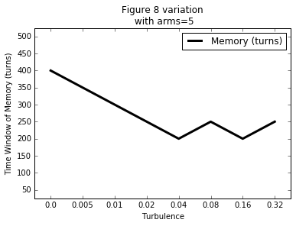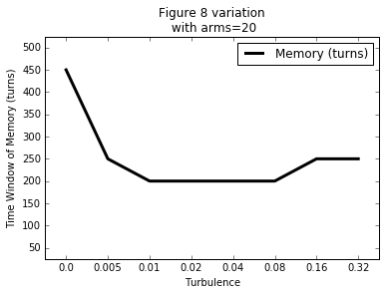
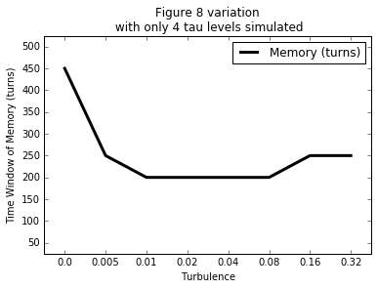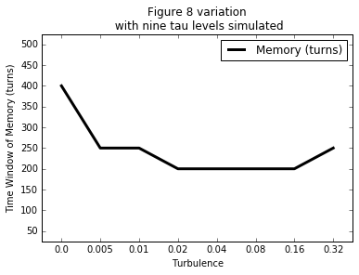
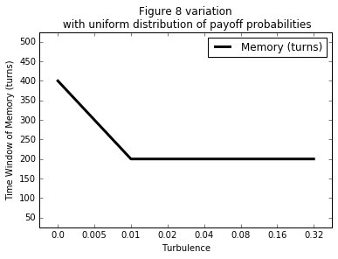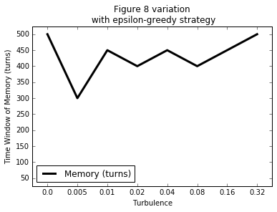

The second main finding, confirming Hypothesis 4, is that there is an interaction between real-time business intelligence and optimal organizational forgetting in turbulence. Figure 9 showed that for at least one level of M, the value of real-time was greater than it would be with perfect memory. This finding, too, is confirmed robust by the results of several variations on the base simulation parameters. Again the exception is that our program produces strange results when using an ε-greedy strategy.

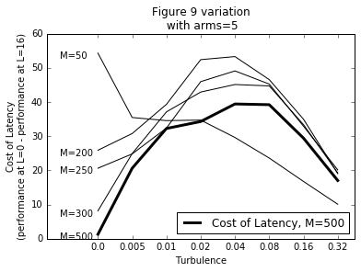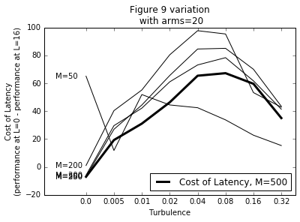
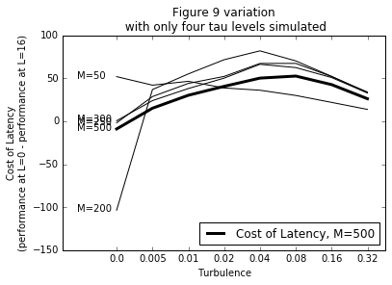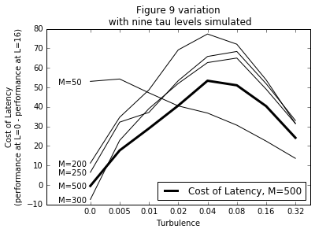
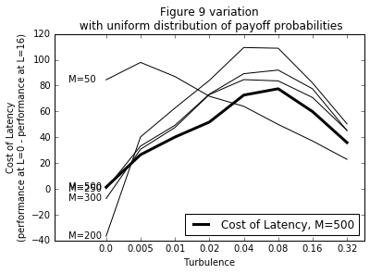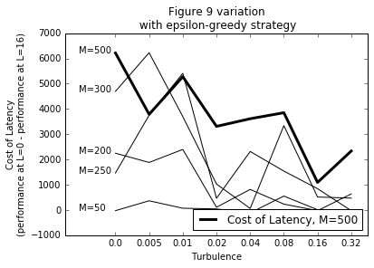

One lesson learned from this exercise is that when we simulate a decision maker with an ε-greedy strategy (instead of the softmax strategy), simulation results are extreme and probably unreliable. We believe that the reference model’s algorithm for finding the optimal strategy (τ or ε) doesn’t work well with this model, turning up extreme values of ε that make little sense. Future researchers who wish to study ε-greedy strategies in depth are advised that they may need to discover how to improve the program. Nevertheless, some of our findings were found robust even to this variation on the model.
Overall, we conclude that our findings are robust to numerous variations in simulation parameters. Due to the complexity of the simulation program, there are undoubtedly extreme parameters that could be used to “break” the program. Finding such limits is not really the purpose of robustness checks; rather, we wish to show that our findings are not themselves outliers or accidents dependent upon arbitrary parameter values.

4. Conclusion
Isik, Jones, and Sidorova (2013) have called for research to relate the affordances of business intelligence technologies to the types of decision environments in which they are most effectively used (Isik, Jones, & Sidorova, 2013). We hoped to answer this call by investigating how the value of real-time business intelligence (RTBI), construed as any BI/analytics technology that reduces the latency between a business event occurring and an organization responding to it, is moderated by environmental turbulence. Additionally, as suggested by the theory of dynamic capabilities, we sought to test whether an organizational forgetting capability was necessary for, or complementary to, the benefits of RTBI. We extended a formal model from organizational learning theory, the canonical multi-armed bandit, and carried out a series of simulation experiments to test our hypotheses.
We confirmed our first hypothesis (H1), that decision making performance in turbulent environments increases as latency approaches zero, but perhaps our most surprising and important new finding is that the value of real-time BI (which may also be called the cost of latency) varies nonlinearly with turbulence, contradicting our second hypothesis (H2) which predicted a simple positive correlation. We discovered that at moderate levels of turbulence, a shorter action distance confers a markedly greater advantage to a decision maker than it does in mostly-stable environments or highly turbulent environments. We conjecture that in stable environments, there is little penalty to using “old” knowledge, and at the other extreme, change is so rapid that knowledge becomes stale before it can be exploited (Posen & Levinthal, 2012; Selsky, Goes, & Baburoglu, 2007).
The second main thrust of this study was to investigate what (de Holan et al, 2004) calls “organizational forgetting”. Prior research has rarely made explicit the notion that old knowledge must be discounted or discarded in order for new knowledge and innovation to take root (Hermann et al, 2007). Modeling this capability as a time window of memory, we demonstrated that a moderate rate of organizational forgetting, neither too fast or too slow, gives our simulated decision-maker his best performance in turbulent environments, confirming our third hypothesis (H3). Furthermore, we confirmed our fourth hypothesis (H4) that there is a complementarity between real-time business intelligence and an organizational forgetting capability: RTBI becomes more valuable, in any turbulent environment, when organizational forgetting is practiced.
The implications for practice are that real-time business intelligence capabilities, enabled by the Internet of Things, data stream analytics, artificial intelligence, complex event processing, etc., are not equally valuable in all decision environments (Isik et al, 2013). Because these technologies are not implemented without significant challenges and costs in money, time, risk, and attention, businesses may use this research as a guide to determine which types of problems and solutions are the best candidates for such investment. Our findings indicate that it is not as simple as saying that the more turbulent the problem space, the more value one will get from real-time data. Instead, RTBI is best applied in situations where change is rapid enough to warrant the expense of real-time information, but not so disruptive and unpredictable that learning from experience cannot be exploited for profit or advantage.
In less turbulent environments, businesses may choose to accept more latency in their business intelligence in exchange for greater accuracy or more sophisticated analysis (Davenport & Snabe, 2011). Townsend et al (2017) suggest that an organization’s need for real-time data may depend on its industry’s “clockspeed”, and Fink et al (2017) argue that the business value of BI assets is contingent on their compatibility with an organization’s learning routines; if they are right, RTBI technologies may generate more or fresher data but this does not necessarily mean the organization needs or can benefit from it.
In faster-changing environments up to a point, real-time information can be vital to successful decision making, as observed by Eisenhardt (1989) in the early microcomputer industry. Some researchers have begun to distinguish between dynamic capabilities and a new type of capability called improvisational (Pavlou & El Sawy, 2010) or adaptive capabilities (Day, 2011). The difference according to Pavlou and El Sawy is that dynamic capabilities (like strategic planning and new product development) are systematic and planned activities by which a firm regularly modifies its capabilities at pace with environmental change, whereas improvisational capabilities are the skills that an organization needs to pivot when needed to respond to unpredictable change and unknown unknowns. Eisenhardt (1989) observed that real-time information is more likely to be unfiltered operational information rather than analysis and forecasts. Park et al (2017) too found that communication technologies, with their ability to deliver diverse and unfiltered information in near real-time, become a more important part of the IT mix in fast, unpredictable environments, as compared to traditional BI systems that deliver more structured information. Our findings bolster the argument that real-time information systems are more important in certain types of environments than others.
When operating in extreme turbulence, though, “far from equilibrium”, some other approach may need to be taken (Emery & Trist, 1965; Meyer, Gaba, & Colwell, 2005). Organizations may choose strategies that optimize for robustness and antifragility (Taleb, 2012) instead of attempting to adapt to environmental volatility. Alternatively, organizations may pursue industry-level systems strategies to “tame” the (hyper) turbulence in their environments (Emery & Trist, 1965; Selsky, Goes, & Baburoglu, 2007).

4.1. Opportunities for Further Research
Simulation studies produce if/then knowledge: if decision-making in turbulent environments works the way we have modeled it, then the results predict what will happen in the real world (all else being equal). Thus, the strength of this research is its internal validity: the cold logic of the computer comes up with the right results based on its premises, but cannot tell us if the model is correct. Therefore, the natural follow-up to this research is to confirm whether the same phenomena can be observed empirically. In particular, studies are needed to confirm whether the surprising nonlinearity in the effect of turbulence on the value of real-time feedback comports to reality.
The simulation model itself extends a successful replication of a multi-armed bandit model previously used in peer-reviewed research, and this helps us establish that the outcomes of our experiments are due to our experimental treatments rather than to software bugs or an idiosyncratic model. A validated simulation is a powerful laboratory for controlled experimentation with additional assumptions. For example, further research may build on our findings by simulating different types of environmental dynamism. Recent simulation studies by other authors have proposed ways to model and manipulate other aspects of environmental dynamism such as velocity, complexity, ambiguity, and (un)predictability (Davis et al, 2009), and direction, magnitude, and frequency of change (Stieglitz et al, 2015). Extensions to our work might adapt those ideas to our multi-armed bandit, and experimentation with those dynamics may allow us to better contextualize the value of real-time business intelligence.
Bandit models may evaluate the decision maker’s performance in different ways, such as the probability of making the “correct” choice at some arbitrary n^{th} turn, or the match between the decision maker’s beliefs and the true payoff probabilities in the environment (Puranam et al, 2015). Some bandit models instead use a natural selection metaphor and evaluate decision maker performance in terms of survival rates over time (e.g. Stieglitz et al, 2016) rather than cumulative performance.
Memory management and organizational forgetting have not yet received enough attention in organizational simulation research, so there is a real opportunity to develop different and more sophisticated ways to plausibly model how it may occur in real life. Instead of a time window of memory, for example, a bandit model could use an exponential recency-weighted average to discount older experiences and simulate a bias toward fresher evidence (Puranam et al, 2015). Another possibility is an extension to the Posen & Levinthal model tested by LiCalzi and Marchiori (2014) that adds a two-stage “refresh” process in which the decision maker periodically tries to decide if a shock has occurred, and if so, discards some of its older experiences and resets its beliefs about some not-recently-tried options to ½.
Increasingly, we find variations on the canonical multi-armed bandit model in the literature that not only alter definitions and algorithms, but change the model’s assumptions in fundamental ways. Each such variation makes a claim to be a more plausible representation of real-world adaptive learning, in some domain. The contextual-bandit model is one such variation. In it, the unknown payoff distributions of the decision maker’s options are correlated with observable features of the context, rather than changing over time due to invisible shocks. This proves to be a feature of many real-world decisions such as the automated recommendation of news articles or advertisements to website users, when known facts about user profiles or activity are assumed to correlate with the unknown propensity of a particular ad to interest the user (Li et al, 2010). Because our simulation relies on the more traditional bandit model, the applicability of its findings may be limited to scenarios that resemble the model’s assumptions of intermittent disruptive change—such as budgeting and investment decisions in which the firm must decide which projects to fund in a complex, hence unpredictable environment. Each such variation, like the contextual bandit, may be viewed as another opportunity to corroborate our findings or extend our research to other types of decisions.
There is an important role for empirical research to complement simulation research by determining whether the bandit model’s assumptions are realistic, and in which domains they hold true. Empirical work also identifies other potentially important variables that may be left out of the simulation; for example, Park et al (2017) show that organization size and top management team (TMT) energy are interrelated with the value of BI and communication technologies in turbulent environments. The meaningfulness of simulation results depends on the degree to which the assumptions of the formal model match the real, empirical world, so each variation on the basic model may teach us something new about a different type of real-world decision making.

5. References
S.L. Brown and K.M. Eisenhardt, “The art of continuous change: Linking complexity theory and time-paced evolution in relentlessly shifting organizations”, Administrative Science Quarterly 42, 1997, pp. 276-304.
K.M. Carley, “Computational Approaches to Sociological Theorizing”, in J.H. Turner (ed.), Handbook of Sociological Theory (pp. 69-83), Kluwer Academic/Plenum Publishers, New York, 2002.
S.A. Carlsson, O.A. El Sawy, “Managing the five tensions of IT-enabled decision support in turbulent and high-velocity environments”, Information Systems and eBusiness Management 6.3, 2008, pp. 225-237.
S. Chaudhuri, U. Dyal, and V. Narasayya, “An Overview of Business Intelligence Technology”, Communications of the ACM 54(8), 2011, pp. 88-98.
H. Chen, R.H.L. Chiang, and V.C. Storey, “Business Intelligence and Anlytics: From Big Data to Big Impact”, MIS Quarterly 36(4), 2012, pp. 1165-1188.
J.W. Clark, O.A. El Sawy, “Business Intelligence at Guthy-Renker: The Promise and Challenges of Sensing the Pulse”, SIGDSS/TUN BI Congress II, St. Louis, 2010.
T.H. Davenport & J.H. Snabe, “How Fast and Flexible Do You Want Your Information, Really?”, MIT Sloan Management Review 52(3), pp. 57-62.
J.P. Davis, K.M. Eisenhardt, and C.B. Bingham, “Developing Theory Through Simulation Methods”, The Academy of Management Review 32(2), 2007, pp. 480-499.
J.P. Davis, K.M. Eisenhardt, and C.B. Bingham, “Optimal Structure, Market Dynamism, and the Strategy of Simple Rules”, Administrative Science Quarterly 54(3), 2009, pp. 413-452.
J.S. Denford, “Building knowledge: developing a knowledge-based dynamic capabilities typology”, Journal of Knowledge Management 17(2), 2013, pp. 175-194.
J. Denrell and J. G. March, “Adaptation as Information Restriction: The Hot Stove Effect”, Organization Science 12(5), 2001, pp. 523-538.
K.M. Eisenhardt, “Making Fast Strategic Deicisions in High-Velocity Environments”, The Academy of Management Journal 32(3), 1989, pp. 453-576.
K.M. Eisenhardt and J.A. Martin, “Dynamic capabilities: what are they?”, Strategic Management Journal 21(10/11), 2000, pp. 1105-1121.
F.E. Emery and E.L. Trist, “The Causal Texture of Organizational Environments”, Human Relations 18(1), 1965, pp. 21-32.
L. Fink, N. Yogev, and A. Even, “Business intelligence and organizational learning: An empirical investigation of value creation processes”, Information & Management 54, 2017, pp. 38-56.
R. Hackathorn, “Real-Time to Real-Value”, DM Review 14(1), 2004.
S. Hanov, “20 lines of code that will beat A/B testing every time”, Steve Hanov’s Blog, 2012, http://stevehanov.ca/blog/index.php?id=132.
(HBR) Harvard Business Review Analytic Services, “Making the Real-Time Enterprise a Reality” [TDWI white paper], 2015, http://tdwi.org/whitepapers/2015/03/making-the-real-time-enterprise-a-reality.
A. Hermann, O. Gassmann, and U. Eisert, “An empirical study of the antecedents for radical product innovation and capabilities for transformation”, Journal of Engineering and Technology Management 24, 2007, pp. 92-120.
P.M. de Holan, N. Phillips, and T.B. Lawrence, “Managing Organizational Forgetting”, MIT Sloan Management Review 45(2), 2004.
R. Houghton, O.A. El Sawy, P. Gray, C. Donegan, and A. Joshi, “Vigilant Information Systems for Managing Enterprises in Dynamic Supply Chains: Real-Time Dashboards at Western Digital”, MIS Quarterly Executive 3(1), 2004, pp. 19-35.
O. Isik, M.C. Jones, and A. Sidorova, “Business intelligence success: The roles of BI capabilities and decision environments”, Information & Management 50, 2013, pp. 13-23.
M. Kohtamäki and D. Farmer, “Strategic Agility—Integrating Business Intelligence with Strategy”, in M. Kohtamäki, Real-time Strategy and Business Intelligence: Digitizing Practices and Systems (pp.1 11-36), Palgrave Macmillan, 2017.
O.K. Lee, V. Sambamurthy, K.H. Lim, and K.K. Wei, “How Does IT Ambidexterity Impact Organizational Agility?”, Information Systems Research 26(2), 2015, pp. 398-417.
D.A. Levinthal and J.G. March, “The Myopia of Learning”, Strategic Management Journal 14, 1993, pp. 95-112.
L. Li, W. Chu, J. Langford, & R.E. Schapire, “A contextual-bandit approach to personalized news article recommendation”, Proceedings of the 19th international conference on World wide web, 2010, pp. 661-670.
M. LiCalzi & D. Marchiori, “Pack Light on the Move: Exploitation and Exploration in a Dynamic Environment”, in S. Leitner & F. Wall (eds.), Artificial Economics and Self Organization (pp. 205-216), Springer International Publishing, 2014.
J.G. March, “Exploration and exploitation in organizational learning”, Organization Science 2(1), 1991, pp. 71-87.
J.G. March, “Learning to Be Risk Averse”, Psychological Review 103(2), 1996, pp. 309-319.
A.D. Meyer, V. Gaba, and K.A. Colwell, “Organizing Far from Equilibrium: Nonlinear Change in Organizational Fields”, Organization Science 16(5), 2005, pp. 456-473.
M. Nadj and C. Schieder, “Quo Vadis Real-Time Business Intelligence? A Descriptive Literature Review and Future Directions”, ECIS 2016 Proceedings, 2016.
D. E. O’Leary, “Supporting decisions in real-time enterprises: autonomic supply chain systems”, Information Systems and e-Business Management 6(3), 2008, pp. 239-255.
Y. Park and O.A. El Sawy, “Discovering the Multifaceted Roles of Information Technology with a Holistic Configurational Theory Approach”, Proceedings of HICSS, 2012.
Y. Park, O.A. El Sawy, and P.C. Fiss, “The Role of Business Intelligence and Communication Technologies in Organizational Agility: A Configurational Approach”, Journal of the Association for Information Systems 18(9), 2017.
P.A. Pavlou, O.A. El Sawy, “From IT Leveraging Competence to Competitive Advantage in Turbulent Environments: The Case of New Product Development”, Information Systems Research 17(3), 2006, pp. 198-227.
P.A. Pavlou, O.A. El Sawy, “The ‘Third Hand’: IT-Enabled Competitive Advantage in Turbulence Through Improvisational Capabilities”, Information Systems Research 21(3), 2010, pp. 443-471.
P.A. Pavlou, O.A. El Sawy, “Understanding the Elusive Black Box of Dynamic Capabilities”, Decision Sciences 42(1), 2011, pp. 239-273.
H.E. Posen and D.A. Levinthal, “Chasing a Moving Target: Exploitation and Exploration in Dynamic Environments”, Management Science 58(3), 2012, pp. 587-601.
P. Puranam, N. Stieglitz, M. Osman, & M.M. Pillutla, “Modelling Bounded Rationality in Organizations: Progress and Prospects”, The Academy of Management Annals 9(1), 2015, pp. 337-392.
M. Rivera, “Real-Time Business Intelligence in the Real World”, TDWI, February 3, 2015, http://tdwi.org/articles/ 2015/02/03/real-time-bi-real-world.aspx.
V. Sambamurthy, A.S. Bharadwaj, and V. Grover, “Shaping agility through digitial options: Reconceptualizing the role of IT in contemporary organizations”, MIS Quarterly 27(2), 2003, pp. 237-263.
J.W. Selsky, J. Goes, and O.N. Baburoglu, “Contrasting Perspectives of Strategy Making: Applications in ‘Hyper’ Environments”, Organization Studies 28(1), 2007, pp. 71-94.
N. Stieglitz, T. Knudsen, & M.C. Becker, “Adaptation and Inertia in Dynamic Environments”, Strategic Management Journal 37, 2016, pp. 1854-1864.
D. Stodder, “Chasing the Real-Time BI Dream”, TDWI, Oct. 21, 2014, http://www4.tdwi.org/TDWI/TDWI-Staging/ Articles/2014/10/21/Chasing-Real-Time-BI-Dream.aspx.
N. N. Taleb, Antifragile, Penguin Books, London, 2012.
D.J. Teece, G. Pisano, and A. Shuen, “Dynamic capabilities and strategic management”, Strategic Management Journal 18(7), 1997, pp. 509-533.
M. Townsend, T.L. Quoc, G. Kapoor, H. Hu, W. Zhou, and S. Piramuthu, “Real-Time business data acquisition: How frequent is frequent enough?”, Information & Management, forthcoming (2017).
H.J. Watson and B.H. Wixom, “The Current State of Business Intelligence”, Computer 40(9), 2007, pp. 96-99.
J.M. Whyte, Bandit Algorithms for Website Optimization, O’Reilly Media, Sebastopol, CA, 2013.
M. Zollo and S.G. Winter, “Deliberate learning and the evolution of dynamic capabilities”, Organization Science 13(3), 2002, pp. 339-351.
L. Zliobaite, A. Bifet, M. Gaber, B. Gabrys, J. Gama, L. Minku and K. Musial, “Next challenges for adaptive learning systems”, ACCM SIGKDD Explorations Newsletter 14(1), 2012, pp. 48-55.

Posen and Levinthal (2012) used 25,000 replications.
Two additional trials with one positive outcome are averaged in with this history. This provides the initial belief and prevents the belief from jumping all the way to 0.0 or 1.0 after the first experience. Instead the first real feedback is “averaged in” with the prior belief.
Instead of a true zero we used 0.02 to avoid a division-by-zero problem. This is true to the replication of Posen and Levinthal (2012).

