React learning

1. Virtual DOM to change the HTML, 只增減有變的東西
2. 通常由js檔和html檔來實現，透過修改js檔並將內部的JSX(在js內寫html)內容傳給html來改變html DOM結構, js檔內的render內容則為virtual DOM, 裡面的element為react element這些JSX的語法會經由Babel自動編譯成js內容讓網站可以理解

React's goal is in many ways to render HTML in a web page.

React renders HTML to the web page by using a function called ReactDOM.render().

[從文件中擷取絕佳的引文或利用此空間來強調重點，藉此吸引讀者的注意力。若要將此文字方塊放置在頁面的任一位置，請進行拖曳。]

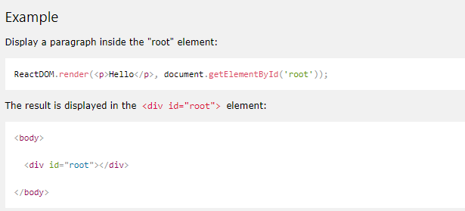

.js

.html

1. 什麼是JSX

JSX allows us to write HTML elements in JavaScript and place them in the DOM without any createElement()  and/or appendChild() methods.

1. With JSX you can write expressions inside curly braces { }.內部可執行JS code

The expression can be a React variable, or property, or any other valid JavaScript expression. JSX will execute the expression and return the result:



1. To write HTML on multiple lines, put the HTML inside parentheses:

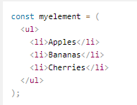

1. The HTML code must be wrapped in ONE top level element. So if you like to write two headers, you must put them inside a parent element, like a div element

如果不想有無意義的<div>可以改成<React.Fragment>

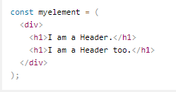

1. JSX follows XML rules, and therefore HTML elements must be properly closed.



1. state和 props之間的差異

props可以在不同component之間share, 另外props為read-only一旦給定attr值後就不能在其他地方改變

state則是分別獨立於各個component, 不受外界所影響

1. update the state: The component that owns a piece of the state, **should be the one modifying it**

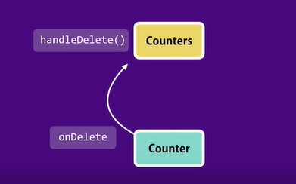

# React Component

Components are independent and reusable bits of code. **They serve the same purpose as JavaScript functions**, but work in isolation and r**eturns HTML via a render function.**

Components come in two types, **Class components** and **Function components,** in this tutorial we will concentrate on Class components.

* class component

class名開頭大寫

extends繼承 React.component’s function

render()method則return HTML

To use this component in your application, use similar syntax as normal HTML: <Car />

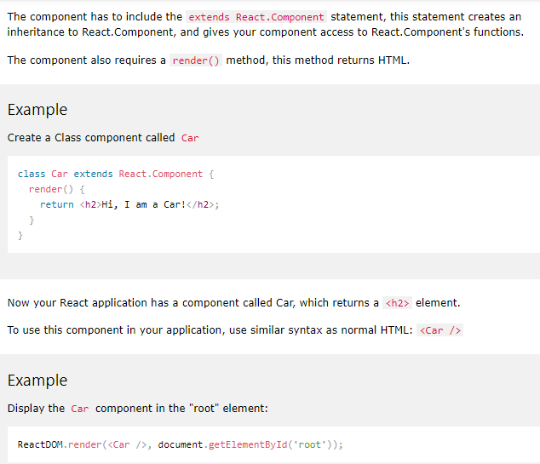

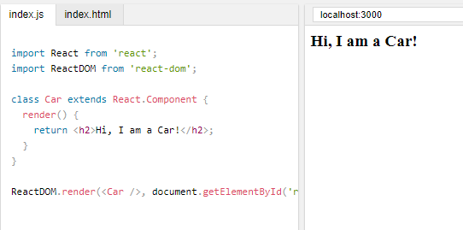

* Function component

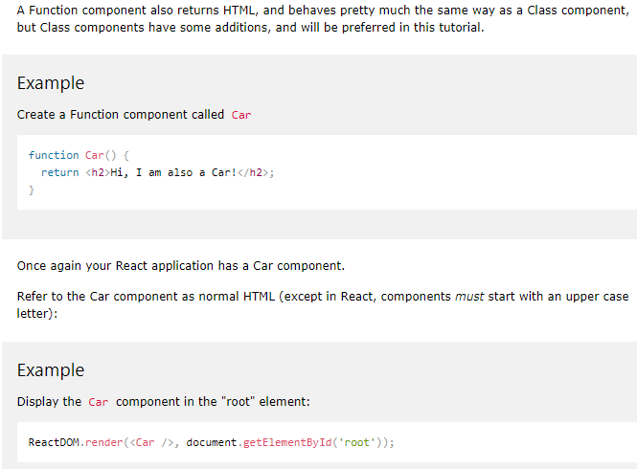

* Component constructor

1. 只被呼叫一次
2. 內部放初始的state(由props obj得到(記得constructor(props)&super(props)才能用props obj)或由super(props)得到parent的constructor function)→感覺constructor用於component間溝通用
3. 不一定要有，有時state可有可無，property皆由props得到或是直接在宣告一個state object

The constructor function is **where you initiate the component's properties**. In React, component properties should be kept in an object called state. the **super() statement, which executes the parent component's constructor function,** and your component has access to all the functions of the parent component (React.Component).

* 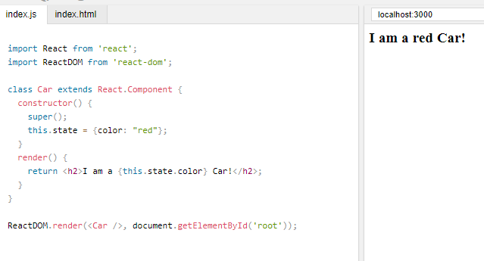Prop

prop為attribute object

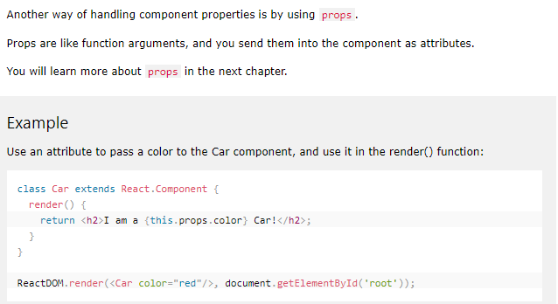

* Component in components
* 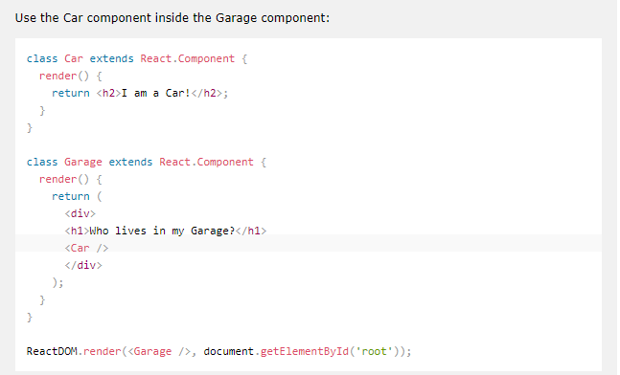
* Components in File(把components存.js檔案 用的時候在import

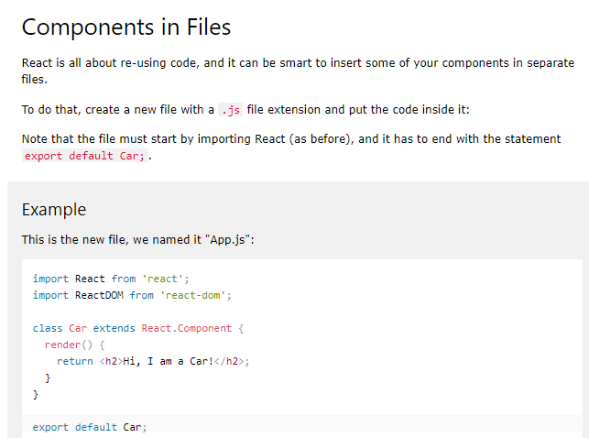

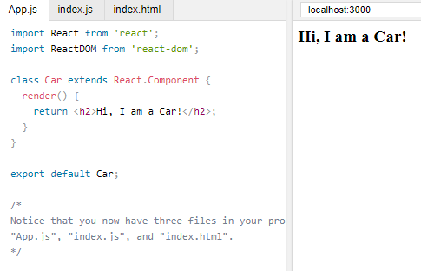

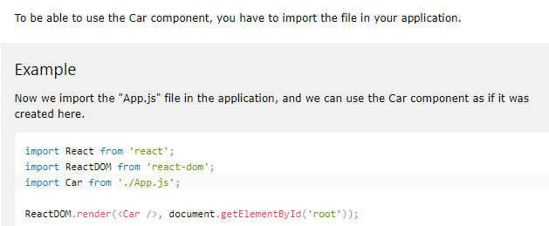

# React Props

**React Props are like function arguments in JavaScrip**t and**attributes in HTML.**

1. 於component內宣告的attr會存在於props(想成富含attr的obj)當中(ex this.props.brand/value/children)

note: key並非props裡面的屬性，主要給react自己辨識用

note: 當在component tag內加其他標籤時，這些標籤會成為children attr並存於props當中

1. props(可用於不同component之間)和state(component內部獨立屬性)的差別，但可以以將state的property assign給props再傳給其他的component
2. 比較容易理解的寫法為(以props為data溝通橋樑)

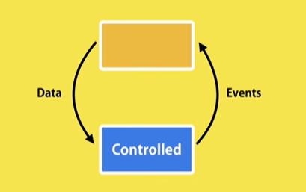

Controlled component

parent component

controlled component內部放local state，所有的data(property)全部由parent component的 props提供。

另外當controlled component有data要update時，則透過raise event的方式(ex this.props.onClick)呼叫parent的function/method去修改其state內部的內容，改完之後再回傳給新data給component

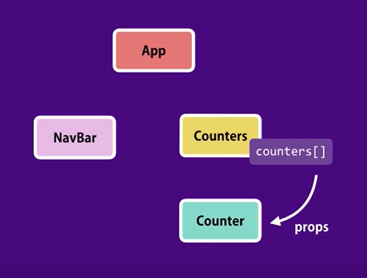

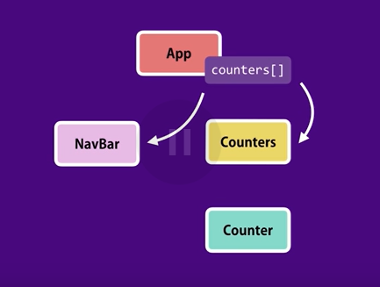

To send props into a component, use the same syntax as HTML attributes:

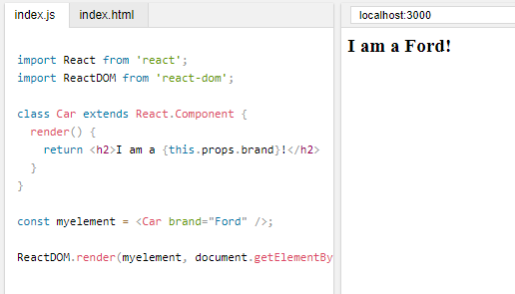

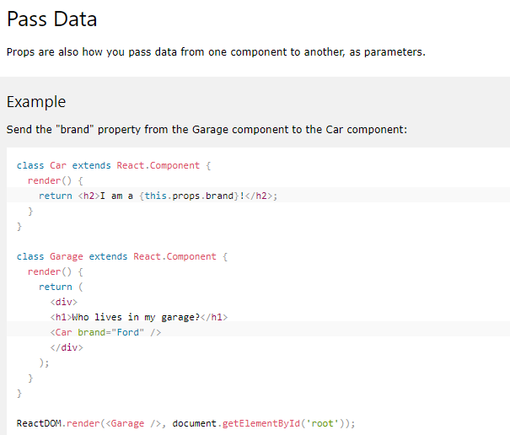

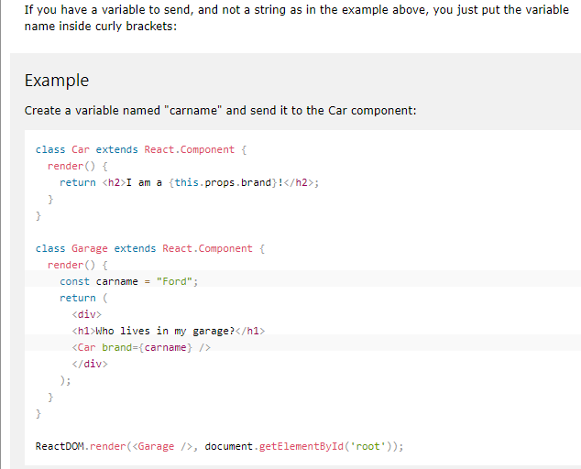

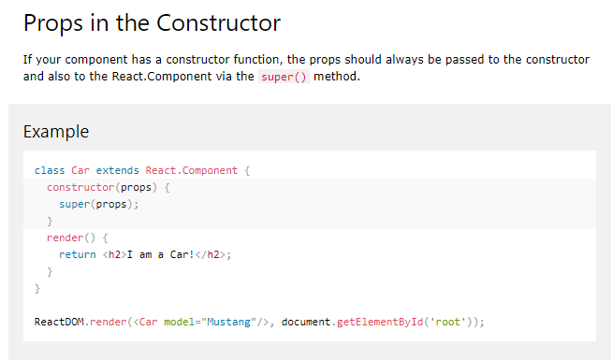

# React State(獨立於每個componenet)

The state object is where you store property values that belongs to the component.

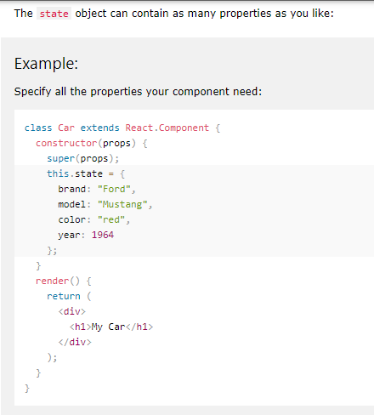

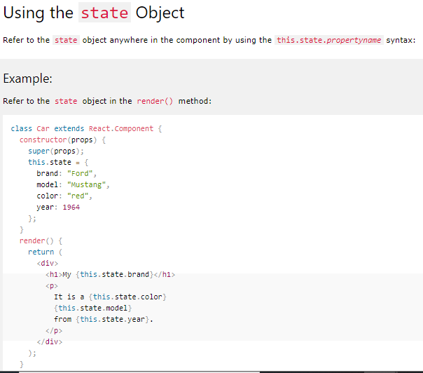

改變state的方式

**change a value in state object**

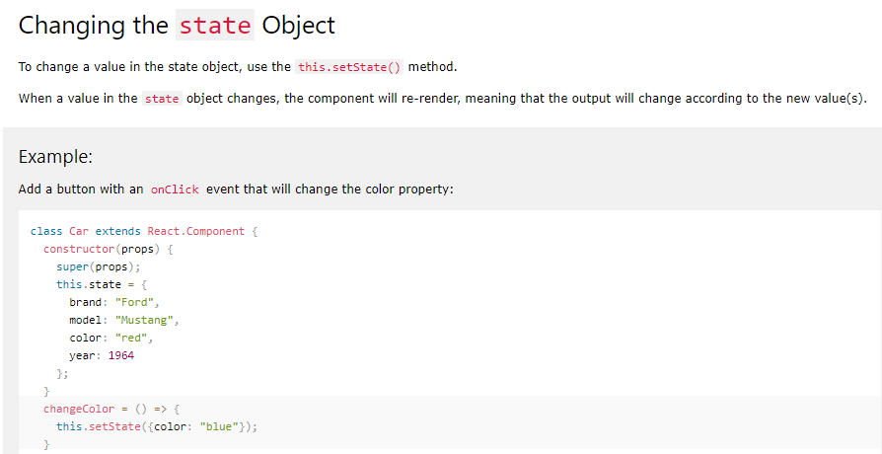

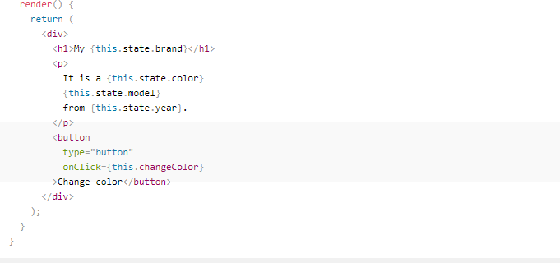

Always use the setState() method to change the state object, it will ensure that the component knows its been updated and calls the render() method (and all the other lifecycle methods).

# React Lifecycle

Each component in React has a lifecycle which you can monitor and manipulate during its three main phases. The three phases are: **Mounting**, **Updating**, and **Unmounting**

每個component有三個cycle不同cycle下有各自的method

當把component input到DOM時(in the DOM)

當component is removed from DOM

當props /state改變時

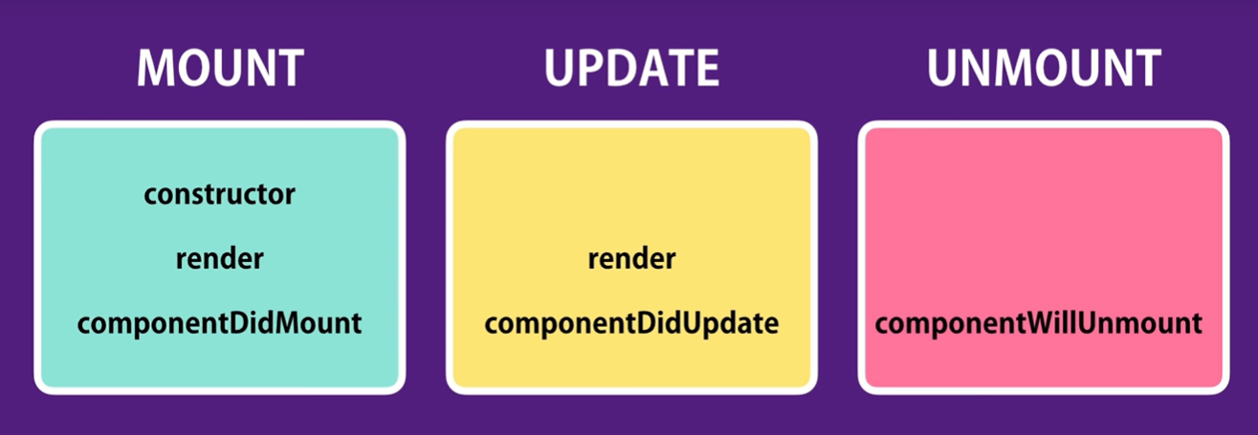.

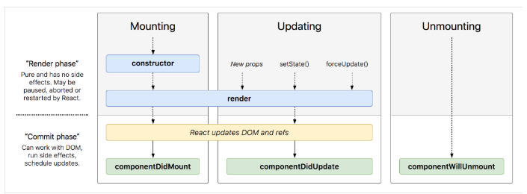

當del 某component from DOM時，執行render update virtual dom，比對new/old virtual dom有什麼差別，找出哪個component被del，之後在component在被真正從DOM移除之前呼叫component willMount做一些備分/清理的動作

render意思為update virtual DOM

當state/props改變時，執行render update virtual dom, 之後再比對old/new virtual Dom哪裡有變，在上傳到DOM,當有任何state/props改變時，則透過componentDidUpdate發出AJAX request to get data from the server.

一開始的初始頁面執行constructor, 之後執行render updating到virtual dom, 之後再比對old/new virtual Dom哪裡有變，在上傳到DOM(這時候執行DidMount)

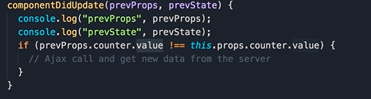

當parent is rendered其child們也會跟著rendered

* Mounting

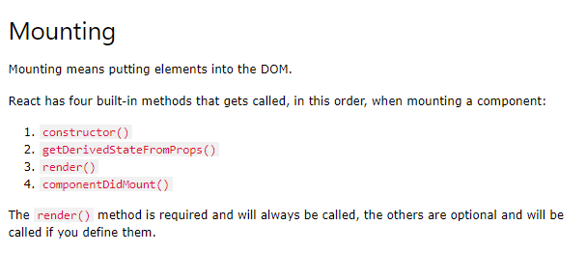

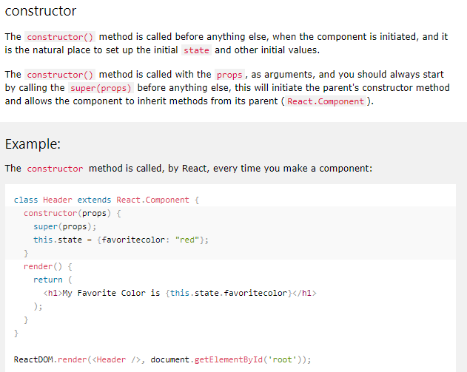

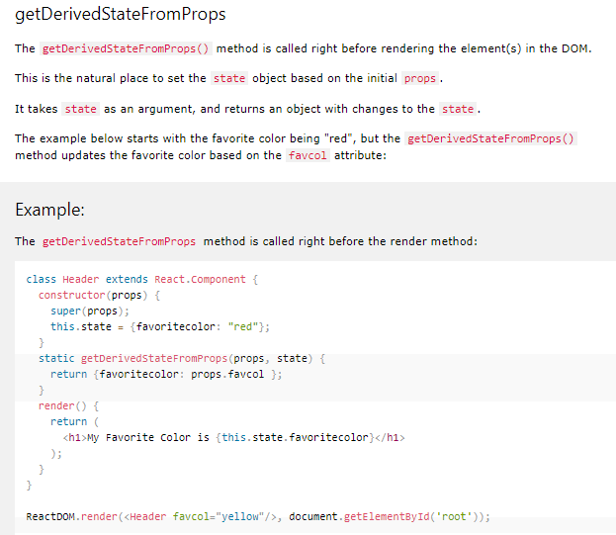

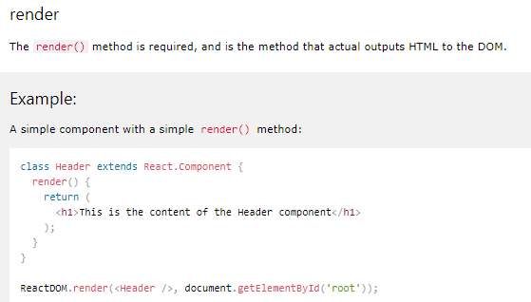

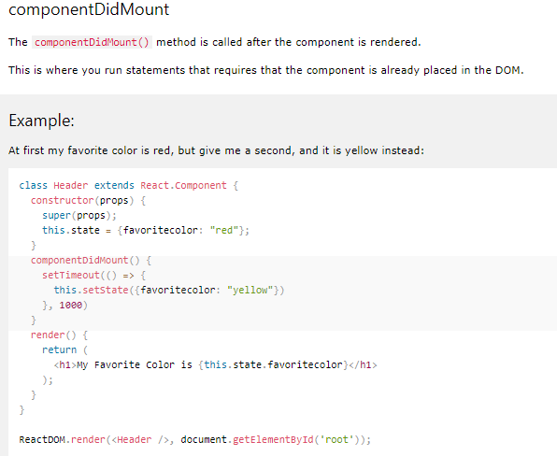

* Updating

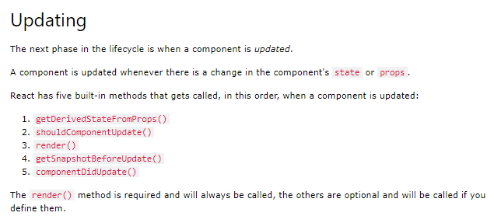

* unmounting

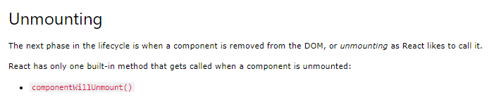

### componentWillUnmount

### The componentWillUnmount method is called when the component is about to be removed from the DOM.

# React Events

Just like HTML, React can perform actions based on user events.

React has the same events as HTML: click, change, mouseover etc.

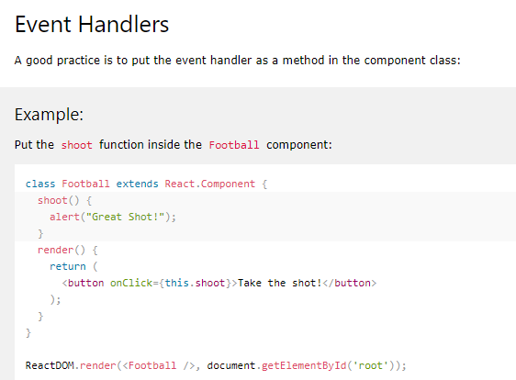

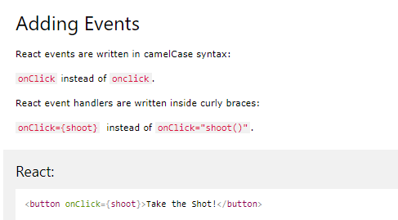

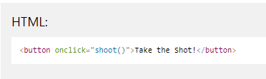

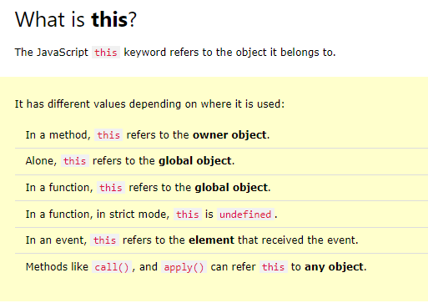

**建議都使用arrow function這樣this就會皆為object component**

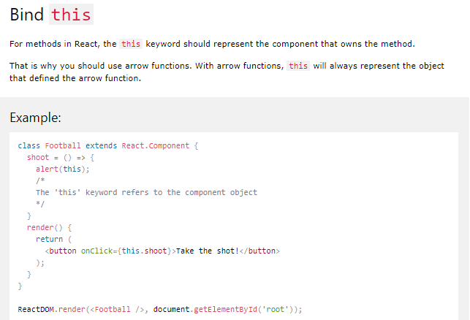

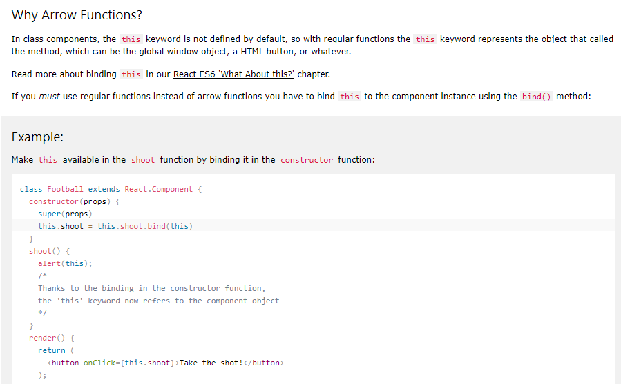

使用第一種方式

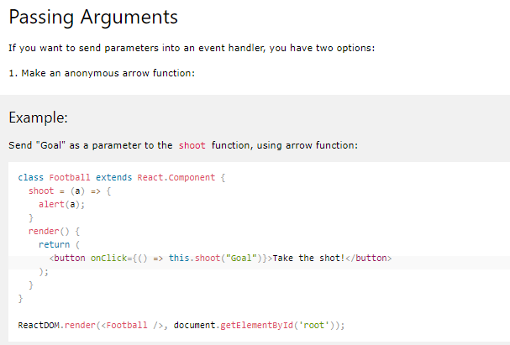

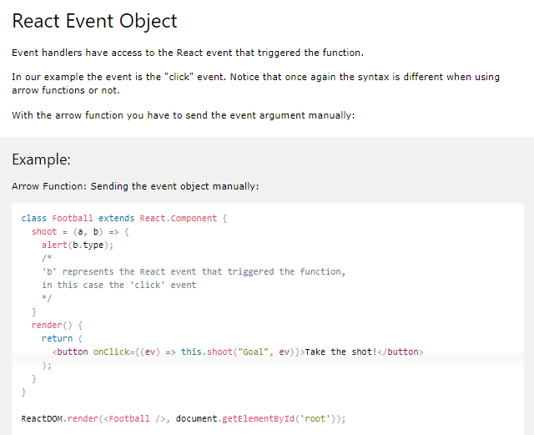 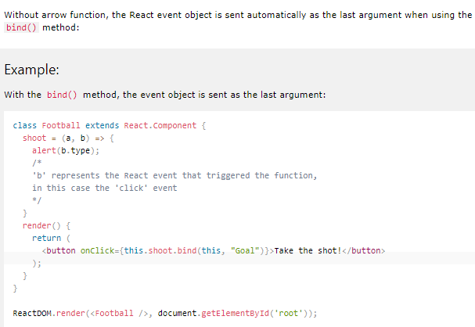

# React forms

Just like in HTML, React uses forms to allow users to interact with the web page.

1. Styling React Using CSS
2. use className來呼叫bootstrap等其他框架，而不是class
3. Inline styling

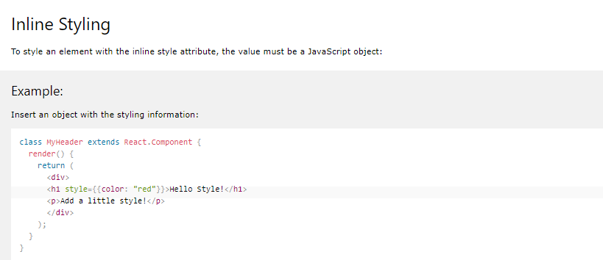

**Note:** In JSX, JavaScript expressions are written inside curly braces, and since JavaScript objects also use curly braces, the styling in the example above is written inside two sets of curly braces {{}}.

Since the inline CSS is written in a JavaScript object, properties with two names, like background-color, must be written **with camel case syntax:**

1. 把css寫成物件

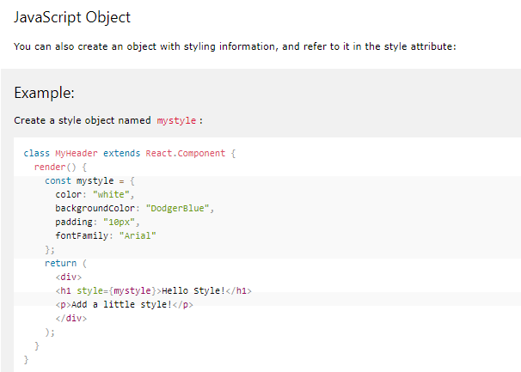

1. external import

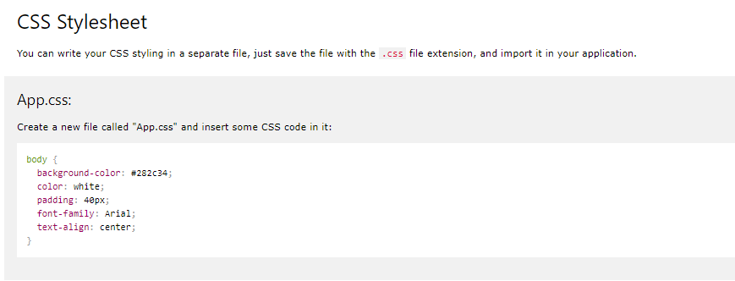

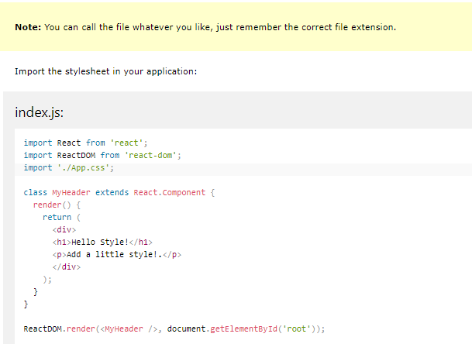

1. css module

