REMOTE INTERFACE CARD FOR LINK RECEIVERS (DRAFT)
A project of the Orange County Repeater Group “and the NORTHEAST CONNECT”

Overview
The remote interface card ( hereinafter referred to as ‘the card’) has been through three revisions. With the addition of multiple link sites, the current revision of the remote interface card is not quick to produce nor remotely controllable. It has been the desire of the trustees to redesign the card with the following goals:

Ease of Construction - PCB Layout and reduced construction time
Ease of Integration - Installed without modificationof existing external circuits.
Ease of Expansion - Hardware Revision lifetime of six months.

Hardware
(To be Completed)

Program Listing (DRAFT)
The following is a fully documented listing of the software used on the BASIC STAMP.

' BASIC STAMP Remote Interface Card
' for Link Receivers
' By Joe Cupano NE2Z
' For the Orange County Repeater Group
' and the NORTHEAST CONNECT
' 23 May, 1995
'
' This progran reads the COS and PL Inputs (COS, PL1, PL2)
' respectively.and keys the transmitter while toggling
' audio.
'
' When COS and PL1, PTT is brought HIGH. TOUT is set for 3 minutes
' When TOUT reaches 0, the repeater has timed out (TIMEDOUT is set HIGH.)
' When this occurs, PTT is brought LOW and COS is looped until there is no
' carrier (COS goes low.)
'
' The COS and PL2 pair are reserved for future use.
'
' *****************************************
'
' DEFINITIONS & VARIABLES
'
' Pin 7 = Output PTT PTT on TX
' Pin 6 = Output AUD Audio Toggle
' Pin 5 = Output Future
' Pin 4 = Output Future
' Pin 3 = Output Future
' Pin 2 = Input PL2 PL (Control Op PL ?)
' Pin 1 = Input PL1 PL
' Pin 0 = Input COS COS
' Bit 0 = timedout TimeOut Timer Flag (1=TimedOut)
‘
' B5 TimeOut Timer Default (These variables will
' remotely set in a future revision.)
' B6 Hangtime Default (These variables will be
' remotely set in a future revision.).
'
' tout = TimeOut timer count
' hangtime = Hang timer
'
symbol PTT = pin7
symbol AUD = pin6
symbol PL2 = pin2
symbol PL1 = pin1
symbol COS = pin0
symbol TOUT = b2
symbol HANGTIME = b3
symbol TIMEDOUT = bit0
'
'
' POWER ON DEFAULTS
'
‘ B5 Set for 180 Seconds (3 Minutes)
B5 = 36000
‘ B6 set for 2 Seconds
B6 = 600
dirs = %11111000
'
' PTT Off
low 7
' Audio Off
low 6
' Reset Hang Timer (VALUE IS SECONDS)
HANGTIME = B6
' Reset TimeOut timer (VALUE IS SECONDS)
TOUT = B5
' Reset Time Out Toggle
TIMEDOUT = 0
'
'
MAIN:
if TIMEDOUT=1 then DOWNIT
if PL2=1 AND COS=1 then INCMD
if PL1=1 AND COS=1 then INCOMING
AUD = 0
TOUT = B5
HANGTIME = HANGTIME - 1
if HANGTIME > 0 then MAIN
PTT =0
HANGTIME = B6
GOTO MAIN
DOWNIT:
PTT = 0
AUD = 0
TOUT = B5
TIMEDOUT = 0

COSOFF:
IF COS=1 THEN COSOFF
GOTO MAIN

INCMD:
'
' THIS MIGHT BE A COMMAND PL FOR
' IMPLEMENTING REMOTE CONTROL
'
INCOMING:
HANGTIME = B6
PTT = 1
AUD = 1
TOUT = TOUT - 1
IF TOUT>0 THEN MAIN
TIMEDOUT=1
GOTO MAIN
'
END

Program (Raw)
The following is raw code for direct input to a STAMP.

symbol PTT = pin7
symbol AUD = pin6
symbol PL2 = pin2
symbol PL1 = pin1
symbol COS = pin0
symbol TOUT = b2
symbol HANGTIME = b3
symbol TIMEDOUT = bit0
B5 = 36000
B6 = 600
dirs = %11111000
low 7
low 6
HANGTIME = B6
TOUT = B5
TIMEDOUT = 0
MAIN:
if TIMEDOUT=1 then DOWNIT
if PL2=1 AND COS=1 then INCMD
if PL1=1 AND COS=1 then INCOMING
AUD = 0
TOUT = B5
HANGTIME = HANGTIME - 1
if HANGTIME > 0 then MAIN
PTT =0
HANGTIME = B6
GOTO MAIN
DOWNIT:
PTT = 0
AUD = 0
TOUT = B5
TIMEDOUT = 0
COSOFF:
IF COS=1 THEN COSOFF
GOTO MAIN
INCMD:
INCOMING:
HANGTIME = B6
PTT = 1
AUD = 1
TOUT = TOUT - 1
IF TOUT>0 THEN MAIN
TIMEDOUT=1
GOTO MAIN
END

Program Flowchart

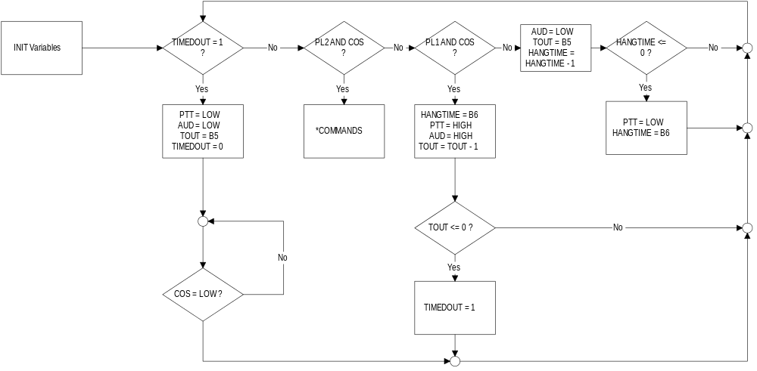

* Commands - For future use.

