HatRock: Audiovisual Tactile Table (AVTT)

Joe Daly, Marco Gomez-Wong, Lucas Abelanet, Kyle Dalton

**Abstract**

With the advancement of touchscreen technology and the increasing prevalence of touch-based and “smart” technology, everyday objects have the potential to take on additional functionality. Our project explores a cost-effective way of bringing the functionality of a drum kit and light controller into a tabletop surface. Much like a traditional “analog” drum kit, our audiovisual tactile table (AVTT) uses the vibrations caused by the impact of a drum stick or user’s finger or fist to create sound. However, unlike a traditional kit which amplifies the vibrations inside the hollow body of the drums, the AVTT uses an array of vibration sensors built into a single surface to detect the hit of a drum stick or finger, and an embedded computer, such as the NI myRIO, to detect variation in the time that the vibration takes to register on each sensor. Using the variation in time to triangulate the location where the user hit the surface, and associating a stored sound file to each location, the single drumming surface can be broken up into individual sounding drum pads, much like how a single touch screen can have many digital keys or icons. In addition, a matrix of LEDs built into the surface will light up in accordance with where and how hard the the surface is hit. By running frequency analysis on the output signal, we will create a visualization of the spectrum using a matrix of LEDs or a LCD. The end result is an audio visualizer built into an everyday surface that allows the user to create a wide array of entertaining sound-light combinations with more possible sounds than a traditional drum kit and a mere fraction of the space. By changing the sound files associated with each location on the drum surface, and by varying the rhythms played by the user, each performance has the potential to be unique.

## Background

We have been experimenting with signal analysis since our first electrical engineering classes and wanted our Capstone project to be a culmination of previous projects. When brainstorming, our group’s ideas kept coming back to sound or music, detecting vibration, and frequency analysis. We therefore decided to see how complex it would be to make an ordinary surface (ie: plexiglass) react like a touchscreen using vibrations instead of capacitive sensing. In addition, we wanted to have some exciting features and therefore decided to add an audiovisual component to our project. Beyond the proof of concept that it is possible to make an innovative tactile surface, our device will also have an interactive fun factor.

We were unable to find any existing devices that match our project, making our device truly innovative. Furthermore we were able to gage that table touchscreens are very expensive ($2000-$10000) and the price estimate for our device is less than $100. Compared to existing touch technology, our project would be drastically cheaper.

A lot of our coursework experiences will play a role in this project. We all have experience designing Printed Circuit Boards (PCBs) which will be used in the project. From our Fundamentals 2 course we also have experience using frequency analysis to make LEDs react to sound waves. Finally, we are all accustomed to the use of microcontrollers, either the MSP430 or the myRIO in managing I/O devices. This project will truly be the climax of our electrical engineering curriculum.

## Description of Project

The core of this project is to design a tactile tabletop that interfaces with a light display that is fueled by user input and a frequency analysis of the output signal such as a Fast Fourier Transform (FFT). A tabletop surface will be converted into a our spin on a MIDI-Board or digital drum kit that will be able to output different sounds based on the location of the surface that is touched. The project will also include multiple arrays of LEDs that will describe many of the outputs. One array of LEDs will be used to visualize how the vibration caused by the user travels through the surface while another will be used to visualize the FFT of the output signal.

The tabletop will work by utilizing piezoelectric film to detect localized vibrations created by the user touching the tabletop surface. The myRIO will act as the embedded computing device that will be used to locate where the surface was hit by the user and to store output short sound bytes for each location. The sound bytes will also be able to be changed or updated via USB allowing different instruments or functionality to be uploaded and changed dynamically.

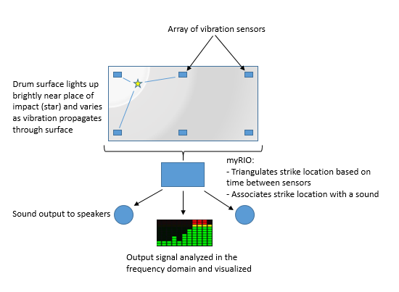

*Block Diagram of the AVTT*

The figure above details how each of the components will interact with each other. The flow of data starts with a user touching on the tabletop surface. The piezoelectric films will pick up different values, and pass that on to the myRIO. The myRIO will use this data to triangulate the location of the user’s touch and then select the appropriate sound. The sound will be simultaneously transmitted to the speakers and the array of LEDs.

There are a few concerns with using this type of technology to interface with the myRIO. One of the more striking problems is processing multiple touches and quick rhythms while being able to perform all of the tasks described. Another problem is having enough computing power to run the FFT, store all of the sounds, and process everything all at the same time. Since music is also being created, the delay from touching the surface and outputting the sound must be extremely small and unnoticeable. If there is a delay, it must also be uniform between each of the locations and sounds.

The lab equipment required for this project is readily available within the ECE labs. Any other tools required to fully deliver this project can be found within the Engineering School. Assorted power tools and hand tools might be required but can easily be found in the labs at the University.

If a 3D Printing route is decided, then CAD tools may be used for the enclosure design. Otherwise, LabView will be used as well as a sound editor or Digital Audio Workstation will be used to select and edit the sound files prior to loading onto the myRIO.

## External Considerations

**Constraints**

The environmental impact of this project derives from using electricity to generate sounds as opposed to using physical, traditional instruments or drums. This goes both ways, since once we have the device built, it is able to produce and digital sounds uploaded to the myRIO instead of having multiple instruments that need to be manufactured in order to be used.

The economic constraints are simple, the piezoelectric sensors are relatively cheap and the LEDs will also be very cheap. The only variable costs that must be considered are the speakers and the tabletop surface that will be used. The speakers will have a small footprint and should not be very costly, and the tabletop surface can be salvaged from scrapwood. This ties into the sustainability factor of being able to use recycled parts or materials for end-of-use disposal.

Part availability will not be a problem since all of the components can be found on multiple different websites.

A safe voltage is generally to be considered anywhere under 48 Volts, and the device will not allow the user to directly interact with voltages above this threshold. Voltages pulled from the wall at 120 V AC will require the device to be appropriately grounded. Sound volume will also be limited to ensure that harmful levels will not be permitted.

Manufacturability will not include very specific tools, all of which are available for use within the engineering school.

The ethical issue associated with this device includes the infringement upon others’ enjoyment of peace and quiet. In order to combat that, the output volumes for this device have be appropriately limited.

### Standards

The main standard that needs to be followed is te NEMA Type 2 standard for non-hazardous enclosures. The NEMA Type 2 Standard is as follows:

*Enclosures constructed for indoor use to provide a degree of protection to personnel against access to hazardous parts; to provide a degree of protection of the equipment inside the enclosure against ingress of solid foreign objects (falling dirt); and to provide a degree of protection with respect to harmful effects on the equipment due to the ingress of water (dripping and light splashing).*[1]

The plan is to allow this device to be used both at leisure and during parties, and therefore the electrical components should not be exposed to liquids from accidental spillage.

## Deliverables

## The group will deliver an interactive surface that detects vibration via piezoelectric sensors and uses an embedded computer to locate where on the surface the vibration originated. To provide appropriate contact with the surface and to increase the stability of the product, the sensors will be directly fixed to the surface. The sensors will the interface with the myRio through a printed circuit board that . Additionally, the group will use a PCB for the circuit associated with the frequency display. This frequency display will be an array of different color LEDs. This PCB will also be interfaced with the myRio microcontroller.

Sound files will be transferred from a computer to the myRio device through a USB. The myRio will also send the sound output through a 3.5mm jack to connected speakers. The myRio, sensors and LED will be powered by the myRio power supply, while the speakers will be powered by their own power supply.

|  |  |
| --- | --- |
| **Item** | **Cost** |
| myRio Student Embedded Device | Provided |
| myRio power supply | Provided |
| 12” x 24” x .125” Plexiglass sheet | $16.66 |
| Piezo Vibration Sensor - Large SEN-09196 x 10 | $29.15 |
| AmazonBasics AC Powered Computer Speakers | $12.98 |
| Graphic Equalizer Display Filter - MSGEQ7 | $4.98 |
| 100 LEDs | $8.00 |
| **TOTAL** | **$66.77** |

## Timeline

Our timeline is structured in such a way that tasks overlap by about a week between the ending of one sub-project and the beginning of the next. This allows us roughly week long test and integration periods so that the pieces of the project comes together procedurally and in a way that allows us to troubleshoot a sub-segment before adding more functionality.

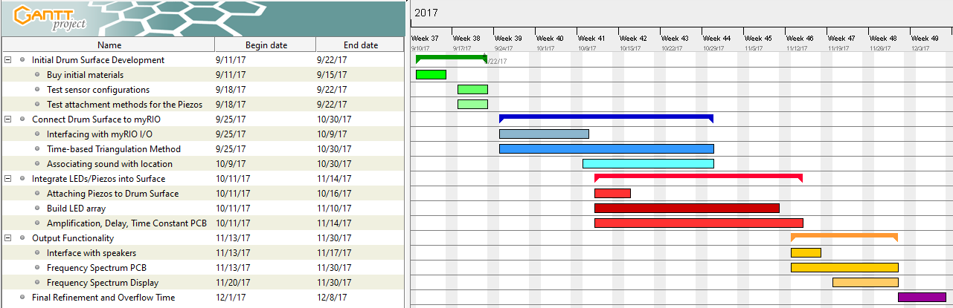

The software tasks are allotted the greatest amount of time to complete. These tasks require us to use the myRIOs I/O ports, detect very small variations in time, store sound files, and output audio. Lucas and Marco will primarily handle Labview and the association of sounds in the embedded computer with each pad. The triangulation and location detection is probably the most complex part of the project and will be a largely collaborative effort. Kyle and Joe have more hardware experience and will primarily work with the design of the PCB that connects the piezo -electric sensors to the myRIO, the circuit board that controls how the LEDs in the board light up, and the frequency analysis circuit.

## Expectations

We expect to deliver a working audiovisualiser built around a plexiglass surface that outputs one of many specific sounds through a set of speakers depending on which areas of the surface the user strikes. LEDS built into the kit will light up corresponding to when, where, and how hard the user strikes the surface. An array of LEDs will visualize the frequency spectrum of the audio output after it passes through the MSGEQ7 chip for analysis.

The table below summarizes the grades we expect to receive for different levels of functionality in the finished project.

|  |  |
| --- | --- |
| Grade | If we do this…. |
| A | Table plays sounds, the surface LEDs operate properly when the corresponding area is hit, and the frequency spectrum display works properly |
| B | No FFT Display |
| C | No Table lights |

## References

[1] *NEMA Enclosure Type 2*, NEMA Standard 250, 2003