IST 652

Joseph Davis

**Project Overview**

The intent of this database was to store the data generated from the tik tok review show *Can it Kirkland?*. The show has a basic premise; the contestants try a Kirkland brand alcoholic drink and its name brand counterpart and try to pick which one is Kirkland. If they guess that the Kirkland brand is the name brand that is a point for Kirkland. If they guess properly then that’s a point against Kirkland. These points determine “can it Kirkland?”. The intent is to use the date, episode, cast, beverage, and reviews of the judges to build an application that will allow users to look up the reviews for a particular kind of drink in Costco and see how it compares to the standard brand.

**Team Log**

All work was done by Joseph Davis April 7th-April 9th.

**Conceptual Model**

As stated earlier the conceptual model will house a few entities. These are the reviews given, the judges, the cast for that episode, the episode itself, and the kind of beverage. A conceptual model has been created and can be seen below.

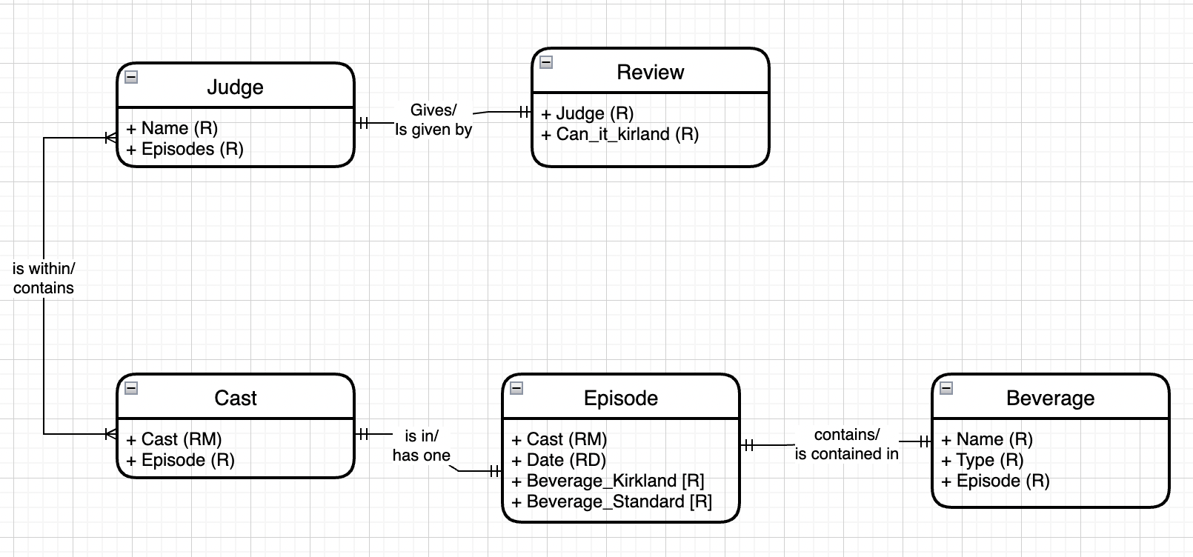

As we can see, the review itself will be given by one judge and one judge only, and a judge can only give one review per drink. The review just consists of guessing which drink is which, if the judges guess correctly more than incorrectly then it cannot Kirkland. The judges include repeats for each episode and sometimes guest judges. Therefore, a judge can be on one or multiple casts for the episode. The cast includes one or many judges. The cast can appear on one and only one episode. There are repeat casts, however each cast will appear on one episode once. The episode will contain one cast only, making this a 1 to 1 relationship. The episode consists of the cast, date, and the beverages. Finally, each episode has one and only one beverage and the beverages are not repeated between episodes so this is also a 1 to 1 relationship.

Next a logical model was created from this conceptual model. This model can be seen below.

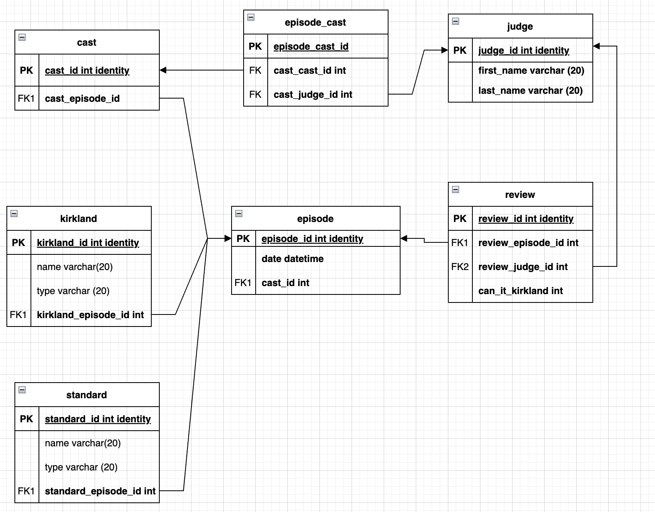

The focal point of this logical model centers around the episode. The episode_id is referenced in many other tables. The tables themselves are very straightforward. The judges will have a table, and that will be referenced in both the reviews and episode_cast. The episode_cast will bridge the cast and judge’s tables. The cast then connects to the episode table. The Kirkland and standard tables will reference the episode table as each episode will have a different drink. Finally, the review table uses the episode_id as a foreign key to connect the episode to the reviews.

**Reflection**

In conclusion the start of a potential database was created. It may have utility for people who regularly shop at Costco and shows different relationships between different entities. I don’t have enough time to put data into the database, create a presentation, or implement the application. Given more time, I would of course like to complete these things as well as a video presentation, however that isn’t feasible. I hope you can at least follow the conceptual beginnings of a future useful application.

**SQL Script**

create database FINAL

GO

alter table standard

drop CONSTRAINT if exists standard_episode

GO

alter table review

drop CONSTRAINT if exists review_judge

GO

alter table review

drop CONSTRAINT if exists review_episode

GO

alter table kirkland

drop CONSTRAINT if exists kirkland_episode

GO

alter table episode_cast

drop CONSTRAINT if exists episode_cast_judge

GO

alter table episode_cast

drop CONSTRAINT if exists episode_cast_cast

GO

alter table cast

drop CONSTRAINT if exists cast_episode

GO

drop table if exists cast

GO

CREATE TABLE cast (

cast_id int NOT NULL,

cast_episode_id int NOT NULL,

CONSTRAINT cast_pk PRIMARY KEY (cast_id)

);

-- Table: episode

drop table if exists episode

GO

CREATE TABLE episode (

episode_id int NOT NULL,

date date NOT NULL,

cast_id int NOT NULL,

CONSTRAINT episode_pk PRIMARY KEY (episode_id)

);

-- Table: episode_cast

drop table if exists episode_cast

GO

CREATE TABLE episode_cast (

episode_cast_id int NOT NULL,

cast_cast_id int NOT NULL,

cast_judge_id int NOT NULL,

CONSTRAINT episode_cast_pk PRIMARY KEY (episode_cast_id)

);

-- Table: judge

drop table if exists judge

GO

CREATE TABLE judge (

judge_id int NOT NULL,

first_name varchar(20) NOT NULL,

last_name varchar(20) NOT NULL,

CONSTRAINT judge_pk PRIMARY KEY (judge_id)

);

-- Table: kirkland

drop table if exists kirkland

GO

CREATE TABLE kirkland (

name varchar(20) NOT NULL,

type varchar(20) NOT NULL,

kirkland_id int NOT NULL,

kirkland_episode_id int NOT NULL,

CONSTRAINT kirkland_pk PRIMARY KEY (kirkland_id)

);

-- Table: review

drop table if exists review

GO

CREATE TABLE review (

review_id int NOT NULL,

can_it_kirkland int NOT NULL,

review_episode_id int NOT NULL,

review_judge_id int NOT NULL,

CONSTRAINT review_pk PRIMARY KEY (review_id)

);

-- Table: standard

drop table if exists standard

GO

CREATE TABLE standard (

name varchar(20) NOT NULL,

type varchar(20) NOT NULL,

standard_episode_id int NOT NULL,

standard_id int NOT NULL,

CONSTRAINT standard_pk PRIMARY KEY (standard_id)

);

-- foreign keys

-- Reference: cast_episode (table: cast)

ALTER TABLE cast ADD CONSTRAINT cast_episode

FOREIGN KEY (cast_episode_id)

REFERENCES episode (episode_id);

-- Reference: episode_cast_cast (table: episode_cast)

ALTER TABLE episode_cast ADD CONSTRAINT episode_cast_cast

FOREIGN KEY (cast_cast_id)

REFERENCES cast (cast_id);

-- Reference: episode_cast_judge (table: episode_cast)

ALTER TABLE episode_cast ADD CONSTRAINT episode_cast_judge

FOREIGN KEY (cast_judge_id)

REFERENCES judge (judge_id);

-- Reference: kirkland_episode (table: kirkland)

ALTER TABLE kirkland ADD CONSTRAINT kirkland_episode

FOREIGN KEY (kirkland_episode_id)

REFERENCES episode (episode_id);

-- Reference: review_episode (table: review)

ALTER TABLE review ADD CONSTRAINT review_episode

FOREIGN KEY (review_episode_id)

REFERENCES episode (episode_id);

-- Reference: review_judge (table: review)

ALTER TABLE review ADD CONSTRAINT review_judge

FOREIGN KEY (review_judge_id)

REFERENCES judge (judge_id);

-- Reference: standard_episode (table: standard)

ALTER TABLE standard ADD CONSTRAINT standard_episode

FOREIGN KEY (standard_episode_id)

REFERENCES episode (episode_id);

-- End of file.