Title Goes Here

Joe DeCesaro2,✉

24 August, 2021

Text of abstract

1 University of California Santa Barbara  
2 UCSB

✉ Correspondence: [Joe DeCesaro <[jdecesaro@bren.ucsb.edu](mailto:jdecesaro@bren.ucsb.edu)>](mailto:jdecesaro@bren.ucsb.edu)

Keywords: keyword 1; keyword 2; keyword 3

Highlights: These are the highlights.

# 1 Introduction

Wow this is so amazing. Below is a Lorem Ipsum to fill the space of a document.

Lorem ipsum dolor sit amet, consectetur adipiscing elit, sed do eiusmod tempor incididunt ut labore et dolore magna aliqua. Hendrerit gravida rutrum quisque non tellus. Pellentesque dignissim enim sit amet venenatis urna cursus. Mi bibendum neque egestas congue quisque egestas diam in. Odio euismod lacinia at quis risus sed. Tempus urna et pharetra pharetra massa massa ultricies. Aliquam vestibulum morbi blandit cursus risus. Nulla malesuada pellentesque elit eget gravida cum. Quis viverra nibh cras pulvinar mattis nunc sed blandit. Aliquam eleifend mi in nulla. Mauris vitae ultricies leo integer malesuada nunc vel.

Here is a citation (Marwick, 2017)

# 2 Background

Et tortor at risus viverra. Nulla facilisi cras fermentum odio eu. Massa sed elementum tempus egestas sed. Odio facilisis mauris sit amet massa vitae. Accumsan in nisl nisi scelerisque eu. Risus in hendrerit gravida rutrum. Vel eros donec ac odio tempor orci dapibus ultrices. Felis donec et odio pellentesque. Purus semper eget duis at tellus at urna. At lectus urna duis convallis convallis tellus id interdum. Tellus id interdum velit laoreet id donec ultrices tincidunt arcu. Sed adipiscing diam donec adipiscing tristique. Lorem ipsum dolor sit amet consectetur adipiscing.

# 3 Methods

Tristique magna sit amet purus gravida quis blandit turpis. Vitae proin sagittis nisl rhoncus mattis. Semper viverra nam libero justo laoreet sit. Enim nec dui nunc mattis enim. Diam donec adipiscing tristique risus nec feugiat in fermentum. Mattis ullamcorper velit sed ullamcorper morbi. Quis risus sed vulputate odio ut enim blandit volutpat maecenas. Lobortis feugiat vivamus at augue eget arcu dictum. Orci phasellus egestas tellus rutrum tellus pellentesque eu tincidunt tortor. Orci nulla pellentesque dignissim enim sit. Id consectetur purus ut faucibus pulvinar elementum. Amet nisl purus in mollis nunc sed id. Lobortis mattis aliquam faucibus purus in massa tempor nec feugiat. Etiam non quam lacus suspendisse faucibus. Egestas integer eget aliquet nibh praesent tristique. Malesuada bibendum arcu vitae elementum.

Sit amet nisl purus in mollis nunc sed id. Sed viverra ipsum nunc aliquet bibendum enim facilisis gravida neque. Tincidunt ornare massa eget egestas purus viverra. Velit dignissim sodales ut eu sem integer vitae justo. Euismod in pellentesque massa placerat. Arcu risus quis varius quam. Sit amet nisl purus in mollis. Sed odio morbi quis commodo. Diam quis enim lobortis scelerisque fermentum dui faucibus in ornare. Integer enim neque volutpat ac tincidunt vitae. Aliquam eleifend mi in nulla posuere sollicitudin aliquam ultrices. Pulvinar mattis nunc sed blandit libero volutpat.

# 4 Results

Et tortor at risus viverra adipiscing at. Purus non enim praesent elementum facilisis leo vel fringilla. Id porta nibh venenatis cras sed felis. Adipiscing tristique risus nec feugiat in. Massa tempor nec feugiat nisl pretium fusce. Sit amet aliquam id diam. Quisque non tellus orci ac auctor augue mauris augue neque. Urna nec tincidunt praesent semper feugiat nibh sed. In nulla posuere sollicitudin aliquam. Risus at ultrices mi tempus imperdiet nulla malesuada. Consequat ac felis donec et odio. Consectetur adipiscing elit duis tristique sollicitudin nibh.

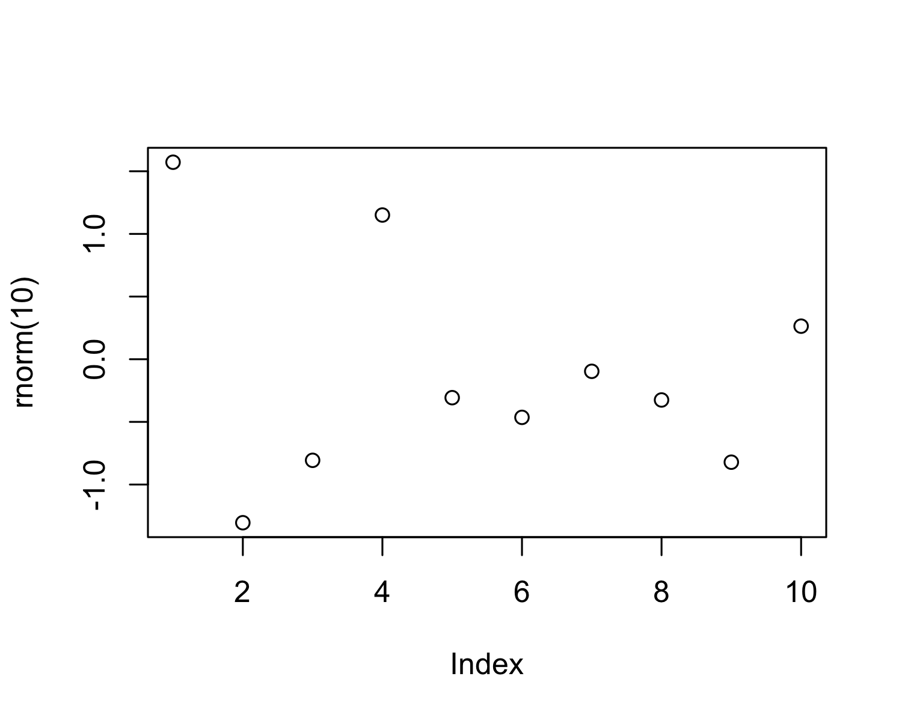

Figure 4.1: A plot of random numbers

Figure 4.1 shows how we can have a caption and cross-reference for a plot

Here is an example of inline code 3.14 in the middle of a sentence.

# 5 Discussion

# 6 Conclusion

# 7 Acknowledgements

# 8 References

Marwick, B., 2017. Computational reproducibility in archaeological research: Basic principles and a case study of their implementation. Journal of Archaeological Method and Theory 24, 424–450. <https://doi.org/10.1007/s10816-015-9272-9>

### 8.0.1 Colophon

This report was generated on 2021-08-24 11:36:34 using the following computational environment and dependencies:

#> ─ Session info ───────────────────────────────────────────────────────────────  
#> setting value   
#> version R version 4.1.0 (2021-05-18)  
#> os macOS Big Sur 11.5.2   
#> system aarch64, darwin20   
#> ui X11   
#> language (EN)   
#> collate en_US.UTF-8   
#> ctype en_US.UTF-8   
#> tz America/Los_Angeles   
#> date 2021-08-24   
#>   
#> ─ Packages ───────────────────────────────────────────────────────────────────  
#> package * version date lib source   
#> bookdown 0.23 2021-08-13 [1] CRAN (R 4.1.0)  
#> cachem 1.0.6 2021-08-19 [1] CRAN (R 4.1.1)  
#> callr 3.7.0 2021-04-20 [1] CRAN (R 4.1.0)  
#> cli 3.0.1 2021-07-17 [1] CRAN (R 4.1.0)  
#> crayon 1.4.1 2021-02-08 [1] CRAN (R 4.1.0)  
#> desc 1.3.0 2021-03-05 [1] CRAN (R 4.1.0)  
#> devtools 2.4.2 2021-06-07 [1] CRAN (R 4.1.0)  
#> digest 0.6.27 2020-10-24 [1] CRAN (R 4.1.0)  
#> ellipsis 0.3.2 2021-04-29 [1] CRAN (R 4.1.0)  
#> evaluate 0.14 2019-05-28 [1] CRAN (R 4.1.0)  
#> fastmap 1.1.0 2021-01-25 [1] CRAN (R 4.1.0)  
#> fs 1.5.0 2020-07-31 [1] CRAN (R 4.1.0)  
#> glue 1.4.2 2020-08-27 [1] CRAN (R 4.1.0)  
#> highr 0.9 2021-04-16 [1] CRAN (R 4.1.0)  
#> htmltools 0.5.1.1 2021-01-22 [1] CRAN (R 4.1.0)  
#> knitr 1.33 2021-04-24 [1] CRAN (R 4.1.0)  
#> lifecycle 1.0.0 2021-02-15 [1] CRAN (R 4.1.0)  
#> magrittr 2.0.1 2020-11-17 [1] CRAN (R 4.1.0)  
#> memoise 2.0.0 2021-01-26 [1] CRAN (R 4.1.0)  
#> pkgbuild 1.2.0 2020-12-15 [1] CRAN (R 4.1.0)  
#> pkgload 1.2.1 2021-04-06 [1] CRAN (R 4.1.0)  
#> prettyunits 1.1.1 2020-01-24 [1] CRAN (R 4.1.0)  
#> processx 3.5.2 2021-04-30 [1] CRAN (R 4.1.0)  
#> ps 1.6.0 2021-02-28 [1] CRAN (R 4.1.0)  
#> purrr 0.3.4 2020-04-17 [1] CRAN (R 4.1.0)  
#> R6 2.5.1 2021-08-19 [1] CRAN (R 4.1.1)  
#> remotes 2.4.0 2021-06-02 [1] CRAN (R 4.1.0)  
#> rlang 0.4.11 2021-04-30 [1] CRAN (R 4.1.0)  
#> rmarkdown 2.10 2021-08-06 [1] CRAN (R 4.1.1)  
#> rprojroot 2.0.2 2020-11-15 [1] CRAN (R 4.1.0)  
#> rstudioapi 0.13 2020-11-12 [1] CRAN (R 4.1.0)  
#> sessioninfo 1.1.1 2018-11-05 [1] CRAN (R 4.1.0)  
#> stringi 1.7.3 2021-07-16 [1] CRAN (R 4.1.0)  
#> stringr 1.4.0 2019-02-10 [1] CRAN (R 4.1.0)  
#> testthat 3.0.4 2021-07-01 [1] CRAN (R 4.1.0)  
#> usethis 2.0.1 2021-02-10 [1] CRAN (R 4.1.0)  
#> withr 2.4.2 2021-04-18 [1] CRAN (R 4.1.0)  
#> xfun 0.25 2021-08-06 [1] CRAN (R 4.1.1)  
#> yaml 2.2.1 2020-02-01 [1] CRAN (R 4.1.0)  
#>   
#> [1] /Library/Frameworks/R.framework/Versions/4.1-arm64/Resources/library

The current Git commit details are: