ImgBeamer – Quick Start Guide
Table of Contents
ImgBeamer – Quick Start Guide 1
Introduction 2
Intended Users 2
Installation 2
System Requirements 3
Documentation 3
Source Code 3
Getting Started 4
Example Usage / Tutorial 4
User Interface Basics 11
Main Views 11
Advanced Views 13
Options Window 14
Example Scenarios 15
References 18

Introduction
There is a common misconception that sharper is more desirable for its perceived better “resolution” or clarity. The purpose of this software “ImgBeamer” is to elucidate the effects of the spot size and shape of the beam versus the pixels on image quality. Depending on the imaging conditions, a blurrier image may contain more (useful) information than a sharp but “pixelated” counter example (see Example Scenarios). This strictly simulates the SEM (Scanning Electron Microscope) image formation process [1]: a focused electron beam is deflected to sample discrete locations, scanning in two dimensions (see Figure 1), to produce an intensity-based raster graphic of a specimen’s surface.
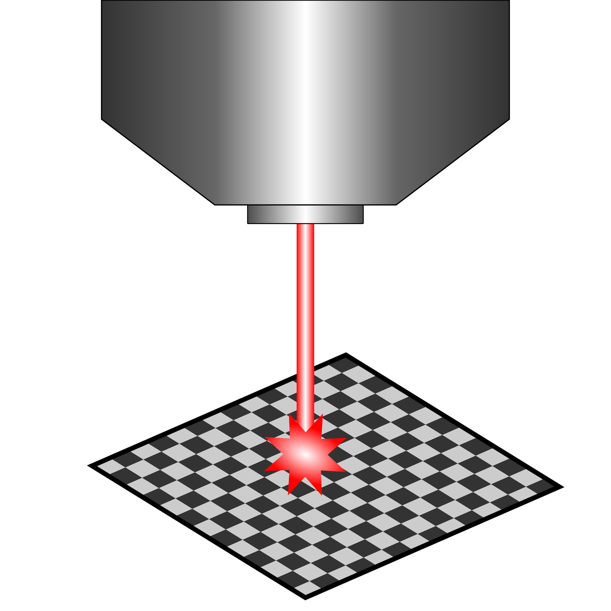
Figure 1: Schematic drawing of an electron beam sampling the surface of a specimen with an SEM chamber [2].

Intended Users
The software is intended for use by individuals with introductory (or better) knowledge of SEM imaging such university science undergraduate students learning about EM (Electron Microscopy) or SEM operators. Image processing knowledge is useful but not required.

Installation
Provided a supported web browser (see System Requirements) is installed and used, the web application itself requires no extra installation setup and can be accessed at the following web location: https://joedf.github.io/ImgBeamer/app

System Requirements
Operating System | Windows 7+, macOS 10.12+, Linux (any with a supported web browser)
Web Browser | Mozilla Firefox v105+, Google Chrome v99+, or equivalent HTML5 compliant web browser with support for offscreen canvas
Processor | Intel Pentium 4 or better
Memory | 2GB minimum, 8GB recommended
Screen Resolution | 1024x768 or larger, 1920x1080 recommended
Graphics | Dedicated graphics card recommended
Internet Connection | Required

Documentation
The software design documentation (with example use cases, terminology, and in-depth information on the modules, requirements, and validation) is available at: https://github.com/joedf/CAS741_w23
Mainly, the Software Requirements Specification (SRS) document contains relevant information for more experienced users and application developers: https://github.com/joedf/CAS741_w23/blob/main/docs/SRS/SRS.pdf
Application programing interface (API) code-generated documentation is available at: https://joedf.github.io/ImgBeamer/jsdocs/index.html

Source Code
The source code of the software is available at: https://github.com/joedf/ImgBeamer

Getting Started

Example Usage / Tutorial
- Open the application in your web browser.
- Click on “Import Image” option to load an image file. You also may skip this step and step 3 to simply use the default preloaded image.
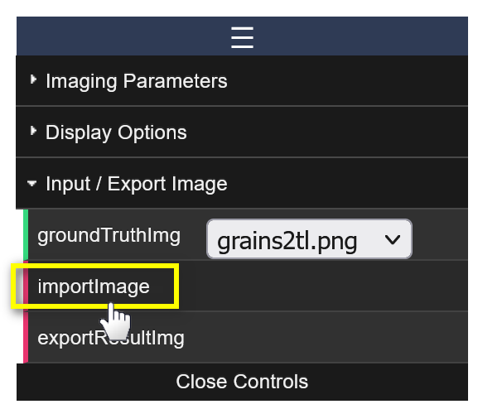
- Set the pixel size of the image in nanometers if this is known. For example, if the loaded image is 1024 by 1024 pixels and represents 100 by 100 micrometers in physical space, the pixel size should be around 10 nm/px (1024 / 100 = 10.24).
You may also use the “show ruler” option; movable and a resizable line will be displayed on the “Ground Truth Image” display. You can double-click it to set the length of the ruler in physical units.
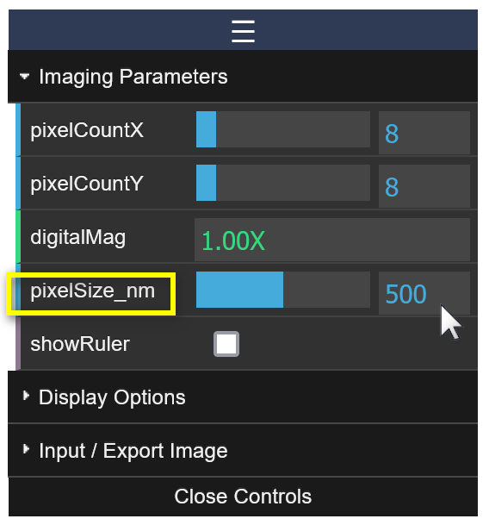 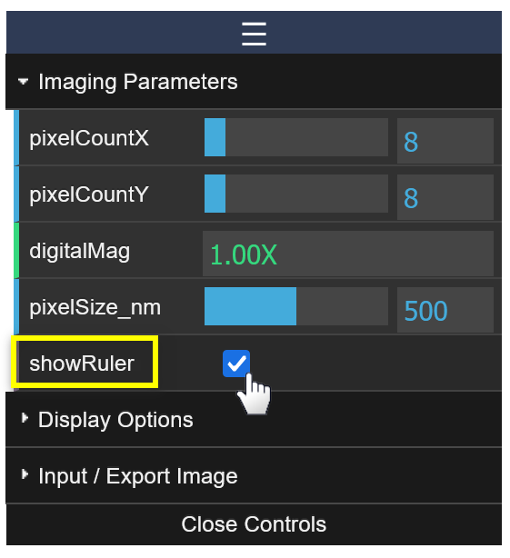
- Change the pixel counts to 10 x 10 to obtain a subregion that is 10 by 10 pixels.
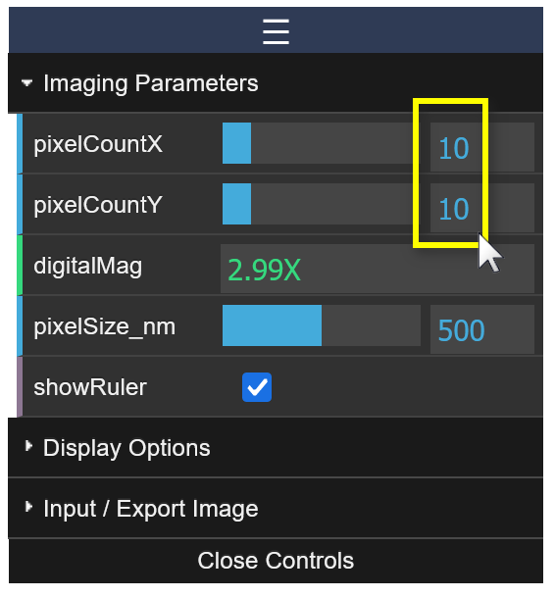 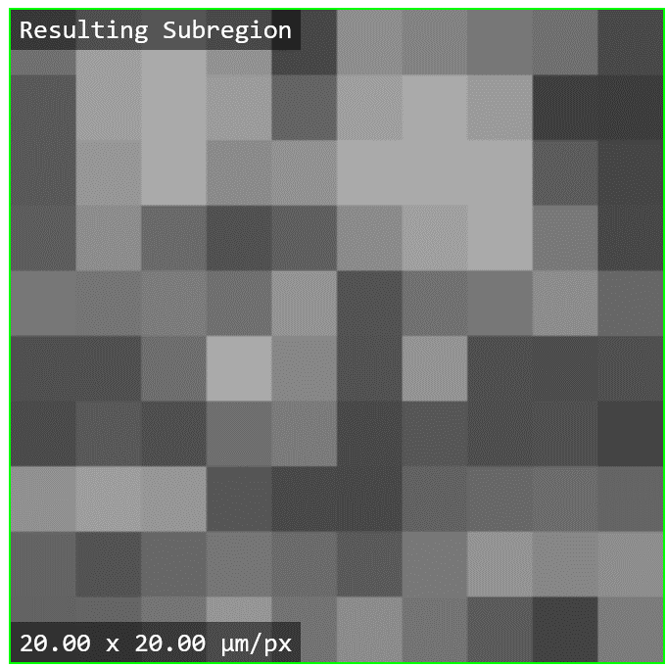
TIP! If you set the pixel counts to 1 x 1, the subregion will essentially be the size of one “pixel” in “Resulting Image” view.
- Scroll over the “Subregion View” to zoom-in on a feature of interest. Panning can be achieved by dragging the view area.
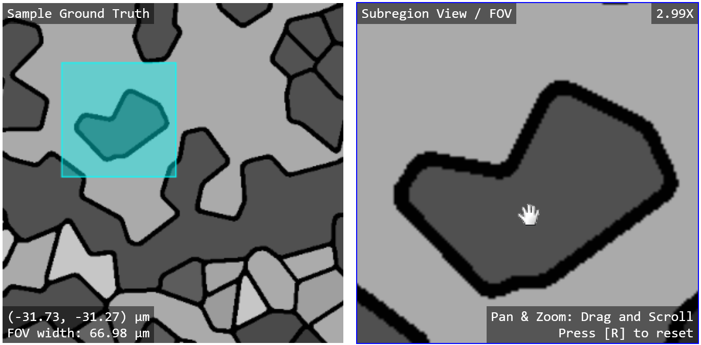

- Scroll upwards over the “Spot Profile” view to make the spot size smaller (relative to pixel size). This results in “undersampling” when the spot is smaller than a pixel. The “Resulting Subregion” image will look shaper than earlier but may result in some detail loss (ex: missing parts of a grain boundary).
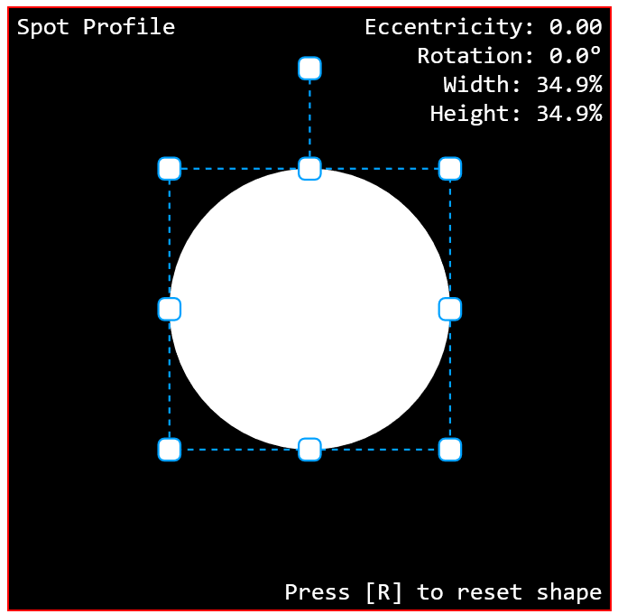 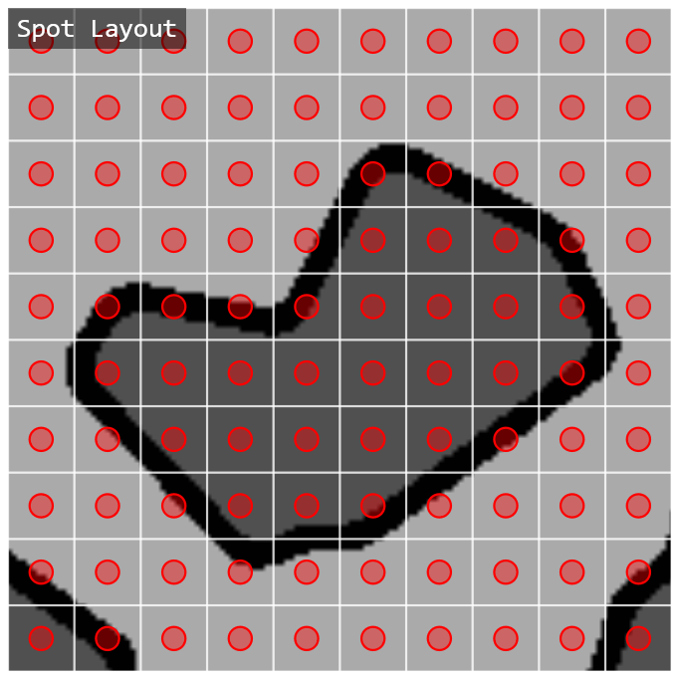 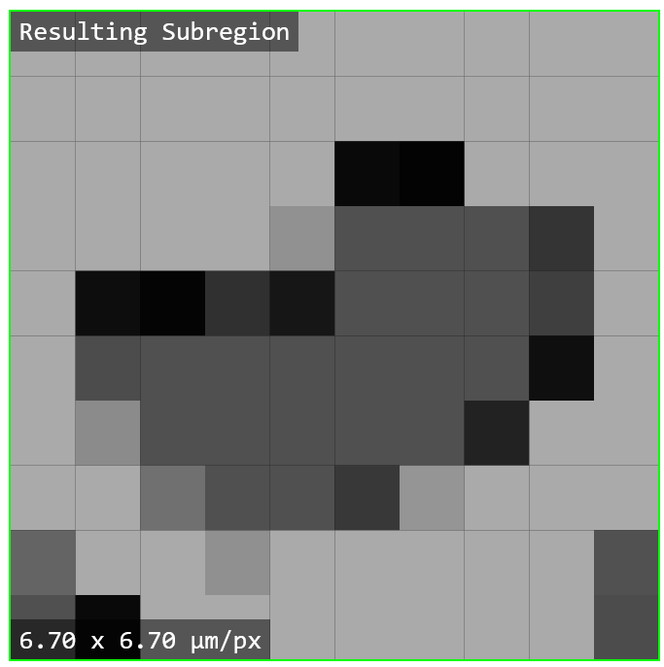

- Scroll downwards over the “Spot Profile” view to make the spot size larger. This results in “oversampling” when the spot is larger than a pixel, covering more area than that of the pixel. The “Resulting Subregion” image will look blurrier than earlier but still encompasses most of the visual information (ex: the entire grain boundary is preserved but faint). This simulates an “under focused” image.
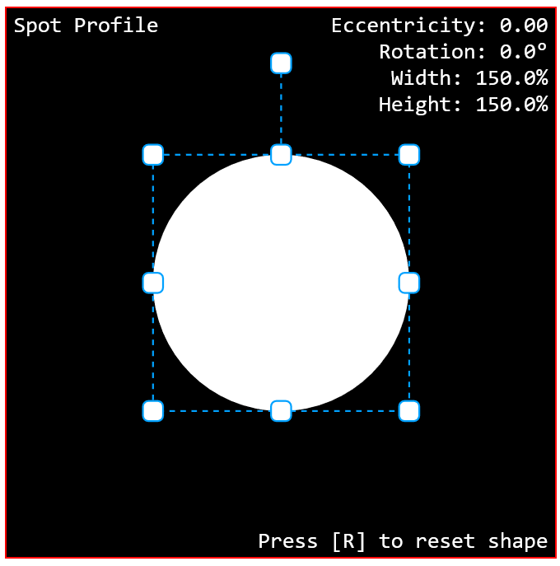 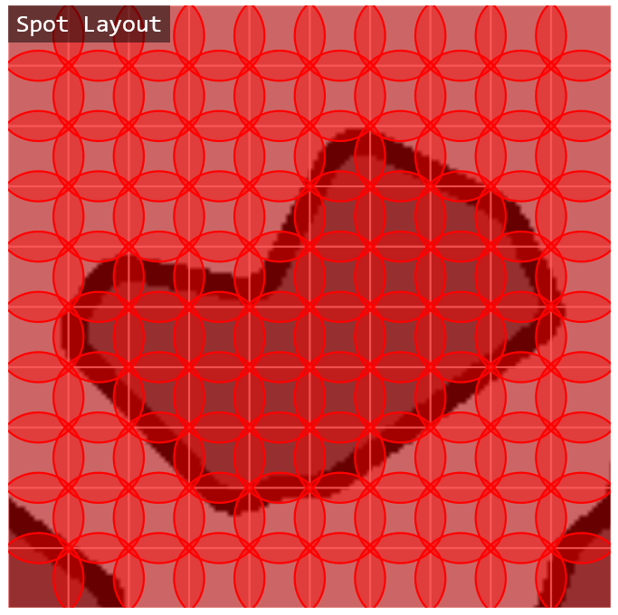 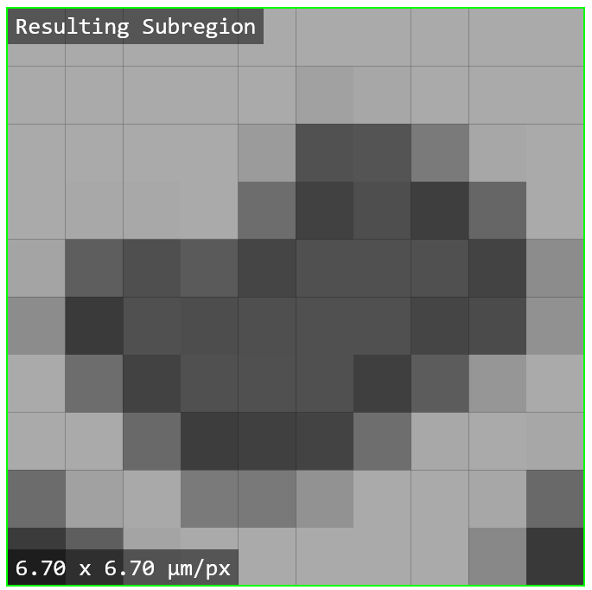

- Double click on the “Width: ...%” in spot parameters display in the “Spot Profile” view. A prompt will appear to change the spot width (%). Click “OK” to set it to the default value of 100%.
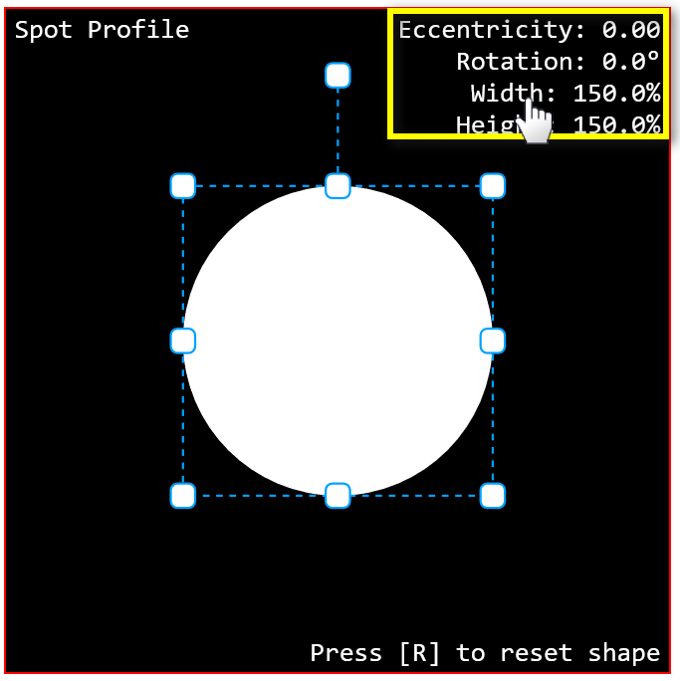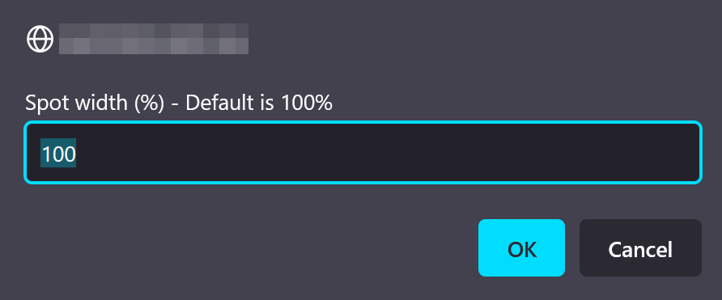
- Now drag the bottom middle node upwards to shape the spot into an ellipse that is much wider than it is tall. For example, a width of 100% but with a height of about 23%. Then, rotate the spot shape by 45 degrees clockwise by dragging the upper floating node.
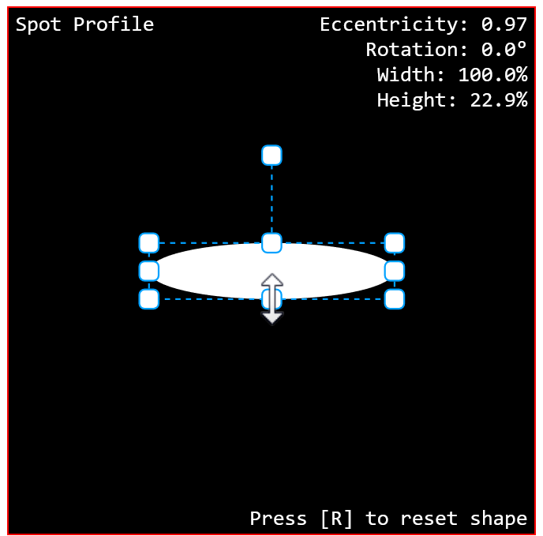 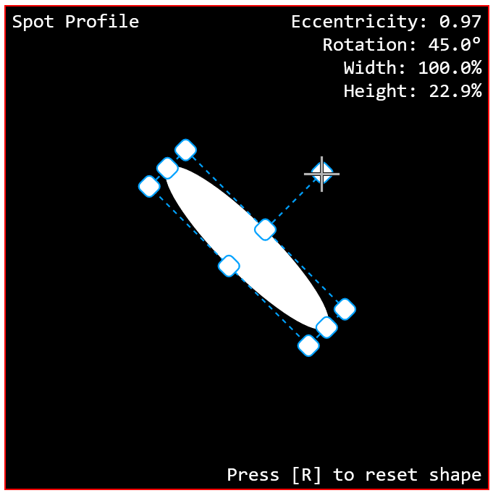

- Scroll upwards on the “Spot Profile” view until a spot width of 300% is reached. Optionally, this can be done by numerical input as explained in step 8. This produces an astigmatic image with an “under focus” in the north-west / south-east direction and an “over focus” in the south-west / north-east direction.
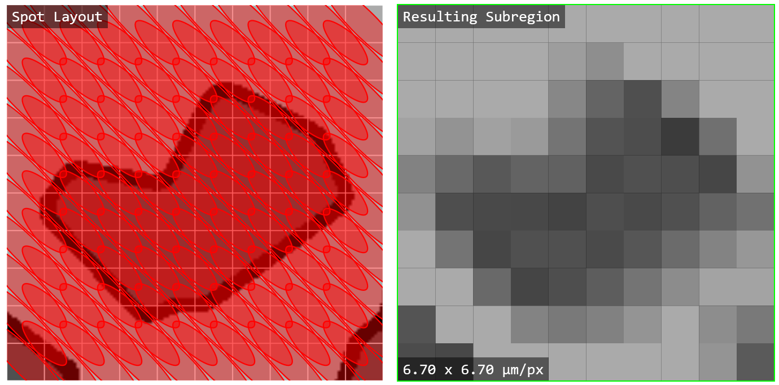 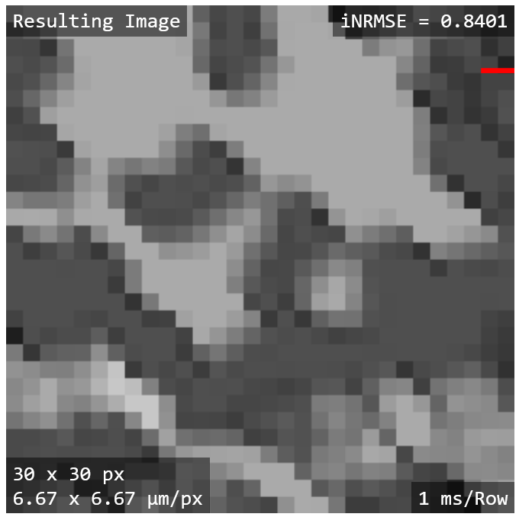
- Finally, click on the “Export Result Image” option to save the resulting image to a file.
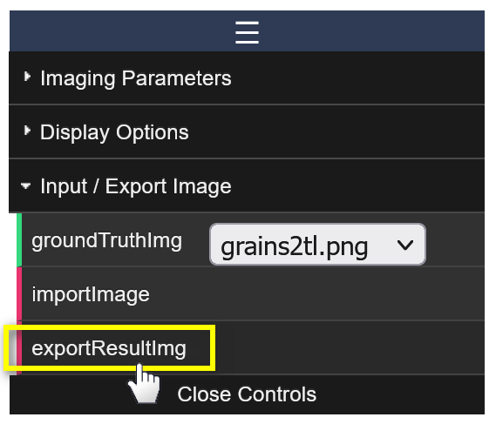
- Try experimenting with asymmetric pixel counts to get asymmetric pixels. You can also set the pixel counts to 1 to get the perspective of a single spot or beam like the “Spot Content” tool in “Advanced Mode”.

User Interface Basics
This section gives an overview of the user interface (UI) of the application. A brief description of each view and the primary application options are presented.
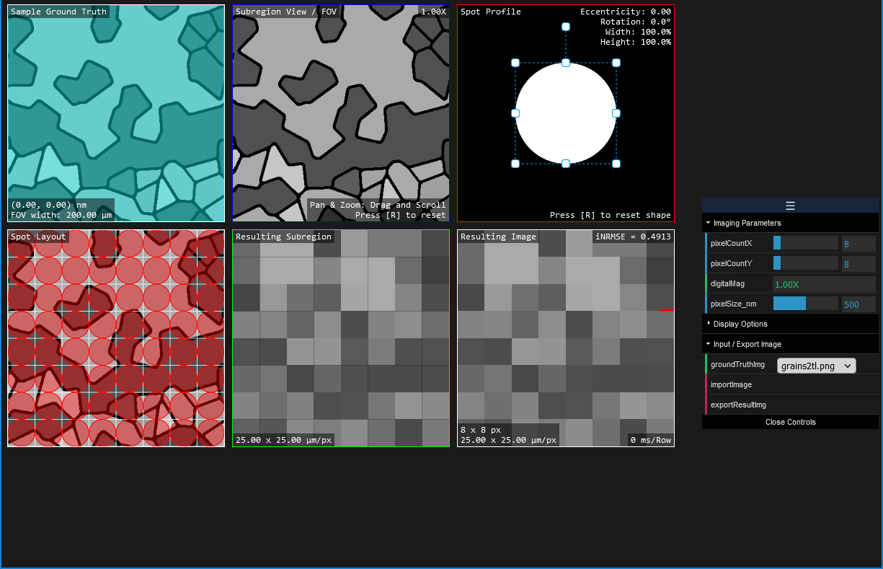
Figure 2: Screenshot of the application’s initial state.

Main Views
In the initial state of the application, you are presented with six main views (on a preloaded ground truth image) and an options window (see Figure 2). Each view is briefly described.
- Sample Ground Truth
  - This view acts as an overview of the ground truth image and as a navigational view of the subregion as a blue overlay. The Field of View (FOV) width (or width of the subregion) and the coordinates of the subregion’s center are displayed in the lower left corner.
- Subregion View
  - This displays the region of interest or subsection (zoomed-in) view of entire ground truth image. The relative magnification with respect to the “Sample Ground Truth” view is displayed in the upper right corner.
- Spot Profile
  - This display allows the user to edit the shape of the beam / spot that will be used to sample the ground truth / input image. The size of the beam with respect to the pixel size may be changed by the mouse scroll wheel or by double clicking on the spot parameters for numerical input as displayed in the upper right corner.
- Spot Layout
  - This view previews the beam sampling layout over the subregion. It shows the relative beam area coverage / size as red semi-transparent overlay shapes at each discrete imaging pixel location.
- Resulting Subregion
  - This view shows the resulting “image” where imaging pixels (as shown in “Spot Layout”) are filled in by the signal sampled by the spot at each discrete location. The values of all pixels within the area covered by the spot at each location are averaged to be the resulting imaging pixel’s “grayscale” value. The image pixel size (width x height) is displayed in the lower left corner of the view.
  - Note: When the pixel counts (see Options Window) are set to a subregion image with more than 256 pixels (e.g., 16x16), the view is updated row by row like the “Resulting Image” view. This is done for performance reasons and responsiveness.
- Resulting Image
  - Like the “Resulting Subregion”, this view represents the resulting image but for the entire ground truth image. The image resolution (pixel counts) and pixel sizes are displayed in the lower left corner of the view. This display is continuously updated row-by-row with the draw rate displayed in the lower right corner. A short animated red line indicates the last row that was updated.

Advanced Views
These views (as highlighted in Figure 3) are only displayed if the “advanced mode” is checked under “Display Options” in the Options Window.
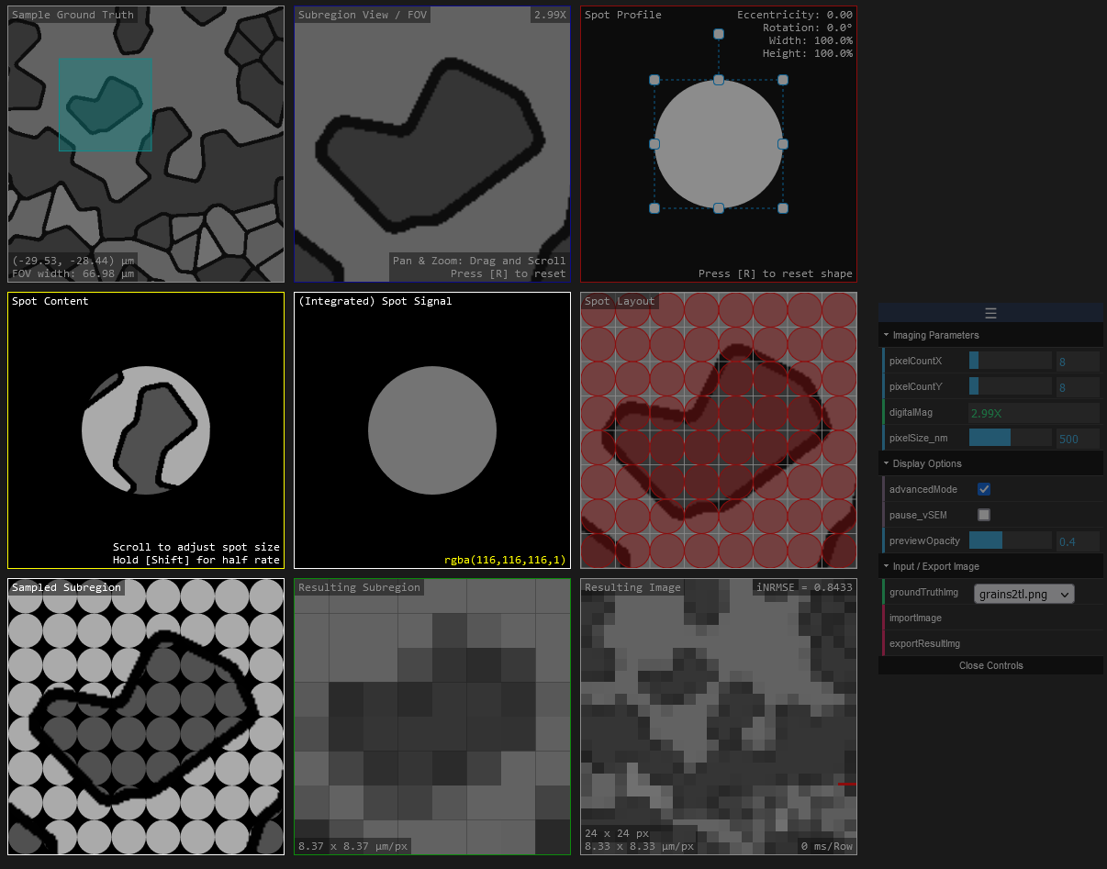
Figure 3: Screenshot of the application with “Advanced Mode” enabled.
- Spot Content
  - This view is separate from the Main Views and is coupled with the “Spot Signal” view. The ground truth image copy is “stenciled” by the spot shape as provided by the “Spot Profile”. The size of the spot is determined by zooming this image copy. over a copy of the ground truth image. This represents the information content for a signal spot that will be used to process the “Spot Signal”.
- Spot Signal
  - This display represents the resulting pixel color or value. The pixels selected or as stenciled in the “Spot Content” are used to calculate the resulting pixel “color” or “grayscale” value shown here.
- Sampled Subregion
  - This view is essentially the stenciled version of the “Spot Layout” view. It shows the area covered by the spot at each pixel location that will be used to calculate the pixels for the “Resulting Subregion” image.

Options Window
This window (see Figure 4) provides the ability to load and export images, change the subregion pixel size / counts, the image scaling (in physical length units), and display options.
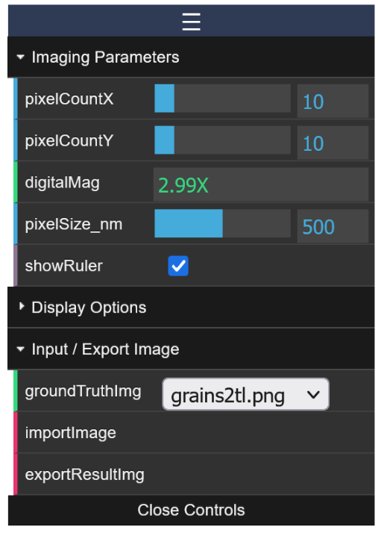
Figure 4: Screenshot of the “Options” window.
- Imaging Parameters
  - Pixel Count X / Y changes the number of pixels used (horizontally and vertically) for the subregion as shown in the “Spot Layout” and “Resulting Subregion” views.
  - Digital mag. simply displays the current size of the subregion with respect to the full input image.
  - The “pixel size” and “show ruler” options can be used to set the scaling in “real” or physical units.
- Display Options
  - This section provides the ability to enable the Advanced Views, change the opacity of the spots previewed in the “Spot Layout” view, and disable or pause any row-by-row drawing such as the “Resulting Image” view.
- Input / Export Image
  - The ground truth image dropdown provides a list of preloaded images to use as the input image.
  - An image file may be loaded in as the input ground truth image using the “Import Image” option.
  - The “Export Image” option lets the user save the “Resulting Image” as a file without any of the informational displays or overlays.

Example Scenarios
This section provides a brief description of different sampling / imaging scenarios.
Note: The application currently only supports a uniform intensity beam.
As covered by the Example Usage / Tutorial section, under-sampling is when the spot is smaller than the pixel and over-sampling is when the spot is larger than the pixel. A third scenario is exact-sampling which is achieved when the spot diameter is equal to the pixel size.
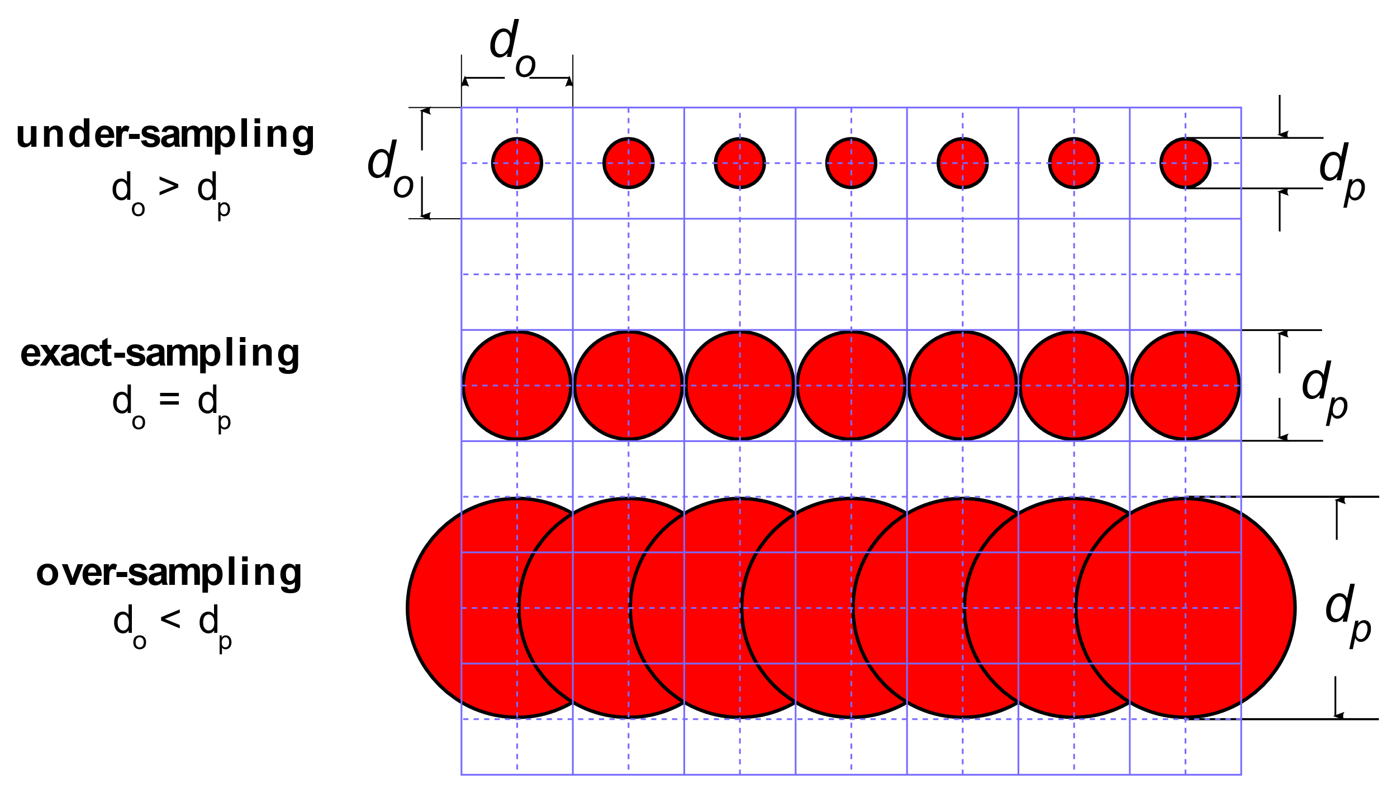
Figure 5: Schematic overview of three sampling scenarios where d₀ depicts the pixel size and d_{p} depicts the spot diameter [2]. Adapted from Lifshin et al. (2014) [3].
The red circles shown in Figure 6 represent the spot area covered by the beam and the overlap that would occur in a raster scan. At 100%, there is no overlap between the spots, but we have gaps in-between the spots that are not covered. At 130%, we have somewhat significant overlap between spots, but the gaps between the stops are nearly non-existent. To achieve full coverage (at the cost of significant overlap) meaning no gaps, the spot diameter should approach the square diagonal ($\sqrt{2}≈1.4142$).
That said depending on the imaging conditions, these effects may not be noticeable when a very large image resolution is used (e.g., 16384 x 16384 px) where the pixels are much smaller than the smallest observed features.
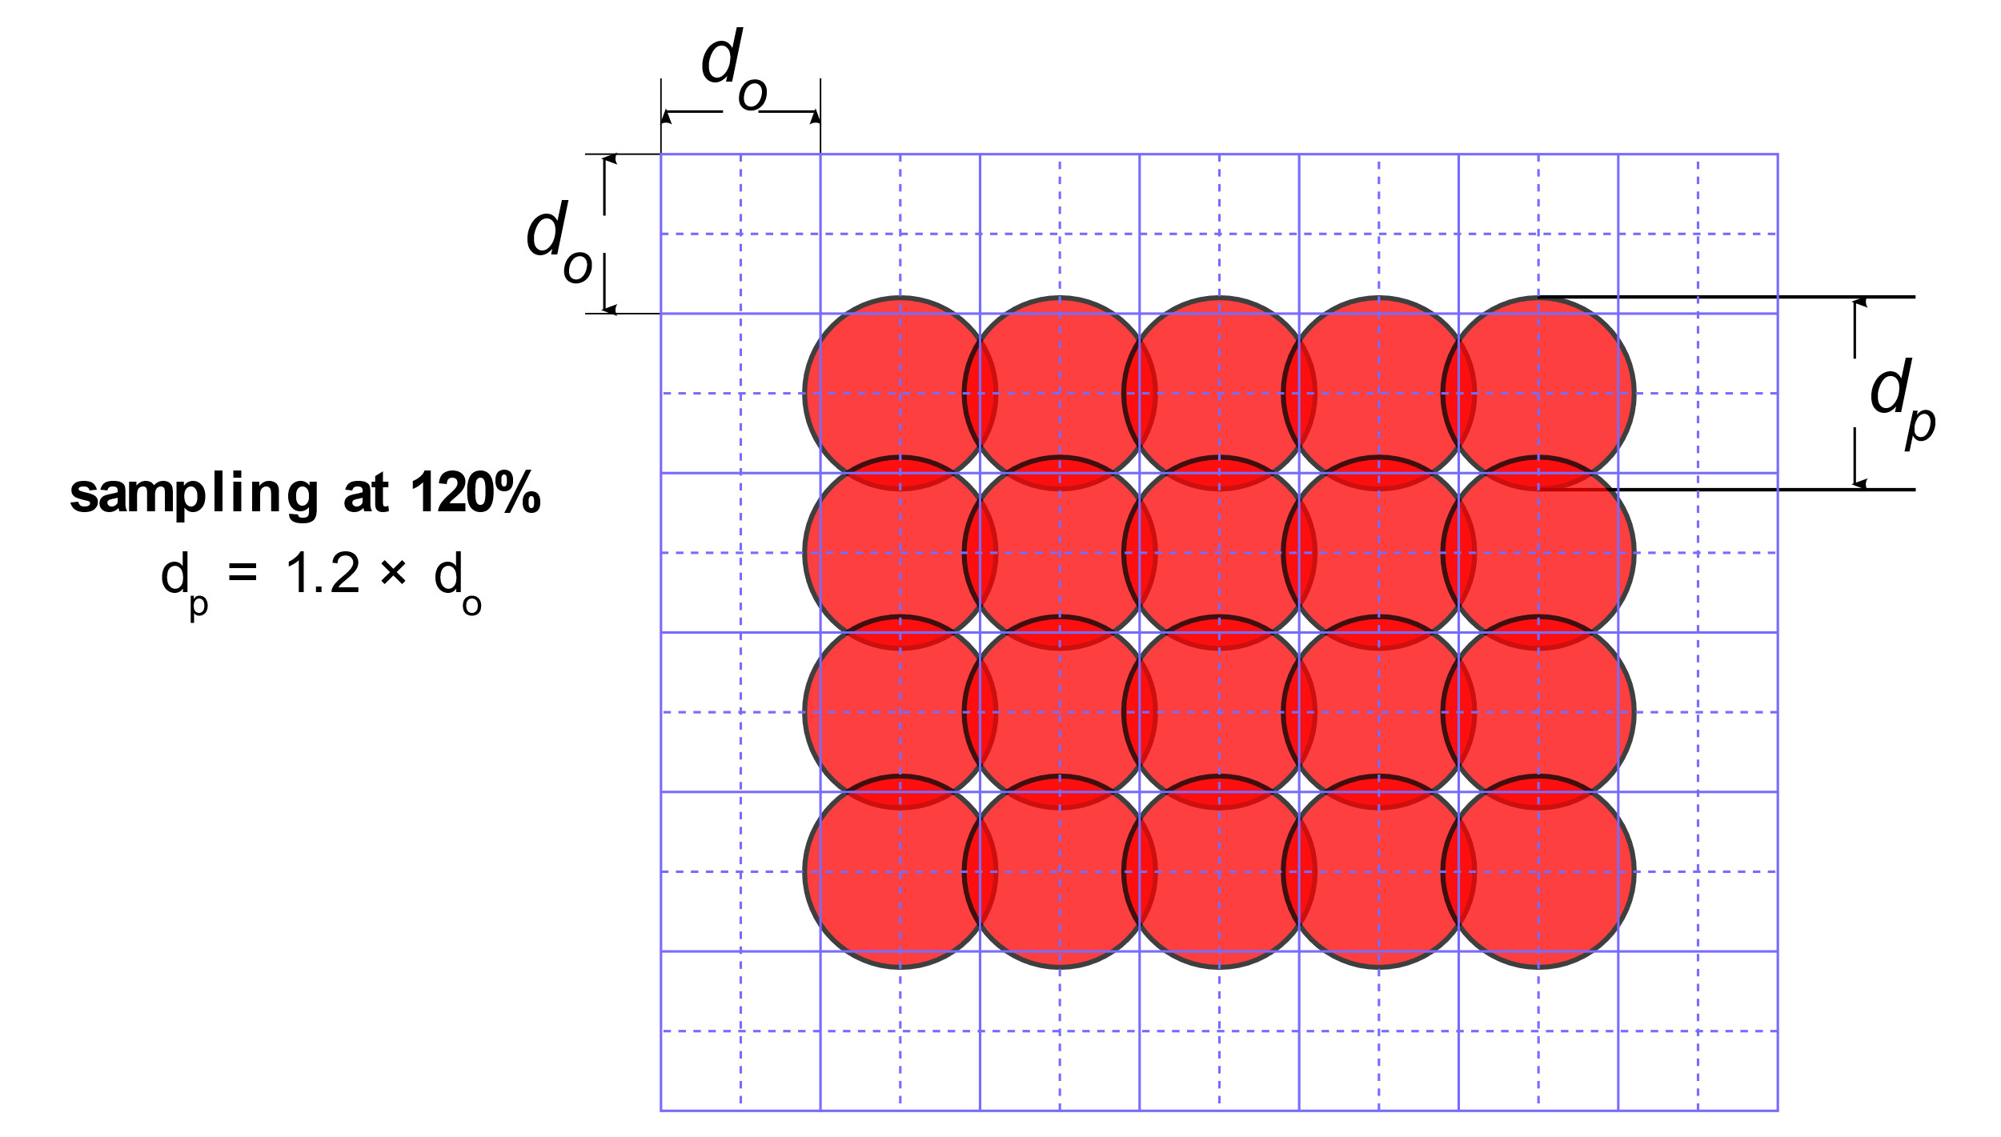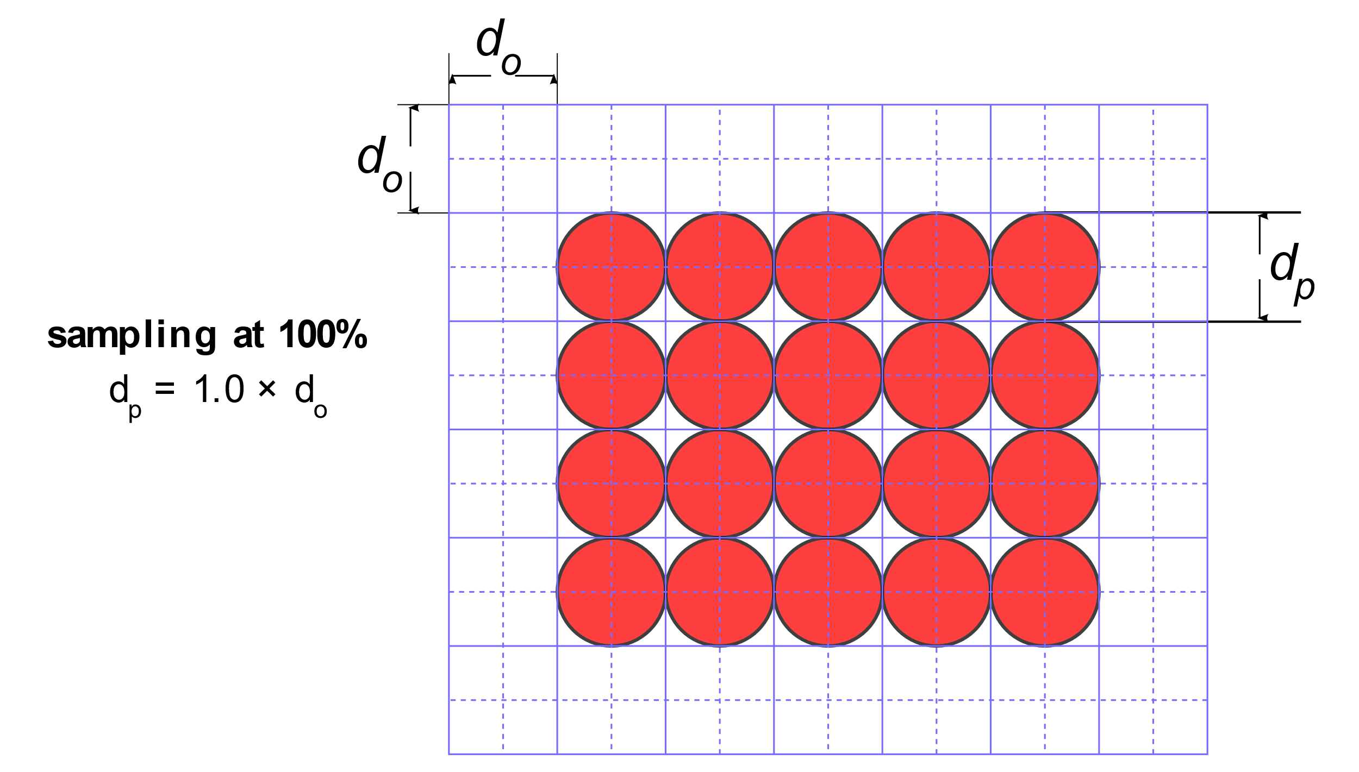
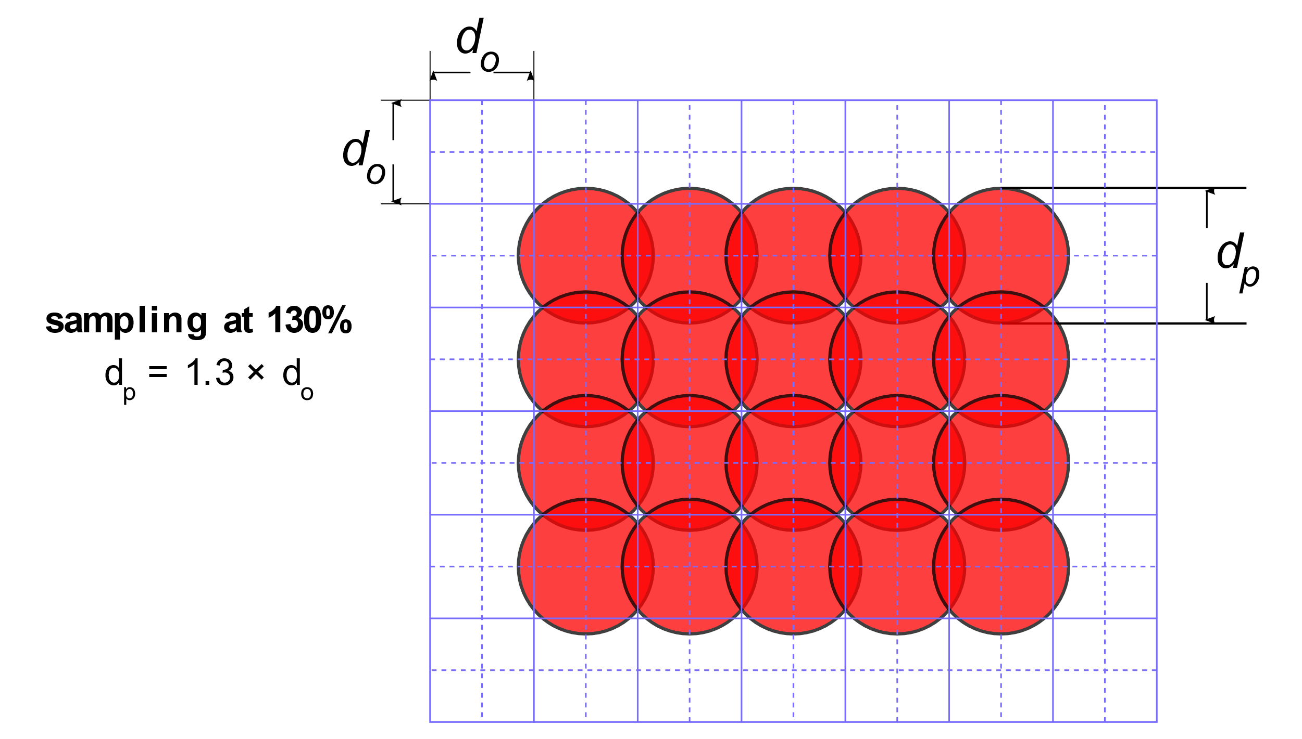
Figure 6: Scenarios depicting area coverage with a spot size of 100%, 120%, and 130% [2].

In Figure 7, we observe an example of astigmatism like what was achieved in step 10 of the Example Usage / Tutorial section. We also observe an example of image that is greatly under-focused like what was achieved in step 7. The small squares on the left-hand side represent the imaging pixel. The blue overlays represent the spot shape and its relative size to the imaging pixel. On the right-hand side is what generally results from using these spot “profiles” (size and shape).
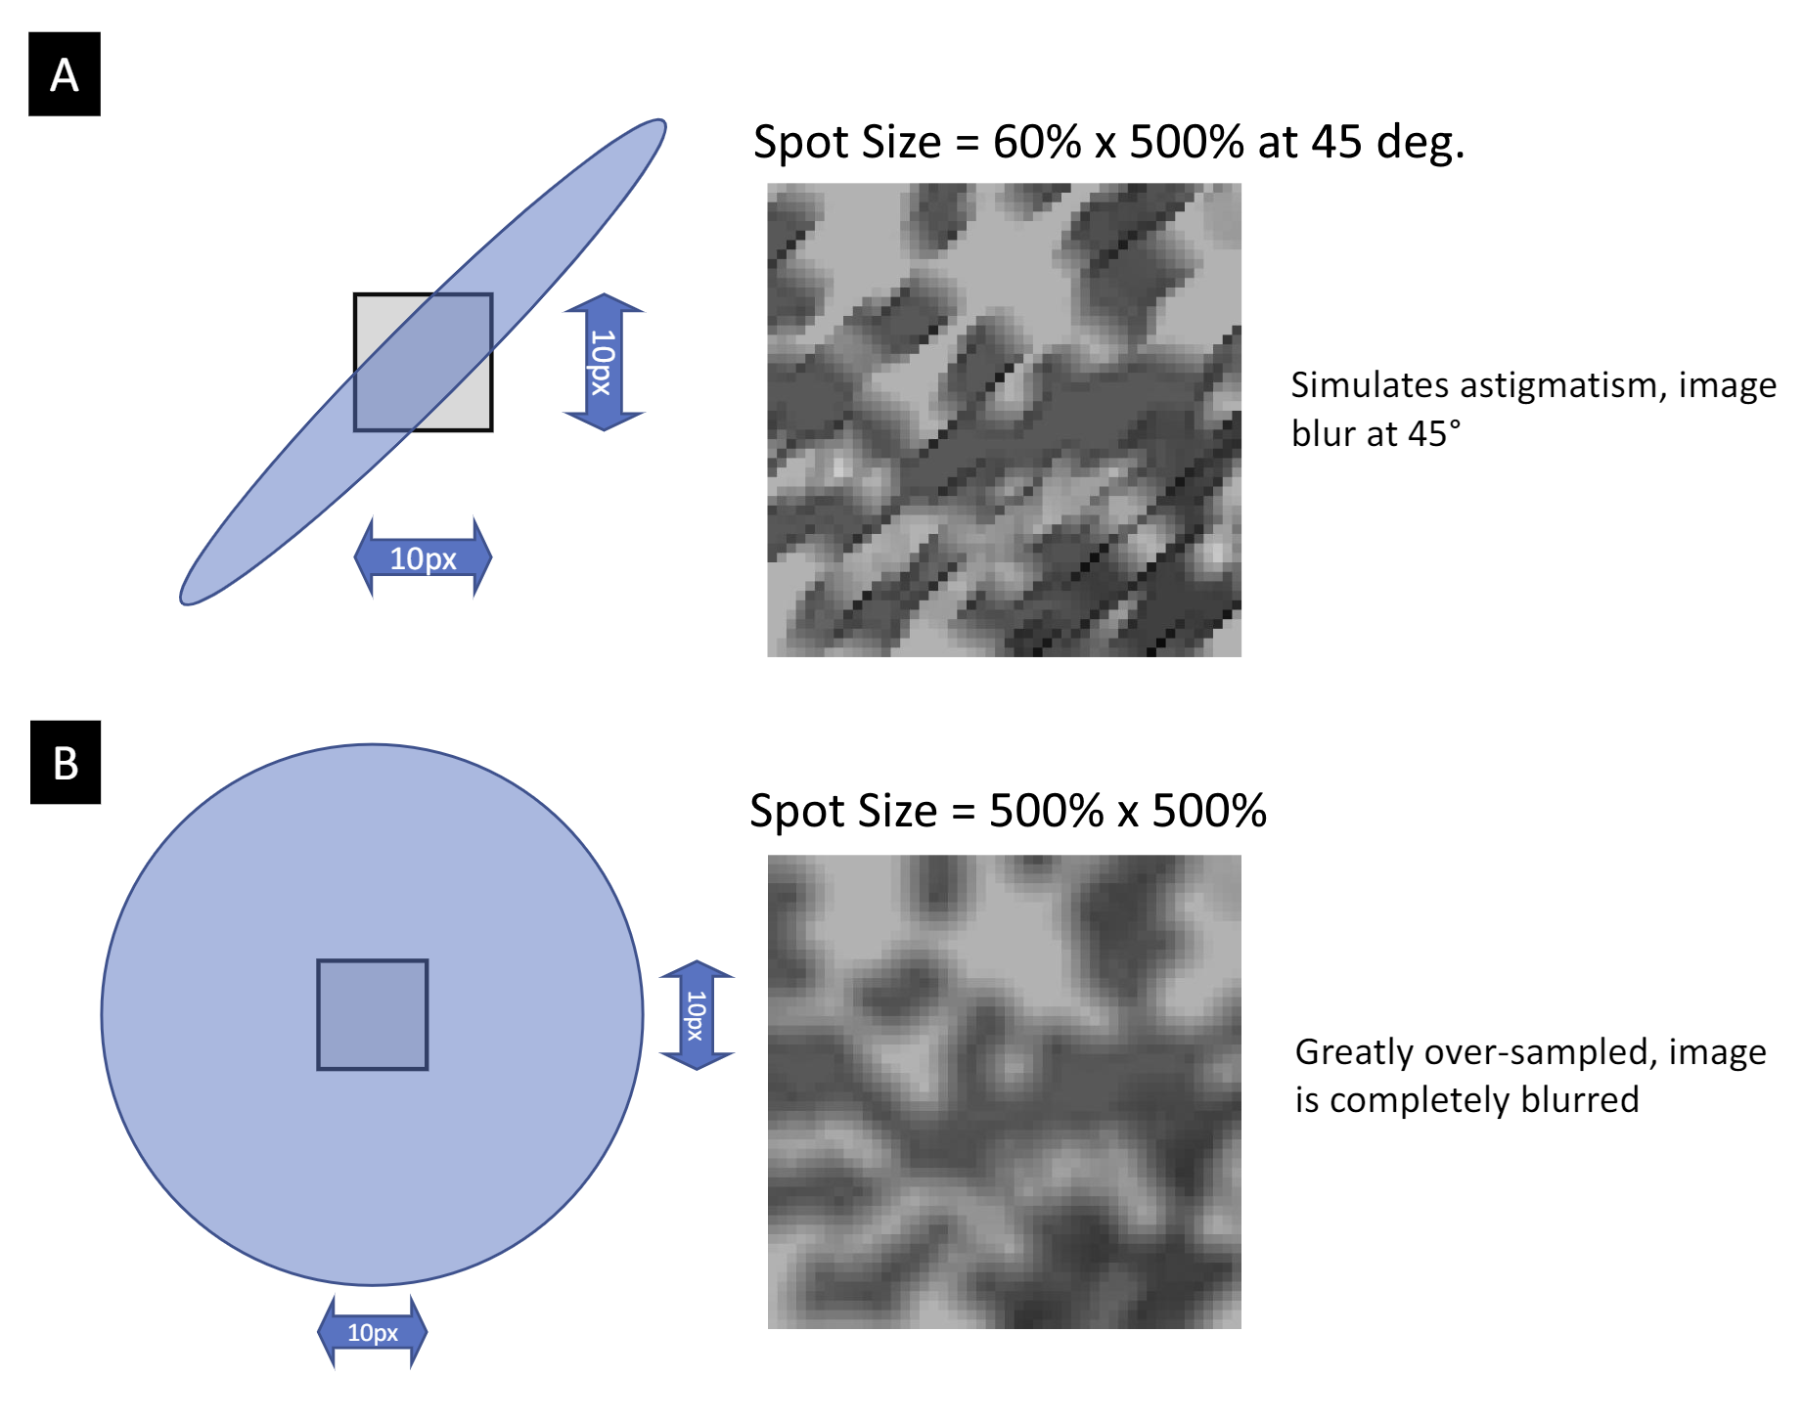
Figure 7: Examples scenarios of astigmatism and under-focus. Modified from [2].

References
[1] J. I. Goldstein, D. E. Newbury, J. R. Michael, N. W. M. Ritchie, J. H. J. Scott, and D. C. Joy, ‘Image Formation’, in Scanning Electron Microscopy and X-Ray Microanalysis, J. I. Goldstein, D. E. Newbury, J. R. Michael, N. W. M. Ritchie, J. H. J. Scott, and D. C. Joy, Eds., New York, NY: Springer, 2018, pp. 93–110. doi: 10.1007/978-1-4939-6676-9_6.
[2] J. de Fourestier, ‘Software Requirements Specification for ImgBeamer: Scanning Electron Microscope Image Formation’, CAS 741 (Winter 2023). McMaster University, 2023. [Online]. Available: https://github.com/joedf/CAS741_w23/blob/main/docs/SRS/SRS.pdf
[3] E. Lifshin, Y. P. Kandel, and R. L. Moore, ‘Improving Scanning Electron Microscope Resolution for Near Planar Samples Through the Use of Image Restoration’, Microscopy and Microanalysis, vol. 20, no. 1, pp. 78–89, Feb. 2014, doi: 10.1017/S1431927613013688.

