Convolutional Neural Networks
Overview
- design and implement Convolutional Neural Networks (CNNs)

Async
Neural Networks for Images | - complexity issue with processing images with a NN  - for a 1024 x 1024 image and a NN with 100 neuron input layer: 1024 x 3 (RGB channels) x 100 $≈$ 300 million parameters  - locality  - many useful features are local  - can be computed from small patches of the image  - ex: is Mr. Poopybutthole in this picture?    - you would not generally process the image all at once, but you would scan zone by zone classifying each edged object    - until you identify the target object or run out of searchable objects / zones  - translation invariance  - the exact coordinates of the feature in the image is irrelevant  - solution:  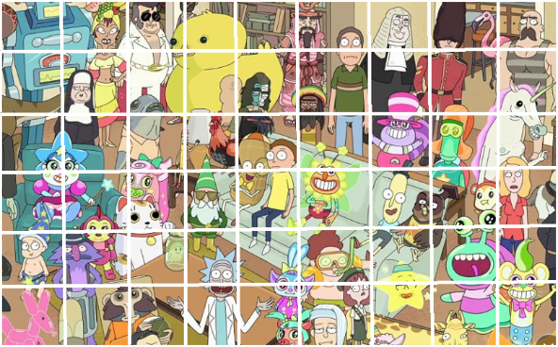  - look at 3 x 3 patches of the image  - we still get a different output at each patch location  - as abstract example: assuming each patch is 3 x 3  - full image: 27 x 18 x 3 x 100 $≈$ 146,000  - single patch: 3 x 3 x 3 x 100 $≈$ 3,000  - the features extracted from each patch is then combined to construct a feature map for the full image
Convolutions in Image Processing | - convolution  - achieved through a “sliding dot product”  - defined by weight matrix $W_{F}$ (filter)  - optionally an additive bias term
CNNs | - using the sliding window to calculate the dot product value for each pixel  - the representation is still large (e.g., 1024 x 1024 x $n_{F}$)  - to compress, “pool” features form non-overlapping segments  - example: take a max or average over each 2 x 2 region for each channel  - no learnable parameters here  - introduces spatial invariance  - produces: 512 x 512 x $n_{F}$  - example CNN  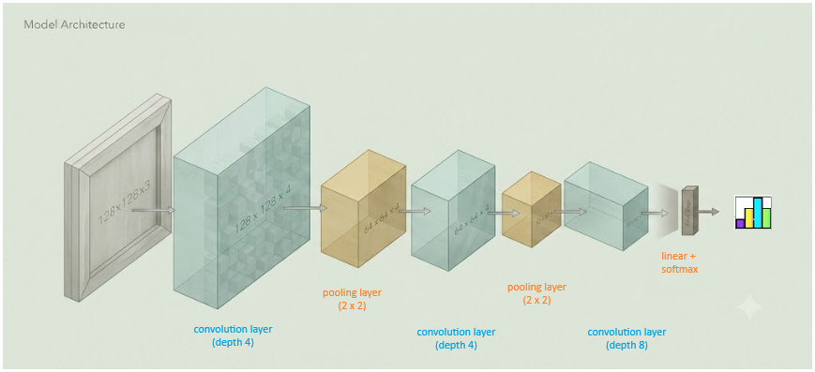
Paddings and Edges | - stride  - the number of spaces the sliding-window travels in a single sliding action  - suppose an image is 7 x 7 and has a sliding window with no padding  - a stride of one produces: 5 x 5  - a stride of two produces: 3 x 3  - we cannot apply a stride of 3 or more to this size matrix  - padding  - add ‘0 pad border’ around the image  - this ensures that the output is the same size as the input (for stride = 1)  - output size formula  $$Output Size=\frac{X_{side}+2P-f}{stride}+1$$  - pooling layer summary  - input  - tensor with dimensions $W_{1}×H_{1}×C$  - number of filters $n_{F}$  - length of filter: $F$  - length of strides: $S$  - zero padding: $P$  - output  - tensor with dimensions $W_{2}×H_{2}×n_{F}$,  where, $W_{2}=\frac{W_{1}-F+2P}{S}+1$ and $H_{2}=\frac{H_{1}-F+2P}{S+1}$  - number of learnable parameters:  - $n_{F}×F×F×C$ weights and $n_{F}$ bias terms
Examples of CNN Architectures | - LeNet for Handwritten Digit Recognition (1988: Yann LeCun!)  - well-known 30+ year old handwriting reading tool  - AlexNet (2012)  - revolutionary model in terms of performance (16.4% error rate)  - one of the real first deep learning successes  - classic deep CNN architecture  - first use of ReLU activations  - trained with L2 regularization and dropout  - VGG Net (2014)  - large increase in depth over previous models  - homogeneous stacks of smaller filters rather than layer-specific hyper-parameters  - 3 x 3 convolution filters with stride 1, padding 1  - 2 x 2 pooling filters with stride 2  - ResNet (2015)  - 152 layers  - no giant fully connected networks  - all positions averaged (single layer)  - skip and residual connections to provide better gradient optimization (enables training of really deep models)

