Batch-Layer Norms and Residual Connections
Overview
- implement batch normalization to accelerate training
- utilize residual connections to build deeper networks

Async
Training Really Deep NNs | 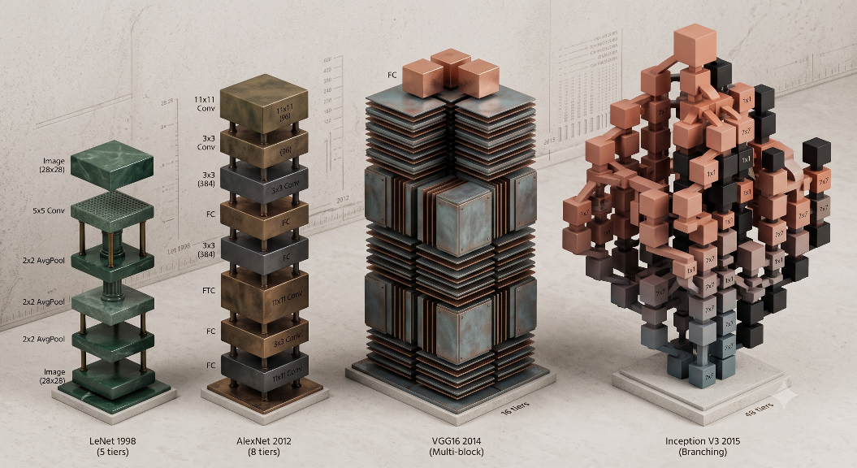  Gemini 3.5  - NNs have been increasing in complexity and numbers of layers over time

Batch Normalization | 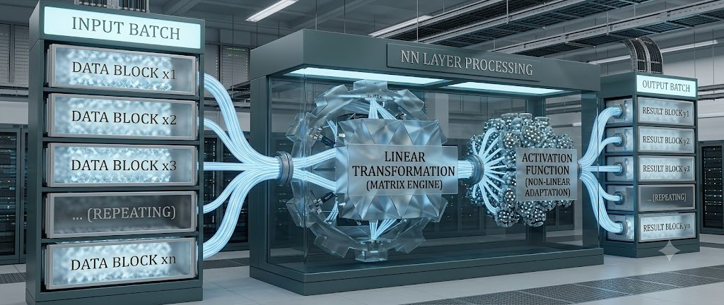  Gemini 3.5  - the input batch is similar to a mini batch with stochastic gradient descent, essentially it is a set of examples along which we want to make an update in gradient descent  - the output batch becomes the input batch for the next layer  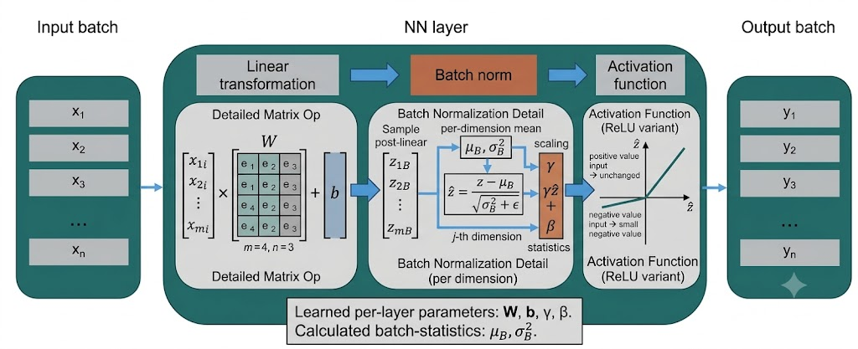  Gemini 3.5  - with batch normalization, once the data has been transformed linearly, a standardization operation is performed before being passed to the non-linear activation function  - alternatively, batch normalization can be after NL activation  - to compute batch normalization:  - compute the batch mean:  computes average vector input  $${\hat{μ}}_{B}=\frac{1}{\left|B\right|}\sum_{x∈B}{x}$$  - compute the batch variance:  computes variance of vectors  $${\hat{σ}}_{B}^{2}=\frac{1}{\left|B\right|}\sum_{x∈B}{{\left(x-{\hat{μ}}_{B}\right)}^{2}}$$  - normalize each batch sample:  normalization with mean = 0 and s.d. = 1  $$BN\left(x\right)=\frac{x-{\hat{μ}}_{B}}{{\hat{σ}}_{B}}$$  - it is unclear if normalizing to mean = 0 and s.d. = 1 and can lead to division by zero in the third equation if the batch variance is zero  - to avoid this, we add a small amount of noise ($ϵ$) to the second equation  $${\hat{σ}}_{B}^{2}=\frac{1}{\left|B\right|}\sum_{x∈B}{{\left(x-{\hat{μ}}_{B}\right)}^{2}}+ϵ$$  - additionally, we add two parameters (vectors $γ$ and $β$) to the third equation  $$BN\left(x\right)=γ⊙\frac{x-{\hat{μ}}_{B}}{{\hat{σ}}_{B}}+β$$  - we do an element-wise product of each batch normalized example with $γ$ to re-scale and constant vector $β$ which shifts the value of the normalized batch and redefines to a different mean and variance  - during test time, this is done somewhat differently by using the values collected during training to estimate reasonable values for $μ$ and $σ$  - batch normalization for images  - for each channel is $μ$and $σ$ are calculated and normalized separately  - benefits of batch normalization  - smooths the optimization landscape  - can use a larger learning rate – faster convergence  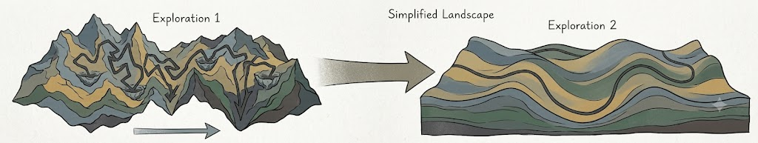  Gemini 3.5  - regularization from noisy estimates of mean and variance  - “sweet spot” for batch size  - batch too small  - noisy mean and variance estimates  - batch too large  - mean and variance estimates not noisy enough

Layer Normalization | - with layer normalization, we don’t compute aggregated statistics across a batch, each example in the batch is normalized independently  - benefits of layer normalization  - inputs to layer never explode or vanish  - no dependence on batch size  - forward pass during training and testing are the same
Residual Connections | - let $F$ be the set of functions an NN architecture can represent  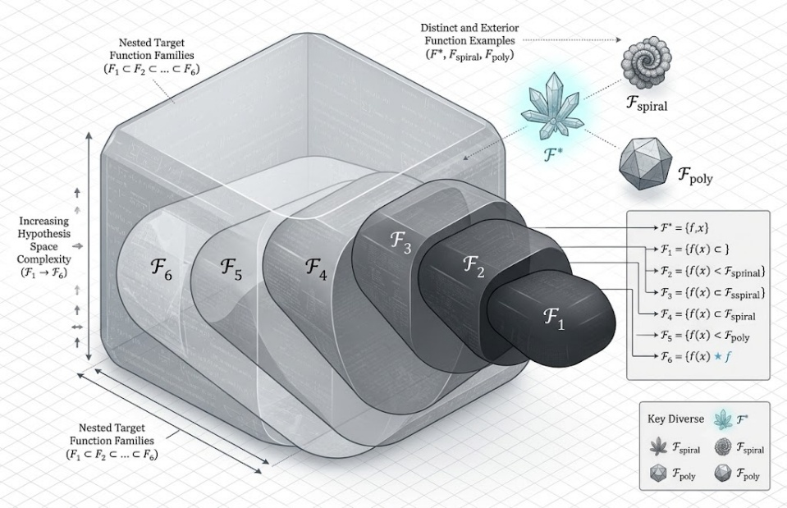  - let $f^{*}$ be the function we want to learn  Gemini 3.5  - each layer is a set of functions that can be represented by out feed forward network and outputs to the next layer with each layers’ functions increasing in complexity  - this leads to a situation where more complex layers become disjointed from the simpler architectures  - ideally, the more complex architectures should already encapsulate the simpler architectures absorbing the horizons of the lower layers  - to guarantee that the $n+1$ layer NN can represent a superset of the functions that the $n$ layer NN can represent, make sure that the $n+1$ layer can represent the identity function    Gemini 3.5  - several convolution layers, activation, and batch normalizations are used and at the end, you add a residual connection that bypasses this computation and adds x back into loop  - this implies that with the residual connection, we can always implement the identity function ensuring that computations made by a smaller network can also be performed by any larger network  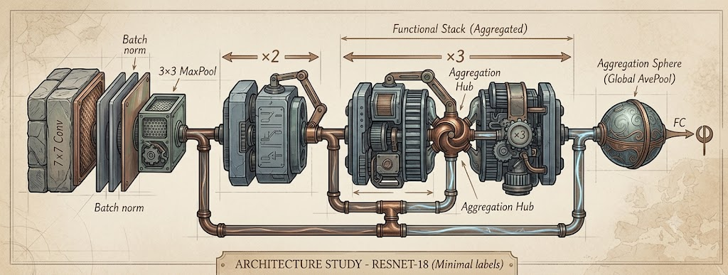  - additionally, a $1x1$ convolution can be added to the residual loop before it is passed  Gemini 3.5  - many modern architectures for deep learning and specifically for computer vision have moved towards uniform computation layer blocks that repeat with ResNet connections across each block  - benefits of residual connections  - expands the set of functions that a NN can represent  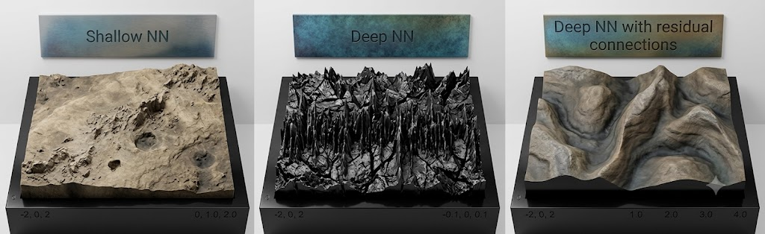  - prevents “shattering gradients”  Gemini 3.5  - in a shallow network, points close together on the x-axis have similar gradients  - extending to deeper architectures, the pattern breaks and there is very little correlation between adjacent points resulting in a “spiky” network  - by adding residual connections, this spiky-ness is normalized producing a better fitting model
Summary | - increasing depth has proven to be a reliable way of improving NNS  - bath normalization can layer normalization smooth the optimization landscape by normalizing activation/pre-activation  - residual connections smooth the optimization landscape and ensure that adding layers expands the set of representable functions  - normalization and residual connections are important components of sequence-modeling architectures such as RNNs transformers

