Course Preparation
Requirements |  |  | 13 Aug 2026
- DBeaver
- Java 21 or higher
- OpenJDK 23.0
  - https://dbeaver.io/download/
- Campus VPN: Cisco Secure Client
  - https://tdx.unc.edu/TDClient/33/Portal/KB/ArticleDet?ID=30
  - You need VPN to access
    - GitLab Services
    - F5 Load Balancer
    - Grouper

Connect to a new MySQL Database

You must be connected to the Campus VPN, or on EDUROAM to connect
- Click the icon to create a new connection OR
- From the Menu click Database > New Database Connection OR
- Ctrl + Shift + N (Cmd + Shift + N on Mac)
- Choose MySQL from the database driver list
- Settings:
  - Server Host: db2.ils.unc.edu
  - Port: 3306
  - Database: db2_onyen (example db1_aml14)
  - Username: db2_onyen (example db1_aml14)
  - Password: Emailed to each student (be sure not to copy trailing spaces)
  - Click: ‘Save password’ > ‘Test Connection’ > ‘OK’ > ‘Finish’

Screenshots | 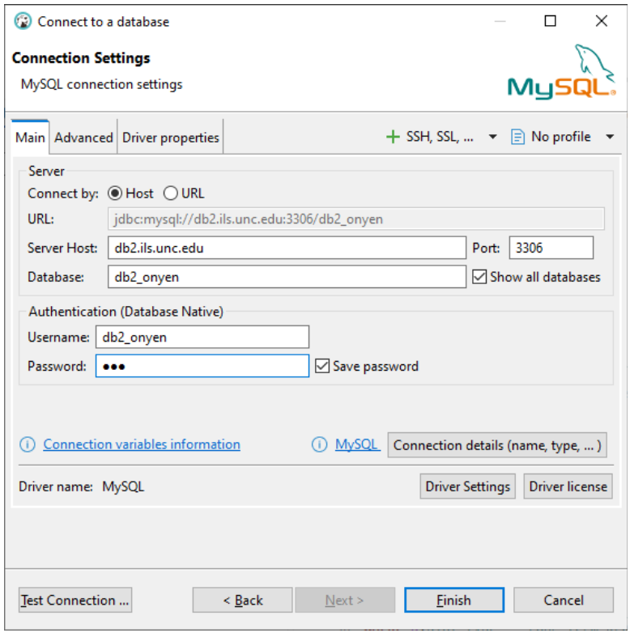  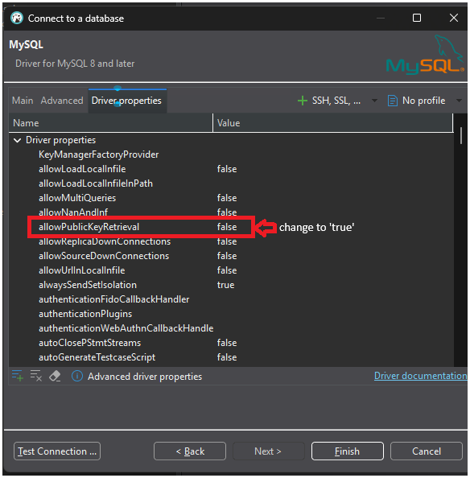  be sure to enable public key retrieval  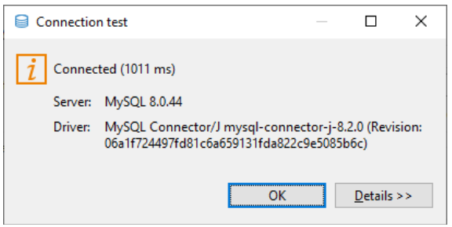
Getting Connected: Connect to Sakila.db
- Downloads
  - saklia.db
    - https://www.timestored.com/data/sample/sakila.db
  - duckdb-demo.duckdb
    - https://www.timestored.com/sqlnotebook/files/duckdb-demo.duckdb
  - Open DBeaver
  - Create a New Database Connection
    - Choose SQLite
  - Connect by: Host
  - Path: Location of downloaded sakila.db e.g. C:\Downloads\sakila.db
  - Click: ‘Test Connection’ > ‘OK’ > ‘Finish’
  - View Database Connection in the navigation pane

Write Your First SQL Query in DBeaver
  - Open a New SQL Editor Tab
  - You have several ways to open a new SQL editor tab in DBeaver:
    - Click the SQL Editor icon in the main toolbar
    - go to SQL Editor > New SQL Script
    - press F3
  - Type: SELECT * FROM actor;
  - Execute the Query
    - Click the Execute SQL Statement button (▶️) in the toolbar
    - Or go to SQL Editor > Execute SQL Statement
    - Or go to SQL Editor > Execute SQL Statement
  - View your results
    - If your query runs successfully and you see a results grid showing data from the actor table, congratulations! You're all set and ready for Introduction to Databases section of the course..

