Sequence Modeling and RNNs
Overview
- evaluate and critique techniques for modeling sequential data with N-grams and Recurrent Neural Networks (RNNs)
- identify and describe the probabilistic basis of Language Models

Async
Modeling Sequential Data | - examples of sequence modeling  - weather forecasting  - stock market trends  - autocomplete for texting  - genetic sequencing  - speech recognition  - video frame projection  - music composition  - sequences can be thought about as a list and can span many scopes and formats  - bytes  - letters (words)  - words (sentences)  - sentences (documents)  - frames (video)  - amino-acids (genetic code)  - the goal of sequence modeling is to compute the probability of a sequence of items  $$P\left(X\right)=P\left(x_{1},x_{2},x_{3},…,x_{n}\right)$$  - what it the next item in the sequence?  $$P(x_{5}|x_{1},x_{2},x_{3},x_{4})$$  - recall the chain rule:  - definition of conditional probabilities  $$P\left(A,B\right)=P\left(A\right)P(B|A)$$  - with > 2 variables  $$P\left(A,B,C,D\right)=P\left(A\right)P\left(B | A\right)P\left(C | B,A\right)P(D|A,B,C)$$  - history-based models  implication: each token is dependent on all previous tokens  $$P\left(x_{1}…x_{n}\right)=P\left(x_{1}\right)P\left(x_{2} | x_{1}\right)P\left(x_{3}…x_{n}|x_{1},x_{2}\right)$$  $$=\prod_{i=1}^{n}{P(x_{i}|x_{1},x_{2}…x_{i-1})}$$  - this presents a complexity issue as the number of parameters scales with length of sequence
Markov Models | - the complexity issue can be mitigated by limiting the history with Markov Assumption  - state is independent of history given previous state  ignore older history  $$P\left(x_{i} | x_{1},x_{2}…x_{i-1}\right)=P\left(x_{i}|x_{i-1}\right)$$  $$P\left(x_{1}…x_{n}\right)=\prod_{i=1}^{n}{P\left(x_{i} | x_{1},x_{2}…x_{i-1}\right)=\prod_{i=1}^{n}{P(x_{i}|x_{i-1})}}$$  - first order MM:  - maintain history of last state  - bigram model  - second order MM:  - maintain history of last two states  - trigram model  - Examples:  - Bigram model trained on "The Legend of Sleepy Hollow"  - "But it were grunting in former times of the battle in the quietest places which last was found favor in with snow which he heard in a knot of doors of the fence Ichabod stole forth now came to look behind"  - Trigram model  - "As Ichabod jogged slowly on his haunches and unskillful rider that he was according to the lot of a snowy night, with what wistful look did he shrink with curdling awe at the mention of the screech owl"  - Five-gram model  - "About two hundred yards from the tree a small brook crossed the road and ran into a marshy and thickly wooded glen known by the name of the Headless Horseman of Sleepy Hollow"  - clearly the quality increases quickly with the 5-gram generation being completely intelligible  - limitations of Markov models  - finite context  - Markov models are constrained by their fixed order, which limits their ability to capture long-term dependencies  - lack of memory  - do not possess memory of past states or events  - stationarity  - assume that the data-generating processes remain fixed over time
RNNs: Form and Parameters | - Recurrent Neural Networks recursively update hidden state to handle varying context sizes  - often context changes, branches, and runs in parallel, with articles near the end of the prompt referencing information presented anywhere in the earlier text up to the very beginning  - the notion of state in the RNN can be expressed:  $$h_{t}=σ(W_{1}h_{t-1}+W_{2}x_{t}+b)$$    Gemini 3.5  =  t
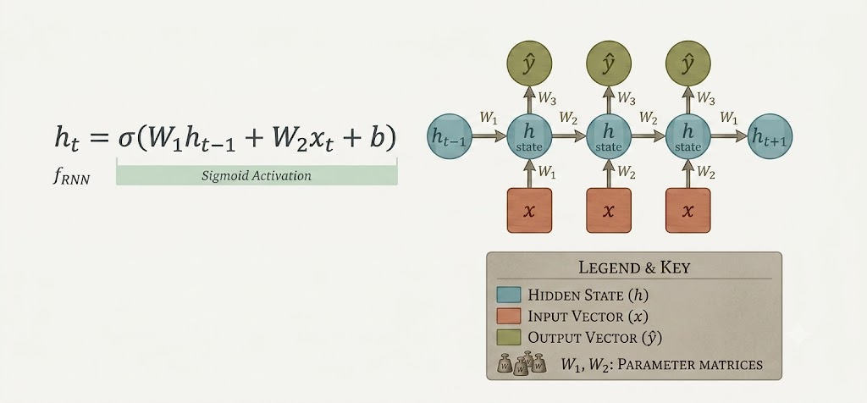
Gemini 3.5

- recursively combine new input with old state to handle varying context sizes
- $λ$ is a transformational function to get output form state:
  - binary classification
    - sigmoid
    - if desired output = {+1,1}
  - multi-class classification
    - softmax
    - if desired output = {1, 2, 3 … K}

RNNs in Action | - generating sequences using RNNs  - assume we currently have observation $x_{1}$ and want to predict $x_{2}$  - we compute hidden state $h_{1}$ first  $$h_{1}=σ(W_{1}h_{0}+W_{2}x_{1}+b)$$  - then, predict next token ${\hat{x}}_{2}$ by:  - first, computing $W_{3}h_{1}$ and applying $λ$ to get a distribution ${\hat{y}}_{1}$ (e.g., over a vocabulary)  - then, sampling ${\hat{x}}_{2}$ from the distribution ${\hat{y}}_{1}$  $${\hat{x}}_{2}\sim {\hat{y}}_{1}=λ(W_{3}h_{1})$$  - an RNNs is a type of NN that has a recurrence structure  - each hidden unit ($h_{t}$)  - encodes information from previous unit ($h_{t-1}$)  - which in turn encodes information from its previous unit ($h_{t-2}$)  - and so on...  - can model long range dependencies  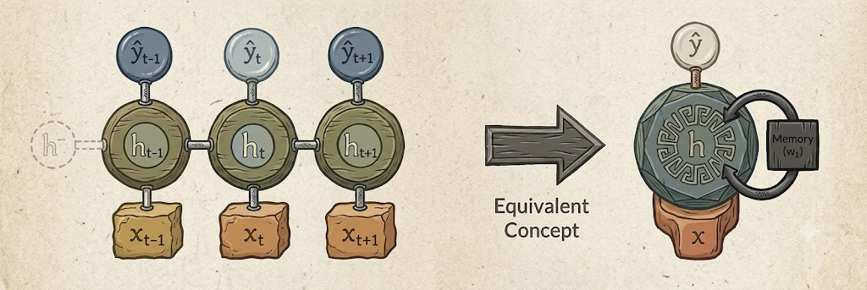  Gemini 3.5  - FNNs vs RNNs  - FNNs:  - number of inputs is fixed (fixed context)  - each hidden unit is dependent on all inputs but not on other hidden units  - RNNs:  - unlimited number of inputs (flexible context and long-range dependencies)  - each hidden unit is dependent only on the previous hidden unit and current input  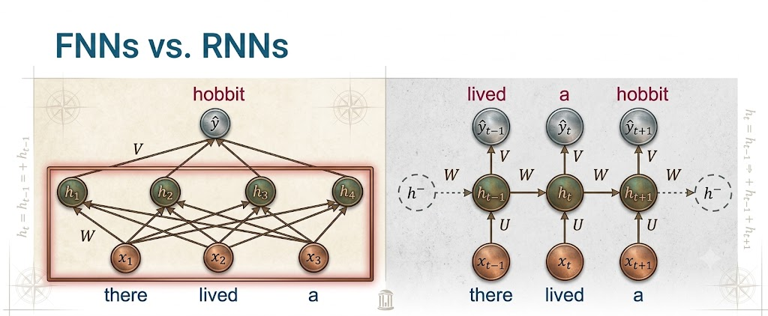  Gemini 3.5  - RNNs are Auto-Regressive Models  - an ARM predicts value at time t based on a function of the previous values at times $t-1, t-2,$ and so on…  - therefore, an RNN-based LM is also called an auto-regressive generation model  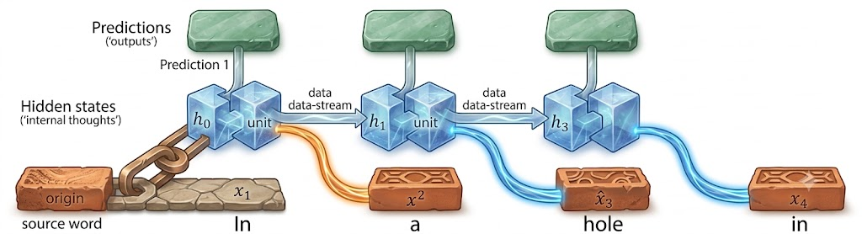  Gemini 3.5

