Advanced RNN Topics
Overview
- enumerate advanced RNN architectures including GRUs and LSTMs for handling long-term dependencies
- implement sampling and beam search strategies for generating sequences

Async
Advanced Topics with RNNs | - using RNNs for classification  - take the last token’s hidden representation ($h_{n}$) as the representation of the sequence  - loss computed at the FFN’s softmax layer    Gemini 3.5  $$FNN$$  $$RNN→$$  - errors flow back to RNN (end to end training)  - alternative:  - element-wise mean or max over states  - example: $h_{seq}≔\frac{1}{n}\sum{h_{i}}$  - RNN Training  - use a text corpus – make the RNN model predict the next word at each time step $t$  - RNN does not predict the word directly  - at each time step $t$, it predicts a probability distribution over vocab: ${\hat{y}}_{t}$  - next word is sampled from this probability distribution: ${\hat{y}}_{t}$  $$h_{t}=σ\left(W_{1}h_{t-1}+W_{2}x+b\right)$$  $${\hat{y}}_{t}=λ(W_{3}h_{t})$$  - objective function is to minimize the error in predicting the next word using cross-entropy as the loss function  - Cross-Entropy Loss for Sequence Modeling  - measures the difference between a predicted probability distribution and the correct distribution  - correct distribution (over full vocabulary): $y_{t}$  - predicted distribution (over full vocabulary): ${\hat{y}}_{t}$  $$L_{CE}=-\sum_{w∈V}{y_{t}\left[w\right]\log{{\hat{y}}_{t}[w]}}$$  - probability of a word $w$ under a distribution:  $$y_{t}=y_{t}\left[w\right]$$  - in language modeling  - we know the next word ($y_{t}$) is a one-hot vector with $dim=|V|$ where the entry for the next word is 1 and the rest are 0  - cross-entropy loss at time $t$ is:  $$L_{CE}\left({\hat{y}}_{t},y_{t}\right)=-{\log{\hat{y}}}_{t}[w_{t+1}]$$  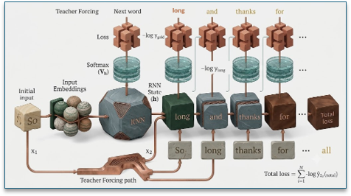  - Teacher Forcing  Gemini 3.5  - at train time, feed the initial input word at $t$ irrespective of what the model predicted at $t-1$  - embeddings $e_{t}$ can be obtained by multiplying input (one-hot) vector of $x_{t}$ with matrix $E_{d_{h}×|\tilde{V|}}$, where $\tilde{V}=vocabulary$  - $E$ is the input embedding matrix  - columns of $E$ are the embeddings for words in $\tilde{V}$
Gradient Computation | - Gradient Computation with RNNs  - RNNs can still be trained with backpropagation  - gradient involved repeated multiplications of $W$s  $$h_{t}=\tanh\left(Ux_{t}+Wh_{t-1}\right)$$ $$z_{t}=Ux_{t}+Wh_{t-1}$$ $$h_{t}=\tanh{(z_{t}})$$ $$\frac{∂E_{k}}{∂W}=\frac{∂E_{k}}{∂h_{k}}\frac{∂h_{k}}{∂W}$$ $$\frac{∂h_{k}}{∂W}=\frac{∂h_{k}}{∂z_{k}}\frac{∂z_{k}}{∂W}$$  $$\frac{∂z_{k}}{∂W}=h_{k-1}+W\frac{∂h_{k-1}}{∂W}$$  - the issue with W being continually propagated through this chain is, depending on the state of W, the gradient will likely either vanish or explode  - solutions:  - special activations  - gradient of ReLU activation avoids this  - normalization techniques  - batch and layer normalization to normalize the activations of a network  - gradient clipping  - clipping to a max value avoids gradient explosion
Greedy and Beam Search | - greedy decoding:  - at any time step, generate the most likely word$:$  $${\hat{w}}_{t} = argmax_{w∈ V }P\left(w | w_{<t}\right)$$  - locally optimal  - leads to extremely predictable results  - output is generic and repetitive  - not commonly used in practice  - beam search is a good alternative  - common in very constrained tasks like machine translation  - alternatives commonly used in LMs  - top-k sampling  - top-p/nucleus sampling  - temperature sampling  - greedy search tree  - representation of the search space for the output  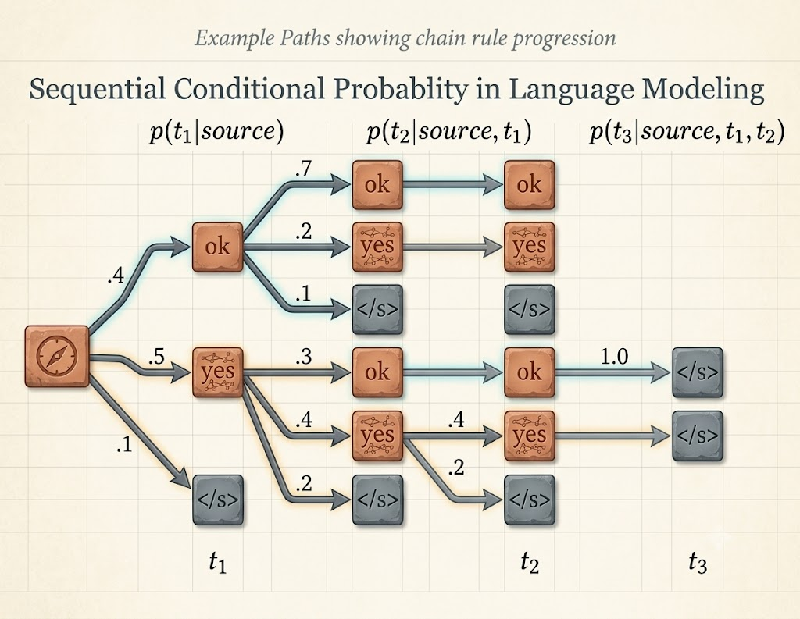  - branches represent possible actions  Gemini 3.5  - the greedy output (taking argmax)  - $yes, yes, </s>$  - $probability = 0.5*0.4*1.0= 0.2$  - highest probability output  - $ok, ok, </s>$  - $probability=0.4*0.7*1.0=0.28$  - greedy search may not uncover the global optimal output  - to obtain, execute exhaustive search of all possible sequences  - for a vocabulary of size $V$ and an output of length $T$  - you must explore $V_{T}$ sequences  - Beam Search  - keep track of the $K$ best possibilities at each step  - $K$ would be called the beam width  - generally ~5 or 10  - at $i = 1$  - given $x$ (source text), obtain probability distribution over entire vocabulary  - keep the top $K$ (highest probability) tokens  - for $i = 2$ onwards  - obtain probability distributions over entire vocabulary given the $K$ possibilities from $i – 1$  - $K ×V$ options  - compute probability score for each of the $K× V$ options  - $P\left(y_{i}\right|x, y_{1}, y_{2}, …, y_{i-1})$  - keep the top $K$ highest scoring options out of the $K× V$ options  - $s$  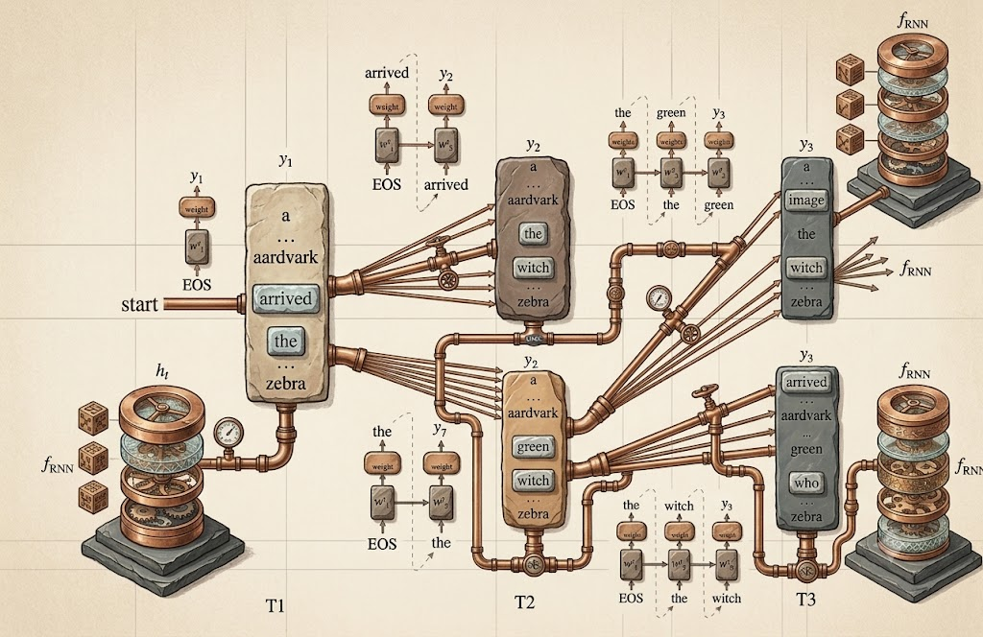  - result:  Gemini 3.5  - $K$ paths, now pick the highest scoring among them
Advanced Sampling Methods | - by only generating the highest probability words, you can end up with grammatical, but predictable and repetitive sentences  - sometimes picking the 2nd, 3rd, or 4th word might be more interesting  - two important factors  - quality  - highest probability words  - diversity  - high, not highest probability words  - top-k sampling  - simple generalization of greedy decoding  - choose in advance a number of words $k$  - truncate the distribution to the top $k$ most likely words  - renormalize to produce a legitimate probability distribution  - randomly sample from within these k words according to their renormalized probabilities  - when $k=1:$  - top-k sampling = greedy decoding  - $k>1$:  - select a word which is not the most probable, but still probable enough  - results in generating more diverse but still high-quality text  - top-p / nucleus sampling  - for top-k, k is fixed  - for some contexts, original probability distribution can be flat  - top-k words can cover most of the original probability mass  - for other contexts, original probability distribution can be flat  - top-k words will convert only a small part of the original probability mass  - solution  - use percent instead of absolute $k$ value  $$\sum_{w∈V^{p}}{P(w|w_{<t})≥p}$$  - temperature sampling  - don’t truncate the distribution  - reshape it instead  - intuition from thermodynamics  - a system at high temperature is flexible and can explore many possible states  - while the system is at a lower temperature, it is likely to explore a subset of lower energy (better) states  - low-temperature sampling  - smoothly increase the probability of the most probable “common” words and decrease the probability of the “rare” words  - reminder: with RNNs  - hidden states from the last layer used to obtain scores (logits, V-dimensional) via a linear layer  - logits converted to a probability distribution using a softmax function  - in temperature sampling  - divide the logits by a temperature, $τ∈(0,1]$ before doing softmax  $$y=softmax(u / τ)$$
Summary | - greedy decoding  - leads to extremely predictable results  - output is generic and repetitive  - beam search is a good alternative  - alternatives commonly used in LLMs  - top-k sampling  - top-p / nucleus sampling  - temperature sampling

